Leadership Skills for the 21st Century

1. Emotional Intelligence and Social Intelligence
Since the publication of Goleman’s (1996) ‘Emotional Intelligence: Why it can matter more than IQ’, there has been increased interest in the role emotions play in our actions and, as such, performance at work. Due to the complexity of organisational change and the role emotions play in changes such as global expansion, job eliminations, leadership changes, and the stressors of day-to-day responsibilities, the EI and SI of leaders and how they interact with multiple stakeholders is something that organisations need to give attention to (Goleman, 1995; Nath, 2013). It is commonly acknowledged that employee motivation goes beyond the usual monetary reward systems traditionally offered (Njoroge & Yazdanifard, 2014, Pink, 2012). In motivating today’s employees, organisations must engage their minds and captivate their hearts, which can be achieved by incorporating social and emotional intelligence. These skills assist leaders in attending to individual employee needs enabling organisations to offer an environment that motivates and develops people (Njoroge & Yazdanifard, 2014).
Many practitioners and scholars believe that emotional intelligence can be improved upon through development and training programs (Goleman, et al., 2002; Mattingly & Kraiger, 2018; Nath, 2013; Neale, et al., 2009; Rajah, et al., 2011). Mattingly and Kraiger (2018) suggest the need to individualise EI training and provide accurate feedback on participants' skills as EI is better trained using an active/experiential approach versus passive. One example of a development intervention as described by Goleman & Boyatzis (2008) included a 360° feedback. The case study leader used the feedback from the 360 to secure a mentor who coached her on how to express her viewpoint about contentious issues, modelling for her the art of giving feedback. Observing a role model of effective behaviour allows individuals to directly experience, internalise, and ultimately emulate what they observe and thus is an effective development mechanism (Goleman & Boyatzis, 2008).
Coaching is thought to be an effective intervention for developing EI and SI (Hughes, et al., 2009; Neale, et al., 2009). Coaching can help identify the interferences (negative thoughts and attitudes) that limit cognitive capacity and inhibit ability to manage emotions, preventing optimal performance (Neale et al., 2009). Removing these interferences will enhance learning (Goleman, 2008). A good starting point for the coaching might be a measure of current EQ using the Sparrow and Maddocks individual effectiveness tool (The British Psychological Society, n.d.).
High emotional intelligence is linked to a leader’s ability to build active networks (Cullen, et al., 2014), which in turn are linked to effective innovation leadership.

2. Networks and Boundary Spanning
“Complexity leadership requires leaders to develop their skills in effectively managing and developing networks” (Clarke, 2013, p. 141). However, a study by Ibarra & Hunter (2007, p. 101) found networking is “simultaneously one of the most self-evident and one of the most dreaded developmental challenges that aspiring leaders must address.’ As organisations strive for effective collaboration across boundaries, leaders must look beyond the organisational chart to the invisible informal networks supporting the organisation (Cross, et al., 2013; Cullen, et al., 2014). Research by MIT found that getting people to collaborate across boundaries was the biggest barrier to collaboration in organisations (Kane, et al., 2018).
Boundary spanners are individuals who are skilled at bridging interests and transferring information from disparate parts of the organisation (Cullen, et al., 2014; Williams, 2002). In reaching across boundaries, leaders learn to broaden their perspectives and generate more diverse and alternative ways of problem-solving, fostering cross-organisational innovation and transformation (Clarke, 2013; Ibarra & Hunter, 2007; Yip, et al., 2016).
Williams (2002) identified the following traits that characterise boundary spanners:
- Can communicate effectively without jargon and listen actively.
- Empathy and the ability to disagree and move on without harming the relationship.
- An easy and inviting personality that fosters honesty and openness.
- Politically sensitive
- Ability to manage interdependencies (complexity) – contributing factors: inter-organisational experience, transdisciplinary knowledge and cognitive ability.
- Have a large quantity of social capital
- Influencing and negotiating skills
- Is a trusted colleague
An effective way of identifying and developing boundary spanners within an organisation is first to conduct an Organisational Network Analysis (ONA) which provides insight into how social capital is distributed across the organisation (Brash, et al., 2008; Willburn & Cullen, 2014). An ONA will identify whether executives are isolated from the rest of the organisation and where there might be gaps in the boundaries they are spanning. This knowledge will help to accelerate the development of their own social capital. In addition to ONA a series of workshops, using action-learning techniques to explore the results of the analysis is recommended (Cross, et al., 2013).
The greater levels of collaboration inspired by boundary spanning leadership can facilitate the creation of shared meaning, where the leader engages in sensemaking with team members to promote shared understanding (Clarke, 2013).

3. Innovation
As a result of the relentless march of globalisation and increasing customer expectations, innovation has become a key driver of growth, performance and valuation (Brash, et al., 2008; Mickahail, 2015). Innovation is not just about product and service performance anymore, it also involves business models, company configuration, distribution and customer experience (Brash, et al., 2008; de Coutere & Horth, 2016).
In the face of challenging and unpredictable circumstances, leaders cannot rely on rational decision-making based on previous patterns, as ambiguity cannot be managed away (Horth & Buchner, 2014; Mitchell, 2017). Instead, they must try to make sense of the unfamiliar, which requires innovation leadership. This means bringing new thinking and different actions to how leaders lead (approach to leadership) and how they create a climate for innovative thinking (ibid).
There are a number of parts to the innovation process; clarify, ideate, develop and implement (see figure 1) and a different style of leadership may be required at each stage (Kesting, et al., 2015). A number of studies have been conducted in the attempt to establish the impact of leadership approach on the innovation capability of organisations (see Kesting, et al., 2015 for a review and synthesis of the literature). Though no definitive style has been identified, it is agreed the leadership antithesis to developing an innovation culture is that of command and control, especially within the ideation stage (Dodge, et al., 2017; Kesting, et al., 2015).
Figure 1: 4 Step Targeted Innovation Process
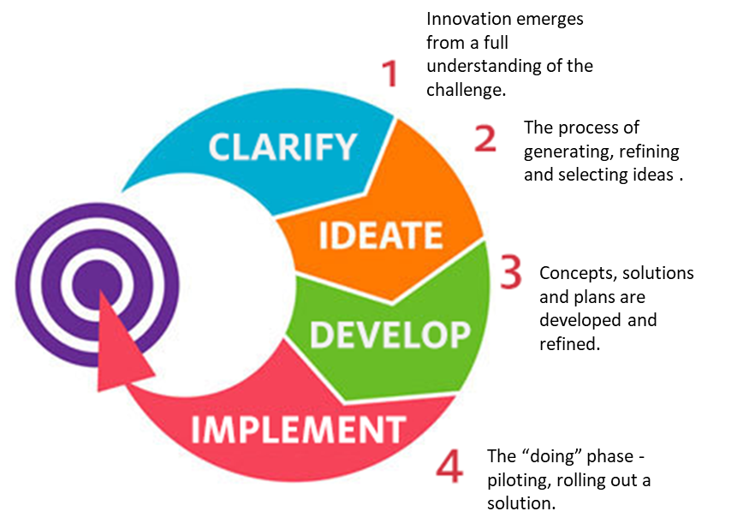
(Source: Centre for Creative Leadership, n.d.)
However, there is more to innovation than idea generation alone. Leaders must learn how to navigate ideas through a complex organisation. Championing ideas requires collaboration, (innovation does not happen in isolation) (Horth & Buchner, 2014), empathy with those you want to get on board, the ability to tell a compelling story (connecting the proposed innovation to results) (de Coutere & Horth, 2016) and seeing with new eyes (Liedtka, 2015). This requires skill in the areas of networking, sensemaking, and EI and SI previously discussed.
Design Thinking (DT) has emerged as a mechanism through which ideation can be encouraged (Liedtka, 2015; van Reine, 2017) and as a best practice through which organisations can influence corporate culture (Mickahail, 2015). DT can be defined as “an iterative process in which we seek to understand the user, challenge assumptions we might have, and redefine problems in an attempt to identify alternative strategies and solutions that might not be instantly apparent with our initial level of understanding” (Hasso Plattner Institute of Design Stanford, 2017). The process consists of a number of defined steps as outlined in figure 2.
Figure 2: Stages of Design Thinking Process
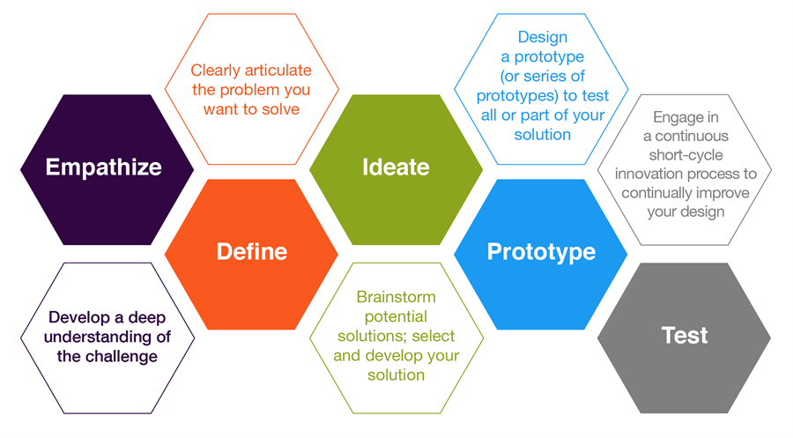
(Source: Hasso Plattner Institute of Design Stanford, 2017)
Some of the world’s leading brands, such as Apple, Google and General Electric, have adopted the DT approach and DT is being taught at leading universities around the world, including Stanford d.school, Harvard, and MIT (Interaction Design Foundation, 2018). Bootcamps are offered at these institutions and others as a means of experiencing and practising the process, offering the opportunity to learn how to apply DT to problems using practical methods.

References
Ancona, D., 2012. Sensemaking: Framing and Acting in the Unknown. In: The Handbook for Teaching Leadership. Thousand Oaks: Sage, pp. 3-18.
Clarke, N., 2013. Model of complexity leadership development. Human Resource Development International, 16(2), pp. 135-150.
Cross, R., Ernst, C. & Passmore, B., 2013. A Bridge too Far? How Boundary Spanning Networks Drive Organizational Change and Effectiveness. Organizational Dynamics, 42(2), pp. 81-91.
Cullen, K. L., Palus, C. J. & Appaneal, C., 2014. Developing Network Perspective: Understanding the Basics of Social Networks and Their Role in Leadership, Greensboro: Centre for Creative Leadership.
de Coutere, B. & Horth, D. M., 2016. Innovation Leadership. Training Journal, pp. 12-15.
Hasso Plattner Institute of Design Stanford, 2017. d School Crash Course in Design Thinking.
Available at: http://www.openculture.com/2017/08/take-a-90-minute-crash-course-in-design-thinking-from-stanfords-design-school.html
[Accessed 13 August 2018].
Horth, D. & Buchner, D., 2014. Innovation Leadership, Greensboro: Center for Creative Leadership.
Ibarra, H. & Hunter, M. L., 2007. How Leaders Create and Use Networks. Harvard Business Review, January.
Interaction Design Foundation, 2018. Design Thinking Programs.
Available at: https://www.interaction-design.org/courses/design-thinking-the-beginner-s-guide?ad-set=design-thinking-programs&gclid=Cj0KCQjwquTbBRCSARIsADzW88xGUlLYNsNfZrMhdubMAHfiP_ihFm9U6Oad_tnFsoiGkFMO3slDcO4aAtFeEALw_wcB
[Accessed 13 August 2018].
Kane, G. C. et al., 2018. Coming of Age Digitally, MIT Sloan Management Review and Deloitte Insights.
Kesting, P., Ulhøi, J. P., Song, L. J. & Niu, H., 2015. The impact of leadership styles on innovation management - a review and a synthesis. Journal of Innovation Management, 3(4), pp. 22-41.
Liedtka, J., 2015. Perspective: Linking Design Thinking with Innovation Outcomes through Cognitive Bias Reduction. Journal of Product Innovation Management, 32(6), pp. 925-938.
Mickahail, B., 2015. Corporate Implementation of Design Thinking for Innovation and Economic Growth. Journal of Strategic Innovation and Sustainability, 10(2), pp. 76-79.
Njoroge, C. N. & Yazdanifard, R., 2014. The impact of social and emotional intelligence on employee motivation in a multigenerational workplace. Global Journal of Management And Business Research., 14(3), pp. 30-36.
Pablo, Z., London, K. & Wong, P., 2017. Adapting Novel Research Techniques to Analyse Collaboration in Offsite Manufacturing Housing Construction Innovations. In: P. W. Chan & C. J. Neilson, eds. Proceeding of the 33rdAnnual ARCOM Conference, 4-6 September 2017. Cambridge: Association of Researchers in Construction Management, pp. 124-133.
The British Psychological Society, n.d. Psychological Testing Centre.
Available at: https://ptc.bps.org.uk/roles/public
[Accessed 14 November 2017].

Social capital is defined by the OECD as “networks together with shared norms, values and understandings that facilitate co-operation within or among groups”

