Leading Sustainability Change (BMSP7004)
Glenn Behenna
Carmarthenshire’s Renewable Energy Critical Reflection
Joaquim Anthony Fernandes (1805865)

Introduction

Carmarthenshire is a county in the south west of Wales, which stretches from Carmarthen Bay in the south to the western Beacons and the Cambrian Mountains in the north. Carmarthenshire is made up of astounding gardens, incredible castles, Wales’s longest beaches, and market towns that consists of their biggest towns which are Carmarthen, Llanelli and Ammanford that are full of local produce and chic shopping (Visit Wales, 2023).

Renewable energy derives from sources that will not be depleted in our lifetimes such as the sun and the wind. The wind, the sun and the Earth are sources of renewable energy which can naturally regenerate or replenish themselves, and people have invented different ways to obtain the energy from these renewable energy sources through the utilisation of solar energy, wind energy, geothermal energy, biomass energy and hydroelectric energy (National Geographic, 2023).

Sustainable leadership is a responsible approach that reflects on the whole impact of a company’s action on internal stakeholder, external stakeholders and the environment. These leaders look beyond short term improvements to see the organisations role in a larger context. For example, sustainable leaders would look at strategies and make sure teams work towards a collaborative change and transformation, that provides solutions for environmental, social and economic challenges that fulfil the criteria for great financial, environmental and social performance (Indeed Editorial Team, 2022).

In my opinion my local area of Carmarthenshire have a great level of sustainability leadership, as Carmarthenshire County Council were the first local authority in Wales to publish a climate change action plan specifying how it will work towards becoming net zero by 2030 which is 20 years ahead of the Welsh and UK government which shows how far ahead Carmarthenshire is in sustainable leadership and this will be done by doing things to reduce carbon emissions such as:

- Reducing their carbon emissions from their non domestic buildings by 38% since 2005 and 2006, and procuring all of their electricity from renewable energy sources
- Investing in £2 million in 200 energy efficiency projects to save 41,100 tons of carbon emissions
- Reducing carbon emissions by 65% since 2011 and 2012 from street lights and 80% of the country’s street lights have been converted to low energy LED
- The councils fleet, which consist of refuse and gritting vehicles has also reduced their carbon emissions by 19% since 2012 and 2013, which leads to more investment due to the upgrade to a more energy efficient fleet
- Carmarthenshire County Council were the first in Wales to purchase electric cars to reduce the impact of business mileage, which has been supported by new agile working practices to reduce staff travel (Carmarthenshire County Council, 2019).

In 2019 Carmarthenshire County Council were the first councils in the UK to state a climate emergency. Another reason why I feel Carmarthenshire has a great level of sustainable leadership is because the council obtains all of their electricity from renewable energy sources and guarantees that all new major build projects will incorporate renewable energy, that consists of solar panels, air and ground source heat pumps where suitable (Carmarthenshire County Council, 2021).

For example, the council has been collaborating with a company called Ameresco, which is a cleantech company on the public sector that focuses on energy efficiency and renewable energy to improve local authority, school and hospital buildings across Wales and England. The wide range of energy conservation measures that have been installed across council buildings consist of solar PV panels on the building’s roofs which is shown in the image below, LED lighting replacements, lighting controls, pipework insulation, building fabric improvements, boiler upgrades and water and heat saving technology (Ameresco, 2021).

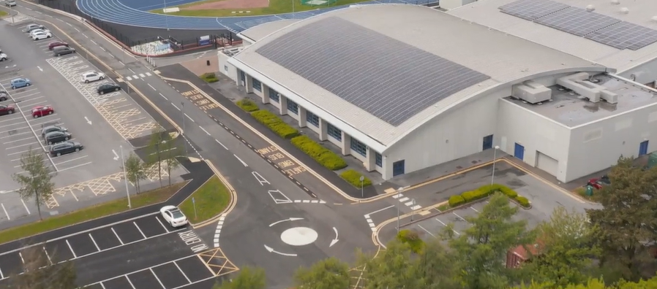
(Carmarthenshire County Council, 2021)

As Onshore wind and solar is the cheapest renewable energy available to Carmarthenshire, therefore the purpose of this essay is to reflect why I think Carmarthenshire has a great sustainable leadership and this is going to be done by producing evidence of the existing projects and what projects Carmarthenshire are looking into to further develop their renewable energy methods to create green clean energy such as solar, wind, biomass and hydroelectricity. Another purpose for this essay is to argue why these renewable energy methods show how Carmarthenshire has a great level of sustainable leadership through identifying the opportunities and barriers of these renewable energy methods.

Reflection on Solar Energy within Carmarthenshire

Upon reflecting on my local area of Carmarthenshire, I have identified that Carmarthenshire has begun to use the renewable resource of solar energy through the process that generates electricity directly from solar radiation and this process is called the photovoltaic effect or photovoltaics. The photovoltaic technology that usually harnesses solar energy is called Solar PV panels which can be done on a large scale through Solar PV panel farms or they can be done as a smaller scale, where the Solar PV panels can be fixed to the roofs or exterior walls of buildings which supplies electricity for that building (National Geographic, 2023).

For example, Carmarthenshire are showing their sustainable leadership by using a company called Celtic Green Energy that consists of independent specialists in renewable energy solutions for domestic, commercial, industrial and agricultural markets, that allow the installation of Solar PV panels onto a building as it is an environmentally friendly and more affordable way to generate energy all year round as it saves money from long term uncertain rising energy prices, and decreases the amount of energy you buy from the grid which lowers the energy bill as obtaining the energy that is generated from the sun is free (Celtic Green Energy, 2023).

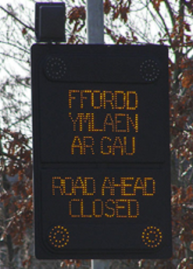
Another example, where Carmarthenshire use solar panels to show their sustainable leadership, is through a company called Sunset Solar that specialise in the design and manufacture of mains and solar powered street lighting and the design of manufacture of bespoke systems that consist of solar powered road traffic signs, which are shown in the image below (Sunset Solar, 2023).
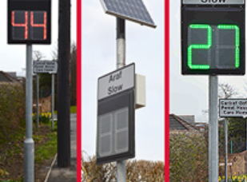
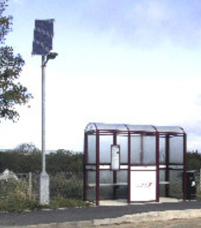
(Sunset Solar, 2023)

Carmarthenshire’s Potential Barriers and Opportunities to Solar Energy

Even though using solar energy is an environmentally friendly and more affordable way to generate energy, the potential barriers that could occur is that it can be a very expensive investment, as the solar panels would need to be installed, cleaned and maintained, the location of the panels can become a barrier as the panels that are to be allocated in shaded areas may cause the panels not to perform at a 100% capacity which means you get less energy out of the panels (Celtic Green Energy, 2023).

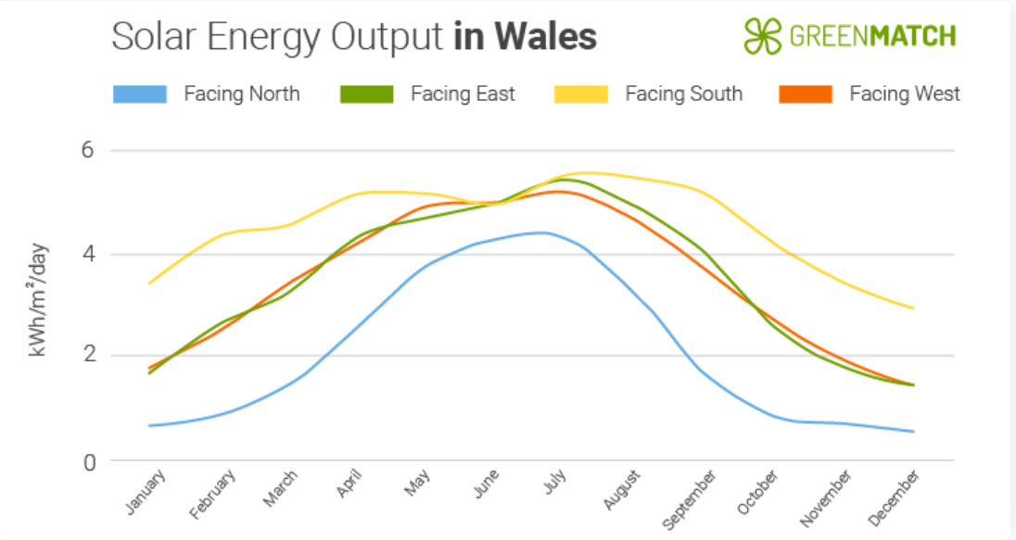
To overcome these barriers and allow Carmarthenshire to have a better opportunity to have a positive impact towards using solar energy as a renewable source, people can locate their solar panels in a non-shaded areas so that they can function at 100% capacity, and to have the Solar PV panels work more efficiently on the building it would be better to have south facing panels as they are more efficient than the north facing panels which can be shown in the chart below. Also to help with the expense of the Solar PV panels there are grant schemes for solar energy such as the Nest Scheme, ECO4, Smart Export Guarantee (SEG) and there are VAT Reductions (GreenMatch, 2023).
(GreenMatch, 2023)

Reflection on Wind Energy within Carmarthenshire

Carmarthenshire is showing that they have a great level of sustainable leadership through the utilisation of onshore wind energy, which is already playing a big role in distributing renewable electricity in Carmarthenshire (Carmarthenshire County Council, 2023). Onshore wind development first made an appearance in Carmarthenshire in the 1980’s in Pembrey, as this was part of The Carmarthen Bay Wind Turbine Test Programme. Wind turbines are a common sight in the Carmarthenshire landscape today as there are many different sizes of wind turbines that can be shown in the table below:
 | Turbine development  Blade tip height | Number of turbines
Micro | 25m or less (or roof mounted | 1 turbine
Small | 50m or less | Up to 3 turbines
Medium | 80m or less | Up to 4 turbines
Large | 109m or less | Up to 5 turbines
Very large | More than 109m | Six or more turbines
(Carmathenshire County Council, 2019)

Upon reflecting Carmarthenshire’s onshore wind energy they have currently 6 existing wind turbine developments within the Carmarthenshire area and their largest existing windfarm is located in Brechfa Forest and that consists of up to 28 turbines with 145m blade tips (Carmarthenshire County Council, 2013).

Also on further reflection Carmarthenshire are collaborating with Green Gen Cymru that are planning to create green energy pathways across Wales, through capturing the wind that blows across the Welsh hills and mountains. The way that the wind is going to be captured is through the Green Gen Towy Usk proposal that consists of a new overhead electricity distribution line connecting the proposed Nant Mithil Energy Park. The energy park will generate around 237MW of clean Green Energy in the Radnor Forest, with the new overhead line connecting to the national grid at a point near Carmarthen

Carmarthenshire’s Potential Opportunities and Barriers to Towy Usk

The potential opportunities that argues that Green Gen Towy Usk will be good for the area of Carmarthenshire is that it will reduce pressure that is already on the existing electricity grid, it will support green businesses and provide green heating for over 200,000 homes, whilst supporting the rollout of electric vehicles across rural Wales. This project will also give the opportunity for Carmarthenshire to meet the Welsh Government’s target for electricity to come from renewable sources by the year 2035 which is 15 years before the UK Government. Which shows the great level of sustainable leadership Carmarthenshire has (Green Gen Cymru, 2023).

However, as the Green Gen Towy Usk is still at an early stage in development, the barriers that have come up is the local communities that live near the proposals have campaigned against this project by having more than 1,000 people signing an online petition calling for the electricity pylons to be buried underground as there would be 60 miles of electricity pylons (BBC, 2023).

Another barrier is that Wales’s grid infrastructure is not fit for purpose as there is an inadequate grid capacity, which is holding back renewable energy development. Therefore, to have Wales’s grid capacity fit for purpose investment, reinforcement and upgrading is required (Green Gen Cymru, 2023).

Reflection on Biomass Energy within Carmarthenshire

Biomass is an energy that is made from burning raw organic waste or biomass feedstock which consists of living organisms such as plants, wood, waste and animals. Once the biomass feedstock is burned it can be converted into clean products such as steam, biodiesel and biofuels. It can also be transformed into gasses such as ethanol and methane and it can also be transformed into electricity, which can then be used in either residential, industrial or agricultural settings (National Geographic, 2023).

The services that Biomass Energy provide in Carmarthenshire are:
- Biomass heating systems is a wood fuelled heating system that burns wood pellets, chips or logs in an attempt to provide warmth to a room or power a central heating system or boilers with hot water (Biomass Energy, 2023)
- Domestic biomass boilers – The domestic biomass boilers use a wood fuelled heating system that allows the boiler to generate clean energy. The system is fed by pellets of organic matter which are carbon neutral when burned. Also, some domestic biomass boilers even include self-feeding and self-cleaning systems (Biomass Energy, 2023)
- Commercial Biomass Boilers work in the same way as a domestic biomass boiler does just on an industrial scale, but instead of heating homes it will heat up housing associations, hospitals and schools (Biomass Energy , 2023)
- Biomass wood pellets are made out of compressed organic matter, which can either consist of energy crops, agricultural waste, food waste, virgin lumber or industrial waste. The most popular ones are the compacted sawdust and waste food products as the pellets are more energy dense which means that they can burn longer making them more energy efficient. The pellets are small, around the size of a cigarette but, but they can be made into certain sizes, allowing them to become easier to use in self-feeding systems (Biomass Energy, 2023).
- Ground source heat pumps contain a network of pipes, that is known as a ground loop and these pipes are buried underground. The pipes then remove natural heat at a low temperature from the ground and distribute it to a heat pump, then the heat pump will make the temperature rise so that it can be dispersed to power things that consist of underfloor heating, hot water and radiators (Biomass Energy , 2023).

Carmarthenshire’s Potential Opportunities and Barriers to Biomass Energy

The potential opportunities that biomass energy has in Carmarthenshire to show that Carmarthenshire have a great level of sustainable leadership is that it is a clean source of energy and does not produce carbon so it does not add to global warming which will reduce Carmarthenshire’s carbon footprint, biomass energy is renewable and the sources that make up the energy are almost limitless, due to the fact that anything organic can be used as a component of biomass and these things include grass cuttings, dead leaves, wood chippings and even dead animals can be converted into energy (Biomass Energy, 2023).

Also, more opportunities can arise from the other services that biomass energy provides such as biomass heating can be reflected as carbon neutral as the carbon dioxide that is produced whilst burning the biomass is equal to the same amount of carbon dioxide that was absorbed during the original growth of the biomass during the photosynthesis, which means that biomass heating is not burning any extra carbon dioxide to create biomass heating (Biomass Energy, 2023). Biomass boilers can reduce fuel bills by as much as 80%, and they can also be considered to be carbon neutral as the only carbon that is emitted is the carbon that is stored inside the pellets that feed the system, and the carbon that emitted into the atmosphere is then reabsorbed by the trees and plants making it a cleaner and more environmentally friendly system as it reduces Carmarthenshire’s carbon footprint (Biomass Energy , 2023).

However, there can be some barriers in using biomass energy in Carmarthenshire as biomass can be expensive to attain in the first place, due to the building and energy that is converted from the plants, and from time to time biomass energy surpasses any savings that may have been made in the long term. Another barrier of utilising biomass energy in Carmarthenshire is that you need to have lots of space for the plants, products, raw materials and, the trucks that bring in the raw materials can cause a barrier as well due to them being filled up by fossil fuels which therefore cancels the majority of the positive effect that the biomass may have on the environment (Biomass Energy, 2023).

Reflection on Hydroelectricity within Carmarthenshire

Hydroelectric energy is a form of renewable energy that uses the power of moving water such as water flowing out of a waterfall to generate electricity. This is done by having a reservoir of water, a gate or valve that allows the control of how much water can flow out of the reservoir into an outlet or place where the water ends up after flowing downwards. Just before the water flows over the top of the reservoir or dam, the potential energy is then converted into kinetic energy which then turn the blades of the turbines to generate electricity, which then gets circulated to the power plants customers (National Geographic, 2023).

Carmarthenshire is reflecting that they have a great level of sustainable leadership as they have been given the green light for a hydroelectric project in the upper reaches of the River Towy in Carmarthenshire, which consists of and underground pipeline and a powerhouse containing a turbine, generator and associated equipment (Lewis, 2017).

Carmarthenshire’s Potential Opportunities and Barriers to Hydroelectric Energy

Due to hydropower being a climate friendly energy source, by creating power that does not emit out air pollution into the atmosphere. The opportunities that Carmarthenshire can gain from this is cleaner air and water and have another renewable energy source, as it can not run out as it can be topped up by the rainfall that occurs and it can pair well with other renewables such as wind or solar. Also, hydroelectricity can meet peak demand as it has the ability to generate electricity on demand, which is done by the release of dammed water through turbines, which makes many hydroelectric plants dispatchable resources (energy sage, 2022).

However, even though hydroelectric power is a renewable and reliable source of energy it can cause adverse environmental impacts such as destroying wildlife habitats, which has caused a barrier to have the go ahead of this hydroelectric project in Carmarthenshire due to where it is located is where a RSPB nature reserve is so they have had to be moved further from the river in the new plans due to the sensitive nature of the area (Lewis, 2017).

Conclusion

Upon critically evaluating the reflection, it has shown that Carmarthenshire has a great level of sustainable leadership as they are moving towards a wider community action by looking at their strategies and they have done this by being the first local authority to publish a climate change action plan that consists of all of their detailed efforts to reduce and offset their carbon emissions.

Also, Carmarthenshire has a great level of sustainable leadership as they have communicated the need to increase the uptake of renewable energy through utilising existing renewable energy projects such as onshore solar and wind and have further developed these renewable energy projects by converting street lights and road signs to solar powered streetlights and road signs. Carmarthenshire have also further developed their onshore wind projects through the new project of Green Gen Towy Usk that looks to design green energy pathways across Wales.

Another way that Carmarthenshire have communicated the need to increase the uptake of renewable energy is by introducing new renewable energy sources into the Carmarthenshire area such as biomass energy which is a clean source of energy and does not produce carbon so it does not add to global warming which reduces Carmarthenshire’s carbon footprint, and the other new renewable energy source that Carmarthenshire are looking to have is hydroelectric power and this supports Carmarthenshire’s great level of sustainable leadership as it is a climate friendly energy source, as it does not emit out air pollution into the atmosphere, and it produces cleaner air and water and it can pair well with other renewables such as wind or solar.

Recommendations

For future preferences, the way that Carmarthenshire can improve on their level of sustainable leadership by having a net zero energy development to reduce the energy intensity of Carmarthenshire through further developing their renewable energy source of solar power which could be done by having buildings painted with ultraviolet repelling paint to reduce the thermal heat gain, have windows and roofs of buildings to have thermal values and to have solar panels on top of car park space in car parks so that electric vehicles can be charged through a renewable energy source and so the solar panels can power up a town as you could have 40,000 solar panels built on top of car parks.

References
Ameresco. (2021). THE CARMARTHENSHIRE HERALD – COUNCIL COMPLETES £2.4 MILLION ENERGY CONSERVATION SCHEME. Retrieved from https://www.ameresco.com: https://www.ameresco.com/the-carmarthenshire-herald-council-completes-2-4-million-energy-conservation-scheme/
BBC. (2023). Towy Valley: Campaign to stop 60 miles of electricity pylons. BBC News, 1.
Biomass Energy . (2023). Commercial Biomass Boilers. Retrieved from https://www.biomass-energy.org.uk: https://www.biomass-energy.org.uk/boiler/commercial/carmarthenshire/
Biomass Energy . (2023). Ground Source Heat Pumps in Carmarthenshire. Retrieved from https://www.biomass-energy.org.uk: https://www.biomass-energy.org.uk/heat-pumps/ground-sources/carmarthenshire/
Biomass Energy. (2023). Biomass Heating in Carmarthenshire. Retrieved from https://www.biomass-energy.org.uk: https://www.biomass-energy.org.uk/renewable-energy/heating/carmarthenshire/
Biomass Energy. (2023). Biomass Pros and Cons in Carmarthenshire. Retrieved from https://www.biomass-energy.org.uk: https://www.biomass-energy.org.uk/pros-and-cons/carmarthenshire/
Biomass Energy. (2023). Domestic Biomass Boilers. Retrieved from https://www.biomass-energy.org.uk: https://www.biomass-energy.org.uk/boiler/domestic/carmarthenshire/
Carmarthenshire County Council. (2013). Pembrokeshire and Carmarthenshire: Culmative Impact of Wind Turbines on Landscape and Visual Amenity Guidance. Carmarthenshire: Carmarthenshire County Council.
Carmarthenshire County Council. (2019, December 27). Carmarthenshire first to publish climate action plan. Retrieved from https://newsroom.carmarthenshire.gov.wales: https://www.bing.com/search?q=when+was+1229+days+ago&qs=n&form=QBRE&sp=-1&ghc=1&lq=0&pq=when+was+1229+days+ago&sc=10-22&sk=&cvid=E4DDB4F717D74795812768E861F753E4&ghsh=0&ghacc=0&ghpl=
Carmarthenshire County Council. (2021, July 20). Council completes £2.4million energy conservation scheme. Retrieved from https://newsroom.carmarthenshire.gov.wales: https://newsroom.carmarthenshire.gov.wales/2021/07/council-completes-24million-energy-conservation-scheme/
Carmarthenshire County Council. (2023, January 25). Renewable Energy. Retrieved from https://www.carmarthenshire.gov.wales: https://www.carmarthenshire.gov.wales/home/council-services/planning/renewable-energy/
Carmathenshire County Council. (2019). Supplementary Planning Guidance Wind and Solar Energy. Carmarthenshire: Carmarthenshire County Council. Retrieved from https://www.carmarthenshire.gov.wales: https://www.carmarthenshire.gov.wales/media/1219839/adopted-spg.pdf?v=202112141603080000
Celtic Green Energy. (2023). Solar Panels. Retrieved from https://celticgreenenergy.co.uk: https://celticgreenenergy.co.uk/solar-panels-wales/
energy sage. (2022, April 28). Hydropower pros and cons. Retrieved from https://www.energysage.com: https://www.energysage.com/about-clean-energy/hydropower/pros-cons-hydropower/
Green Gen Cymru. (2023). Green Gen Cymru. Retrieved from https://greengencymru.com: https://greengencymru.com
GreenMatch. (2023, April 05). Solar Panels in Wales. Retrieved from https://www.greenmatch.co.uk: https://www.greenmatch.co.uk/solar-energy/solar-panels/solar-panels-in-wales
Indeed Editorial Team. (2022). What Is Sustainable Leadership? (With Importance and Skills). Indeed, 1.
Lewis, I. (2017). Hydro electric scheme given go ahead for upper reaches of Towy Valley in Carmarthenshire. Wales Online, 1.
National Geographic. (2023). Biomass Energy . National Geographic, 1.
National Geographic. (2023). Hydroelectric Energy. National Geographic, 1.
National Geographic. (2023). Renewable Energy. National Geograohic, 1.
National Geographic. (2023). Solar Energy. National Geographic, 1.
Sunset Solar. (2023). Home - Sunset Solar. Retrieved from https://www.sunsetsolar.co.uk: https://www.sunsetsolar.co.uk
Visit Wales. (2023). Discover Carmarthenshire. Retrieved from https://www.visitwales.com: https://www.visitwales.com/destinations/west-wales/carmarthenshire

