Assessment of Practical Tasks (Menu Engineering)
By
Rifat Jahan
Student ID: 2212255
Module Title: Hotel Placement-Food and Beverage Operations
Module Code: BMIH4002
Tutor Name: Laurance Blake
Wordcount: 999
Date: 17/02/2023

Below I designed a valentine’s menu for Trinity Hotel. I have explained all items and offer after creating this menu.
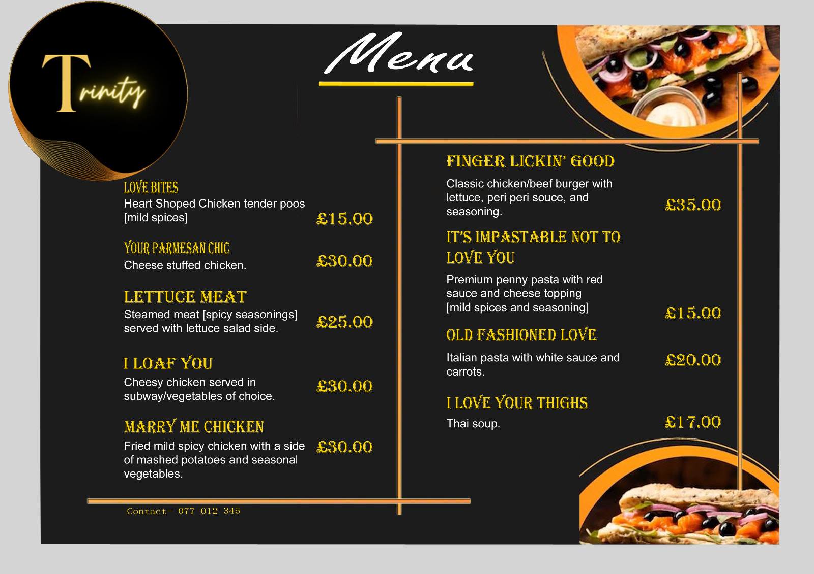
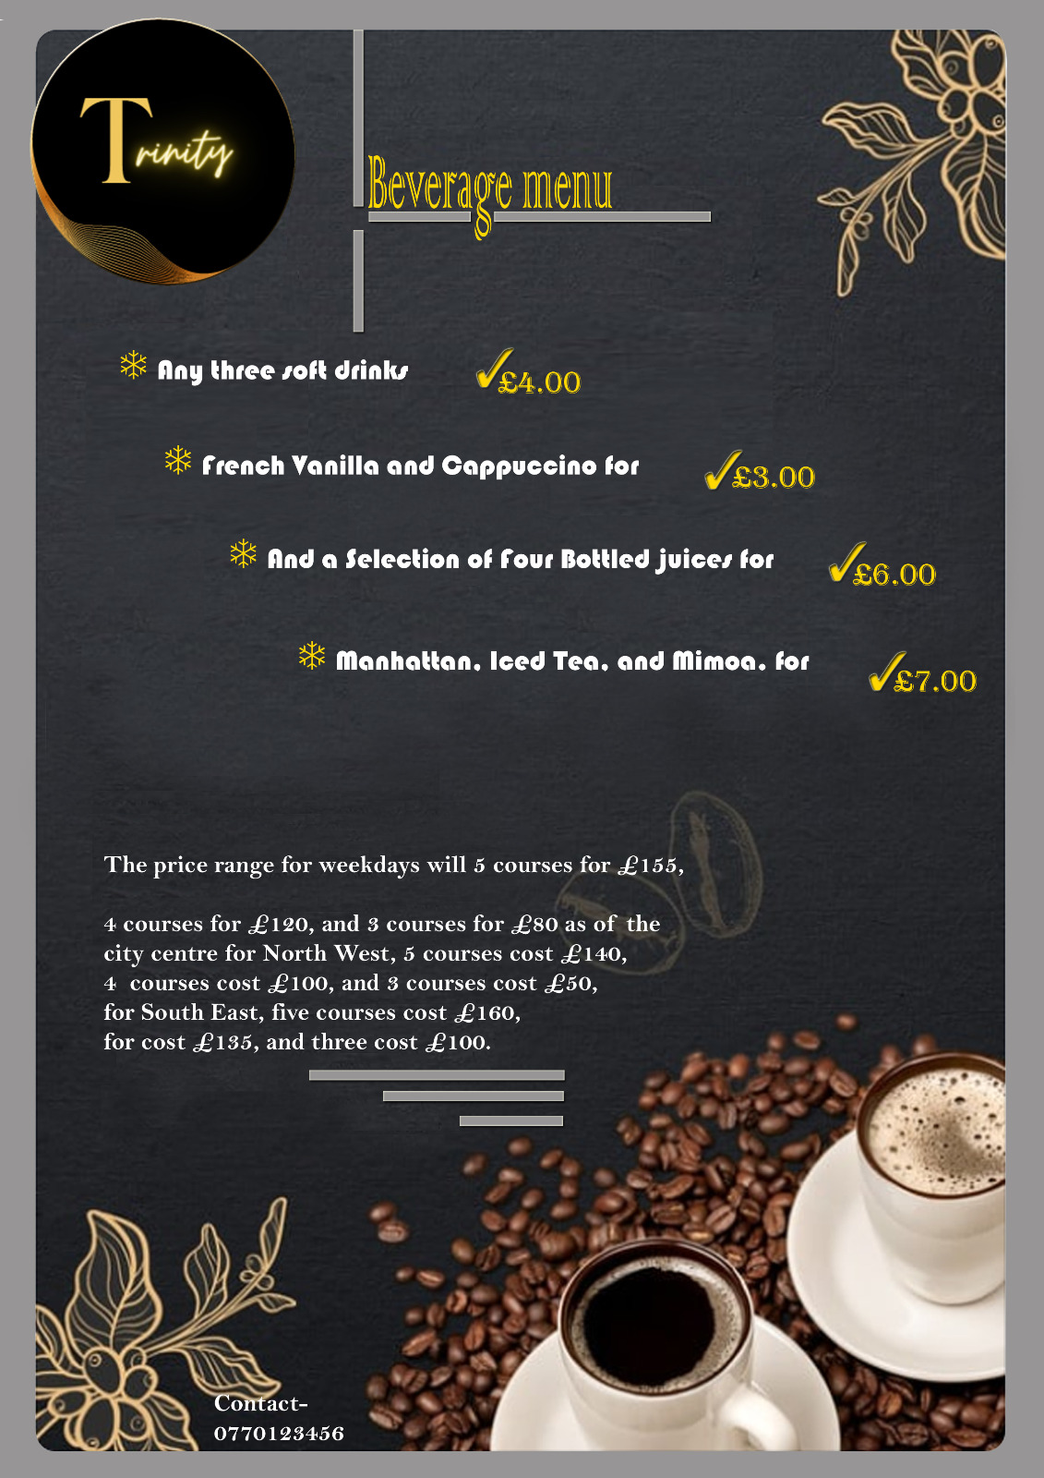

The look of the menu

The look of the menu will be a dark theme to promote emotions and class (Bleich, Wolfson and Jarlenski, 2015). The font style is Arial Rounthe ded MT Bold, 12 sizes, golden colour to write the name of the dish, and white colour for its description (Linassi, Alberton and Marinho, 2016). The headlines will be the main course, drinks, starters, add-ons, and desserts. The drink packages will be detailed under the heading of drinks, and live music and entertainment will be under Add-ons (Bleich, Wolfson and Jarlenski, 2016).

Number of courses, cheese-stuffed cuisine (seasonality and ingredients)

The total number of dishes is 9 named:
- Love bites: tender pops with mild spices,
- Parmesan chicken: cheese-stuffed chicken,
- Lettuce meat: steamed beef with spicy seasonings and lettuce salad,
- I loaf you: cheesy chicken with subway and vegetables of choice,
- Marry me chicken: fried mild spicy chicken with a side of mashed potatoes and seasonal vegetables,
- Finger-lickin’ good: classic chicken/beef, with peri sauce, and seasoning,
- Its impastable not to love you: premium penny pasta with red sauce and cheese topping (mild spices and seasoning),
- Old-fashioned love: Italian pasta with white sauce and carrots,
- I love your thighs: Thai soup.

Theme

The theme of the overall restaurant on Valentine’s Day will be dim lights in red with soft music and props hanging all around the place written romantic quotes on it (Bleich, Wolfson and Jarlenski, 2016). On one corner, there will be a photo booth with a valentine’s frame where couples can take pictures. There will be a rose corner at the exit of valentines theme in red, pink, white, and scarlet colour for sale. The waiters should serve the customers with respect and care for their privacy while dining (Linassi, Alberton and Marinho, 2016). The customers should always feel welcomed and respected in the restaurants, the toilets should be clean and tidy and the staff should always respond to customer concerns, complaints, and seating preferences.

Price point

The price range for weekdays will be 5 courses for £155, 4 courses for £120, and 3 courses for £80 as of the city centre (Bleich, Wolfson and Jarlenski, 2015). For the North West, 5 courses cost £140, 4 courses cost £100, and 3 courses cost £50. For South East, five courses cost £160, four cost £135, and three cost £100. For the South West, 5 courses cost £130, 4 courses cost £110, and 3 courses cost £70. For the North East, 5 courses cost £110, 4 courses cost £98, and 3 courses cost £67. Five courses will set you back £170 for weekend courses in the city centre, £165 in the South East, £150 in the South West, and £130 in the North East (Linassi, Alberton and Marinho, 2016).

What information is needed on a menu?

The types of allergies that are present in each dish are included in the textual information that must be included on the menu. In addition, there must be a sign indicating which dishes are gluten-free and which are vegan. It should be told which foods are always available and which are seasonal. Additionally, the appropriate meals will bear the ready-to-order and cook-by-order stamps to prevent any disturbance (Bleich, Wolfson and Jarlenski, 2016). The nutritional information for each item on the menu will also be included to accommodate those who adhere to strict diets. Other than that, the staff should have information about the calories and meals that should and should not be consumed by customers with certain health conditions (Linassi, Alberton and Marinho, 2016). The seasoning and spices can be added according to customer preferences and should be listed carefully by the staff. The customer care and serving should be served in order starting from starters, then the main course with drinks, and then desserts.

Availability

The menu will be presented to the guests once their pre-meal drinks have been served (Bleich, Wolfson and Jarlenski, 2015). The menu will serve as their introduction. Orders must be placed in advance for the foods that are prepared as ordered. All the items listed on the menu will be available in the kitchen or semi-cooked according to the time taken by the dish to maintain (Linassi, Alberton and Marinho, 2016). If the dish takes more time to be ready such as pasta, it usually takes 15 to 20 minutes to boil the pasta so the chef needs to keep boiled pasta, other than that the chicken meals need to be marinated since morning or last night (Bleich, Wolfson and Jarlenski, 2016).

Offers/discounts to encourage more bookings

Offers and discounts to encourage more reservations Deals like complimentary beverages with three- to five-course meals will be available (Bleich, Wolfson and Jarlenski, 2015). There will also be offers like two seniors getting a free kid's lunch.

Beverages

In addition, there will be packages available for £7 that include a Manhattan, Iced Tea, and Mimosa,
- any three soft drinks for £4,
- French Vanilla and Cappuccino for £3,
- And a Selection of Four Bottled Juices for £6.

Additionally, there may be standard deals like three iced or hot drinks for the price of six. French Vanilla, Cappuccino, Coffee, Lemonade, Hot Chocolate, a variety of bottled juices, Manhattan, Iced Tea, Mimosa, Mocha, Tomato Juice, Milk, Mojito, Gimlet, and soft drinks are among the drinks that cost between £5 and £7 (Bleich, Wolfson and Jarlenski, 2016).

Menu planning fundamentals

Descriptive language is used so that the guest will understand the menu easily. Also, the local elements are present to satisfy locals' needs (Bleich, Wolfson and Jarlenski, 2015).

References:
Bleich, S.N., Wolfson, J.A. and Jarlenski, M.P. (2015). Calorie Changes in Chain Restaurant Menu Items. American Journal of Preventive Medicine, 48(1), pp.70–75. doi:https://doi.org/10.1016/j.amepre.2014.08.026.
Bleich, S.N., Wolfson, J.A. and Jarlenski, M.P. (2016). Calorie Changes in Large Chain Restaurants. American Journal of Preventive Medicine, 50(1), pp.e1–e8. doi:https://doi.org/10.1016/j.amepre.2015.05.007.
Linassi, R., Alberton, A. and Marinho, S.V. (2016). Menu engineering and activity-based costing. International Journal of Contemporary Hospitality Management, 28(7), pp.1417–1440. doi:https://doi.org/10.1108/ijchm-09-2014-0438.
Ozdemir, B. and Caliskan, O. (2015). Menu Design: A Review of Literature. Journal of Foodservice Business Research, 18(3), pp.189–206. doi:https://doi.org/10.1080/15378020.2015.1051428.

Islam, S. (2021) how to make a restaurant menu on Microsoft word. available at: https://www.youtube.com/watch?v=OVxtbm27B8w (Accessed: 24 February 2021)

VanEpps, E.M., Roberto, C.A., Park, S., Economos, C.D. and Bleich, S.N. (2016). Restaurant Menu Labeling Policy: Review of Evidence and Controversies. Current Obesity Reports, 5(1), pp.72–80. doi:https://doi.org/10.1007/s13679-016-0193-z.

