Health Questionnaire and Findings
The following essay will reflect and evaluate a health questionnaire, identifying any health concerns or health recommendations that may appear in the answers provided. Consent has been provided (see Annex one) to analyse, evaluate and make recommendations from the recorded data, the identity of the participant will be protected with the use of pseudonyms and will be referred to throughout the essay has Joe Blogs; to protect the privacy and confidentiality of Joe Bloggs under the Nursing and Midwifery Council (NMC) code of conduct (2018). To evaluate the data provided on the health questionnaire (see annex two), I will be referring to current health provisions outlined by the National Health Service (NHS) and the Government to make recommendations on how to improve their overall health, lifestyle and mental and social wellbeing.
Joe Blogs is a female aged between 31 and 40 years of age with a height of five foot seven inches with a current body weigh of 90 Kg, with using these statistics on the NHS bmi calculator the results show that Joe Blogs current BMI is 31.1 which results in Joe Blogs being classed has obese (NHS 2018). According to the NHS (2018) the healthy weight range for Joe Blogs is 53.5kg to 72.2kg: and that Joe Blogs should look to lose around 4.5Kg with a daily calorie intake of 1645 – 2116 kcal, if Joe Blogs was to stick to the recommended calorie intake there would be a healthy weight loss of 1-2lbs per week. With losing just that amount of weight to start with Joe Blogs would benefit from reducing high blood pressure and not developing type 2 Diabetes. If Joe blogs weight and bmi were to remain the same, then there is an increased risk of developing heart disease, type 2 diabetes, stroke and certain types of cancer. Joe Blogs has highlighted that she is currently 30 weeks pregnant and has gestational diabetes, depending on whether pre-pregnancy weight was provided for the bmi calculator or pregnancy weight could have a big impact on the results of the bmi; it is recommended that any weight loss should be discussed with the Midwife due to concerns during the pregnancy, joe blogs should also be seeing a dietician who will discuss a healthy diet to help with the gestational diabetes.
Joe blogs have indicated that exercise is very minimal with only taking part in at least 20 minutes of exercise once or twice a week. Haskel et al (2007) links 30 minutes of moderate exercise five days a week to help promote and maintain good health. Usually you should feel rested after a goodnights sleep, but this is not the case for Joe Blogs; if a better and more regular exercise regime was adopted then not only will it help with weight loss but would provide a healthy life style which is not only good for Joe Blogs health but also for good mental health. To clarify the Sleep Doctor (2017) writes that there are many health benefits associated to exercising, not only do you get a goodnight’s sleep, but the more time spent in a deeper sleep will help by boosting the immune system, supporting good cardiac health and keeping stress and anxiety levels low.
Joe Blogs do not smoke anymore due to quitting them in 2011, Nicorette (2017) the benefits of not smoking for eight years have reduced the risk of a heart attack by half in comparison to if they were still smoking. Due to pregnancy Joe Blogs do not drink alcohol Tommys (2019) states that drinking while pregnant is not good for the baby particularly in the first trimester where it can affect the baby’s growth and development. Joe Blogs have not used or tried drugs, so no recommendations or health concerns have been noted.

A healthy diet and drinking the recommended daily intake (RDI) of water provides great health benefits, according to the Mayo clinic (2009) the recommended daily intake for men is 3.7 litres and for women it is 2.7 litres. The Push Doctor (2018) agrees with The Mayo Clinic (2009) and adds that without water we just wouldn’t survive, water not only keeps us hydrated, it cleans our system of toxins, regulates our temperature, protects our sensitive tissue and protects our joints. Joe Blogs water intake is very poor and would recommend on this being increased to receive the benefits that water has to offer. Even though Joe blogs diet is well and contains a variety of different food. Maintaining a well-balanced diet by eating smaller regular meals and choosing the correct foods that provide a good source of carbohydrates, less saturated fats, sugar and salt will help manage gestational diabetes without the need to go on a strict diet (Diabetes UK 2019). Joe blogs would benefit from following the eat well guide (2016) (See annex 3) after the baby is born to help maintain a healthy diet and to reduce the risk of Type 2 diabetes in later life.

Joe Blogs family history reveals type two diabetes from the maternal parent, leaving Joe blogs to be more susceptible to having this in later life especially with other factors of being over weight and gestational diabetes during pregnancy, Once the gestational diabetes go after birth then Joe Blogs will receive a diabetes testing 6 weeks later and then be monitored every year thereafter with a glucose intolerance test (National Institute for health and care excellence 2019). Joe blogs previous medical history already show signs of high blood pressure even though this is not treated through medication, Joe Blogs need to adjust her lifestyle and diet to reduce any serious medical conditions that this may course; or possibly leave Joe Blogs impaired. (Bupa 2019) stresses that having constant high blood pressure runs the risk of suffering from heart attack, Heart failure even stroke which can be life threating and other illnesses like kidney disease or dementia. Joe Blogs blood pressure is currently 132/74 which puts her in the bracket for pre-high blood pressure; the midwives will monitor this because high blood pressure in pregnancy can lead to pre-eclampsia. Bounty (2017) assures that if the blood pressure is elevated before 20 weeks of pregnancy then there could be an underlying issue, if it increases after 20 weeks of pregnancy then this will be monitored due to increase risk of pre=eclampsia, this can be caused due to the development of the placentas and thin blood vessels, it can cause serious complications if left undiagnosed.

Joe Blogs feels content most of the time but only sometimes reaches her aspirations; contently working towards her employment goals that will give her satisfaction of achieving something that she has set her sight on and worked hard towards

Joe Blogs enjoys the company of her social connections and gets together at least once a month in a social environment. Having a change of environment and get together is also great for mental health reasons and laughter can be good for the soul. Joe blogs advises that her daily environment is quiet so there is no worry of noise pollution or air pollution apart from when she commutes to the city.

Hobbies that Joe Blogs take is making wine glass charms and walking the dog both provide calm and relaxation which again is good for blood pressure and provides time out to clear the mind and unwind whilst having an extra bit of exercise when walking; to stimulate the Brain Joe Blogs enjoys completing puzzles like Mah-jong and solitaire they can be mentally challenging and provides speed coordination and patients, to relax Joe Blogs enjoys reading a book whether this be a paper version or a computer version they can both carry health issues by straining the eyes, regular eye checks will be needed and appropriate eye wear if recommended. Joe Blogs do not follow any religious or spiritual groups.

Conclusion
Consequently, throughout this report it has been highlighted that there are some areas of concern to the Joe Blogs current health, hopefully these will return to normal after the Baby is born. If these health issues were to continue after child birth, then there would be cause for concern, if there were any underlying factors that were having a direct impact on the health issues, is Joe Blogs lifestyle or mental health being overlooked allowing for bad choices to be made. Joe Blogs is under direct care of the midwives, so all issues should be monitored so they do not develop in to serious conditions. After child birth all impacts on health issues should be addressed again to suit joe Blogs needs.

Reference
- National Health Service (NHS) (2018) BMI healthy weight calculator. Available at: https://www.nhs.uk/live-well/healthy-weight/bmi-calculator/( Accessed 11th January 2019)
- Nursing and Midwifery Council (NMC) (2018) The Code: Professional standards of practice and behaviour for nurses, midwives and nursing associates. Available at: https://www.nmc.org.uk/standards/code/. (Accessed 11th January 2019)
- Haskell, W, L. Lee, I, M. Pate, R, R. Powell, K, E. Blair, S, N. Franklin, B, A. Macera, C, A. Heath, G, W. Thompson, P, D. and Bauman, A. (2007) Physical activity and Public health: updated recommendation for adults from the American College of Sports Medicine and the American Heart Association. 116 (9), pp. 1081-1093.
- Mehnaz Farooque (2018) Body Mass Index Calculator for Men And Women – Indian BMI Chart. Available at: https://truweight.in/blog/health/indian-bmi-calculator-men-women.html [Accessed on 11th January 2019]
- THE Sleep Doctor (2017) The Benefits of Exercise for Sleep. Health, How to Sleep Better. Available at: https://www.thesleepdoctor.com/2017/05/22/benefits-exercise-sleep/. [Accessed 11th January 2019]
- Nicorette (2017) Health Benefits of Quitting. Available at: https://www.nicorette.co.uk/get-ready-to-quit/health-benefits-quitting-smoking? [Accessed 11th January 2019]
- Tommys (2019) Drinking in Pregnancy. How can alcohol harm my unborn baby? Available at: https://www.tommys.org/pregnancy-information/im-pregnant/drinking-alcohol-pregnancy? [Accessed 11th January 2019]
- The Mayo Clinic (2019) Healthy Lifestyle Nutrition and Healthy Eating. Nutrition basics. Available at: https://www.mayoclinic.org/healthy-lifestyle/nutrition-and-healthy-eating/basics/nutrition-basics/hlv-20049477 [Accessed 11th January 2019]
- The Push Doctor (2018) 11 Benefits of Drinking Water. Available at: https://www.pushdoctor.co.uk/blog/11-benefits-of-drinking-water-backed-by-doctors [Accessed 11th January 2019]
- Diabetes UK (2019) Diabetes UK Know diabetes, fight diabetes. What can I eat? Gestational diabetes. Available at: https://www.diabetes.org.uk/diabetes-the-basics/food-and-diabetes/i-have-gestational-diabetes [Accessed 11th January 2019]
- National Health Service (2016) Eat Well. The Eatwell Guide. Available at https://www.nhs.uk/live-well/eat-well/the-eatwell-guide/ [Accessed on 11th January 2019]
- National Institute for health and care excellence (2019) Diabetes in Pregnancy: management from preconception to the postnatal period. Available at: https://www.nice.org.uk/guidance/ng3/ifp/chapter/follow-up-care-and-future-pregnancy [Accessed 11th January 2019]
- Bupa (2019) High blood pressure (hypertension). Available at: https://www.bupa.co.uk/health-information/heart-blood-circulation/high-blood-pressure-hypertension [Accessed on 11th January 2019]
- Bounty (2017) High blood pressure in pregnancy. High blood pressure is often harmless but very high blood pressure can be a sign of pre-eclampsia. Available at : http://www.bounty.com/pregnancy-and-birth/pregnancy/pregnancy-other-conditions/high-blood-pressure-in-pregnancy [Accessed on 11th January 2019]

Appendix
Annex 1
Consent Form
I have been asked to participate in a questionnaire conducted by a level 5 student from the university of South Wales Trinity St David which has been devised as part of a module Physiology of the Body Including Nutrition, I am free to contact the module lead with any question or concerns I have regarding this questionnaire by contacting felicity.page@uwtsd.ac.uk or (01792) 481255
INTRODUCTION: Below is a description of the research procedures and an explanation of my rights as a research participant. In accordance with the policies of Davidson College, I have been asked to read this information carefully. If I agree to participate, I will sign in the space provided to indicate that I have read and understood the information furnished on this consent form. I am entitled to and will receive a signed copy of this form.
PURPOSE: The purpose of this assignment and the questionnaire is for students of the university to assess the normal and abnormal physiology, health and nutritional status of a
chosen individual. Students are required to assess the current health and fitness of a chosen individual. Collected date will be reported on a health and fitness questionnaire designed by the student. The data will be analysed and evaluated, and recommendations made, in line with current health recommendations. The evaluation will focus on the physical, intellectual, emotional and spiritual needs of the individual. Recommendations will be made on how the chosen individual can improve their overall health and wellbeing. The student will also discuss current Government, public health and NHS strategies put in place to overcome any health damaging behaviours identified for example high blood pressure, obesity. The student working in agreement with yourself will be expected to perform a variety of health assessment tests; these tests must be within their skill ability and proved to be valid and reliable assessment tools. The test results will be collated, analyzed, and recorded on a data collection form of your own design. In line with the data protection act 1998 it is compulsory that, all reported data will be anonymized and non- identifiable. The collected data will be analyzed and compared to norms for the undertaken test. In the report, please note that students can only work within the scope of their ability and are not a replacement for medical advice or treatment.
POTENTIAL RISKS AND DISCOMFORTS: Should your assessment reveal readings out of the normal range, you will be advised to consult your general practitioner. If you have any questions or queries please contact the course lead.
BENEFITS: A benefit to me of participating in this study is that you will have access to the student’s assignments and recommendation within which will help to identify ways that you can improve your health and well-being. However these are only a guide are a not a substitute for medical advice.
RIGHT TO REFUSE OR WITHDRAW: I understand that my participation is voluntary. I may refuse to participate or discontinue my participation at any time; there will be no penalty for doing so. Some details of this project may not be made known to me until my session is completed. I realize at the completion of the session that I have the option of withholding the responses I have provided from subsequent analysis. .
DURATION AND LOCATION OF STUDY: If I agree to participate in this study, my participation will last for approximately 30 minutes and will take place at my home
PROCEDURES: During this study, I will be asked to respond to a health questionnaire, which will be designed to design my current levels of health and well-being.
CONFIDENTIALITY: I understand the data collected in this study will be kept confidential unless law requires disclosure. : reported data will be anonymized and non- identifiable.
OFFER TO ANSWER QUESTIONS: If I have any questions about this questionnaire and subsequent assignment in the first instance please contact felicity.page@uwtsd.ac.uk or (01792) 481255
*I CERTIFY THAT I AM AT LEAST 18 YEARS OLD AND I AGREE TO PARTICIPATE IN THIS RESEARCH PROJECT.

-----------------------------------------------------------------------------------------------
PARTICIPANT'S SIGNATURE DATE
PERSON OBTAINING CONSENT: I have allowed the individual named above the time to read this consent form and have answered any questions that have been asked. I will provide the participant with a copy of this consent form.

----------------------------------------------------------------------------------------------------
RESEARCHER'S SIGNATURE DATE

Annex 2
Health Questionnaire
1, Gender?
Female

2, What is your Age Range?
Under 20 21-30 31-40 41-50 51 plus
3, What is your Height in feet and inches?
5.7”

4, What is your current weight in Kilo Grams?
90

5, Are you a smoker?
Yes No (if no please go to question 6)
5a. How many do you smoke per day?
1-5 6-10 11-15 16-20 21 plus
6, How much alcohol do you consume per week?
None 1-3 units 4-6 Units 7-9 units 10 units -plus
7, Do you or have you ever used drugs
Never Tried regular use still uses ex-user
8, Any previous Medical history or long-term conditions that should be noted?
Sometimes Raised blood pressure which gets monitored (never been
medicated for it)
Currently pregnant at 30 weeks with gestational Diabetes

9, Family medical history?
Type 2 Diabetes – mother

10, Do you know your Heart Rate, Blood Pressure and cholesterol levels?
Heart Rate -
Blood Pressure – 132/74
Cholesterol Levels -

11, Do you have any Hobbies, if so, what are they?
Making wine glass charms
Walking the dog

12, Do you feel content within yourself?
None of the time Sometimes Most of the times All of the time
13, Do you feel rested after sleeping?
no
14, Do you Socialise, if so, how often?
Once a month
15, What activities do you do to keep your Brain Stimulated?
Puzzles

16, Are you meeting your aspirations?
sometimes
17, Have you reached your employment Goals?
Not yet
18, Are you Religious, Spirituality or other?
No

19 Do you have a wide network of social connections?
yes
20, What is your social environment mainly like?
Rural City Mixture of both
21, What are the noise levels like in your daily environment?
Quiet main roads train tracks industrial noise
22, how many fluids do you drink daily based on a 250ml glass? (excluding Alcohol)
0 1-2 3-4 5-6 7 plus
23, Please complete a food diary for one week.
Monday –
B -Oat so Simple,
D -Ham and pickle Sandwich,
T - Whole-wheat pasta, veg, tomatoes and chilli, Pork Sausage

Tuesday –
Oat So Simple
Pasta left overs
Sweet potato waffles, egg, chicken kiev and beans

Wednesday –
Crunchy Nut Cornflakes
Vegetable soup
Sausage and chips – 1 slice of bread

Thursday-
Oat so simple
Savoury Rice
Chicken curry and basmati rice

Friday –
Oat so simple
Cheese sandwich
Spaghetti Bolognaise

Saturday –
Oat so simple
Croissants
Home-made burgers Brioche Bun cheese, tomato

Sunday-
Crunchy Nut Cornflakes
Boiled potatoes mixed veg and pork loin

Food is all homemade, with changes advised by the dietician and diabetes nurse.
24, How many times per week do you take part in at least 20 minutes of continuous physical exercise?
0 1-2 3-4 5-6 7-plus

Thank you for taking part in this survey, all personal details will be treated with the strictest of confidentiality and Pseudonyms will be used where required.
Sarah Page

Annex 3
Eat well guide 2016
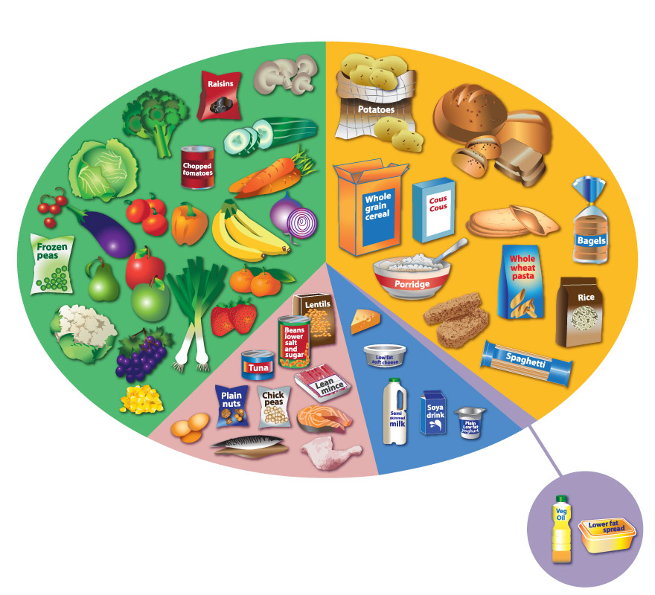

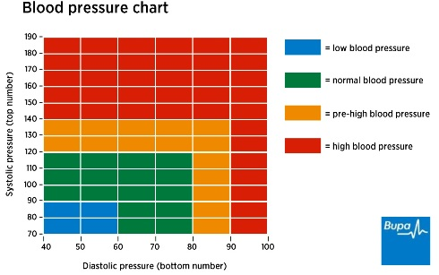
Annex 4

