
Patisserie Valerie
Corporate Reporting and Social Responsibility - BMBM6004

March 26, 2020
University of Wales Trinity Saint David
OLUWAYEMISI SOBOLA - 1601824

TABLE OF CONTENTS
TABLE OF CONTENTS 1
EXECUTIVE SUMMARY 1
1. INTRODUCTION 4
2. MAIN BODY 5
2.1 Earnings Management 5
2.2 Reasons for Earning Management 7
2.3 Methods of Manipulating Financial Statements 8
2.4 The “Earnings Management” Manipulation in Patisserie Valerie Case 10
2.5 The Role of the UK Corporate Governance Structure in Constraining Earnings Management 14
2.5.1 Financial Regulation 14
2.5.2 Monitoring, Enforcing and Penalties 14
2.5.3 Internal audit and identifying fraud 14
2.5.4 Corporate Governance 15
2.5.5 Ethics 15
2.5.6 Whistle Blowing Culture 15
2.5.7 Corporate Social Reporting 15
2.5.8 Incorporating Islamic religious beliefs and values 16
3. CONCLUSION 17
4. RECOMMENDATIONS 18
REFERENCE 19
APPENDICES 25

EXECUTIVE SUMMARY

This report will be discussing the incentives and pressures that drives managers towards earnings management, with specific reference to the case of Patisserie Valerie.
Earnings management (EM)/Creative accounting is described by some authors such as Cotter (2012) and Young & Cohen (2013) as the way of consciously presenting financial statement information with the aim of misleading the readers, as management could be induced to engage in earnings-management when exercising their legitimate right to judgement due to the vagueness and subjectivity in accounting standard.
There are several reasons why management could resort to earning management or creative accounting, different authors such as Atrill & McLaney (2005) analyse some of these reasons. Which include, avoiding government action as in relation to taxation on excessive profits, or in order to avoid restrictions in reporting enough profit in relation to dividend payment, or when there is direct link between earnings and director’s and managements remuneration, this may stimulate the manipulation of sales and profit targets, such as the CEO’s total compensation being tied to the value of stock and option holdings.
Some of the methods that might be used to manipulate financial statements include overstating of revenue such as the early recognition of sales income or recording fictitious sales, overstating the market value of asset that does not reflect the true and fair market value or eliminating losses and liabilities by creating a separate entity that absorbs the losses and liabilities thus making the financial statements look healthy.
In the case of Patisserie Valerie, some accounting irregularities involves in earning management were revealed during PwC investigation into Patisserie Valerie’s financial report, exposing some accounting irregularities and cash shortfall, which led to the disclosing of a multimillion-pound gap in their accounts. The irregularities were conducted through thousands of false entries into the company’s ledger. The Company’s cash flow and its profitability were also overstated.
Unfortunately, earning management or creative accounting cannot be fully eradicated but there are several effective ways to reduce it happening, such as globally adapting the Sarbanes-Oxley Act and IASB accounting standard role in attempt to reduce the flexibility for companies to engage in creative accounting (Cotter, 2012). And where an effective internal audit function could be made mandated to be able to identify any fraudulent activity that could take place in a company along with effective implementation of Corporate Governance Code and the Quoted Companies Alliance Code.
Suggested recommendations such as improving the UK Corporate governance structure could assist in an effort to curtail creative accounting/ earning management and maintaining a good governance must be underpinned, by enforcement to ensure companies do not succumb to creative accounting.

INTRODUCTION

This report is will be discussing the principle of earnings management and will be identifying and critically discussing several incentives and pressures that drives managers towards earnings management, with specific reference to Patisserie Valerie. Furthermore, this report will be discussing the role of the UK corporate governance structure in constraining earnings management.
Linder & Foss (2015) and KOPP (2019) described Agency Theory (appendix X1) as a principle that explain the relationship between business owners and their agents or managers or directors, shareholders, principals and their company executives. These agents are tasked with making business decisions based on delegated authority from the principals. One of such decision is managing earnings which potentially could lead to conflict of interest. Scott (1997) proposed that Agency theory enables managers to report on earnings because they are in the best position to select the most appropriate method of reporting which aligns with shareholders’ interests (appendix-1).

MAIN BODY

Earnings Management

Cotter (2012) and Young & Cohen (2013) defined earnings-management (EM)/creative-accounting as a way of consciously presenting information that is inconsistent with the underlying facts aimed at misleading the stakeholders and readers of financial statement. Cotter (2012) then described EM as the income smoothing practices by management in order to reduce the perceived risk of their company.
In addition, Auditing-Practices-Board (APB, 2001) and Schipper (1989) suggested that EM could be done to enhance profits, such as, when creditors payments are deferred, it will certainly increase the year-end cash position. This exercise may be conducted due to commercial pressure (appendix-2) to deceive the bank by showing a better than normal cash position. It could be concluded that EM does not always favour investors because of its impact on the transparency and reliability of the financial (Cotter, 2012). However, Healy & Wahlen (1999) expressed the conundrum faced by shareholders in that it is unwise not to allow management to exercise judgement but given managers unlimited decision-making powers is also detrimental.
Young & Cohen (2013) alluded to two areas of creative-accounting/EM as recognising faulty revenue recognition, and the recognition of genuine losses and expenses. The Enron controversy revealed off-balance-sheet financing creative accounting which is also similar to 2008 financial crisis. Rosner (2003) proposed that “earnings manipulation” could incorporate both earnings-management practices and fraudulent accounting. Schipper (1989) and Healy & Wahlen (1999) maintained that earnings-management manipulation is aimed at disguising poor financial performance thus investors are misled.
Braun (2001) and Wright & Wright (1997) contended that auditors are likely to waive a detected misstatement when misstatement is measured subjectively and not objectively by management. Elliot & Elliot (2015) proposed that good governance must be underpinned by enforcement to ensure companies do not succumb to creative accounting.

Reasons for Earning Management

The Public Oversight Board (POB, 2000) in USA and Levitt (1998) affirmed that earnings-management due to management exercising their legitimate right to judgement because of the vagueness and subjectivity in Accounting standard at one end all the way to fraudulent accounting (with intent to deceive). Companies such as Enron an American energy company used off-balanced sheet financing as a tool of aggressive EM (Nobles & Parker, 2010; Young & Cohen, 2013). In 2003, WorldCom a telecommunication company used earning-management to inflate profit and loss by $4 billion by manipulating their financial data. The company treated its operating expenses and spread it across several property accounts which are capital expenditure (Kennon, 2003). In January 15, 2018 Carillion collapsed because of a £1.5 billion debt as the reality of the business was grossly misrepresented (Blackburn, 2019).

There are several reasons why management could resort to earning-management or creative-accounting (Atrill & McLaney, 2005).

Author | Reason for earning management
APB (2001); Atrill & McLaney (2005). | - To avoid restrictions such as reporting enough profit in dividend payment.
APB (2001); Atrill & McLaney (2005). | - Avoiding government action such as taxation relating excessive profits.
APB (2001); Atrill & McLaney (2005). | - To conceal poor management decisions.
APB (2001); Atrill & McLaney (2005); Bergstresser & Philippon, (2006). | - When there is direct link between earnings and director’s and managements remuneration, may stimulate the manipulation of sales and profit targets, such as the CEO’s total compensation being tied to the value of stock and option holdings.
APB (2001); Atrill & McLaney (2005). | - To secure bank loans, capital or credits may lead to the manipulation of financial position
APB (2001); Atrill & McLaney (2005). | - The demand of high returns by investors could motivate managers in creative accounting.
APB (2001); Atrill & McLaney (2005). | - Earning could be inflated to conceal losses

Methods of Manipulating Financial Statements

Author | Methods of manipulating financial statements
Dechow and Skinner (2000); Atrill & McLaney (2005); Cotter (2012); Elliot & Elliot (2015). | - Overstating of revenue like early recognition of sales income or recording fictitious sales.
Dechow and Skinner (2000); Atrill & McLaney (2005); Cotter (2012); Elliot & Elliot (2015). | - Manipulation of expenses especially expenses that require management judgement especially on stock valuation i.e. residual value of an asset FIFO/AVCO.
Dechow and Skinner (2000); Atrill & McLaney (2005); Cotter (2012); Elliot & Elliot (2015). | - Eliminating losses and liabilities by creating a separate entity that absorbs the losses and liabilities thus making the financial statements look healthy i.e. Enron used off-balanced sheet financing method.
Dechow and Skinner (2000); Atrill & McLaney (2005); Cotter (2012); Elliot & Elliot (2015). | - Overstating the market value of asset that does not reflect the true and fair market value.
Dechow and Skinner (2000); Cotter (2012). | - The aggressive capitalisation of cost like Research & Development that other companies written off routinely.
Dechow and Skinner (2000). | - By under stating bad debt provision.
Dechow and Skinner (2000). | - Overvaluation of acquired in-process.

Collier (2004) revealed the susceptibility of corporate reporting to manipulation however, it has always been subjected to scrutiny by non-executive directors and audit committees (Elliott & Elliott, 2015). More still, Iqbai & Strong (2010) warned that companies with higher debt to equity ratio and with a low ratio of non-executive directors are very likely to manipulate earnings especially during equity offerings.

The “Earnings Management” Manipulation in Patisserie Valerie Case

Patisserie-Valerie is a cafe chain and the company was valued at £450m prior to the scandal. The company operates 200 cafes and employs 3,000 staff. The company achieved increased sales, revenue and net income annually since it was listed on the London Stock Exchange. Between 2014 and 2018, Patisserie-Valerie’s share price increased from 170p to over 400p (Eley, 2019; figure 1 & 2). In October 2018, Patisserie-Valerie’s revealed accounting irregularities and cash shortfall and exposed a multimillion-pound gap in its accounts. The irregularities were conducted through thousands of false entries into the company’s ledger. The Company’s cash flow and its profitability were overstated (point-1 in methods of manipulating financial statements; Butler, 2019). This exercise was conducted to deceive the bank by showing a better than normal cash position (APB, 2001).

Figure 1: Patisserie Valerie Revenues 2018
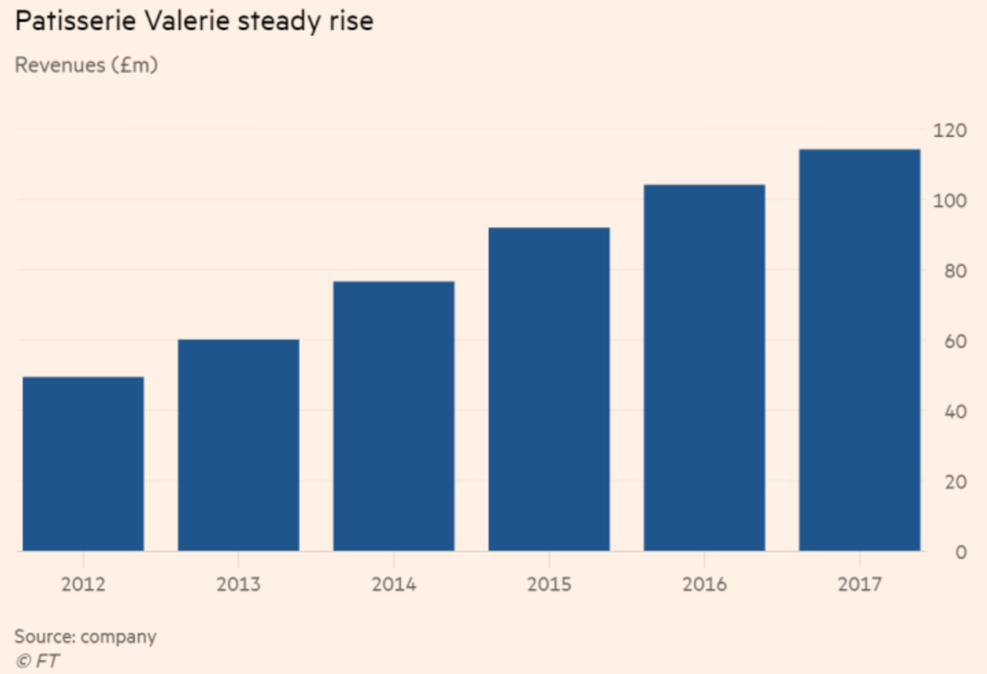
(Patisserie Valerie, 2018; Eley, 2019)

Figure 2: Patisserie Valerie Net Income 2018
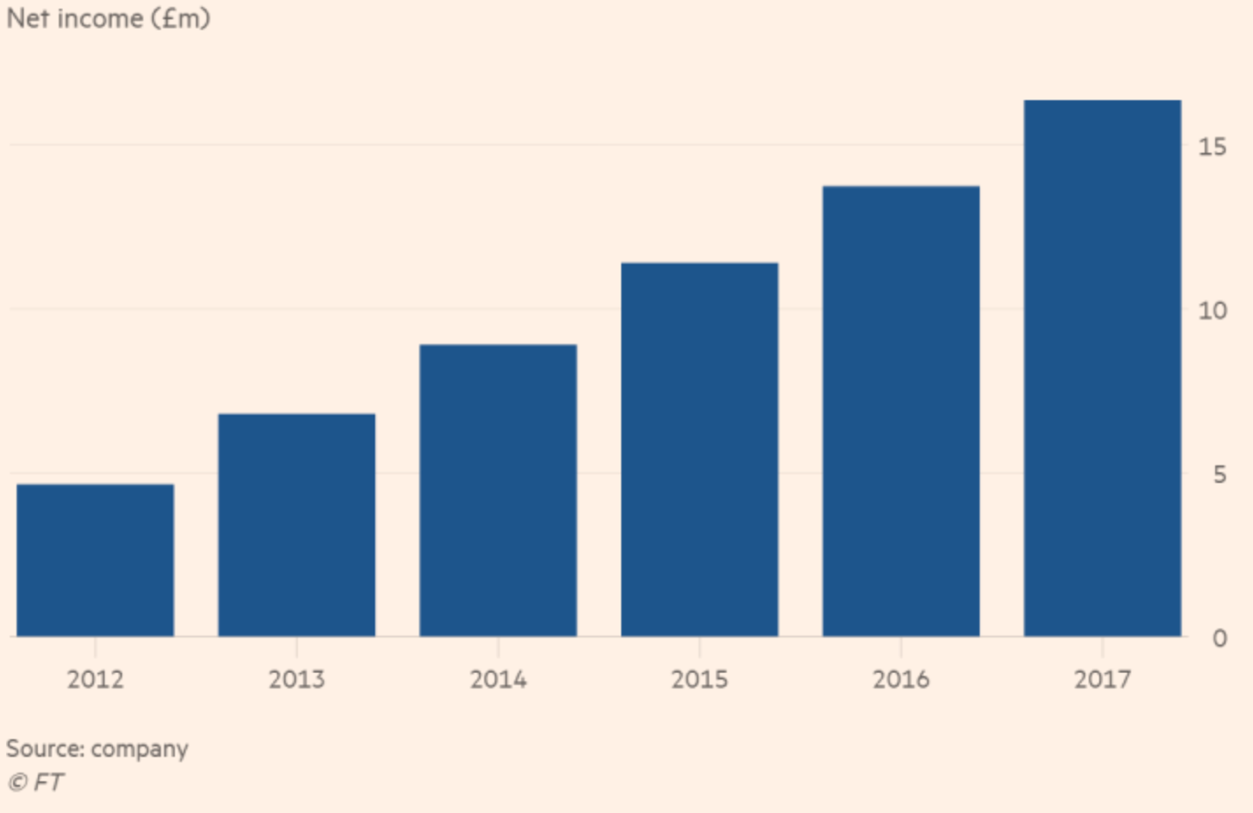(Patisserie Valerie, 2018; Eley, 2019)

PwC investigation of Patisserie-Valerie’s financial report revealed £40m fraud involving the finance staff and supplier through the provision of fake invoices for refurbishment work, this is a manipulation of expenses (point-2 in methods of manipulating financial statements). Furthermore, the administrator discovered a £94m black hole in the accounts (Ahmed, 2019). Patisserie-Valerie’s cash position was overstated by £54m, its debt was understated by £17m, a further £23m discrepancy in asset valuation (Wood, 2019a), this was a fraudulent accounting (Rosner, 2003). The management eliminated liabilities to make their financial position look healthy (point-3 in methods of manipulating financial statements; Dechow and Skinner 2000; Atrill & McLaney, 2005; Cotter, 2012; Elliot & Elliot , 2015).

Patisserie-Valerie made pre-tax profits of £11.1 million on revenues of 60.5 million pounds in the six months to the end of March, with £28.8 million pounds of net cash which the company claimed to be in the bank when scandal initially broke, but the company was actually carrying a £10m debt (Martin & Sangameswaram, 2018; Butler, 2019). Furthermore, there was a claim of inflated margins. Market analyst concluded that Patisserie-Valerie’s 18 per cent operating margin was well above the Greggs and Costa Coffee margins operating profit margins of 8 per cent and 12 per cent respectively (Eley, 2019). This is a creative-accounting/ earning-management (Dechow and Skinner, 2000; Atrill & McLaney, 2005; Cotter, 2012; Elliot & Elliot , 2015; Young & Cohen, 2013).
Still, it was alleged that the purported Board resolutions and directors’ signatures deemed necessary to open ‘secret’ bank accounts and overdrafts that were not included in the accounting records were forged, and the extent of the fraudulent transactions required the collusion of several finance capable personnel (BDO, 2019), this is the elimination of losses and liabilities by creating a separate entity to absorbs the liability (Dechow and Skinner 2000; Atrill & McLaney, 2005; Cotter, 2012; Elliot & Elliot , 2015).
This scandal led to company’s finance director, Chris Marsh, being arrested by police. Likewise, KPMG was brought for restructuring and insolvency (Butler, 2019). The administrators KPMG closed 70 stores before selling Patisserie-Valerie and Phillpotts chains 96 stores to Causeway Capital Partners (White, 2019).
The auditors, Grant-Thornton were culpable for signing off the published accounts without qualification. Besides, Patisserie-Valerie has trouble paying suppliers. There were claim that credit period was stretched from 60 days to almost double, leading to several suppliers pursuing legal action (Eley, 2019).

The executive-chairman Johnson said he was ‘tricked by a fake picture of its financial health’ and also questioned the clean bill of health provided by auditor (Wood, 2019b). Yet, David Dunckley, head of Grant-Thornton, the café chain’s former auditors, insisted that normal audit procedures was not designed to identify sophisticated fraud when he appeared before Parliaments (Sharp, 2019).
Lack of effective Governance, poor internal-control system, insufficient whistle-blowing procedures and ineffective Audit-Committee could be a contributing factor to the scandal. The chairman did not have a hands-on at Patisserie-Valerie (BDO, 2019; Eley, 2019).
The managers abused the judgement afforded them by accounting standard (Levitt, 1998) by manipulating the financial data (Dechow and Skinner 2000). The investors were also manipulated (Schipper, 1989; Healy & Wahlen, 1999) and were demanded to invest additional £25 million to keep into the distressed company afloat (Butler, 2019; BDO, 2019).

The Role of the UK Corporate Governance Structure in Constraining Earnings Management

Cotter (2012) affirmed that EM cannot be fully eradicated but claimed that there are several effective ways to reduce it happening.

Financial Regulation

Statutory legislation is viable option against creative accounting, and the company’s Act is vital tool in preventing EM. The 2002 Sarbanes-Oxley Act that was enacted in America after the ENRON fiasco demands strict compliance on rules. The Sarbanes-Oxley Act has been adopted globally (Cotter, 2012). The IASB accounting standard role in revamping and unifying accounting standard in attempt to reduce the flexibility for companies to engage in creative accounting (Cotter, 2012).

Monitoring, Enforcing and Penalties

More policing, monitoring and enforcement of accounting and legal requirement. The Auditors could ensure a true and fair view of financial statement. The auditor should not be allowed to hide behind not being tasked to “detect fraud”. The jail sentence of any culpable executive like in Enron case could deter creative accounting (Cotter, 2012; Sharp, 2019).

Internal audit and identifying fraud

An effective internal audit function could be able to identify any fraudulent activity that could take place. In UK, internal audit function is not mandatory, but it is recommended under Corporate Governance Code and the Quoted Companies Alliance Code (BDO, 2019).

Corporate Governance

Creative accounting can be prevented by adhering to the corporate governance code. The appointment of non-executive Directors could be a control against management abuse (Cotter, 2012). The Financial Reporting Council (FRC) (2018) recommended half the board, excluding the chair to be non-executive directors, and Provision 13 of FRC, 2018 demands the non-executive Directors should scrutinise performance of management against agreed performance objectives and hold management to account.

Ethics

More focus on Ethics in education across all curriculum could discourage future managers from creative accounting. This could assist managers in understanding the illegality and the unethical nature of creative accounting (Cotter, 2012).

Whistle Blowing Culture

Nadler & Schulman, (2015) defined whistleblowing as a way of calling the public attention to wrongdoing within an organization. Whistleblowing should be encouraged and protected (Cotter, 2012; FRC, 2018).

Corporate Social Reporting

The motivation for EM is significantly reduced if a good citizen culture is cultivated within an organisation. Therefore, management’s focus goes beyond meeting the needs of investors/shareholders, but it extends to wider stakeholders (Cotter, 2012).

Incorporating Islamic religious beliefs and values

Companies that incorporate Islamic religious believes into their operations were found to seldom engage in EM (Elghuweel, et al., 2017).

CONCLUSION

Since the accounting standards empowers managers to make subjective judgements, therefore, EM cannot be fully eradicated. There are several reasons why creative accounting is deployed by management to mislead investors and other stakeholders, nonetheless, it is illegal and criminal, and tougher penalties should continue to be handed down on culprits.

RECOMMENDATIONS
There have been several major accounting scandals in recent years. therefore, effective Audit-Committee, effective Internal-Audit control system must be mandated along with effective implementation of Corporate Governance Code and the Quoted Companies Alliance Code.
Maintaining a good governance must be underpinned by enforcement to ensure companies do not succumb to creative accounting/EM.
Ethics, Islamic religious principles could be incorporated into corporate operations could deter managers engaging in EM.
Whistleblowing should be encouraged and protected.

REFERENCE

Accountancy
Accountancy Age
Ahmed, M., (2019). Five arrested in Patisserie Valerie fraud probe. [Online] Available at: https://www.ft.com/content/f3de68ba-959d-11e9-9573-ee5cbb98ed36 [Accessed 7 March 2020].
Arya, A., Glover, J. C., and Sunder, S., (2003). "Are Unmanaged Earnings Always Better for Shareholders?" Accounting Horizons 17(Supplement): 111-116.
Atrill, P. & McLaney, E., (2005). Financial Accounting for Decision Makers. 4 ed. Harlow: Pearson Education Limited.
Auditing Practices Board (APB), (2001). Aggressive Earnings Management, London: The Auditing Practices Board. https://www.frc.org.uk/getattachment/fa2e4c67-cbaa-48ab-a8e9-46b93bfa881e/Aggressive-Earnings-Management-June-2001.pdf.
BDO, (2019). Patisserie Valerie: a case for internal audit. [Online] Available at: https://www.pqmagazine.com/patisserie-valerie-a-case-for-internal-audit/ [Accessed 8 March 2020].
Becker, C. L., Defond, M. L., Jiambalvo, J., and Subramanyam, K. R., (1998). "The Effect of Audit Quality on Earnings Management." Contemporary Accounting Research 15(1): 1-24.
Beneish, M. D. (1999a). "The Detection of Earnings Manipulation." Financial Analysts Journal. 55(5): 24-35.
Beneish, M. D. (1999b). "Incentives and Penalties Related to Earnings Overstatements that Violate GAAP." The Accounting Review. 74(4): 425-457.
Beneish, M. D. (2001). "Earnings Management: A Perspective." Managerial Finance. 27(12): 3-17.
Bergstresser, D. and Philippon, D., (2006). CEO Incentives and Earnings Management. Journal of Financial Economics, Issue 80, p. 511–529.
Blackburn, V., (2019). Top accounting scandals in 2018. [Online] Available at: https://www.accountancyage.com/2019/03/20/a-summary-of-the-cases-of-financial-scandals-of-2018/ [Accessed 7 March 2020].
BPP Learning Media (2017) ACCA P2 Corporate Reporting (International & UK): Study Text, BPP Learning Media
Braun, K. W., (2001). The Disposition of Audit-Detected Misstatements: An Examination of Risk and Reward Factors and Aggregation Effects. Contemporary Accounting Research, 18(1), pp. 71-99.
British Accounting Review
Butler, S., (2019). Patisserie Valerie says its accounts were 'significantly manipulated'. [Online] Available at: https://www.theguardian.com/business/2019/jan/16/patisserie-valerie-accounts-cafe [Accessed 7 March 2020].
Collier, J., (2004). Aggressive earnings management: Is it still a significant threat? The Institute of Chartered Accountants in England and Wales, Audit and Assurance Faculty.
Cotter, D., (2012). Advanced Financial Reporting, A Complete Guide to IFRS. Harlow: Pearson Education Limited.
Cotter, D., (2015). Cases and Solutions in International Financial Reporting. (4th Ed) Chartered Accountants Ireland
Dechow, P. M., and Skinner, D. J., (2000). "Earnings Management: Reconciling the Views of Accounting Academics, Practitioners, and Regulators.". Accounting Horizons, 14(2), pp. 235-250.
Dechow, P. M., Sloan, M. R., and Sweeney, A. P. (1995). "Detecting Earnings Management." The Accounting Review. 70(April): 193-225.
Dunn, J., and Stewart, M., (2015) Advanced Financial Reporting and Analysis John Wiley and Sons
Elarde, J. V. and Chong, F. F., (2012). The Pedagogical Value of “Eduployment”: Information Technology Internships in Rural Areas. In Proceedings of the 13th Annual Conference on Information Technology Education (pp. 189–194). New York, NY, USA: ACM. [Online] Available at: https://doi.org/10.1145/2380552.2380607 [Accessed 20 February 2020].
Eley, J., (2019). How Patisserie Valerie’s recipe turned sour. [Online] Available at: https://www.ft.com/content/78c1d05a-0c1c-11e9-acdc-4d9976f1533b [Accessed 7 March 2020].
Elghuweel, I. M., Ntim, C. G., Opong , K. K. and Avison , L., (2017). Corporate governance, Islamic governance and earnings management in Oman: A new empirical insights from a behavioural theoretical framework. Journal of Accounting in Emerging Economies, 7(2), pp. 190-224. https://doi.org/10.1108/JAEE-09-2015-0064 [Accessed 7 March 2020].
Elliot, B. and Elliot, J., (2015). Financial Accounting and Reporting. (17th Ed). London: Financial Times-Prentice Hall.
Financial Reporting Council (FRC), (2018). The UK Corporate Governance Code. [Online] Available at: https://www.frc.org.uk/getattachment/88bd8c45-50ea-4841-95b0-d2f4f48069a2/2018-UK-Corporate-Governance-Code-FINAL.pdf [Accessed 8 March 2020].
Finch, C., (2012). A Student’s Guide to International Reporting Standards, 3rd Ed. Kaplan
Gray, R., Adams, C., and Owens, D., (2105) Accountability, Social Responsibility and Sustainability: Accounting for Society and the Environment, Pearson
Healy, P. M. and Wahlen, J. M., (1999). A Review of the Earnings Management Literature and Its Implications for Standard Setting. Accounting Horizons, 13(4), pp. 365-383.
Iqbai, A. and Strong, N., (2010). The effect of corporate governance on earnings management around UK rights issues. International Journal of Managerial Finance, 6(3), pp. 168-189. https://doi.org/10.1108/17439131011056215 [Accessed 7 March 2020].
Kennon, J., (2003). The WorldCom Scandal Explained. [Online] Available at: https://www.thebalance.com/worldcom-s-magic-trick-356121 [Accessed 7 March 2020].
KOPP, C. M., (2019). Agency Theory. [Online] Available at: https://www.investopedia.com/terms/a/agencytheory.asp [Accessed 6 March 2020].
Levitt, A., (1998). "The Numbers Game.". The CPA Journal, 68(12), pp. 14-19.
Linder, S. and Foss, N. J., (2015). International Encyclopaedia of the Social & Behavioural Sciences. Edited by James Wright. 2 ed. s.l.: Elsevier.
Martin, B. and Sangameswaram, S., (2018). Patisserie Valerie finds accounting errors, suspends CFO. [Online] Available at: https://www.reuters.com/article/uk-patisserie-hldg-accounts/patisserie-valerie-finds-accounting-errors-suspends-cfo-idUKKCN1MK0KD [Accessed 8 March 2020].
Nadler, J. and Schulman, M., (2015). Whistle Blowing in the Public Sector. [Online] Available at: https://www.scu.edu/government-ethics/resources/what-is-government-ethics/whistle-blowing-in-the-public-sector/ [Accessed 8 March 2020].
Nobles and Parker, (2012). Comparative International Accounting London: Prentice Hall
Nobles, C. and Parker, R., (2010). Comparative International Accounting. 11th ed. Harlow, Essex: Pearson Education Limited.
Powell, L., Jubb, C., Lange, P. d. and Langfield-Smith, K., (2005). The distinction between aggressive accounting and financial reporting fraud: Perception of auditors. s.l., s.n.
Public Oversight Board (POB), (2000). The Panel on Audit Effectiveness Report and Recommendations. Stamford, USA, Panel on Audit Effectiveness, The Public Oversight Board: Panel.
Rosner, R. L., (2003). "Earnings Manipulation in Failing Firms.". Contemporary Accounting Research, 20(2), pp. 361-408.
Schipper, K. (1989). "Commentary on Earnings Management." Accounting Horizons, Volume 3, pp. 92-102.
Scott, W. R. (1997). Financial Accounting Theory. New Jersey, Prentice-Hall Inc.
Sharp, N., (2019). Patisserie Valerie: It’s Not the Accountants Responsibility to Spot Fraud. [Online] Available at: https://www.lawyer-monthly.com/2019/02/patisserie-valerie-its-not-the-accountants-responsibility-to-spot-fraud/ [Accessed 7 March 2020].
White, S., (2019). SFO arrests over Patisserie Valerie accounting fraud. [Online] Available at: https://www.accountancydaily.co/sfo-arrests-over-patisserie-valerie-accounting-fraud [Accessed 7 March 2020].
Wood, Z., (2019a). Patisserie Valerie accounts black hole now £94m, says KPMG. [Online] Available at: https://www.theguardian.com/business/2019/mar/15/patisserie-valerie-accounts-black-hole-94m-say-kpmg [Accessed 7 March 2020].
Wood, Z., (2019b). Patisserie Valerie ex-chair says he was tricked by false picture of company's health. [Online] Available at: https://www.theguardian.com/business/2019/jun/09/patisserie-valerie-luke-johnson-says-he-was-tricked [Accessed 7 March 2020].
Wright, A. and Wright, S., (1997). An Examination of Factors Affecting the Decision to Waive Audit Adjustments. Journal of Accounting, Auditing, and Finance, 12(1), pp. 15-36.
Young, S. D. and Cohen, J., (2013). Corporate Financial Reporting and Analysis: A Global Perspective. Third ed. Padstow, Cornwall: TJ International.

APPENDICES

Appendix 1:
Scott (1997) still contended that earnings management is a medium through which inside information is conveyed to the stock market and (Arya, Glover and Sunder 2003) also conclude that it promotes efficient decision-making. The Auditing Practices Board (APB), 2001) argued that the increasing commercial pressure on those responsible for financial statements may result in management earning.

Appendix 2:
The Auditing Practices Board (APB, 2001) listed the commercial pressures such as
- The negative market reactions to the company’s share price if they fail to achieve their targeted market result.
- A strategy to evade tax by understating profits
- A strong desire to achieve Legal and regulatory requirements in meeting intended financial thresholds or ratios etc.

