Part 2 – portfolio
Jordana Baylis
2125426
Mrs Opeyemi Odejimi
LCHS4005_BIRM
Professional Development within health and social care

Contents page
CV…………………………………………. 3&4
Cover letter……………………………………..5
SWOT analysis…………………………………….6
Personal Development Plan ……………………7
Personal statement…………………………..……..8
Reflection from presentation……………………….9
References………………………………………………10

Jordana baylis
Miss
97 Chatham Road
Northfield
Birmingham
B312PL
Professional summary
I am extremely trustworthy and respectful, loyalty and reliable. I am compassionate and enthusiastic, quick learner and good at solving problems, work brilliantly in a team.
I am looking for a job that can challenge me, I like learning new things individually and in a team.
Professional history and skills:
- Worked in domiciliary and Residential Care for all ages. 2016 - 2020
- Manager at market, I worked in a café, cleaner, key holder. 2016 - 2018
- Domestic cleaner. 2015 – 2019
- Retail (Card factory). 2019 - 2020
- Bar work. 2022
- Cosmetic injections. 2022
Level 2 Diploma – sport and exercise science.
English – c, Math’s – c, Science – c, art – B, Dance – A, Health and social care -PASS.
I am respectful, hardworking, supportive, on time, coaching, motivating, confident, these jobs have given me so much experience over the years so I am able to adapt to change really well. Compassionate.
References
Sharon kennedy- jones
101 chatham place
Northfield, Birmingham
B31 2PL
Contact - 01217768399
Kerrie james
256 Grosvenor
Northfield, Birmingham
B31 5QP
Contact - 07706002666
Sales and cashier, 12/2019 – 01/2020
Kerrie James – Northfield, Birmingham
Processed all transactions efficiently and timely.
Bagged, boxed or wrapped goods and product purchases.
Accepted cash, cheque, credit and debit payments accurately and efficiently.
Maintained professionalism with clean, tidy, and well-stocked check-out lines.
Used POS system to enter orders, process payments, and issue receipts.
Sales and Cashier, 12/2019 – 01/2020
Kerrie James – Northfield , Birmingham
Processed all transactions efficiently and timely.
Operated cash register with proficiency during high-volume shopping times.
Issued receipts for purchases and gifts.
Answered customer questions, provided store information and escorted to desired store areas.
keeping adequate change.
Worked closely with the card factory to solve problems and handle customer complaints.
Maintained professionalism with clean, tidy, and well-stocked check-out lines.
support and care home worker, 02/2017 – 08/2018
Sharon Kennedy-Jones – Northfield , Birmingham
Helped elderly, visually impaired, hearing impaired and multiple of disabilities, wash, dress, cook, clean,
administer medications and bandages.
Health and safety, safe guarding.

CV

CONTACT
PHONE NUMBER:
07904285658

EMAIL ADDRESS:
Jordanabaylis9@gmail.com

Residential Care home
Dear The Residential Care home,
In response to your job advert I would like to explain briefly why I am a suitable candidate for this position that’s recently opened.
As a previous Residential and domiciliary care and support worker for the past 7 years. I think I would be suitable for management, as I am fully reliable, and trusted by staff and service users within this job. I know all health and safety regulations. I am up to date with all data protection acts and confidentiality of all residents. I am extremely enthusiastic and reliable; I work hard, and I love a daily challenge. I am a motivating team worker and outstanding communication, I bring brilliant ideas to the boards and help any company progress.
As a professional care worker, I have understood all disabilities and how to challenge my knowledge when performing my work. I am very ambitious and always handle changes and adaptation well. I engage with service users and staff; accordingly, I help assisting as and where is necessary. I fulfill every requirement that is issued.
When being given the responsibility of caring for someone who needs the requirements of assisting, administering medication, bathing and grooming, shopping, general cleaning to meet the requirements appropriately. I complete all journals and MAR charts, detailed description of what I assisted and sported the service users with, informing family and close ones when follow up appointments, progression, and incidents.
I provide full care and I believe this role is for me as for the next steps and challenges this will help me progress and show my full potential to help myself and company be the best. I believe I can be the new face of this residential home and show how proud and hardworking as well as maintaining professionalism with my colleagues and residents.

Thank you for your time and consideration. I hope to hear from you very soon.
Yours Faithfully
Jordana Baylis
Jordanabaylis9@gmail.com
07904285658

SWOT analysis
SWOT analysis helps underline the challenges of strategic managements, illustrating the balance view and techniques that is needed to face strengths, weaknesses, opportunities and threats and how to approach and make them useful within the job. (Helms, M.M. and Nixon, J,. 2010).
Strengths-
Decision making as this shows different challenges and how they are decided on what steps needs to be taken. This can either be a team effort or individually, the outcome on a decision is normally taken up by the team as well as the managers. This allows staff to bring all ideas together and help underline what strengths from decision making and the importance of the decision. (Van, Wijingaaden, et. Al 2012).
Weaknesses-
Lack of training. Most care jobs especially Domiciliary care gives the staff a week of shadowing without meeting the whole team, this becomes an issue because when going home to home, sometimes the staff don’t know one another especially when it comes to 2:1 care, can keep professionalism but staff should all meet before performing an important role of care and assisting each service user, this can cause health and safety risks is no communication when using equipment, this is neglecting the health and safety regulations.
Opportunities-
Giving service users more mobility, doing more activities can help residents feel more active and its important by obtaining healthy lifestyles, this allows positive influences with staff and service users. (Chow, B. C, al et 2020).
Threats-
Lack of communication from staff to staff, although there’s communications sheet for each staff to explain what went well during the visit of care and what did, this also shows what medication was prompt, administered or declined by serviced user. If each staff doesn’t explain what went well and what didn’t, needs to be explained within the communication log. Staff must read previous from the last time that staff was on the visit, this helps insight of what went on during the staff’s time away, but lack of communication from a staff member can cause complications of the rest of the team as well as the service user.

Personal Development Plan
For my first goal is to become a manager and own my own company.
For this I will need to become a manager at a care home, in order for myself to progress and help find new challenges an running a company by showing my motivation, enthusiasm in order to take the next step of building my own company.
This is to be achieved within 2 years, spend a year within management to progress and see what company I can build of my own.
Issues can be through fundings if unable to have the funding to build my own company this may delay and take more than 2 years to get the company, or whether to fail at the managers vacancy, this can put a doubt on whether I could progress in building my own foundation.
To improve my goal, I must look and research to find what my company can bring that is different to any other residential care home. For example, taking service users on day trips to help fulfill their wishes and goals, I would be doing raffles and different activities to keep the residents as happy, healthy, and comfortable as I can.
For support I would turn to community and hold events to help bring people together I would have a page where anyone can write how they can support one another this wouldn’t be just for my company, but it would be worldwide allowing other residential homes have great ideas and bring them together to help the elderly be more comfortable.
Every 3 months I would review on how well things are going and what will need improving this will help myself develop better as a manager as well as building my own company. This will also keep myself and my team members motivated to do either change things or keep the good work up.
For my 2nd biggest goal is to move to a country to help the un-educated children to become more successful within education. This will be very motivational and rewarding as well as helping children become more educational.
To take these steps, I would need to visit schools in different countries and see where the children are needed most academically.
For the process of two years, I would hope to have majority of my planning complete which full research. Although within a year the plan is travelling around and find my right fit.
Difficult experiences along the way will include, learning new languages as well as finding a school where I can use my resources and knowledge in the right educational and academical way. Being accepted by another culture and learning just as much as they would be learning from myself can also be an obstacle as well as a reward.
The way I can improve this is by learning new languages and understanding different cultures, being able to experience a new life with new people will help improve myself academically. For support I would ask community and government to help fundings, getting volunteers, make a webpage for the community to help advise with steps and what can be progressed.
Ever month I would write a progression diary with improvements and what will need to change and how and what stages are next.
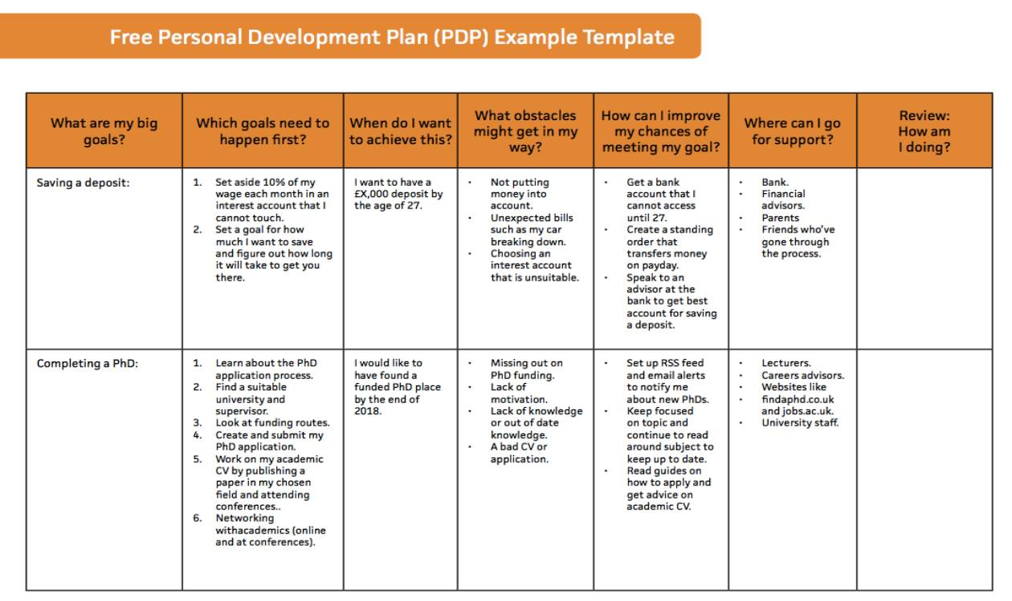 https://www.ismartrecruit.com/blog-personal-development-plan-help-your-employees

Personal statement
As a trusted and respected care worker, I know I am a right candidate for this management role, because my past 7 years of experience within care, knowing from basic to advance knowledge of health and safety regulations, fully qualified in medications and phlebotomy. I’ve educated myself within teamwork, pursued extra training courses within CPR, understandings of disabilities, learning sign language. I’ve improved every job satisfactory and completely trusted from every previous employment.
I have the communication and insight from previous employment to help improve the health cares work quality, allowing more information on research and help with cost reductions to be more effective and help the company, financially.
During school I was really interested within health and social care which later led me into residential and domiciliary care. This improved my skills of safeguarding, understanding, trusting and knowledge of health and safety, medications and this helped me pursue a goal of phlebotomy training which enhanced and opened more doors. I was an award winning nominated for the best carer in 2018 which gave me more motivation to continue in a career which I love.
I believe I have the skills to work to perform the role of management understandingly, professional, and efficiently. I believe I can provide care and deliver the role because I love what I do, I thoroughly maintain professional standards and boundaries, I also support all physical and psychological needs, this was educational because I managed to learn about all limitations on each service user and how ever need is different, that is what made the carer role interesting as learning about all different needs and requirements are all different due to conditions of each resident.
Being able to learn and be educated in the health care profession firsthand was more challenging as learning all different disabilities, psychological and physical requirements from each service user was different but what helped was having a supportive teamwork and documents stating what each resident needs in order to maintain their health at a sustainable and healthy. Working in care has taught me valuable lessons such as not to take freedom for granted knowing the physical and disabled service users are living with. Most rewarding is knowing how welcomed I felt every time I work, knowing that the residents and family of the residents respected and trust me, knowing I can have a professional and suitable relationship that helps bring the company and residents together. Motivation and being punctual was my biggest reward knowing that I was doing and helping whilst maintain the professionalism and reliable work ethic.
I would benefit the company in great ways as I have multiple ideas to help reduce costs, maintain happy and comfortable residents, enhance patient skills, keeping staff motivated and help with decisions. I would like you to consider me as your new Manager because I can bring new perspective ideas to the company, help the company progress and expand in a beneficial and healthy way. I am extremely professional and enthusiastic; this job will give me the power and ambition to continue pursuing my dream in health and social care.

Reflection on presentation
After my presentation I was given very positive feedback, I was giving good eye contact and had very useful information on each slide, which explained in detail of what my assignment was about. My lecturer explained that when I was discussing reflection on self-awareness and what good reflection is.
Although I demonstrated what The Johari Window model is and how it was useful within my presentation, I could have compared it and noted in shorter sentences, this gave myself the idea of not to go off track when going into detail with my research but keeping it to minimal of writing as my sides did look overpowering with writing. For myself I do find it useful to write more as it gives me the chance to go into detail and explain how much understanding I have with the tasks. As for my progression I could have used more time to add photographs instead of making an extra side to add more writing, as my lecturer unraveled. I could improve on my presenting skills, even though I maintained eye contact and was using my body language to show how much I understand from the presentation, I did repeat myself a few times which was noticed by my lecturer, this has given me insight on how to practice for my next presentation, therefore I will need more planning time to rehearse my presentation before performing in front of the lecturer.
My thoughts were very positive and motivational. I managed to maintain presenting skills of performing in front of my lecturer really understanding and professional, I was proud of the positive outcome which has helped my ability to overcome some anxiety of speaking out loud, it is also rewarding knowing I presented my presentation a week before any of my classmates which has given me more motivation to know I can succeed and have more control with my presenting skills without rehearsing more than once. but to improve I must plan accordingly and rehearse my presentation before presenting. I need to use my time a bit more efficiently to know I will not go off track when completing my assignment, I know I should keep my writing to factual statements without writing too much on each slide. Also use more photographs to help make my presentation look ore eye catching.
References
Chow, B.C., Choi, P.H.N., Huang, W.Y. and Pan, C.Y., (2020). Promoting physical activity in group home settings: Staff perspectives through a SWOT analysis. International Journal of Environmental Research and Public Health, 17(16), p.5805. [Accessed date 29/03/23].
Helms, M.M. and Nixon, J., (2010). Exploring SWOT analysis–where are we now? A review of academic research from the last decade. Journal of strategy and management, 3(3), pp.215-251. [accessed date 28/03/23].
Van Wijngaarden, J.D., Scholten, G.R. and van Wijk, K.P., (2012). Strategic analysis for health care organizations: the suitability of the SWOT‐analysis. The International journal of health planning and management, 27(1), pp.34-49. [accessed date 29/03/23].
https://www.ismartrecruit.com/blog-personal-development-plan-help-your-employees

