BMSW4004
Khizar Fareed 2028871
Problem-solving and decision making
Task 2

Contents
Introduction
Scope and Impact – a case study of Stress in the UK
Cause and effect analysis
Pestel
SWOT
PMI
Conclusion and recommendations
References

Introduction
This report will aim to further elaborate my presentation regarding the case study and problem solving of Stress in the UK. The report will briefly discuss elements of my presentation and also provide an in-depth explanation for each step and its purpose. Using the slides incorporated into this report, it should aim to discuss;
  - The scope and impact of the main problem (stress in the UK)
  - Fish-bone diagram analysis
  - Provide further analysis of the problem via PESTEL,SWOT, PMI
  - Run an assessment of the issue and find solutions to begin implementing a plan.

Scope and Impact
Solving problems is at the heart of human development. By identifying things that we wish to change, and determine what processes have to be achieved to get to the end result, you have to employ a process to comprehend what is going on in the environment, and begin examining and highlighting anything that presents it self as a possible barrier. All new technologies, social and cultural progress, and market-driven economies are founded on problem resolution. It is the foundation for lifelong learning, communication, and progress.
According to Kepner Tre-goe (2021), problem-solving is the process of observing what is going on in your environment, recognizing what changes could be implemented, what improvements could be made, identifying any factors that may influence and situation, and making decisions to correct this.
In this case study, we examined the widespread problem of stress in the UK, and how stress manifests itself in several ways, such as work-related stress, financial stress, and family stress, to name a few. When examining this issue, it was recognized that stress could lead to several other issues surrounding a person's work life, personal life, and health. This is a strategic problem that everyone should be concerned about as the well-being and mental health of individuals can lead to a negative impact on businesses and organizations. The mental health foundation (2018) recognized that 51% of adults reported feeling depressed, and 37% reported feeling lonely as result. This was from a sample size of 4,619 people. The University of Cambridge the effects of stress on an organization include;
- High labor turnover
- Poor productivity and performance
- Low motivation
- Increased absences

Stress may have a big influence on physical and emotional well-being, which may eventually hinder your productivity. What stress can mean for businesses and organizations is that it can drain your energy having a significant impact on the level of productivity of an individual, create a lack of focus, reduce creativity and then lead to several other problems business can face such as having a higher turn over of staff, increased sick days, impact on teamwork and harmony within the workplace and also having poor quality of work (Peek, 2021).

Cause and effect analysis
A cause-and-effect analysis, also known as a fishbone was initially used for quality improvement. Created by Professor Kaoru Ishikawa, this tool may also be used to aid in the analysis of business processes by identifying their causes and issues, as well as assisting in the discovery of potential remedies (Wade, 2020). To begin creating a fishbone diagram, it was necessary to first list the major issue areas and determine the fundamental reasons. The next step is to start examining the components that might be contributing to the situation. These can include systems, equipment, materials, external factors, persons involved in the situation, and so on (Cause and Effect Analysis: Identifying the Likely Causes of Problems, 2020). For each of the detected elements, you may then begin to identify the difficulties that may be causing it, which can be mentioned as sub-clauses as well.
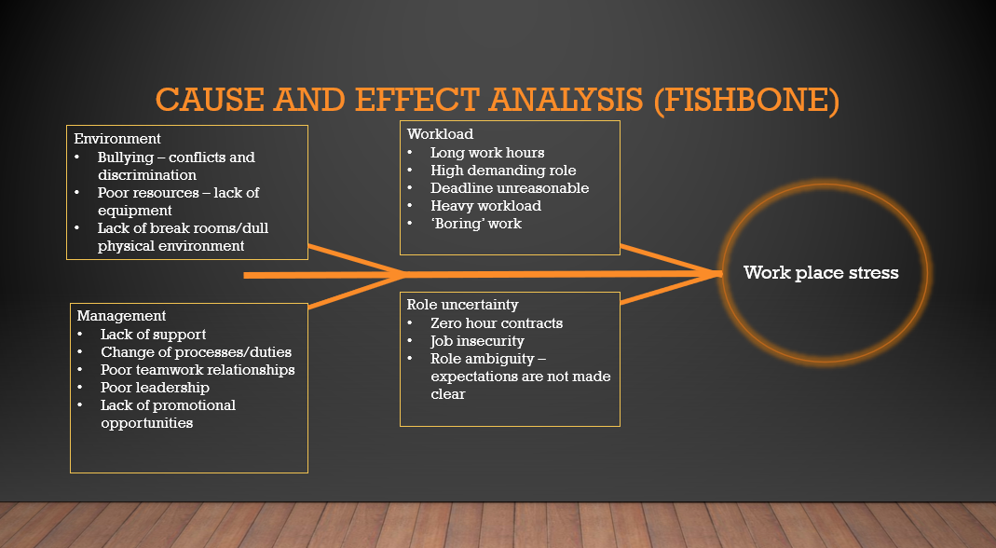
Before you start looking for a remedy, a fishbone analysis may help you investigate everything that is incorrect and could be causing the problem. This may be a very helpful tool in resolving an issue. It allows you to 'see both backward and forwards.' Looking backward can assist in determining the core factors that lead to the challenges at hand in the first place, as well as how to prevent them in the future. By 'seeing forward,' it is possible to develop solutions that can be adopted and predict future consequences (Cause and Effect Analysis: Identifying the Likely Causes of Problems, 2020).
My fishbone analysis listed four key areas; Environment, Workload, Management, and Role uncertainty. Withing these four areas, I expanded on them to provide a further descriptor. With these descriptors, you can then start taking the problem apart and start to formulate solutions for each of these problems at hand.

PESTEL
A PESTEL study is an abbreviation for a method that is used to determine the macro (external) factors that an organisation faces. Political, Economic, Social, Technological, Environmental, and Legal are represented by the letters.
Before implementing any strategy or tactical plan, it is critical to undertake a thorough situational analysis. To detect changes in the macro-environment, this examination should be done every six months. Organizations that properly monitor and respond to changes in the macroenvironment can separate themselves from the competition and so gain a competitive edge.
The framework is also used to discover prospective threats and weaknesses, which are then utilised in a SWOT Analysis to determine any business's strengths, weaknesses, opportunities, and threats. (What is a PESTEL analysis? 2021).
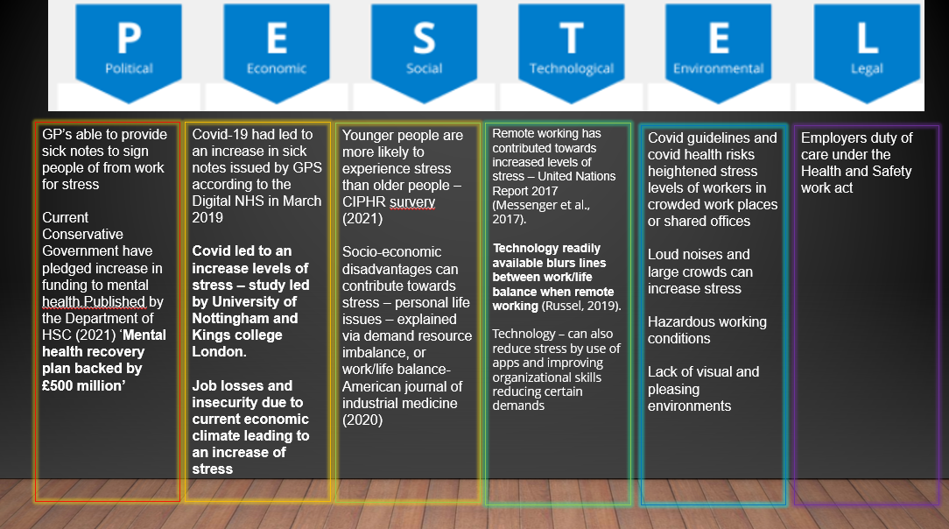
My PESTEL analysis identified several key factors.

SWOT
A swot analysis is a technique that can aid in the development of a corporate strategy. This aids in determining a company's present situation. SWOT is an acronym that stands for strengths, weaknesses, opportunities, and threats.
Internal to the firm, such as people, geographical location, or other assets, can be characterized as strengths and weaknesses. External opportunities and hazards exist. These are elements you cannot modify or influence, such as competition, the market, external supplier costs, and consumer trends. (Parsons, 2020)
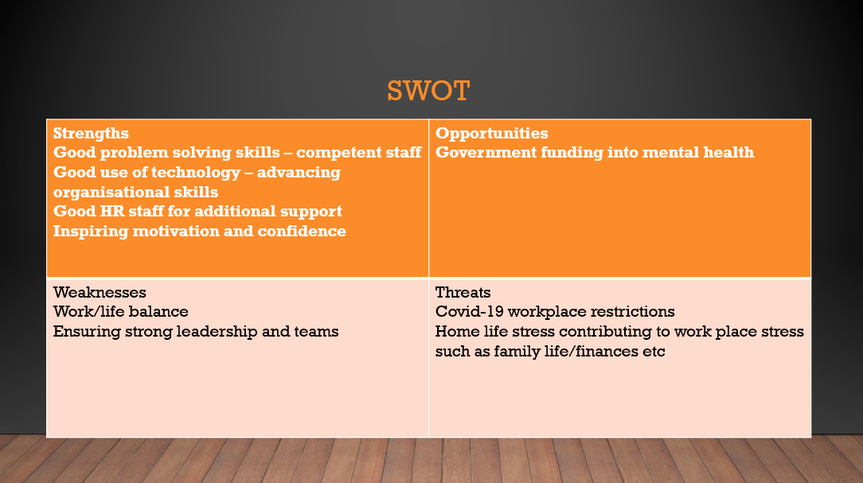
Looking at my SWOT analysis I can see different areas, to then start formulating a plan to address the threats and weaknesses. Also using the opportunities identified would help combat the weaknesses the organization is facing.

PMI analysis
PMI is an acronym created by Doctor Edward De Bono that stands for "Plus, Minus, Interesting." "Plus" for those that are positive, "Minus" for those that are negative, and "Interesting" for those that are neither positive nor negative but may offer opportunities or merit additional study. McDermott (McDermott, 2020)
The PMI helped to weigh these decisions up by scoring them.
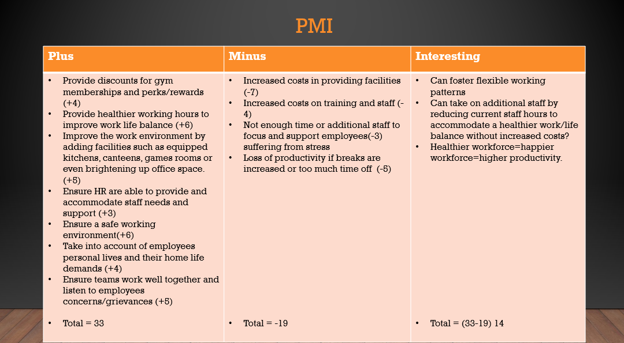
In the Plus column, I listed all of the good attributes/strengths that came to me. In the Minus column, I wrote the bad elements, and in the last column, Implications/interesting, I put all the things that I could think of that did not fit into either the plus or minus category. 2020 (UNISA).
All of these would then be graded. I've posted my ratings from -10 to 10. These would then be examined and analyzed to provide a more conclusive picture of the decision-making process.
From this analysis, I found that Offering gym discounts may inspire employees to join a gym and improve their health. According to research and studies, excellent health enhances overall well-being and minimizes stress (Exercising to Relax - Harvard Health Publishing - Harvard Health, 2020).

Conclusion – recommendations
Providing gym memberships encourages healthy lifestyles, and the discount alleviates financial stress. Most businesses and organisations will find the four alternatives I've reviewed to be cost-efficient. Reducing current employees' hours frees up time that may be used to hire new personnel. Simple solutions like as feedback and team meetings where employees may share their opinions, whether in a group or anonymously, can have a significant influence on employee well-being.

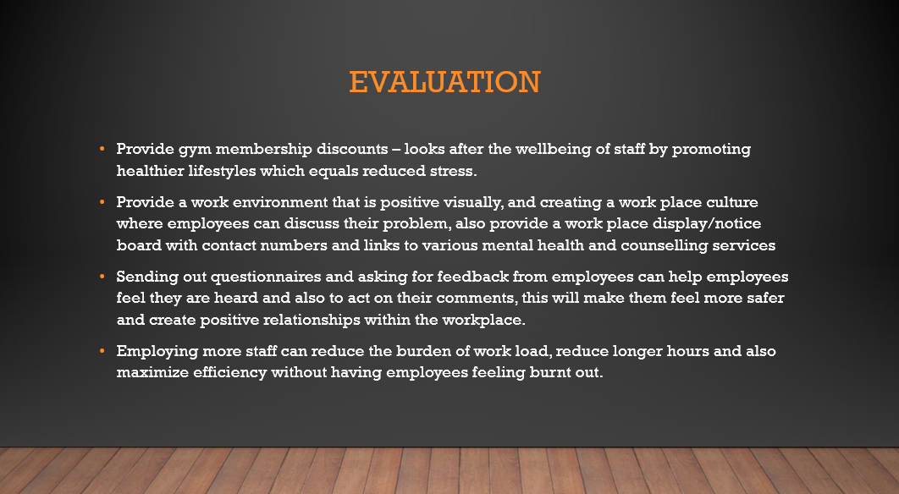
I found from all my analysis that the above solutions, as presented in my presentation were adequate solutions to address the problem presented of Stress in the Workplace.

References
knowledgeCity, k., 2020. Grid Analysis To Make Tough Business Decisions | Knowledgecity. [online] KnowledgeCity. Available at: <https://www.knowledgecity.com/blog/grid-analysis-easy-way-make-tough-business-decisions/> [Accessed 20 November 2021].
Mental Health Foundation. 2018. Stressed nation: 74% of UK 'overwhelmed or unable to cope' at some point in the past year. [online] Available at: <https://www.mentalhealth.org.uk/news/stressed-nation-74-uk-overwhelmed-or-unable-cope-some-point-past-year> [Accessed 2 December 2021].
Mindtools.com. 2020. Cause And Effect Analysis: Identifying The Likely Causes Of Problems. [online] Available at: <https://www.mindtools.com/pages/article/newTMC_03.htm> [Accessed 26 November 2021].
NHS, 2020. Cause And Effect Diagram (Fish Bone) : Quality Improvement – East London NHS Foundation Trust. [online] Qi.elft.nhs.uk. Available at: <https://qi.elft.nhs.uk/resource/cause-and-effect-diagram-fish-bone/> [Accessed 20 November 2021].
Oxford College of Marketing Blog. 2021. What is a PESTEL analysis?. [online] Available at: <https://blog.oxfordcollegeofmarketing.com/2016/06/30/pestel-analysis/> [Accessed 1 December 2021].
Parsons, N., 2020. What Is A SWOT Analysis, And How To Do It Right (With Examples). [online] LivePlan Blog. Available at: <https://www.liveplan.com/blog/what-is-a-swot-analysis-and-how-to-do-it-right-with-examples/> [Accessed 21 November 2021].
Peek, S., 2021. Stress and Productivity: What the Numbers Say. [online] Business.com. Available at: <https://www.business.com/articles/stress-and-productivity-what-the-numbers-say/> [Accessed 2 December 2021].
Tre-goe, K., 2021. What is problem solving and why is it important - Kepner Tregoe. [online] Kepner Tregoe. Available at: <https://kepner-tregoe.com/gbr/blogs/what-is-problem-solving-and-why-is-it-important/> [Accessed 1 December 2021].
UNISA, U., 2020. Thinking And Mind Tools: PMI Chart. [online] Lo.unisa.edu.au. Available at: <https://lo.unisa.edu.au/mod/book/view.php?id=611321&chapterid=100451> [Accessed 25 November 2021].
Wade, L., 2020. How To Use Cause And Effect Analysis To Easily Solve Business Problems. [online] Creately Blog. Available at: <https://creately.com/blog/diagrams/how-to-use-cause-and-effect-analysis/> [Accessed 28 November 2021].

