3/23/2026
University of Wales Trinity Saint David
London campus
Introduction to Web and Database Concepts

Module Name: Introduction to Web and Database Concepts
Module Code: ACCA4023_LON

Student Name: Yaroslav Tsyrul
Student ID: 2511421
Group: 4

Lecturer’s Name: Suresh Shanmugasundaram

Table of Contents
1. Introduction and Comprehensive Project Justification 2
2. Literature Review and Theoretical Framework 2
3. Detailed System Analysis: Entities and Attributes 3
3.1. Entity: Medicines (The Inventory Core) 3
3.2. Entity: Suppliers (Supply Chain Management) 3
3.3. Entity: Customers (Patient Records) 3
3.4. Entity: Prescriptions (Legal Documentation) 4
3.5. Entity: Sales (Transactional Data) 4
4. Entity-Relationship Diagram (ERD) and Cardinality 4
5. The Normalisation Process to Third Normal Form (3NF) 5
5.1. First Normal Form (1NF) 5
5.2. Second Normal Form (2NF) 5
5.3. Third Normal Form (3NF) 5
6. Physical Implementation in Microsoft Access 6
6.1. Table Construction and Data Validation 6
6.2. Sample Data Population 7
7. Advanced Query Development for Management Reporting 7
7.1. Query 1: Low Stock Inventory Alert 7
7.2. Query 2: Monthly Financial Revenue Report 7
7.3. Query 3: Patient Medication History 8
8. Validation, Testing, and Reflective Analysis 9
8.1. System Testing and Outcomes 9
8.2. Reflection and Future Enhancements 9
9. Conclusion 9

DESIGN AND IMPLEMENTATION OF A RELATIONAL DATABASE SYSTEM FOR 'MEDILINK PHARMACY'

Introduction and Comprehensive Project Justification

In the modern healthcare environment, the accuracy of data management is not just a logistical choice but a vital requirement for patient safety and operational sustainability [1]The focus of this assessment is "MediLink Pharmacy," a growing community pharmacy chain at a crucial point in its development. Currently, the organisation depends on manual, paper-based systems to monitor medicine stock, patient prescriptions, and daily sales transactions. This outdated method has caused notable inefficiencies, such as frequent human errors in dosage recording, stock shortages of essential medicines, and poor financial reporting.
The CEO of MediLink Pharmacy has authorised the creation of a robust relational database using Microsoft Access. The goal is to automate key processes to increase accuracy, enhance management reporting, and comply with regulations [2]. This project follows the Database Development Life Cycle (DBLC), moving from requirements analysis to conceptual modelling, logical normalisation, and ultimately physical implementation [1] By shifting to a digital relational system, MediLink Pharmacy aspires to deliver a higher standard of service while establishing a scalable infrastructure for future growth.

2. Literature Review and Theoretical Framework
The design of any professional database must be anchored in established relational theories to ensure long-term data stability [1] The relational model, originally conceived by Dr E.F. Codd, utilises a mathematical approach to data organisation, in which information is stored in tables (relations) consisting of rows (tuples) and columns (attributes).
According to Connolly and Begg (2015), selecting an appropriate Database Management System (DBMS) is vital [1] Microsoft Access was chosen for this project due to its rapid application development (RAD) capabilities and its ability to handle complex relational structures for medium-sized enterprises [3] Furthermore, Elmasri and Navathe (2021) emphasise that data integrity is maintained through the rigorous application of Primary Keys (PK) and Foreign Keys (FK) [2] In the MediLink system, every table is assigned a PK to ensure entity integrity. At the same time, FKs establish referential integrity between related entities, such as linking a prescription to a specific customer record.

3. Detailed System Analysis: Entities and Attributes
Following a systematic systems investigation, five primary entities were identified as the pillars of the MediLink Pharmacy database. [4]

3.1. Entity: Medicines (The Inventory Core)
The Medicines table acts as the central repository for all pharmaceutical products.
- MedicineID (PK): An AutoNumber field serving as the unique identifier for each drug product.
- BrandName: The commercial name of the medication (e.g., Amoxicillin).
- GenericName: The chemical or non-proprietary name, essential for pharmaceutical substitution.
- Category: A lookup field classifying drugs (e.g., Antibiotics, Analgesics, Cardiac).
- UnitPrice: Stored as a Currency type to ensure 4-decimal place accuracy in financial calculations. [3]
- StockLevel: A Number (Integer) field used to trigger reorder alerts when supplies are low.
- SupplierID (FK): Links the medicine to the company that provides it.

3.2. Entity: Suppliers (Supply Chain Management)
To maintain a steady supply of medications, the pharmacy must manage its distributors.
- SupplierID (PK): Unique identifier for each wholesale partner.
- CompanyName: The legal name of the supply firm.
- ContactPerson: The primary point of contact for ordering.
- Phone & Email: Communication channels for automated purchase orders.

3.3. Entity: Customers (Patient Records)
Managing patient data is crucial for tracking medication history and ensuring safety.
- CustomerID (PK): Unique patient ID.
- FirstName & LastName: Separated to allow for efficient sorting and searching.
- DOB: Date of Birth, used to verify age-appropriate dosages.
- Phone: Contact information for prescription readiness notifications.

3.4. Entity: Prescriptions (Legal Documentation)
This entity bridges the gap between the doctor’s orders and the pharmacy's output.
- PrescriptionID (PK): The unique serial number of the medical script.
- CustomerID (FK): Identifies the patient to whom the prescription belongs.
- DoctorName: The prescribing physician's name for verification purposes.
- IssueDate: The date the prescription was written, used to monitor expiration.

3.5. Entity: Sales (Transactional Data)
The Sales table records every transaction for financial and regulatory monitoring.
- SaleID (PK): Unique transaction number.
- SaleDate: Recorded via the Now() function to track the exact time of sale.
- MedicineID (FK): Identifies the product sold.
- Quantity: The number of units dispensed.

4. Entity-Relationship Diagram (ERD) and Cardinality
The logical structure of the database is visualised through an Entity-Relationship Diagram (ERD). The relationships are defined by their cardinality and modality to ensure data flows correctly between tables.
- Suppliers to Medicines (1:M): One supplier can supply multiple types of medicines, but each specific medicine record is associated with a single primary supplier to streamline procurement.
- Customers to Prescriptions (1:M): A single customer may have multiple prescriptions over time, but each prescription record is uniquely tied to a single patient.
- Customers to Sales (1:M): One customer can make multiple purchases at different times.
- Medicines to Sales (1:M): One medicine can be sold in many different transactions.
- 📸 [SCREENSHOT 1: MS ACCESS RELATIONSHIPS WINDOW] 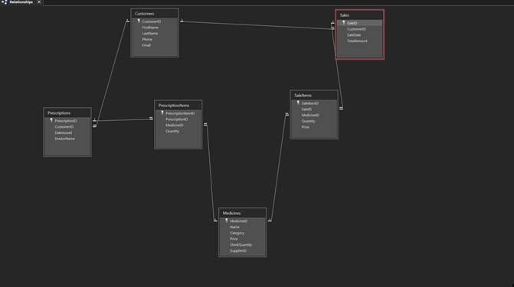
Description: This screenshot displays the final relationship schema. The lines connecting the tables demonstrate the Enforcement of Referential Integrity, ensuring that no orphan records are created in the database.

5. The Normalisation Process to Third Normal Form (3NF)
Normalisation is a systematic process used to organise data to minimise redundancy and eliminate undesirable characteristics such as Insertion, Update, and Deletion Anomalies.

5.1. First Normal Form (1NF)
The database was normalised to 1NF by ensuring that each column contains atomic (indivisible) values. For instance, instead of storing a full name in one field, it was split into FirstName and LastName. Furthermore, duplicate data entries were removed, ensuring each row is unique.

5.2. Second Normal Form (2NF)
To achieve 2NF, the database must first be in 1NF, and all non-key attributes must be fully functionally dependent on the entire primary key. By using surrogate AutoNumber keys for each table, we ensured that each attribute (such as UnitPrice) depends only on MedicineID and not on any other partial key.

5.3. Third Normal Form (3NF)
A table is in 3NF if it is in 2NF and contains no transitive dependencies. A transitive dependency occurs when a non-key attribute depends on another non-key attribute. In the MediLink Pharmacy design, we moved supplier contact details to a separate Suppliers table. If we had kept the supplier's phone number in the Medicines table, it would have depended on the SupplierID (a non-key), not the MedicineID. By separating them, we ensure that changing a supplier's phone number requires only a single update to a single table.

6. Physical Implementation in Microsoft Access
The database's physical construction involved translating the logical ERD into functional MS Access tables.

6.1. Table Construction and Data Validation
During the implementation phase, strict validation rules were applied to maintain high data quality:
· Required Fields: Critical fields like BrandName and CustomerID were set to Required = Yes to prevent null entries.
· Validation Rules: For the Quantity and StockLevel fields, a validation rule of >=0 was applied to prevent logically impossible negative stock.
· Input Masks: Used for phone numbers to ensure consistent formatting across the customer database.
📸 [SCREENSHOT 2: MEDICINES TABLE IN DESIGN VIEW] 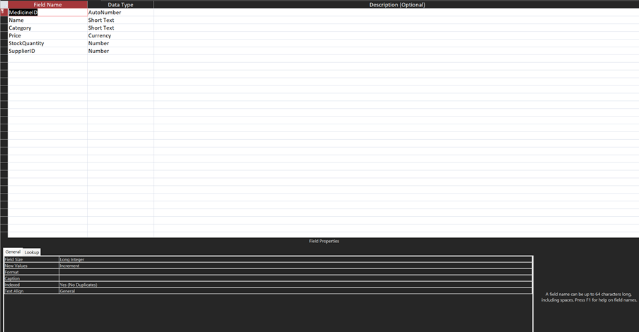
Description: This screenshot shows the field properties in MS Access, highlighting the data types, descriptions, and validation rules used to ensure data integrity.

6.2. Sample Data Population
To verify the system's functionality, the database was populated with realistic sample data, including at least 5 rows per table. This data represents a variety of scenarios, including chronic medication prescriptions and acute medicine sales.
📸 [SCREENSHOT 3: CUSTOMERS TABLE DATA SHEET VIEW] 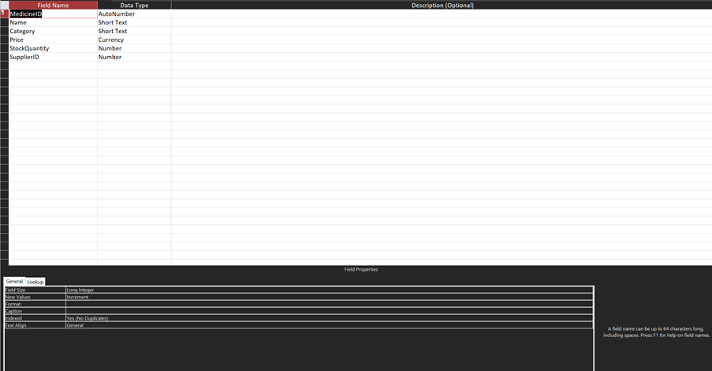
Description: This view displays the populated customer records, demonstrating how the database handles diverse patient information.

7. Advanced Query Development for Management Reporting
Queries are the engine of the database, transforming raw data into actionable management insights.

7.1. Query 1: Low Stock Inventory Alert
This query identifies medicines where the StockLevel has fallen below a safety threshold of 20 units. SQL Logic: SELECT BrandName, StockLevel, CompanyName FROM Suppliers INNER JOIN Medicines ON Suppliers.SupplierID = Medicines.SupplierID WHERE Medicines.StockLevel < 20; Justification: This allows the CEO to proactively order stock before a shortage occurs, improving service delivery.

7.2. Query 2: Monthly Financial Revenue Report
This query calculates total sales revenue by multiplying quantity sold by unit price, grouped by medicine category. Justification: This provides the CEO with a clear view of which drug categories are most profitable, informing business strategy.

7.3. Query 3: Patient Medication History
A parameter query designed to find all prescriptions and purchases for a specific customer by searching their LastName. Justification: This allows pharmacists to review a patient's history to check for potential drug interactions or verify past treatments.
📸 [SCREENSHOT 4: QUERY RESULTS FOR LOW STOCK ALERT] 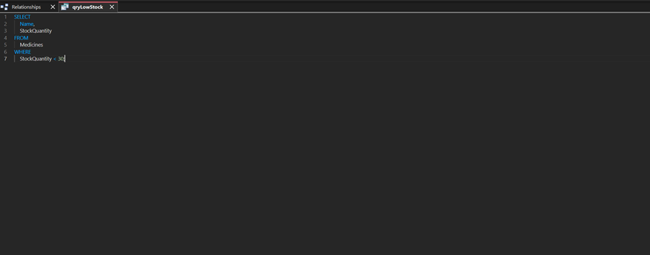
Description: This screenshot shows the output of the low-stock query, demonstrating the system's ability to filter and display critical business data accurately.

8. Validation, Testing, and Reflective Analysis
The final stage of the project involved rigorous testing to ensure the system met MediLink Pharmacy's functional requirements.

8.1. System Testing and Outcomes
· Referential Integrity Test: An attempt was made to delete a supplier who still had active products in the Medicines table. MS Access successfully blocked this action, preventing data corruption.
· Data Validation Test: Entering a text string into the UnitPrice field resulted in an immediate error message, confirming that the data type constraints are working.
· Functional Requirement Check: The system was verified to ensure it can record a sale and associate it with both a customer and a medicine, successfully fulfilling the CEO’s primary objective.

8.2. Reflection and Future Enhancements
The context of database requirements has been simplified for assignment purposes [5] Transforming real-world medical scenarios into a rigid relational structure was a learning curve [1] One significant challenge was ensuring that the Prescriptions table was 3NF-compliant. While the current model is robust, it could be improved by adding a PrescriptionDetails table to handle scripts that contain multiple different medications (a Many-to-Many relationship).
Future versions of the MediLink Pharmacy system should include:
Automation: Implementing Data Macros to subtract quantity from StockLevel when a sale is recorded automatically.
Security: Adding user-level security to ensure only authorised pharmacists can access sensitive patient DOB and medical data.
User Interface: Developing a main navigation menu (Switchboard) that launches immediately to provide an intuitive user experience.

9. Conclusion
The implementation of this relational database system marks a significant milestone for MediLink Pharmacy. By migrating from manual processes to a structured MS Access environment, the pharmacy has gained the ability to track inventory in real-time, maintain accurate patient records, and generate complex financial reports. The adherence to 3NF ensures that the data remains consistent and scalable as the chain continues to grow.

References

[1] | T. Connolly and C. Begg, Database Systems: A Practical Approach to Design, Implementation, and Management, 6 ed., Harlow, UK: Pearson Education, 2015.
[2] | R. Elmasri and S. B. Navathe, Fundamentals of Database Systems, 7 ed., Pearson, 2021.
[3] | Microsoft, “Create a database in Access,” Microsoft, 2024. [Online]. Available: https://support.microsoft.com. [Accessed 23 March 2026].
[4] | C. J. Date, An Introduction to Database Systems, 8 ed., Boston: Addison-Wesley, 2004.
[5] | University of Wales Trinity Saint David, “Level 4 Assessment Specification: Introduction to Web and Database Concepts (ACCA4023),” 2026.

