DS 2 -SCENERIO
DIGITAL ARTEFACT
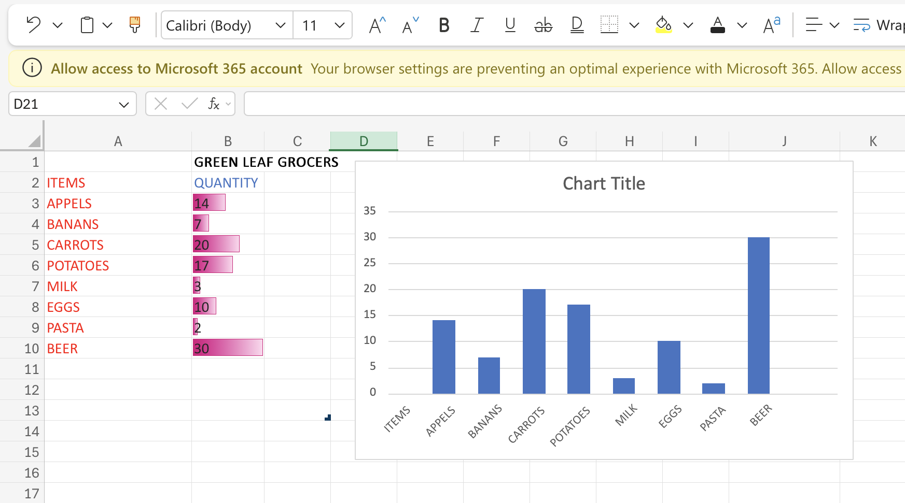

1. Why I choose my tool
Excel is useful for numbers, tables, and charts, which is why I choose it. It enables me to properly display sales statistics for a company. On the UWTSD Digital Skills page, I also read a brief tutorial on utilizing Excel tables. My decision was reinforced by the statement that tables assist make numbers obvious.
2. The data I utilized I used the scenario's weekly sales figures.
I included the price per product, total sales, and units sold.
3. How I made my artifact
I used this methodical approach:
All raw sales data was entered into an Excel table that was structured correctly and included distinct columns for the product name, units sold, price per unit, and total sales.
eliminated human calculation mistakes by automatically calculating the total sales for each product using a straightforward multiplication formula (units sold × price per unit).
In order to graphically compare total sales across all items, a bar chart was created. This method was suggested by the Microsoft Support chart guide, which said that bar charts make performance comparisons simple to comprehend at a glance.
completed a thorough accuracy check of all formulae and numbers to guarantee the dependability of the finished product.
4. The modifications I made throughout the iteration
From my initial writing, I greatly improved the artifact:
The table's initial simple style was difficult to read and understand, therefore strong headers and subtle color coding were added.
changed from a pie chart to a bar chart since comparing more than three goods made the pie chart crowded and unclear.
All axis markers and chart labels had their font sizes increased since they were too tiny to read.
The table now has a distinct "Total Sales" column, making it possible to view important financial data without having to rely solely on chart interpretation.
5. Feedback I used to improve my work
Feedback I used to make my work better.I improved the spreadsheet and bar chart for Green Leaf Grocers by incorporating recommendations from my instructor and a classmate, making the work more readable, consistent, and clear.
Modifications made in response to tutor commentsMy teacher pointed out that the colors I had chosen were haphazard and ill-planned: all of the bars in the chart were a single dark blue, and there was no obvious connection between the two, while the table cells utilized various shades of pink. Additionally, they saw that certain color selections did not adhere to fundamental accessibility guidelines, making it more difficult for certain individuals to discern information. In order to make the document appear tidy, professional, and easy to read for everyone, I substituted the haphazard colors with a single, accessible color scheme that is applied consistently to both the table and the chart.
Modifications made in response to input from classmatesThe chart only had the generic placeholder title "Chart Title," the axis labels were too brief and ambiguous, and there were minor spelling mistakes in the item names (such as "Appels" instead of "Apples" and "Banans" instead of "Bananas"), according to a classmate who reviewed my work. I updated all of these: I gave the chart a comprehensive, descriptive title, such as "Quantity of Stock Items at Green Leaf Grocers," rewrote labels to be more precise (for instance, changing "Quantity" to "Quantity of Items in Stock"), fixed all spelling errors, and ensured that each label made clear what information was being displayed (UWTSD, 2026).
6. Final explanation
The purpose of this spreadsheet and chart artifact is to provide Green Leaf Grocers and café owners with an easy-to-understand summary of their product performance. Most significantly, it makes it easy for them to see exactly where their money is coming from by clearly highlighting which goods are the most profitable and which are not.
Beyond this, the paper also shows how small enterprises can benefit greatly from the use of programs like Microsoft Excel. Instead of depending just on speculation, Excel helps owners make confident, well-informed judgments about which goods to stock more of, promote, or review by organizing data neatly and displaying it clearly.

REFERENCES
University of wales trinity saind David (2025), Welcome to the digicentre, (Accessed on 18 july 2026)

