Plant and Asset Engineering
  - ACMA 6007
Table of Contents
1. Introduction 1
2. The system 2
2.1 Ducting 2
2.2 Bag Filter 2
2.3 Fans & Casings 2
2.4 Transportation systems 2
2.5 Air pulsing system 2
3. Review of current maintenance practices 2
3.1 Ducting 2
3.2 Bag Filters & Hopper Cleans 3
3.3 Fans & Casings 3
3.4 Transportation System 4
3.5 Air Pulsing 4
4. Evaluation of how the current approaches to maintenance could be improved. 4
4.1 Ducting 4
4.2 Bag Filters & Hoppers 4
4.3 Fans & Casings 5
4.4 Transportation system 5
4.5 Air Pulsing System 6
5. Consideration of costs and resources required to implement proposed changes 6
5.1 Cost 6
5.2 Resource 6
5.3 Planning 7
6. Conclusions/Recommendations 7
7. Referencing 7
7.1 References 7

Introduction
This project will be exploring a asset within the business that has an effect during the production of the product, this will focus on the fume extraction system that is used during the basic oxygen steel making process, mainly focusing on the converter charging, blow and tapping processes. I will be looking at the current maintenance practice and procedures and the effectiveness of them. Based on my findings I will looking into methods to improve the practices taking in consideration of efficiency, effectiveness, cost and manning levels / availability. This is all to have a positive effect on the system.

The system
The fume extraction system can be broken down into key aspects that have the biggest effect on the systems efficiency.
2.1 Ducting
This is what transports the dust from the process to the fume extraction plant, the suction comes from the fan, this draws the material through the bag filter house. If holes are found in the ducting it can reduce the amount of pressure that is created during the process and cause less efficiency throughout the process.

2.2 Bag Filter
This is the system that filters the dust particles from the gas, the dust is captured in small bags which holds the dust, this allows clear gas to be drawn through the system. The bag filters can break and burst resulting in less filtration throughout the system, this increase the levels of dirty gas that are emitted through the stack.

2.3 Fans & Casings
The fan is that draws the fume from the process, the speed and condition of the fan will effect the pressure that are created during the process. If cracks are found on the fan or casing it can effect the speed of the fan resulting in less fume extraction and less pressure throughout the system.

2.4 Transportation systems
Once the dust is caught in the bag filters a system will pulse air through the bags dropping the dust into a hopper below, the dust should then automatically fall onto a chain system that transports the dust to a larger finial hopper. If this system is not operational or damaged it can allow dust to be trapped in the bag filter and cause less fume extraction.

2.5 Air pulsing system
The air pulsing system will pulse dry air into the bag filters to drop the dust from the bags, if this system is damaged, not operational or has moisture ingress the bags can become full and not filter incoming fume or can bond with the moisture and cause blockages throughout the system.

Review of current maintenance practices

3.1 Ducting
The Systems ducting is inspected on a 26 week bases, this is where 2 mechanical personel will walk all the lines of the ducting looking for defects such as holes, thin material, hot spots and breakages. Any defects found will then have anew work order placed against the repairs for the work to be carried, this is not based off any historical performance it is based from consultants guidance.
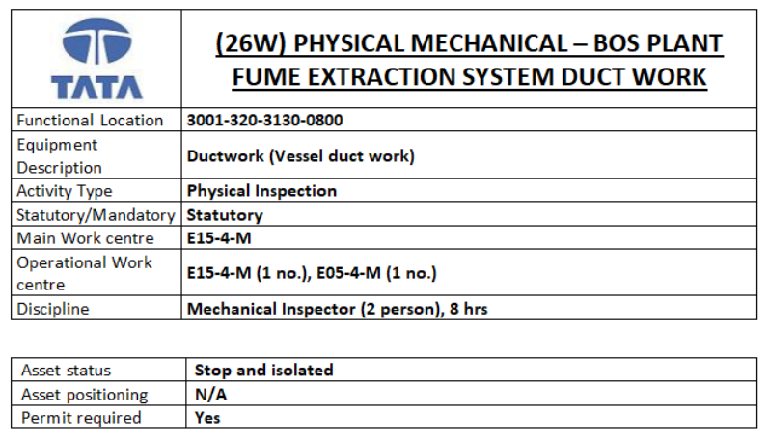

3.2 Bag Filters & Hopper Cleans
Bag filter and hopper cleans are currently cleaned on a 26 week bases, this is not based on any historic performance or history of failure. The cleaning is mandatory meaning if it not completed it can affect the businesses J2R performance. During the cleaning the bags will be changed for new clean bags, the hoppers will be cleaned and any remaining debris or hard material will be taken away from the system. This will be done over 12 hours with 2 mechanical personel. This is tracked and recorded within SAP and reviewed after the work has been complete.
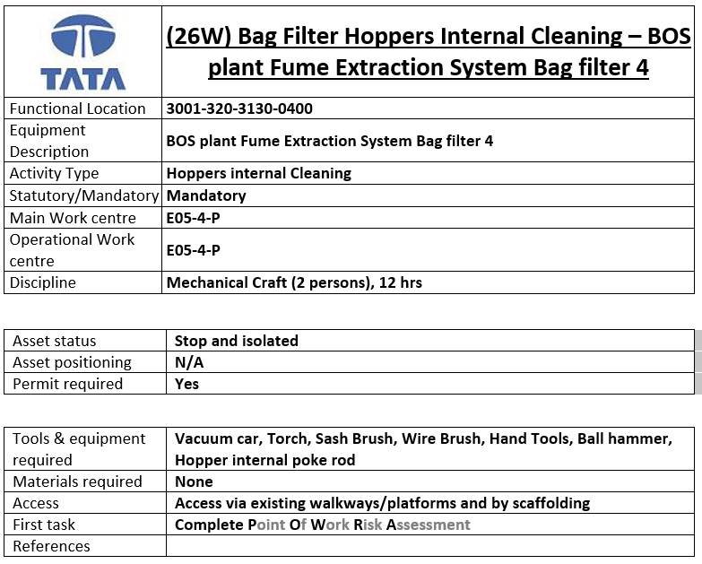

3.3 Fans & Casings
The fan is inspected on a 48 weekly period, this is physical inspection that is also mandatory, during the inspection casing of the fan will be inspected along with the fan blades and NDT testing will be carried out to determine the asset health of the fan. If any defects are found job orders will be raised to remove the faults, if major faults / defects are found the fan will not return to service until the system is safe. There have been many occasions where the system has not came back online as per plan due to faults being found during the inspection.
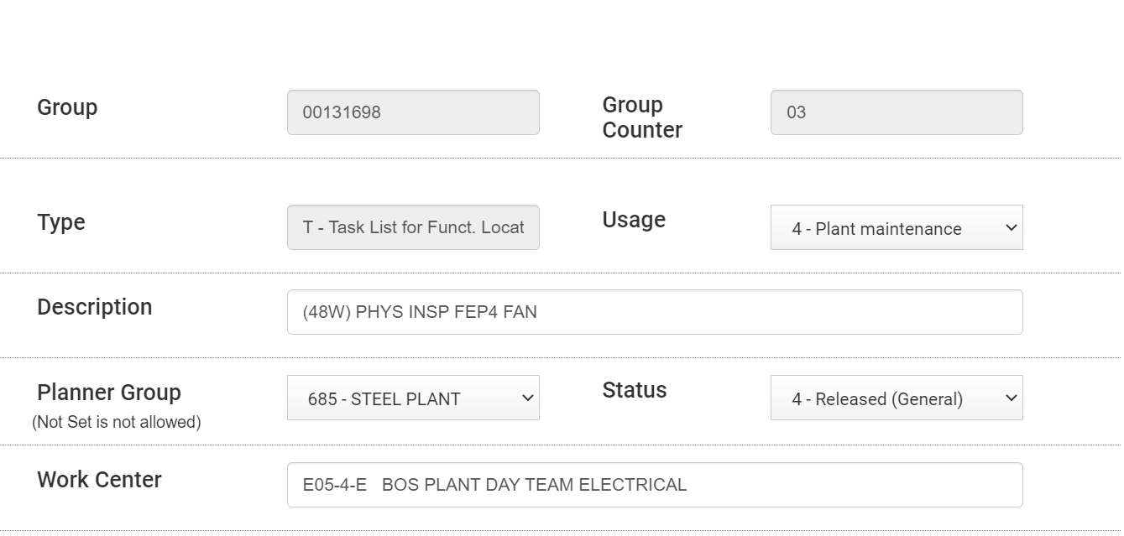

3.4 Transportation System
The transportation system has been unserviceable for the past 3 years with work currently ongoing to renew the system. As it has been online for so long all checks and inspections have not been carried out, it is paramount that when the system returns to service it is to be inspected on a high frequency during the initial period.

3.5 Air Pulsing
The air pulsing system also does not have any maintenance plans within SAP that are tracked, during the year it was found on a random inspection that moisture has found ingress into the air compressor, this could have prevented earlier if we have a maintenance plan in place.

Evaluation of how the current approaches to maintenance could be improved.

4.1 Ducting
As the ducting is currently based on consultancy recommendations and we are still seeing issue occur on each inspection I would look to instal ducting temperature monitors across the system as the high temperatures are what leads to the holes and gap occurring, I would then review the data over a months period to determine where the hot spot are occurring, if there is a common theme I would then look to increase the inspection rates on most effected areas. This will allow us to increase the our focus on the most important areas and reduce our failure rates. This would maintain more pressure throughout the ducting and fume extraction system.
(Monnit, 2023)

4.2 Bag Filters & Hoppers
Bag filters are currently not based off any past data, the 26 weekly clean is from the local mechanical engineers recommendations, although it is a valid recommendation as they spend the most time on the asset there is no data behind the inspection frequency. We have a number of system across the site that can tell us the fume extraction systems performance. Our CEMS (Continuous Emission Monitoring System) is able to give us an idea of bag filters performance. As you can see form the image below there are times where the emissions level increase. All investigations carried out point towards a broken or burst bag within the filtration system. We can use this data to determine the mean time to failure across each bagging system, this will allow us to create a maintenance plan based from the failure rate. By doing this we will be proactively changing the filtration system before failure allowing for constant efficient dust filtration.
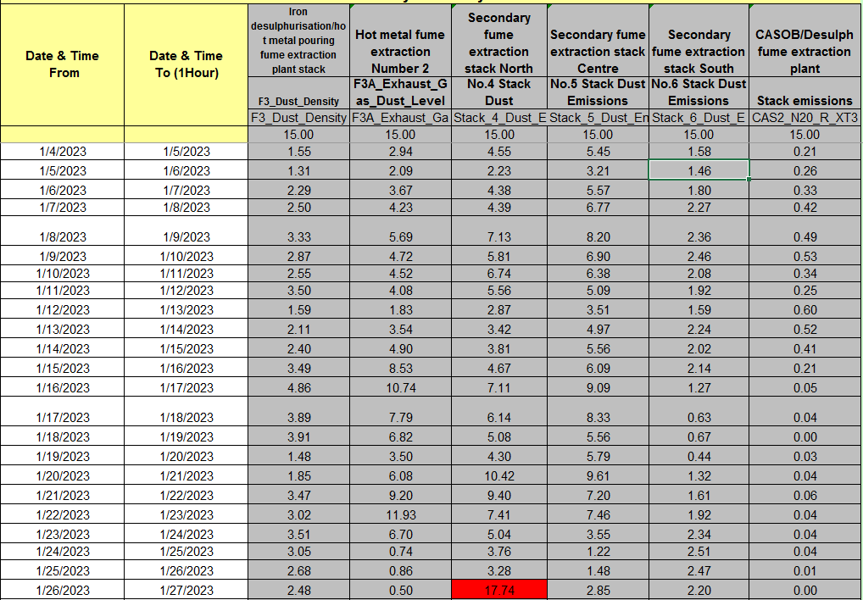
There is also work ongoing to instal a automatic broken bag detector within the filtration plant, this will give us an accurate reading of exactly what bags fail and when, this data would be a lot more accurate and precise but would come at an extra cost to the business.
(Envea, 2023)

4.3 Fans & Casings
Currently the inspection rate is based off OEM recommendations, but one each inspection we are finding faults with fans blades and casings, this can reduce the effectiveness and speed of the fan result in less fume extraction. During many of he inspections we have found that the root cause of the faults are due to the fans vibrations. The system already has vibration monitors attached. Going forward I recommend that we trend the data to analysis where the vibration start to increase. This ill tell us when we should be taking the fan offline and carrying out repairs, but proactively repair the system before failure it should increase the mean time to failure allowing us to have greater fume extraction for a greater amount of time.
(GUTZWILLER, 2001)

4.4 Transportation system
Once the transportation system is operational it is extremely important that this is inspected and maintained correctly. The initial maintenance plan will be based off the OEM’s recommendations which is monthly inspections. But as we know thought the 6 patterns of failure it is common for assets to fail when newly commissioned, this is why I recommend that weekly inspections are carried out, from this we can build data that will show us the mean time of failure. We can then put in place a rigid maintenance plan that is an output from the mean time to failure data.

(Philip Kosky, 2021)

4.5 Air Pulsing System
As there is currently no maintenance regime on the pulsing system I would recommend that a moisture sensor is retrofitted to the air compressor that supplies the air for the pulsing system. This would allow us to trend when moisture has ingress into the system so we can create an alert to carry out repairs. I would also recommend a monthly ultrasonic acoustic measurement to be taken on the system to determine if there are any holes within the compressed air line that are allowing moisture ingress into the system. This would stop the bags from becoming solid and stopping dust being filtered.
(Vaisala, 2023)
(Chicago Pneumatic, 2023)

Consideration of costs and resources required to implement proposed changes

5.1 Cost
To implement all the changes / modifications above it will have a substantial cost to the business, this spend will have to be planed throughout the year in order to be placed in next years annual plan, the cost will have to be spread across the year with delivery and instal dates being clear from the beginning of the purchase. We will also have to take man hours into consideration as local engineers will be assisting with the instal of the equipment, this can often be a hidden cost. We will also have to be able to so demonstrable evidence that the implementation of the changes will have the impact we want on the systems.
By introducing this equipment we may see more maintenance plans and inspections being carried out, this means that extra manning resource will be required which will be a cost from the changes.

5.2 Resource
We currently undertake all current inspections with current manning levels, if we introduce new inspections and increase the frequency of others we will require increased manning resource in order to carry out the inspections effectively.
Some of the new systems will also require internet access which is not accessible across all areas of site, this means additional cabling may have to be run or a 4G system implemented.
The new monitoring system will also have to be linked to the local site servers requiring the need to electrical and PC&A resource.

5.3 Planning
Each one of the new monitors will have to be planned in for instal based on a risk assessment, as we will not be able to implement all changes at once. We would focus on the systems that would give us the biggest impact for the least cost and instal time allowing us to focus on the larger projects throughout the area. To plan the instal / improvements we would follow the works area environmental improvement template to apply resource, time and completion rate to a single project.
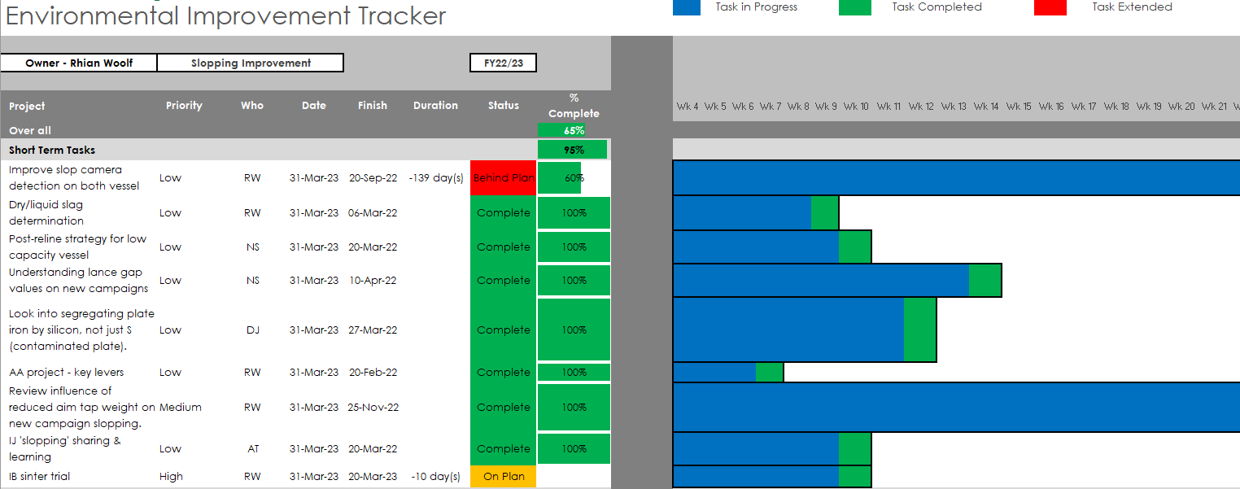

Conclusions/Recommendations
The majority of our fume extraction systems maintenance plans are currently procedure by OEM / consultant recommendations or local mechanical engineers guidance, none of the current maintenance regimes are based of performance data, to improve the systems effectiveness I have listed a number of changed that would of positive effect on the performance. These changed would come at a cost for the business and would have to planned based on effectiveness, cost, resource and man hours. The changes / improvements would be tracked using the works areas template for environmental improvements. Once all the changes of been implemented the change in maintenance schemes would be reviewed and the relative changes would have to be made. The system should then be review a year after the changes to review the impact.

Referencing

7.1 References
Chicago Pneumatic. (2023, March 20). Chicago Pneumatic. Retrieved from How to Find a Leak in Your Air Compressor?: https://compressors.cp.com/en-international/expert-corner/blog/how-to-find-a-leak-in-your-air-compressor#:~:text=The%20most%20reliable%20tool%20in,are%20associated%20with%20air%20leaks.
Envea. (2023, March 20). Process Optimization . Retrieved from BROKEN BAG DETECTION: https://www.envea.global/solutions/process-optimization/broken-bag-detection/
GUTZWILLER, L. (2001, May 1). Plant Engineering . Retrieved from Understanding fan vibration and imbalance: https://www.plantengineering.com/articles/understanding-fan-vibration-and-imbalance/
Monnit. (2023, March 15). Monnit. Retrieved from Duct Temperature Sensors: https://www.monnit.com/products/sensors/temperature/duct-temperature/
Philip Kosky, R. B. (2021). Exploring Engineering. In R. B. Philip Kosky, Exploring Engineering (pp. 229 - 257). Robert Balmer.
Vaisala. (2023). The Fundamentals of Dew Point Measurement in Compressed Air Systems. Vantaa: Vaisala.

