

MODULE CODE: ECPT6006

ASSESSMENT COMPONENT: A Critical Evaluation of the Role of Digital Innovation in Professional Practice

STUDENT NAME: Elsayed Elhoshi

STUDENT NUMBER: 2420482

Academic Year: 24/25

Use of Generative AI in Assessment

(Lecturer to indicate Yes or No against each element)

RESEARCH | For this assessment, you can use Generative AI to support you in research, including searching for bibliography, using tools to summarise, compare and interrogate materials. | Yes ☒  No ☐
STRUCTURE | For this assessment, you can use Generative AI to support you in structuring your submission, including creating a draft argument structure, identifying parts and headings, etc. | Yes ☒  No ☐
PROOFREADING | For this assessment, you can use Generative AI to check your own text/creation for grammatical and syntactical mistakes, including rephrasing of your own work within specific standards. | Yes ☒  No ☐
WRITING | For this assessment, you can use Generative AI to create text for submission. | Yes ☐  No ☒
CREATIVE | For this assessment, you can use Generative AI to create creative materials, such as images. | Yes ☒  No ☐
PROGRAMING | For this assessment, you can use Generative AI to create and check code. | Yes ☐  No ☒
NONE | For this assessment, you are not allowed to use any type of Generative AI support. This includes research support, structure support, writing/proofreading support and creative support. | Yes ☐  No ☒

AI Acknowledgement
I confirm that I have not used any AI tools in the research and creation of this assignment.
I confirm that I have not presented any AI generated materials as my own work.
I confirm that I have copies of my drafts, notes, and other resources I used, which I may be asked to provide in evidence.
OR:
I acknowledge the use of [AI Tool] [(AI Tool url)] on [Date] to [Purpose my work]. I used the prompt(s):
1. [Prompt]
2. [Prompt]
3. [Prompt]
I confirm that I have not presented any AI generated text as my own work.
I confirm that I have copies of my drafts, notes, and other resources I used before and after the use of AI tools which I may be asked to provide in evidence.
Please refer to the next page for examples.
Prior to submission of your assignment, please delete any information on these pages that is not relevant to your submission, including the examples given below.
Examples of AI statements
Example 1:
I acknowledge the use of Grammarly (https://www.grammarly.com/) on 10 February 2024 to check my work using the prompt(s):
1. Please check the following text for readability, grammar and syntax.
I confirm that I have not presented any AI generated text as my own work. I confirm that I have copies of my drafts, notes, and other resources I used before, and after the use of AI tools which I may be asked to provide in evidence.
Example 2:
I acknowledge the use of SciSpace (https://typeset.io/) on 7 March 2024 to support my research using the prompt(s):
1. Please provide me with materials on the biology of the liver.
2. Please provide me with materials on liver cells.
I confirm that I have not presented any AI generated text as my own work. I confirm that I have copies of my drafts, notes, and other resources I used before, and after the use of AI tools which I may be asked to provide in evidence.
Example 3:
I acknowledge the use of ChatGPT (https://chatgpt.com/) on 13 April 2024 to write my notes into submission format using the prompt(s):
1. Please write up these bullet points as an essay paragraph at university level.
I confirm that I have not presented any AI generated text as my own work. I confirm that I have copies of my drafts, notes, and other resources I used before, and after the use of AI tools which I may be asked to provide in evidence.
Example 4 - acknowledgement of the use of multiple AI tools:
I acknowledge the use of SciSpace (https://typeset.io/) on 28 June 2024 to support my research using the prompt(s):
1. Please provide me with materials on the American Civil War.
2. Please provide me with materials on the reception of Gone with the Wind.
I confirm that I have not presented any AI generated text as my own work. I confirm that I have copies of my drafts, notes, and other resources I used before, and after the use of AI tools which I may be asked to provide in evidence.
I acknowledge the use of Adobe Express (https://www.adobe.com/express/) on 24 June 2024 to edit photographic material:
1. Remove background from Figure 1.
I confirm that I have not presented any AI generated materials as my own work. I confirm that I have copies of my drafts, notes, and other resources I used before and after the use of AI tools which I may be asked to provide in evidence.

A critical evaluation of the role of digital innovation in professional practice
1. Introduction
The use of technology and the ability to effectively engage with it has become an urgent and essential need across all fields of life, such as healthcare, entertainment, business, and educational environments, where learning management systems and virtual classrooms enhance teaching and learning experiences. Therefore, in my view, while the integration of technology has become vital in all aspects of life, it is even more critical in the field of education and learning, as education serves as the foundation of every renaissance, a fundamental pillar for building and advancing societies, and a means of preserving their identity and essence. As a result, creativity and digital innovation in education have become fundamental tools for enhancing learning quality by using modern technologies to provide interactive educational experiences, engage students, and facilitate access to knowledge in quick and innovative methods.
This critical evaluation examines the role of creativity and digital innovation in teaching and learning, exploring how emerging technologies and pedagogical strategies can complement each other to enhance educational outcomes. The first section will take the form of a literature review, synthesizing key perspectives on topics such as the intersection of technology and pedagogy, ethical considerations in digital innovation, and the potential of emerging technologies to shape the future of education. The second section focuses on the selection and justification of appropriate teaching tools or resources, grounded in the theoretical insights from the literature review. The third section investigates the practical application of these tools, providing a detailed lesson plan and evidence of implementation. Finally, the assignment concludes with an evaluation and reflection on the chosen tool’s impact, considering its effectiveness, challenges, and implications for future practice.
2. The Role of Creativity and Digital Innovation
The integration of creativity and digital innovation into education has become a significant pillar of modern pedagogical practices. As technology is increasing rapidly and continuously, its ability to change and enhance teaching and learning environments also increases significantly. This literature review explores the integration of technology and pedagogy, the ethical implications of digital innovation, and the future possibilities of emerging technologies in education. Additionally, this review aims to give a clear and full understanding of how creativity and digital tools can improve learning results while also looking at the challenges and opportunities they create.
2.1. The Integration of Technology and Pedagogy
The relationship between technology and educational sciences has become closely connected in what is known as the age of technology. From my perspective, to be a qualified and competitive teacher in today’s job market, the teacher must be proficient in integrating technology into teaching strategies. We need a balanced integration between technology and pedagogy, as has been widely discussed among many scholars in academic literature. According to Mishra and Koehler (2006), the Technological Pedagogical Content Knowledge (TPCK) framework highlights the importance of aligning technology with pedagogical strategies and subject matter expertise. This approach asserts that effective and interactive teaching requires teachers to integrate technology creatively in ways that improve the teaching and learning process.
Undoubtedly, the modern information and technological revolution has given a new shape to the educational system worldwide due to the speed of accessing and sharing information, as well as the provision of innovative educational tools that facilitate the learning and teaching process. This enhances the efficiency and quality of education and provides opportunities for self-directed and interactive learning for students. According to Roopa and Rajesh Kanna (2024), the integration of Information and Communication Technology (ICT) in education has transformed learning by enhancing student engagement and academic achievement. ICT tools, such as interactive whiteboards, online platforms, and virtual classrooms, enable active learning, personalized instruction, and collaboration. These kinds of digital environments provide flexible access to resources, foster critical thinking through multimedia content, and redefine modern educational systems.
Digital tools such as Learning Management Systems (LMS), virtual classrooms, and interactive software have revolutionized traditional teaching methods. For instance, flipped classrooms, where students engage with digital content at home and participate in collaborative activities in class, have been shown to improve student engagement and understanding (Bergmann and Sams, 2012).
It is also worth mentioning that learning through games in schools or any educational field is an effective motivator that enhances student engagement and increases their motivation to learn. It also helps simplify complex concepts enjoyably and engagingly, which aids in better understanding and comprehension. The use of game design elements in non-game contexts, or gamification, has been found to motivate learners and foster creativity (Deterding et al., 2011). This example also illustrates how technology applications and games can complement pedagogy by providing innovative ways to deliver content and engage students.
On the other hand, some researchers indicate that the use of games can sometimes lead to superficial learning and does not lead to proper learning, where students focus more on winning or completing tasks rather than critically engaging with the content due to distraction. Gee (2003) mentions that while games promote problem-solving, they can also encourage trial-and-error learning without deep reflection. Hofstede (1986) highlights that the effectiveness of gamification varies across different cultural and educational contexts. What works well in one setting might not be as effective in another.
Despite the great advantages of integrating technology, creativity, and digital innovation into educational systems, this may also have risks and negative impacts on other aspects, such as reducing social interaction among students, increasing dependence on electronic devices, and the possibility of exposure to inappropriate content. Selwyn (2016) argues that the over-reliance on digital tools can lead to a "technocentric" approach, where the focus shifts from learning outcomes to the technology itself. This stresses the need for educators to critically evaluate the role of technology and its challenges in their teaching practices and ensure that it aligns with their pedagogical goals. Therefore, it is essential to strike a balance between the use of technology and traditional methods to ensure a comprehensive and safe educational experience.
2.2. The Role of Ethics in Digital Innovation
Since digital creativity has become more common in modern educational systems, it is essential for value and ethical considerations to be strongly present to ensure the responsible and beneficial use of these tools. Values such as integrity, respect, and privacy must be taken into consideration in the design and implementation of digital technologies. We must emphasize data privacy because it is not merely a technical issue but primarily an ethical and human matter, particularly in an era known as the technological and digital revolution worldwide, where the use of online platforms and tools has increased dramatically. According to Williamson (2017), the commercialization of educational technology raises questions about who owns and controls student data. While these technological tools can make a big difference in enhancing the educational outcomes of students, they also can cause risks to student privacy and independence.
Additionally, ethical awareness should be promoted among students and educators to avoid potential violations, such as the unethical use of data, including invasion of privacy and sexual and verbal abuses. Furthermore, principles of inclusivity, fairness, and equality should be integrated to ensure that all students have equitable access to educational opportunities without any discrimination. Some scientific journals have concluded that there is an ethical concern that is called the digital divide, which refers to the gap between those who have access to digital technologies and those who do not. Warschauer (2003) highlights how socioeconomic disparities can limit students' access to digital tools, exacerbating existing inequalities in education environments. This raises an important question about the equity of digital innovation and the responsibility of educators and education administrators to ensure that all students have access to the resources they need in their learning. Creators and sellers of technological and digital tools should not be allowed by government education authorities to control the futures and outcomes of students for commercial or profit-driven purposes.
2.3. Emerging Technologies and Their Potential in Education
Integrating modern technological tools into educational systems, such as artificial intelligence, virtual reality, machine learning, remote learning, and interactive educational applications, has become an inevitable reality. It can be argued that such digital tools are recommended to reform the future of the educational system completely. According to Luckin and Holmes (2016), emerging technologies such as artificial intelligence (AI), virtual reality (VR), and blockchain are poised to transform the future of education. For instance, Luckin. (2016) highlights how AI can revolutionize personalized learning by analyzing student data and tailoring instruction to individual needs.
Similarly, virtual reality (VR) can create stimulating learning experiences that allow students to explore complex concepts practically (Dalgarno and Lee, 2010). Undoubtedly, these technological tools provide new and diverse environments and possibilities that stimulate learning. In addition, these modern digital tools are completely different from the familiar and traditional educational settings.
In contrast, some educators and researchers warn against relying too much on technological tools in education. They believe it should be supported only and not take the place of traditional teaching methods. Scholars argue that human interaction, critical thinking, and creativity cannot be fully replicated by digital tools (Biesta, 2015). Despite their capacity, the adoption of emerging technologies in education does not come without challenges. Cost, infrastructure, and training are significant barriers that must be addressed to ensure equitable access and effective implementation (Selwyn, 2016). It is also important that educators carefully evaluate these technological tools to truly improve learning and students’ progress and make sure they support clear educational goals.
2.4. Creativity in the Digital Age
Creativity in the digital age has become an essential component for achieving excellence in effective teaching and learning. In addition, digital innovation provides new and unlimited opportunities for expression, communication, learning, and thinking in effective and creative ways. According to CSI-Sastre et al. (2022), cultivating creativity in education has been widely acknowledged, and digital technologies and tools can play a key role in achieving communication, collaboration, and dialogical interaction of creative expression in education.
For example, Ohler. (2013) asserts that digital storytelling tools allow students to express their ideas in innovative ways, while collaborative platforms enable them to work together on creative projects.
However, the relationship between creativity and technology is highly complex. Some scholars argue that the overuse of digital tools can stifle creativity by limiting opportunities for hands-on, experiential learning (Carr, 2020). Meanwhile, Cachia et al. (2010) note that creative learning and innovative teaching are significantly supported by technology, which provides access to a wide range of resources and tools that enhance creative expression. These contradictory perspectives assert the need for educators to strike a significant balance between digital and traditional approaches to foster creativity in the classroom. Ultimately, the impact of technology on creativity depends on how it is used, the context in which it is applied, and the balance achieved or the harmony of digital innovation.
2.5. Critical Perspectives on Digital Innovation
While digital innovation offers many benefits, it is important to critically examine its limitations and potential disadvantages, such as loss of privacy, digital addiction, social and economic disparities, lack of human interaction, spread of misinformation, etc. One of the most important concerns is the marketization of education, where the focus shifts from learning to profit-making. As noted by Selwyn (2016), the increasing involvement of private digital tools companies in the development of educational technology raises critical questions about the commercialization of education and its impact on the teaching and learning process.
Warschauer (2003) argues that the emphasis on digital skills in the curriculum can marginalize students who lack access to technology or the necessary training. A related viewpoint is the concern that digital technologies may exacerbate existing inequalities within educational systems. For instance, algorithms used in educational software can unintentionally amplify biases present in the data they are trained on, leading to unequal learning experiences if not properly managed (Noble, 2018). Another critical perspective is the potential for digital tools to reinforce existing power dynamics in education. For example, the use of AI-driven tools can perpetuate biases if they are not carefully designed and monitored (O’Neil, 2017). All these issues show the need for a more careful look at digital innovation, which considers its social and ethical impacts instead of just focusing on its advantages.
As a final point, creativity and digital technology are essential components of modern education that require careful consideration, wisdom, caution, and thorough research when integrated into the educational system. It is crucial to leverage and harness the benefits of these innovations while maintaining the values and ethical integrity and development of students.
3. Selection and Justification of Appropriate Teaching Tool Resources (Kahoot)
When educating adults, it is significant to consider their needs and prior experiences, using interactive teaching methods that respect their independence and encourage active participation. Learning should be relevant to learners' professional and personal lives, focusing on practical applications and participatory discussions rather than traditional memorization methods (Gitterman, 2004). The need for a learning environment that respects adult learners' autonomy, experiences, and self-direction is a cornerstone of adult education theory. According to Knowles et al. (2020), creating a supportive and respectful environment is essential for fostering engagement and motivation among adult learners. This approach aligns with the principles of Adult education, which emphasize the importance of valuing learners' prior experiences and promoting self-directed learning. Additionally, providing a supportive and motivating learning environment enhances the students' experience and increases their motivation to learn.
In the modern educational landscape, digital tools have become essential for fostering engagement, creativity, and effective learning. Among these tools, Kahoot is the most common digital tool used as a versatile and interactive learning and engagement platform in classrooms, which aligns with pedagogical theories, promotes digital innovation, and enhances professional teaching practices. Pratama and Suastha (2024) explored the use of Kahoot, a game-based learning platform, to enhance student engagement in English language education at Warmadewa University. Their findings revealed that Kahoot significantly boosted students' motivation, participation, and learning quality by offering instant feedback and creating a competitive yet enjoyable learning environment.
This section explores the selection and justification of Kahoot as a teaching tool, supported by theoretical frameworks, and demonstrates its application in creating an engaging and innovative learning environment.

3.1. Theoretical Frameworks Supporting Kahoot
3.1.1. Constructivism and Active Learning Theory
Constructivism, as proposed by theorists such as Piaget (1954) and Vygotsky (1978), emphasizes that students construct their knowledge through active engagement and social interaction. Kahoot tool aligns with this theory by providing an interactive and immersive learning experience and platforms where students actively participate in quizzes, games, and discussions. The tool (Kahoot) can be used to create quizzes that encourage students to build knowledge collaboratively and solve problems as they engage in real-time competitions and discussions. Additionally, Kahoot quizzes can test students' understanding of key concepts while encouraging them to explain their answers to peers.
3.1.2. Connectivism and Collaborative Digital Learning Theory
Siemens (2005) introduced connectivism as a theory for the digital age, emphasizing the importance of social interaction, networks, collaboration, and technology in the learning process. Kahoot supports this theory by enabling students or group activities and discussions to connect with peers and instructors in real time, fostering a collaborative learning environment where students can learn from each other’s perspectives, experiences, and insights. The tool also integrates seamlessly with digital devices, aligning with the principles of connectivism. This way of teaching not only reinforces learning but also builds teamwork and communication skills.

3.1.3. Gamification and Motivation Theory
Gamification, a concept supported by Self-Determination Theory (SDT) by Deci and Ryan (2013), leverages game-like elements to enhance motivation and engagement. Kahoot incorporates gamification through features like points, leaderboards, and timed challenges, which tap into students' intrinsic motivation by making learning fun and competitive. By using Kahoot quizzes for formative assessments, educators can create a motivating environment where students are eager to participate and improve their scores. For instance, a history teacher can use Kahoot to review key events before an exam, turning a potentially stressful revision session into an engaging game.
3.1.4. Cultural and Contextual Considerations Theory
Hofstede's (1986) cultural dimensions theory highlights the influence of cultural factors on learning preferences and behaviours. A tool like Kahoot can be adapted to suit diverse cultural contexts by customizing content, language, and reward systems. For example, in collectivist cultures, team-based quizzes can be emphasized to align with the cultural values of collaboration and group achievement.

3.1.5. Formative Assessment and Feedback Theory
It is argued that feedback is an essential component of the teaching and learning process. It is equally important for both teachers and students, playing a crucial role in effective teaching strategies. Hattie and Temperley (2007) assert that feedback is one of the most powerful influences on learning and achievement. Furthermore, Kahoot provides instant feedback to students after each question, helping students to identify areas of improvement, correct mistakes, and adjust their understanding in real time. Kahoot also can be used to assess students' understanding of a new concept. According to Black and Wiliam in their theory (1998), formative assessment highlights the importance of timely feedback in improving learning outcomes. In addition, Hattie and Timperly (2007) stress that immediate feedback helps students recognize mistakes and clarify misconceptions before moving on to more advanced topics.

3.1.6. Behaviourism and Reinforcement Theory
Behaviourist theories, particularly Skinner's (1954) concept of operant conditioning, highlight the role of reinforcement in shaping behaviour. Kahoot uses immediate feedback and competitive elements to motivate learners and reinforce positive learning behaviours, making it an effective tool for maintaining student motivation and engagement.
3.2. Justification of Kahoot as a Teaching Tool
There are several reasons to justify Kahoot as a teaching tool, and among them are:
3.2.1. Enhancing Student Engagement
One of the primary challenges in higher education or Adult learning is maintaining student engagement, particularly in large classes. Kahoot smoothly addresses this challenge by transforming traditional lectures into interactive sessions. The competitive nature of Kahoot quizzes, combined with real-time feedback, creates a dynamic and engaging learning environment. According to Wang and Tahir (2020), gamified quizzes have a notable positive impact on enhancing student participation and motivation.
3.2.2. Promoting Active Learning
The Kahoot tool encourages active learning by requiring students to respond to questions, analyze their answers, and reflect on their performance. This harmonizes with the principles of constructivism and active learning, as students are not passive recipients of information but active participants in the learning process. Wang and Tahir (2020) highlight that Kahoot fosters active learning by engaging students in responding to questions, analyzing their answers, and reflecting on their performance. Additionally, Kahoot supports formative assessment, allowing instructors to identify areas where students may need additional support. Kahoot serves as an effective and valuable formative assessment tool, enabling educators to identify specific areas where students may require additional support (Wang & Tahir, 2020).
3.2.3. Addressing Diverse Learning Needs
Kahoot tool is very flexible and works well for different learning styles and needs. For example, it helps visual learners by including pictures and videos in quizzes and supports auditory learners with questions that use sound. It allows teachers to add content that reflects different cultures and adjust difficulty levels to suit learners of all abilities. Wang and Tahir (2020) highlight that Kahoot is highly adaptable, catering to various learning styles and preferences. Visual learners benefit from the integration of images and videos, while auditory learners can engage with audio-based questions. Furthermore, Kahoot supports inclusivity by allowing educators to incorporate culturally relevant content and adjust difficulty levels to accommodate learners with different proficiency levels.
3.2.4. Facilitating Collaborative Learning
Kahoot encourages teamwork by allowing students to participate in group quizzes. They can work together to answer questions, solve problems, and reach shared goals, making learning a collaborative experience. In addition, working together on quizzes helps students feel like they belong to a group. This is helpful in online or mixed-learning settings. This matches Vygotsky's (1978) idea of the zone of proximal development, where students learn by working with others and growing their understanding together.
The selection of Kahoot as a teaching tool is justified by its alignment with theoretical frameworks, pedagogical principles, and professional practice. By promoting active learning, enhancing student engagement, and addressing diverse learning needs, Kahoot represents a valuable resource for educators in the digital age. Its integration into teaching practice demonstrates a synthesis of innovation, theory, and professional practice, highlighting the potential of gamification to transform education and create meaningful learning experiences.
4. Application of the chosen learning tool (Kahoot)
4.1. Application of Kahoot in Teaching Conditional Clauses
This lesson plan incorporated Kahoot as an interactive learning tool to facilitate the understanding and practice of conditional clauses among intermediate to advanced English learners. The 60-minute session was designed to make grammar learning more engaging through gamification, active participation, and instant feedback.
Kahoot was implemented at various stages of the lesson, including a warm-up quiz to assess prior knowledge, interactive practice exercises, and a final review to reinforce key concepts. By using Kahoot’s quiz-based format, students were encouraged to think critically about different types of conditional clauses and apply them in real-time scenarios. The immediate feedback feature helped identify common misconceptions and provided opportunities for clarification.
As evidence of this implementation, annotated screenshots were taken to document students’ engagement, their responses to Kahoot activities, and the overall impact of the tool on learning outcomes. This integration of technology not only enhanced student motivation but also made grammar practice more dynamic and effective.


Lesson Plan (Conditional Clauses with Kahoot Integration)
Topic: Understanding and Practicing Conditional Clauses |  | Class: Intermediate to Advanced English Learners
Date: 24/02/2025 | Length of lesson: 60 minutes |  | Student Number: 2420482
Resources required:
- Technology & Digital Tools:
- Kahoot Platform (PC, Laptop, Tablet, or Smartphone with Internet Access)
- Projector or Smartboard (for displaying Kahoot and lesson materials)
- Printed & Written Materials:
- Handouts with examples of Zero, First, Second, and Third Conditional Clauses
- Worksheet for sentence creation and matching exercises
- Homework Assignment Sheet (short paragraph using all four conditionals)
- Classroom Supplies:
- Whiteboard & Markers for explanations and examples
- Pens/Pencils & Notebooks for student note-taking
- Assessment Tools:
- Kahoot Quiz (pre-designed with multiple-choice, fill-in-the-blank, and sentence matching)
- Teacher’s Observation Checklist for student participation in discussions and activities
Aim of Lesson
To enhance students’ understanding and application of all types of conditional clauses through interactive learning methods, including the use of the Kahoot tool, to reinforce comprehension and engagement.
Learning Objectives – The Learners Should Be Able To:
1. Identify and differentiate between zero, first, second, and third conditional clauses.
2. Construct grammatically correct conditional sentences.
3. Apply conditional clauses appropriately in spoken and written communication.
4. Engage with Kahoot to test and reinforce their knowledge of conditional clauses interactively
Previous student knowledge required for the session:
1. Basic understanding of sentence structures (subject, verb, object).
2. Familiarity with all verb tenses (present, past, and future).
3. Experience with if-clauses in simple sentences, at least.
Anticipated difficulties and solutions
1. Distinguishing between different types of conditional clauses.
2. Using correct verb tenses in conditional sentences.
3. Understanding hypothetical versus real situations.
4. Some students may struggle with the competitive nature of Kahoot.
Solutions
1. Providing clear explanations and examples.
2. Using visual aids and sentence structure charts.
3. Offering peer support and teacher guidance.
4. Encouraging collaborative learning before the Kahoot activity.
Professional Standards (where are these being met within the session)
1. Effective Teaching Strategies: Engaging students with interactive tools like Kahoot.
2. Assessment & Feedback: Using formative assessment through Kahoot to gauge understanding.
3. Inclusive Learning: Catering to different learning styles with discussion, practice, and technology.

Lesson Details:
Stage | Focus | Strategy | Time
Introduction  Development  Practice  Interactive Kahoot Quiz  Application  Conclusion | Warm-up activity with prior knowledge  Explaining Conditional Clauses  Sentence Construction Activity  Reinforce Learning through Gamification  Group Discussions & Role-Play  Review & Reflection | Ask students questions like: “What happens if you mix red and blue paint?” “What would you do if you won the lottery?” and "What would you expect me to do if I were you?" to introduce conditionals in context.  Use a whiteboard and slides to explain zero, first, second, and third conditional clauses with real-life examples.  Examples of Conditional Clauses:  1. Zero Conditional (General truths & scientific facts) Ex. If you heat water to 100°C, it boils.  2. First Conditional (Possible future events) Ex. If it rains tomorrow, we will stay inside.  3. Second Conditional (Hypothetical or unlikely situations) Ex. If I won the lottery, I would travel the world.  3. Third Conditional (Past hypotheticals & regrets) Ex. If she had studied harder, she would have passed the exam.  Students work in pairs to create conditional sentences for each type.  Students participate in a Kahoot quiz with multiple-choice, fill-in-the-blank, and matching questions on conditionals.  Students apply conditionals in conversations and role-plays based on real-world scenarios (e.g., planning an event or giving advice).  Summarize key points and ask students to share one new concept they learned during the lesson. | 10 mins  10 mins  10 mins  15 mins  10 mins  5 mins

Assessment Strategies: When and how are they included within the lesson?
1. Formative Assessment:
- Observing student participation in pair and group activities during the practice phase.
- Monitoring correct use of conditionals during sentence construction activity.
2. Summative Assessment:
- Kahoot quiz scores to assess individual understanding.
- Homework assignment: Write a short paragraph using all four types of conditionals.

Informal reflection (to be completed after the session)
I'm really glad my peers enjoyed the Kahoot quiz and found it both engaging and beneficial for reinforcing learning. It's great to hear that they appreciated the well-structured and challenging questions, as I wanted to create something that was both fun and educational. The fact that they mentioned it helps with English language learning, grammar, and knowledge retention is reassuring because that was one of my key aims.
However, the feedback about the time limit being too short is something I need to consider. I can see how 20 seconds might not be enough, especially when the multiple-choice options are quite similar at first glance. I didn’t want to make it too easy, but I also didn’t want it to feel rushed or stressful. Next time, I’ll experiment with slightly longer time limits to allow for better comprehension and decision-making.
I also love that the quiz created a fun and relaxed atmosphere, and hearing that my peers were able to laugh at themselves for getting things wrong shows that Kahoot can make learning feel less pressured and more enjoyable. The social aspect, including motivation and collaboration, is something I want to keep fostering in future sessions.
Overall, this feedback is extremely helpful. I’ll make some tweaks to improve the experience while keeping the energy and engagement levels high.
4.2. Evidence of Kahoot implementation
This Kahoot practical activity was conducted in a classroom on the university campus at the University of Wales in Swansea, Wales, on February 24, 2025. Here are some images that prove the implementation of the digital tool Kahoot during the lesson.

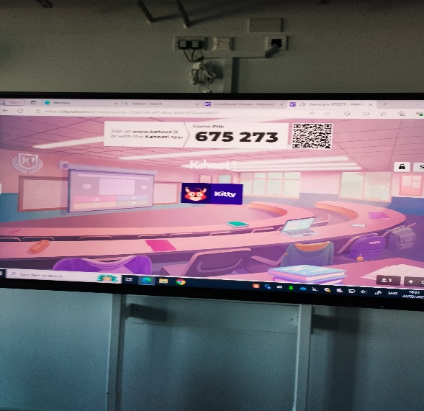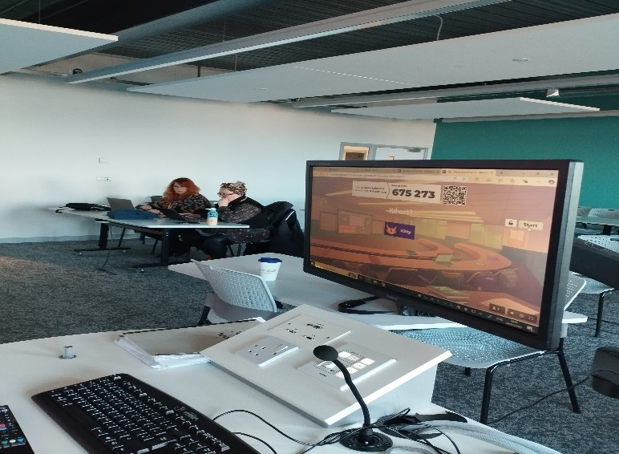
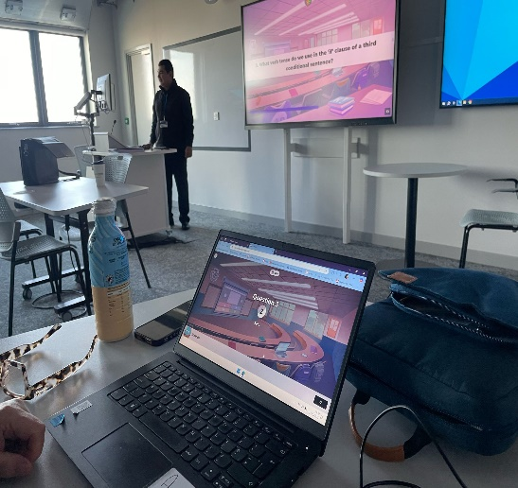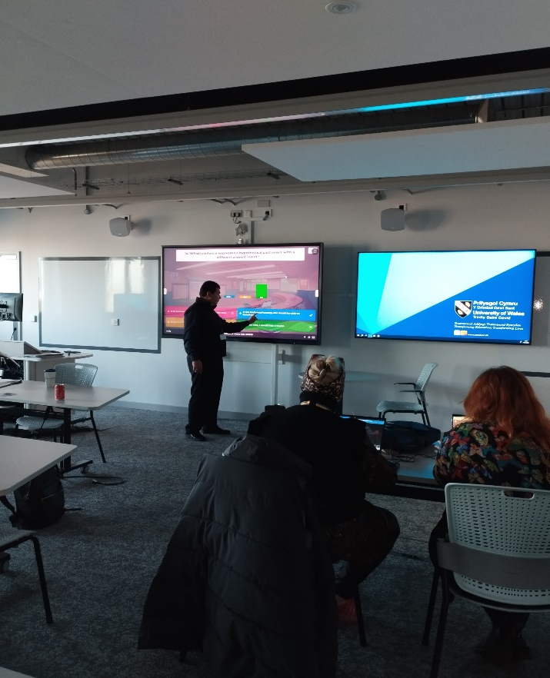
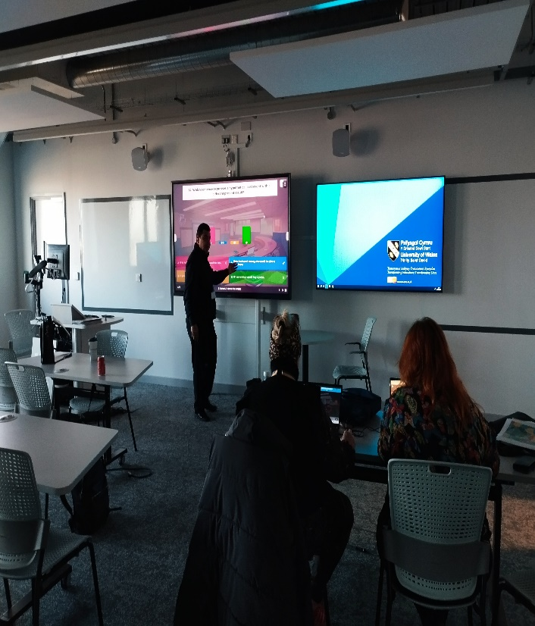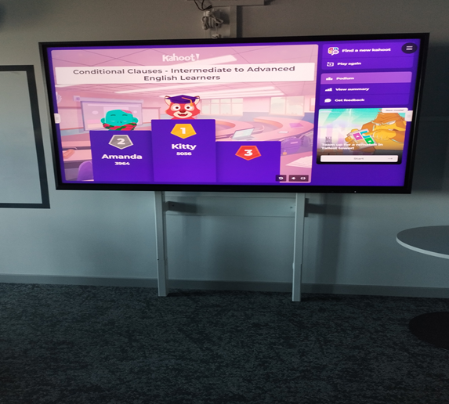
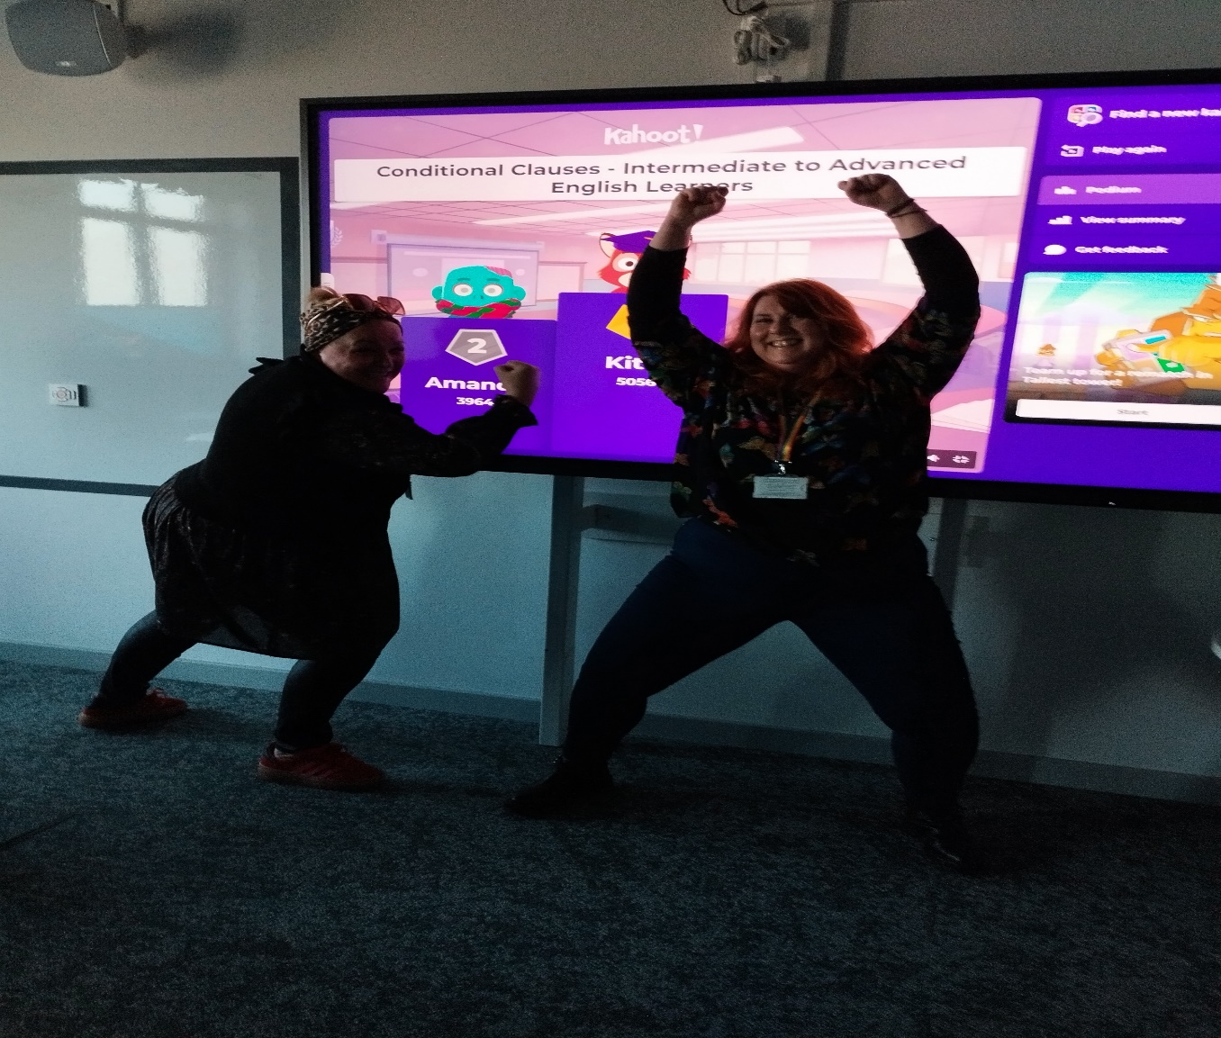
5. Evaluation and Reflection on the Use of Kahoot as a Learning Tool
Integrating Kahoot into my teaching practice has been a new and insightful experience for me, as I previously used to teach using traditional methods (blackboard or whiteboard) before arriving in the UK. Before using Kahoot, I was excited but also slightly apprehensive about incorporating digital tools into my teaching. I was eager to explore how gamification could enhance student engagement but unsure how well it would align with deeper learning objectives. It has offered both significant benefits and areas for improvement. This evaluation critically examines the tool’s implementation, its alignment with intended outcomes, and its impact on both teaching and learning. Additionally, it reflects on how the insights gained have informed my future practice in terms of digital technology and professional development.
5.1. Implementation and Intended Outcomes
To assess the effectiveness of Kahoot, I designed a quiz with 15 questions aligned with specific learning outcomes and administered it during various questions on understanding and practicing conditional clauses. I collected feedback from peers through informal discussions during and after the Kahoot session to measure its impact on their learning experience.
It is worth mentioning that I could not properly compare my peers' assessment performance after incorporating Kahoot! to evaluate its role in knowledge retention, as I had not taught them before the Kahoot session. My peers had simply offered to come to the classroom to help me with the Kahoot task.
The quiz's interactive and gamified design was intended to create a dynamic learning environment that motivates students and reinforces key concepts. Kahoot was introduced to enhance student engagement, foster active participation, and provide immediate feedback to support learning. Furthermore, Kahoot was expected to cater to diverse learning styles, including visual, auditory, and active or physical learners, through its multimedia features and collaborative quizzes.
In practice, Kahoot largely met most of these objectives. Students responded positively more than I expected to the interactive quiz, with many expressing interest and keenness for the competitive and gamified features. The non-traditional learning environment has captured students' attention and motivated them to continue learning throughout the lesson. The quick and immediate feedback provided by Kahoot allowed students to identify gaps in their knowledge, take corrective action, and make self-corrections and perhaps future decisions, aligning with behaviourist principles of reinforcement.
During the session, I was happy to see my peers actively participating and enjoying the competitive nature of the quiz, even though they mentioned lacking sufficient knowledge to answer the questions despite being highly educated. They shared that they had never studied English grammar in the UK as it is taught in the U.S. However, I also observed moments of frustration, particularly when they struggled with the short response times. After gathering feedback, I felt both satisfied and reflective. While Kahoot effectively engaged the learners, I recognized the need to balance time constraints to allow for more thoughtful responses.
5.2. The Impact of Kahoot on Teaching and Learning
5.2.1. Positive Outcomes
5.2.1.1. Increased Engagement and Motivation
The Kahoot tool successfully captured students’ attention and maintained their interest throughout the session. The competitive element, such as leaderboards and timed responses, motivated students to participate actively. Feedback from peers indicated that they found the quiz much more enjoyable than the traditional assessments that I used in my microteach. Kazar (2024) notes that Kahoot's innovative approach to learning can have a profound impact on students’ motivation and ultimately lead to improved learning by creating a more enjoyable learning experience.
5.2.1.2. Active Learning and Collaboration
The tool encouraged active participation and collaboration. Although I had only two peers in the Kahoot session, they sometimes worked together and discussed the problem before submitting their answers, fostering peer learning and a sense of community. This aligns with Vygotsky’s (1978) concept of the zone of proximal development, where learners benefit from social interaction and shared knowledge.
5.2.1.3. Immediate Feedback and Formative Assessment
Kahoot’s instant feedback mechanism allowed students to understand their mistakes and learn from them in real time. This feature was particularly useful for formative assessment, enabling me to identify areas where students needed additional support. Wang and Tahir (2020) emphasize that one of Kahoot's key strengths is its ability to provide immediate feedback to students. Additionally, immediate feedback helps students identify gaps in their knowledge and take corrective steps, improving their learning outcomes.
5.2.1.4. Accessibility and Ease of Use
The intuitive interface of Kahoot and its compatibility with multiple devices made it accessible to both students and educators. Its simplicity ensured that even those with limited technical expertise could use it effectively. According to Kazar 2024, the ability to play Kahoot quizzes on mobile phones has boosted student motivation by leveraging new technology and bridging the gap between teachers and students.
5.2.2. Challenges, Limitations, and Considerations
5.2.2.1. Technical Issues
The effectiveness of Kahoot in teaching and learning is heavily dependent on stable internet connectivity and access to reliable digital devices. One of the peers faced technical issues and couldn't start Kahoot with her partner, which delayed the lesson. In resource-limited environments, these prerequisites created significant challenges for some students, limiting their ability to participate fully (Wang & Tahir, 2020). Furthermore, technical issues such as server delays or app malfunctions occasionally interrupted the flow of lessons, emphasizing the necessity for a robust infrastructure to ensure smooth integration (Licorish et al., 2018).
5.2.2.2. Overemphasis on Competition
While the competitive features of Kahoot have been shown to motivate many students, they also introduced unintended negative effects. Peers mentioned that the short time limit for responding to questions did not allow sufficient time to fully understand the question, which sometimes led to guesswork rather than thoughtful answers. However, despite this, they continued selecting answers merely to compete. The timed nature of responses and the prominence of leaderboard rankings generated stress for some learners, resulting in disengagement and anxiety (Plump & LaRosa, 2017). This raised questions about the platform's inclusivity, as students who were less competitive or had slower response times often felt marginalized (Wang & Tahir, 2020).

5.2.2.3. Limited Depth of Learning
The Kahoot tool is primarily designed for quick reviews and assessments, leaving no room for delving into details or elaborating on explanations, which limits its effectiveness in facilitating in-depth exploration of complex subjects. The multiple-choice format restricts opportunities for critical thinking, creativity, and higher-order learning, which are essential for comprehensive understanding (Licorish et al., 2018). While educators acknowledge its utility in reinforcing foundational concepts, they also recognize its limitations in promoting deeper analytical and problem-solving skills (Wang & Tahir, 2020).
5.3. Reflection and Evaluation of Peer Feedback
The feedback from my peers highlights both the strengths and areas for improvement in my use of Kahoot as a teaching tool. One of the most positive aspects mentioned was that the questions were well-structured and challenging, making the quiz enjoyable and effective in reinforcing learning. Additionally, my peers acknowledged Kahoot’s role in aiding English language learning by helping students reconstruct language rules, reinforce grammar, and test their knowledge. This aligns with my goal of using digital tools to enhance engagement and deepen understanding.
However, a key concern raised was the short time limit for answering questions. My peers felt that 20 seconds was too fast, especially when multiple-choice answers appeared similar at first glance. This limited their ability to fully read, process, and select the correct response. In future sessions, I will consider adjusting the time settings based on the complexity of the questions to allow students more time to think critically rather than relying on quick reflexes.
The feedback also emphasized the social and motivational benefits of Kahoot! as it created an enjoyable learning atmosphere where students could collaborate, engage with the material, and even laugh at their mistakes. This reinforces the importance of gamification in education and its positive impact on classroom dynamics.
Moving forward, I will refine my approach by balancing the challenge level of questions with an appropriate response time to maximize both learning and enjoyment. I will also explore additional ways to integrate Kahoot into lessons to further enhance motivation, collaboration, and overall learning outcomes.

5.4. Recommended Development of Future Practice
The insights gained from this evaluation have influenced my future practice, particularly in the areas of digital technology integration and professional development. The following are key recommendations for future implementation.
1. Adjusting Time Limits: I will customize the response time based on question complexity, ensuring students have adequate time to process and respond thoughtfully. This change will help reduce anxiety and encourage deeper cognitive engagement rather than reflex-based answering.
2. Balancing Fun and Learning: While gamification can enhance engagement, it is essential to maintain a balance between entertainment and educational value. In the future, I plan to use Kahoot strategically, complementing it with other teaching methods that promote critical thinking and deeper learning.
3. Accommodating Diverse Learning Needs: For students with slower processing speeds, I will offer a mix of timed and untimed activities to provide equitable learning opportunities.
4. Exploring Other EdTech Tools: I have been informed by my peers who teach in higher education settings and my children who study in high schools that other digital tools are more effective and interesting than Kahoot. As a result, I will research and experiment with additional digital tools such as Blooket, Quizizz, Mentimeter, or Socrative to diversify interactive learning experiences.
5. Mitigating Technical Challenges: Recognizing the limitations of technology, I will explore offline alternatives or low-tech solutions to ensure that all students can participate, regardless of their access to devices or internet connectivity.
6. Continuous Professional Development: Enrolling in digital teaching workshops or online courses will strengthen my ability to integrate technology effectively into my teaching.
7. Collaborative Learning Communities: Engaging with fellow educators through professional networks will provide insights into best practices and innovative digital strategies.

6. Conclusion
This research has critically evaluated the role of digital innovation in professional practice, with a focus on the use of Kahoot in teaching. As an innovative tool, Kahoot seamlessly integrates technology, pedagogical theory, and professional practice to enhance the learning experience. Its user-friendly design and cross-device compatibility make it accessible for both educators and students, fostering interactive and engaging learning environments.
From a pedagogical perspective, Kahoot aligns with key learning theories, including constructivism, behaviorism, and connectivism, while incorporating gamification and formative assessment strategies. By encouraging active participation, reinforcing positive learning behaviors, and promoting collaboration, Kahoot proves to be an effective and flexible teaching tool.
In professional practice, Kahoot is widely adopted across various educational levels, from primary schools to universities. Research evidence, such as the study by Licorish et al. (2018), highlights its significant impact on student engagement, motivation, and academic performance.
Overall, the integration of Kahoot into teaching demonstrates the transformative potential of digital innovation in education. By bridging theoretical frameworks with practical application, it exemplifies how gamified learning tools can enhance student engagement and contribute to meaningful learning experiences in the digital age.
7. References
Biesta, G.J., 2015. Good education in an age of measurement: Ethics, politics, democracy. Routledge.
Bergmann, J. and Sams, A., 2012. Flip your classroom: Reach every student in every class every day. International Society for Technology in Education.
Black, P. and Wiliam, D., 1998. Assessment and classroom learning. Assessment in Education: Principles, Policy & Practice, 5(1), pp.7-74.
Cachia, R., Ferrari, A., Ala-Mutka, K. and Punie, Y., 2010. Creative learning and innovative teaching: Final report on the study on creativity and innovation in education in the EU member states.
Carr, N., 2020. The shallows: What the Internet is doing to our brains. WW Norton & Company.
Cole, M., John-Steiner, V., Scribner, S. and Souberman, E., 1978. Mind in society: The development of higher psychological processes. Cambridge, MA: Harvard University Press.
Dalgarno, B. and Lee, M.J., 2010. What are the learning affordances of 3‐D virtual environments? British Journal of Educational Technology, 41(1), pp.10-32.
Deci, E.L. and Ryan, R.M., 2013. Intrinsic motivation and self-determination in human behavior. Springer Science & Business Media.
Deterding, S., Dixon, D., Khaled, R. and Nacke, L., 2011. From game design elements to gamefulness: Defining "gamification". In Proceedings of the 15th International Academic MindTrek Conference: Envisioning Future Media Environments, pp. 9-15.
Duke, B., Harper, G. and Johnston, M., 2013. Connectivism as a digital age learning theory. The International HETL Review, 2013(Special Issue), pp.4-13.
Gee, J.P., 2003. What video games have to teach us about learning and literacy. New York: Palgrave Macmillan.
Gitterman, A., 2004. Interactive andragogy: Principles, methods, and skills. Journal of Teaching in Social Work, 24(3-4), pp.95-112.
Hattie, J. and Timperley, H., 2007. The power of feedback. Review of Educational Research, 77(1), pp.81-112.
Hofstede, G., 1986. Cultural differences in teaching and learning. International Journal of Intercultural Relations, 10(3), pp.301-320.
Kazar, M., 2024. Investigating the effects of using Kahoot as a gamified learning experience on students’ learning motivation in online classes: The case study of second-year Master students of English at Biskra University.
Knowles, M.S., Holton III, E.F., Robinson, P.A., Swanson, R.A., 2020. The adult learner: The definitive classic in adult education and human resource development.
Licorish, S.A., Owen, H.E., Daniel, B. and George, J.L., 2018. Students’ perception of Kahoot!’s influence on teaching and learning. Research and Practice in Technology Enhanced Learning, 13(1), pp.1-23.
Luckin, R. and Holmes, W., 2016. Intelligence unleashed: An argument for AI in education.
Mishra, P. and Koehler, M.J., 2006. Technological pedagogical content knowledge: A framework for teacher knowledge. Teachers College Record, 108(6), pp.1017-1054.
MR, R.K., 2024. Revolutionizing learning: The role of ICT in enhancing student engagement and achievement. Library of Progress-Library Science, Information Technology & Computer, 44(3).
Noble, S.U., 2018. Algorithms of oppression: How search engines reinforce racism. New York University Press.
O'Neil, C., 2017. Weapons of math destruction: How big data increases inequality and threatens democracy. Crown Publishing Group.
Ohler, J.B., 2013. Digital storytelling in the classroom: New media pathways to literacy, learning, and creativity. Corwin Press.
Piaget, J., 1954. The construction of reality in the child. Routledge. (Reprinted in 2013).
Plump, C.M. and LaRosa, J., 2017. Using Kahoot! in the classroom to create engagement and active learning: A game-based technology solution for eLearning novices. Management Teaching Review, 2(2), pp.151-158.
Pratama, A.D.Y. and Suastha, P.V.M., 2024. Enhancing English learning engagement through Kahoot: A study at Warmadewa University’s English Language and Literature Program. ICON-ELT.
Selwyn, N., 2016. Is technology good for education? John Wiley & Sons.
Selfa-Sastre, M., Pifarré, M., Cujba, A., Cutillas, L. and Falguera, E., 2022. The role of digital technologies to promote collaborative creativity in language education. Frontiers in Psychology, 13, p.828981.
Siemens, G., 2005. Connectivism: A learning theory for the digital age. International Journal of Instructional Technology and Distance Learning, 2(1), pp.3-10.
Skinner, B.F., 1954. The science of learning and the art of teaching. In Readings in Educational Psychology, pp.301-312. Routledge. (Reprinted in 2012).
Vygotsky, L.S. and Cole, M., 1978. Mind in society: Development of higher psychological processes. Harvard University Press.
Wang, A.I. and Tahir, R., 2020. The effect of using Kahoot! for learning – A literature review. Computers & Education, 149, p.103818. doi: https://doi.org/10.1016/j.compedu.2020.103818.
Warschauer, M., 2003. Technology and social inclusion: Rethinking the digital divide. Cambridge, MA: MIT Press.
Williamson, B., 2017. Big data in education: The digital future of learning, policy, and practice.

