Mummification of a pear: A comparative experiment with Ancient Egyptian practices
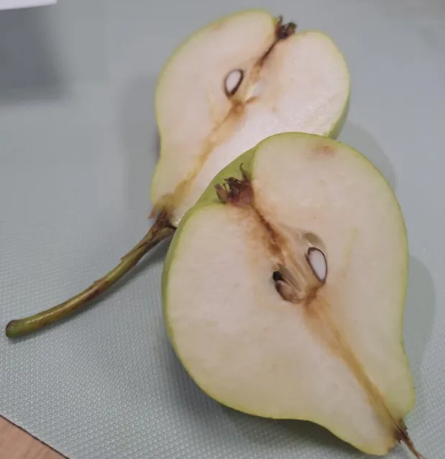

The two halves of pear used for this experiment, Jessopp, L.
Abstract
This experiment investigated the process of mummification using two halves of a pear to compare. One half was stored in an airtight bag with nothing else, the other half was covered in salt and stored in the same kind of airtight bag, both over a time span of three weeks. The aim of this experiment was to partially replicate and observe aspects of ancient Egyptian mummification, observing physical changes such as mass reduction, desiccation, and structural preservation. The pear halves initially weighed around 75 grams each, with the salt covered half decreasing to about 20-23 grams and the control half decreasing to about 26-29 grams after the three weeks. Results demonstrated progressive loss of moisture and shrinkage in both, but more so in the salted pear, supporting the hypothesis that salt promotes preservation through desiccation. Comparisons with Egyptian practices highlight similarities in technique but also show limitations due to material differences.
Keywords: Desiccation, Mummification, Salt, Decay, Preservation, Comparison

Introduction
Mummification is a preservation process most often associated with ancient Egypt, where it was used to prepare bodies for the afterlife. The process involved removing internal organs, drying the body using the salt mixture natron, and wrapping it in linen. Historical accounts, including those by the Greek historian Herodotus, describe the careful and methodical nature of these procedures, emphasising the importance of dehydration in preventing decay of the body. The scientific principle most important for mummification is desiccation, this is the removal of moisture from organic material. Micro organisms responsible for decomposition need water to survive, so removing moisture slows their activity and preserves tissue. In ancient Egypt natron played a crucial role in absorbing water from the body over a long period. This process dried the body and also created an environment that was hostile to bacteria and enzymes that would otherwise break down tissue. In addition to its religious significance, mummification represents an early use of scientific principles. The ancient Egyptians may not have understood biology in modern ways, but their methods demonstrate a practical understanding of preservation. Their success is clear in the survival of mummified people for thousands of years, providing valuable archaeological and biological information.
This experiment aimed to observe this process using a simplified system, which was two halves of a pear. Fruit was used instead of animal tissue due to ethical and practical issues, however it differs significantly in composition. The experiment involved covering on half of the pear in salt and observing changes compared to the unsalted pear over three weeks. While not being identical to Egyptian mummification, the setup still allowed for the investigation of the fundamental principles of dehydration. The study also considers the limitations of using table salt instead of natron, and fruit instead of human or animal tissue. Despite these differences, the experiment provides insight into how desiccation affects organic material and offers a basis for comparison with ancient techniques.

Aims and Hypothesis
The primary aim of this experiment was to observe the effects of salt-induced desiccation on organic material over time and to compare these effects with ancient Egyptian mummification processes. A secondary aim was to record visible and inferred changes in mass, size, texture, and moisture content over a three-week period, using observation and analysis.
The hypothesis was that covering half of a pear in salt would result in progressive dehydration, leading to shrinkage, increased density, and preservation of structure. It was also predicted that the salted pear half would lose a significant proportion of its mass due to water loss, similar to the effects observed in mummified remains. It was also expected that most of the mass loss would occur within the first week, when the moisture content is highest.

Issues and Contentions
Some limitations and considerations should be acknowledged. Firstly, the experiment did not use natron, which was the primary drying agent in ancient Egypt. Natron contains sodium carbonate and bicarbonate, which may have different drying efficiencies compared to table salt. This chemical difference could affect both the rate and extent of dehydration.
Secondly, the use of fruit rather than animal tissue. Pears have a high water content and lack the complex protein structures found in muscle tissue. This means the results may not accurately reflect the preservation of flesh in mummification, particularly in terms of texture and longterm stability.
However, a control sample (the unsalted pear half) was used for direct comparison, which gave the ability to isolate the effects of salt vs natural decay. The control pear helped show mould growth and decomposition, strengthening the conclusion that salt slows decay.

Methods
The experiment was designed as a simple observational study over three weeks. The independent variable was time, while the dependent variables included physical characteristics such as size, texture, and mass. Salt was used as the desiccating agent, and the pear halves were stored in an airtight environment to minimise external influences.
Materials included one pear cut in half, table salt (sodium chloride), and two airtight bags

Procedure
A fresh pear was cut in half, and one half was selected to be salted, the salted pear half was fully covered in salt, ensuring all exposed surfaces were coated, both the salted pear half and the control half were placed into an airtight bag to reduce moisture exchange with the external environment. The samples were left undisturbed for one week, after that one week, observations were recorded of size, texture, and moisture. The pear halves were then left in the same conditions for an additional two weeks, with observations recorded at weekly intervals, no additional salt was added during the experiment.
Results
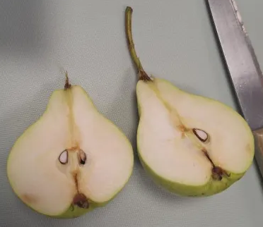
Over the three week period, the pear underwent significant physical changes.
Week 1:
The salted pear half appeared slightly shrunken, with a noticeable reduction in moisture. The surface became firmer, and had a rougher feel to the skin, showing water extraction by the higher density of the salt. The smell also became less fresh, suggesting chemical changes within the fruit. The control pear did also shrink, however the material was wetter and more squishy, with a slightly bad smell, small spots of mould also started to grow.
Pear halves, week 1, Jessopp, L.

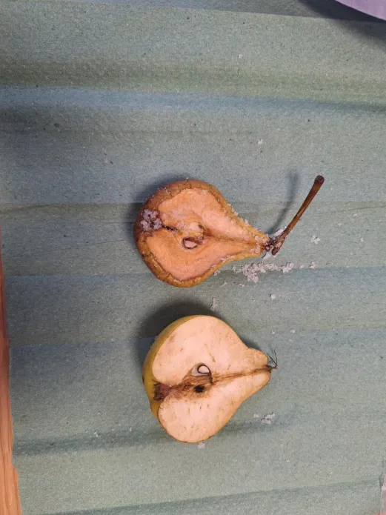
Week 2:
For the salted pear, more shrinkage was obvious. The pear became darker in colour and significantly drier. The texture was leathery, and the pear began to resemble preserved material rather than fresh fruit. At this stage, the salted pear showed no signs of microbial decay, such as mould. The control pear however had continued to decay, mould spreading more and the smell getting worse, this control sample also stayed wet, and felt soft to the touch.
Pear halves, week 2, Jessopp, L.
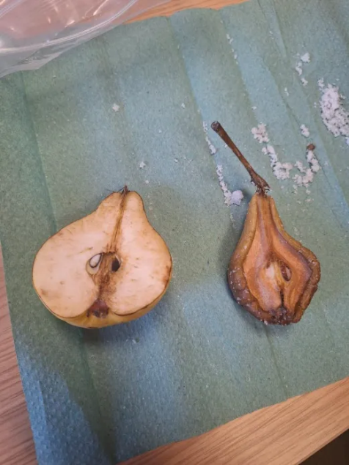
Week 3:
The salted pear was considerably smaller and much denser. It was dry to the touch, with no remaining moisture. The structure remained together, indicating preservation rather than decomposition. The colour had deepened further, likely due to oxidation and concentration of pigments. The control pear showed further decline, mostly taken over by mould with minimal green colouring shown. The smell also worsened and the material felt weaker when touched.
Pear halves, week 3, Jessopp, L.

Mass Changes
The initial mass of both halves were quite similar at around 75 grams, the mass of the salted pear reduced to around 20-23 grams, showing a loss of 55-52 grams, while the mass of the control pear was reduced to 26-27 grams, showing a loss of 48-49 grams. This loss is consistent with dehydration processes and shows more lightness in the salt drying method.

Discussion
Interpretation of Results
The results support the hypothesis that salt induces desiccation and preservation. The progressive shrinkage and drying observed from the salted pear over three weeks indicate that moisture was effectively removed from the pear. The presence of liquid caused denser salt in the early stages confirms that water was drawn out by osmosis, a process where water moves from an area of higher concentration (inside the pear) to lower concentration (the salt). The increasing density of the pear can be explained by the loss of water while solid materials remain. As water content decreased, the structure became more compact and firm. The lack of visible mould growth further suggests that microbial activity was significantly reduced, supporting the idea that dehydration inhibits decay.

Comparison to Egyptian Mummification
There are clear parallels between this experiment and ancient Egyptian mummification. In both cases, salt or natron is used to remove moisture, preventing decay. The time scale of several weeks, though shorter, also aligns with historical accounts, which suggest that bodies were left in natron for around 40 days. However, there are also important differences. Egyptian mummification involved removal of internal organs, which was not replicated in this experiment. Additionally, natron is chemically different from table salt and may be more effective at drying tissue. The use of fruit also limits the comparison. Human tissue contains proteins and fats that behave differently during decomposition and preservation. Despite this, the experiment successfully demonstrates the core principle of dehydration. It also shows that even a simplified model can reflect key aspects of a complex historical process.

The preservation observed can be attributed to the slowing of microbial activity. Bacteria and fungi require water to grow and reproduce. By removing water, the salt creates an environment unsuitable for these organisms, slowing or preventing decay. This is also used in food preservation methods such as curing meat and drying fruit. In both cases, salt or air drying removes moisture and extends the lifespan of the food. The experiment therefore reflects broader applications of desiccation beyond mummification, reinforcing its importance as a preservation technique throughout human history.

Conclusion
The experiment demonstrated that covering an pear in salt leads to significant dehydration and preservation over time. The salted pear lost around 69-73% of its mass and became smaller, drier, and denser over the three weeks. These findings support the hypothesis and align with the principles of ancient Egyptian mummification. While differences in materials and methods limit direct comparison, the experiment effectively illustrates the role of desiccation in preservation. Overall, the study provides a simple but effective model for understanding how mummification works and highlights the importance of moisture removal in preventing decay. It also demonstrates how historical practices can be explored through modern scientific experimentation, as well as showing its efficiency over the unsalted pear.

Evaluation
The experiment was successful in demonstrating the effects of salt on organic material, but several improvements could be made. Firstly, using natron instead of table salt would make the experiment more historically accurate. Additionally, repeating the experiment with animal tissue in a space that is appropriate and ethical could provide a closer comparison to human mummification. Secondly, environmental factors such as temperature and humidity were not controlled or recorded, which may have influenced the rate of dehydration. Future experiments could include these measurements to improve reliability and reproducibility. Finally, increasing the duration of the experiment could provide more insight into longterm preservation and whether the pear remains stable over extended periods. Despite these limitations, the experiment achieved its aim and provided valuable insights into the Ancient Egyptian mummification process.

References
Herodotus, Histories (translated accounts of Egyptian mummification practices)
Ikram, S. (2015). Death and Burial in Ancient Egypt.
Nicholson, P. T., & Shaw, I. (2000). Ancient Egyptian Materials and Technology.
Aufderheide, A. C. (2003). The Scientific Study of Mummies.

