The Global Business Environment
LCCB4005
Assessment 1
Student Name: Martina Martinova Karadzhova
Student ID: 2021296
University of Wales

Table of Contents
Introduction 3
Part A 4
1. PESTLE analysis 4
2. Competitive analysis 6
3. Overall changes over the year 7
Part B 8
1. Critically assessing the opportunities and challenges 8
2. Response of organizations 9
Conclusion 11
References 12

Introduction
Global business environment is very competitive and there are a lot of factors that shape the operations of a specific industry. Same condition is also applicable to the fashion industry of UK. Different foreign organizations have also taken part on this industry because of the political stability and international business policies. From the past several years, government had been providing with some sort of tax cut or other economic advantages for the fashion industry. Alongside that, the customers’ behaviour have also been changed. In the fashion industry, it is very crucial to understand the customer demand. Due to the changes on the customer rights act, organizations in the fashion industry are making changes on the service standard and procedures.

Part A

1. PESTLE analysis
Over the years, fashion industry of UK has changed a lot and a lot of macro factors are responsible for these changes. It is clear that factors like political, economic, environment, and others have changed the market condition of the fashion industry. Because of the changed market pattern, organizations like fashion industry are getting influenced. To analyse these factors, the competitive five forces analysis and PESTLE analysis will be required.
Political: Political conditions are very important for any business industry of a specific country. As example, government of UK is very stable and it had been stable for a long time. As the result, the organizations in the fashion industry have got the chance to evolve. Different foreign organizations have also taken part on this industry because of the political stability and international business policies (Zhang et al., 2021). However, Brexit was a political event and it has changed the fashion industry significantly. Many foreign small organizations have left UK because of the Brexit. On the other side, the import and export on the fashion industry have also been hindered.
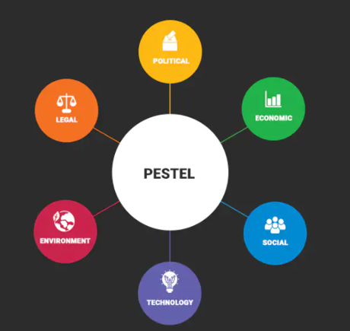
Figure: PESTEL factors (Sung et al., 2020)
Economic: A huge amount of products were being imported from countries like Romania, and so on. Because of having no significant treaties, import costs have been increased. As the result, economic conditions of UK are getting negatively influenced. However, because of having positive interest rate and inflation rate, higher investments are being seen on the fashion industry. From the past several years, government had been providing with some sort of tax cut or other economic advantages for the fashion industry (Sung et al., 2020). As the result, a lot of new market entrants have been seen. Income of the population of UK is also higher and it has helped the luxury organizations to tap into the market. So, in the past 5 years, the number of market entrants in fashion industry have been increased by 30%.
Social: Choices of the customers have changed significantly in last few years. From being involved in the social and customer trends, organizations in the particular industry have made several changes. On the other side, these organizations have also made changes on the customer interaction process. For example, the demands of jeans and shirts get higher in the winter season. So, the organizations have been responding to these changing market demands (Silva et al., 2020). Alongside that, the customers’ behaviour have also been changed. In the last few years, peoples have started to order dresses online. Because of increased focus on the online platform, fashion industry have taken the turn. This is why, in last 10 years, the online related fashion industry has increased by 200%.
Technology: Technology is very important for dealing with the operational procedure. In the last few years, various technology disruption such as analytics, robotics, artificial intelligence, and other techniques have been applied. With the support of effective analytics, organizations are now being able to understand the customer pattern easily. In the fashion industry, it is very crucial to understand the customer demand. So, all of these customer demands can be well administered through the analytics method (Donnelly et al., 2020). Large organizations like Primark, Zara, and others have been using the analytics method to understand the customer demand. By understanding the better customer demand, fashion industry are being able to bring effective services.
Legal: Legal factors are highly influenced by the laws and regulations of the organization. As example, in the last few years, changes on customer service act, customer rights act, and other acts have been changed. Due to the changes on the customer rights act, organizations in the fashion industry are making changes on the service standard and procedures (Ahmadi Lari and Foroudi, 2020). These changes standard and procedures are taking direct part on the legal service system easily. In this way, the operations of the fashion industry have been influenced.
Environmental: Environmental operations are also getting changed with the time. In the last few years, the pressure from different groups in terms of environmental groups has been increased. As working in fashion industry, different organizations have been making changes on their operating procedures to bring environmental sustainability (Ozuem et al., 2020). As example, Zara UK have started using the recycling process where customers’ product has been recycled to make it usable once again. With the support of this environmental condition, fashion industry has been started acting in more responsible manner. This type of awareness has lead toward the environmental effective on the fashion industry.
In this way, it is fair to say that these factors are making impact on the fashion industry and the industry operation has been shaped significantly.

2. Competitive analysis
Competitive analysis in the fashion industry is very important to understand the overall operations. In the competitive analysis, five forces analysis can be very important. Thus, the competitive analysis is given on the following:
Threats of buyers | High
Threats of new market entrants | High
Threats of competitors | High
Threats of substitute products | Low
Threats of suppliers | Low

There are a lots of buyers and over the time, the cost of service switching has been relatively lower. As the result, the market engagement process has been changed. Because of having lower cost of service, organizations are now making their services even influential and effective. So, organizations have changed their customer engagement and connection process (Gazzola et al., 2020). On the other side, it has also been seen that there are being a lot of new market entrants. Among these market entrants, many organizations are very small and they are trading on online. As the result, the competitive situation has been shaped and developed.

3. Overall changes over the year
Over the year, fashion industry of UK has been influenced significantly because of the available external factors. Different foreign organizations have also taken part on this industry because of the political stability and international business policies. Income of the population of UK is also higher and it has helped the luxury organizations to tap into the market. In the last few years, peoples have started to order dresses online (Mukendi and Henninger, 2020). With the support of effective analytics, organizations are now being able to understand the customer pattern easily. As working in fashion industry, different organizations have been making changes on their operating procedures to bring environmental sustainability.

Part B

1. Critically assessing the opportunities and challenges
Covid-19 pandemic has brought different impacts on the operations of fashion industry. In different cases, pandemic had changed the operations on several manner. Fashion industry of UK is one of the leading context in terms of expansion. Effective expansion can be possible if fashion industry is being able to deal with the pandemic situation.
Strengths and Weaknesses: Due to the pandemic, the industry had gained different weaknesses. Decreased sale is one of the leading weakness that had made bad impact on the industry. The industry had seen curtail on sales amount with condition of pandemic. The physical sales had significantly reduced and it had changed the overall industry performance too. Peoples’ productivity had been reduced because of the pandemic as well (Colucci et al., 2020). In the long run, because of the covid-19 pandemic, peoples were forced to work from home. It had brought the weaknesses on the operations. However, increased force from the online aspects have brought strengths.
Opportunities: Due to the covid-19 pandemic, a lot of market trends have been seen. Online sales have been rocketed because of covid-19 pandemic. So, fashion industry will also be facing different types of trends such as increase on the online market and all. Competitor weaknesses are also very much opportune amid the covid-19 pandemic. Because of the covid-19 pandemic, the low cost manufacturers are getting upper hand (Barkova, 2020). As the result, the export business market has been shaping the industry for the future days. As example, Zara has exported many products to other countries as the form of export. Support from government had been an opportunity for the players in the fashion industry.
Government had been acting in supportive manner to provide with required services and other aspects. On the other side, it had also been seen that the inflation rate had been higher amid the pandemic. Because of having a very effective inflation rate, organizations in the fashion industry still have been able to survive (Mukendi and Henninger, 2020). Even in case of the covid-19 pandemic, the organizations in fashion industry have expanded their areas significantly. On the other side, from being involved in the social and customer trends, organizations in the particular industry have made several changes. All of these positive impacts are supporting fashion industry to be effective.
These are the key opportunities that market leaders have been able to get amid the pandemic.
Challenges: There have been various appearing challenges on the fashion industry. Brexit was a political event and it has changed the fashion industry significantly. Many foreign small organizations have left UK because of the Brexit. Even during the time of pandemic, this issue had continued. Because of pandemic, the challenges associated with Brexit have been even more visible (Ozuem et al., 2020). On the other side, it has also been seen that there are being a lot of new market entrants. Among these market entrants, many organizations are very small and they are trading on online. Due to the pandemic, a lot of new market entrants are also being seen.
Compared to that, these challenges have increased the level of competition for the other organizations. This is how, this had been a matter of challenge for the UK fashion industry.

2. Response of organizations
To deal with these challenges, organizations in the fashion industry have been taking different steps. Value creation model is one of the reason that has supported to make changes on the fashion industry. Better value creation model had shown the changes on the approaches made by organizations in fashion industry.
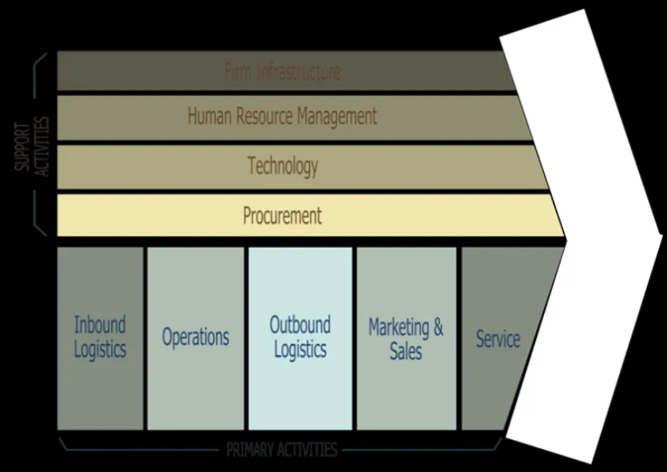
Figure: Value chain operation (Mukendi and Henninger, 2020)
As example, Zara, Primark, and other organizations have used better and effective types of technologies. They have applied the mobile app based sales where many organizations have used the website based sales only. Because of the technological consideration, the responses of different organizations have been unique and different. Procurement and production process have also made differences on the responses toward these conditions (Mukendi and Henninger, 2020). Because of having more interactive marketing process, organizations like Burberry, Mark and Spencer, and others have continued their sales level. In this way, changed value chain process had made impact on facing these challenges and opportunities.

Conclusion
Covid-19 pandemic has brought different impacts on the operations of fashion industry where Brexit was a political event and it has changed the fashion industry significantly. Income of the population of UK is also higher and it has helped the luxury organizations to tap into the market. Technology is very important for dealing with the operational procedure. In the last few years, various technology disruption such as analytics, robotics, artificial intelligence, and other techniques have been applied. With the support of this environmental condition, fashion industry has been started acting in more responsible manner. There are a lots of buyers and over the time, the cost of service switching has been relatively lower.

References
Ahmadi Lari, H., and Foroudi, P. (2020). Behavioral intentions in the UK fashion industry: the impact of perceived fashion innovativeness on fashion brand image with the moderating role of social media marketing and lovemark.
Barkova, N. Y. (2020). Application of robotic technology in the fashion industry. Vestnik Universiteta, (2), 85-91.
Colucci, M., Tuan, A., and Visentin, M. (2020). An empirical investigation of the drivers of CSR talk and walk in the fashion industry. Journal of Cleaner Production, 248, 119200.
Donnelly, S., Gee, L., and Silva, E. S. (2020). UK mid-market department stores: Is fashion product assortment one key to regaining competitive advantage?. Journal of Retailing and Consumer Services, 54, 102043.
Gazzola, P., Pavione, E., Pezzetti, R., and Grechi, D. (2020). Trends in the fashion industry. The perception of sustainability and circular economy: A gender/generation quantitative approach. Sustainability, 12(7), 2809.
Mukendi, A., and Henninger, C. E. (2020). Exploring the spectrum of fashion rental. Journal of Fashion Marketing and Management: An International Journal.
Ozuem, W., Ranfagni, S., Willis, M., and Rovai, S. (2020). User-generated content, service failure and recovery strategies in the fashion industry: the need for a hybrid approach. American Marketing Association.
Silva, S. C., Duarte, P., and Sundetova, A. (2020). Multichannel versus omnichannel: a price-segmented comparison from the fashion industry. International Journal of Retail and Distribution Management.
Sung, K., Cooper, T., Oehlmann, J., Singh, J., and Mont, O. (2020). Multi-stakeholder perspectives on scaling up UK fashion upcycling businesses. Fashion Practice, 12(3), 331-350.
Zhang, B., Zhang, Y., and Zhou, P. (2021). Consumer attitude towards sustainability of fast fashion products in the UK. Sustainability, 13(4), 1646.

