Title: Research Project: Case Study based on an Electives Experience. Word count:

Aim, focus and purpose of the research / Research Context.
The aim of this assignment is to propose, carry out, and critically assess a close-to-practice research project that centres on the transformative teacher model for creating a curriculum that benefits all learners. My research focused on children’s emotional well-being in the primary setting and the strategies implemented to support individuals and groups. I chose this area because of my classroom experiences and also my interest in the research that informed the inclusion of Health and Wellbeing in the Curriculum for Wales. During my previous placements I worked closely with children who were experiencing low levels of emotional well-being. However, I felt unequipped, inexperienced and was unable to offer the correct support at the time. Therefore, I decided to research this area in order to further develop my knowledge and ability to support children and their emotional well-being during my future practices. My research was conducted in a school with 549 pupils on roll, aged 3-11 years, including 24 full-time and 60 part-time pupils in the nursery class. The school has 19 classes, including the nursery, nurture class and two additional learning resource centres (Estyn. 2019). The school recorded that 55% of their pupils have one or more Advance Childhood Experiences (ACEs) and that a further 34% of pupils have 3 or more ACEs. Experiencing ACEs can have an impact on a child’s future physical and mental health. REF. With research suggesting that children with ACEs are at a greater risk of developing mental health problems, such as anxiety, depression, and post-traumatic stress and that 1 in 3 diagnosed mental health conditions in adulthood directly relate to ACEs (Webster, E.M., 2022). Having identified high levels of ACEs, the school have nine trained Emotional Literacy Support Assistants (ELSAs) in order to support pupil well-being. My research focused on pupils from years three, four, five and six because 54% of Key Stage 2 pupils (149) accessed one or more wellbeing intervention last year​. The school has a variety of support strategies available to the students and they openly access them. This ensured that I could gather valuable data on these strategies, how they are used, and the impact they have on pupil well-being. Conducting this research project allowed me to continue to develop my professional practice and gain the valuable knowledge and experience to support pupils. Refer to PTS OR PLP
WHERE IS THE ACTUAL RESEARCH QUES

Overview of relevant literature.
More than one in ten primary school children aged five to ten has an identifiable mental health condition – that’s around three children in every class (Barry, etal.,2017,p.434-451). A study in 2006 found good psychological wellbeing in childhood creates an important foundation for mental health, throughout childhood and into adulthood (Moore, 2006). However, rates of poor well-being have been shown to rise as children grow up, suggesting that a need for early intervention is essential to providing an optimal start in life for young people. In order to promote children's mental health, primary schools must provide them with the skills they need to identify and manage their emotions as well as encourage those who find it particularly difficult to accept the support they need (Barry, etal.,2017,p.434-451). Mental health promotion involves creating and enhancing environments that support the development of positive mental health, wellbeing and healthy lifestyles. Research shows that developing positive mental health and wellbeing is most effective when it takes place early in a child or young person's' life (Robson,. 2023). There is sufficient evidence suggesting that pupils learn more effectively, if they are happy in their work, believe in themselves and have positive relationships with adults. However, outside of school children can be exposed to many factors which can influence their mental health and wellbeing (Robson,. 2023). The ecological model developed by Bronfenbrenner in 1992 is a useful tool for analysing the several aspects that might impact the wellness of pupils (Bronfenbrenner,. 1992). According to this model, a person is situated inside concentric domains that all inform and impact on one another. The Bronfenbrenner model draws attention to the environmental factors that educators should be aware of as they may have an impact on a student's well-being. These factors include the communities' beliefs and values, as well as the availability of supportive and loving social relationships, food, shelter, and transportation (Brown, 2022). Furthermore, in order to identify vulnerable children and children at risk, the House of Commons Health Committee (Dorrell.,2014) and the Pursuit of Happiness report (Centre Forum Commission, 2014, p. 36) advise that teaching and educational staff undergo training in child development, mental health, and psychological resilience. Although teachers are not trained in mental health, the Centre Forum Commission acknowledged that they should be able to identify mental health issues, know where to get support, and know when to send students to Child and Adolescent Mental Health Services (CAMHS). However, the reports written in 2014 made other recommendations, such as mandating that lessons on enhancing resilience and mental health in children and adolescents be included in the National Curriculum. Since then, following The Successful Futures report, a new Curriculum for Wales has been designed. It focuses on promoting the “spiritual, moral, cultural, mental and physical development of pupils at school” (Donaldson, G., 2015). The Curriculum for Wales also recognises the importance of a child centred approach, which is widely known of the humanistic approach, developed by Carl Rogers in the 1950s (Rogers,1957). In a Welsh Government report on “Person-centred practice in education” (2015) it suggests that students will learn more efficiently if a person-centered approach is adapted across a school or institution because their education will be tailored to not only their academic needs but also their social and emotional development (Welsh Government. 2015) – Link this to how this literature led you to form your research question? Add in something about strategies.
The school environment provides a valuable opportunity for wellbeing to be promoted and mental health to be protected for all children, including the most vulnerable and at risk. Promoting good mental health and emotional wellbeing of children is an increasingly important function of all schools. Therefore, promoting and supporting positive wellbeing through building resilience is essential to ensuring that each child has the tools and strategies to enable them to reach their full potential.
Explanation of Case Study
The main research aim was to gather information on the different strategies used in schools to support the emotional well-being of children aged between seven and eleven. This was done using a mixed-method approach, in the form of an exploratory case study. An exploratory case study is defined by Yin (1994) as “an empirical inquiry that investigates a contemporary phenomenon within its real-life context, especially when the boundaries between phenomenon and context are not clearly evident (Yin, R.K., 2009). It is evidence-led, research-based, and accommodating of many methodologies. The main goal is to provide a thorough understanding of a particular subject, programme, policy, institution, or system in order to produce knowledge and/or provide guidance for the formulation of policies or professional practices (Simons, 2009, p.11). The strengths of this approach have been highlighted throughout literature, with Dyer (1995) concluding that the case study methods are thorough, descriptive, and include quantitative, subjective, and objective data (Dyer, C., 19950). The case study method was selected for this research because it aligns with the instrumental method definition, which is the analysis of a particular scenario to provide insight into the issue in question (Stake, 2005). However, the reliability of this method is questioned by researcher Gerring (2004). He observed an anomaly in which he clearly recognised that a case study exists in a "strange, curious methodological limbo", which he believes is caused by a lack of understanding of this method (Gerring 2004, p. 341). Another major drawback is the existence of bias among researchers, which highlights how simple it is to draw participants' attention to specific beliefs and opinions (Nisbet & Watt, 1984: Denscombe, 2017). This can tamper with the results of the study, hence reducing the validity and trustworthiness of the findings. Thus, in order to enhance the reliability of responses and data, certain beliefs and leading questions should be restricted to prevent potential researcher bias while still allowing participants to participate freely in the study (Nisbet & Watt, 1984: Denscombe, 2017).

Research methods
A pragmatic approach was used to conduct the research project, implying that the researcher acquires a deeper comprehension of the phenomenon under investigation by combining different methods including questionnaires, interviews and observations (Clark, A. 2005).
The semi-structured interviews included a series of open-ended questions (see appendix C) along with the opportunity to probe more into specific themes or answers with follow-up questions. Three distinct focus group interviews with students in years three, four, five, and six were conducted as part of the study. I chose to audio record the interviews so that I could concentrate on listening, questioning, following up, and keeping eye contact with the children I was interviewing in order to gather sufficient evidence. I created a transcript of each interview and highlighted the main ideas and supporting details that addressed the questions in order to assess the qualitative data that had been gathered. Qualitative data retrieves non-numerical information, such as words and sounds (Mcleod. 2023). The discipline of social science research has long recognised the significance of interviews, which is why I chose to employ them as a research technique. Since they frequently provide "extensive accounts of people and events in their natural surroundings," interviews have thus always been seen as an essential part of the research process (Weiss, 1995). Furthermore, Kvale (Kvale, S. 1996, p. 2006) presents a convincing case that talking to others is one of the best methods to learn about and explore various topics. More precisely, because they are interactive, interviewers may probe for considerate, in-depth responses and inquire about any possible new topics. Since interviewing is a less structured and more practical method of data gathering, it is anticipated that it will enhance understanding of the persons under investigation (Kvale, S. 1996, p. 2006). In addition, according to Dörnyei (Dornyei, Z., 2007), having an interviewer present may guarantee mutual comprehension since they can reiterate or clarify any points the interviewees were unable to comprehend. This will enable the collection of higher-quality data and the subsequent generation of more accurate statistics. Walford contends, however, that "interviews alone are an insufficient form of data to study social life" (Walford, G., 2007, p.145-577). This is due to the possibility that both the interviewer and the interviewee have insufficient or erroneous information about the subject matter being covered. This enables researchers to evaluate if carrying out interviews alone is an effective method to obtain information (Potter, J., etal. 2005, p. 281-307). Furthermore, because interviews need to be transcribed, categorised, and sometimes translated—as was the case in this study—they have been criticised (Robson, C., 2002) for being time-consuming in terms of gathering and analysing data. For this particular project the interviews were an extremely valuable instrument for collecting data. The audio evidence method allowed the interviewer to put the interviewees at ease, maintain eye contact and provide a warm, nurturing environment. The reactions to some of the more sensitive questions could be gauged by the interviewer and adaptions could be made.
Questionnaires ( see appendix D) were another tool utilised in the study to collect data. This involved sending questionnaires to members of staff who worked in KS2, of which five responded. The questionnaires aimed to gather relevant information in order to inform the research question "What strategies are used in schools to support the emotional well-being of children?” Quantitative data was gathered, which was examined through creating tables and graphs, highlighting important details, and evidence that answered the questions. Quantitative data analyses numerical data using statistical methods, thus providing genuine, empirical data that can be measured and expressed mathematically is the aim. It is frequently applied to forecast, identify trends, and test theories (Mcleod, 2023). I chose to employ questionnaires as a research method since conducting a validated survey can save costs and time, allow data from other studies to be compared, and possibly make it simpler to publish the findings (Boynton, P.M. etal, 2004, p.1312–1315). In addition, compared to interviews, a well-crafted questionnaire can produce high-quality, useful data and reasonable response rates, all of which encourage more open and honest replies. Therefore, bias could be decreased (Williams, A., 2003, p. 245-252). However, a questionnaire's primary drawback, is that it may only be useful to responders who are well-versed in the subject. A sizable portion of the responders are individuals that have little time in their day to do questionnaires. Surveys are therefore not always an appropriate technique to gather data (Prasanna, 2023). Adding to the previous issue, questionnaires do not provide for the same face-to-face interaction as interviews do. In the absence of an associate, those filling out the questionnaire have no one to clarify any technical terms or questions they don't understand with. It is therefore stated that the best approach to accomplish the purpose and objectives of the study is through in-person conversations, because ensuring that the respondents complete the questionnaire to their full potential may be challenging in the absence of a genuine human connection (Prasanna, 2023). Teacher work load was a factor to consider when using questionnaires as a research tool. I was aware that having a sufficient amount of time to complete the questionnaire might affect the credibility of the responses.
The third and final research strategy used to conduct this research study was observations. Observation in qualitative research “is one of the oldest and most fundamental research methods approaches. According to McKechnie (McKechnie 2008, p. 573), this method entails gathering information via the use of one's senses, particularly by seeing and hearing in a methodical and significant way. Likewise, observations are the "fundamental basis of all research methods" in the social and behavioural sciences, according to Adler & Adler (Adler, etal.,1994,.p. 389). Dring my research study, I was given the opportunity to observe an ELSA session (see appendix E). This session involved observing the ELSA leading a small group as they discussed and identified their emotions using pictorial cards.
When using alternative techniques, such as questionnaires and interviews, the researcher must rely on the respondents' information. Since these are indirect approaches, the investigator lacks the tools necessary to verify the validity of the information they have been provided. However, through direct observation, the observer may verify the accuracy of the observation. Therefore, information gathered through observation is frequently more trustworthy than information gathered through questionnaires or interviews (Barker., 1980). Furthermore, unlike other approaches, the observation method of data collecting does not introduce any artificiality and accurately represents the observed phenomenon. They provide an accurate description of the phenomena as it happens in the natural research context (Prasanna. 2023). However, collecting data in the natural research environment can prove challenging, because it can be difficult to control any variables (Delve.,2020). Furthermore, another issue that may arise with the use of observations is that they may require an extensive amount of resources and planning (Prasanna. 2023). Observations require a significant investment of one’s time and focus, which can prove to be problematic. Insufficient time for research execution may result in unreliable data emerging from the observation, which lowers the standard of the data gathering procedure and negatively affects the analysis (Asudani, etal.,2013).

Data Presentation and Analysis Method(s)
Explain the method(s) that you will use to report your data. Refer to relevant literature to support your decisions. Include information about any processes that you carried out to ensure trustworthiness (credibility, transferability, dependability and confirmability) if relevant.
In order to report, analyse and interpret the data gathered during the study, the information from the questionnaires was represented using graphs. The display of statistical data often involves the use of diagrams. Geometric shapes such as squares, circles, bars, and lines are the sole elements that make up a diagram. It is suggested that when it is presented diagrammatically data is easier to interpret and understand (Stapleton, etal., 2017). The ability to track trends is one of the main advantages of using graphs to display data. Graphs are intended to assist, track and recognise trends, which supports the researcher in identifying possibilities for expansion or unsuccessful sectors (Booth,etal., 2012). Furthermore, graphs make it easier to store and arrange large amounts of data. For organisations who are unable to consistently monitor the data being gathered, this method is extremely useful. By utilising the facts to create a chart or graph, the researcher will have an improved understanding of the topic being studied (Lacerda., 1986). However there are certain disadvantages that come with using graphs to display data. One of the primary drawbacks is that, in the event that they are improperly created, labelled, or understood, they may be misleading unclear, or inaccurate. Due to the fact that the researcher may alter the data or the visual components to highlight or conceal particular findings (Khan, etal., 2011). Additionally, graphs can also distract or overwhelm readers, if too many, too complex, or too colourful graphs are used (Kuznetsova, etal., 2004). For this particular project, using Microsoft Forms to create the graphs benefitted and supported the aims of my research study. Once the staff members had completed the questionnaire, their responses were automatically displayed in the from of a graph. This made analysing the data less time consuming and more efficient.
In order to report, analyse and interpret the data gathered during the study, the information from the interviews were transcribed. Research interview transcription is a sufficient technique to use when recording data. When qualitative research uses transcripts of interviews, the responses gathered may be examined in more depth as often as required (Alsaawi., 2014). They can be read aloud to researchers, who might then highlight key words or phrases and look for themes and trends. By identifying important points, this technique can aid in the development of insightful findings (Poland., 2003,p.267-287). Furthermore, researchers can minimise mistakes and misinterpretations by using interview transcription to verify that their interpretation of the discussion is accurate. In addition, the interview is permanently documented in the transcription, which means that other individuals may consult it in the future to verify the results (MacLean, etal., 2004,p.113-123). However, there may be certain disadvantages to transcribing, including issues with ethics, quality, and accuracy. The details, emotions, and context of human speech may be lost, particularly in situations when the audio quality is low, the speakers have accents, or the subject matter is complicated. Errors introduced by using technology to transcribe include mispronouncing words, punctuation, or names, as well as deleting portions of speech (Widodo, H.P., 2014).

Ethical considerations
It was crucial that any potential ethical issues were considered before planning the research study and that it adhered to all British Educational Research Association (BERA) guidelines. In order to safeguard the dignity, rights, and well-being of study participants, an ethics form (see appendix A) and a consent form (see appendix B) were produced and distributed to the participants (BERA 2018). The ethics form is detailed to ensure that the researcher and the participants are both protected during the research study. I acknowledged that the participants may feel under pressure to give the correct answers during the interview process. In order to overcome this risk the participant were made aware of the fact that there would be no consequences for open and honest answers. Staff and students were informed that they were free to leave the study at any time. The students were allowed to indicate that they would no longer desire to engage in their interview by holding up a red flag, and the staff could end by leaving the questionnaire (BERA 2018). Safeguarding was also crucial when carrying out the study, as it assures the safety and well-being of all students, staff and the researcher (Tes Marketing. 2023). Before carrying out the project I recognised the risk of accusation of fabrication or falsification of data. Suggesting that I could have possibly be accused of favouritism by those not involved in the research project. In order to prevent this issue from arising, I followed the Universities and BERA (2018) ethical guidelines when conducting my primary research in school. I also treated each pupil equally in accordance to the schools’ guidelines.
The literature makes the case that minors have the right to be heard and to express their opinions, which should be taken into account based on their age, level of development, and wisdom. This claim is based on international ethical standards. The United Nations Convention on the Rights of the Child, which was adopted on November 20, 1989 (United Nations. General Assembly, 1989), expresses the growing recognition that minors have rights and the ability to make their own decisions. Nonetheless, the vast majority of parents and professionals feel that most children will have difficulty making decisions. To account for these limitations, the term "informed assent" provides a broader perspective on the ability for decision-making. It acknowledges that children are entitled to take part in research without fully understanding the implications or fulfilling all requirements of full consent (Cotrim, etal., 2021). The assent process is intended to be an ongoing, interactive conversation between the research team and the child throughout the research project (Ericsson, etal., 2017). Another one of the foundations of research ethics is informed consent. Its objective is for the research participants to be able to freely (voluntarily) participate in research after being fully informed about the implications of doing so and having given their agreement before beginning the study (University of Oxford. 2021). In order to ensure that I follow the guidelines, I conversed with my professional tutor and lecturer and informed them of the research, providing reason and rationale. In addition to this the school was contacted and parental consent was sought (see appendix b) ensuring that the child’s informed consent was given, whilst also asking for their ongoing consent throughout the research project.
Anonymity in research refers to the inability of any person, including the researcher, to recognise individual study participants. This implies that in an anonymous study, no personally identifying data may be shared with outside stakeholders. Confidentiality, on the other hand, means that the participants can be identified, but their identities are not revealed to anyone outside of the study (Wiles, etal., 2008). In order to ensure anonymity and confidentiality throughout my research project no names were recorded and no individual data (raw scores, individual identifiable performance outcomes) were made available to schools/parents etc.

Results / Analysis of results / Discussion
The content of this section will depend on the research methods that you have used. Once you have presented the data and discussed it, you should consider: What does the data mean? What did I find out? What does that mean for my class?
From conducting this research project and analysing the data, I was able to collect a sufficient amount of data to assist in answering the overall research question.
The questionnaires began by asking the staff members “How do you identify children who are in need of additional support with their emotional well-being?”. Each response (see appendix f) gave a variety of strategies in which they use to identify the pupils, although the “check in” strategy was one that emerged throughout each response. This implies that this method is consistently used throughout the school, ensuring a whole school approach. An emotions check-in allows children to ask themselves how they are feeling. By integrating daily feelings check-in into the day, it can help make sure the needs of every learner are met. Sometimes children struggle with problems or challenges that teachers don’t see. Quite often, these challenges impact students during the academic day. A check-in can help understand those struggles, giving the pupils a chance to talk about how they are feeling. Which is paramount to helping them reach their full potential (pathway2success. 2022).
The questionnaire also looked into the strategies used currently in the school to support emotional well-being. By analysing the responses (see appendix f) it is clear that the school have employed a variety of strategies to support their pupil’s emotional well-being, specifically ELSA sessions. The staff have praised this intervention and find it useful when the “ELSA provider gives feedback after certain sessions to discuss development/responses of the children”. ELSA has an overall positive impact on the emotional development of children and is effective when it comes to developing crucial skills (Bowerman, etal. 2018). Suggesting that when this intervention is used throughout the school, teachers are able to gain further insight into the feelings and opinions of their pupils.

Conclusion
Critically examine the work that you undertook when preparing for your research study; for example: Would the methods of collecting data be reliable within your context? • How valid would the methods be? Would the findings be able to be generalised? What would you like to do in future in terms of carrying out research? How might this link to the Professional Standards?

References.
Adler, P.A. and Adler, P., 1994. Observational techniques.
Alsaawi, A., 2014. A critical review of qualitative interviews. European Journal of Business and Social Sciences, 3(4).
Asudani, D. and Tolia, V., 2013. Pros and cons of clinical observation units. The Hospitalist, 11, pp.1-7.
Barker, K.N., 1980. Data collection techniques: observation. American journal of hospital pharmacy, 37(9), pp.1235-1245.
Barry, M.M., Clarke, A.M. and Dowling, K., 2017. Promoting social and emotional well-being in schools. Health Education, 117(5), pp.434-451.
Booth, J.L. and Koedinger, K.R., 2012. Are diagrams always helpful tools? Developmental and individual differences in the effect of presentation format on student problem solving. British Journal of Educational Psychology, 82(3), pp.492-511.
Boynton, P.M. and Greenhalgh, T., 2004. Selecting, designing, and developing your questionnaire. Bmj, 328(7451), pp.1312-1315.
British Educational Research Association (2018) Ethical guidelines for educational research. 4th edn. Available at: https://www.bera.ac.uk/researchers-resources/publications/ethical-guidelines-foreducational-research-2018
Bronfenbrenner, U., 1992. Ecological systems theory. Jessica Kingsley Publishers.
Brown, J (2022). Strategies to promote student wellbeing. Available at: https://www.structural-learning.com/post/strategies-to-promote-student-wellbeing
CentreForum Commission (2014) The Pursuit of Happiness: A New Ambition for Our Mental Health.
Clark, A. (2005). Three: Ways of seeing: using the Mosaic approach to listen to young children’s perspectives. In Beyond listening, Bristol, UK: Policy Press. available from: < https://doi.org/10.51952/9781447342403.ch003>
Cotrim, H., Granja, C., Carvalho, A.S., Cotrim, C. and Martins, R., 2021, July. Children’s understanding of informed assents in research studies. In Healthcare (Vol. 9, No. 7, p. 871). MDPI.
Delve. (2020). What is observational research?. [Online]. delvetool.com. Last Updated: 10 November 2020. Available at: https://delvetool.com/blog/observation#:~:text=a%20controlled%20setting.-,Disadvantages,expensive%20 [Accessed 4 January 2024].
Donaldson, G., 2015. Successful futures: Independent review of curriculum and assessment arrangements in Wales. Welsh Government.
Dornyei, Z., 2007. Research Methods in Applied Linguistics: Quantitative. Qualitative and.
Dorrell, S., 2013. House of Commons-Health Committee: After Francis: Making A Difference-HC 657: Making a Difference, Third Report of Session 2013-14, Report, Together with Formal Minutes and Oral and Written Evidence (Vol. 657). The Stationery Office.
Dyer, C., 1995. Beginning research in psychology: A practical guide to research methods and statistics. Blackwell Publishing.
Ericsson, S. and Boyd, S., 2017. Children’s ongoing and relational negotiation of informed assent in child–researcher, child–child and child–parent interaction. Childhood, 24(3), pp.300-315.
Estyn. (2019). Inspection report Gelliswick Church in Wales Voluntary Controlled Primary School 2019. [Online]. estyn.gov.wales. Available at: https://www.estyn.gov.wales/provider/6683061 [Accessed 4 January 2024].
Gerring, J., 2004. What is a case study and what is it good for?. American political science review, 98(2), pp.341-354.
Given, L.M. ed., 2008. The Sage encyclopedia of qualitative research methods. Sage publications.
Khan, M. and Khan, S.S., 2011. Data and information visualization methods, and interactive mechanisms: A survey. International Journal of Computer Applications, 34(1), pp.1-14.
Kvale, S., 1996. Inter views. An introduction to qualitative research interviewing, p.2006.
Kuznetsova, I.M., Turoverov, K.K. and Uversky, V.N., 2004. Use of the phase diagram method to analyze the protein unfolding-refolding reactions: fishing out the “invisible” intermediates. Journal of proteome research, 3(3), pp.485-494.
Lacerda, F.W., 1986. Comparative advantages of graphic versus numeric representation of quantitative data (Doctoral dissertation, Virginia Polytechnic Institute and State University).
Liz Robson. (2023). Mental Health and Wellbeing in Primary Schools. [Online]. worthit. Last Updated: 4 April 2023. Available at: https://www.worthit.org.uk/blog/mental-health-wellbeing-primary-schools [Accessed 4 January 2024].
MacLean, L.M., Meyer, M. and Estable, A., 2004. Improving accuracy of transcripts in qualitative research. Qualitative health research, 14(1), pp.113-123.
Moore, K., David, T.J., Murray, C.S., Child, F. and Arkwright, P.D., 2006. Effect of childhood eczema and asthma on parental sleep and well‐being: a prospective comparative study. British Journal of Dermatology, 154(3), pp.514-518.
Nisbet J. & Watt J. (1984) Case study. In Conducting Small-scale Investigations in Educational Management ( J. Bell, T. Bush, A. Fox, J. Goodey & S. Goulding eds), pp. 79–92, Harper & Row, London.
pathway2success. (2022). Daily Emotions Check-In Ideas for Students. [Online]. pathway2success.com. Last Updated: 10 May 2022. Available at: https://www.thepathway2success.com/daily-emotions-check-in-ideas-for-students/
Potter, J. and Hepburn, A., 2005. Qualitative interviews in psychology: Problems and possibilities. Qualitative research in Psychology, 2(4), pp.281-307
Poland, B.D., 2003. Transcription quality. Inside interviewing: New lenses, new concerns, pp.267-287.
Prasanna. (2023). Advantages And Disadvantages Of Questionnaire | Top 6 Questionnaire Advantages and Dsadvantages, Pros and Cons. [Online]. Aplustopper. Last Updated: 10 May 2023. Available at: https://www.aplustopper.com/advantages-and-disadvantages-of-questionnaire/
Prasanna. (2023). Advantages and Disadvantages of Observation Method | Merits and Demerits of Observation in Marketing. [Online]. aplustopper.com. Last Updated: 31 March 2023. Available at: https://www.aplustopper.com/advantages-and-disadvantages-of-observation-method/ [Accessed 4 January 2024].
Robson, C., 2002. Real world research: A resource for social scientists and practitioner-researchers. Wiley-Blackwell.
Rogers, C. (1957) The necessary and sufficient conditions for therapeutic change. Journal of Consulting Psychology, 21: 95-103.
Simons, H., 2009. Case study research in practice. Case study research in practice, pp.1-200.
Stake, R.E., 2005. Qualitative case studies.
Stapleton, G., Jamnik, M. and Shimojima, A., 2017. What makes an effective representation of information: a formal account of observational advantages. Journal of Logic, Language and Information, 26, pp.143-177.

Tes Marketing. (2023). Why is safeguarding so important in schools?. [Online]. Tes.com. Last Updated: 16 February 2023. Available at: https://www.tes.com/for-schools/blog/article/why-safeguarding-so-important-schools#:~:text=Safeguard [Accessed 4 January 2024].
United Nations. General Assembly, 1989. Convention on the Rights of the Child, 20 November 1989. Annual review of population law, 16, pp.95-501.
University of Oxford. (2021). Informed consent. [Online]. researchsupport.admin.ox.ac.uk. Last Updated: 2 December 2021. Available at: https://researchsupport.admin.ox.ac.uk/governance/ethics/resources/consent#:~:text=Informed%20consen [Accessed 4 January 2024].
Walford, G., 2007. Classification and framing of interviews in ethnographic interviewing. Ethnography and Education, 2(2), pp.145-157.
Webster, E.M., 2022. The impact of adverse childhood experiences on health and development in young children. Global Pediatric Health, 9, p.2333794X221078708.
Weiss, R.S., 1995. Learning from strangers: The art and method of qualitative interview studies. Simon and Schuster.
Welsh Government. (2015). Person-centred practice in education: a guide for early years, schools and colleges in Wales. [Online]. Welsh Government. Available at: https://www.gov.wales/sites/default/files/publications/2019-01/person-centred-practice-in-education- [Accessed 4 January 2024].
Widodo, H.P., 2014. Methodological considerations in interview data transcription. International Journal of Innovation in English Language Teaching and Research, 3(1), pp.101-107.
Wiles, R., Crow, G., Heath, S. and Charles, V., 2008. The management of confidentiality and anonymity in social research. International journal of social research methodology, 11(5), pp.417-428.
Williams, A., 2003. How to… Write and analyse a questionnaire. Journal of orthodontics, 30(3), pp.245-252.
Yin, R.K., 2009. Case study research: Design and methods (Vol. 5). Sage.

Appendices.
A – Ethics form (completed)

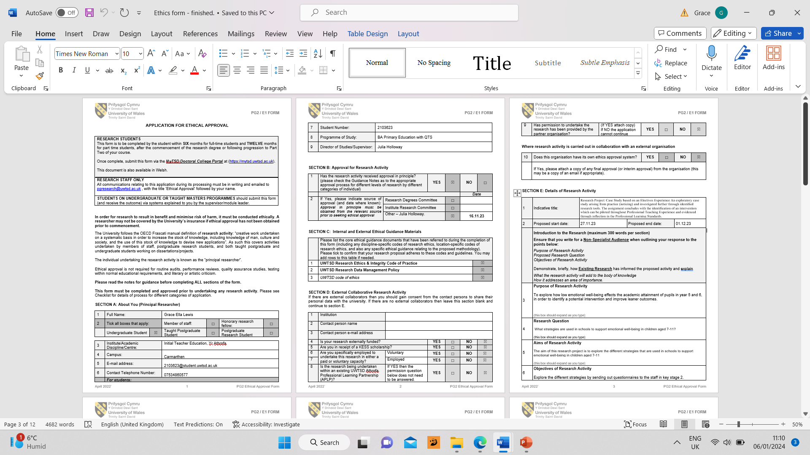

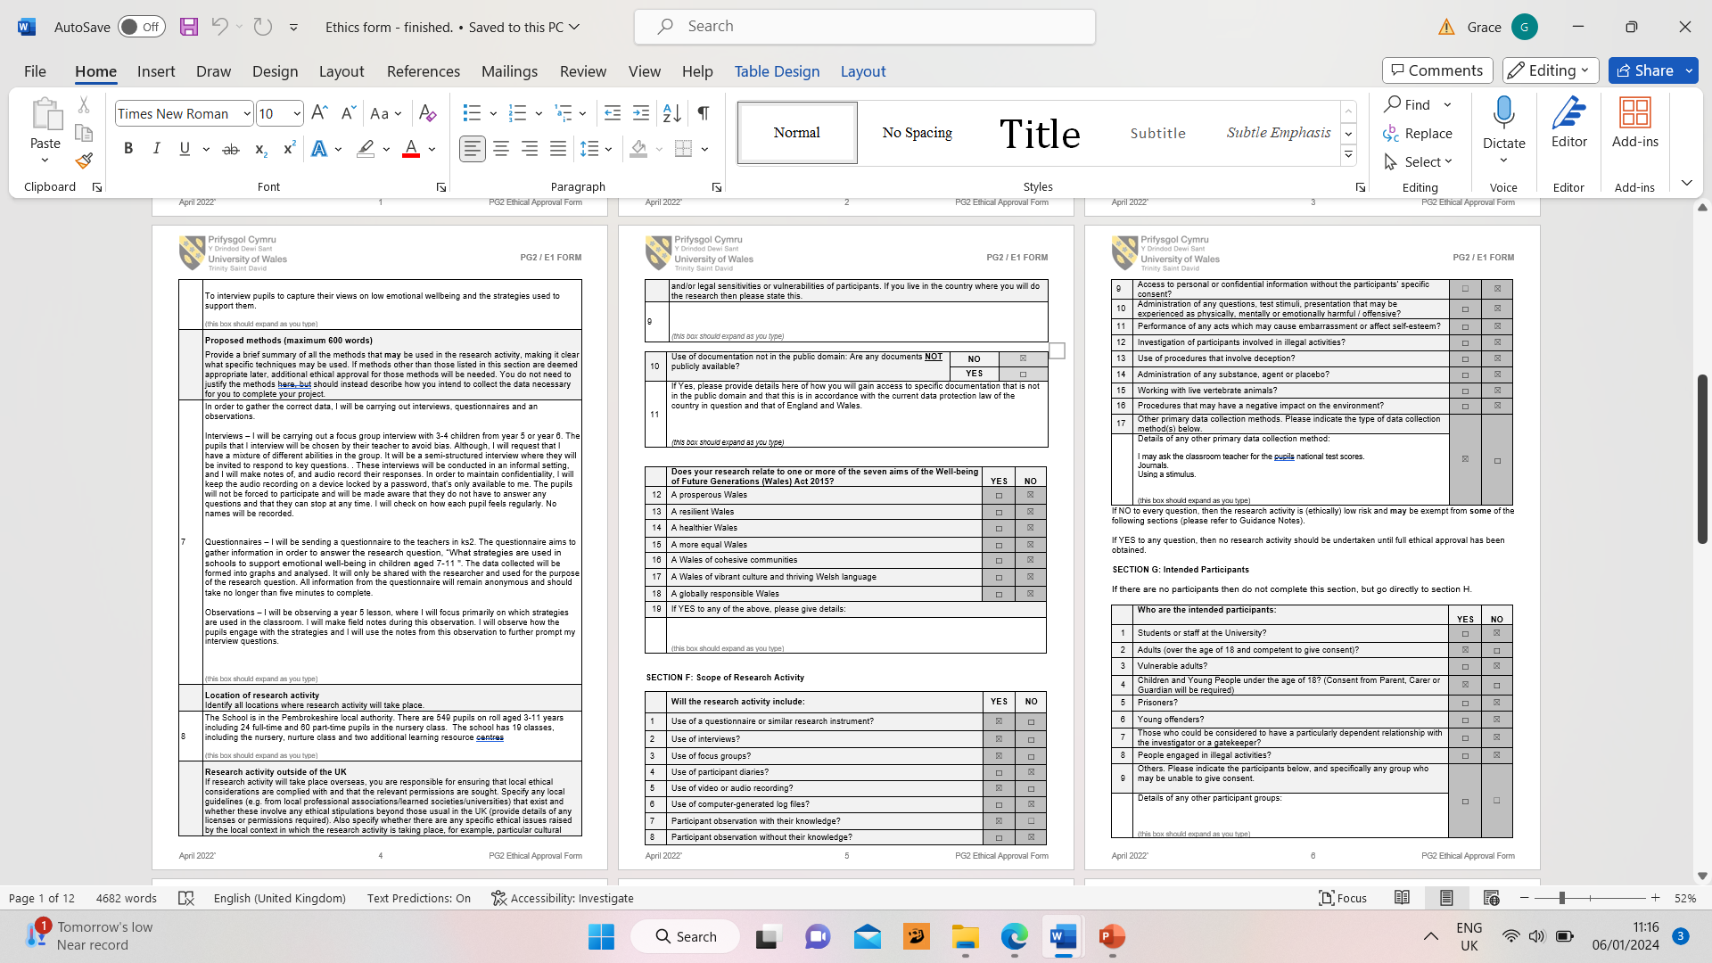

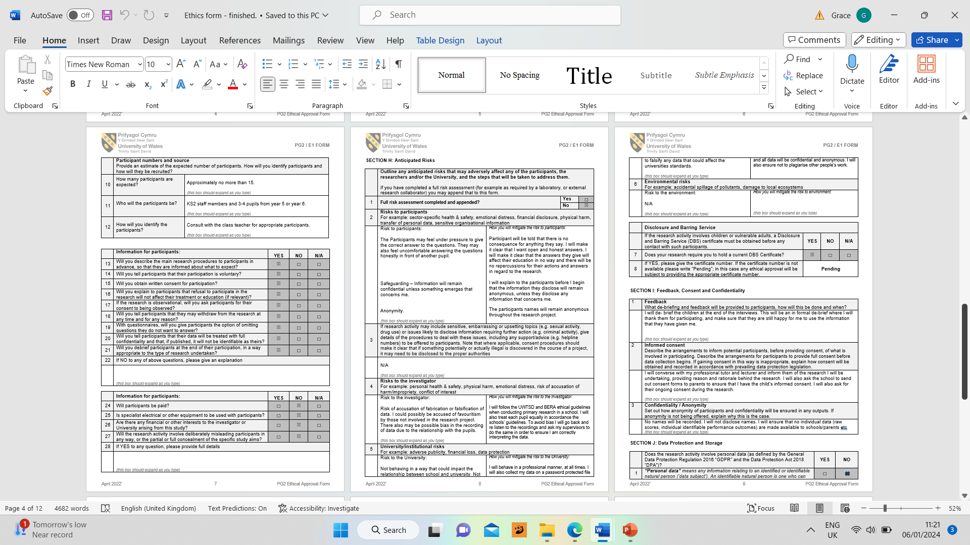

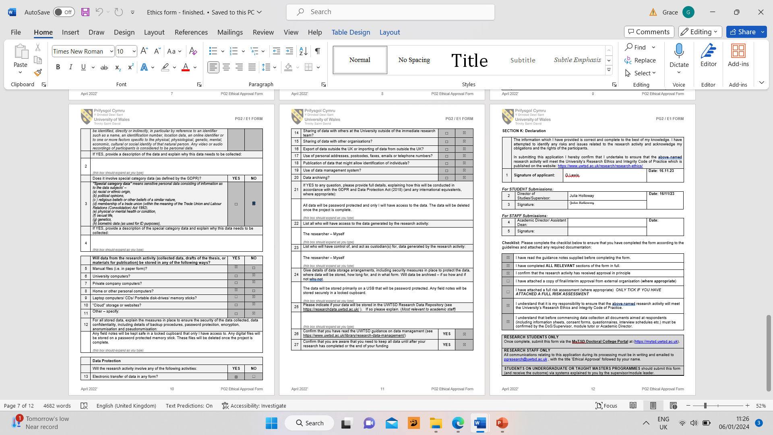

CONSENT FORM
B – Blank copy of a consent form and letter to parents.

PROJECT TITLE: What strategies are used in schools to support emotional well-being in children aged 7-11?

Name of Researcher: Grace Lewis
Please initial box

1.I confirm that I have read and understand the information sheet dated 27.11.23 for the above study.

2. I understand that my child’s participation is voluntary and that I am free to withdraw my child from the study at any time, without giving any reason.

3. I understand that my child can choose to withdraw at any time, without giving a reason.

4. I understand that the information given by my child will be used in a university assignment.

5. I understand that my child’s name will not appear at any time.

6. I agree for my child to take part in the above study.

_____________________ _____________________________ __________
Child’s name Parent signature Date

When completed, please return in the envelope provided to your childs class teacher by the 29th of November.

Thank you.

Date: 27.11.23

INFORMATION sheet

PROJECT TITLE: What strategies are used in schools to support emotional well-being in children aged 7-11?

Dear Parent / Guardian,
My name is Grace Lewis and I am studying for a BAEd qualification at Yr Athrofa, University of Wales Trinity Saint David.

I would like to invite your child to participate in my research project. The title of the project is “What strategies are used in schools to support emotional well-being in children aged 7-11?” and I aim to explore the different strategies that are used in your child’s school to support their emotional well-being. Through your child’s participation, I hope to determinate which strategies within the school are successful in supporting and further developing children’s well-being.

Part of my research project will involve interviewing a group of children to further discuss the strategies used in their school to support their emotional well-being. I will make sure to gain fully formed consent from the parents by sending out a consent form. I will also be sure to gain assent from the children involved with the interview.

All names will be kept strictly confidential and will only be known by myself and my research partner. Your child’s participation in this study is completely voluntary so you or your child can withdraw from the study at any stage. Your child will also be asked to give their assent before the beginning of the study.

After careful and precise analysis of the data obtained from the lesson observation and group interview, I would be happy to provide you with a copy of the findings at your request. The results of the research will be discussed in a university assignment that will contribute to my degree. The results of this study will be stored on my password secured personal lap top and all raw data will be destroyed once the assessment has been marked.

I thank you in advance for your time. If any questions do arise, feel free to contact me at your convenience.

Yours sincerely,

Grace Lewis.

C – Copy of the interview questions.

Interview Questions for the pupils.

1. How do you feel when you go to school?
2. What are some things that make you feel happy or excited in school?
3. Is there anything in school that makes you feel unhappy or anxious?
4. Do you feel like you have someone in school to talk to if you are feeling upset or worries in school?
5. Do you have a safe place in school that you can go to if you are feeling sad or worried?
6. If you do have a safe place, what can you do there? Does it make you feel better?
7. Do you take part in the daily check ins in class?
8. Do you enjoy taking part in the daily check ins? Does it make you feel uncomfortable?
9. Do you think that there is anything else that your school could do to help you when you feel sad or worried?

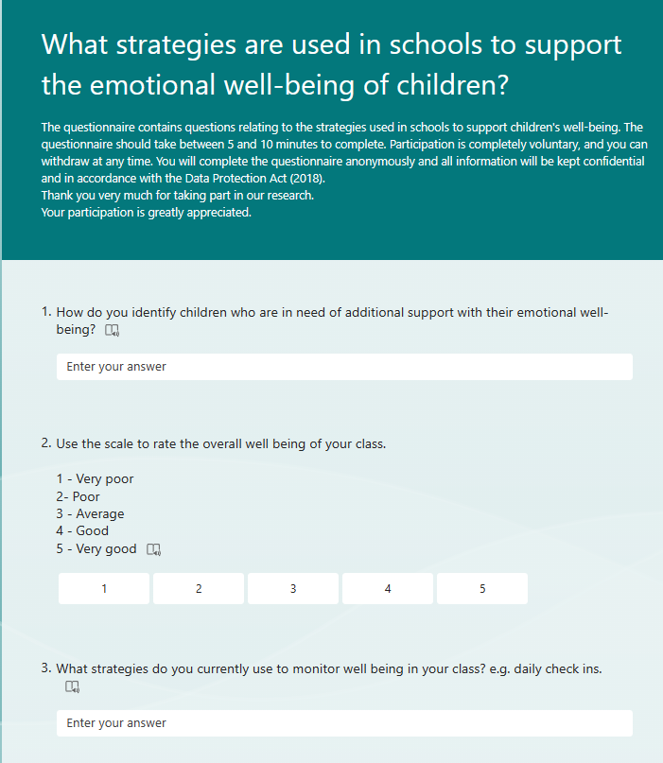
D – Copy of the questionnaire questions.

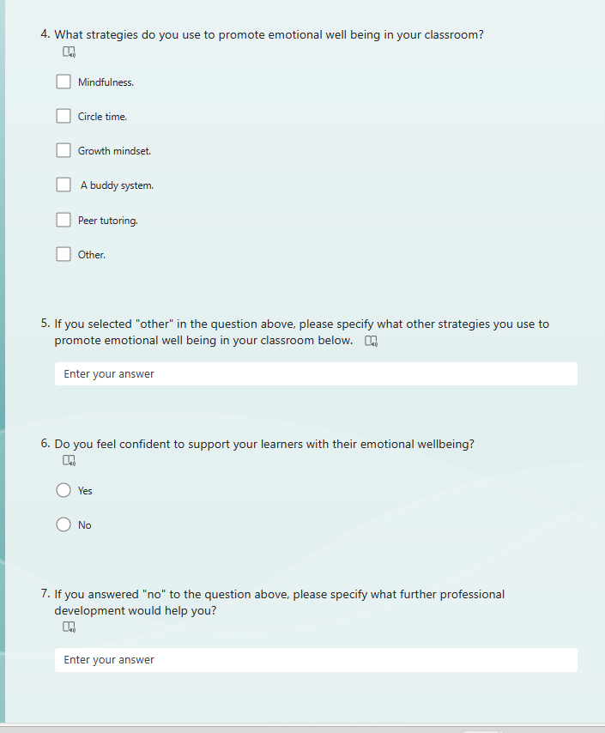

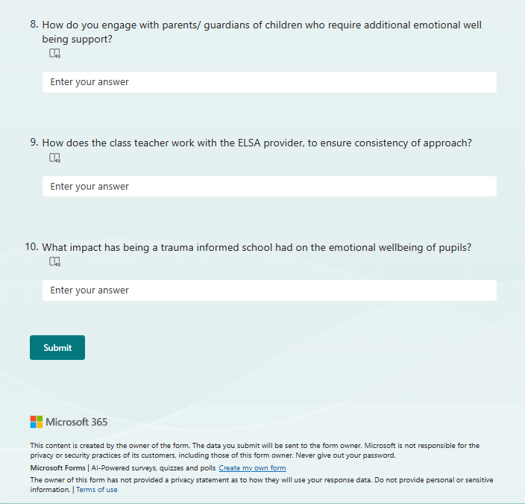

E – Observation Schedule.

