Luke Morgan

Game Design and Asset Creation 2
M5X02044

3rd Person Arcade shooter Report

Initial Idea
I was unsure of what theming I could use this game initially. To help me generate an idea I created a mind map on the software Mindmiester[1].
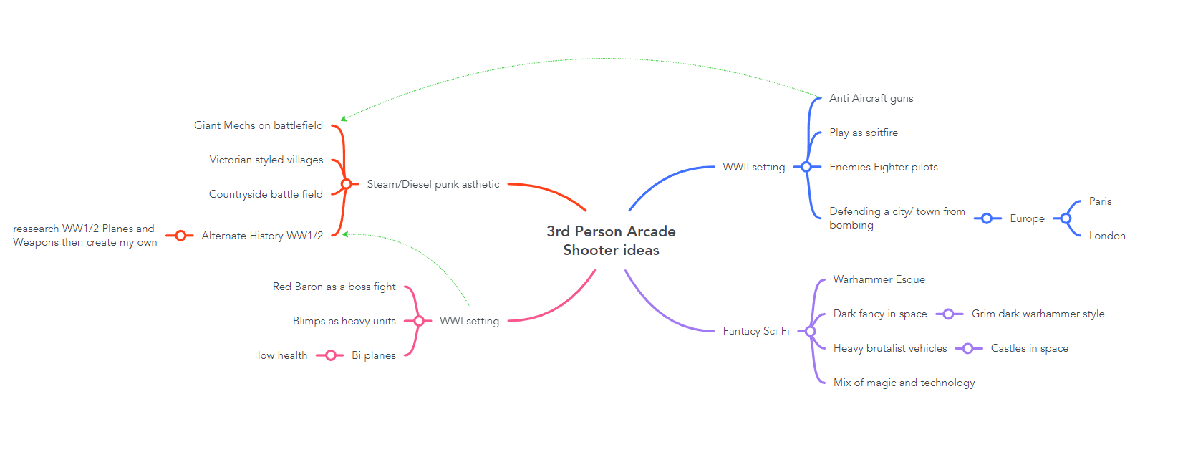
From this brainstorming I came up with the idea of a steam/diesel punk aesthetic. I came up with this idea after playing the board game Scythe[2] and the video game Iron Harvest[3]. Using a mind map to create ideas was great as it allowed me to jot down ideas and expand them as more came to me. I will use mind maps again in the future. However, I may not use mindmiester again, even though it allowed me to create an online version of my mind map it wasn’t as intuitive as just writing things down on paper. This isn’t a problem with mindmiester it’s just that I feel putting my thoughts and ideas directly on paper first would be more beneficial as it is quicker.
To continue my research into this aesthetic I had a look in to the artist behind Scythe and Iron Harvest. After a visit to the Steam community page[4] for Iron Harvest I found out it was the same person who did the art for both games who is an artist named Jakub Rozalski. I then did a search on Google for Jakub Rozalski and found their art station page[5]. From this page I had a look at the method they used to create his artwork and used this method to inform my own concepts.
Early concepts and research.
To create designs for this game I first took technology from WW2 and WW1 and used Adobe Photoshop to photobash it together and create the designs.
The first design I came up with was a design for a mech (shown below) 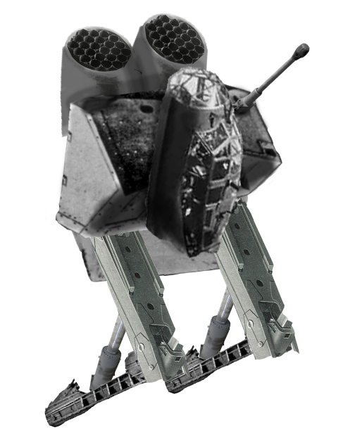
To create this design I took aspects of many vehicles from the era as well whilst taking in to an aesthetic similar to that of Mr Rozalski. For example, on this mech design the legs are crane arms, the gun is off an Abrams Tank and the cockpit is off a bomber.
After creating this Mech design, I thought about how technology of aircraft would have evolved. The solution I came to was that the planes would have had to be fitted with larger weapons to pierce the thick armour of the mechs. Whilst doing research on weapons that might fit the Era I found the YouTube channel forgotten weapons[6]. This Youtube channel has many videos on weapons throughout history and through this channel I found a WW2 weapon called the boys AT rifle. This was a high-powered Gun from WW2 that was design to pierce armour, so I adapted it into a design to fit under my plane design (see below).
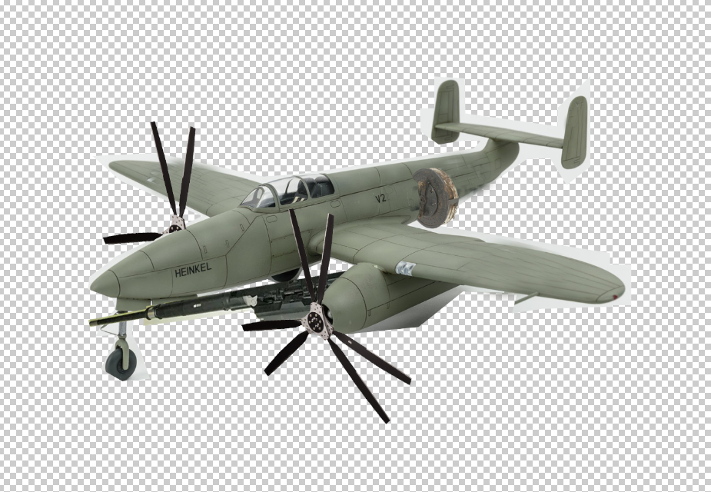
After creating the designs for the planes, I also need to create designs for the environmental models like the building. I didn’t photo bash these together as I didn’t want the environment to be true to what a valley would look like during the time period. To research this I did an image search for old European buildings and used various images as reference. I also took inspiration from the Glenfinnan Viaduct in Scotland for the design of the bridge.
Modelling and Texturing
To create my models, I used Autodesk Maya. I decided to use Maya for two reasons, firstly I am already familiar with it as it is the software as I have used for all my previous projects and secondly it is the industry standard and is what I will most likely have to use when entering the industry in the future. After I had created the models to speed up the UV unwrapping process, I used the automatic unwrap tool. This tool was extremely powerful and allowed me to quickly unwrap complicated models that would have taken hours to unwrap manually at the click of a button. One drawback to using this tool however was it didn’t always unwrap objects in the most logical way. This meant many of the UVs had to be manually edited after they had been unwrapped. I also found that some of the simpler models like the bridge were better to be manually unwrapped as the time it takes to manually unwrap these was minimal and the readability of the UV was vastly improved. The automatic Unwrap tool is something I will be using again in the future as it saved so much time on unwrapping complicated models.
The texturing process for this project is something that I feel I have improved massively from and is the area of the project I am most proud of. All my textures were created in Adobe Substance Painter. One thing I have learnt from my previous projects is that Polygon count matters less than texture size so although the polygon count of all my models increased for this project the textures size decreased. To decide where Higher quality textures went, I thought about the importance of the models. For example, the players plane has two 4K textures as it is the main thing the player will see during gameplay same for the enemy fighters. On the other hand, something like the well which is a tiny bit of set decoration only used a 512 texture as it will hardly ever be seen by the player.
The method I used for creating these textures was layering textures on top of each other. First, I created a few base materials for the model on areas like the main body of a plane or the wall of a house. I then made some masks on the models and added details like the doors on a house or the cockpit of the plane. After adding these details, I created a series of grime layers using a mix of grime masks and painted on details. These layers made all the models look used and less like they had just been rolled out of the factory. This was for details like a moss-covered roof or the soot on the engine exhausts. To add decals like the Royal Air Force emblem or the identification numbers on the planes I created a detail in photoshop then imported it the Substance painter files. There I could add it on like any other brush tool or decal from the substance painter library. The advantage of layering all grime details is that doing things like painting on the camo pattern could be done under the grime layers without affecting them.
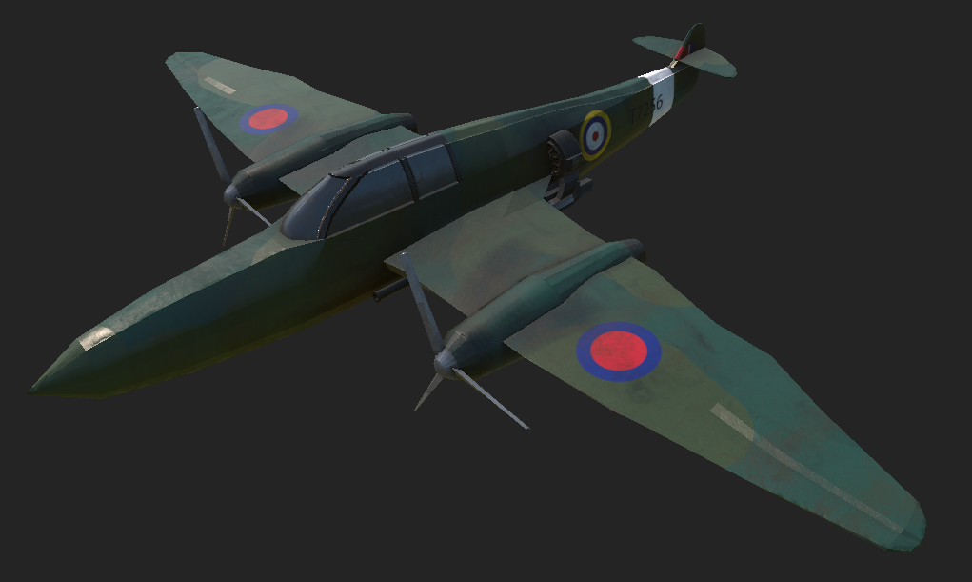Unreal Engine Work
Prior to this project I hadn’t real spent too much time in Unreal I had imported models and textures before but never done anything to the extent of this project. This is another area of the project I feel I have made massive improvements in. The first new thing I learnt in this project was the use of actors. I had previously only ever imported in new models into the engine however with this project I replaced the models in the template with my own by accessing the actors and changing their models and textures. I also learnt to edit the nodes of the actors and used this to remove some of the enemy units that weren’t being replaced like the flying saucer.
I also learnt how to use the foliage and terrain tools. These were extremely powerful tools for creating a quick environment. I used the terrain tool to make the ground and add elevated areas like the mountain and some hills, I then used the grass tool that came with the template.
Using the foliage brush did cause some problems, however. The way I had created my trees in the engine was by taking a simple tree trunk model that I made in Maya then adding some large textures of clusters of leaves as sprites to the tree. I then saved this as an actor in Unreal. This is where the problem occurred. As I used the foliage brush to create the forested areas there were hundreds of trees and as every single one of these trees was an actor not a mesh it caused massive lag and frame drops whilst looking at the forests. With 600 trees on screen my frame rate dropped from over 100 to just 20. I realised this issue and resolved it by adding the leave textures in Maya and then importing it as one mesh to Unreal. This came with its own problem of causing the leaves to render invisible however this was simply a bug in the way Unreal interpreted the leave textures in the node editors after some adjustments in the nodes editor I managed to fix the way the texture was applied and fixed my lag issue. Now the game has hundreds of trees all other the forest areas and barely drops in frame rate.
Things I would Change.
There are many aspects of this project that I would like to change and improve if I were to have more time. One big thing that would be high on my list is the environment. One area of the project I’m not happy with is the way the environment just drops off. I would probably achieve this effect of the world looking bigger than it is in a similar way to a game like Warthunder[7]. It achieves its large looking worlds by having a detailed part of the map below where the planes are fighting, however the environment is much bigger than the play space and most of it outside the immediate play space is lower quality. The lower quality areas are not seen by the player as they are in an area where a kill timer starts if the player goes there. I could achieve a similar effect and then use a week fog effect to hide the edge of the world.
Another thing I would do is increase the amount of variety in the village models. I am happy with the models I did make however the lack of variety makes the village feel small and the reuse is clear to the player. This is an easy fix, I just create more models however due to the limited time on this project I was unable to create them.
When creating models, I did create some anti-aircraft weapons that would act as ground targets for the player to shoot. However, again due to time constraints I couldn’t work out how to animate them correctly in engine. The model and texture are fully completed (pictured below) and are some of my favourite ones I created but just didn’t have time to use in the way I wanted.
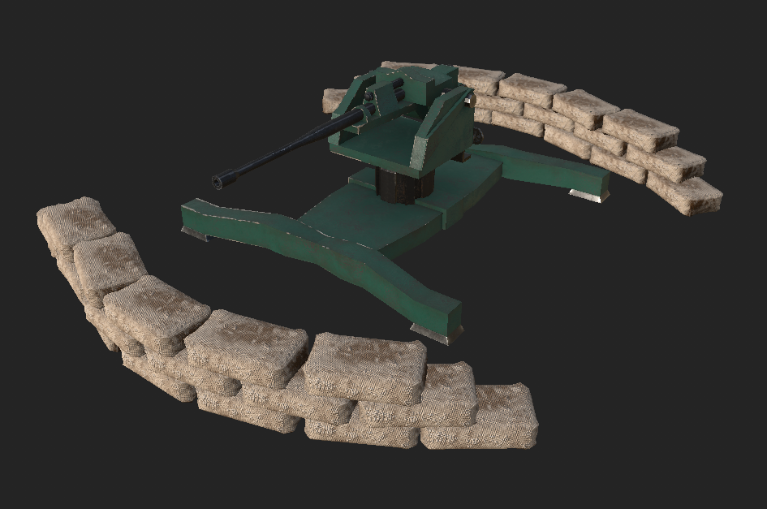
Overall thoughts
Overall, I was extremely happy that I completed this project. I feel my texturing and abilities in the unreal engine vastly improved due to this project and that I will be much better at them when working on future projects. I am happy with everything I created for this project however I do wish I had more time to fix some bugs and get things that aren’t working, working.

Referencing
[1] MeisterLabs (no date) Mindmiester, MindMeister. Available at: https://www.mindmeister.com/map/2750750929 (Accessed: 10 May 2023).
[2] Scythe.[Boardgame], USA: Stonemaier games, 2016
[3] Iron Harvest.[software], Austria: KING Art, 2020
[4] Langevin, R. (2020) Does Iron Harvest has a board game named scythe?, Steam Community. Available at: https://steamcommunity.com/app/826630/discussions/0/2996543814100883778/ (Accessed: 10 May 2023).
[5] J. Rozalski, “Artstation - Jakub Rozalski,” Art Station. [Online]. Available: https://www.artstation.com/jakubrozalski. (Accessed: 30-April-2023).
[6] McCollum, I. (2011) Forgotten weapons, YouTube. Available at: https://www.youtube.com/@ForgottenWeapons (Accessed: 10 May 2023).
[7] Warthunder.[Software], Hungry: Gaijin Entertainment, 2012

