An Engineering Assessment Focussing On:

Remediation of Coal Tip Sites

Module Code – ACBA6014

Word Count Required – 2500 (+/- 10%
Word Count: 2750

Prepared for:
H. Williams

Created By:
E. Evans (2211009)

Submission Deadline – 9th January 2026

Table of Contents
1. Introduction and Background 3
1.2 Engineering Perspectives 3
1.3 Risks 3
1.4 Regulations and Stakeholder Interest 4
1.5 Report Brief 4
2. Engineering Factors Influencing Stability 4
2.1 Geotechnical Conditions 4
2.1.1 Soil and Rock type 4
2.1.2 Particle Size & Gradation 4
2.1.3 Shear Strength 5
2.2 Hydrological factors 5
2.3 Load and slope conditions 5
2.3.1 Tip Height 6
2.3.2 Vegetation 6
2.4 Human impacts 6
3. Case Study Site 7
4. Risk Assessment 11
5. Engineering Remediation Plan 13
5.1 Short Term Plan 13
5.2 Long Term Plan 14
References 16

Table of Figures

Figure 1: OS Mapping of coal tip (binnies, 2025) 7
Figure 2: Penyrenglyn coal tip (Natural Resources Wales, 2023) 8
Figure 3: Penyrenglyn disused tip Category D (Purple) (Welsh Govermnent, 2023) 8
Figure 4: Historical above-ground industrial land use extents (binnies, 2025) 9
Figure 5: Superficial & Bedrock Geology (Groundsure, 2023) 9
Figure 6: 2024 Site aerial imagery with 5m contours (binnies, 2025) 10
Figure 7: Location of boreholes for ground investigation (binnies, 2025) 10
Figure 8: DTM Lidar (1m) 2020 hill shade mapping (binnies, 2025) 11

Introduction and Background
This report is prepared by an Assistant Civil Engineer to highlight the significance of monitoring stability and remediating coal tip sites in Wales. There are up to 2573 disused coal tip sites across Wales with varying levels of safety categories defined by the Welsh Government and Coal Authority. Coal tips or slag heaps remain a legacy from Wales’ mining past and are large mounds of soil, rocks, and fragments of coal that were discarded as waste material in mining operations. Mining operators did not dispose of the waste materials properly as there were very little rule and enforcement to act upon, this leads to today where Government bodies are having to step in with funding to assess, monitor and remediate coal tip sites at a high cost (Coal Action Network, 2024) (gov.wales, 2025) (Nation Cymru, 2025).

1.2 Engineering Perspectives
From an engineering/geological perspective a coal tip is formed through the removal of the material from the earth, with the deposition of waste material layered into a mound. This will have had little to no compaction creating a high void ratio with low shear strength and slopes that have a near natural angle of repose. This poses issues with different material stratification as well as concerns of slope failure from water infiltration and steep material height that will settle unevenly (S. Fityus, 2008).
There are multiple factors of concerns; failure from steep slopes, poor drainage, weak layering, loading or rapid deposition as well as vibrations from machinery and liquefaction of soils. Liquefaction is what caused the Aberfan disaster in 1966 that stemmed from tipping waste material onto a waterlogged surface that led to liquefaction (soil behaving like liquid) and flow failure, which engulfed the Aberfan town below and killed many victims and destroyed a community (ICE, 2025).
The Aberfan disaster marked a significant push for new legislation such as the Mines and Quarries (Tips) Act 1969 which focussed on tip safety, although this was designed while tips were still active and did not identity long term risks of disused tips. After many landslides in south Wales there has been a focus from Welsh Government to re-assess tips and take measures on remediation (ICE, 2025).

1.3 Risks
There are many risks associated with unstable coal tips that can affect local communities with possible threat to life if located downslope. There is also a risk of obstruction and damage to surrounding infrastructure such as roads, rail lines and bridges. Disruption of utilities like gas, water, electrical and drainage networks potentially causing risks within themselves such as harm or fatality as well as blocked watercourses and redirected surface water runoff. Long term ground settlement, altering soil structure for existing and planned developments which can be harm to life (Law Commission, 2025) (Law Commission Impact Assessment, 2022).

1.4 Regulations and Stakeholder Interest
The Welsh Government started a coal tip safety programme in 2020 along with local authorities, Natural Resources Wales and the Coal Authority to aid in planning regular inspections and carry out maintenance/routine works to keep disused coal tips safe. This was further backed up by publishing the location and category of disused coal tips on the .gov. website in 2023 for public access. These tips were separated into different categories that defined safety and inspection intervals (gov.wales, 2025). Many of these sites have been constructed on or are very near to infrastructure and communities, which is of great concern and poses risks that can be unknown.

1.5 Report Brief
This report will provide a detailed engineering assessment of the geotechnical challenges associated with coal tip stability with the purpose of providing information on engineering factors influencing the stability as well as risk assessments and remediation plans. There will also be focus on a case study of a category D coal tip in Rhondda Cynon Taff to assess and identify any concerns with the site, root causes and possible solutions.

Engineering Factors Influencing Stability
Engineering practices must treat coal tip sites as geotechnical structures that are affected and influenced by variable material properties, localised groundwater, weathering and historical abandonment. There are several factors that affect stability of a coal tip and can include the geometry and strength of the tip material, hydrological and rainwater conditions. Load bearing capacity of the ground and external loading factors. The slopes geometry and geo-mechanical strength material will control the stability of the tip (Kainthola, 2011).

2.1 Geotechnical Conditions
The main factors to be concerned with when analysing the geotechnical conditions influencing stability of a coal tip are;

2.1.1 Soil and Rock type
This plays a crucial role in determining the behaviour properties of the slope stability and how the soils will react to the loading and environmental conditions of the site. Weak or loose soils are more likely to slide such as silt and clay, but the characteristics of the soils and rock can vary due to the randomness in the dumping process as well as different excavation processes (Masoudian, 2019).

2.1.2 Particle Size & Gradation
Due to the make-up of the discarded material, there can be a mixture of fine/poorly graded soil that can be unstable due to their narrow particle size distribution properties which leads to voids and lower overall density. This combined with little to no compaction and cohesion, implicates stability and settlement especially under loading. This is a crucial element for any construction works and would need to be designed accordingly to stabilise the soil and take advantage of compaction techniques (Bahr, 2024).

2.1.3 Shear Strength
As previously noted, the randomness of dumping plays a role in a soils shear strength, this negatively effects the cohesion between the soils particles which enhances the chance of slip. The friction angle can also vary considering some tips can be very high and steep, for fine graded soils this can pose a risk of collapse. Increased strength can be derived from vegetation by increasing cohesion of tips by 100-150% and the angle of friction by 2-3 degrees. Consolidation can also improve the strength by reducing the porosity of the tip, although processes such as weathering and mineral dissolution can deteriorate the texture of the soil and therefore increase the porosity and permeability (Masoudian, 2019).

2.2 Hydrological factors
Soil porosity is an important factor to consider for tip stability and can be affected by compressibility, particle shape, size and gradation. Due to the random make up of a coal tip the internal factors can be influenced by how porous the soil is and therefore can store more water resulting in excessive pore water pressure in prolonged rainfall or heavy showers.
Extreme and prolonged rainfall has been documented to be a serious threat to slope instability and landslide events which causes a rise in the water table and increased pore water pressure that leads to shallow failures and debris flows or ‘liquefication’ (Landslides Analysis and Management, 2024). The tip can also be affected by freeze/thaw cycles that may swell from retaining groundwater and rainfall, this cycle may present more voids and weaken the structure.
Coal tips feature artificial characteristics in comparison to naturally occurring hills, many coal tips have since been effectively restored and reused so their characteristics better resemble natural hills (Bedford, 2022). Continuous and heavy rainfall can oversaturate the soil leading to slip due to erosion, low cohesion and high void space. The non geomorphic profile of coal tips negatively effects water runoff and can be reduced by constructing concave slopes similar to natural hills to act as drainage channels that improves the stability of the tip by reducing water infiltration and saturation as well as directing the water away from communities and into watersheds to help prevent flooding (Hancock, 2003).

2.3 Load and slope conditions
The behaviour of a coal tip is greatly influenced by loading and conditions of the slope; the stability of the tip is mainly controlled by the load and slope angle with greater risks posed with larger loads and steeper slopes. These factors combined with before mentioned material properties, drainage and rainfall need to be accounted for otherwise there is a large risk of disaster.
The dead load such as material weight, sheer volume and density can cause the underlying layers to become unstable if the material properties are not capable to bear the weight. Load from excessive rainfall raising pore water pressure can reduce shear strength in the tip and trigger landslides, this was prominent in the 2020 Tylorstown landslide in Wales which was initiated by extreme rainfall (Redstart, 2021). External applications of loading should also be considered such as the movement and vibration of heavy machinery, vehicular traffic and blasting will unsettle the tip.

2.3.1 Tip Height
The tip height is used to determine the classification of the site, how it can be managed and inspected. According to the Welsh Coal Tip Consultation, any tip that is higher than 15 metres must carry out inspections because this is the height at which issues arise (gov.wales, 2025). The stability can be analysed and monitored in several ways using equipment such as LIDAR mapping and GNSS, as well as inclinometers/piezometers to measure ground movement and water pressure. These methods can be combined with aerial surveys using drones to give a full perspective and scope of the site, the engineers can then apply Factor of Safety calculations which consider the driving forces such as weight and the resisting forces such as shear strength. This is used to determine how stable the slope is and considers the natural angle of repose where material will not move downslope, if the calculations determine an unstable factor of safety then remediation will be sought (Kainthola, 2011).

2.3.2 Vegetation
Vegetation growth on a coal tip can lead to improvements in the physical characteristics of the soil such as the bulk density, water retention and porosity. The roots of the vegetation penetrate layers while increasing soil cohesion and enhancing resistance to erosion causing an ‘anchoring’ effect. This anchoring effect acts as mechanical reinforcement to the soil by using the roots as binders and reducing soil mobility. The anchoring is particularly in the upper layers of soil and relies on the root tensile strength and density to hold the soil together. Vegetation can increase the shear strength of the soil by transferring stress through the root’s natural reinforcement, therefore tips with vegetation are more likely to control higher loads (Gong, 2024).

2.4 Human impacts
When coal mining was at its peak, there was no consideration about the correct disposal of the waste material and resulted in very random shape, size, compaction and layering. This poses many risks that are now coming to light for remediation and monitoring sites that have changed use, such as housing construction. Since the end of coal mining there has also been very little inspection, monitoring or remediation up until the last few years where landslides occurred such as the Aberfan Disaster 1966 that initiated regulations such as the Mines and Quarries Act in 1969 but did not specifically require an inspection regime. Recently, the Welsh Government has introduced its coal tip safety programmed in 2020 to provide structure to the management of coal tip sites (ICE, 2025).
Due to the sheer number of coal tips in Wales being close to communities, it has become a worry for many that landslide events will become a more frequent reality with the belief that there is more intense rainfall because of climate change that will cause liquefication like Aberfan. There is also concern about mistreatment of tips from trespassers using offroad vehicles that may disturb and unsettle the tip, trespassers may also be unaware of any danger while using the site (bbc.co.uk, 2021).

Case Study Site
Coal tip site details;
UID | Tip Location | What3Words | Category | Last Inspected
T65208 | Treherbert, Rhondda Cynon Taf, Wales, CF42 5HA | ///newsprint.rooftop.flaked | D | 23/07/2025
Table 1: Case study details
The Penyrenglyn coal tip is located in the Rhondda Fawr Valley between Treorchy and Treherbert (Figure 2), it is a category D site which is classed as the highest concern with the potential to impact public safety and is required to be inspected at least twice a year (gov.wales, 2025).
The topography of the site (Figure 6) consists of steeply sloping valleys and a raised plateau at the base that was created during previous remediation works to cap shallow mine entries. The slopes are steep in the central tip area which has created difficulty for surface water management (Natural Resources Wales, 2025). The ground geology contains mainly made ground with overlying glacial till and South Wales coal measures bedrock (Figure 5) (binnies, 2025). The site is situated partly within the Mynydd Ystradffernol Site of Importance for Nature Conservation (SINC) and the Rhondda Registered Historic Landscape.
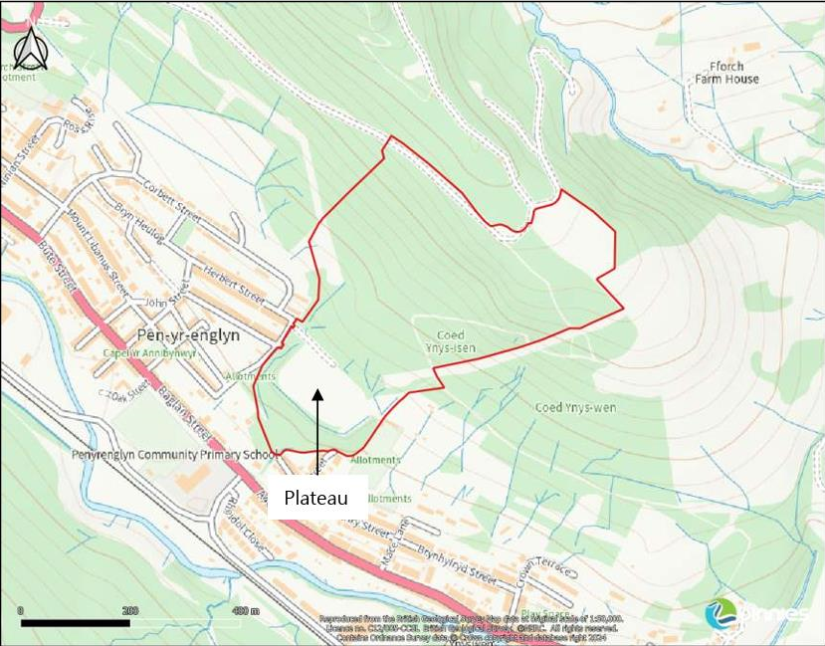
Figure 1: OS Mapping of coal tip (binnies, 2025)
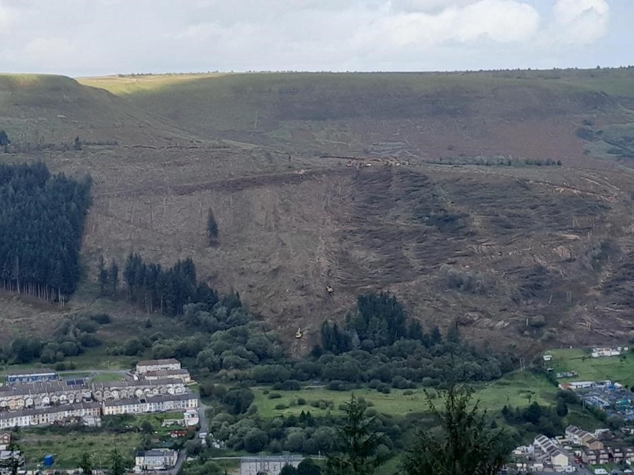
Figure 2: Penyrenglyn coal tip (Natural Resources Wales, 2023)
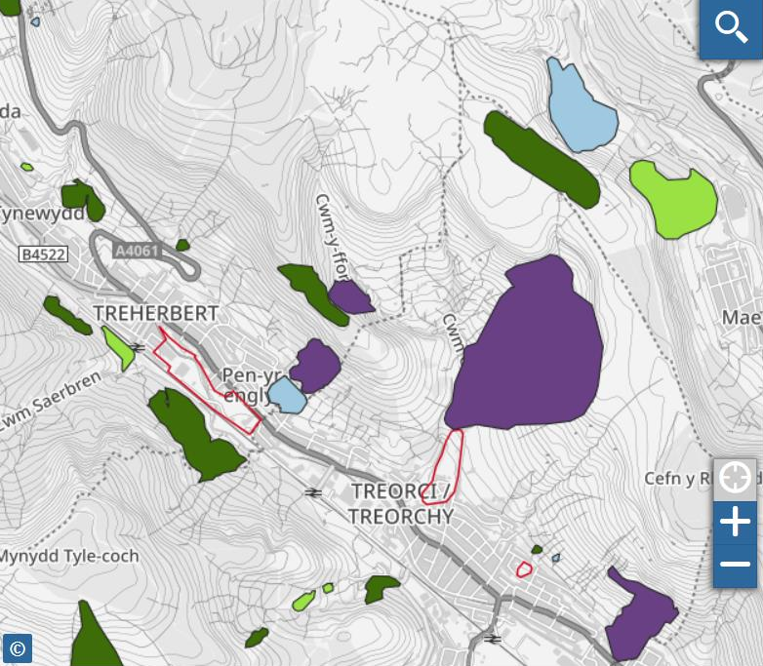
Figure 3: Penyrenglyn disused tip Category D (Purple) (Welsh Govermnent, 2023)
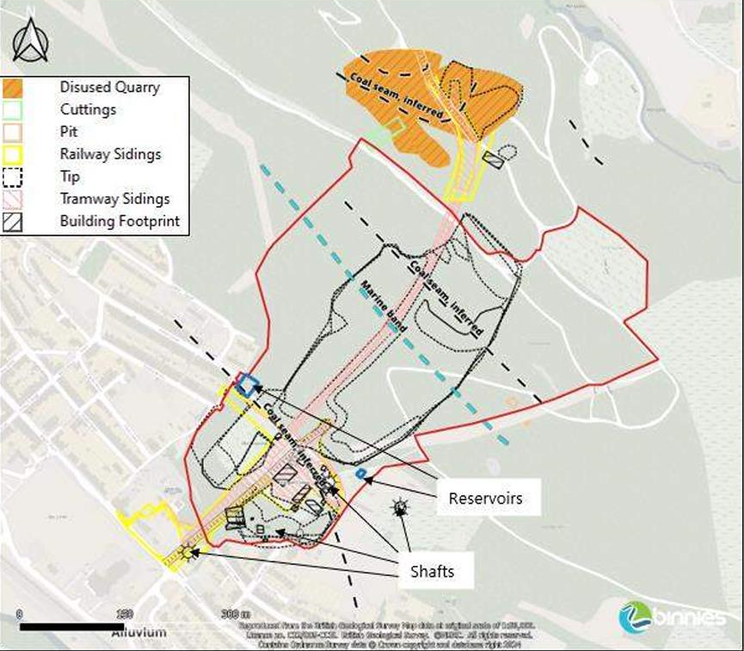
Figure 4: Historical above-ground industrial land use extents (binnies, 2025)
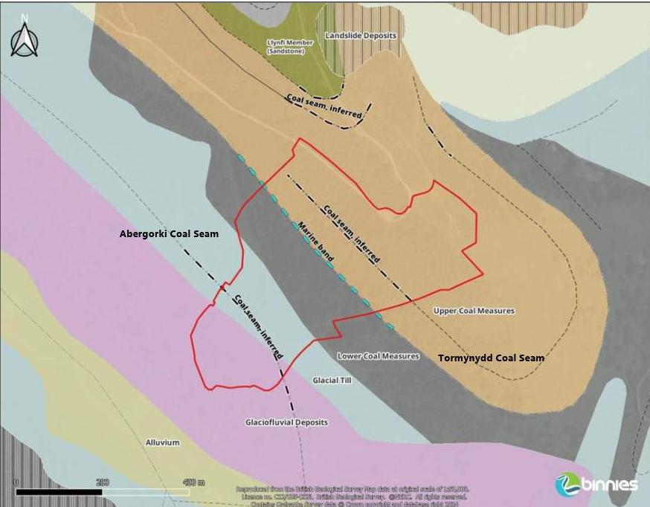
Figure 5: Superficial & Bedrock Geology (Groundsure, 2023)
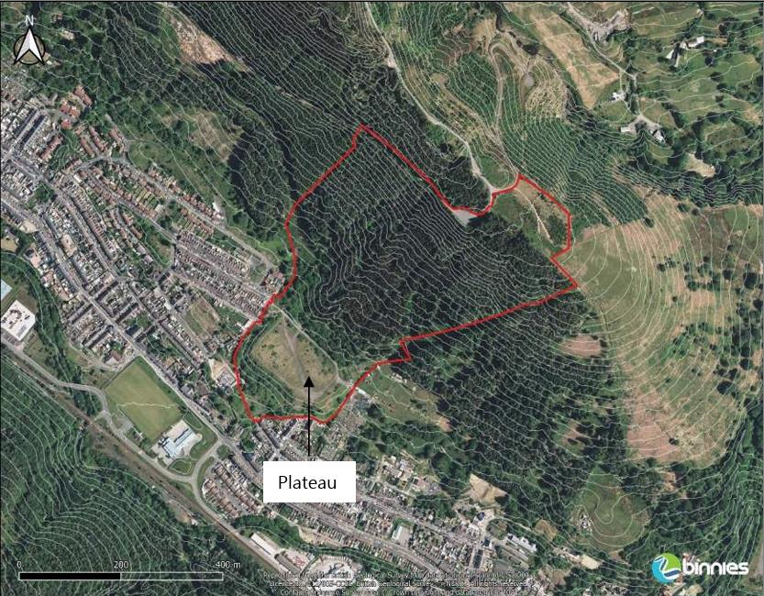
Figure 6: 2024 Site aerial imagery with 5m contours (binnies, 2025)
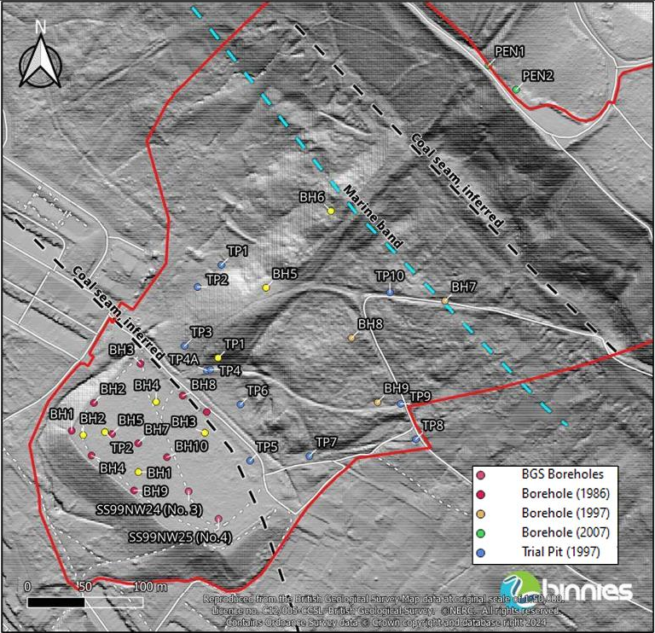
Figure 7: Location of boreholes for ground investigation (binnies, 2025)
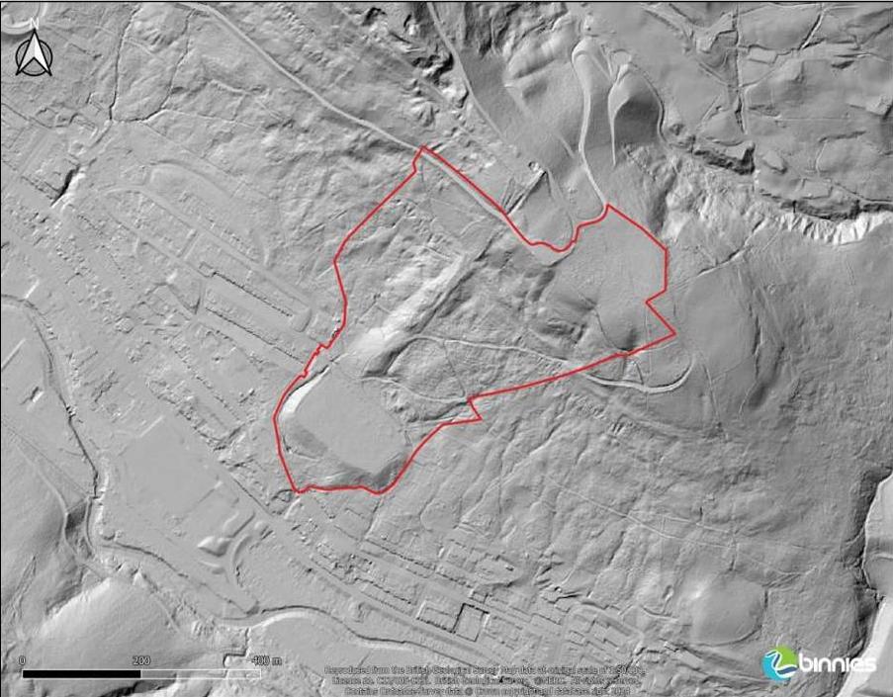
Figure 8: DTM Lidar (1m) 2020 hill shade mapping (binnies, 2025)

Risk Assessment
Identified hazards and risks posed with the site and works that need to be carried out, the aim of the risk assessment is to document risks associated and mitigate to reduce the risk completely or find alternative outcomes.
Hazard | Likelihood | Reason | Triggers | Severity | Risk Rating | Mitigation
Slope Failure/Landslip | Likely | Category D – Highest category with potential impact to public safety. | Movement scars exacerbated following storm events such as Storm Dennis in 2020 and lack of drainage measures. (Natural Resources Wales, 2025) | Severe – Risk to residential properties, business, infrastructure, electricity, nearby primary school and primary A class highway. | High | Installation of drainage systems to reduce infiltration and lower pore water pressure.
Mining Legacy | Likely | Significant mining history with many mine entries nearby. | Unstable soil and ground gas emission | Severe – Risk to soil stability, putting workers and nearby community at risk. | High | Intrusive site investigation and plotting of shafts and entries.
Environmental Contamination | Likely | Tip will potentially contain heavy metals, sulphides and chlorides. | Exposing of tip waste material from remediation or site use/trespassing. | Moderate – Risk to human health low due to testing of soil. Risk to controlled waters, testing of surface water showed copper and zinc (binnies, 2025). | Moderate | Proposed works to to drainage infrastructure will reduce risk to low.
Flooding | Likely | Increased water flow because of added drainage measures | Addition of drainage network causing downstream flooding | Moderate – Storm events causing material movement and infiltration, water has to be distributed to prevent landslide. | Moderate | Design system that controls water before discharging, addition of possible water tank to manage flow.
Construction Works | Likely | Heavy machinery on unstable made ground, shallow obstructions & access to site. | Extensive vibrations from machinery and excavation making the tip more unstable. | Severe – Harm to construction workers and surrounding communities and nature/conservation. | High | Design for best engineering practices such as providing reinforcement pads to distribute loading when excavating. Reduce noise and vibration through fencing and floor padding. Plan for access, ecological and procedures.
Table 2: Risk assessment

Engineering Remediation Plan
Based on available surveys, reports and relevant documentations there will be a short- and long-term remediation plan outlined below that encompasses the required work to monitor, maintain and alleviate the potential for harm using civil engineering techniques and practices on the coal tip. This can be utilised by stakeholders, designers and engineers to initiate works with safety at the forefront of impact and eliminate the likelihood of any collapse.

5.1 Short Term Plan
Due to the classification of the site being identified as a category D with potential to impact public safety, it is paramount that the site is documented by the following;
Site setup and Access
- Site inspection – By foot & aerial
- Photographs – Handheld photos of cracks, seepages or other significant features
- Drone survey
- Topographical survey using LIDAR
- Baseline groundwater surveys using piezometers for regular readings
- Produce health and safety plan
- Risk assessment for individual locations and works
- Identify access for HGV and machinery without disrupting local community
- Signpost site for danger of trespassing and hazards
- Designate footpaths
- Traffic Management for access and egress
- Use of spider excavators to reduce human risk and dissipate loading
Temporary water runoff measures
- Temporary drainage channels to filter rainfall away from site
- Install silt fences and filter bags to reduce contamination from tip
- Setup water level monitoring
- Document water testing
- Marker post drainage channels

5.2 Long Term Plan
Once temporary solutions have been set up and surveys have been carried out, there is scope to input civil engineering practices to remediate issues and reduce risks. Monitoring and maintenance will need to be documented, recorded and consistently carried out to ensure best practice and to inform stakeholders.
Maintenance and Monitoring schedules
These tasks should be carried out more frequent and reported on consistently weekly and monthly.
- Regular, more frequent inspections collaborated with NRW and The Coal Authority as well as updating The Welsh Government
- Accurate filing and documentation to keep records
- Install permanent piezometers, inclinometers and crack gauges for regular surveys and comparison
- Datalogging using software for real time accuracy
- Scheduled cleaning of drainage catchments and sediment traps
- Vegetation control
- Monthly progress reports of data, rainfall, movement and trends with reports available for stakeholders
Permanent Solutions
- Regrading of sections where instability is documented
- Reinforcement of slopes
Soil can be reinforced using geotextile methods that utilise polymer sheets to provide layering and distribute loads. Another method can be the use of soil nailing which is usually used to stabilise landslides that features drilling steel bars into the soil. Both methods can be very costly and will not fully reduce the risks but will aid in stabilising the structure.
- Implement vegetation where excavation or remedials have been carried out to control erosion and promote ecology
Remediation from vegetation can be utilised to bring nature back to the tip including habitants that can thrive and offer a structural advantage.
- Design and implement subsurface drains to reduce pore water pressure from coal seam
Historic spring line covered by tipping at the higher part of the slope. Testing revealed that if groundwater phreatic (zone of saturation) is below mid height of tipped mass, it will remain stable (binnies, 2025). Proposed subsurface drainage are to be designed to maintain groundwater head below 5m to maintain factor of safety.
- Install and test outfalls with sediment capture
- Monitor downstream waterflow to reduce flooding
- Capture rainfall through channels off the tip to reduce infiltration
The proposed drainage systems are to be designed and implemented with the maximum long-term efficiency and risk reduction, the main goal is to stabilise the slope but also to manage volume of discharged water downstream to not increase flood risk and erosion. With the concerns of climate change and increased heavier rainfall, drainage channels will be utilised to disperse this runoff before it becomes an oversaturation incident, outfalls will manage the volume, and monitoring will capture trends and help tighten maintenance schedules.
Permanent solutions need to be approached in a manner of acknowledging trade-offs between safety improvement and carbon footprint. Offsetting carbon footprint from activities such as excavation is a prime example as the need for the activity is high to remove weaknesses in the structure and provide sufficient drainage, if this works the offset would far outweigh the negatives and provide safety for communities and reduce the need for remedials in the future.

References
Bahr, B., 2024. Poorly-graded soils. [Online]
Available at: https://fiveable.me/key-terms/introduction-civil-engineering/poorly-graded-soils
[Accessed 23 11 2025].
bbc.co.uk, 2021. Climate change: Life in the shadow of Wales' landslide coal tips. [Online]
Available at: https://www.bbc.co.uk/news/uk-wales-59160734
[Accessed 27 11 2025].
Bedford, F. G. C., 2022. Modelling flooding due to runoff from spoil heaps during heavy rainfall. [Online]
Available at: https://journals.sagepub.com/doi/epub/10.1080/25726668.2022.2143645
[Accessed 25 11 2025].
binnies, 2025. Interpretive Ground Investigation Report. [Online]
Available at: chrome-extension://efaidnbmnnnibpcajpcglclefindmkaj/https://ymgynghori.cyfoethnaturiol.cymru/south-central-wales/penyrenglyn-coal-tip-consultation/user_uploads/-22b--4021526-buk-zz-00-rp-ge-00003_interpretive-ground-investigation-report_p01_ver1.pdf
[Accessed 27 11 2025].
binnies, 2025. Project Envioronmental Report. [Online]
Available at: chrome-extension://efaidnbmnnnibpcajpcglclefindmkaj/https://ymgynghori.cyfoethnaturiol.cymru/south-central-wales/penyrenglyn-coal-tip-consultation/user_uploads/-12--4021526-buk-zz-00-rp-en-00001_project-env-report_p03_ver1.pdf
[Accessed 28 11 2025].
Coal Action Network, 2024. Coal tip remediation - not coal tip mining. [Online]
Available at: https://www.coalaction.org.uk/2024/11/27/coal-tip-remediation-not-coal-tip-mining/
[Accessed 19 11 2025].
Gong, D. N. Y. L. Y. L. Q. H. Y. T. H. Z., 2024. Herbaceous Vegetation in Slope Stabilization, s.l.: s.n.
gov.wales, 2025. Coal Tip Safety. [Online]
Available at: https://www.gov.wales/coal-tip-safety#:~:text=The%20response%20provides%20an%20overview,and%20maintenance%20regime%20across%20Wales.
[Accessed 19 11 2025].
gov.wales, 2025. disused coal tips: frequently asked questions. [Online]
Available at: https://www.gov.wales/find-disused-coal-tips-frequently-asked-questions-html
[Accessed 19 11 2025].
gov.wales, 2025. Record investment in coal tip safety continues to protect Welsh communities. [Online]
Available at: https://www.gov.wales/record-investment-coal-tip-safety-continues-protect-welsh-communities
[Accessed 19 11 2025].
Hancock, L. R. W., 2003. The design of post-mining landscapes using geomorphic principles, s.l.: s.n.
ICE, 2025. Aberfan disaster – lessons learned. [Online]
Available at: https://www.ice.org.uk/what-is-civil-engineering/infrastructure-projects/aberfan-disaster-lessons-learned
[Accessed 19 11 2025].
Kainthola, V. S. S. G. T. N., 2011. A Coal Mine Dump Stability Analysis—A Case Study. [Online]
Available at: https://www.researchgate.net/publication/235217201_A_Coal_Mine_Dump_Stability_Analysis-A_Case_Study#:~:text=Abstract%20and%20Figures,slope%20height%20of%2075%20m.&text=Effective%20shear%20strain%20plot%20along%20the%20slope%20length%20for%20different%20du
[Accessed 25 11 2025].
Landslides Analysis and Management, 2024. Modelling the Control of Groundwater on the Development of Colliery Spoil Tip Failures in Wales, s.l.: s.n.
Law Commission Impact Assessment, 2022. mpact Assessment. [Online]
Available at: chrome-extension://efaidnbmnnnibpcajpcglclefindmkaj/https://webarchive.nationalarchives.gov.uk/ukgwa/20250109100128mp_/https://cloud-platform-e218f50a4812967ba1215eaecede923f.s3.amazonaws.com/uploads/sites/30/2022/03/Regulating-Coal-Tip-Safety-Impact-Asse
[Accessed 19 11 2025].
Law Commission, 2025. Regulating coal tip safety in Wales. [Online]
Available at: https://lawcom.gov.uk/project/regulating-coal-tip-safety-in-wales/
[Accessed 19 11 2025].
Masoudian, M. Z. I. D. A. e. a., 2019. Stability and characterisation of spoil heaps, s.l.: Environmental Earth Sciences.
Nation Cymru, 2025. Predicting the next coal tip disaster. [Online]
Available at: https://nation.cymru/opinion/predicting-the-next-coal-tip-disaster/
[Accessed 19 11 2025].
Natural Resources Wales, 2023. Penyrenglyn Coal Tip Risk Management. [Online]
Available at: https://ymgynghori.cyfoethnaturiol.cymru/south-central-wales/penyrenglyncoaltip/
[Accessed 01 12 2025].
Natural Resources Wales, 2025. Drainage Strategy. [Online]
Available at: chrome-extension://efaidnbmnnnibpcajpcglclefindmkaj/https://ymgynghori.cyfoethnaturiol.cymru/south-central-wales/penyrenglyn-coal-tip-consultation/user_uploads/-09--pen-yr-englyn-landslide-risk-management-drainage-strategy-report_ver1.pdf
[Accessed 28 11 2025].
Redstart, 2021. Tylorstown Landslide Impact Assessment. [Online]
Available at: chrome-extension://efaidnbmnnnibpcajpcglclefindmkaj/https://www.rctcbc.gov.uk/EN/GetInvolved/Consultations/CurrentConsultations/PhaseFourofTylorstownLandslip/Relateddocuments/EnvironmentalStatementReportAppendicesNotec/Appendices/13.MajorAccidentsandDisas
[Accessed 25 11 2025].
S. Fityus, G. H. T. W., 2008. Geotechnical characteristics of coal mine spoil, University of Newcastle Australia: Australian Geomechanics Journal .
Welsh Govermnent, 2023. Find disused coal tips. [Online]
Available at: https://www.gov.wales/find-disused-coal-tips
[Accessed 01 12 2025].

