Project Planning and Management in Workplace
(BMSW5104_BIRM)

Student Name – Mustafizur Rahman
Student Number – 1711957
Lecturer Name – Paul Ranson
Group - One

Executive summary
The report defines the methods and approaches that are applied to progress with the project in the case study, the report scrutinises all the tools that are compulsory in managing a project. Similarly categorising the difficulties which can rise inside the project. Likewise, the focus will be on the steering group, and the way we co-operate with each other, lastly a conclusion to summarise the entire report regarding project management.

Contents
Contents 2
1. Introduction. 5
2. Outline the case study of Vintners Antiques. 6
3. Steering group. 6
4. Risk involved in project management. 7
5. Techniques or tools that will be utilized. 8
5.1. Users stories. 8
5.2. Product project technique. 9
5.3. Gantt Chart. 11
5.4 Changing or altering (iron triangle). 11
6. Waterfall Model. 12
7. Conclusion 13
8. Reference 14

Table of Figures.
Figure 1: Method applied to risk management ……………………………………………… 8 Figure 2: Users Stories (micro-soft planner) …………………………………………………… 9
Figure 3: Gantt Chart……………………………………………………………………………. 10
Figure 4: Iron triangle………………………………………………………………………………11

List of tables.
Table 1: Defining steering group roles.…………………………………………………………. 6
Table 2: Task and Day to achieve Chart… …………………………………………………….9
Table3: Product project technique…………………………………………………………… 10

Introduction.
This report defines the techniques and approaches taken to develop the project in the case study of relocating the Vintners antiques present business to Spark hill from Shirley. The project is being managed for the proprietors of Vintners antique (their steering group) this report will highlight their accountabilities to the project and how both parties will co-operate with each other in the future. Likewise, the report inspects the techniques applied, identifying the significance of these techniques in managing projects. Also recognizing the practical issues that is able to rise inside the project management and highlighting the methods used to mitigate the problems that can appear.

REPORT

Outline the case study of Vintners Antiques.
This project is being developed for Vintners Antiques, which is an antique shop presently running their business in Shirley trade antiques to the surrounding nearby areas and also nationally. Vintners Antiques also are the owners of a warehouse in Spark hill, where their goods are kept. The project involves relocating the vintners antiques present trade to Shirley to Spark hill. Being a project manager. The objective of writing this report is to inform the Boston Consulting Group (BCG) on how this project will be handled, as a student, the learnings that have been achieved at the university will be put to use.

As you are one of the five largest consulting firm in the world, by obtaining your feedback regarding the approaches, techniques and tool, it will enhance the knowledge and understanding of project management. According to Stern and Daimler (2006), BCG is one of the leading consulting group in the world.

Steering group.
Applying the Roberts 2012 approaches. To manage this project, it can be assumed that the steering group ought to be structured like this diagram. According to Sam and Scherer (2006), steering groups are made up of the business management team, the purpose of the steering group is to make sure that all process is followed according to the guideline of project management. It is important for steering group and the project manager to interact together properly. The process which is going be applied is telecommunications, email and live web chats on a steady basis.



Doreen Vintners Denis Vintners Omer King Shuha Madani

Outlining the steering groups characters
Doreen Vintner should take the responsibility of the sponsor, who is going to take the decisions. Collaborating with the project manager regarding any new decisions, changing or modifying anything or changing any existing decisions and supervising on the way the project is developing. | Denis Vintners should be the commercial personality who deals with all the plans about the company and its funds. He gives the impression of being a very knowledgeable individual.
Omer King should be the specialist character, who is going to continuously stay in contact with the project manager regarding any desires or needs management.. | Shuha Madani should take on the accountability of the user character, having to dispute in favour of the management and employees that are going to work in the warehouse.
Table 1: Outlining steering group characters. (source. Roberts 2011)

Risk involved in project management.
It can be assumed that project managers are many faced with many challenges and risks connected to project management. As projects are established around guesses and estimates, some of the most noticeable risks involved in project management have to be mitigated are listed below.

Time estimation. Supervising this project, one of the most vital problems that will be encountered concerning completing this project is time estimation for each stories accurately. According to Willumsen (1984) as time for short stories are guesses and estimates and each stories are discrete from others, it’s not all the time you are likely to come up with correct estimations of the time.
Impacts. Making a mistake in guessing the time scale of stories incorrectly will impact the project and its stories. These authors Trkman, et. al. (2019), claim that every task (stories) are linked to each other and if one stories is postponed, then the others stories will automatically be delayed as all the stories are linked together and they all can be affected.

Risks associated with suppliers. Handling this project, it can be understood that there are many risks connected with the suppliers such as equipment failing, the order can be misunderstood or lost, goods can get damaged, broken on delivery or incorrect products delivered from the supplier, for example shelves or worktops that are too big or to small.
Impacts. This can have an influence on the delivery time of the goods. If the products arrive late, then this suggests that the task which requires these specific goods will be behind. If default or improper products are delivered, this means these products has to be replaced or exchanged, arising in more backlog.

Unanticipated situations. Handling and developing the project, there is always a challenges with unexpected situations, each and every one of us are human’s, for instance, someone can be unwell or sick or the project managers might not be able to understand the Gantt chart correctly or insufficient cash flow when progressing along the project.
Impact. Difficulties like this will create a backlog in the project for a specific period of time as no one can predict, anticipate or have control over this types of issues. This issues needs to be solved or find alternative approaches on putting the project on track again.

  - Solutions.
Being a project manager, before applying the approaches, the above key factors and other issues had to be kept in mind, recognising every potential risks to this project, arranging the risks in order, creating a risk reaction plan, keeping records and track of all the risks that have been recognised, informing the steering group on any updates or changes and every action that are taken in respects to finding solutions to the arisen risks, adding extra two weeks for the accomplishment of the project. According to Roberts (2011) there are 4 main phases to decreasing a risk. Underneath is a drawing of the 4 phases.

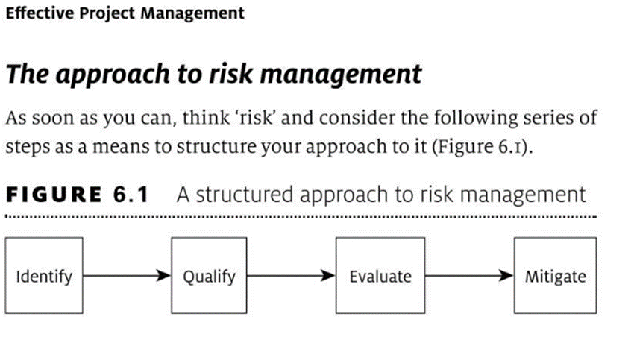
Figure 1: Method applied to risk management.
(Source Roberts-2011, pp.142)

Techniques or tools that will be utilized.

5.1. Users stories.
Primary technique which should be applied will the user’s stories, as you know, we have formerly approved the user’s stories that will be applied in your new warehouse in spark hill. Briefly defining what user’s stories are and how they are going to be applied in project management. Aim of this technique is not to discover answers, but to recognise the cause of the issue that a project requires to answer. Users stories is short sentences, what are written on posit notes, micro soft planner is often utilised to create user’s stories on.

These authors claim Meredith, et. al. (2017), user’s stories can be written by various manager’s stakeholders, clients or team members. This technique is beneficial in co-operating with stakeholders as posit notes can be relocated to where you think its suitable, the 3 main phases are, must have - want to have - nice to have, as all stories produced by stakeholders are not similar and must not be left unattended, the method that is used in resolve them is they have should be arrange in the way it’s done below, so it is easier in solving them.

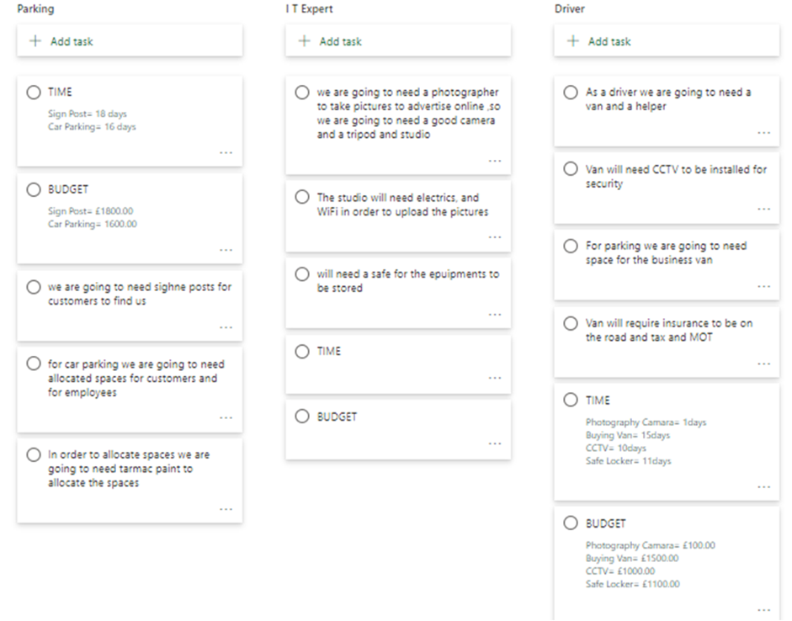
Figure 2: Users Stories (micro-soft planner). (source Author)

5.2. Product project technique.
Following methodology used is to work out accurately workout approximate time of long each stories will take to complete, to achieve this, utilization of an another process of Roberts identified as product project technique (Delphi technique) will be applied to get the best guesses in how complexed each stories would be, also the possibility of how the stories to resolve, this requires haggling with all the traders to get the best results. According to Roberts (2012), he called this approach the wisdom of the crowd. Underneath is a sample of this method.

TASKS DAYS TASKS DAYS
Electric 7 Washroom / Toilet 7
Internet connections / laptop 1 Alarm / CCTV Cameras 1
Roofing 10 Gas 6
Painting / Decorating 4 workshop 6
Central heating 4 Partitions / walls 5
Reception Counter 3 Lightings / Wirings 5
Business Vehicle 4 Industrial Bins 4
Signs 2 Outside Parking Space 1

Table 2: Task and Day to achieve Chart. (source Author)

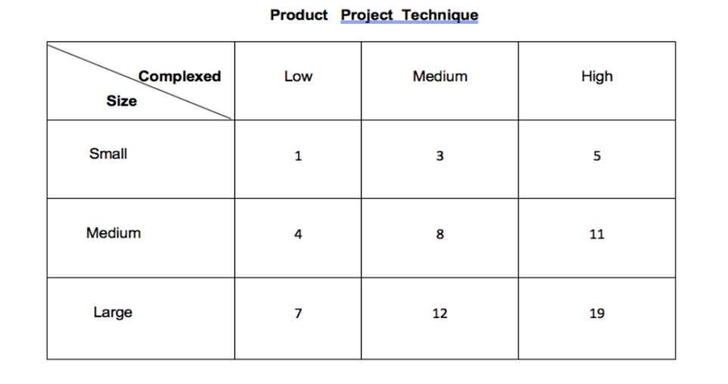
Table 3: Product project technique (source Author).

5.3. Gantt Chart.
Gantt Chart is a distinctive procedure of recognising each and every task (stories) must be focused on and in which pattern the stories should be completed in final project. A cross the upper level of the Gantt chart is a calendar and the tasks or stories and at the left side of the chart, each block signifies how many days it will take to complete that task and in that order the task is placed suggests when the task should begin in the project. According to Bourne (2015), Gantt chart helps to indicate how the project is going to advance and also assist in monitoring the movement of all the tasks, for instance. To complete a task, it will take 5 working days and 2 day’s work has been already being done on that task, then the two days have to be highlighted red to indicate that the two day’s work is achieved. It is essential to communicate with the steering group on the updates of the Gantt chart and the stories and explain every step of the procedure.

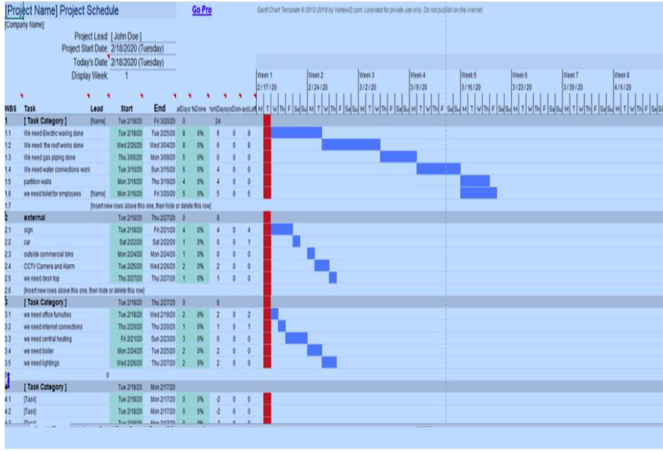
Figure 4: Gantt Chart (source author)

5.4 Changing or altering (iron triangle).
The tools that have been utilised are significant for project management, these tools and techniques assist in generating a balance in managing a project effectively. These authors claim Pollack et. al. (2018), that once you have made your mind on the final details of the project and you have the approval of the steering group, then the Iron triangle is locked.

Afterwards, if there is an alteration required, for instance add another stories or decide to save on costs, well it cannot be done easily, since the iron triangle is rigid, by finalising all the details in the plan a balance has been created. Otherwise, if it’s necessary to alter or add anything, then you have to at least alter one of the corner, probably more. This indicates that either it will take longer to accomplish the project or the costs will increase.

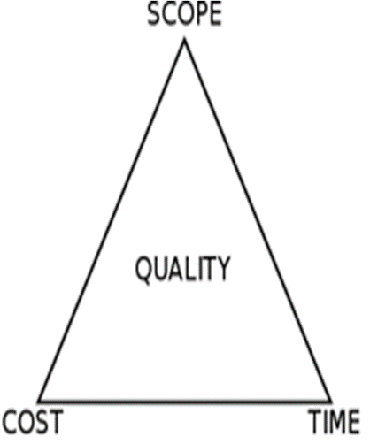
Figure 5: iron triangle
(Source: Heagney .2011)

Waterfall Model.
The project was accomplished by using the waterfall model approach. Waterfall model theory is an authentic approach that is applied in layout and expansion the life cycle to establish a structure with a direct and enlightened method. According to Petersen et. al. (2009), is labelled as waterfall since the theory progresses systematically from stage by stage, drifting downward (just the way a waterfall does) going through the stages of knowledge, Initiation, examination, plan, construction, challenging, production/completion, and preserving.

Conclusion
Now this report is complete, it is established that it is important to adopt suitable project management tools and take essential steps necessary to achieve the desired success of the project. This project management involved transferring the Vintners antique present business in Shirley to Spark hill. This project has assisted in gaining and achieving greater understanding and immense knowledge of manage projects, also learning about various approaches and methods that will help in handling projects such as appropriately collaborating with the steering group, by completing this project, it has been recognised, the importance of Delphi techniques, Users stories and analysis and understanding the Gantt Chart properly. The report has furthermore helped in recognising the difficulties that a project confronts and how to apply tools and techniques to overcome this issues within the static time framework.

Reference

- Bourne, L., 2015. Making Projects Work: effective stakeholder and communication management, EBook. (Vol. 19). CRC press.
- Joseph, Heagney. 2011. Fundamentals of project management. Ama com Publisher.
- Meredith, J.R., Shafer, S.M. and Mantel Jr, S.J., 2017. Project Management: A Strategic Managerial Approach. John Wiley & Sons.
- Petersen, K., Wohlin, C. and Baca, D., 2009, June. The waterfall model in large-scale development. In International Conference on Product-Focused Software Process Improvement (pp. 386-400). Springer, Berlin, Heidelberg.
- Pollack, J., Helm, J. and Adler, D., 2018. What is the Iron Triangle, and how has it changed? International Journal of Managing Projects in Business.
- Roberts, Paul. Effective project management: Identify and manage risks plan and budget keep projects under control. Kogan Page Publishers, 2011. pp 139-160.
- Roberts, P. (2012). Strategic Project Management: Creating the Conditions for Success. London: Kogan Page Publishers.pp.66-71.
- Sam, M.P. and Scherer, J., 2006. The steering group as policy advice instrument: A case of “consultocracy” in stadium subsidy deliberations. Policy Sciences, 39(2), pp.169-181.
- Stern, C.W. and Deimler, M.S. eds., 2006. The Boston consulting group on strategy: Classic concepts and new perspectives. John Wiley & Sons.
- Trkman, M., Mendling, J., Trkman, P. and Krisper, M., 2019. Impact of the conceptual model's representation format on identifying and understanding user stories. Information and software technology, 116, p.106169.
- Willumsen, L.G., 1984, July. Estimating time-dependent trip matrices from traffic counts. In Ninth international symposium on transportation and traffic theory (pp. 397-411). VNU Science Press Utrecht.

