

Student name: Nazra Bibi
Student ID number: 2321286
Programme: BA (Hons) Leadership and Management Skills for the Workplace
Module: Research Methods for Business
Module code: LCLM6004
Lecturer: Dr Ashikul Alam
Assignment Title: Component 1 – Business Research Proposal
Title: Investigating the Role of Staff Training in Improving Service Quality and Customer Satisfaction in a Small Hospitality Business

Contents
1.Introduction 3
2. Identification of the Business Problem 3
3. SWOT Analysis of Staff Training in a Small Hospitality Business 4
4. Research Aim 5
5. Research Objectives and Questions 5
6. Literature Review 5
7. Conceptual Framework 6
8. Research Methodology and Design 6
9. Research Design Table 7
10. Data Collection Methods 7
11. Sampling Strategy 8
12. Data Analysis 8
13. Reliability, Validity and Research Quality 9
14. Ethical Considerations 9
15. Proposed Research Timeline 9
16. Business Relevance and Practical Implications 10
17. Limitations 10
18. Conclusion 10
19.Reference List 10

1.Introduction
Business research aids organizations in problem-solving, evidence gathering, and decision-making. Business research is a methodical investigation that offers data to assist managerial decision-making, according to Cooper and Schindler (2014). Customer service is a crucial component of corporate performance in the hospitality sector since consumers evaluate a company based on the quality of its products as well as the professionalism, behaviour, and communication of its employees.

The lack of regular employee training and its potential effects on client happiness and service quality in a small hotel business are the chosen business issue. This is important since front-line employees are crucial to providing positive client experiences in cafés, restaurants, and dessert stores. Employees oversee
receiving orders, preparing goods, responding to grievances, and keeping things tidy. Customer satisfaction and service standards may suffer if they are not adequately taught.

Staff training gives workers the information, abilities, and self-assurance they need to work well (Armstrong and Taylor, 2020). However, training is frequently informal and may occur during hectic shifts in small organizations. Employees may deliver inconsistent service, make mistakes, or communicate poorly with consumers in the absence of a formal training plan, documented standards, or frequent follow-up.

This issue is significant because poor service can damage customer trust and business reputation. Zeithaml, Bitner and Gremler (2018) argue that customer satisfaction depends on whether customer expectations are met or exceeded. Therefore, this research will investigate current training practices, staff perceptions, management views and customer feedback to identify training gaps and recommend practical improvements.

2. Identification of the Business Problem

The primary business issue is that customer happiness and service quality may be impacted by uneven employee training. During their shifts, employees in a small hospitality business are expected to accomplish many responsibilities. Serving guests, making drinks or desserts, handling online orders, upholding hygienic standards, and handling client complaints are a few examples of these duties. Staff members might not comprehend the desired level of work if they are not given proper instruction.
The issue is complicated because there may be multiple contributing factors to subpar service. Lack of knowledge, poor communication, low confidence, inadequate supervision, a heavy workload, time constraints, employee turnover, or confusing processes could all be contributing factors. According to Saunders, Lewis, and Thornhill (2019), before formulating research questions and methodologies, business research should start with a well-defined problem or management conundrum. The management conundrum in this situation is whether organized employee training could raise customer happiness and service quality.
Business performance may be impacted by this issue in several ways. Employees with little training may make more mistakes, deliver uneven service, or find it difficult to handle complaints. Negative customer experiences may result from this. According to Heskett et al. (1994), customer satisfaction and profitability are impacted by service quality, which is influenced by employee capability and satisfaction. Therefore, enhancing employee training could benefit both corporate performance and consumer experience.

3. SWOT Analysis of Staff Training in a Small Hospitality Business

The training that is now provided may be irregular and unstructured.
Small firms might not have as much money or time for training.
Different employees may teach new hires different techniques.
It's possible that managers don't always keep an eye on how well training is being implemented.

Employee confidence and productivity can both be enhanced by training.
Employees with greater training are probably less likely to make mistakes.
Training can lower complaints and enhance customer service.
Teamwork and service consistency can be enhanced by well-defined procedures.

Weaknesses
Strengths

Threats

Negative evaluations and a decline in business might result from subpar service.
Competitors could draw clients and provide superior service.
Training may become more challenging if there is a high personnel turnover rate.
Staff may disregard service standards due to hectic shifts.

Online reviews and customer happiness can both be enhanced by structured training.
Staff members can learn from customer concerns.
Employee retention and motivation can be enhanced through training.
By providing superior service, the company can strengthen its reputation.

Opportunities

Staff training clearly benefits the company, according to the SWOT analysis. It can boost employee confidence, cut down on errors, and promote higher-quality services. However, shortcomings including time constraints, informal teaching, and a lack of oversight could make training less effective. According to Noe (2020), to guarantee that training enhances performance, it must be connected to organizational objectives and appropriately assessed.

4. Research Aim
This study aims to examine the impact of employee training on customer satisfaction and service quality in a small hospitality business. The study intends to investigate whether regular, organized staff training might enhance workers' self-assurance, expertise, communication abilities, and capacity to provide high-quality service. Additionally, it will look at how training might improve complaint management, lower service errors, and boost customer satisfaction. By examining this problem, the study will assist in identifying training deficiencies and offer workable solutions that can promote higher service standards and improved corporate success.

5. Research Objectives and Questions
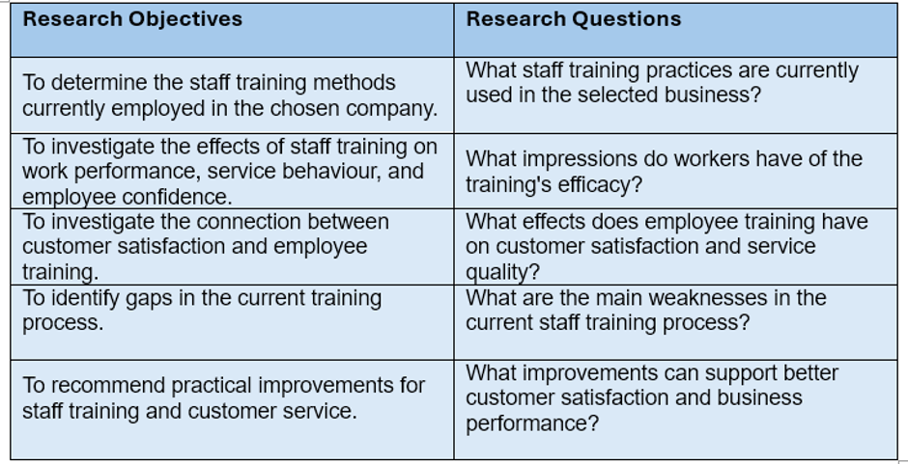
The study's overall goal is in line with the objectives and research questions. Research questions should direct the research design and assist the researcher in determining what data must be gathered, according to Saunders, Lewis, and Thornhill (2019).

6. Literature Review
The researcher can better grasp current theories, knowledge, and gaps related to the selected issue by doing a literature review. According to Hart (2018), a literature review should do more than just report prior research; it should also analyse and assess it. Employee training, customer satisfaction, service quality, and business performance are the study's main themes.
Because it increases workers' knowledge, abilities, and self-assurance, staff training is a crucial component of human resource management (Armstrong and Taylor, 2020). In the hospitality industry, where front-line employees interact directly with clients and have an impact on their service experience, this is particularly crucial. According to Noe (2020), training ought to be connected to organizational requirements and assessed to see if it enhances performance.
The focus of this study is service quality. The SERVQUAL model, created by Parasuraman, Zeithaml, and Berry in 1988, incorporates tangibles, assurance, responsiveness, empathy, and dependability. These areas are important because patrons of the hospitality industry need precise orders, prompt service, courteous employees, and tidy facilities.
Service quality and customer satisfaction are closely related. Customers are satisfied when service meets or above their expectations, according to Zeithaml, Bitner, and Gremler (2018). According to the service-profit chain model, customer satisfaction, profitability, and service quality are all impacted by employee capabilities (Heskett et al., 1994).
Motivation may also be enhanced by training. According to Herzberg's two-factor theory, workers are more driven when they are given possibilities for advancement, responsibility, and recognition (Herzberg, 1966). But training is insufficient on its own. Leadership, oversight, feedback, and well-defined protocols are necessary to support it (Armstrong and Taylor, 2020). By concentrating on small hospitality enterprises, where resources may be scarce and training is sometimes informal, this study fills a vacuum.

7. Conceptual Framework
Customer Satisfaction
Staff Training
Employee Confidence
Business Performance
Service Quality

This figure illustrates how employee confidence and service behaviour may be enhanced by systematic staff training, which can subsequently enhance customer satisfaction, service quality, and business performance. SERVQUAL (Parasuraman, Zeithaml, and Berry, 1988) and the service-profit chain model (Heskett et al., 1994) also support this concept.

8. Research Methodology and Design
Because the goal of this study is to solve a real-world business problem and generate practical solutions, it will use a pragmatic research philosophy. Because it enables the researcher to select approaches that best address the study objectives, pragmatism is appropriate (Saunders, Lewis, and Thornhill, 2019).
Since data will be gathered first and then used to find patterns and themes, the study will take an inductive method. This is acceptable because, rather than testing a predetermined hypothesis, the research examines staff training and service quality in a single company environment.
Both qualitative and quantitative data will be combined using a mixed-methods approach. This is helpful since staff and management perspectives can be better understood through interviews, whereas surveys can yield quantitative data (Creswell and Creswell, 2018).
Because the study focuses on a single small hospitality firm in a real-world situation, a case study approach will be used. Case studies are helpful for thoroughly examining real-world problems (Yin, 2018).
Data will be gathered at a single moment in time because the study will have a cross-sectional temporal horizon. This is appropriate as the project doesn't need long-term data gathering and is constrained by assignment deadlines (Saunders, Lewis, and Thornhill, 2019).

9. Research Design Table
A precise plan for conducting the investigation is provided by the research design. Saunders, Lewis, and Thornhill (2019) state that the study design should link the data collecting and analysis techniques with the research questions.

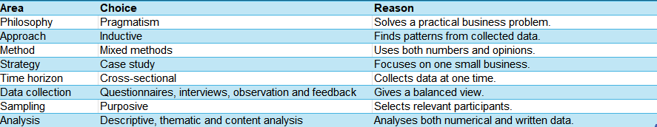
10. Data Collection Methods

The study will use four data collection methods: staff questionnaires, semi-structured interviews, customer feedback analysis and observation.
Employee training, confidence, service knowledge, and support requirements will all be gathered through staff questionnaires. When gathering structured replies from multiple individuals, questionnaires are helpful (Bryman and Bell, 2015).
The manager or supervisor will participate in semi-structured interviews to discuss present training procedures, service issues, and potential enhancements. This approach permits both follow-up conversation and planned questions (Saunders, Lewis, and Thornhill, 2019).
To find typical service problems, such delayed service, inaccurate orders, or staff communication, customer evaluations, complaints, and comments from the previous three to six months will be examined.
To determine if employees implement training and service standards in practice, observation can also be employed during regular business operations (Bryman and Bell, 2015).

11. Sampling Strategy
Purposive sampling will be used in the study. Purposive sampling is the process of choosing participants based on their experience or understanding of the study issue (Saunders, Lewis, and Thornhill, 2019). This is suitable since the study requires data from those who work directly in customer service and staff training.
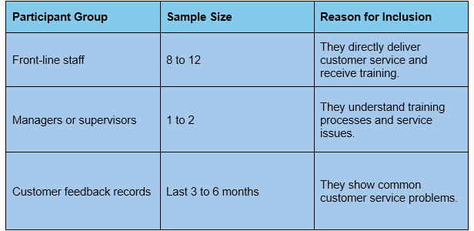

12. Data Analysis
Descriptive statistics, such as averages and percentages, will be used to analyse questionnaire results to clearly summarize staff opinions (Bryman and Bell, 2015).
To find recurring themes, such as confidence, communication, supervision, and training needs, interview data will be subjected to thematic analysis (Braun and Clarke, 2006).
To categorize frequent problems including order accuracy, staff attitude, cleanliness, and service speed, customer feedback will be examined using content analysis (Krippendorff, 2018).

13. Reliability, Validity and Research Quality
Using the same questionnaire for all employees and crafting questions with clarity will increase reliability. To ensure that the questions are simple to comprehend, a brief pilot test could be utilized.
To give a fair assessment of the issue, triangulation will be used to support validity through staff questionnaires, manager interviews, customer feedback, and observation (Saunders, Lewis, and Thornhill, 2019).
By avoiding leading questions, avoiding participant pressure, and basing conclusions on data rather than subjective judgment, research bias will be minimized.

14. Ethical Considerations
Because participants must be treated properly and kept safe, ethical considerations are crucial. Informed permission, voluntary participation, confidentiality, anonymity, and no harm will all be adhered to in this study (Bell, Bryman, and Harley, 2019).
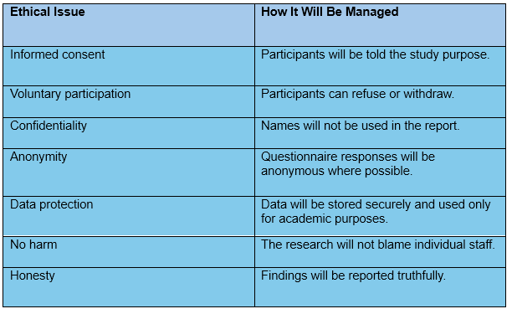
The purpose of the study is to improve training and service quality, not to criticise individual employees.

15. Proposed Research Timeline
The study will take six weeks to finish. Verifying the subject and starting the literature research will be the main goals of the first week. The design and testing of the research instruments will take place in weeks two and three. Weeks 3 and 4 will be dedicated to data collecting; Weeks 5 and 6 will be dedicated to analysis and final writing.

16. Business Relevance and Practical Implications
The company may be able to enhance customer satisfaction, staff training, and service quality with the use of this research. Practical measures like introduction checklists, refresher training, and improved complaint management protocols could be supported by the findings.

17. Limitations
Because the study only looked at one small company, its conclusions might not apply to all hospitality enterprises. Employees could be reluctant to provide candid criticism.

18. Conclusion
This research proposal focuses on the role of staff training in improving service quality and customer satisfaction in a small hospitality business. The selected problem is important because inconsistent training can lead to poor service, customer complaints, low staff confidence and reduced business performance.
The proposal is supported by relevant theories and models, including SERVQUAL, the service-profit chain and Herzberg’s two-factor theory. These theories suggest that staff training can influence employee confidence, service quality, customer satisfaction and business performance.
The proposed research will use a mixed-methods case study approach. Data will be collected through staff questionnaires, manager interviews, customer feedback analysis and observation. The study will follow ethical principles, including informed consent, confidentiality, anonymity and no harm.
The expected outcome is to identify training gaps and recommend practical improvements. These improvements may help the business improve staff confidence, service standards, customer satisfaction and overall performance. Therefore, the proposal is relevant to business decision-making and demonstrates how applied research can help solve real organisational problems.

19.Reference List
- Armstrong, M. and Taylor, S. (2020) *Armstrong’s Handbook of Human Resource Management Practice*. 15th edn. London: Kogan Page.
- Bell, E., Bryman, A. and Harley, B. (2019) *Business Research Methods*. 5th edn. Oxford: Oxford University Press.
- Braun, V. and Clarke, V. (2006) ‘Using thematic analysis in psychology’, *Qualitative Research in Psychology*, 3(2), pp. 77–101.
- Bryman, A. and Bell, E. (2015) *Business Research Methods*. 4th edn. Oxford: Oxford University Press.
- Cooper, D.R. and Schindler, P.S. (2014) *Business Research Methods*. 12th edn. New York: McGraw-Hill Education.
- Creswell, J.W. and Creswell, J.D. (2018) *Research Design: Qualitative, Quantitative, and Mixed Methods Approaches*. 5th edn. London: SAGE.
- Hart, C. (2018) *Doing a Literature Review: Releasing the Research Imagination*. 2nd edn. London: SAGE.
- Herzberg, F. (1966) *Work and the Nature of Man*. Cleveland: World Publishing Company.
- Heskett, J.L., Jones, T.O., Loveman, G.W., Sasser, W.E. and Schlesinger, L.A. (1994) ‘Putting the service-profit chain to work’, *Harvard Business Review*, 72(2), pp. 164–174.
- Krippendorff, K. (2018) *Content Analysis: An Introduction to Its Methodology*. 4th edn. London: SAGE.
- Noe, R.A. (2020) *Employee Training and Development*. 8th edn. New York: McGraw-Hill Education.
- Parasuraman, A., Zeithaml, V.A. and Berry, L.L. (1988) ‘SERVQUAL: A multiple-item scale for measuring consumer perceptions of service quality’, *Journal of Retailing*, 64(1), pp. 12–40.
- Saunders, M., Lewis, P. and Thornhill, A. (2019) *Research Methods for Business Students*. 8th edn. Harlow: Pearson.
- Yin, R.K. (2018) *Case Study Research and Applications: Design and Methods*. 6th edn. London: SAGE.
- Zeithaml, V.A., Bitner, M.J. and Gremler, D.D. (2018) *Services Marketing: Integrating Customer Focus Across the Firm*. 7th edn. New York: McGraw-Hill Education.

