Student Name:Luca Gerardi

Student ID:2219573
Module Name: Strategic Management
Module Code: LCMB7003
Lecturer:
Amare Desta
Zulf Khan
Internal Verifier: Vasilios Tavlaridis
Hoang Nguyen

Master of Business Administration
Assessment component :Report
Word count:5312

AI USE ACKNOWLEDGEMENT
I acknowledge that, in accordance with the module guidelines, I used a restricted variety of digital and AI-supported tools to prepare this evaluation. These tools were only utilised to help with research, finding sources, managing references, and editing my own writing.
The tools used included: UWTSD Library AI Assistant; Microsoft Copilot; RefWorks; Google Scholar , etc]. Google Scholar and RefWorks were used to locate, organise and format academic sources, while any AI-supported tools were used to identify potentially relevant literature, check references, compare or interrogate research materials, and review my own writing for grammar, syntax and readability. Requests to find pertinent scholarly sources, highlight assertions that could need proof, verify that references adhered to Harvard style, and examine my own writing for grammatical or readability problems without introducing new scholarly arguments or substance were typical prompts or directions.
I was in charge of choosing, interpreting, and citing all of the material, and I verified the original sources before utilising them in the evaluation. The strategic analysis, recommendations, structure, and reflective content of the submitted work were not created by AI.
I certify that I have not claimed to be the author of any text or other AI-generated content.

Table of Contents
Table of Contents 2
1. Strategic Management Report: Unilever PLC 3
1.1 Organisational Context and Overview 4
2. External and Internal Environment Analysis 6
2.1 External Environment: PESTEL Analysis and Evaluation 7
2.2 PESTEL - Unilever 8
2.3 Critical Success Factors and Strategic Challenges 10
2.4 Internal Environment: Resources, Capabilities and VRIO 11
3. CSR and Sustainability Objectives 13
4. Comprehensive and Holistic View: Balanced Scorecard 15
5. Strategic Choices and Implementation 17
6. Strategic Evaluation and Recommendations 19
6.1 SWOT Analysis 20
6.2 Practical Recommendations 21
7. Section 2: Reflective Account Using Gibbs' Reflective Cycle 22
References 26

1. Strategic Management Report: Unilever PLC

1.1 Organisational Context and Overview
Unilever is one of the world's largest fast-moving consumer goods (FMCG) companies and operates across food, home care, personal care, and beauty and wellbeing (Unilever, 2026a). Following the merger of Lever Brothers and Margarine Unie, the firm was formally founded in 1930. It was first focused on soap, fats, and margarine before branching out into international branded consumer goods (Unilever, n.d.-a). Approximately 3.7 billion people use Unilever products each day across 190 countries. In 2025, turnover was €50.5 billion; 59% came from emerging markets and 78% from Power Brands (Unilever, 2026a).
While its current goal is development through outstanding brands, innovation, and execution, Unilever's mission is to make sustainable living ubiquitous. Its business strategy transforms international brands and R&D expenditures into locally tailored goods that are marketed through traditional trade, e-commerce, and retail. The model relies on preserving trust while keeping expenses under control because value is generated by brand preference and size but captured through pricing, mix, productivity, and repeat business (Unilever UK & Ireland, n.d.; Unilever, 2026a).
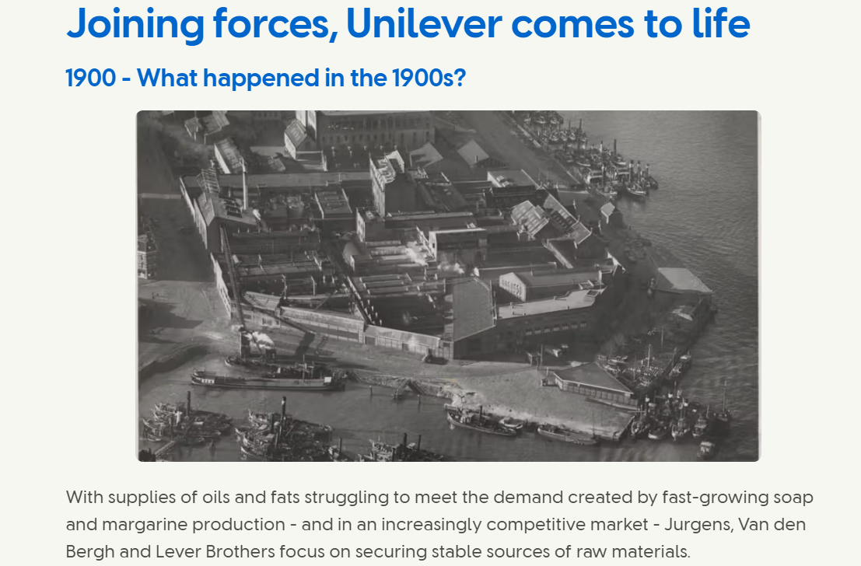
Figure 1. Unilever historical development, 1900-1950. Source: Unilever (n.d.-a).
Integrity, respect, accountability, and innovative behaviour toward stakeholders, communities, and the environment are highlighted in Unilever's corporate values (Unilever UK & Ireland, n.d.). Because of this, the corporation is a good example for analysing the conflict between corporate performance and CSR leadership. Unilever's earlier Sustainable Living Plan helped establish its sustainability position. More recently, the company has moved towards clearer and more measurable priorities, particularly climate, nature, plastics and livelihoods (Unilever, 2026a; Unilever, 2026). This makes it easier to judge whether sustainability actions produce operational and reputational benefits.
High-volume branded consumer goods are the foundation of the company's business strategy, which is bolstered by innovation, worldwide distribution, supply-chain size, marketing investment, and category leadership. With over 16,500 active patents and €836 million invested in R&D in 2025 (Unilever, 2026a), Unilever was able to differentiate itself through product performance and brand innovation.
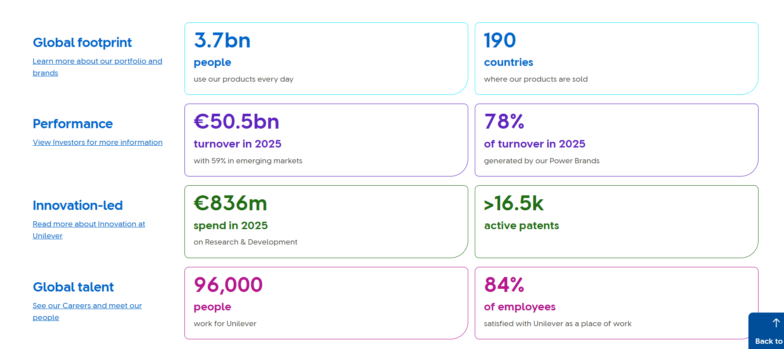
Figure 2. Unilever at a glance. Source: Unilever (n.d.-b).
Using the "Desire at Scale" approach, a "Play to Win" mentality, and a technology-enabled organisation "Fit for the AI Age," its current strategic direction is to become simpler, faster, and more focused (Unilever, 2026a).
The FMCG industry is driven by innovation, price sensitivity, and intense competition. Procter & Gamble, Nestlé, L'Oréal, Colgate-Palmolive, Reckitt, Henkel, and private-label stores are competitors of Unilever. With $84.3 billion in net sales in fiscal 2025, P&G is particularly relevant because it directly competes in fabric care, home care, grooming, cosmetics, and personal care (Procter & Gamble, 2025).
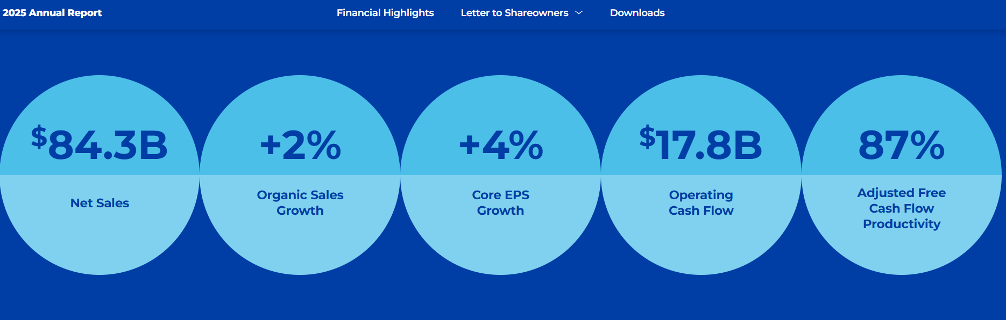
Figure 3. Procter & Gamble 2025 performance highlights. Source: Procter & Gamble (2025).
With €44.05 billion in sales in 2025 and an operating margin of 20.2%, L'Oréal is another significant rival in the beauty and personal care sector, demonstrating the allure and intensity of premium beauty markets (L'Oréal Finance, 2026).
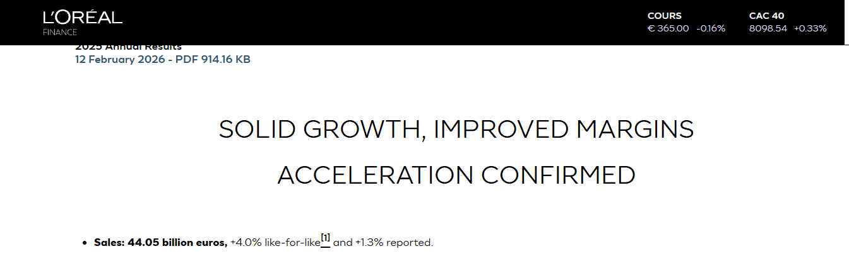
Figure 4. L'Oréal 2025 annual results. Source: L'Oréal Finance (2026).
Consequently, Unilever has a dominant yet fiercely competitive market position. Its benefits include exposure to emerging markets, route-to-market capacity, reliable brands, and worldwide reach. Inflation, competition from private labels, pressure on plastics, scrutiny of ecological claims, and the need to resume volume growth following periods of price-led performance are some of its strategic concerns. A corporate shift toward a more concentrated home, personal care, and beauty-led portfolio is indicated by the division of ice cream and the 2026 deal to merge Unilever Foods with McCormick (Unilever, 2025; Unilever, 2026c).

2. External and Internal Environment Analysis

2.1 External Environment: PESTEL Analysis and Evaluation
PESTEL is a strategic framework used to examine the main external factors that can affect an organisation: political, economic, social, technological, environmental and legal factors. It helps managers identify external risks and opportunities that may influence strategic decisions (Rahman et al., 2025; Vino Ocho et al., 2024).
According to research, PESTEL is adaptable to various sectors and circumstances. One study combines PESTEL with neutrosophic analysis to better manage ambiguity, uncertainty, and conflicting expert opinions. This enhances an organisation's capacity to make adaptable and resilient decisions in challenging circumstances.
Other studies use PESTEL in contexts like big data analytics in sustainable supply chains, where resource optimisation, political support, cultural preparedness, technology compatibility, data security regulations, and environmental objectives are crucial elements. PESTEL is used in Moldovan tourist management to assess conditions unique to the nation in order to lower investment risks and boost competitiveness.
PESTEL and Porter's Five Forces are used in the U.S. retail sector to analyse how technical advancements, demographic changes, regulatory changes, and sustainability trends affect competitive strategy. PESTEL is used in the green construction sector to identify key external factors, demonstrating that while some impacts are powerful now, others may become more significant as the sector develops.
PESTEL analysis is a flexible tool for assessing external factors across industries. Adaptations such as neutrosophic evaluation help address uncertainty, while the framework supports strategic decision-making by identifying key macro-environmental influences and their relationships (Rahman et al., 2025), (Ulubeyli et al., 2019), (Vino Ocho et al., 2024),(Jain, Tambuskar and Narwane, 2024), (Platon, 2018).
Crucially, PESTEL shouldn't be used as a checklist. Economic pressure, environmental regulations, and technological advancements are Unilever's top priorities due to their interplay: inflation increases the need for reformulation and packaging, regulations increase the expense of traceability, and digital systems determine whether improvements can be scaled. Therefore, rather than just describing components, the framework works best when factors are rated according to impact, urgency, and organisational reaction (Jain, Tambuskar, and Narwane, 2024; Vino Ocho et al., 2024).

2.2 PESTEL - Unilever
Political factors
Because its supply chains, manufacturing processes, and markets cover both developed and emerging economies, Unilever operates in a politically complex context. Strategic decision-making is impacted by a number of factors, including import/export regulations, labour standards, food safety regulations, trade limitations, taxation, and political instability. Because it compels businesses selling goods including palm oil, cocoa, coffee, soy, rubber, and wood products on the EU market to demonstrate that their products are not connected to recent deforestation or forest degradation, the EU Deforestation Regulation is particularly pertinent (European Commission, n.d.-a). This presents Unilever with a reputational potential as well as a compliance cost. Its sustainability positioning is supported by its claim that it has achieved 97% independently verified NO deforestation direct sourcing across important crops like palm oil, paper and board, tea, soy, and cocoa. However, the remaining gap is strategically significant because even minor sourcing errors can erode consumer confidence in purpose-driven brands.
Economic factors
Inflation in commodities, packaging, shipping, and wages can affect FMCG companies. When the cost of living increases, consumers in developed markets frequently switch to private-label substitutes. Even in emerging markets with robust underlying demand, currency volatility can lower reported turnover. The firm appears to be attempting to move from price-led growth to more sustainable volume-led development, as evidenced by Unilever's 2025 results, which showed 3.5% underlying sales growth with 1.5% from volume and 2.0% from price. (Unilever, 2026d).
Unilever reported 2.9% volume growth and 3.8% underlying revenue growth in Q1 2026, with emerging countries expanding more quickly than established markets (Unilever, 2026b). This is important from a strategic standpoint since maintaining a competitive edge in FMCG necessitates both price hikes and repeat business. Value-conscious consumers may be drawn to competitors like Aldi, private-label companies, or regional firms if price increases erode customer loyalty.
Social Factors
Consumer expectations are changing, especially around affordability, wellness and sustainability. Unilever's 2025 results show strong performance from Dove and Vaseline and growth in wellness brands such as Liquid I.V., Nutrafol and OLLY (Unilever, 2026d).This validates Porter's differentiation logic, which holds that companies can demand loyalty and price power by providing both functional and emotional benefits (Porter, 1985). But there are risks associated with the social environment as well. Corporate sustainability statements are viewed with greater scepticism by younger consumers, and activist criticism can swiftly proliferate on social media. Therefore, rather than making generalisations, CSR leadership needs to be genuine, supported by data, and connected to quantifiable results.
Technological Factors
Unilever is impacted by technology through supply-chain analytics, digital commerce, AI-enabled marketing, product innovation, and customer insight. Digital capability appears to be becoming a key component of the company's operational model, based on its strategy rhetoric about becoming "Fit for the AI Age", (Unilever, 2026a).
Technology in FMCG encompasses more than just product science; it also includes automated production, social commerce, influencer content, quicker campaign testing, and demand forecasting. Unilever must make sure that technology promotes speed and accountability rather than turning into a corporate catchphrase, in contrast to P&G, which has always placed an emphasis on productivity and integrated execution. This is where McKinsey's 7S model comes in handy because a technology-enabled strategy will only be effective if staff, systems, skills, structure, style, and shared values are all in line (Waterman, Peters, and Phillips, 1980).
Environmental factors
Since many of Unilever's goods depend on agricultural commodities, chemicals, water, packaging, and international logistics, environmental pressure is a key component of the company's strategy. Climate, nature, plastics, and livelihoods are now Unilever's top sustainability concerns. Its Supplier Climate Program seeks to assist priority suppliers in sharing product-level greenhouse gas emissions data, reporting progress, and setting science-based goals (Unilever, 2026).
A large share of Unilever's emissions comes from its wider value chain rather than its own operations, which makes supplier action important (GlobalData, 2026). Plastic packaging also creates reputational risk.
Unilever collected and processed more plastic packaging than it sold, reduced the amount of virgin plastic used in product packaging by 29% compared to 2019, and achieved 25% recycled plastic in packaging by 2025. However, only 57% of its plastic packaging was reusable, recyclable, or compostable, with flexible packaging and sachets still being challenging to address (Unilever, 2026a; Unilever, 2026).
Legal Factors
There is growing legal emphasis on supply-chain due diligence, consumer protection, green claims, and sustainability disclosures. European Sustainability Reporting Standards must be followed by businesses covered by the EU Corporate Sustainability Reporting Directive (European Commission, n.d.-b).
In November 2024, the UK's Competition and Markets Authority concluded its investigation into Unilever's environmental claims. The Authority noted that Unilever had modified several product claims, but it did not express any opinion regarding Unilever's adherence to consumer law (Competition and Markets Authority, 2024). This is important from a strategic standpoint since a corporation may receive procedural legal clearance but still be subject to reputational scrutiny. As a result, Unilever's CSR messaging needs to be accurate, supported by data, and careful.

2.3 Critical Success Factors and Strategic Challenges
Brand equity, innovation pace, distribution size, price-pack architecture, emerging-market performance, sustainability credibility, and cost effectiveness are some of Unilever's key success elements. Because they streamline resource allocation and focus marketing effort on globally scalable brands, the company's Power Brands are strategically significant. Power Brands are essential to Unilever's performance strategy, accounting for 78% of turnover in 2025 (Unilever, 2026a).
But there are still strategic difficulties. First, Unilever needs to strike a balance between premiumisation and affordability. Although many customers are price conscious, premium innovation helps profitability. Secondly, it needs to streamline its portfolio without sacrificing category diversity. The planned Foods-McCormick merger and ice cream demerger may increase strategic focus, but they also lessen the advantages of diversification. Third, it needs to restore its sustainable credibility following the revision of earlier environmental goals. Fourth, it has to contend with fiercely disciplined competitors. P&G's scale and productivity culture offer a helpful comparison: L'Oréal's beauty growth demonstrates the fierce rivalry in high-end personal care, while P&G's 2025 results reflect a larger sales scale than Unilever (Procter & Gamble, 2025; L'Oréal Finance, 2026).
The few areas where excellent performance is crucial are known as critical success factors. These include route-to-market reach, economical price-pack architecture, innovation pace, brand preference, and credible sustainability implementation for Unilever. Market-share change, innovation revenue, distribution availability, repeat purchases, plastic reduction, and supplier-compliance measures should all be tracked since they have a direct impact on volume, margin, or trust (Unilever, 2026a; Procter & Gamble, 2025).

2.4 Internal Environment: Resources, Capabilities and VRIO
According to the resource-based perspective, businesses can maintain a competitive edge by controlling resources that are rare, valuable, hard to replicate, and deeply ingrained in their organisations (Barney, 1991; Knott, 2015; Lin et al., 2012).
Global brands, route-to-market skills, innovation assets, supplier partnerships, sustainability expertise, data capabilities, and emerging-market experience are Unilever's primary strategic assets.
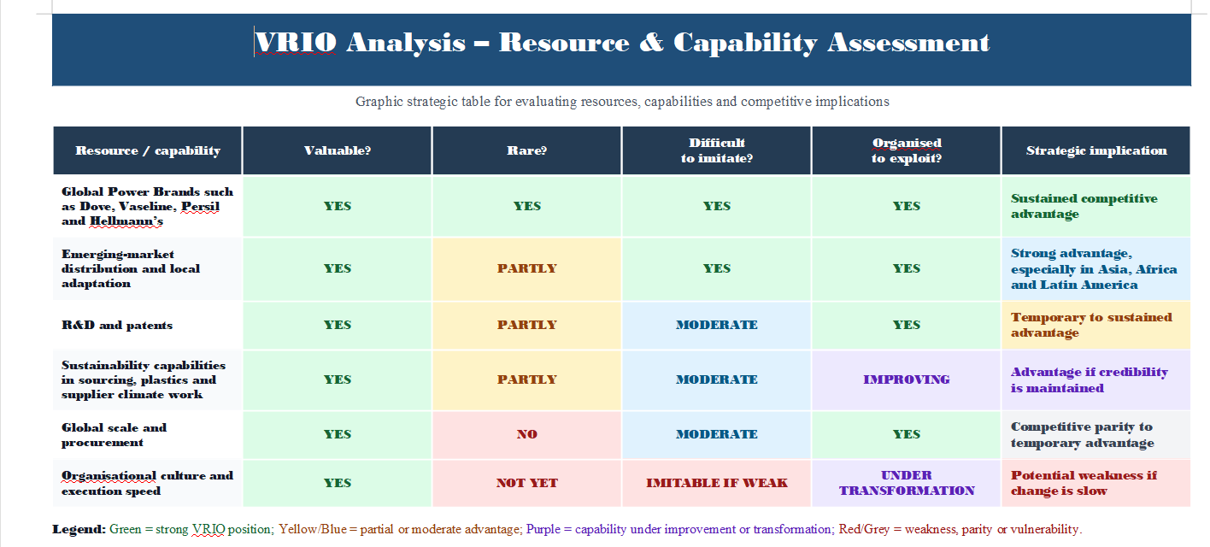
Figure 5. VRIO assessment of Unilever's strategic resources. Source: Author's analysis based on Barney (1991), Knott (2015) and Lin et al. (2012).
Figure 5 summarises the VRIO assessment. Unilever's brand portfolio is its most powerful VRIO asset. Companies like Dove add value through social significance and emotional positioning in addition to practical advantages. Unilever has a CSR-related brand asset because of Dove's longstanding relationship with genuine beauty, but this also raises expectations and puts the firm at risk of criticism if its sourcing or packaging practices don't align with its core principles. This is the point at which competitive advantage and CSR leadership converge: distinction can only be strengthened by purpose when it is backed by reliable operations.
Another key competency of Unilever is its capacity to operate in emerging markets. The corporation has a thorough understanding of local customer behaviour, pricing points, channels, and distribution networks because emerging regions account for 59% of its turnover in 2025 (Unilever, 2026a). Because it relies on connections, local adaptability, and operational learning, it is challenging for new competitors to duplicate. Additionally, Unilever's ability to expand successful ideas across nations while modifying formats and pricing lends credence to Ansoff's market development rationale.
However, not every resource produces a long-term advantage. Scale is important, but P&G, Nestlé, and L'Oréal share it. Although sustainability is important, it is no longer seen as a distinct advantage but rather as a requirement. Consequently, Unilever needs to transform sustainability into cost resilience, product innovation, regulatory readiness, and brand trust. According to Hart's (1995) natural resource-based perspective, environmental capabilities can develop into strategic capabilities when they lower risk, boost productivity, and open up new market opportunities. For Unilever, this implies that rather than being viewed as a messaging subject, sustainability needs to be integrated into sourcing, packaging design, innovation, and performance management.
Advantage is conditional rather than permanent, according to the VRIO analysis. Emerging-market distribution and brand equity are hard to replicate, but they only produce a long-term advantage when local resources, incentives, and processes are set up to take advantage of them. VRIO can oversimplify dynamic competition, as Knott (2015) warns; resources need to be updated as consumer tastes, laws, and technology evolve.

3. CSR and Sustainability Objectives
Because it connected corporate expansion with social and environmental responsibility earlier and more prominently than many FMCG rivals, Unilever has long been seen as a CSR leader. From the standpoint of stakeholder theory, Unilever acknowledges that long-term value is dependent on communities, workers, suppliers, consumers, regulators, and ecosystems in addition to shareholders. Climate, nature, plastics, and livelihoods are its current sustainability objectives. This is consistent with the triple bottom line approach, which contends that businesses should jointly manage their social, economic, and environmental performance (Nisa et al., 2021),(Raja, 2021), (Mirvis, 2008).
Unilever's CSR approach is strengthened by its connection to significant business risks. Climate action matters because agricultural inputs, packaging and supplier emissions affect future costs and supply-chain resilience (Unilever,2026 ; GlobalData, 2026.).Plastics are important because consumers and regulators can see the packaging. Because FMCG supply chains depend on farmers, small merchants, and workers in emerging economies, livelihoods are important. By forcing priority suppliers to set SBTi-aligned targets, report progress, and share emissions data, Unilever's Supplier Climate Program demonstrates a more practical form of CSR (Unilever, n.d.-e).
But now, there is increased competition for CSR leadership. Unilever has come under fire from Greenpeace for its plastic packaging, and the organisation has demanded a more detailed plan to phase out single-use sachets and expand reuse schemes (Greenpeace International, 2026). Environmental claims must be specific and supported by evidence, as demonstrated by the CMA's closed investigation (Competition and Markets Authority, 2024). As a result, Unilever's CSR strategy is in line with corporate goals; yet, the company has to minimise "purpose-performance gaps." Unilever has the chance to integrate sustainability credibility with operational discipline, in contrast to L'Oréal's sustainability-linked beauty innovation and P&G's productivity-led approach.
Overall, Unilever's CSR approach is in line with corporate goals, but alignment does not equate to efficacy. Stakeholder and triple-bottom-line viewpoints need proof that pledges enhance results while preserving financial stability. The key question is whether CSR is integrated into managerial incentives, resource allocation, and product design; without this connection, it runs the risk of staying reputational communication rather than competitive advantage (Freeman, 1984; Elkington, 1997; Hart, 1995).

4. Comprehensive and Holistic View: Balanced Scorecard
According to Kaplan and Norton's Balanced Scorecard, performance should be evaluated from the perspectives of internal processes, customers, learning and growth, and finances rather than just financial outcomes (Kaplan and Norton, 1992). This is helpful for Unilever since its strategy relies on both profitability and non-financial skills like organisational change, innovation, sustainability, and brand trust.
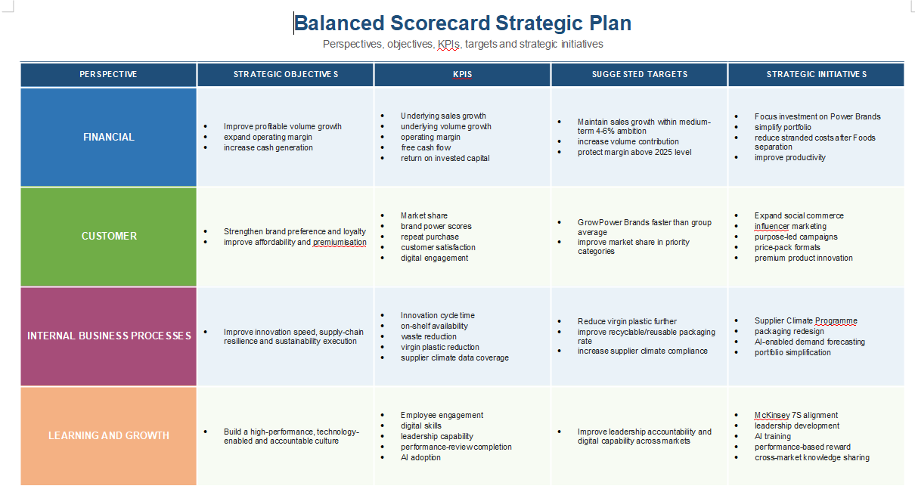
Figure 6. Balanced Scorecard for Unilever. Source: Author's analysis based on Kaplan and Norton (1992) and evidence reviewed in this report.
Figure 6 summarises the four Balanced Scorecard perspectives. The Balanced Scorecard emphasises that sales growth alone cannot be used to evaluate Unilever's strategy. Price rises, cost reductions, and sustainability rollbacks may be encouraged by a limited financial perspective, but this could harm long-term brand credibility. Unilever is forced to consider whether consumers still regard its brands as exceptional and significant. The internal process viewpoint links innovation, packaging, and procurement to sustainability. Because cultural change is essential to Unilever's transition, the learning and growth viewpoint is especially pertinent.
Controls for the proposed adoption of the balanced scorecard:
Financial perspective: initiative: reinvest efficiency savings in Power Brands and innovation; goal: restore volume-led profitable growth; KPI and suggested target: underlying volume growth over 2% with a stable or growing operating margin by 2027.
From the customer's point of view, the goal is to increase preference and confidence; the KPI and suggested target are measurable improvements in brand preference and repeat purchases in priority categories; the project is evidence-based sustainability claims and regionally affordable pack designs.
Internal-process viewpoint: goal: decrease packaging risk and speed up innovation; KPI and suggested target: quicker concept-to-launch cycles, increased innovation revenue, and ongoing virgin plastic reduction; initiative: supplier traceability and cross-functional innovation teams.
Building AI, analytics, and sustainability capability is the learning-and-growth perspective's goal; role-based training completion and higher employee engagement scores are the KPI and suggested target; capability academies and incentives connected to Balanced Scorecard results are the program.
Stronger capabilities enhance processes, better processes enhance customer value, and stronger customer value enhances financial performance. These suggested goals make Figure 6 actionable and provide cause-and-effect reasoning. Prior to adoption, targets must to be benchmarked to 2026 actuals.
This approach is reinforced by McKinsey's 7S model. Unilever's strategy—fewer categories, stronger brands, and greater execution discipline—is becoming more apparent. The planned Foods-McCormick merger and the ice cream demerger are simplifying its structure. Faster innovation, digital marketing, and sustainability reporting must be supported by its systems. AI, analytics, social commerce, and packaging science must become its new areas of expertise. Its employees have to adjust to performance pressure and reorganisation. Under Fernando Fernandez, its approach is more execution-oriented. Its common ideals must strike a balance between responsible business practices and performance. Even if the approach is sound in theory, its implementation will fail if these seven components are out of alignment.

5. Strategic Choices and Implementation
Based on the PESTEL, VRIO, CSR and Balanced Scorecard findings above, Unilever should compete mainly through differentiation at the business level, supported by cost efficiency. Porter (1985) identifies cost leadership, differentiation and focus as generic competitive strategies. Pure cost leadership is less suitable for Unilever because its advantage depends on brands, innovation and consumer trust. Cost control still matters in a price-sensitive FMCG market, but it should support rather than replace differentiation.
This means offering affordable pack sizes in emerging markets while using brands such as Dove, Vaseline, Persil and Cif to support preference and price premiums.
The business should avoid being caught in the middle: value formats shouldn't weaken brand equity, while premium claims should be supported with superior products. Unilever needs better execution consistency than P&G, and it needs better premium beauty reputation in some categories than L'Oréal.
Related diversification across personal care, home care, wellness, and beauty is Unilever's best option at the corporate level. The ice cream split and the Foods-McCormick merger show a shift away from broad conglomerate diversification and toward a more specialised portfolio. This is justified since it maintains relevant competencies in marketing, R&D, and distribution while reducing complexity and concentrating capital in categories with better growth and brand synergies (Unilever, 2025; Unilever, 2026c).
Market penetration, market development, product development, and diversification are the four growth alternatives suggested by Ansoff's Matrix (Ansoff, 1957). Product development and market development are Unilever's best possibilities. Premium deodorants, skincare products driven by science, wellness items, concentrated detergents, and environmentally friendly packaging are examples of product development. Scaling successful goods across emerging regions, where Unilever already has robust distribution, is part of market development.
Pure cost leadership is therefore less suitable because it could weaken brand investment when competing with private labels. Unrelated diversification could also add unnecessary complexity. Focused differentiation, related diversification and selective market development fit Unilever's brand, innovation and distribution strengths more closely (Porter, 1985; Barney, 1991; Ansoff, 1957).
Because Unilever is concurrently restructuring, streamlining, inventing, and maintaining sustainability credibility, strategic implementation is difficult. According to change-management theory (Kotter, 1995), urgency, coalition building, communication, and institutionalisation are necessary for transformation. Through productivity goals and portfolio rearrangement, Unilever has generated urgency, but the cultural issue is more complicated. While external stakeholders may perceive sustainability modifications as a retreat from purpose, employees may feel uneasy about restructuring. As a result, implementation needs to be balanced, quantifiable, and transparent.
The primary implementation risk, according to the McKinsey 7S model, is a mismatch between strategy and shared values. Brand confidence may decline if Unilever promotes sustainability leadership while putting short-term profit ahead of packaging reform. On the other hand, investors can doubt discipline if sustainability objectives are overly expansive and unrelated to business. Integrating sustainability into executive incentives, supplier contracts, product design, and the Balanced Scorecard is the most effective implementation strategy.
Phased implementation is recommended. Unilever should give executive ownership, align incentives, and define category-level targets throughout the first six months. It should reinforce supplier data, scale prioritised innovations, and use the Balanced Scorecard to report progress over the next 12 to 24 months. Clear communication, constrained priorities, and open trade-offs should be used to manage employee resistance, target overload, and short-term margin pressure (Kotter, 1995; Waterman, Peters, and Phillips, 1980).

6. Strategic Evaluation and Recommendations

6.1 SWOT Analysis
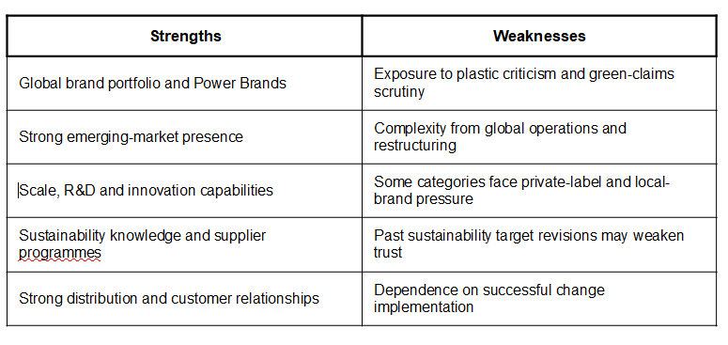
Figure 7. SWOT analysis - strengths and weaknesses. Source: Author's analysis based on evidence reviewed in this report.
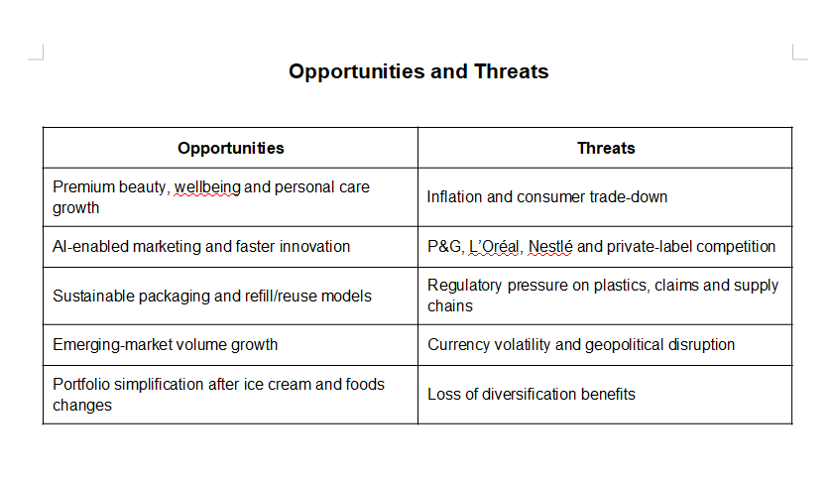
Figure 8. SWOT analysis - opportunities and threats. Source: Author's analysis based on evidence reviewed in this report.
Figures 7 and 8 summarise the main SWOT factors. The most important opportunities identified are growth in premium beauty and wellbeing, AI-enabled marketing and faster innovation, and emerging-market volume growth. The most important threats are inflation and consumer trade-down, strong competition from P&G, L'Oréal, Nestlé and private labels, and regulatory pressure on plastics and sustainability claims. Unilever's focus on fewer Power Brands is therefore reasonable, but it needs careful execution. Portfolio simplification alone will not guarantee faster innovation or stronger performance.
These results are transformed into decisions by a TOWS-style synthesis. Unilever should take advantage of premium beauty and wellness opportunities through Power Brands and emerging-market distribution; reduce plastic and regulatory risks through R&D and supplier partnerships; address portfolio complexity through targeted investment; and safeguard weaker categories through price-pack redesign rather than general discounting. This provides a stronger analytical foundation for the recommendations and connects internal evidence to external circumstances.

6.2 Practical Recommendations
Instead of approaching sustainability primarily as CSR communication, Unilever should concentrate on making it a quantifiable source of competitive advantage. This entails focusing on a smaller number of more significant sustainability targets that are closely related to product design, sourcing, packaging, and consumer value. Because packaging is so apparent to consumers, regulators, and activist groups, plastics should continue to be a top concern. Unilever may improve its CSR leadership and lower regulatory and reputational risk by making additional investments in refill, reuse, and plastic-free formats, particularly in personal care and home care. This is consistent with the natural resource-based perspective (Hart, 1995), which contends that environmental skills can become strategic when they lower risk, boost productivity, and generate new value. While maintaining affordability in price-sensitive countries, Unilever should simultaneously fortify its position in premium beauty and wellbeing. The company has the chance to expand in higher-margin areas thanks to brands including Dove, Vaseline, Nutrafol, Liquid I.V., and its Prestige Beauty portfolio. However, Unilever should concentrate on areas where it already has great brand credibility rather than dispersing investment too widely. This well-rounded strategy would enable the business to take advantage of premiumisation to provide affordable formats for emerging-market customers.
The Balanced Scorecard can provide a clearer way to control strategic performance.
Non-financial metrics like brand preference, volume growth, innovation speed, plastic reduction, supplier climate progress, and employee competency should be linked to financial goals like sales growth and margin. This would assist the business in avoiding short-term choices that increase profitability at the expense of long-term sustainability performance or brand trust.
Finally, Unilever should apply the McKinsey 7S framework to manage transformation more effectively. Its strategy is becoming clearer through portfolio simplification and focus on Power Brands, but implementation will depend on whether structure, systems, skills, staff, leadership style and shared values are properly aligned. A stronger performance culture should not mean abandoning purpose; instead, purpose should become more operational, measurable and commercially relevant. Linked to this, Unilever must improve transparency in CSR communication by avoiding broad sustainability claims unless they are supported by clear evidence and product-specific data. This is especially important because green claims are now a legal and reputational risk.
Three measurable actions should be prioritised: lowering the intensity of virgin plastic and expanding refill and reuse pilots in the highest-volume personal and home-care categories; increasing marketing and innovation investment behind specific Power Brands while safeguarding affordable pack sizes; and connecting executive incentives to indicators of volume, margin, brand trust, innovation speed, and supplier climate. Underperforming projects should be redesigned or discontinued rather than perpetuated for reputational reasons, and progress should be evaluated on a quarterly basis.Overall, Unilever has the resources to maintain a competitive advantage, but execution will determine whether the strategy works. Its strongest option is differentiation through Power Brands, faster innovation, cost discipline and sustainability built into operations. This position will be stronger if CSR commitments are matched by measurable business results.

7. Section 2: Reflective Account Using Gibbs' Reflective Cycle
Figure 9 presents Gibbs' six-stage reflective cycle. Gibbs' reflective cycle, which offers a clear framework for reviewing an academic activity through six stages—description, feelings, evaluation, analysis, conclusion, and action plan—is what I employed for this reflective account (Gibbs, 1988). This technique is helpful since it enables me to evaluate not just my actions but also my research, analysis, and preparation of the Unilever strategic management report.
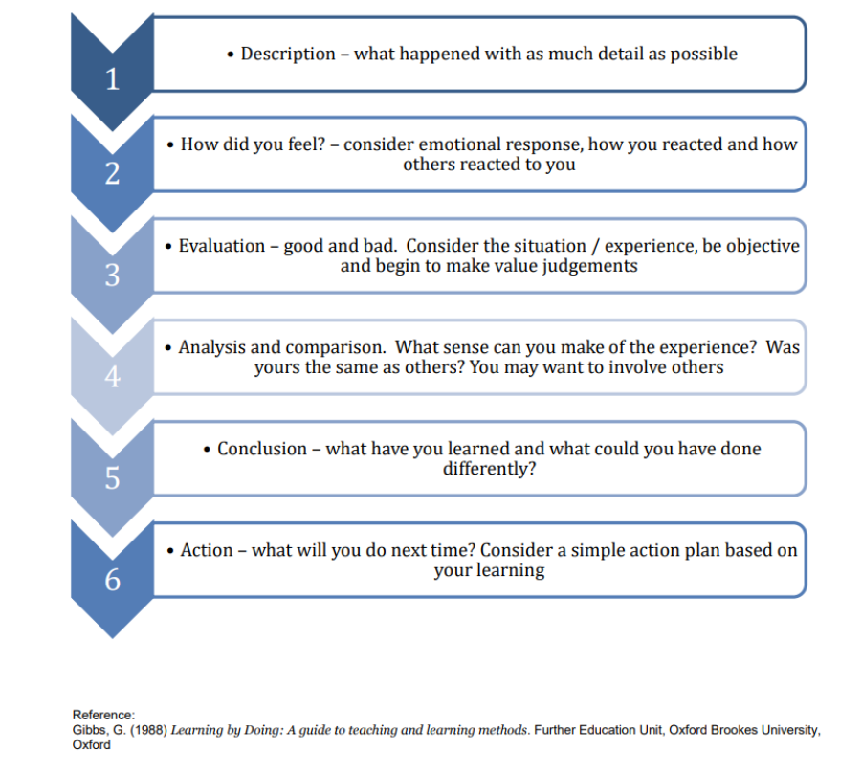
Figure 9. Gibbs' reflective cycle. Source: Adapted from Gibbs (1988).
Description
In order to determine which company was most suited for strategic analysis, a number of companies were compared, including Tesco, Toyota, Microsoft, and Starbucks. Unilever was chosen due to its great strategic complexity, academic relevance, and dependable information in areas like competitive advantage, SWOT, McKinsey 7S, external and internal analysis, CSR, sustainability, and strategic suggestions.
Following the selection of Unilever, data was acquired from academic theories, government sources, competition reports, corporate websites, sustainability reports, and annual reports. Unilever's history, mission, business model, market position, sustainability approach, and present difficulties were all better understood thanks to these sources. After that, the work was organised according to the assessment criteria, starting with an organisational overview and moving on to PESTEL, VRIO, CSR and sustainability, Balanced Scorecard, strategic decisions, SWOT, and recommendations.
Feelings
Because the assessment required a thorough 4,000-word study and a wide range of strategic management tools, I initially felt a little overwhelmed. Even though Unilever offered a wealth of material, it was difficult to determine what was most pertinent and to go beyond description to critical analysis.
Because the assignment structure and frameworks like PESTEL, VRIO, SWOT, and the Balanced Scorecard helped organise the research, my confidence grew as the task went on. Selecting Unilever was beneficial since it made it possible to talk about contemporary strategic concerns like sustainability, corporate social responsibility, the risk of greenwashing, plastic packaging, portfolio restructuring, and competition from P&G and L'Oréal.
Evaluation
Because it integrated academic theory with company-specific information, the research and preparation process was successful overall. This contributed to the creation of a well-rounded report that linked actual business data with strategic management ideas like the Balanced Scorecard, Barney's VRIO framework, and Porter's competitive advantage.
The incorporation of sustainability and CSR, which are essential to Unilever's competitive positioning, was a significant strength. By taking into account problems like plastic waste, sustainability claims, and the disconnect between CSR communication and quantifiable performance, the analysis also remained critical.
Analysis
This assignment taught me that strategic management analysis involves interpretation and judgement in addition to a list of strengths, flaws, or trends. For instance, Unilever's sustainability plan might help differentiate itself, but when promises are not backed up by quantifiable action, it becomes a strategic vulnerability. My understanding was enhanced by using a number of frameworks: McKinsey 7S emphasised alignment in implementation, PESTEL looked at external pressures, VRIO assessed internal capabilities, and the Balanced Scorecard combined financial and non-financial performance.
I also discovered that the analysis should be the primary source of strategic recommendations. For instance, potential in beauty and wellbeing supported a proposal to expand these sectors while retaining affordability in emerging economies, while dangers related to plastics and sustainability credibility prompted a recommendation to make sustainability more quantifiable.
Conclusion
In conclusion, my comprehension of how strategic management theories may be implemented in an actual organisation has improved as a result of my research and preparation of the Unilever report. I discovered that frameworks function best when they are directly applied to the strategic context of the organisation, and that good analysis necessitates solid evidence, a clear structure, and critical thinking.
Selecting Unilever was the best aspect of the process since it offered sufficient data and strategic complexity to enable in-depth study of competitive advantage, CSR, sustainability, innovation, portfolio shift, and global rivalry. To make the writing process more effective, I may enhance the early planning phase by making an evidence table that connects each source to the pertinent report part.
Action Plan
I will begin future tasks with a well-defined research strategy that outlines the necessary sections, pertinent theories, important sources, and supporting data for each. Additionally, I'll retain a more structured reference list while conducting research and separate descriptive data from critical analysis earlier in the process.
By concentrating on what they indicate about the organisation's strategic decisions and potential hazards, I will use strategic frameworks more critically. In order to assess my learning and pinpoint areas for growth for upcoming academic projects, I will also keep utilising reflective models like Gibbs' cycle.
I would additionally perform a final evidence audit prior to submission in response to the initial input. Every framework would conclude with a judgement rather than a description, every key claim would be verified for an in-text citation, and every suggestion would be linked to supporting data from the PESTEL, VRIO, CSR, Balanced Scorecard, or SWOT analysis. This would enhance the logical argument, practical relevance, and consistency of references.

References
Ansoff, H.I. (1957) 'Strategies for diversification', Harvard Business Review, 35(5), pp. 113-124. Available at: https://librarysearch.uwtsd.ac.uk/discovery/fulldisplay?docid=cdi_econis_primary_374820031&context=PC&vid=44WHELF_UWTSD:44WHELF_UWTSD_VU1&lang=en&search_scope=MyInst_and_CI&adaptor=Primo%20Central&tab=Everything&query=any,contains,Ansoff%20%20H.I.%20(1957)%20%27Strategies%20for%20diversification%27%20%20Harvard%20Business%20Review%20%2035(5)%20%20pp.%20113-124.(Accessed: (Accessed: 29 July 2026).
Barney, J.B. (1991) 'Firm resources and sustained competitive advantage', Journal of Management, 17(1), pp. 99-120. Available at: https://www.proquest.com/docview/215258436?accountid=130472&parentSessionId=3fLc8mVz%2Fpt0ikaAe9A0lRrzJVp3JjZUKb6RnvVqM0E%3D&pq-origsite=primo&sourcetype=Scholarly%20Journals (Accessed: 29 July 2026).
Competition and Markets Authority (2024) Fast Moving Consumer Goods (FMCG). Available at: https://www.gov.uk/cma-cases/fast-moving-consumer-goods-fmcg (Accessed: 29 July 2026).
Elkington, J. (1997) Cannibals with Forks: The Triple Bottom Line of 21st Century Business. Oxford: Capstone. Available at: https://books.google.com/books?id=dIJAbIM7XNcC (Accessed: 29 July 2026).
European Commission (n.d.-a) Regulation on Deforestation-free Products. Available at: https://environment.ec.europa.eu/topics/forests/deforestation/regulation-deforestation-free-products_en (Accessed: 29 July 2026).
European Commission (n.d.-b) Corporate sustainability reporting. Available at: https://finance.ec.europa.eu/capital-markets-union-and-financial-markets/company-reporting-and-auditing/company-reporting/corporate-sustainability-reporting_en (Accessed: 29 July 2026).
European Commission (n.d.-b) Corporate sustainability reporting. Available at: https://finance.ec.europa.eu/capital-markets-union-and-financial-markets/company-reporting-and-auditing/company-reporting/corporate-sustainability-reporting_en (Accessed: 29 July 2026).
Freeman, R.E. (1984) Strategic Management: A Stakeholder Approach. Boston: Pitman. Available at: https://research-ebsco-com.uwtsd.idm.oclc.org/c/onvpsy/viewer/pdf/dt63mnrsln?route=details (Accessed: 29 July 2026).
GlobalData (2022) 'Unilever's price hikes may push 32% of consumers to opt for more affordable private labels, says GlobalData', 10 February. Available at: https://explorer-globaldata-com.uwtsd.idm.oclc.org/HomePage/Home (Accessed: 10 August 2026).
GlobalData (n.d.) Unilever: Greenhouse Gas Emissions in 2021. Available at: https://www.globaldata.com/data-insights/consumer/unilever-greenhouse-gas-emissions-2091478/ (Accessed: 10 August 2026).
Gibbs, G. (1988) Learning by Doing: A Guide to Teaching and Learning Methods. Oxford: Oxford Polytechnic. Available at: https://thoughtsmostlyaboutlearning.files.wordpress.com/2015/12/learning-by-doing-graham-gibbs.pdf (Accessed: 29 July 2026).
Greenpeace International (2026) Greenpeace reaction to the Unilever Annual Report 2025. Available at: https://www.greenpeace.org/international/press-release/82055/greenpeace-reaction-unilever-annual-report-2025/ (Accessed: 29 July 2026).
Hart, S.L. (1995) 'A natural-resource-based view of the firm', Academy of Management Review, 20(4), pp. 986-1014. Available at: https://www.proquest.com/docview/210956314?accountid=130472&parentSessionId=2XixJuzULH9N5RYEz9oD1Ndm973p41P4%2FlJ2hLWWV4w%3D&pq-origsite=primo&sourcetype=Scholarly%20Journals(Accessed: (Accessed: 29 July 2026).
Jain, P., Tambuskar, D.P. and Narwane, V. (2024) 'Identification of critical factors for big data analytics implementation in sustainable supply chains in emerging economies', Journal of Engineering, Design and Technology, 22(3), pp. 926-968. Available at: https://doi.org/10.1108/JEDT-12-2021-0739 (Accessed: 29 July 2026).
Kaplan, R.S. and Norton, D.P. (1992) 'The Balanced Scorecard - measures that drive performance', Harvard Business Review, January-February, pp. 71-79. Available at: https://hbr.org/1992/01/the-balanced-scorecard-measures-that-drive-performance-2 (Accessed: 29 July 2026).
Knott, P.J. (2015) 'Does VRIO help managers evaluate a firm's resources?', Management Decision, 53(8), pp. 1806-1822. Available at: https://doi.org/10.1108/MD-08-2014-0525 (Accessed: 29 July 2026).
Kotter, J.P. (1995) 'Leading change: why transformation efforts fail', Harvard Business Review, May-June. Available at: https://hbr.org/1995/05/leading-change-why-transformation-efforts-fail-2 (Accessed: 29 July 2026).
Lin, C. et al. (2012) 'A fuzzy quantitative VRIO-based framework for evaluating organisational activities', Management Decision, 50(8), pp. 1396-1411. Available at: https://doi.org/10.1108/00251741211261999 (Accessed: 29 July 2026).
L'Oréal Finance (2026) 2025 Annual Results. Available at: https://www.loreal-finance.com/eng/press-release/2025-annual-results (Accessed: 29 July 2026).
Mirvis, P.H. (2008) 'Can you buy CSR?', California Management Review, 51(1), pp. 109-116. Available at: https://doi.org/10.2307/41166471 (Accessed: 29 July 2026).
Nisa, D.K. et al. (2021) 'Unilever's contribution to achieving Sustainable Development Goal 3 in Indonesia', E3S Web of Conferences, 316, 01023. Available at: https://doi.org/10.1051/e3sconf/202131601023 (Accessed: 29 July 2026).
Platon, N. (2018) 'Use of the PESTEL model in the management of the tourism branch of the Republic of Moldova', Ovidius University Annals, Economic Sciences Series, XVIII(1), pp. 370-375. Available at: https://ibn.idsi.md/sites/default/files/imag_file/18-1_0.pdf (Accessed: 29 July 2026).
Porter, M.E. (1985) Competitive Advantage: Creating and Sustaining Superior Performance. New York: Free Press. Available at: https://books.google.com/books?id=H9ReAijCK8cC (Accessed: 29 July 2026).
Procter & Gamble (2025) 2025 Annual Report. Available at: https://us.pg.com/annualreport2025/ (Accessed: 29 July 2026).
Rahman, K.O. et al. (2025) 'Decoding US retail dynamics: a holistic strategic analysis using PESTEL and Porter's Five Forces frameworks', Journal of Business and Management Studies, 7(2), pp. 176-183. Available at: https://doi.org/10.32996/jbms.2025.7.2.12 (Accessed: 29 July 2026).
Raja, S. (2021) The Do-Good Spirit: A Study in Unilever's Digital Communication of Corporate Social Responsibility. ProQuest Dissertations & Theses. Available at: https://www.proquest.com/ (Accessed: 29 July 2026).
Ulubeyli, S., Kazancı, O., Kazaz, A. and Arslan, V. (2019) 'Strategic factors affecting the green building industry: a macro-environmental analysis using the PESTEL framework', Sakarya University Journal of Science, 23(6), pp. 1042-1055. Available at: https://doi.org/10.16984/saufenbilder.474824 (Accessed: 29 July 2026).
Unilever (2025) The Magnum Ice Cream Company demerger. Available at: https://www.unilever.com/investors/the-magnum-ice-cream-company-demerger/ (Accessed: 29 July 2026).
Unilever (2026a) Annual Report and Accounts 2025. Available at: https://www.unilever.com/investors/annual-report-and-accounts/ (Accessed: 29 July 2026).
Unilever (2026b) Strong volume growth; full-year outlook reconfirmed. Available at: https://www.unilever.com/news/press-and-media/press-releases/2026/strong-volume-growth-full-year-outlook-reconfirmed/ (Accessed: 29 July 2026).
Unilever (2026c) Unilever announces the combination of Unilever Foods with McCormick to create a global flavour powerhouse with a superior growth profile. Available at: https://www.unilever.com/news/press-and-media/press-releases/2026/unilever-announces-the-combination-of-unilever-foods-with-mccormick/ (Accessed: 29 July 2026).
Unilever (2026d) What's behind Unilever's 2025 full-year results? Available at: https://www.unilever.com/news/news-search/2026/whats-behind-unilevers-2025-full-year-results/ (Accessed: 29 July 2026).
Unilever (n.d.-a) 1900-1950: Joining forces, Unilever comes to life. Available at: https://www.unilever.com/our-company/our-history-and-archives/1900-1950/ (Accessed: 29 July 2026).
Unilever (n.d.-b) Unilever at a glance. Available at: https://www.unilever.com/our-company/at-a-glance/ (Accessed: 29 July 2026).

Unilever (n.d.-c) Our work to maintain no deforestation across palm oil, paper and board, tea and soy. Available at: https://www.unilever.com/sustainability/nature/maintaining-no-deforestation/ (Accessed: 29 July 2026).
Unilever (n.d.-d) Towards a circular economy for plastics. Available at: https://www.unilever.com/sustainability/plastics/rethinking-plastic-packaging/ (Accessed: 29 July 2026).
Unilever (n.d.-e) Addressing climate change with action. Available at: https://www.unilever.com/sustainability/climate/ (Accessed: 29 July 2026).
Unilever UK & Ireland (n.d.) Purpose, values and principles. Available at: https://www.unilever.co.uk/sustainability/purpose-values-principles/ (Accessed: 29 July 2026).
Vino Ocho, N.V. et al. (2024) 'Neutrosophic evaluation through the PESTEL method', Neutrosophic Sets and Systems, 74, pp. 480-488. Available at: https://doi.org/10.5281/zenodo.14420384 (Accessed: 29 July 2026).
Waterman, R.H. Jr, Peters, T.J. and Phillips, R.J. (1980) 'Structure is not organisation', Business Horizons, 23(3), pp. 14-26. Available at: https://doi.org/10.1016/0007-6813(80)90027-0 (Accessed: 29 July 2026).

