Assignment 1

Data Analysis and Visualisation
Dr Nik Whitehead

Shannan Lewis
1701272
Task 1
Message
The message of the poster is unclear, the title of the actual poster is “the size of the Mobile Market”, for me to read this, it’s very vague. Its title doesn’t explain what the Mobile Market is. As for the poster itself, it’s still not clear on what the information is portraying, there is too much information on one page. The reader can’t focus on one thing at a time as it’s all crammed in.
Colour
The colour of the background isn’t a good choice as it’s quite hard to focus on the information, your eyes are drawn to the black background. If the background was white, you’d be able to focus on the information much more clearly. The colours of each segment don’t make sense. Why are they different colours? What do they mean? Nothing specifies this. Similarly, to this, to try and look at this image clearly, it’s difficult because there’s so much going on. For instance, if a colour blinded person were to look at this, they’d find it very difficult to read as the font is white and the background colours of the segments are not clear as well as the black background.
Text
To try and read the information it’s quite difficult as the text is too small. The font it’s self is clear and easy to read however the size is too small, you need to zoom in the page quite a lot to be able to read the text clearly. Although, the colour of the font (white) against the black background is quite easy to see. However, this isn’t ideal for this type of infographic as there are so many other colours clashing.
Graphs
The graphs themselves are ok to read, however the data may be hard to read for some people, so you could use either a bar graph or a scatter graph. The data in those graphs can be easier to read/work out sometimes, that is depending on the individual. Not only this but if there’s similar data in 2 different graphs then you could merge them into one. This would create more space on the infographic and essentially make it easier to read fewer graphs.
Graphics
One of the graphics says which is the most used search engine, this could arguably be useless as it doesn’t have anything to do with the mobile market and the selling of mobiles. You could merge this data into the “content being accessed from mobiles” chart, even though this isn’t content as such, it is a way to access content.
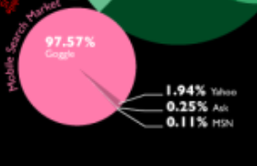
(“Mobile Search market”)

Not only this but the graphics slightly overlap each other, which It’s not covering the data but in one section there is a graph overlapped on another that’s covering quite a lot of it. This is harmless, however by designing infographics like this, you could potentially cover other data and have it hidden by other bits of data.
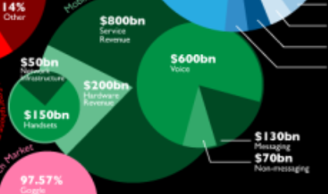
(2 differen’t graphs overlapping onto another bigger graph)

There’s a graph that says “how the internet is accessed”, in which they’ve included PC. This too is irrelevent to this infographic as the information isn’t about how the internet is assessed by other devices, it’s about mobiles. Arguably you could merge “mobile search market” into this graph to make it revelant.
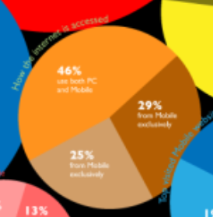
(“how the interent is accessed” graph)

The overall design of the infographic is bad, it should be laid out much more neatly, with a better use of colours, font’s and graphs, not only this it doesn’t explain the data very well. The Infographic doesn’t raise any ethical issues as such, other than gathering permission from the people involved in the data. Who did they ask for the number of people who have a phone? and did they ask their permission to be involved in the infographic? Not only this but, the data could be out of date, it doesn’t say when they gathered the data and when they created this infographic.
Cognition
To look at the infographic and try to take information in at a glance is hard, there’s a definite sensory overload with the eyes. There’s so many colours, graphics and data thrown in your face that you can’t take it in all at once. The reader needs to zoom in and read each graph bit by bit. Not only this there’s bits of data strung off at the side of some graphs which is hard to see which string of data goes where. Another thing that’s hard to see is the title of each graph, it’s a strain on the eyes when trying to read them even zoomed in, on some of the graphs the titles are unreadable as they’re quite small. Not only this but the colour of the small font makes It even harder to see. When trying to view this infographic, the user needs to take their time to process the data and to try figure out which piece belongs where and what it states.
Improvements
There’s several improvements I would make to this infographic; for instance: text, colours, positioning and the graphs.
The text should be a lot bigger and all one colour, on some of the graphs, the text is the same colour as the graph itself, this is hard to read as you’re drawn to the background of the graph rather than the font. I’d change the colour all the text to black. This is such a simple colour that everyone can read clearly and can focus on what the data says.
The colours of the background should be white, so anything on top of it instantly stands out. I wouldn’t so much as change the colour of the graphs; however, I would change the colours of each graphs, so they are different colours. i.e. a few of the graphs are the same colour so I would change this, so they were all different. I would do this because people may assume that it’s related data, even if it isn’t it looks as if it is and can confuse people.
The positioning of the graphics can be better placed. For instance, spread them out a little so they’re not overlapping. I’d also make a few of them a lot bigger too, so that they’re readable. Finally, I’d change some of the graphs to bar graphs. The graph at the bottom of the infographic is a lot easier to see and make out what the data is, if a few more of the graphs were this type that would make more of the infographic easier to read and analyse.

References
Gathered information from infographic on Moodle, distributed by Dr Nik Whitehead
https://moodle.uwtsd.ac.uk/mod/resource/view.php?id=84712

