Jeejo Philip Neerumplackal
Student I D: 1906869
Group : 12
Lecturer: Ms Molly Jack
Effective Team Work and Communication
Introduction:
Team work is the co-operation between those who are working on a task to reach their goal. Team work is generally understand as the willingness of a group of people to work together to achieve a common aim (Parker and Glenn., 2008). The importance of team work are building relationship within the work place, work efficiency, morale building, solves problems, brings new ideas, education and learning(Helen winder., 2013).
Communication and its importance at the workplace:
Work place communication is the process of exchanging information and ideas both verbal and nonverbal between one person/group and another person/group within an organisation.
Effective communication is critical in getting the job done.
Workplace communication tremendously important to organisations because it increases productivity and efficiency.
-It solves problem more easily because it creates an environment where a manager recognise customer Complaints and employee recommendation and develop answers and solution.
-It is a two-way information sharing process that strengthens the work place by helping employees understand direction, complete tasks and become successful.
-It provides the key to co-operation and productivity.
-It creates harmony and trust which leads to good work relationships and productivity (Faizal and Fesmina., 2019).
Name the organisation for which you work and give a very brief explanation of the nature of the organisation (what it does):
I am working as a director of Hummingbirds care ltd. Which is a healthcare resource provider.
Hummingbirds is a company dedicated to provide qualified, quality, high calibre, healthcare staffing with high standards. Our aim is to provide registered Nurses and Health care assistance to nursing homes and residential homes.
Explain why communication is Important at your workplace:
Communication is an important tool at our work place because without effective communication our staff members will not be able to perform their duties as we are dealing with residents at nursing homes and residential homes. Communication is important to solve the staffing solution and also to solve problems and to provide great service and to improve customer satisfaction. It is also important for the sustainable growth of our business.

1.0 Types of communication:
The different types of communications are as follows:
Verbal communication
Non-verbal communication
  - Verbal Communication:
Verbal communication is a type of communication where the information flows through verbal medium like words, speeches, presentations etc. Verbal communication is a written or spoken conveyance of a message. Human language can be defined as a system of symbols and grammars by which the symbols are manipulated. Large number of language use patterns of sound or gesture for symbols which enable communication with others around them. An example of verbal communication is saying no when someone asks you to do something you don’t want to do (Ferguson et al., 2014).
In written communication, there are two things to remember first write clearly and secondly, ensure the content of the message is something you want to promote. Examples are an email, a memo, a report, a face book post etc.
In my work place employees need a range of verbal communication skills to respond to the questions and find about individuals problems or needs. As well as it helps to save time and also helps to provide support and to deal with problems. For instance, if a resident in a nursing home asks for a help, as a staff member they need to have verbal communication skills like speaking clearly, listen them and to understand them and provide them what they requested.
1.2 Non-verbal Communication:
Facial expressions, gestures, hand and hair movements, body postures all constitute non- verbal communication. In other words, it is a speechless communication where content is not put into words but simply expressed through expressions.
Non-verbal communication describe the process of conveying a type of information in a form of non-linguistic representations. This communication is omnipresent and they are included in every communication act. To have total communication, all non-verbal channels such as body, face, voice, appearance, touch, distance, timing, and other environmental sources must be engaged during face to face interaction. Non-verbal behaviours are multi-functional and they are engaged at the same time in communication acts and allow the chance for simultaneous message to send and receive. These behaviours may form a universal language systems like smiling, crying, pointing, caressing and glaring are some of the behaviours which are used by people regardless of nationality. These allow the most basic form of communication when verbal communication is not effective due to language barriers (Burgoon.J et al., 2010).
In my work place nonverbal communication skills helps my employees to convey confidence, certainty, credibility and positive gestures when caring for the patients. It also helps my staff to pass the messages when there is a language barrier issues. In visual communication, the recipient receives information from signboards, displays, hoardings, banners, maps etc. If there is a language barrier between the resident and staff in the nursing home then the role of non-verbal communication comes into play. For example, when a resident is not able to communicate verbally or not able to understand the local language our staff members uses other types of communication like cards and pictures to help these types of residents.
2.0 Theories of communication:
The three models of communications are:

1) Shannon-Weaver model of communication
2) Berol’s Model of Communication
3) Schramm’s model of communication

2.1 Shannon-Weaver model of communication:

Shannon and waver model is a linear model of communication that provides a frame work for analysing how messages are send and received. It is also known for its ability to explain how messages can be mixed up and misinterpreted in the process between sending and receiving. Its also known as the mother of all modules because of its popularity(Eric Hollagel and David D.Woods., 2005).
The aim of this communication is to signal transmission from source to destination through transmitter and receiver across the channel with limited interference and mistakes. This theory initially created to separate noise from the signals carrying the information. Shannon and Weaver model of communication has 7 main elements which are
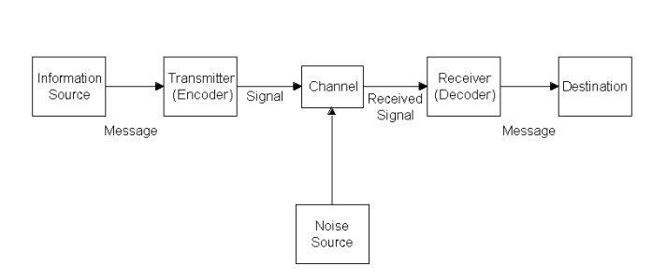
- Information source which choose the desired message from a set of possible messages which can be a mixture of some forms of written or spoken, image or sound.
- Message is the thing that will be sent and received and is all about the communication.
- Transmitter converts the message into the signal, which is also known as encoder.
- Channel is the way that message goes through from the transmitter to the receiver.
- Receiver is the reverse transmitter which converts the signal back into the message, and is also known as decoder.
- Destination is the goal place of the transmitted message.
- Noise is any unnecessary accumulations to the transmitted signal which trigger misrepresentation or fault in transmission.
This model shows the communication progression among the source and destination. The source generates the message which can be separated or continuous. (Taylor.T and Moyle.R.,1999).
In my work place ineffective communication can lead to confusion, ambiguity and anxiety which can create a hostile situation. Hence, this model of communication helps to develop effective communication between my employees and patients.
2.2 Berlo’s Model of Communication:
The Berlo’s Communication process is a simple application for person to person communication which include communication source encoder message and channel de corder and communication receiver. It determines communication skills, attitude, knowledge, social system and culture of the people involved in the communication(Miller and Katherine., 2005).
The model focuses on encoding and decoding which take place before sender sends the message and before receiver gets the message respectively.
Berlo’s communication has generally four components to explain the communication process. They are sender, message, channel and receiver. Each of the component is affected by many aspects.

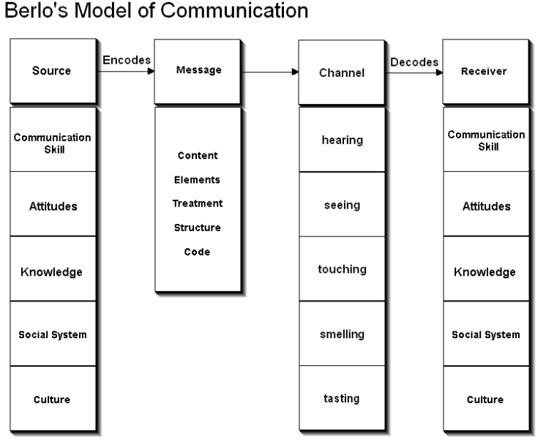
Components of Berlo’s Model of communication

Sender is the source of the message or the person who originates the message. The person or source sends the message to the receiver. The following are the factor related to sender and is also the same in the case of receiver. They are Communication Skills, Attitude, Knowledge, Social Systems and Culture.Communication skills of a person is a factor that affects the communication process. If the sender has good communication skills, the message will be communicated better. Similarly, if the receiver is not able grasp the message, then the communication will not be good enough. Communication skills include the skills to speak, present, read, write, listening, etc. The attitude of the sender and the receiver generates the effect of the message. The person’s attitude towards self, the receiver and the environment changes the meaning and effect of the message. Awareness with the subject of the message makes the communicated message have its effect more. Knowledge on the subject matter makes the communicator send the message effectively. Values, beliefs, laws, rules, religion and many other social factors affect the sender’s way of communicating the message. It makes difference in the generation of message. Place and situation also fall under social systems. Cultural differences make messages different. A person from one culture might find something offensive which is very much accepted in another culture.

Message is the substance that is being sent by the sender to the receiver. It might be in the form of voice, audio, text, video or other media. The key factors affecting the message are content, elements, treatment, structure and code. Content is the thing that is in the message. The whole message from beginning to end is the content. Elements are the non-verbal things that tag along with the content like gestures, signs, language, etc.Treatment is the way in which the message is conveyed to the receiver. Treatment also effects the feedback of the receiver. The structure of the message or the way it has been structured or arranged, affects the effectiveness of the message. Code is the form in which the message is sent. It might be in the form of language, text, video, etc.

Channel is the medium used to send the message. In mass communication and other forms of communication, technical machines might be used as a channel like telephone, internet, etc. But in general communication, the five senses of a human being is the channel for the communication flow and it affects the effectiveness of the channel.
1) Hearing – We receive the message through hearing.
2) Seeing – We perceive through seeing. We also get non-verbal messages by seeing.
3) Touching – Many of the non-verbal communication happens from touching like holding hands.
4) Smelling – We collect information from smelling.
5) Tasting – Taste also provides the information to be sent as a message.

Receiver is the person who gets the message sent in the process. This model believes that the thinking pattern and all other factors mentioned above must be in sync to that of the sender for the communication to be effective. The message might not have the same effect as intended if the receiver and sender are not similar. The receiver must also have a very good listening skill. Other factors are similar to that of the sender (article as businesstopia., 2018). Communication skills, attitudes, knowledge, social systems and culture.

In my work place Berlo’s model of communication is very much effective because this model helps my employees to communicate effectively, as well as to have positive attitudes and to know social system and culture of the workplace.

2.3 Schramm’s model of communication:

Coding and decoding are the two essential process. The communication is incomplete unless and until the sender receives a feedback from the recipient. This communication is a two way process between the first party and the second party (Prachijuneja.,2015).

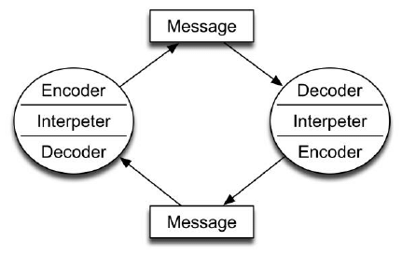

The Schramm is a two way circular communication between the sender and receiver.
Schramm incorporates the study of human behaviour in the communication process.
In addition to the six elements above, Schramm has included the concept of feedback. The information that comes back from the receiver to the sender and tells the sender how well he is doing (article as businesstopia., 2018).

In my work place, we will receive the message and will send back the message with the feedback so Schramm’s model of communication comes in act in these type of situation. For example the manager or the administrator of the nursing home calls for a staffing solution we will receive that message and will send message back to let them know that it is sorted.
4.0 Conclusion :
In conclusion I discussed, researched and learned about different types of communication as well as added my own experience at work place and learned how we can improve our communication skills. The importance of proper communication. Effective communication is the key for success in business.
References:
- Parker and Glenn (2008).Team work-the importance of it and how to work with other companies Helen winder 2013.
2. Faizal and Fesmina (2019).What is workplace communication? (Why does it matter?)
3. Ferguson, Sherry Devereaux, Lennox-Terrion, Jenepher; Ahmed, Rukhsana, Jaya, Peruvemba (2014).Communication in Everyday Life: Personal and professional contexts.
4. Burgoon J, Guerrero L., Floyd K (2010).Nonverbal Communication Taylor & Francis.
5. Eric Hollagel and David D. Woods (2005).Joint Cognitive Systems: Foundation of Cognitive system Engineering.
6. Taylor T and Moyle R (1999). Information Theory. University of South Carolina. Retrieved April 13, 2007)
7. Miller and Katherine (2005). Communication theories perspectives processes and contexts(2nd.ed).McGraw-Hill Higher Education.
8. Article from businesstopia (2018). Berlo’s SMCR Model of communication.
9. Pranchijuneja (2015). Management Study Guide Content Team ISO 2001 -2015.



