Module Code: ACMA6012
Lecturer: Arnaud Marotin
Student Name: Ian Lewis
Student Number: (2015718)
Date: January 2024
Word Count: 3523

Computational Methods

University of Wales Trinity Saint David
Computational Methods - Level 6
Contents
Introduction 2
The Equation 3
Explicit finite difference form of the constitutive equation 5
Taylor series 6
Explicit Finite Difference scheme 7
Fourier's number 9
Stability Criterion 10
The Initial and Boundary Conditions Implemented 11
Code’s details and explanations 13
Validation of the Code 18
Sensitivity Analysis of the Code 20
Main model’s limitations 23
Suggested Improvements and Future Developments 24
Conclusion 25
References 26
Appendix (script) 27

Introduction

This report provides a comprehensive overview of the heat diffusion model developed using the Explicit Finite Difference Method (EFDM). It includes detailed sections on the governing equation, numerical method, initial and boundary conditions, code details, sensitivity analysis, model limitations, and suggested improvements.
A MatLab computer code has been produced (Appendix), to simulate the heat transfer through a six metre by six metre aluminium plate (figure 1) and determine when heat transfer stops and the plate reaches thermal equilibrium. The code has been compared to the analytical solution to determine its accuracy, providing insights into thermal behaviours, and aiding in design optimisation.

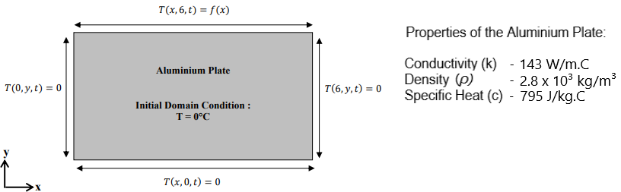
Figure 1 (Marotin, 2023)

Under ideal conditions of consistent density (ρ), uniform specific heat (cₚ), and uniform thermal conductivity (k), coupled with perfect insulation and the absence of internal heat sources, the temperature (T) adheres to a two-dimensional parabolic heat equation. Addressing this equation, the Explicit Finite Difference Method (EFDM) was used, a numerical technique well-suited for modelling transient heat conduction.
The reports objectives encompass the implementation of EFDM, analysing the MatLab code and results, discussion of limitations, and the proposal of improvements for future developments.
Heat diffusion plays a crucial role in various engineering applications, and understanding its behaviour is essential for designing efficient systems.

The Equation
​The study of heat transfer and the mathematical description of heat distribution dates back to the 18th century. French mathematician and physicist Joseph Fourier made foundational contributions to the understanding of heat, and introduced the concept that heat conduction could be described by a partial differential equation. The heat equation's historical development reflects the continuous collaboration between mathematicians and physicists, leading to a deeper understanding of heat transfer and the development of mathematical tools for solving practical problems. (O’Connor and Robertson, 1997)
The two-dimensional heat equation is used to describe the distribution of temperature over time in a two-dimensional spatial domain. In this case, a six metre by six metre aluminium plate. It is a partial differential equation that models how heat diffuses through a material in both the x and y directions. The general form of the 2D heat equation is given by:

$$\frac{∂T}{∂t}=α\left(\frac{∂²T}{∂x²}+\frac{∂²T}{∂y²}\right)$$

T = Temperature.
α = Alpha (thermal diffusivity).
x/y = Spatial coordinates.
t = Time.
Temperature Distribution: The dependent variable T(x,y,t) represents the temperature at a given point (x, y) and time t.
Alpha: Characterises how heat is conducted through a material. It is defined by the ratio of the material's thermal conductivity (k) to its product of density (ρ) and specific heat (Cp​). The formula for thermal diffusivity (α) is given by:
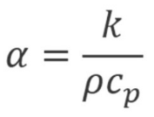
Spatial Coordinates: The 2D heat equation involves two spatial coordinates, typically denoted as x and y, representing the two-dimensional geometry of the system.
Time Variable: The equation includes a time variable t, indicating the evolution of temperature over time.
Partial Derivatives: The equation includes partial derivatives with respect to both spatial coordinates (x and y) and time (t), describing how temperature changes in each direction and over time. (Chegg, 2023)
The heat equation is a fundamental mathematical tool that plays a significant role in our understanding of heat transfer processes. Its applications are diverse, ranging from optimising engineering systems to advancing scientific research and innovation. The equation finds applications in various fields, including thermal analysis of materials, heat transfer in electronic devices, modeling of temperature distribution in buildings, and environmental studies, especially while studying temperature variations in the Earth's subsurface. (Cain, 2021)
The analytical solution of the 2D heat equation can be achieved through methods such as separation of variables for partial differential equations. However, in practical engineering applications, numerical methods are often employed to provide close approximations of the solution. Nodal analysis emerges as a particularly valuable technique for solving the two-dimensional heat equation. In the context of a heated plate, the plate is discretised into distinct points known as nodes, evenly distributed across the plate. Employing an energy balance equation at each node, the temperature at each point can be determined using Fourier's Law and a system of equations, as illustrated below (figure 3). Converting this system into matrix form enables the application of linear algebra techniques for solving the matrix equation. (Stewart, 2019)

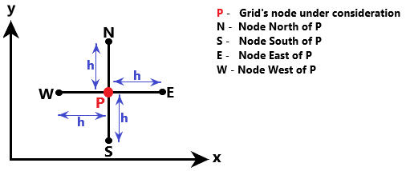
Figure 2 (Marotin, 2023)

Explicit finite difference form of the constitutive equation

Taylor series
The Taylor series expansion is a mathematical technique used to represent a function as an infinite sum of terms, each term corresponding to the value of a derivative of the function at a particular point. In the context of generating difference approximations to the first and second derivatives, the Taylor series can be a valuable tool.
When considering a function f(x) that is sufficiently smooth (has continuous derivatives) around a point x0, the Taylor series expansion of f(x) around x0 is given by:
f(x) = f(x0​) + f′(x0​) (x−x0​) + $\frac{1}{2!}$ ​f′′(x0​) (x−x0​)² + $\frac{1}{3!}$​f′′′(x0​) (x−x0​)³ +…

f(x0​) = The value of the function at the point x = x0​
f′(x0​) = The first derivative of the function evaluated at x = x0​
f′′(x0​) = The second derivative of the function evaluated at x = x0​
f′′′(x0​) = The Third derivative of the function evaluated at x = x0​

The Taylor series is particularly useful in generating difference approximations for derivatives, which is often applied in numerical methods. We can estimate the value of a function at a specific point x = x0 by utilizing Taylor polynomials. The greater the order of the polynomial, the more terms it includes, resulting in a closer approximation to the actual value of the function at that particular point. In figure 4 (graph) the green line represents the actual function f(x0​) =$\frac{1}{x}$ ​, and the pink line illustrates the approximation using a second-order polynomial. (Saeed, 2022)
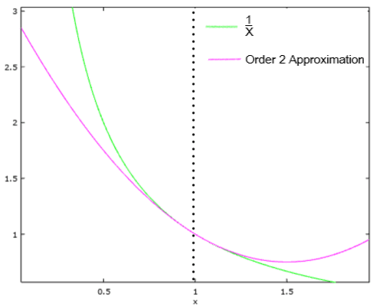
Figure 3 (Saeed, 2022)

Explicit Finite Difference scheme
The Explicit Finite Difference scheme is a numerical method used to approximate solutions to partial differential equations, particularly the heat equation. This scheme involves discretising both the time and space dimensions.
The forward difference approximation (Temporal discretisation) in the heat equation represents how temperature changes over time. The forward difference approximation is applied to discretise this derivative. In simple terms, it involves estimating the rate of change of temperature at a certain point in time based on the temperature values at the current and previous time steps. (Wais, 2014)

$$\frac{∂T}{∂t}≈\left(\frac{T^{n+1}-T^{n}}{∆t}\right)$$

$T^{n+1}$ = Temperature at the next time step.
$T^{n}$ = Temperature at current time step.
$∆t$ = Time step.

The central difference approximation (Spatial discretisation) in the heat equation describes how temperature varies across the spatial dimensions. The central difference approximation is used to discretise the second spatial derivative. This involves estimating the curvature of temperature distribution at a specific point based on the temperatures at neighbouring points.
$$\frac{∂T}{∂t}≈\left(\frac{T_{i+1}-2T_{i}+T_{i-1}}{\left(∆x²\right)}\right)$$

$T_{i+1}, T_{i}, T_{i-1}$ = Temperature values at neighbouring spatial grid points.
$∆x$ = Grid spacing.

The Explicit Finite Difference scheme substitutes the temporal derivative with a forward difference approximation and substitutes the second spatial derivative with a central difference approximation. This discretised approach enables the calculation of temperature values at discrete points in both time and space, simplifying the numerical solution of the heat equation.
Combining these discretisation’s into the constitutive equation yields the explicit finite difference form for simulating heat conduction through a two-dimensional plate. The specific implementation can be seen in the provided MatLab code, which performs the time-stepping loop using these finite difference approximations.
To discretise the spatial domain, the continuous spatial coordinates are replaced by a grid of discrete points. This grid is typically composed of rows and columns, and the discretisation is done by defining a uniform grid spacing. The process involves dividing the spatial domain into a mesh of discrete points, each representing a specific location on the grid.
For a two-dimensional domain with spatial coordinates (x, y), the discretisation involves creating a set of grid points (xr, yc) where r represents the index along the x-direction, and c represents the index along the y-direction. The grid spacing is denoted as $∆x$in the x-direction and $∆y$ in the y-direction. (Adak, 2020)
Mathematically, the discretisation of spatial coordinates can be expressed as:
xr​ = r⋅$∆x$, yc​ = c⋅$∆y$
Here, r and c are integer indices corresponding to the grid points of rows and columns.
This discretisation allows for the representation of temperature values at specific grid points, and the spatial derivatives in the heat equation are approximated based on these discrete points. In the context of the MatLab code provided, for heat conduction through a six metre by six metre aluminium plate, the spatial domain is discretised into a grid of points using a uniform grid spacing $∆x$=$∆y$= h (figure 4). (Villiers et al., 2018)
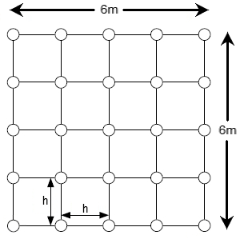
Figure 4 (Villiers et al., 2018)

Fourier's number
Fourier's number ($Fo$) is a dimensionless parameter used in the context of heat conduction and heat transfer. It is named after the afore mentioned French mathematician and physicist Joseph Fourier. Fourier's number is defined as a ratio of the rate of heat conduction within a material to the rate at which heat is stored in the material over time.
The formula for Fourier's number is given by:

$$Fo= \frac{α.∆t}{\left(∆x\right)²}$$
$Fo$ = Fourier's number.
$α$ = Thermal diffusivity of the material.
$∆t$ = Time step.
$∆x$ = Spatial grid spacing.
If the Fourier’s number ($Fo$) is small, this indicates that heat conduction dominates over temporal changes, suggesting that the temperature distribution is relatively stable over time.
If the Fourier’s number ($Fo$) is large, it implies that temporal changes are significant, and the temperature distribution can change rapidly. (Pratik, 2023)

Stability Criterion
The stability criterion is a condition that must be satisfied to ensure that the numerical solution remains stable over time. Stability is crucial for obtaining reliable and accurate results from the simulation. The stability criterion is commonly expressed in terms of a dimensionless parameter called the Courant Friedrichs Lewy (CFL) number. For heat conduction problems, the CFL number is often associated with Fourier's number ($Fo$). If the computed $Fo$ exceeds the stability limit, the numerical solution may become unstable, leading to unrealistic or divergent results. Therefore, one must choose a time step and grid spacing that satisfies the stability criterion for the chosen numerical method. In this application/code, if the Fourier’s number is above 0.25 then the code will ask the user to input new criteria. (Yang and Shi, 2009)

The Initial and Boundary Conditions Implemented
The initial boundary of the 6m by 6 m aluminium plate was determined to have 0 ֯C on its east, south, and west boundaries, with a 50 ֯C heat source applied to its northern boundary.
As illustrated in the two equations below (figure 5), if the northern boundary node is less than two thirds of from 0, then f(x) is multiplied by 12x and if the node is over two thirds from 0, then to sum of f(x) is -25x + 150. This is known as Dirichlet boundary condition. To enforce the Dirichlet boundary condition on the northern boundary, it is necessary to articulate the linear distribution equations delineating the specified function values at distinct points along this boundary. In the given scenario, where the northern boundary is influenced by a temperature profile denoted by the function f(x), the linear distribution equations become apparent when portraying the temperature values at diverse locations along this boundary. (Connor, 2019)
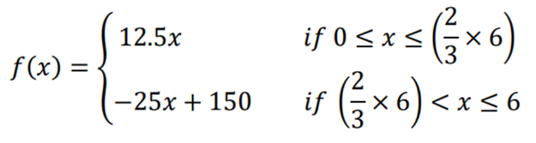
Figure 5 (Marotin, 2023)

This can be shown below, in the initial northern boundary condition graph and the heat distribution graph (figures 6 and 7), and the initial boundary matrix T1 extracted from the code (figure 8).
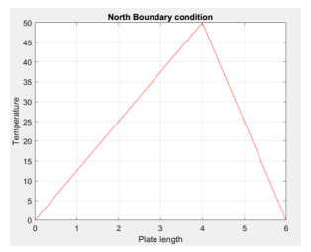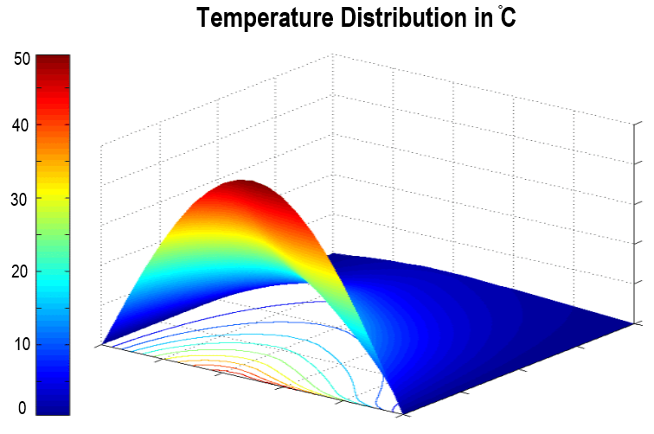
Figure 6 (Marotin, 2023) Figure 7 (Kafle, 2020)
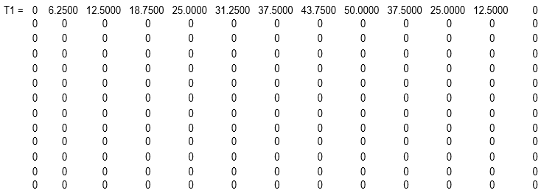
Figure 8 (Lewis, 2023)

Code’s details and explanations
In MATLAB, the commands clc, clear, and close are often used at the beginning of a script or function for code organisation, cleanliness, and to ensure a fresh start for each execution.
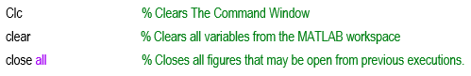
Figure 9

Inputting Parameters to a MatLab code enables the user to reuse the code for different situations or datasets without the need for extensive modifications.

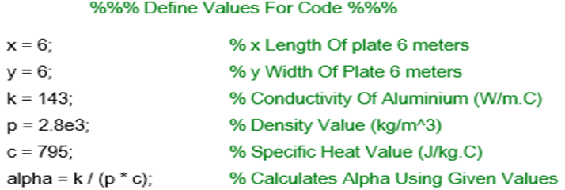
Figure 10

The code will then ask the user to Input their chosen grid spacing in meters and chosen time step in seconds. The grid spacing must be divisible by six. If not, the user will get asked to enter a new grid spacing. The time step must be less than 3600 seconds, if not, the user will get asked to enter a new time step. A while loop is used to ensure the Fourier’s number remains below 0.25 and a positive value (this is important to ensure stable calculations).

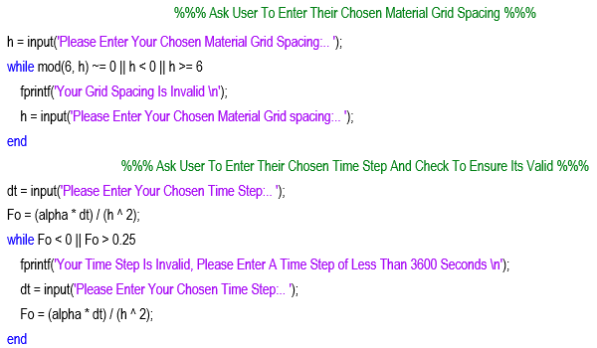
Figure 11
This part of the code defines the number of rows and columns to create a matrix (T1) of zero’s based on the users inputted grid spacing.

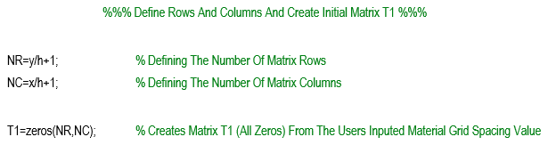
Figure 12

Here the code defines the initial northern boundary condition using Dirichlet boundary condition. The code then goes on to create a second matrix (T2) from the first, while allocating a tolerance (Tol) for the difference between the two matrices.

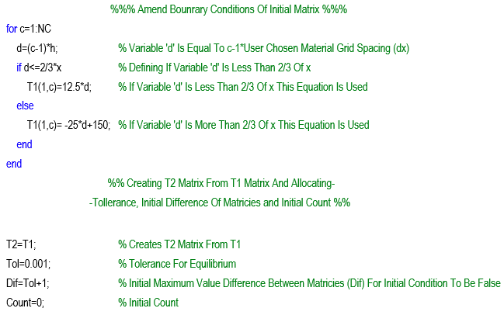
Figure 13

The code will now use a while loop to repeat the calculation shown below to determine when the difference between the two plates has become smaller than the given tolerance and thermal equilibrium is achieved.
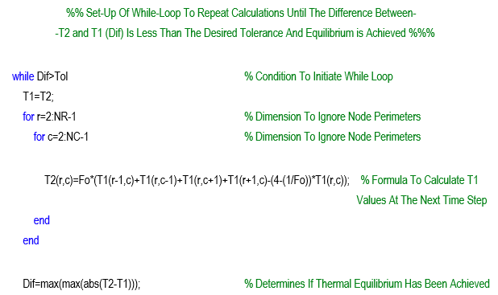
Figure 14

A graph is then created (figure 1) to display the temperature within the plate, which changes to show how the heat will transfer through the plate. The graph is labelled, and a colour bar is added for ease of temperature reference. A counter is put in place to count the number of cycles carried out.

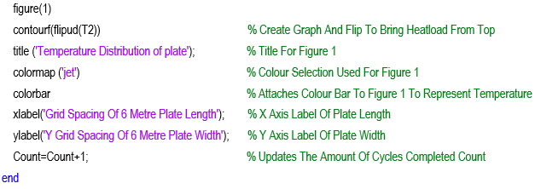
Figure 15

The count is utilised here to determine the time taken to reach equilibrium by multiplying the count by the users inputted time step. The time taken in seconds, minutes, hours, and days is calculated and displayed here. The validation between the code and the analytical solution is made and the difference calculated.
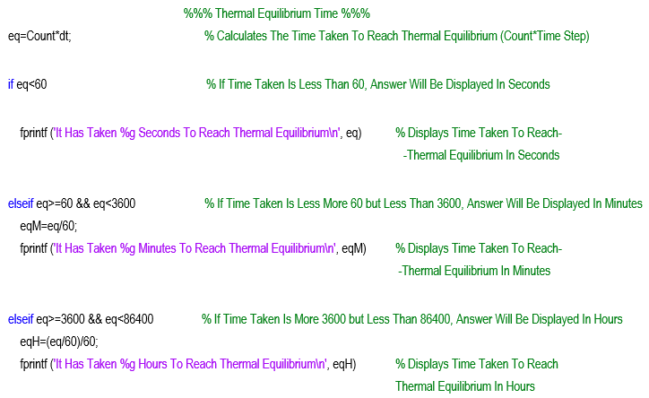
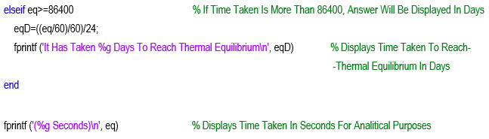

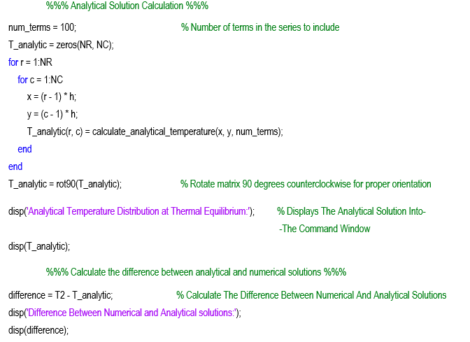
Figure 16

The difference between the two plates is displayed in a graph (figure 3), along with the final calculated graph (figure 2) of the plate showing how the heat has evolved and reached thermal equilibrium.

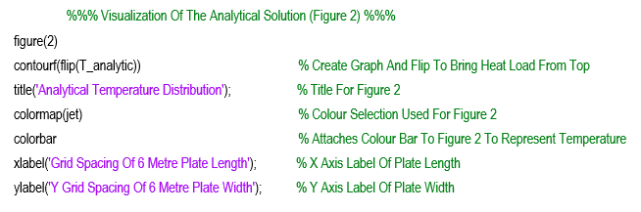
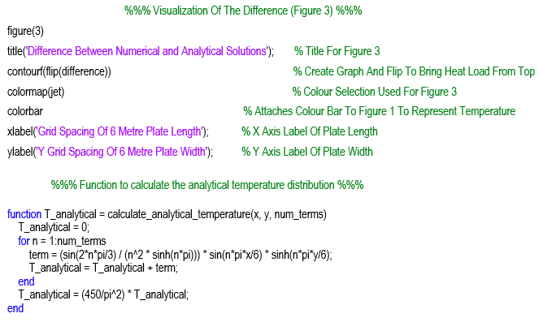
Figure 17

Validation of the Code

To validate the code, difference scenarios were used to identify the difference between the code’s distribution and the analytical solution.

Firstly, a grid spacing of 0.5 meters with a time step of 150 seconds and a tolerance of 0.001 was used. The time taken to reach thermal equilibrium was 119550 (1.38 days)

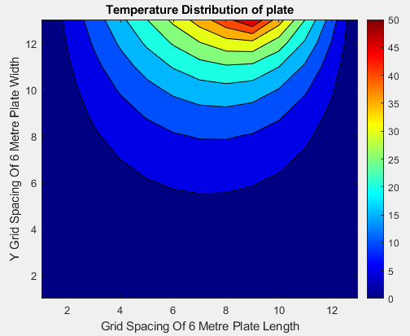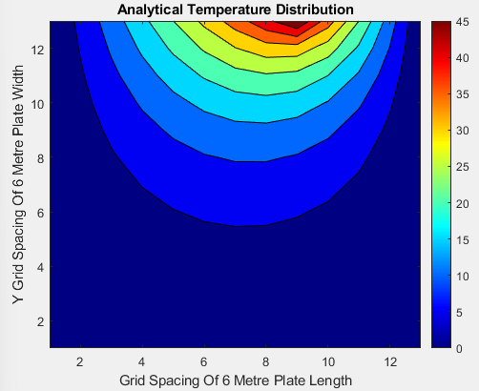
Figure 18 Figure 19
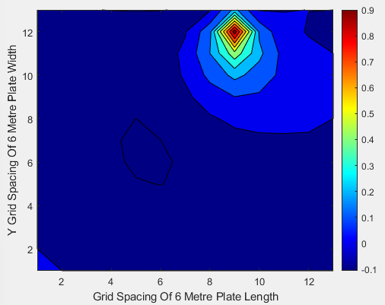
Figures 18 and 19 show the evolved distribution of heat through the plate with the set grid spacing, time step and tolerance above. Figure 20 shows the difference between the two graphs. As you can see, the in figure 20, even in the red area where the biggest difference is, it is still less than 1֯C (shown in figure 21, row 2 column 9).
Figure 21 shows the difference between numerical and analytical solutions in a matrix. In comparison, the difference is extremely small.

Figure 20

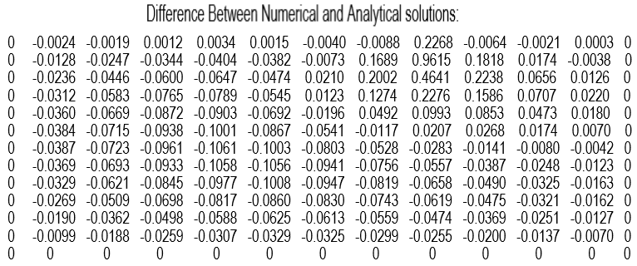
Figure 21
The code was re-run with a grid spacing of 1 metre, a time step of 500 and the same tolerance (0.001). The time to reach thermal equilibrium was 155500 seconds (1.8 days).
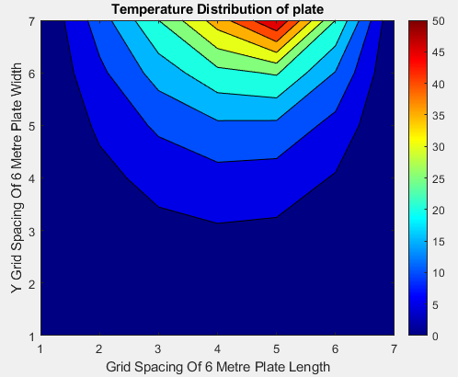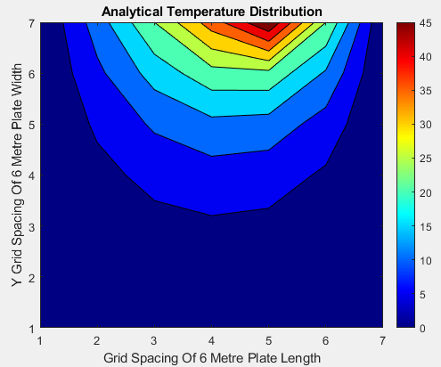
Figure 22 Figure 23

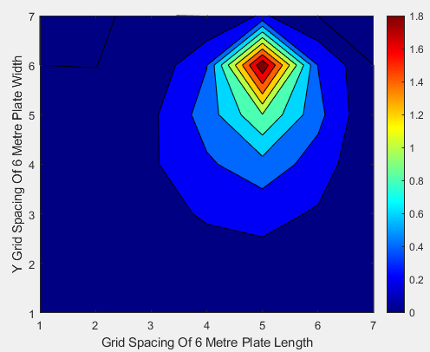
Figure 24

When analysing figures 22 and 23, they still look very similar even with a large grid spacing and time step. But figure 24 shows that there are some discrepancies, but still less than 2 ֯C. This test was less accurate and took longer.
The difference of just under 2 ֯C is shown in row 2, column 5 of the matrix (figure 25). The difference is still extremely small, so carrying out this calculation with this code at this tolerance will save the user a massive amount of time and is extremely accurate with this set tolerance.

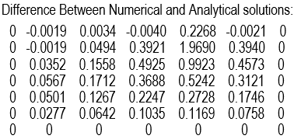
Figure 25

Sensitivity Analysis of the Code

An analysis was carried out to determine the sensitivity of the code using a range of different grid spacing, time steps and tolerances. The results form the grid spacing analysis are given in figures 26 and 27.

Grid spacing (h)  in Meters (m) | Time Step  in Seconds (s) | Tolerance | Thermal Equilibrium Time in seconds (s)
3 | 150 | 0.001 | 129300
2 | 150 | 0.001 | 119400
1.5 | 150 | 0.001 | 121500
1.2 | 150 | 0.001 | 118050
1 | 150 | 0.001 | 121050
0.75 | 150 | 0.001 | 119700
0.5 | 150 | 0.001 | 119550
0.25 | 150 | 0.001 | 119100
0.2 | 150 | 0.001 | 119100
Figure 26

Figure 27

These results show that by increasing the grid spacing, the time taken to reach thermal equilibrium also increases. From figure 27 we also notice that as the grid spacing drops below 2 meters, the time to reach thermal equilibrium fluctuates and gradually levels out from 0.5 meters and below. If the user was to select a smaller grid spacing, there would be no difference in time.

The results from the time step analysis are given in figures 28 and 29.

Grid spacing (h)  in Meters (m) | Time Step  in Seconds (s) | Tolerance | Thermal Equilibrium Time in seconds (s)
0.75 | 2000 | 0.0001 | 254000
0.75 | 1500 | 0.0001 | 247500
0.75 | 1000 | 0.0001 | 238000
0.75 | 800 | 0.0001 | 232000
0.75 | 600 | 0.0001 | 224400
0.75 | 400 | 0.0001 | 213200
0.75 | 200 | 0.0001 | 194000
0.75 | 100 | 0.0001 | 174200
0.75 | 50 | 0.0001 | 154350
0.75 | 25 | 0.0001 | 134475
Figure 28

Figure 29

From the results shown, the impact of using an alternative time step on the program is extremely large. If the time step is too small, the heat transfer might not be sufficient to meet the tolerance within the calculation. Consequently, the program may prematurely assume equilibrium, even though it hasn't been fully achieved. On the other hand, with too large a time step, equilibrium may have been reached shortly after the previous calculation. In such cases, once equilibrium is attained, the accuracy of the result could deviate by a significant timeframe (depending on the users chosen time step).

The results from the tolerance analysis are given in figures 30 and 31.

Grid spacing (h)  in Meters (m) | Time Step  in Seconds (s) | Tolerance | Thermal Equilibrium Time in seconds (s)
1 | 500 | 0.1 | 29000
1 | 500 | 0.01 | 89500
1 | 500 | 0.001 | 155500
1 | 500 | 0.0001 | 222000
1 | 500 | 0.00001 | 288000
1 | 500 | 0.000001 | 354500
Figure 30

Figure 31

Figures 30 and 31 demonstrate that the larger the tolerance, the quicker thermal equilibrium is achieved. This observation is to be expected, because this value essentially determines the precision with which the criteria define equilibrium. A lower value corresponds to a smaller tolerance for equilibrium.

Main model’s limitations
Although evidence has been given to prove the accuracy of the code, it does have its limitations and possible improvements could be made. The mathematical method relies on the stability criterion (Fourier’s number). This can only be accurate to a certain degree.
Round off errors occur from a computers/codes inability to store an infinite number of digits, therefore, rounding the number off. If this is carried out over multiply calculations, the end number could be considerably inaccurate.
Truncation error is inherent in numerical methods that involve discretisation, such as finite difference methods. Truncation error is introduced by approximating a mathematical process, especially when reducing it to a finite and computationally manageable form. It is a fundamental aspect of numerical methods and decreases as the discretisation becomes finer or the approximation becomes more accurate.(Burden et al., 2016)

Suggested Improvements and Future Developments
Potential improvements and future developments for this code are given below:
- Code Structure
  - Including a header at the beginning of the code, describing its purpose, author, date, and any relevant information could be useful for reusability.
  - The code could be organised into functions for better clarity and reusability.
  - Ask the user to set the tolerance value. This could be restricted to certain values below 0.1 to ensure the accuracy of the code is not impaired.

- Graphical Output
  - Visualisation could be enhanced by adding more informative titles, labels, and colour scales to the temperature distribution plots of the graphs.

- Comments
  - By adding additional more-descriptive comments throughout the code to explain complex operations, especially within loops and mathematical calculations could benefit the user.
  - Try to provide comments for function headers with more detail to explain their purpose.

- Alternative Methods
  - Alternative numerical methods such as Implicit Finite Difference or Finite Element Method for solving the heat equation could be investigated, with their performance and accuracy compared.

Conclusion
The objective to complete the computational model in MatLab based on the Explicit Finite Difference Method, while considering the initial and boundary conditions to calculate the temperature distribution within a six metre by six metre aluminium plate through time have been successfully accomplished.
A comprehensive examination of the simulation outcomes shows that among the various user inputs, the time step emerges as a pivotal factor influencing the accuracy of the results. Additionally, the tolerance variations wield a substantial impact on the simulation's precision.
It is important to acknowledge that this code operates within a theoretical framework, and the outcomes obtained are based on simulated scenarios. It is essential to recognise that real world applications may produce different results due to the inherent complexities and variabilities present in physical systems. Therefore, while the simulations provide valuable insights, caution must be exercised when extrapolating these findings to real world situations.

References

Adak, M. (2020) ‘Comparison of Explicit and Implicit Finite Difference Schemes on Diffusion Equation’., pp. 227–238. Available at: link.springer.com/chapter/10.1007/978-981-15-3615-1_15 (Accessed: 27 January 2024).
Burden, R.L., Faires, D.J. and Burden, A.M. (2016) Numerical Analysis. Available at: www.archive.org/details/numericalanalysisi0000burd_t5a0/mode/2up (Accessed: 27 January 2024).
Cain, S. (2021) ‘The intuition behind the heat equation’. Available at: www.medium.com/math-simplified/the-intuition-behind-the-heat-equation-303b6ddcfed3 (Accessed: 20 January 2024).
Chegg (2023) The Time-dependent Heat Equation. Available at: www.chegg.com/homework-help/questions-and-answers/ (Accessed: 21 January 2024).
Connor, N. (2019) ‘What is Dirichlet Boundary Condition - Type 1 Boundary Condition - Definition’. Available at: www.thermal-engineering.org/what-is-dirichlet-boundary-condition-type-1-boundary-condition-definition/ (Accessed: 23 January 2024).
Kafle, J. (2020) ‘Temperature Distribution’. Available at: www.researchgate.net/figure/temperature-distribution-with-a-nylon-at-left-and-quartz-at-right-b-quartz-at-left_fig4_349270107 (Accessed: 24 January 2024).
Lewis, I. (2023) ‘Own Work’.
Marotin, A. (2023) Computational Methods Assessment Specification.
O’Connor, J. and Robertson, E.F. (1997) ‘Jean Baptiste Joseph Fourier’. Available at: www.mathshistory.st-andrews.ac.uk/biographies/ (Accessed: 21 January 2024).
Pratik (2023) ‘Fourier Number: Definition, Formula, Significance (Heat Transfer)’. Available at: www.mechcontent.com/fourier-number/ (Accessed: 23 January 2024).
Saeed, M. (2022) ‘A Gentle Introduction to Taylor Series’. Available at: https://machinelearningmastery.com/a-gentle-introduction-to-taylor-series/ (Accessed: 26 January 2024).
Stewart, K. (2019) Determining Temperature Distribution of a 2D Heated Plate. Available at: www.math.utha.edu/~gustafso/s2019/2270/projects-2019/ (Accessed: 20 January 2024).
Villiers, N., van Rooyen, G. and Middendorf, M. (2018) ‘Sewer network design layout optimisation using ant colony algorithms’. Journal of the South African Institution of Civil Engineering 60(3), pp. 2–15. Available at: www.scielo.org.za/scielo.php?script=sci_arttext&pid=S1021-20192018000300001 (Accessed: 26 January 2024).
Wais, P. (2014) ‘Explicit Finite-Difference Method for Solving Transient Heat Conduction Problems’. in Encyclopedia of Thermal Stresses. Dordrecht: Springer Netherlands, pp. 1510–1524. Available at: https://link.springer.com/referenceworkentry/10.1007/978-94-007-2739-7_895 (Accessed: 21 January 2024).
Yang, B. and Shi, H. (2009) ‘A Thermal Stability Criterion for Heat Conduction in Multilayer Composite Solids’. Journal of Heat Transfer 131(11). doi: 10.1115/1.3153581.

Appendix (script)

clc
clear % Clear all
close all % Close all

%%% Define Values For Code %%%
x = 6; % x Length Of plate 6 meters
y = 6; % y Width Of Plate 6 meters
k = 143; % Conductivity Of Aluminium (W/m.C)
p = 2.8e3; % Density Value (kg/m^3)
c = 795; % Specific Heat Value (J/kg.C)
alpha = k / (p * c); % Calculates Alpha Using Given Values

%%% Ask User To Enter Their Chosen Material Grid Spacing %%%

h = input('Please Enter Your Chosen Material Grid Spacing In Meters:.. ');
while mod(6, h) ~= 0 || h < 0 || h >= 6
fprintf('Your Grid Spacing Is Invalid, Please Ensure Your Grid Spacing Is Divisible By 6 \n');
h = input('Please Enter Your Chosen Material Grid spacing In Meters:.. ');
end

%%% Ask User To Enter Their Chosen Time Step And Check To Ensure Its Valid %%%

dt = input('Please Enter Your Chosen Time Step In Seconds:.. ');
Fo = (alpha * dt) / (h ^ 2);
while Fo < 0 || Fo > 0.25
fprintf('Your Time Step Is Invalid, Please Enter A Time Step of Less Than 3600 Seconds \n');
dt = input('Please Enter Your Chosen Time Step In Seconds:.. ');
Fo = (alpha * dt) / (h ^ 2);
end

%%% Define Rows And Columns And Create Initial Matrix T1 %%%
NR=y/h+1; % Defining The Number Of Matrix Rows
NC=x/h+1; % Defining The Number Of Matrix Columns

T1=zeros(NR,NC); % Creates Matrix T1 (All Zeros) From The Users Inputed Material Grid Spacing Value

%%% Amend Bounrary Conditions Of Initial Matrix %%%

for c=1:NC
d=(c-1)*h; % Variable 'd' Is Equal To c-1*User Chosen Material Grid Spacing (h)
if d<=2/3*x % Defining If Variable 'd' Is Less Than 2/3 Of x
T1(1,c)=12.5*d; % If Variable 'd' Is Less Than 2/3 Of x This Equation Is Used
else
T1(1,c)= -25*d+150; % If Variable 'd' Is More Than 2/3 Of x This Equation Is Used
end
end

%%% Creating T2 Matrix From T1 Matrix And Allocating Tollerance, Initial Difference Of Matricies and Initial Count %%%

T2=T1; % Creates T2 Matrix From T1
Tol=0.001; % Tolerance For Equilibrium
Dif=Tol+1; % Initial Maximum Value Difference Between Matricies (Dif) For Initial Condition To Be False
Count=0; % Initial Count

%%% Set-Up Of While-Loop To Repeat Calculations Until The Difference Between T2 and T1 (Dif) Is Less Than The Desired Tollerance And Equilibrium is Achieved %%%

while Dif>Tol % Condition To Initiate While Loop
T1=T2;
for r=2:NR-1 % Dimension To Ignore Node Perimeters
for c=2:NC-1 % Dimension To Ignore Node Perimeters
T2(r,c)=Fo*(T1(r-1,c)+T1(r,c-1)+T1(r,c+1)+T1(r+1,c)-(4-(1/Fo))*T1(r,c)); % Formula To Calculate T1 Values At The Next Time Step
end
end

Dif=max(max(abs(T2-T1))); % Fromula To Determine If Thermal Equilibrium Has Been Achieved

figure(1)
contourf(flipud(T2)) % Create Graph And Flip To Bring Heatload From Top
title ('Temperature Distribution of plate'); % Title For Figure 1
colormap ('jet') % Colour Selection Used For Figure 1
colorbar % Attaches Colour Bar To Figure 1 To Represent Temperature
xlabel('Grid Spacing Of 6 Metre Plate Length'); % X Axis Label Of Plate Length
ylabel('Y Grid Spacing Of 6 Metre Plate Width'); % Y Axis Label Of Plate Width
Count=Count+1; % Updates The Amount Of Cycles Completed Count
end

%%% Thermal Equilibrium Time %%%

eq=Count*dt; % Calculates The Time Taken To Reach Thermal Equilibrium (Count*Time Step)

if eq<60 % If Time Taken Is Less Than 60, Answer Will Be Displayed In Seconds
fprintf ('It Has Taken %g Seconds To Reach Thermal Equilibrium\n', eq) % Displays Time Taken To Reach Thermal Equilibrium In Seconds

elseif eq>=60 && eq<3600 % If Time Taken Is Less More 60 but Less Than 3600, Answer Will Be Displayed In Minutes
eqM=eq/60;
fprintf ('It Has Taken %g Minutes To Reach Thermal Equilibrium\n', eqM) % Displays Time Taken To Reach Thermal Equilibrium In Minutes

elseif eq>=3600 && eq<86400 % If Time Taken Is Less More 3600 but Less Than 86400, Answer Will Be Displayed In Hours
eqH=(eq/60)/60;
fprintf ('It Has Taken %g Hours To Reach Thermal Equilibrium\n', eqH) % Displays Time Taken To Reach Thermal Equilibrium In Hours

elseif eq>=86400 % If Time Taken Is More Than 86400, Answer Will Be Displayed In Days
eqD=((eq/60)/60)/24;
fprintf ('It Has Taken %g Days To Reach Thermal Equilibrium\n', eqD) % Displays Time Taken To Reach Thermal Equilibrium In Days
end

fprintf ('(%g Seconds)\n', eq) % Displays Time Taken In Seconds For Analitical Purposes

%%% Analytical Solution Calculation %%%

num_terms = 100; % Number of terms in the series to include
T_analytic = zeros(NR, NC);
for r = 1:NR
for c = 1:NC
x = (r - 1) * h;
y = (c - 1) * h;
T_analytic(r, c) = calculate_analytical_temperature(x, y, num_terms);
end
end
T_analytic = rot90(T_analytic); % Rotate matrix 90 degrees counterclockwise for proper orientation

disp('Analytical Temperature Distribution at Thermal Equilibrium:'); % Displays The Analytical Solution Into The Command Window
disp(T_analytic);

%%% Calculate the difference between analytical and numerical solutions %%%

difference = T2 - T_analytic; % Calculate The Difference Between Numerical And Analytical Solutions
disp('Difference Between Numerical and Analytical solutions:');
disp(difference);

%%% Visualization Of The Analytical Solution (Figure 2) %%%
figure(2)
contourf(flip(T_analytic)) % Create Graph And Flip To Bring Heatload From Top
title('Analytical Temperature Distribution'); % Title For Figure 2
colormap(jet) % Colour Selection Used For Figure 2
colorbar % Attaches Colour Bar To Figure 2 To Represent Temperature
xlabel('Grid Spacing Of 6 Metre Plate Length'); % X Axis Label Of Plate Length
ylabel('Y Grid Spacing Of 6 Metre Plate Width'); % Y Axis Label Of Plate Width

%%% Visualization Of The Difference (Figure 3) %%%
figure(3)
title('Difference Between Numerical and Analytical Solutions'); % Title For Figure 3
contourf(flip(difference)) % Create Graph And Flip To Bring Heatload From Top
colormap(jet) % Colour Selection Used For Figure 3
colorbar % Attaches Colour Bar To Figure 1 To Represent Temperature
xlabel('Grid Spacing Of 6 Metre Plate Length'); % X Axis Label Of Plate Length
ylabel('Y Grid Spacing Of 6 Metre Plate Width'); % Y Axis Label Of Plate Width

%%% Function to calculate the analytical temperature distribution %%%

function T_analytical = calculate_analytical_temperature(x, y, num_terms)
T_analytical = 0;
for n = 1:num_terms
term = (sin(2*n*pi/3) / (n^2 * sinh(n*pi))) * sin(n*pi*x/6) * sinh(n*pi*y/6);
T_analytical = T_analytical + term;
end
T_analytical = (450/pi^2) * T_analytical;
end

