DATA HANDLING AND BUSINESS INTELEGENCE
ESSAY
Created by: Vladimir Stoyanov(2219021)
Module code: LCBB5000
Lecturer’s name: Anupam Mazumdar

Contents
Section 1: Order Cancellation and Sales Data Analysis 3
Order Cancellation 4
Preprocessing Dataset 4
Data Analysis: Calculating Order Cancellation 6
Visualisation of Order Cancellation Data in Excel 8
Sales Data Analysis 11
Analysing Trend of Sales 11
Analysing Product Sales Trend 12
Analysing Customer Purchase Distribution 13
Key Customer Segments 14
Recommendations to Improve Profitability 15
Section 2: Data Analysis Using SPSS 16
Students Survey: Gender Ratio 17
Students Survey: Students Who Qualified for Lunch Program 18
Mean and Median of Lunch Program Students 18
K-Means Clustering Analysis of Student Survey Data 19
Variables 19
Initial Clustering 19
Iteration History 20
Final Cluster Centres 21
Statistical Significance 22
Discussion on K-Means Clustering 23
Evaluation of SPSS as a Data Analysis Tool 25
Is SPSS a Better Data Analysis Tool than Excel: Comparative Analysis 26
References 26

Section 1: Order Cancellation and Sales Data Analysis

Order Cancellation

Preprocessing Dataset

Preprocessing
Data preprocessing/preparation/cleaning is the process of discovering and correcting faulty or erroneous records from a dataset. It also refers to recognising wrong, incomplete, irrelevant elements of the data and then changing, replacing, or deleting the filthy or coarse data (Sangaiah, Zhang and Sheng, 2018).

Method

Define Cancellation Status List
- In a separate sheet or a hidden row within the data set, create a list containing two options: "Completed" and "Cancelled".

Apply Data Validation to Quantity Column
- Highlight the Quantity column.
- Navigate to the Data tab.
- Select Data Validation.
- Within the "Settings" tab, choose "Data Type" as List.
- In the "Source" field, specify the location of the cancellation status list (e.g., reference the cell range containing "Completed" and "Cancelled").
- Click OK.

Entering Data
- When entering a value in the Quantity column, a drop-down list will appear with "Completed" and "Cancelled" options.
- Negative number entry is prevented, forcing users to choose the appropriate cancellation status.

Evaluating Preprocessing in Excel
Feature | Standard Functionality | Alternative Feature | Benefit
Data Cleaning | Find/Replace, Text to Columns | Power Query (Get & Transform) | Automates repetitive cleaning tasks, cleans data from various sources (Evans, 2010).
Data Transformation | Formulas (SUM, VLOOKUP etc.) | Power Query (M Language) | Allows complex data manipulation with a user-friendly interface (Fan et al., 2021).
Data Validation | Data Validation tool | Conditional Formatting | Creates visual cues for data quality checks Mallikharjuna (Rao, Saikrishna and Supriya, 2023).
Error Handling | IFERROR function | Data Validation & Conditional Formatting | Combines automated error detection with visual flagging Alexandropoulos (Kotsiantis and Vrahatis, 2019).
Outlier Detection | Boxplots, Charts | Advanced Filtering & PivotTables | Identify outliers using filtering options and quartile calculations (Kathuria, Gupta and Singla, 2021).
Data Integration | Copy/Paste, Import Text/CSV | Power Query | Seamlessly combine data from multiple sources (Duong and Nguyen-Thi, 2021)
Table 1: Preprocessing in Excel

Data Analysis: Calculating Order Cancellation

Data Analytics
Data analytics is the science of integrating data from many sources, identifying links and causalities, and generating predictions to obtain insights and aid decision-making. It also entails using computational approaches on raw data to get valuable findings (Boukouvala et al., 2018).

Method for Calculating Order Cancellation in Excel

Formula Construction
- In an empty cell, enter the following formula:
=SUMPRODUCT((Quantity_Column < 0) * Quantity_Column)
- Replace "Quantity_Column" with the actual column letter containing your order quantities.

Explanation
- SUMPRODUCT function multiplies corresponding elements from two or more arrays and returns the sum of those products.
- (Quantity_Column < 0) creates a logical array with TRUE for negative quantities and FALSE otherwise.
- The multiplication (*) acts as a logical AND operator. Only negative quantities from the original column will be included in sum.

Calculating Additional Metrics
Total Orders: Using SUM(Quantity_Column) to get the total number of orders (including both positive and negative quantities.
Cancellation Rate:
= (SUMPRODUCT((Quantity_Column < 0) * Quantity_Column)) / SUM(Quantity_Column) * 100%

Results of Method
According to the data analysis, buyers cancelled 765 purchases and completed 64,770 orders. The total number of orders was 65,535. This resulted in a cancellation rate of 1.2%.

Evaluating Data Analytics in Excel
Feature | Advantage | Disadvantage
PivotTables & Slicers | Powerful for data summarization, aggregation, and multi-dimensional analysis (Zhou and Zhou, 2022). | Limited for complex calculations within pivots, challenging to build dynamic pivot reports Church, Riley and Schmidt, 2022).
Data Tables & Scenario Manager | Enables "what-if" analysis by running multiple calculations based on changing input values (Derindere Köseoğlu, Ead, and Abbassy, 2022). | Relies on manual input, limited for complex simulations or sensitivity analysis (Mustafy and Rahman, 2024).
Goal Seek | Solves for a specific output value by adjusting an input variable (Kronthaler, 2022). | Can only handle single variable adjustments, not ideal for multi-variable optimization (Laplante and Vernon, 2021).
Solver (Add-In) | Solves linear optimization problems with constraints (Cobcobo and Capua, 2022). | Requires additional setup (add-in installation), can be computationally expensive for large models
Macros (VBA) | Automates repetitive tasks, creates custom functions (Khan, Kalwar and Chaudhry, 2021). | Steep learning curve, can introduce security risks if not written carefully (Luo and Vejvoda, 2023).
Formulas (Advanced) | Extensive library for complex calculations, including logical (IF, AND, OR), statistical (SUMIF, VLOOKUP, INDEX MATCH), and text manipulation (CONCATENATE, LEFT, RIGHT) (Luo and Vejvoda, 2023) | Formulas can become nested and complex, difficult to maintain and debug (Cobcobo and Capua, 2022).
Table 2: Data Analytics in Excel

Visualisation of Order Cancellation Data in Excel

Data Visualisation
Data visualisation is the process of converting information into a visual environment, such as a map or graph, to make it easier for the human brain to grasp and extract insights. The primary purpose of data visualisation is to make it simpler to detect patterns, trends, and outliers in massive datasets. The word is frequently used interchangeably with information graphics, data visualisation, and statistical graphics (Waskom, 2021).

Order Cancellation Chart

Evaluating Data Visualisation in Excel
Feature | Advantage | Disadvantage
Chart Types (Highly Specialized) | Offers charts like Waterfall, Pareto, Marimekko, and Box & Whisker for specific data types (Wood et al., 2021). | Requires in-depth understanding of each chart type to use them effectively
Error Bars & Data Tables | Visually represent uncertainty and variability in data (Miyamoto, Allacker and De Troyer, 2022). | Can clutter charts and overwhelm viewers with too much information (Jang, 2021).
Secondary Axes | Plot two different data scales on the same chart for comparison (Jang, 2021). | Requires careful design to avoid visual confusion, limited to comparing two metrics (Wood et al., 2021).
Cascading Charts | Show how a category breaks down into sub-categories visually (Chow et al., 2022). | Can become visually overwhelming with many levels of hierarchy (Gould, 2022)
Chart Overlays (Advanced) | Combine multiple charts (e.g., heatmap on scatter plot) to show complex relationships (Miyamoto, Allacker and De Troyer, 2022). | Requires design expertise to avoid visual clutter and ensure clarity (Blaney et al., 2021).
Interactive Elements (Limited) | Can create hyperlinks within charts for data exploration (requires VBA) (Blaney et al., 2021). | Limited interactivity compared to dedicated tools, complex setup with VBA (Chow et al., 2022).
Table 3: Data Visualization in Excel

Sales Data Analysis

Analysing Trend of Sales

The graph shows sales per 2 days from 18/11/2019 to 9/12/2019. The data was calculated by adding daily sales for 2 days to give cumulative sales every 2 days. The data was then plotted as shown in graph. Sales were in a downtrend from 18/11/2019 to 28/11/2019. From this point, sales gained momentum to the upside. Sales stabilised for a while between 30/11/2019 to 5/12/2019, then started trending upwards aggressively. There is not much background information given on the situation. But it is obvious that the company sells gift products. December is a time where consumers increasingly buy gifts. This could have led to the explosive increase in sales. Thus, it can be said that the sales of the company is seasonal in nature. A strategy capitalizing on seasonality will boost sales making the business more profitable.

Analysing Product Sales Trend

Analysing sales data reveals apparent trends in product purchase habits. The Rabbit Night Light leads, with a total of 369 units sold. The Paper Chain Kit 50's Christmas emerges as another highly preferred, finishing second with 328 products sold. The Hot Water Bottle Keep Calm grabs attention with a strong sales performance of 243 units sold. Similarly, the Paper Chain Kit Vintage Christmas has maintained a consistent market demand, with 234 units sold. The Jumbo Bag 50's Christmas and the Popcorn Holder finish out the list, with sales of 215 and 207 units, respectively. These detailed insights into sales dynamics serve as critical empirical evidence for strategic decision-making inside the organisational structure. The company can improve profitability by marketing these products more than other products. At the same time, the products which do not sell well a lot, can be investigated to improve sales.

Analysing Customer Purchase Distribution

The given graph shows the distribution of customers purchases. It is evident from the graph that majority of the customers buy less than 300 products whereas a minority of customers buy between 400 to 700 products. Although high-volume buyers are a smaller portion of the client base, their contributions to the company's income are much greater. As a result, prioritising these high-value consumers is critical for building long-term, mutually beneficial partnerships. Investing in personalised services, unique offers, and bespoke marketing techniques for these key clients may help to strengthen their loyalty and increase their lifetime worth to the company.

Key Customer Segments

In conventional company measures, profitability is frequently calculated by deducting expenses from revenue, with more revenue typically indicating better profitability. In this analysis, revenue was calculated by multiplying the amount per order by the corresponding order price. Notably, Segment No: 16446 stood out as the top contributor, generating an outstanding total income of 501,359. Following this, Segment No: 14646 proved to be a profitable business, generating $100,097 in revenue. Such nuances highlight the need of analysing revenue share across different client categories in order to guarantee that the marketing mix and resource allocation are effective. The other segments, each of which contributes an unequal revenue share, are also provided, and an additional section, along with its graphical depiction, may be further examined.

Recommendations to Improve Profitability
Recommendation | Description | Target Area
Leverage Seasonal Trends | Develop targeted marketing campaigns leading up to December to capitalize on increased gift-buying behavior. Consider limited-edition products, bundles, or gift-wrapping promotions (Wolters and Huchzermeier, 2021). | Sales Trend Analysis
Promote Top-Selling Products | Increase marketing and promotional efforts for the Rabbit Night Light, Paper Chain Kits, Hot Water Bottle, and Jumbo Bags. Offer these products in prominent locations on the website or store (Wolters and Huchzermeier, 2021. | Product Sales Trend Analysis
Develop Loyalty Programs | Implement a tiered loyalty program to reward high-volume customers (those buying 400+ products). Offer them personalized discounts, early access to new products, or exclusive promotions (Lin and Bowman, 2022). | Customer Purchase Distribution Analysis
Analyze Low-Selling Products | Investigate reasons behind low sales for some products. Consider factors like price, marketing effectiveness, or product positioning. Revamp marketing strategy or explore discontinuing these products. | Product Sales Trend Analysis
Identify and Target High-Value Segments | Analyze Segment No: 16446 and Segment No: 14646 to understand their buying habits and preferences. Develop targeted marketing campaigns to attract similar customer segments. | Key Customer Segments Analysis
Refine Resource Allocation | Evaluate the marketing mix and resource allocation across all customer segments. Ensure resources are proportionally directed based on their revenue contribution (Alarussi, and Gao, 2023). | Key Customer Segments Analysis
Upsell and Cross-Sell | Train sales staff and develop website features to encourage customers to purchase complementary products. For instance, suggest nightlight accessories with the Rabbit Night Light or recommend popcorn seasonings with the Popcorn Holder (Ghoshal, Mookerjee and Sarkar, 2021). | Sales Trend Analysis
Gather Customer Feedback | Conduct surveys or implement feedback mechanisms to understand customer preferences and buying habits. Use this information to improve product offerings, marketing strategies, and overall customer experience (Agag et al., 2023). | Customer Purchase Distribution Analysis
Offer Free Shipping Promotions | Implement strategic free shipping promotions to incentivize purchases, particularly for larger orders. This can nudge customers who are on the fence about making a purchase (Wu, Zhao and Chen, 2021). | Sales Trend Analysis
Explore Subscription Boxes | Consider developing curated subscription boxes containing seasonal or themed products. This can generate recurring revenue and encourage customer loyalty (Bernstein and Guo, 2023). | Sales Trend Analysis & Product Sales Trend Analysis
Run A/B Testing | Test different website layouts, product descriptions, pricing strategies, and marketing campaigns. Utilize A/B testing to identify the most effective approaches for driving sales and conversions (Koning, Hasan, and Chatterji, 2022). | Sales Trend Analysis & Customer Purchase Distribution Analysis
Develop Strategic Partnerships | Partner with complementary businesses to reach new customer segments and expand market reach. Explore co-branding opportunities or joint marketing initiatives (Tarigan and Siagian, 2021). | Sales Trend Analysis & Key Customer Segments Analysis

Section 2: Data Analysis Using SPSS

Students Survey: Gender Ratio

The gender distribution among 2,133 participants was virtually equal: 49.5% (n = 1,056) were male, whereas 50.5% (n = 1,077) were female.

Students Survey: Students Who Qualified for Lunch Program

Among the 2,133 pupils involved, 57% (n = 1,215) did not qualify for free lunch, while 43% (n = 918) did.

Mean and Median of Lunch Program Students
Since the data for students who qualify for lunch and who do not are categorical variables, mean and median cannot be calculated. Mean and median are calculated for continuous variables.

K-Means Clustering Analysis of Student Survey Data

Variables
The continuous variables “Pretest” and “Posttest” were used for K-means clustering.

Initial Clustering

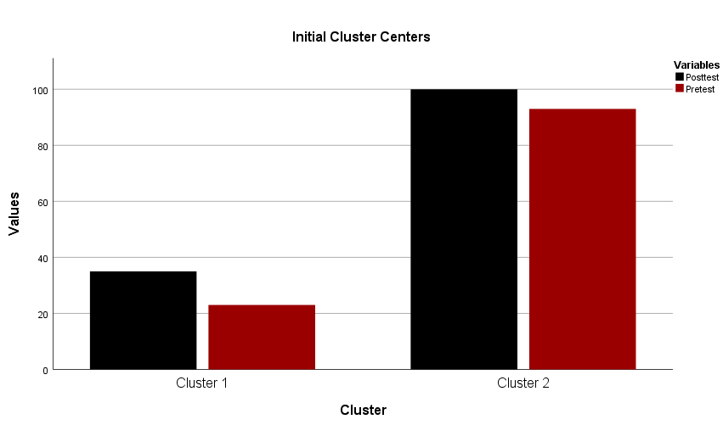

 | 1 | 2
Posttest | 35 | 100
Pretest | 23 | 93

Iteration History
Iterations
Iteration | Change in Cluster Centers
Iteration | 1 | 2
1 | 30.191 | 33.606
2 | .885 | .791
3 | .611 | .532
4 | .212 | .181
5 | .227 | .200
6 | .150 | .128
 | .000 | .000

Final Cluster Centres
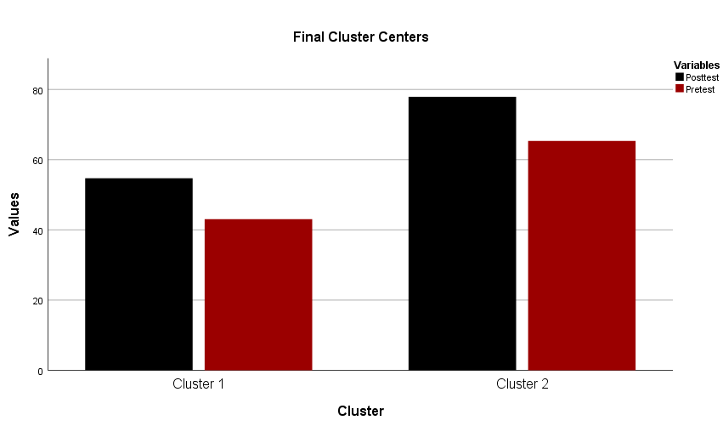

Statistical Significance

Distance Between Final Clusters
Distances between Final Cluster Centres
Cluster | 1 | 2
1 |  | 32.160
2 | 32.160

ANOVA
 | Cluster |  | Error |  | F | Sig.
 | Mean Square | df | Mean Square | df | F | Sig.
Posttest | 285646.166 | 1 | 61.679 | 2131 | 4631.188 | .000
Pretest | 263262.668 | 1 | 60.505 | 2131 | 4351.122 | .000

Case Distribution in Clusters
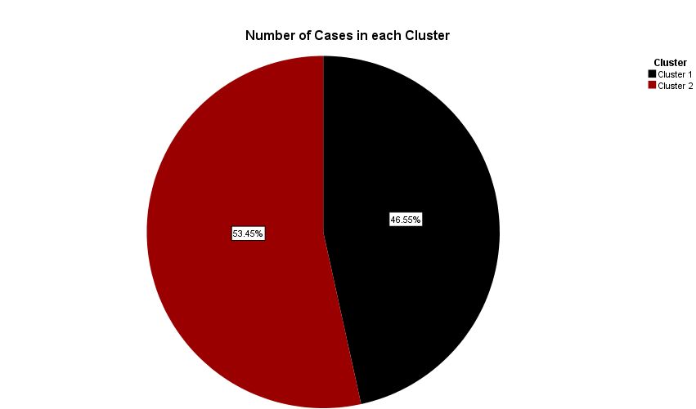

Number of Cases in each Cluster
Cluster | 1 | 993.000
Cluster | 2 | 1140.000
Valid |  | 2133.000
Missing |  | 2133.000

Discussion on K-Means Clustering

Cluster Centres and Iteration History
The K-means clustering algorithm converged after several iterations, with the change in cluster centres decreasing progressively across iterations. The final cluster centres for the two clusters are as follows:

Cluster 1
- Pretest: 23.000
- Posttest: 93.000

Cluster 2:
- Pretest: 35.191
- Posttest: 100.606
The iterative refinement of cluster centers indicates that the algorithm successfully minimized the variance within clusters and maximized the variance between clusters.

Statistical Significance
The ANOVA results indicate that there is a significant difference between the clusters for both pretest and posttest scores. The F-values are highly significant (p < .000), suggesting that the clustering solution is statistically meaningful and not due to random chance.

Distance Between Final Clusters
The distance between the final cluster centers for Cluster 1 and Cluster 2 is 32.160, further confirming the distinct separation between the two clusters in the multidimensional space defined by the pretest and posttest scores.

Case Distribution in Clusters
- Cluster 1: 993 cases
- Cluster 2: 1140 cases
The distribution of cases among the clusters reveals that Cluster 2 had a slightly higher number of cases compared to Cluster 1, which implies that there seems to be a higher proportion of students in Cluster 2 based on their results on pretest and posttest.

Interpretation and Implications
The clustering analysis has identified two distinct groups of students based on their pretest and posttest scores:

Cluster 1 (Lower Scores)
This group represents the students with lower pre-test score (mean of 23.000) and post-test score (mean of 93.000) being below average. There can be students who really need additional assistance and rehabilitation to be able to do well at school.

Cluster 2 (Higher Scores)
This group will demonstrate higher pretest scores (mean of 35.191) and higher posttest scores (mean of 100.606). Such learners have been distinguished by their exemplary academic performance and may get benefits such as enrichment activities or advanced classes.

Evaluation of SPSS as a Data Analysis Tool
Feature | Advantage | Disadvantage | Consideration for Different Users
Advanced Statistical Procedures | * Provides sophisticated techniques, such as multilevel modeling, SEM, and GEE, for dealing with hierarchical data and complex associations. * Has plenty of features that can be used for the following: missing data imputation and weighting (Rahman and Muktadir, 2021). | * Steeper learning curve compared to basic procedures. * Requires a strong understanding of statistical concepts for proper interpretation of results (DeCoster and Claypool, 2004). | * Ideal for researchers conducting advanced statistical modeling, particularly in social sciences or public health. * Less suitable for beginners or those focusing on simpler analyses.
Data Cleaning and Transformation | * Extensive data cleaning tools for handling missing values, outliers, inconsistencies, and data recoding. * Offers functionalities for variable creation, merging datasets, and variable selection (Kulas, Roji, and Smith, 2021). | * Limited automation capabilities for complex data cleaning tasks that might require scripting in other languages. * Data cleaning process can be time-consuming for large datasets, especially compared to in-memory manipulation offered by R or Python (DeCoster and Claypool, 2004). | * A powerful tool for managing messy real-world data, ensuring data quality for downstream analyses. * May not be optimal for users working with extremely large or complex datasets requiring extensive cleaning pipelines.
Syntax Scripting | * Provides a scripting language (SPSS Syntax) for automating repetitive tasks and complex analyses. * Syntax offers greater flexibility and control compared to the point-and-click interface (Rahman and Muktadir, 2021). | * Requires additional learning curve for users unfamiliar with coding. * Debugging syntax errors can be challenging for beginners (Pallant, 2020). | * A valuable feature for experienced users or those requiring automation and customization beyond the point-and-click interface. * Less suitable for those strictly reliant on a user-friendly, menu-driven approach.
Integration with External Tools | * Seamless integration with other IBM SPSS products like Modeler and Amos for a complete data analysis and modeling workflow. * Connects with external databases and statistical software like R or Python for leveraging their functionalities Kulas, Roji, and Smith, 2021). | * Requires additional investment in other software licenses. * Integration complexity can vary depending on the chosen tool (Pallant, 2020). | * Well-suited for organizations utilizing a comprehensive IBM data science ecosystem. * May not be ideal for users working with a variety of open-source tools or preferring a standalone environment.

Is SPSS a Better Data Analysis Tool than Excel: Comparative Analysis
Feature | SPSS | Excel
Statistical Tests | Extensive library of parametric and non-parametric tests (ANOVA, regression analysis, factor analysis, etc.) | Limited set of statistical functions (t-tests, correlations, basic regressions)
Data Cleaning & Transformation | Built-in tools for handling missing values, outliers, recoding variables, data imputation | Requires manual formulas or add-ins for complex data cleaning
Data Management | Efficient handling of large datasets with complex structures, syntax allows for batch processing | Can become cumbersome with large datasets, prone to errors with manual manipulation
Syntax & Scripting | Powerful syntax language for automation, customization, and repeatability | Limited macro capabilities, less flexible for complex analyses
Output & Reporting | Customizable tables and reports with statistical summaries and visualizations | Basic output tables, requires additional effort for presentation-ready reports
Integration | Integrates with other IBM analytics tools (e.g., R) for advanced modeling | Limited integration capabilities, relies on workarounds for complex workflows
Collaboration | Data and analysis can be easily shared with other SPSS users | Data sharing is possible, but version control and collaboration features are limited

References
Agag, G., Durrani, B.A., Shehawy, Y.M., Alharthi, M., Alamoudi, H., El-Halaby, S., Hassanein, A. and Abdelmoety, Z.H., 2023. Understanding the link between customer feedback metrics and firm performance. Journal of Retailing and Consumer Services, 73, p.103301.
Alarussi, A.S. and Gao, X., 2023. Determinants of profitability in Chinese companies. International Journal of Emerging Markets, 18(10), pp.4232-4251.
Alexandropoulos, S.A.N., Kotsiantis, S.B. and Vrahatis, M.N., 2019. Data preprocessing in predictive data mining. The Knowledge Engineering Review, 34, p.e1.
Bernstein, F. and Guo, Y., 2023. Managing customer search: Assortment planning for a subscription box service. Manufacturing & Service Operations Management, 25(5), pp.1623-1642.
Blaney, J., Milligan, S., Steer, M. and Winters, J., 2021. Visualising your data. In Doing digital history (pp. 123-148). Manchester University Press.
Boukouvala, F., Zhai, J., Kim, S.H. and Jariwala, F., 2018. Teaching data-analytics through process design. In Computer Aided Chemical Engineering (Vol. 44, pp. 1663-1668). Elsevier.
Chow, C.W., Liu, J., Li, J., Swain, N. and Saint, C.P., 2022. A Data Visualisation Tool for Treatment Process Monitoring in Web Browsers. Water Conservation Science and Engineering, 7(4), pp.363-373.
Church, K.S., Riley, J. and Schmidt, P.J., 2022. Has excel become a “golden hammer”: The paradox of data analytics in SME clusters. Journal of Emerging Technologies in Accounting, 19(2), pp.211-234.
Cobcobo, A.J. and Capua, R.D.G., 2022. Data Analysis Integration Computer Imported Learning: A Microsoft Excel Case with Statistics. EDUCATUM Journal of Science, Mathematics and Technology, 9(1), pp.20-37.
DeCoster, J. and Claypool, H., 2004. Data analysis in SPSS.
Derindere Köseoğlu, S., Ead, W.M. and Abbassy, M.M., 2022. Basics of Financial Data Analytics. In Financial Data Analytics: Theory and Application (pp. 23-57). Cham: Springer International Publishing.
Duong, H.T. and Nguyen-Thi, T.A., 2021. A review: preprocessing techniques and data augmentation for sentiment analysis. Computational Social Networks, 8(1), p.1.
Evans, D.W., 2010. The impact of underutilising productivity software (Doctoral dissertation, Cape Peninsula University of Technology).
Fan, C., Chen, M., Wang, X., Wang, J. and Huang, B., 2021. A review on data preprocessing techniques toward efficient and reliable knowledge discovery from building operational data. Frontiers in energy research, 9, p.652801.
Ghoshal, A., Mookerjee, V.S. and Sarkar, S., 2021. Recommendations and cross-selling: Pricing strategies when personalizing firms cross-sell. Journal of Management Information Systems, 38(2), pp.430-456.
Gould, S.J., 2022, April. Complex Data Visualisation Made Easy with R and ggplot2. In CHI Conference on Human Factors in Computing Systems Extended Abstracts (pp. 1-3).
Jang, H., 2021. Data visualisation platform for individuals (Doctoral dissertation, Hochschule Rhein-Waal).
Kathuria, A., Gupta, A. and Singla, R.K., 2021. A review of tools and techniques for preprocessing of textual data. Computational Methods and Data Engineering: Proceedings of ICMDE 2020, Volume 1, pp.407-422.
Khan, M.A., Kalwar, M.A. and Chaudhry, A.K., 2021. Optimization of material delivery time analysis by using Visual Basic for applications in Excel. Journal of Applied Research in Technology & Engineering, 2(2), pp.89-100.
Koning, R., Hasan, S. and Chatterji, A., 2022. Experimentation and start-up performance: Evidence from A/B testing. Management Science, 68(9), pp.6434-6453.
Kronthaler, F., 2022. Statistics applied with excel: data analysis is (not) an art. Springer Nature.
Kulas, J.T., Roji, R.G.P.P. and Smith, A.M., 2021. IBM SPSS essentials: managing and analyzing social sciences data. John Wiley & Sons.
Laplante, S.K. and Vernon, M.E., 2021. Incorporating data analytics in a technical tax setting: A case using Excel and Tableau to examine a firm's schedule M-3 and tax risk. Issues in Accounting Education, 36(2), pp.129-139.
Lin, C. and Bowman, D., 2022. The impact of introducing a customer loyalty program on category sales and profitability. Journal of Retailing and Consumer Services, 64, p.102769.
Luo, R. and Vejvoda, B., 2023. Further Adventures in Data Cleaning: Working with Data in Excel and R. Research Data Management in the Canadian Context.
Mallikharjuna Rao, K., Saikrishna, G. and Supriya, K., 2023. Data preprocessing techniques: emergence and selection towards machine learning models-a practical review using HPA dataset. Multimedia Tools and Applications, 82(24), pp.37177-37196.
Miyamoto, A., Allacker, K. and De Troyer, F., 2022. Visual tool for sustainable buildings: A design approach with various data visualisation techniques. Journal of Building Engineering, 56, p.104741.
Mustafy, T. and Rahman, M.T.U., 2024. Excel. In Statistics and Data Analysis for Engineers and Scientists (pp. 81-134). Singapore: Springer Nature Singapore.
Pallant, J., 2020. SPSS survival manual: A step by step guide to data analysis using IBM SPSS. Routledge.
Rahman, A. and Muktadir, M.G., 2021. SPSS: An imperative quantitative data analysis tool for social science research. International Journal of Research and Innovation in Social Science, 5(10), pp.300-302.
Sangaiah, A.K., Zhang, Z. and Sheng, M. eds., 2018. Computational intelligence for multimedia big data on the cloud with engineering applications. Academic Press.
Tarigan, Z. and Siagian, H., 2021. The effects of strategic planning, purchasing strategy and strategic partnership on operational performance. Uncertain Supply Chain Management, 9(2), pp.363-372.
Waskom, M.L., 2021. Seaborn: statistical data visualization. Journal of Open Source Software, 6(60), p.3021.
Wolters, J. and Huchzermeier, A., 2021. Joint in-season and out-of-season promotion demand forecasting in a retail environment. Journal of Retailing, 97(4), pp.726-745.
Wood, A., Kirkwood, L., Feng, Z., Alhaydhal, S., Alomran, A., TALEB, R.B., Durazo-Cardenas, I. and Starr, A., 2021. Cost Data Visualisation. In Advances in Manufacturing Technology XXXIV (pp. 408-413). IOS Press.
Wu, J., Zhao, H. and Chen, H., 2021. Coupons or free shipping? Effects of price promotion strategies on online review ratings. Information Systems Research, 32(2), pp.633-652.
Zhou, H. and Zhou, H., 2022. PivotTable Data Analysis. Mastering Excel Through Projects: A Learn-by-Doing Approach from Payroll to Crypto to Data Analysis, pp.169-201.

