Assignment 1 Contemporary Management
Alexandra Olivia Safadi
School of Management Trinity Saint David’s
29th November 2017

Assignment 1 Contemporary Management
Introduction
This essay views an organisation that relates particularly well to the topics that are discussed in this piece. This essay will look in depth at how Mc Donald’s management operates and how the specific organisation demonstrates its organisational functions, lastly evaluating its management approach to these.
McDonald’s Background History
The organisation that I have chosen to discuss is McDonald's. McDonald's is a fast food American restaurant which provides a drive-through takeaway service. Founded in 1940 and began as a barbecue restaurant, initially operated by Richard and Maurice, the organisation progressed into stalls selling hamburgers stands in 1948. The first franchise opened in Arizona in 1953.
Ray Kroc joined the company and purchased the franchise in 1955. The restaurant has turned into the biggest food chain in the world, and currently serves over 100 countries and are a global business with more than 36,000 locations worldwide.
Approaches to Mc Donald’s Strategy of Management
Businesses must have a strategy of management to be successful, often using a business model. There are many approaches that McDonald's and other organisations use to manage successfully and efficiently, e.g. classical which involves scientific management and bureaucracy; human relations; systems; and contingency. This essay will include theories that relate to McDonald's style of management more than others.
Businesses are seen as an economic activity. The intention of investing in a business activity is to make a profit and acquire wealth through providing society with services and goods. Lewis Henry defines business as "Human activity directed towards producing or acquiring wealth through buying and selling of goods."
Small businesses consist of face to face communication; a formal structure would often be unnecessary. In large companies like Mc Donald's, decisions must be made about the assignment of various tasks ‘Procedures are established that assign responsibilities for various functions. It is their decisions that determine the organisational structure’. (“ORGANIZATIONAL STRUCTURE.” Reference for Business,)
Human relations theory
This theory pays attention to social factors at work - groups, leadership, the informal organisation, behaviour of people and neo-human relations. Human relations approach to management believes that managers need to recognise the importance of the physical environment of the workplace but also the social environment. McDonald’s are obliged to make the workplace sanitary for customer’s wellbeing and the rights of employees.
Social acceptance is significant as employees need to have a positive feeling of mutual respect to feel appreciated and happy to work. Valuing employees allows them to feel positive, appreciated and rewarded when at work.
McDonald's managers use this method to share different responsibilities between different employees which allows them to work together as a team as each assigned task links with the task of another employee. Therefore, McDonald's uses the use of teamwork to manage effectively to provide ‘fast food.'
Team work is vital, according to McDonald's management. Individuals are selected to work as a team and for their good communication skills. While working at McDonald's, employees are assigned to teams, e.g. tills on the front counter, kitchen, drive through taking orders, giving out orders, issuing bills and collecting money, and management teams. Franchises often use suppliers and employees to work together towards a common goal. This allows Mc Donald's to provide quick-service worldwide. ‘Suppliers are dedicated to highest levels of quality and safety, and this also applies to employees that work in the company.’ (“What a McDonald's Franchise Really Costs.” Business Opportunities, 17 Aug. 2015, )
The classical management theory
This theory pays attention to productivity, output and efficiency of employees, rather than certain differences that exist. According to the theory, employees are motivated by rewards. It is also believed that employees work harder and become more productive if they are respected and valued.
Classical management approaches are used today by many small-business owners to build their companies and to succeed. This approach is based on a hierarchical organisation which defines responsibilities and objectives of managers within each level of management. "The approach proposes the division of labor, which reduces expenses and increases employee performance”. ( “What Is the Classical Management Approach?” Reference, IAC Publishing, )
This method has an emphasis on formal purpose structure, the hierarchy of management, technical requirements, and universal principles of organisation. The scientific theories and bureaucratic aspects particularly relate to McDonald’s form of governance.
The Scientific element
This approach looks at the best way to undertake a job. They believe this is completed by analysing work into discrete tasks by identification the best way and use of the rational economic concept of motivation. The approach looks at the development of a true science for each person’s work. The scientific element relates to McDonalds as managers select employees based on their efficiency to complete a task. McDonald's teach staff to work in the most efficient way. The franchise ensures teamwork is carried out in a prescribed direction utilising the application of rational economic concepts of motivation. The hierarchy structures of authority and close supervision is used sufficiently to manage a successful global business like McDonald's.
I have created a hierarchical structure of authority to demonstrate the structure of power in McDonald's. This Leeds to the division of work and responsibilities between managers and workers.

Director/ head of the management
Administrative level
Mcdonalds manager
Executive level
Assistant to McDonald’s manager

HR manager
Operational level
Customer representative

Cooks
McDonald’s supporting staff

The Bureaucracy theory
This theory focuses on specialisation, the hierarchy of authority, the system of rules and impersonal behaviour. McDonalds allocate different organisational tasks between corporate positions. There is a definite division of labour and high degree of task specialisation. McDonalds use the hierarchical authority system to manage and allocate appropriate rolls to staff as I have specified in the structure I created above. The organisation uses rules and regulation to achieve uniformity of decisions. In many organisations employment is based on having a degree in a specific subject. This theory believes that employment should be based on technical qualifications. There is an emphasis on the word ‘technical’ as McDonalds uses this technique to employ staff meaning that employees don’t necessarily need specific grades. Instead it is required that particular skills are necessary for the specific job in the organisation, e.g. McDonalds look for excellent communication in their staff as they are required to speak to customers.
The systems approach
The systems approach is also known as the modern theory of management. Systems are seen as an order of something we do. humans use systems daily without recognising that it is a system e.g. a morning system: we wake up in the morning to have a shower, brush our teeth, get dressed, etc. If there is no water available the system is broken and changed. This system exists in business, and then the system can allow a company to become global. The system can then be duplicated around the world. Adjustments need to be made such as from country to country, but even ‘with modifications, the system makes it much easier for an organization to produce a similar customer experience around the world’ (Systems Management Theory - Video & Lesson Transcript ... (n.d.). McDonalds created a successful system to management, and this system has become global. Every McDonalds is the same, and every individual knows what to do when they enter the organisation.
Food in other countries may differ. Hamburgers are not permitted in McDonalds in India but the food ordering systems are the same. Customers walk up to the counter, scrutinise the menu on the electronic walls, order a meal and wait for their order number to be called out for collection.
A successful system is duplicated around the world. Modifications are made to menus according to beliefs, e.g. Halal, Kosha meat and other dietary requirements. ‘systems make it much easier for an organization to produce a similar customer experience around the world.’ McDonalds is only one example, there are others, such as Costa, Tesco, and KFC.
There are two types of systems.
Firstly, an Open System; based on interaction with the environment e.g. McDonalds might use several different suppliers of meat, flour or milk to make the product they produce, or an ‘organization might have to move or change as the demands of consumers change for them to cut costs and to make money.' ( Wengrzyn, Rob. “Systems Management Theory.” Study.com, Study.com, study.com/academy/lesson/systems-management-theory.html.)
Secondly, a Closed System; the opposite of an open system. It is a system or an organisation independent of the environment around it.

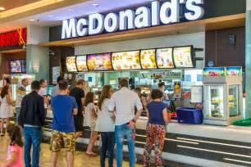
(“Go to Bing Homepage.” Pictures+of+People+Ordering+Mcdonalds+ - Bing Images, )

Work motivation and satisfaction
Research proves there are definite links between how motivated an individual is at their workplace and their level of job satisfaction. According to Lisa money, (“Links Between Motivation & Job Satisfaction.” Chron.com, smallbusiness.chron.com/links-between-motivation-job-satisfaction-13267.html.) resulting in an increased efficiency and better job performance. This is vital for creating contentment, optimism and enthusiasm and the feeling of teamwork in the workplace to allow success.
Maslow’s hierarchy of needs
Abraham H. Maslow presented the idea that human actions are directed toward goal attainment. Once we reach our goal, we aim to achieve the next as we go up the hierarchy triangle until we become self-actualized. (“Maslow's Hierarchy of Needs.” Learning Theories, 2 Sept. 2016)
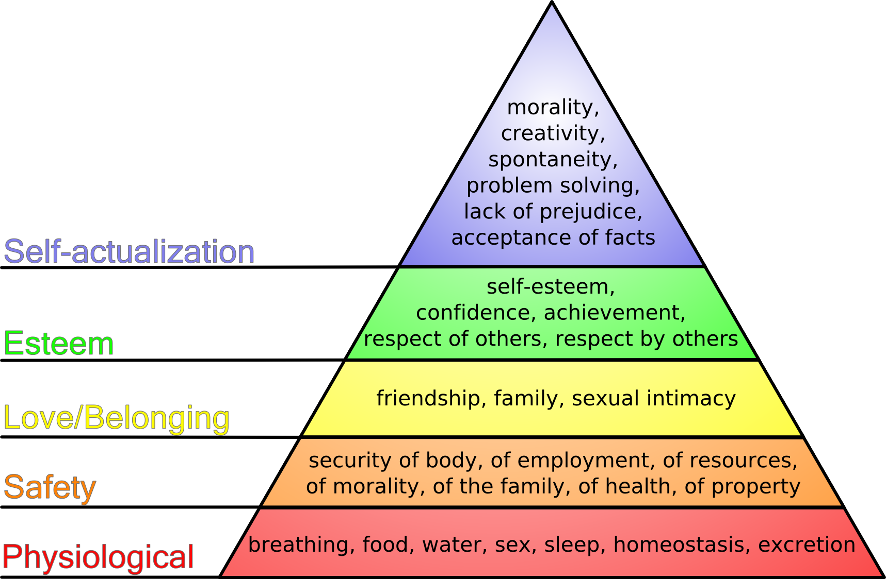
(“Go to Bing Homepage.” Maslow+Hierarchy+of+Needs - Bing Images,)
Managers of this organisation ensure that employee’s needs are met, e.g. their physiological needs. Employees are given breaks throughout their shift, organised shift times to plan their sleep to ensure that they aren't exhausted. Staff can eat and drink during their breaks and clean sanitary toilets are provided throughout the day which is separate to those that customers use.
The safety of the staff is met as they are employed by a well-known franchise, they are guaranteed pay…16-17-year-olds earn £4.25 per hour, 18-21 earn £4.65 and 22+ on £5.55. Reasonable shift hours are given and they can address what days they can work as they apply for the job. Managers are generous and allow staff to take sick days if needed. Sensible uniforms are provided and Staff rooms are available.
The wellbeing of employees is met and employees are provided with the facilities and to create friendships. The access of breaks encourage employees to form the friendship and shared staff rooms can influence a place to socialise to form bonds. Mc Donald's provides a clean environment to promote an atmosphere of positive wellbeing. When individuals are happy, they are prone to making friends as their happiness is likely to aspire and motivate others. In the business industry, emotions can have a massive impact on the overall morale, productivity and job performance of employees. Emotions can be used to create a positive work environment or, if neglected, can cause an adverse place of work. The ‘results are happy employees with positive emotions resulting from a fantastic work environment. The functions of positive emotions are that employees are incredibly productive, motivated and happy. This results in large sales and profits for the company.’ (Emotions In The Workplace: Purpose & Functions - Video ... (n.d.).
Once friendships are formed this can allow an individual's confidence and self-esteem to strengthen. Companies encourage employees to respect one another. Once the levels have been completed an individual becomes self-actualised meaning that they perform to the best of their ability. McDonald’s provides a working place which aims to meet each level in the graph above to allow their employees to become self-actualised and to enable them to perform to the best of their ability which then will result in the growing success of the business.
Perception and communication
‘Perception is the processing, interpreting, selecting and organizing of information. Perception's effect on the communication process is all about how the same message can be interpreted differently by different people.’ (Lombardo, Jennifer. November 17, 2017“Emotions in the Workplace: Purpose & Functions.”)
To communicate effectively, business people need to spend the time to investigate job applicants thoroughly. Managers are obliged not to judge individuals by the first impression. Individuals have stereotypes, and their first impression may not be accurate, the manager's perception could have been incorrect. Individuals can filter out specific information to make it align with their thoughts, beliefs, and judgments.
Present feelings, past experiences and culture may affect perception. Humans receive stimuli from their environment then organise the information and interpret the data. Perception is a personal response.
Effective communication between managers and team members is essential to avoid friction between employees. McDonalds’ employees may relate personal problems to external causes, while managers relate every obstacle to its impact on the workplace. Employees blame an overall condition whereas managers just blame workers. Friction between bosses and team members is a common occurrence. Managers can address this issue by taking into consideration what may be causing issues outside the workplace and adopt an ‘open door’ policy to encourage freedom to communicate and share personal problems.

The nature and context of organisations
Members of an organisation can achieve a synergistic effect and can create goals to be achieved by using collaborative action.
Organisations such as McDonalds are multi-purpose meaning that they have more than one goal in mind, although there is often a predominant goal.
According to McDonalds’ official site, their primary focus is on creating ‘good food’ creating opportunities such as employing individuals and providing them with a reasonable wage, encourage diversity, offer training, facilitating teamwork, and providing rewards for achievement. McDonalds aim to contribute to Ronald McDonald house charities and the organisation has also committed to reducing carbon footprint through using less energy and recycling more. These are all environmental influences on the organisation, e.g. climate and the social attitudes on this topic, such as the carbon footprint strategy… ‘The Company and its Franchisees are seeking new ways to further improve restaurant efficiency, manage energy usage and costs, recycle waste and conserve and reuse water’. ("Good Planet." Planet:: McDonald's, corporate.mcdonalds.com/mcd/sustainability/planet.html.)
McDonalds train their employees in energy efficiency. Staff are trained to put equipment such as toasters and grills into the standby position when they are not in use. They have also installed energy-saving equipment in the franchise for greater efficiency. It is essential to consider the environmental factors such as working closely with suppliers to encourage them to do their part. McDonalds buys all their beef from British and Irish farmers. They believe there is an opportunity to reduce the carbon footprint by buying locally. McDonalds work with independent environmental experts, the E-CO2 company and the Carbon Trust to fund a study into ways they can reduce methane emissions from cattle.

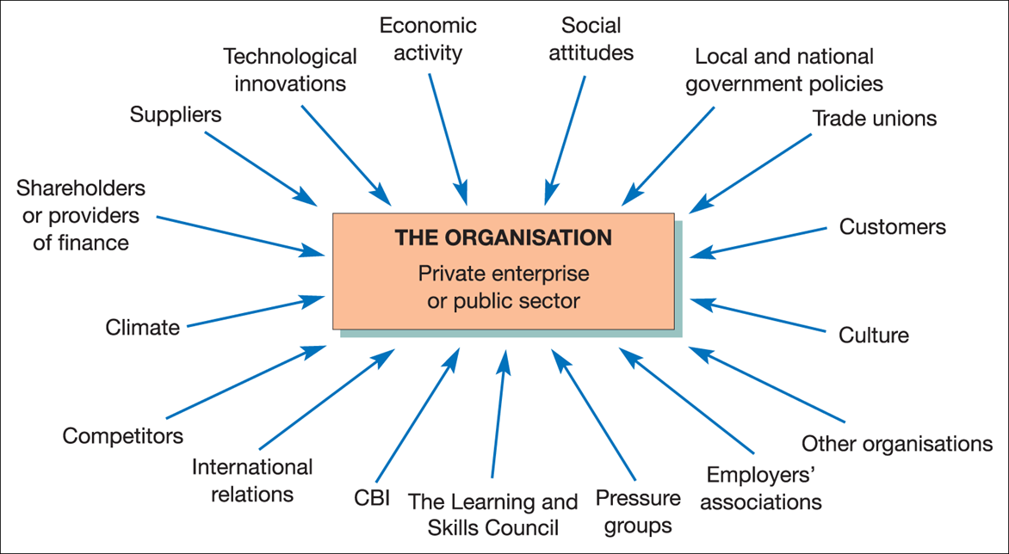
Above is an image showing other environmental issues that affect organisations.
The word PESTLE is used in this essay as a technique to explain the key cooperates to change in the business environment. The abbreviation stands for P for political, E for economic, S social, T for technological, L for legal, and E for the environmental factors. The following now describes how these different environmental factors affect McDonalds.
Political- There are factors that affect the fast food industry which targeted for government initiatives to reducing obesity and improving health for individuals in European countries. Statistics show that 19.1% of children in Year 6 are obese, 14.2% are overweight. Children in Reception 9.1% are obese, 12.8% are overweight. (“Facts about the UK's Growing Obesity Crisis.” ITV News) this shows that obesity is a growing issue in the UK.
The UK government has introduced initiatives to reduce the amount of salt in food within fast food industries. McDonalds was obliged to change their menu which reduced the salt content in the UK menu by roughly14% (Food Standards Agency, 2005). According to McDonalds’ official website, they believe the obesity issue is a shared responsibility. The company started looking at recipe improvements and providing parents with the nutritional facts to educate parents regarding what children are eating. There have since been improvements to nutritional information as they are now included on the backs of all tray liners and most packaging.
Economic- franchises can be seen as substitutes for traditional restaurants as some individuals prefer to eat at a fast food place as it’s cheaper compared to a restaurant. In 2008 the UK saw a growth regarding revenue of 4.5%, with an increase in demand for McDonalds products of 4%. A low-profit margin will result if people choose to eat at home on a small budge.
Socioculture- McDonalds have been unsuccessful at avoiding a public backlash. Fast food has seen its public image decline as society becomes health conscious. The preceding decades have seen a rise in health conscious people and there is increased demand for unprocessed and organic foods. There is a growing public awareness of obesity and heart disease and its links to high-fat diets. In 2004 Morgan Spurlock, who is an American social-commentary filmmaker created a documentary called Super-Size Me (2004). He ate only McDonalds for 30 days. He also had to opt for the super-size meal whenever instructed, which consists of double the food of a medium sized meal. This meal included a 42-ounce coke. At the end of the 30days results showed that he gained one stone and 10.5 pounds representing a 13% body mass increase. He also developed cirrhosis of the liver due to the challenge.
In response to the bad press, McDonalds removed the option of super-sized meals in the US. They instead began offering more healthy options such as smoothies, salads and fruit bags.
Technological- Technology provide many opportunities for high-impact, low-cost marketing across different businesses. Technology these days has the power to ruin a business image if they are viewed as out-of-touch with the modern world. There are many marketing techniques used for businesses ranging from involved, intricate, multi-layered viral campaigns through website design and functionality to simple social media presence. The fast-food industry has now embraced its potential and McDonalds is at the forefront.
The internet has proved to be a perilous strategy of marketing success for McDonalds. There have been many negative articles posted on twitter and Facebook about its products within the company. e.g., the hoax post that claimed a batch of McDonalds hamburgers in Oklahoma was found to have been contaminated with ‘human meat.' Many people online believed the stories, and refused to use McDonalds services again. False information is easily spread online and firms can be at the centre of false accusations and internet pranks.
Legal- Many, if not all of the countries McDonalds operates in has some public health inspection system for food producers. Employees that handle food must take part in food-hygiene training at the company's expense. McDonalds has implemented a system that adds additional controls to those as their customer website states, "there are at least 70 safety checks on beef and chicken every day”.
There are also some employment laws including the maximum length of an employee's weekly and daily working hours. The requirements for facilities, employee breaks, payroll, tax, business registration and accountancy standards for reporting profit and loss (Jones, 2013) tends to adhere to the same legal standards across markets.

Environmental- environmental issues have become an important public issue with the rise of many green initiatives and movements. Food production techniques are associated with poor standards, e.g., budget meat suppliers. Some protests have been levelled at many fast food firms in general, on the 19th of July 1985, Greenpeace (UK) declared an "anti-McD Day of Action" which involved demonstrations, protest marches and pickets of many McDonalds stores across the UK.
McDonalds have placed many Corporate Social Responsibility (CSR) policies to reduce the environmental impact of the business; currently by participating in ‘Earth Hour,' which encourages many companies to turn their lights off and unused equipment off on a specific hour each year, to reduce their carbon footprint. They have also reduced the environmental impact of their packaging, using biodegradable packaging. They have placed paper-reduction policies in their administration centres, they have also investigated the management and care of the animals reared for product supply, aiming to avoid unnecessary cruelty or inhumane treatment. (McDonald's, 2014c)
McDonalds face many challenges from environments external changes as discussed above but by acknowledging these challenges, McDonalds strategy and marketing managers can use the business’ strengths to change challenges into potential business opportunities.
Conclusion
This essay contains information based on how McDonalds management operates and how the specific organisation demonstrates and uses its organisational functions. This essay contains information on the management approach to these. This information was obtained by looking in depth at the different approaches to management and the specific approaches that McDonalds use. The essay also discusses perception and communication, and lastly, PESTLE is used to discuss how the environment is organised around the McDonalds and the effects they have on the business.

References
( “What Is the Classical Management Approach?” Reference, IAC Publishing, ) What Is The Classical Management Approach? | Reference.com. (n.d.). Retrieved from https://www.reference.com/business-finance/classical-management-approach-63ef738

(“What a McDonald's Franchise Really Costs.” Business Opportunities, 17 Aug. 2015, ) ‘The company facilitates learning and sharing across McDonald's more than 36,000 restaurants.’(“Our Business Model.” McDonald's Business Model and Strategy::McDonald's, corporate.mcdonalds.com/mcd/our_company/business-model.html)

(Systems Management Theory - Video & Lesson Transcript ... (n.d.). Retrieved from http://study.com/academy/lesson/systems-management-theory.html)

“Facts about the UK's Growing Obesity Crisis.” ITV News, www.itv.com/news/2016-03-21/facts-about-the-uks-growing-obesity-crisis/.

“Facts about the UK's Growing Obesity Crisis.” ITV News, www.itv.com/news/2016-03-21/facts-about-the-uks-growing-obesity-crisis/.

“Go to Bing Homepage.” Maslow+Hierarchy+of+Needs - Bing Images, www.bing.com/images/search?view=detailV2&ccid=rCEjgSVA&id=4B18F94ECBB8A390458F3AB18579A5D202FBE210&thid=OIP.rCEjgSVA3lw0jMgWGJ7CuAEsDE&q=maslow%2Bhierarchy%2Bof%2Bneeds&simid=607990723300232196&selectedIndex=0&ajaxhist=0.

“Go to Bing Homepage.” Pictures+of+People+Ordering+Mcdonalds+ - Bing Images, www.bing.com/images/search?view=detailV2&ccid=XcxPH3gf&id=2BDE44540D141BE21F7ACC705A122A4C2AA6B6E3&thid=OIP.XcxPH3gf5p7gECepqcCVFAEsDI&q=pictures%2Bof%2Bpeople%2Bordering

“Good Planet.” Planet :: McDonald's, corporate.mcdonalds.com/mcd/sustainability/planet.html.

“Links Between Motivation & Job Satisfaction.” Chron.com, smallbusiness.chron.com/links-between-motivation-job-satisfaction-13267.html.

“Management Overview.” Quizlet, quizlet.com/67003363/management-overview-flash-cards/. https://quizlet.com/67003363/management-overview-flash-cards/

“Maslow's Hierarchy of Needs.” Learning Theories, 2 Sept. 2016, www.learning-theories.com/maslows-hierarchy-of-needs.html.

“ORGANIZATIONAL STRUCTURE.” Reference for Business, www.referenceforbusiness.com/management/Ob-Or/Organizational-Structure.html.

“Our Business Model.” McDonald's Business Model and Strategy :: McDonald's, corporate.mcdonalds.com/mcd/our_company/business-model.html.

“PESTEL Analysis of McDonalds - Food Industry PEST Example.” UKEssays, www.ukessays.com/essays/marketing/pestel-analysis-of-mcdonalds-and-the-food-industry-marketing-essay.php.

“What a McDonald's Franchise Really Costs.” Business Opportunities, 17 Aug. 2015, www.business-opportunities.biz/2015/08/17/mcdonalds-franchise-really-costs/.

“What a McDonald's Franchise Really Costs.” Business Opportunities, 17 Aug. 2015, www.business-opportunities.biz/2015/08/17/mcdonalds-franchise-really-costs/.

“What Has McDonald's Done to Address Childhood Obesity?” What Makes McDonald's, 1 Jan. 1970, www.mcdonalds.co.uk/ukhome/whatmakesmcdonalds/questions/food/diet-&-nutrition/what-has-mcdonalds-done-to-address-childhood-obesity.html.

“What Has McDonald's Done to Address Childhood Obesity?” What Makes McDonald's, 1 Jan. 1970, www.mcdonalds.co.uk/ukhome/whatmakesmcdonalds/questions/food/diet-&-nutrition/what-has-mcdonalds-done-to-address-childhood-obesity.html.

“What Is the Classical Management Approach?” Reference, IAC Publishing, www.reference.com/business-finance/classical-management-approach-63ef738a11276004.

“What Is the Classical Management Approach?” Reference, IAC Publishing, What Is The Classical Management Approach? | Reference.com. (n.d.). Retrieved from https://www.reference.com/business-finance/classical-management-approach-63ef738

Emotions In The Workplace: Purpose & Functions - Video ... (n.d.). Retrieved from http://study.com/academy/lesson/emotions-in-the-workplace-purpose-functions.html

Emotions In The Workplace: Purpose & Functions - Video ... (n.d.). Retrieved from http://study.com/academy/lesson/emotions-in-the-workplace-purpose-functions.html

http://corporate.mcdonalds.com/mcd/our_company/business-model.html

http://corporate.mcdonalds.com/mcd/sustainability/planet.html

http://smallbusiness.chron.com/links-between-motivation-job-satisfaction-13267.html

http://study.com/academy/lesson/how-perception-influences-the-communication-process.html

http://study.com/academy/lesson/how-perception-influences-the-communication-process.html

http://www.business-opportunities.biz/2015/08/17/mcdonalds-franchise-really-costs/

http://www.itv.com/news/2016-03-21/facts-about-the-uks-growing-obesity-crisis/

https://www.learning-theories.com/maslows-hierarchy-of-needs.html

https://www.reference.com/business-finance/classical-management-approach-63ef738a11276004#

Lombardo, Jennifer. “Emotions in the Workplace: Purpose & Functions.” Study.com, Study.com, study.com/academy/lesson/emotions-in-the-workplace-purpose-functions.html.

Spurlock, M (2004), Super-Size Me, Documentary, New York: The Con Production Company

Study.com, Study.com, study.com/academy/lesson/how-perception-influences-the-communication-process.html.

Systems Management Theory - Video & Lesson Transcript ... (n.d.). Retrieved from http://study.com/academy/lesson/systems-management-theory.html

Systems Management Theory - Video & Lesson Transcript ... (n.d.). Retrieved from http://study.com/academy/lesson/systems-management-theory.html

Veggis (2014), What's Still Wrong With McDonalds: Same date every year [Online], Available; http://www.veggies.org.uk/event.

Vizard, S (2013), McDonald's vows to ramp up marketing of healthy options [Online], Available; http://www.marketingweek.co.uk/news/McDonalds-vows-to-ramp-up-marketing-of-healthy-options/4008065.article

Wengrzyn, Rob. “Systems Management Theory.” Study.com, Study.com, study.com/academy/lesson/systems-management-theory.html.

What Is The Classical Management Approach? | Reference.com. (n.d.). Retrieved from https://www.reference.com/business-finance/classical-management-approach-63ef738

