Rhian Powell
2005076
BA Illustration
ADAD4018
Jonathan Pugh

Tasks in the order I received them:
Task 1: Observational Writing = 542 words
Task 2: Manifesto Writing = 506 words
Task 3: Practice-based Writing = 550 words

Task 1: Observational Writing

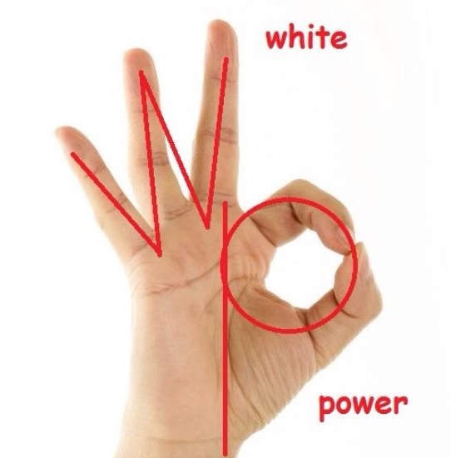
The “OK” hand sign is a gesture that has maintained prominence over time as a symbol of assurance and affirmation. But with the dawn of the internet and a strive for connection and recognition, it was taken and twisted into one of hatred and prejudice, as seen in the image below that was circulated online in 2017:

Fig. 1. White Power Symbol, (2019)

While this picture was a joke initiated by internet trolls, it had rippling consequences that the world can’t seem to forget. In this essay, I aim to analyse this gesture through a semiotic lens and gain insight into how such a ubiquitous and positive signal became a target for white supremacy and discrimination.

The modern interpretation of the gesture lies within our recognition of its components; that is, the “O” created by the touching finger and thumb, and the remaining three fingers jutting out to create the “K”. However, its earliest recorded use didn’t concern the circle at all.

As noted by Müller et al. (2014, p.1514-5), it traces back to Ancient Greece where the contact between the index finger and the thumb was said to symbolise “kissing lips”, being commonly used between partners as a declaration of affection. As such, the main factor of the symbol we know today was merely a by-product of a much more emblematic action; value was only instilled into the circle itself when it started appearing in religious art.

Hand gestures have played a major role in religious art over time, no less the “OK” sign. Buddhist art for example rebrands it as the “Vitarka Mudra”, and the ring created becomes the point of interest as it “symbolizes perfection with no beginning or end” (Tibetan Nuns Project, 2018). The complete and smooth nature of the circle conjures ideas of wholeness and wellness, which brings us the closest to its modern-day meaning.
One reason why I feel this gesture in particular became a target is the gesture is widely used, as popular as the “peace” or “thumbs up” gesture. I put forward that, considering this symbol is so abundant, it’s easier to find imagery that supports your narrative. The formation of the gesture itself is also a factor worth considering, as the meaning of the gesture to most people can be found within the letters that are created by the fingers. Therefore, the claim that there’s a hidden code in the shape of the gesture, as is demonstrated in the original image, is not unreasonable. Finally, the symbolism of the gesture itself, along with the time in which the picture spread, gave credibility to the hoax. Racial tensions were high throughout America in 2017 as Donald Trump settled into his first year as President. Protesters retaliated against and rejected him in his home state of New York, one bluntly stating, “Trump’s values are not New York values” (Gabbatt, 2017). In a climate so attuned to racism and discrimination, it’s easy to see how an image such as this could be believed, and of all the abbreviations “WP” could stand for, this particular phrase only added fuel to the fire.
This symbol is still being used today unironically (Beer, 2020), despite the original post being a joke, and is a testament to the power of (and the power of manipulating) semiotics.

Task 2: Manifesto Writing

- Art should first and foremost evoke an emotional response; skill comes second

- Successful art does not and should not require expensive materials

- The medium of art is its own language, and should be treated as such

- The digital world should adapt to art, not the other way around

- Art in the digital realm has become a beacon for propaganda, so we must stay vigilant and wary about what we see

- We should hold all genres and mediums of art at the same standard

- Art should not be a competition

- Street art should be encouraged in place of graffiti

Art in the digital realm has become a beacon for propaganda, so we must stay vigilant and wary about what we see
The internet has sculpted the way we’ve lived since its creation, opening up a whole host of opportunities and possibilities. But, in turn, it’s also paved the way for discordance and hatred to spread like never before and birthing out of that comes a new form of digital propaganda often referred to as “fake news” or “clickbait”.
In the past, disinformation was mainly propagated through posters or editorial illustration, a classic example being the Uncle Sam “I Want You” illustration of the 1940s. Some of its components as a piece of propaganda include direct address, use of an iconic figure, and moral contagion (Brady, Crockett, Van Bavel, 2020). These techniques are still present today in digital propaganda, but we now see an aspect of intimacy emerge as a prevalent factor from ad personalisation and data collection. Feelings are imperative to manipulation, and through the use of tools such as colour, nostalgia, typography, and exaggeration, this can be done easily. As Hobbs (2019) writes: “Propaganda is becoming highly responsive to user behavior.” In this way, we must recognise these forms of manipulation, and raise awareness to those unaware of the effects.

Art should first and foremost an emotional response; skill comes second
What separates art from other forms of self-expression like writing or music-making is the ability to use visual cues and techniques to communicate meaning, to say something and convey feeling in complete silence. In a lot of cases, however, this sentiment doesn’t carry further than realism, as people continue to criticise abstract art for being easy-to-achieve. As Hodge (2012, p.8) writes: “Many critics continue to regard an absence of technical skill as a lack of artistic sophistication and ability”. One such piece that caused major upset was “The Comedian” by artist Maurizio Cattelan, which featured a banana duct-taped to a wall. Many critics cited it as the death of traditional art (The Traditionalist, 2019) and were angered about the lack of meaning behind the piece, but I think that the discussion (and discourse) it encouraged instils unique meaning in it. We must support art and artists that challenge the preconceived ideas of its predecessors, to dissuade oversaturation in an already overflowing market.

Street art should be encouraged in place of graffiti
Street art is the one true representation of the time we live in. It often tackles subjects like racism, inequality, and political tension, and without the incentive of monetary gain or recognition, the results come from a place of passion and emotion. Graffiti, also known as tagging, is not desirable to anyone, as it adds nothing but an ugly scar to wherever it is, but street art is quite different. As written by Christensen and Thor (2017), street art brings artists and the public together, working with both to create something that reflects the values and beauty of its location. Moreover,
murals and street art were actually noted to deter unappealing tagging or vandalism in a 2006 study (Craw, P.J. et al). If we want to make the world a more inclusive and animated place, we must recognise how street art can lead to the enrichment of our environment when integrated properly and skilfully.

Task 3: Practice-Based Writing
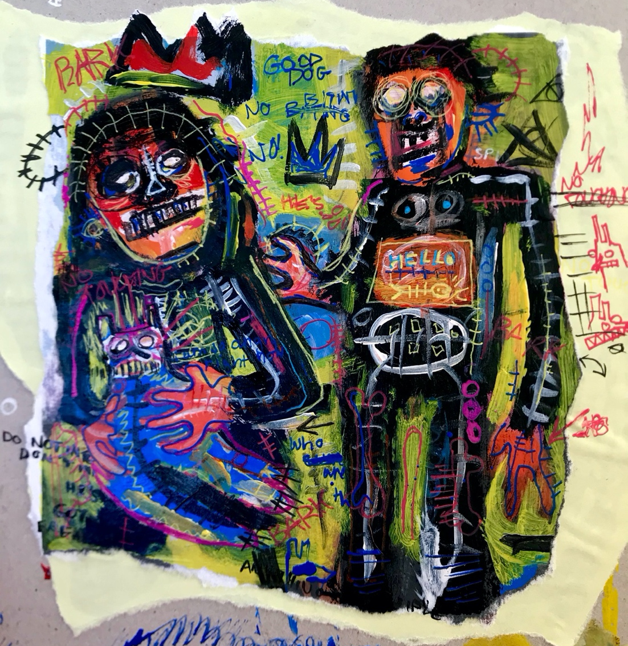

Fig. 1. Basquiat-Inspired Piece, Me, 2018

When evaluating the worth of a work of art (be it within the setting of an art gallery or through a screen), our visual perception and personal interpretation of it is our one and only criteria; what we see determines what we decide of it. However, to gain a deeper appreciation and understanding of the piece and its intentions, one must scrutinise the process and developmental steps the artist took to arrive at its destination.
One artist whose who seemingly uses the canvas as his sketchbook is Jean-Michel Basquiat, and in 2018 I attempted to replicate his style through a painting of an old childhood photograph.

A feature of Basquiat’s work is his use of symbols and typography, often near obscure or intelligible and interwoven within the painting itself. This is intentional, as he once remarked, “I cross out words so you will see them more; the fact that they are obscured makes you want to read them” (Basquiat, 2005, p.87). As a result, I incorporated text throughout the process of this painting, concealing subtextual information and narrative elements behind brush marks or figures as per his goal of imploring the viewers to look deeper. I began to look at my canvas as more of a notebook, noting down what came to mind as I painted. Basquiat also incorporated symbols and semiotics into his work, most notably the crown, which he placed over the heads of those he deemed honourable (Emmerling, 2017, p.37). I placed this particular motif over the figure holding the dog to convey a sense of hierarchy, though painted it red to stand out against the background. His fascination with endoskeletons and skulls, most likely derived from his love of the book “Gray’s Anatomy” by Henry Gray (Weinberg, 2018), also presents itself through the fishbone-like markings on the figures’ bodies and the skull-esque qualities of their faces. In order to integrate these characteristics into my piece, I used acrylic paint pens to capture the same electric vibrancy they are seen in Basquiat’s work.

Another key signifier of Basquiat’s style is the ferocity of his brushwork. The dense, weighty paint strokes that envelope his canvases are almost overwhelming to look at, or as put in Channel 4’s Basquiat Documentary (‘Identity’, 1990), “a struggle for coherence and meaning, in a cacophony of data”. I put forward that these qualities are to be expected however, as his work was a reflection of life in 1980s New York, and the chaos and confusion that came with it. Along with his environment, Basquiat also had experience with graffiti (Goldstein, 2017), which arguably enabled his mind to think more expressively while drawing. I attempted to employ this same looseness by moving away from the canvas to hold the brush more loosely and embracing the mistakes that I made. I repainted different aspects of the piece many times, and in building up the layers, I felt the consuming and erratic nature of his work come through. Even with this freedom of expression, the threshold of oversaturating it is still ever-present, and I feel I was quite close in places (namely the background behind the dog) to overstepping that boundary. Basquiat undeniably rewrote the world in vivacious words, and, thanks to his practice and methodology, I feel I have been successful in rewriting this photograph.

