UWTSD

Course: BA BUSINESS MANAGEMENT

Module Title: LCBB5004 Managing People

Assignment Title: Assessment 2

Employee Engagement
Report

Name: Sergiu Constantin Mecheres
Student Number: 1814709
Year: 2 Term: 1 Group: 2
Module Teacher Name: Mushfiqur Rahman

Submission Date: 18.12.2020

Table of Contents
Introduction 3
Employee Engagement 4
Drivers of employee engagement 4
Tools to measure employee engagement 6
Employee value proposition 8
Conclusion 11
References 12

Introduction
Employee engagement in an organization develops by providing employees various financial, non-financial benefits by which they will be satisfied with the organization. Employees satisfaction will motivate them to work for achieving the organization's goals, values, and will contribute to their professional goal achievement (Finnegan, 2012). As employee engagement is based on proper communication among employer and employees, maintaining a trustworthy situation among them, leading employees for their betterment of career and providing them the opportunity to maintain a balance in their work-life balance. In this way, employees can contribute to the organization’s success, productivity, and can achieve individual development goals. Employee engagement drives from employee welfare, empowerment, maintaining communication. These can be measured by surveys, software, interviews, media analysis (Hutchinson, 2019). The employee value proposition method is used to hold talented employees in the longer-term period by creating a flexible working environment and providing various opportunities for their development. These activities of the organization can make employees engaged in the organization's development work and increase the organization's performance.

Employee Engagement
Employee engagement is in an organization is based on the trust, commitment that employees have towards the organization. If they are satisfied in their working place, they will be motivated to play their roles in the organization (Hodges, 2017). Employees will be committed towards their working place if they find an environment of respect, the value of their talents. From their motivation towards the workplace, the organization can be successful in their goals. An engaged employee will be positive, confident, ambitious, having a goal setting attitude towards their work.

Drivers of employee engagement
In a working environment, employees will be motivated to work if the company follows some rules. These are the drivers of employee engagement by which employees are enforced to do hard work. These drivers of employee engagement are given below-
- Employee welfare: When an organization creates a working environment according to their employee’s satisfaction, the employees will be motivated to work. In this pandemic, the organization has created an environment to work from home as it is risky to operate work by going in an organization (Federman, 2013). That’s why working from home and giving employees flexible working hours in this situation are motivating employees to work for the company. As the more company will think about the employee’s welfare the more, they will go closer to their goals.
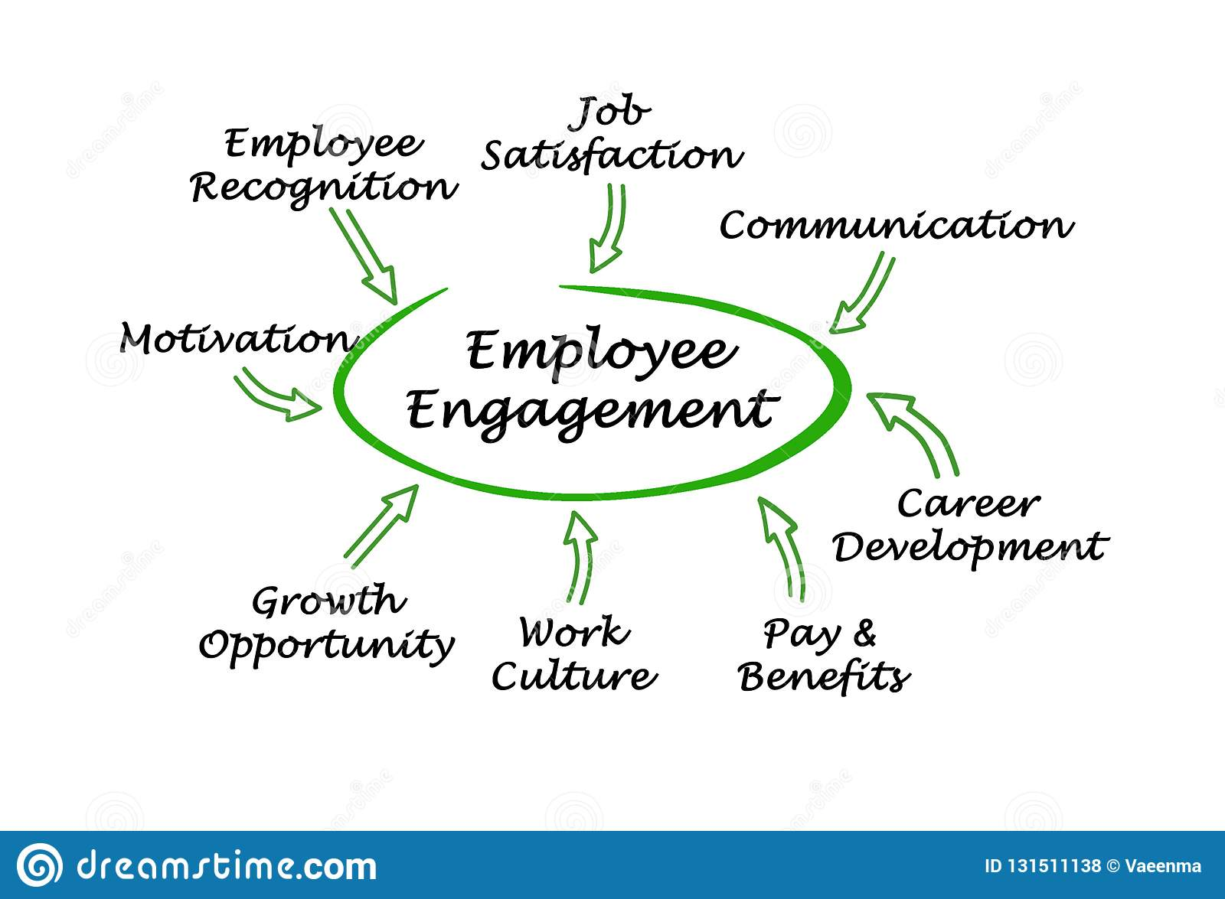
Figure 01: Employee engagement (Bradford, 2018).
- Employee growth: In the organization employee growth can happen if they receive proper training and development programs to strengthen their knowledge. As in this pandemic, situation employees are working from home so their job design has been changed. They can get online training for their career, can attend various professional development programs which in turn can affect their professional advancement. As roles in the organization are restricted now so new development programs online based can help employees to grow.
- Empowerment: In an organization employee empowerment happens to fulfill the employee gap so that newer talents can work in a newer environment. To engage employees in the working environment various training, development activities are set up in the organization (Claxton, 2014). Though in this pandemic employee empowerment is difficult although online interviews, exams, and other selection procedures are applied by the organization to restruck employees in their roles. This technique has been applied by many organizations in their recruitment, selection procedure all over the world now.
- Interpersonal relationship: Employees in an organization will be motivated to work more if they get a friendly, trustworthy environment around them. If superiors perform their leadership in a well-guided way employee will be satisfied. As in an organization employees’ values, integrity plays an important role in building a co-operative environment employee can feel free to share their feelings, ideas, or their demand (Byrne, 2015). In this pandemic through online official works has been performed which has made many employees learn many things from others. As employees used to work in an official environment, working from home has made them learn about technology use more. By which the organization has designed its employees’ jobs in a new way by making their workplace safe.
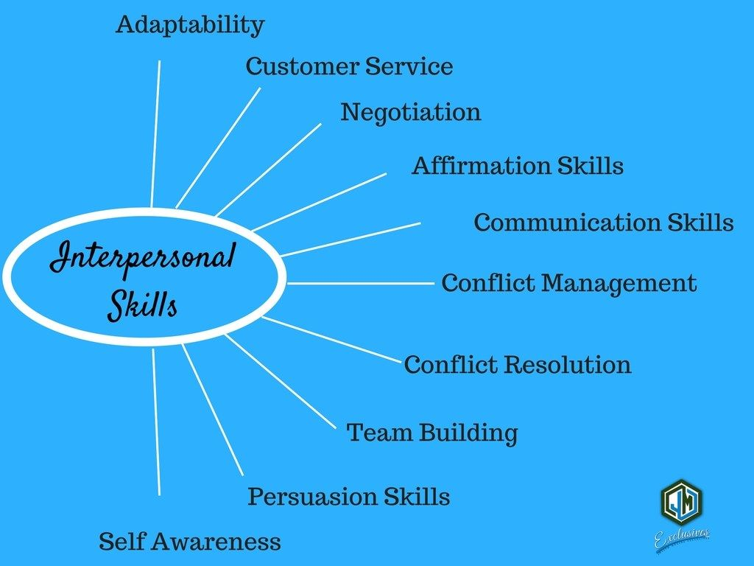Figure 02: Interpersonal skill (Harrison, 2013).
- Leadership: Strong leadership can make employees satisfied with their working superiors' behaviors by which they can do more teamwork. Superiors who have competency in leadership can motivate employees to their job which may include job satisfaction of employees, the commitment of employees towards the organization, active behavior towards the organizational goal (Hutchinson, 2019). Having more trust in the leader and his activities in the organizational environment can fall employees in a safe position by which employees can engage themselves more in the activities and the organization's performance will rise.

Tools to measure employee engagement
Employee engagement measures productivity in a business so that the employees can be engaged more with creativity, high output for the company. To measure employee performance in their workplace some measurement tools are used by the organization those are as follows-
- Survey analysis: Employee survey is used to get feedback from them about their attitudes, feelings, demands from the organization. It is the most effective one as it is submitted randomly so employee participation will be higher and a higher response can be achieved from them (Finnegan, 2016). From the analysis of the survey whether they are motivated, satisfied with the job or not, their workplace relationship can be determined. With that whether they require any monetary or financial rise or not can be known.
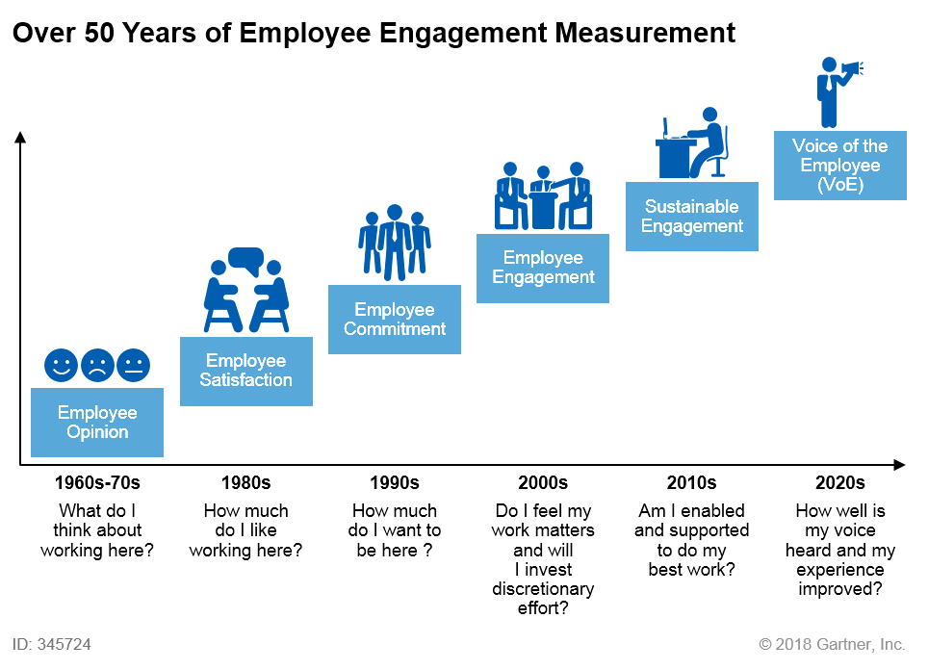
Figure 03: Survey of employee engagement (ELIOT, 2020).
- Software-based analysis: In modern time survey-based analysis may seem time-consuming for that software-based analysis are used to keep track of employee engagement in their activities. In the organization, HR collects feedback to measure whether employees are satisfied or not. This data helps to analyze employee performance and ensure that they can work together in an organization to achieve the company goals. In the software-based system employee’s activities with rating will be notified to measure their position in the workplace.
- Internal media analysis: When an organization wants to measure their employee engagement, they can get information about that employee from their intranet media. This media is based on internal sources in the organization whereby employees share various ideas regarding their work and from their sharing of ideas, they engage themselves in the company development activities (Hodges, 2017). Analyzing employee response, I the intranet media the manager can get to know more about the employee participation in the organization. Not only about employee participation but also employees are doing teamwork effectively or not can be known from here.
- Interviews from the ex-employees: When an organization wants to measure their employee engagement or their team’s performance, they can ask employees who have left the company. by asking them various hard question why they leave or who are the main performers in the organization etc. Form their response analysis organization can get a clear view of which place they need to develop or not or what they can do to stop employees switching tendency can retain them for a longer period. For these analyses, a questionnaire-based survey or phone interview for a short time can be made.
- Knowledge from employee lifecycle: If an organization want to measure their employee engagement, they can get information starting from their recruiting, development activities, performance analysis, retention programs for them, etc. in various stages in a workplace employee face various experience by which organization can get a view of employee feedback (Byrne, 2015). This feedback can help the organization whether to build more development programs for employees or not or to reinforce the company value to the employees. Employee's experience in these activities helps the organization to decide their remuneration package to motivate them in the organization work more.
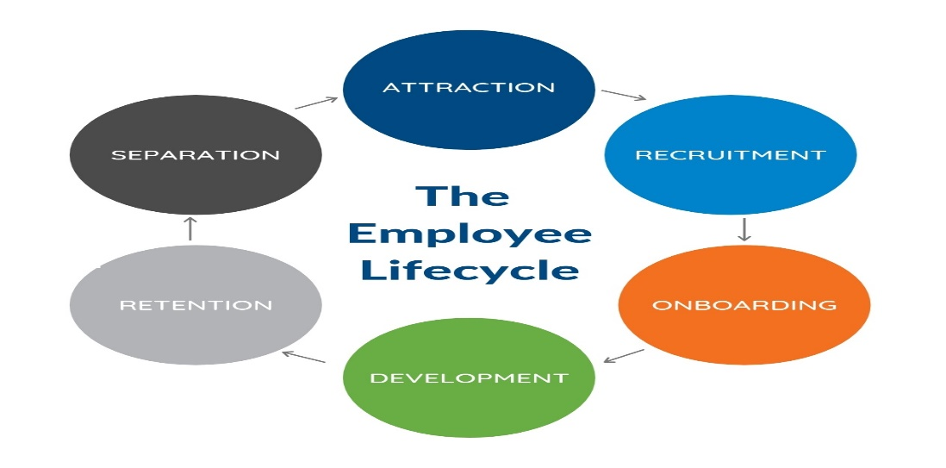
Figure 04: Employee lifecycle (Federman, 2013).

Employee value proposition
It is related to employees' profit that they receive while working in an organization which includes various benefits like- compensation, financial remuneration, development activities, training programs. Through EVP employees can be retained in a company and their switching tendency can be stopped. EVP needs to be attractive for employees, relevant so that employers will be able to hold the talents and retain them for longer-term (Hutchinson, 2019). Employees always tend to switch jobs by which they can get enough financial benefits, comforts. EVP tries to stop those activities of employees by retaining those talented employees for the organizational development activities. EVP can raise the level of engagement of employees in the organizations to some extent those are given below-
- Financial/ non-financial benefits: In any organization, employees will be satisfied if they get enough financial benefits like-rise in their salary, rewards, bonus, promotions, etc. These benefits can help the organization to retain employees for longer-term as an employee will be satisfied with those benefits (Finnegan, 2012). With that other non-financial benefits like- holidays, sick leave, insurance, health benefits, retirement compensation, educational benefits, etc. can motivate employees to stay in that organization and to achieve the organizational goal.
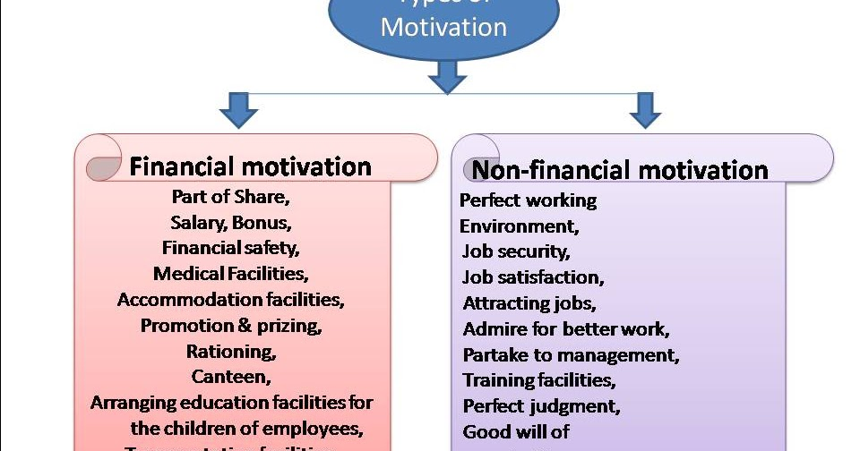
Figure 05: Employee motivation (Byrne, 2015).
- Career development activities: If any organization wants to retain its customers they can contribute to the growth of their employees. Many employees want to achieve various development programs to promote their careers. If the organization sponsors those activities for the employees or manage those activities on the office premises employees will be motivated to work hard for the company. as employees can be successful in their educational learning more through various development programs.
- Flexible working environment: Various factors can create a positive environment in the office which may include- daycare center for keeping babies of employees, comfortable office space, professional consultant, physical consultant, various team-related social development programs. These things in a working environment can make employees satisfied with their work which can increase their values in the organization (Bradford, 2018). If the employees find those activities in their office premises, they will engage themselves more in the organizational development program.
- Organization’s culture: In an organization to create more employee engagement a great culture must be developed which can include- positive relations among superiors and supervisors, a trustworthy environment, supportive colleagues, effective team, flexible collaboration work, etc. When an employee will find those culture among their colleagues and superiors they will be motivated to work hard for the company. By arranging various training, development programs for employees, the employees can get a more positive view of the organization.
- Flexible communication: To engage employee engagement communication play a vital role as employees always require clear ideas from their superiors. Poor communication can be a barrier for employees in their working environment (Claxton, 2014). Effective communication promotes the commitment of employees, awareness among employees, understanding of the organizational goals towards the organization. Through these things’ employees can have an emotional, cognitive engagement for the organization. By which their outcomes will be innovation among employees, competitive position in the organization, and effective organizational environment.
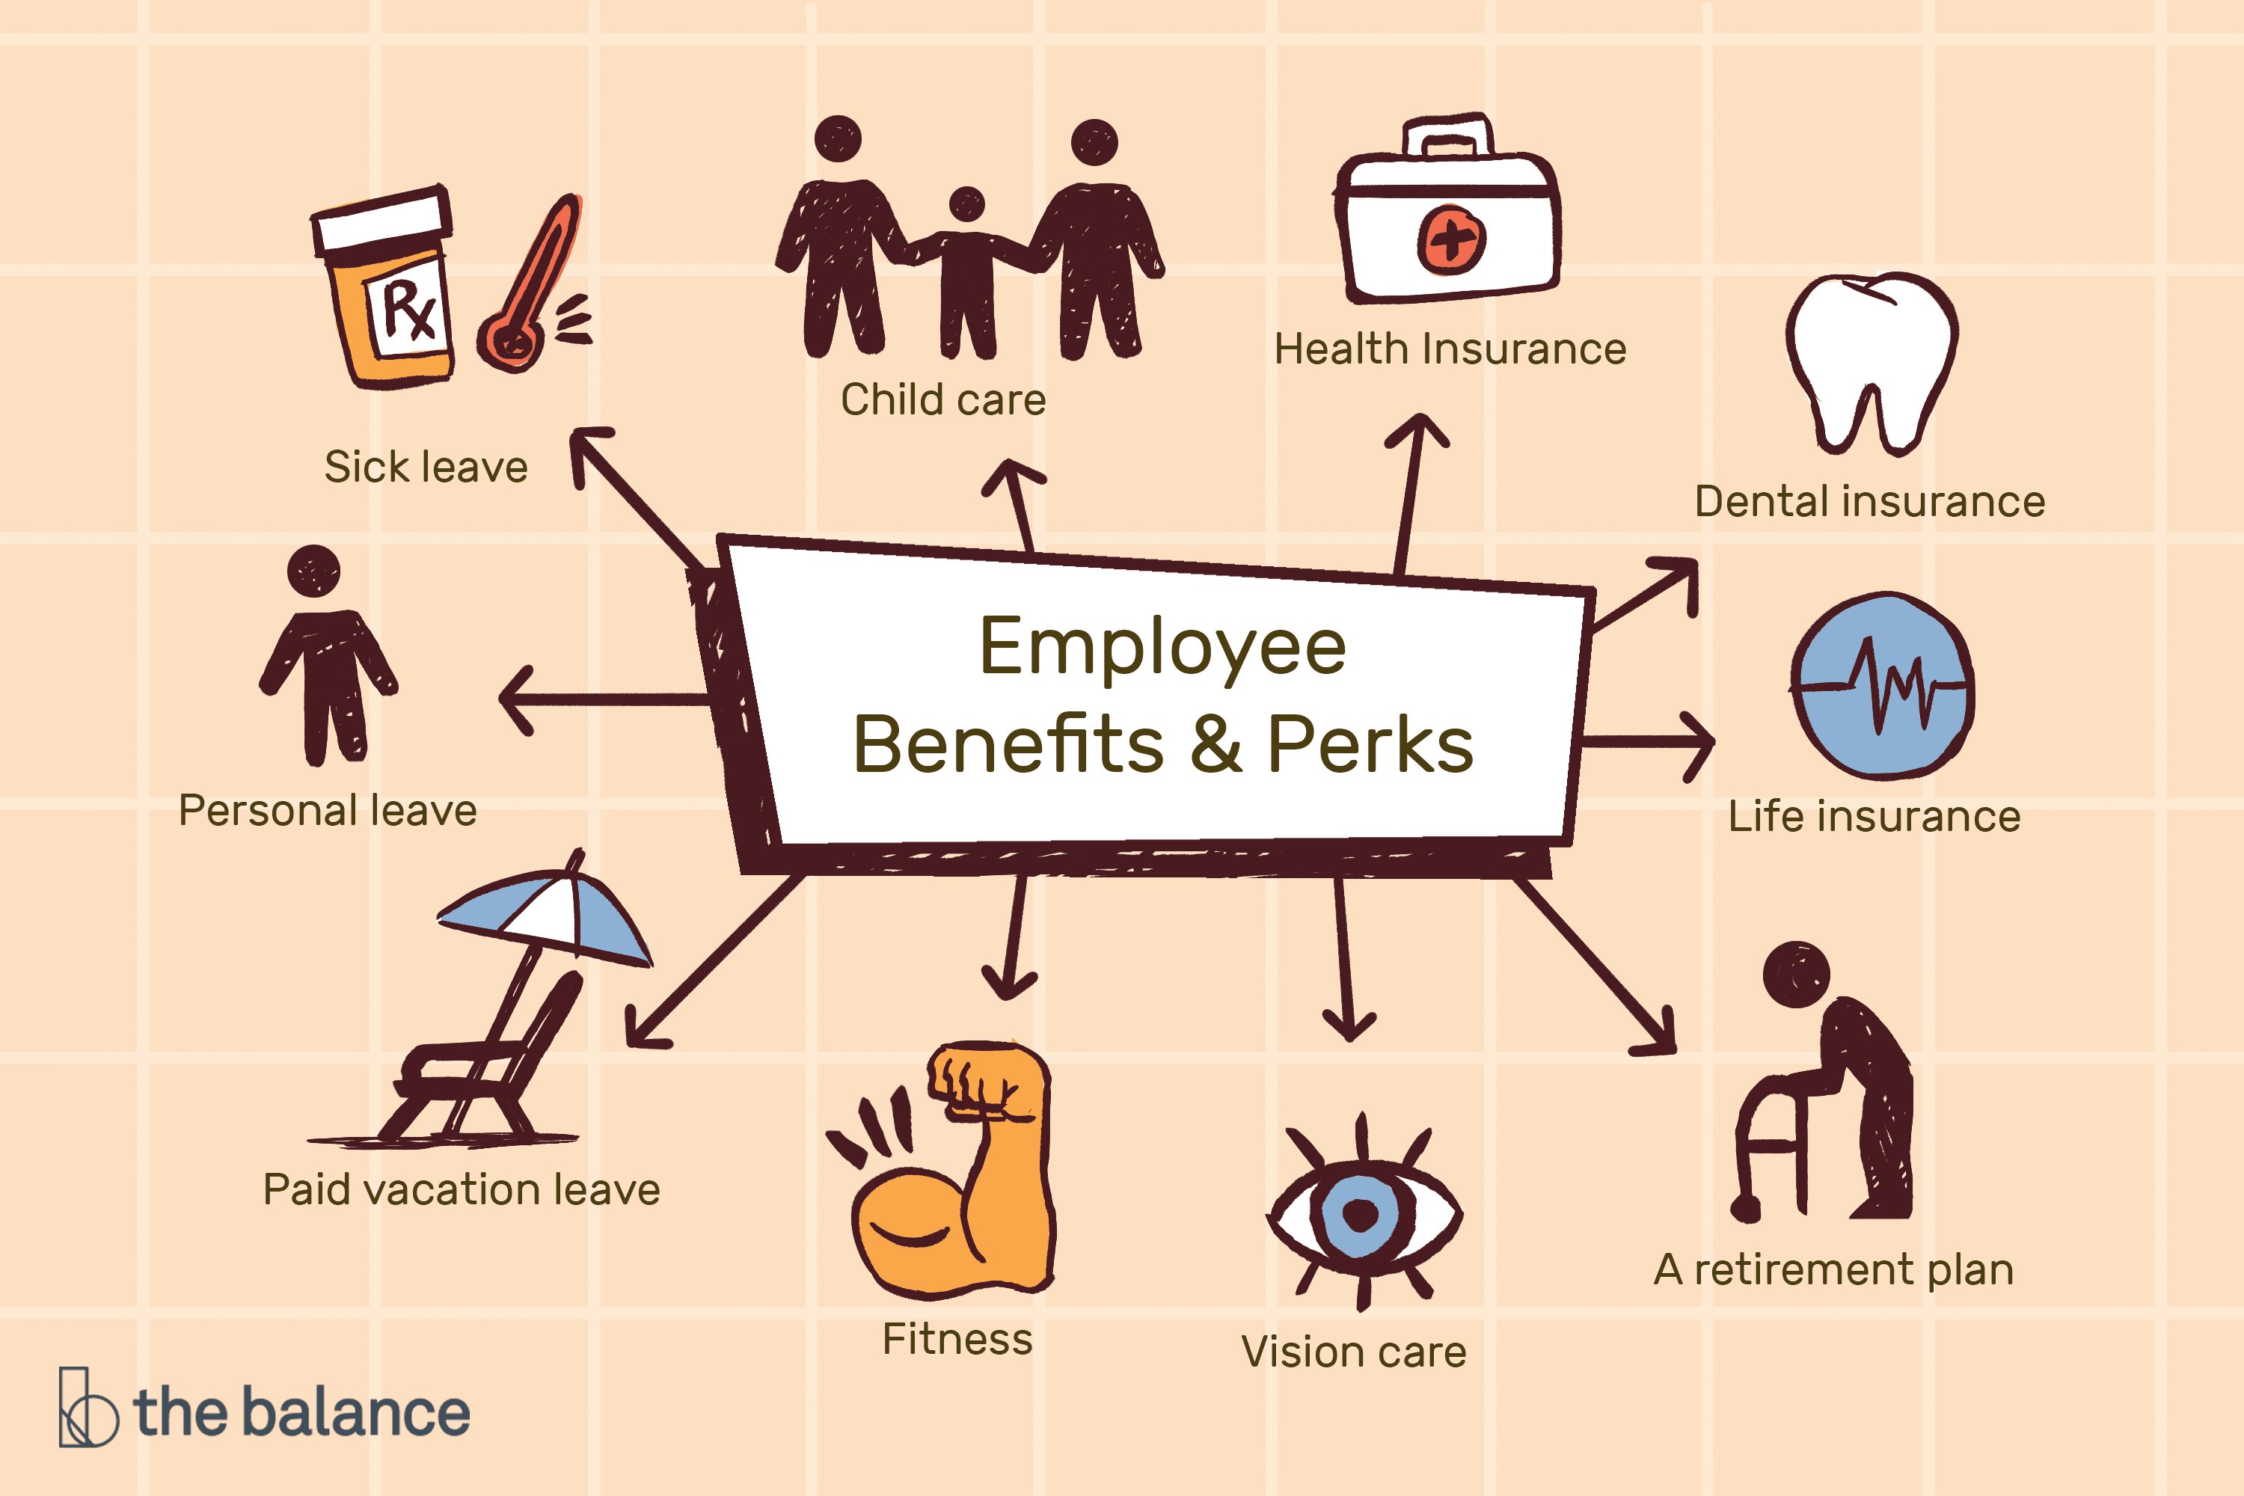
Figure 06: Communication benefits (Harrison, 2013).
- Developing shareholder value: In an organization providing shareholders, their values can make their position stronger in the market. If any organization fail to give their shareholder annual dividend, cash, or other incentives their shareholders will not hold the company shares as they are not receiving any kinds of benefits from them. By giving shareholders their exact value shareholders will be motivated to stay in the company and invest more in its activities. As EVP is a two-way process if the management provides or boosts their services for employees, shareholders will be easier to retain them by engaging themselves in various activities and to bring out more talents from them.

Conclusion
In an organization, the employees should have the freedom to make their work exciting and engage themselves for the betterment of the organization’s goal. Employees are like an asset for an organization if they are not given enough right, benefits, freedom to share their ideas in the workplace they may not feel motivated to work. Employee engagement comes from the value proposition of employees by various activities from the organization (Hodges, 2017). It is a continuous process so that employees can learn, improve, and use their improvements and learning for the development activities of the organization. That's why various organizations are creating measures to raise employee engagement and various value proposition s methods to raise their engagement for the firm's benefit. As the more the drives of employee value proposition will work the more employees' engagement will rise with a rise in the organizational performance.

References
Bradford: Emerald 2018. Employee Engagement.
Byrne, Z., 2015. Understanding Employee Engagement. New York: Routledge.
Claxton, J., 2014. Employee Engagement.
ELIOT, G., 2020. MILL ON THE FLOSS. [S.l.]: DOVER PUBNS.
Federman, B., 2013. Employee Engagement.
Finnegan, R., 2012. HR's Greatest Challenge.
Finnegan, R., 2016 Raise Your Team's Employee Engagement Score.
Harrison, R., 2013. Employee Development. London: Institute of Personnel Management.
Hodges, J., 2017 Employee Engagement For Organizational Change.
Hutchinson, I., 2019. People Glue. Warriewood, N.S.W.: Woodslane Press.

