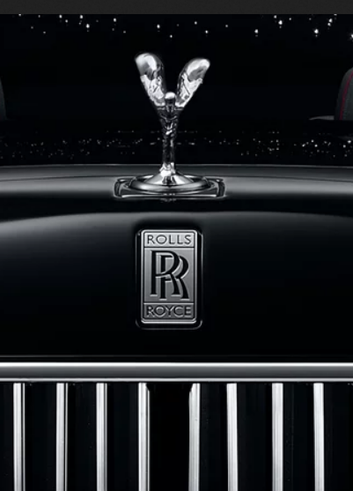
MBA MARKETING MANAGEMENT
LECTURER: Tushara Balendran
STUDENT ID:
STUDENT NAME: Alexandra Kazandjieva

Contents
1. Introduction 3
Question A 3
2. Macroenvironment. Definition and Diagram 3
Figure 1. Macroenvironment Diagram 4
3. Application of PESTLE Analysis in Rolls-Royce 4
3.1 Political Factors in PESTLE Analysis in the Case of Rolls-Royce 4
3.2 Stability 5
3.3 Safety Regulation 5
3.4 Emission Policies 5
4. Economic Factors in PESTLE Analysis for Rolls-Royce 5
4.1 What are Economic Factors? 5
4.2 Growing Disposable Income 6
4.3 Inflation 6
4.4 Labour Supply and Demand 6
5. Social Factors in PESTLE Analysis in Rolls-Royce Motor Car 7
5.1 What are Social Factors? 7
5.2 Buying Behaviour 7
5.3 Cultural and Social Norms 7
6. Technological Factors in PESTLE Analysis for Rolls-Royce Motor Car 7
6.1 What are technological factors? 7
6.2 Technological Innovations 8
6.3 Research and Development 8
7. Legal Factors in PESTLE Analysis 8
7.1 What are the Legal Factors in PESTLE? 8
7.2 Employment Laws 8
7.3 Intellectual Property Law 9
7.4 Consumer Protecting Law 9
8. Environmental Factors 9
8.1 What are Environmental Factors? 9
8.2 Environmental Regulations and Industry Norms for Recycling and Waste Management 10
9. Opportunities and Threats of PESTLE Analysis of Rolls-Royce 10
Opportunities: 10
Threats 11
10. Porter 5 Forces Model 11
Figure 2: Porter's Five Forces Diagram 12
11. Rolls-Royce SWOT Analysis 14
11.1 Rolls-Royce Strengths 14
11.2 Rolls-Royce Weaknesses 14
11.3 Rolls-Royce opportunities 15
11.4. Treats in Rolls-Royce SWOT Analysis 15
12. Rolls-Royce Competitors 15
13. Segmentation, Targeting, and Positioning in Rolls Royce 16
13.1. Segmentation 16
13.2. Targeting 17
13.3. Positioning 17
14. Rolls-Royce Marketing Mix (4Ps) 18
Figure 3. Marketing Mix 4Ps 18
14.1. Product Strategy 18
Figure 4. Product Variety of Rolls-Royce 19
14.2. Price strategy 19
14.3. Place strategy 20
14.4. Promotion and advertising strategy 20
15. Conclusions 21
16. Question B 21
16.1 Rolls-Royce Recommendation of Future Marketing Strategies 21
Figure 4. ANSOF Matrix of Rolls-Royce Motor Cars 22
16.1. Rolls-Royce's use of the Ansof matrix for successful business growth 22
16.2. Market Development 22
16.3. Diversification 23
References 23

Introduction
Micro and macro environments create a business environment that affects the outside and inside the organisations. Rolls-Royce is a British brand part of the BMW Group, continuing to produce one of the world's most luxurious cars, focusing on handcraftsmanship, unparallel customer service and serious diligence.
The following report will do an external and internal analysis of Rolls-Royce Motor Car and propose future recommendations.

Question A

Macroenvironment. Definition and Diagram
The marketing environment consists of internal and external environmental factors essential to company performance, and managers should pay attention to those factors to minimise the risk of organisation failure in the present and future.
According to Monash University, "Macro-environment are all external forces (economic, demographic, technological, natural, social and cultural, legal and political) which influence a firm's decision making and have an impact upon its performance" (Monash University, 2023).

Figure 1. Macroenvironment Diagram
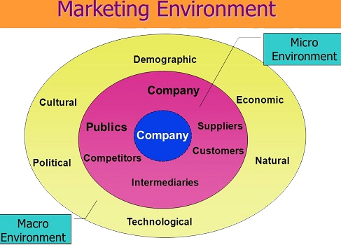
Source: https://marketing-dictionary.org/m/macroenvironment/

Application of PESTLE Analysis in Rolls-Royce
Many external factors affect business success by making its growth or decline, and understanding and considering those essential factors helps companies achieve better results than competitors. PESTLE Analysis helps organisations assess the bad situations in different fields and overcome them or evaluate the opportunities and threats that may come with them. PESTLE analysis stands for Political, Economic, Social, Technological, Legal and Environmental analysis, explaining how external factors impact business performance.
Companies cannot control those factors, but they are a helpful tool for understanding external influence on the industry; however, PESTLE analysis of Rolls-Royce Motor Car can help a company to handle external turbulence, and managers can make wise strategic decisions quickly to respond to external changes.

Political Factors in PESTLE Analysis in the Case of Rolls-Royce

For the long-term sustainability of a business, political factors are the first component in PESTLE analysis, playing a strong impact. Some examples of political factors, trade regulations and taxation policies the government can enforce may affect the business environment. Rolls-Royce must consider some factors such as trade regulations and tariffs related to the automotive industry, Industrial regulations related to safety, level of corruption and bureaucracy, wage legislation, etc. Some of the main factors relative to Rolls-Royce are explained below:

Stability

Political stabilities play a significant role in investors' decisions and customers' confidence and broadly impact the economy. Any political instabilities seriously affect the economic growth of businesses. The risk of military invasion in a country the company operate in significantly affects Rolls-Royce investors and sales. For example, Rolls-Royce achieved a new sales record in 2020 for selling luxury cars in Russia (Intel iNews, 2021), but after the invasion of Ukraine following the European Union's strictest sanctions, the brand left the Russian market.

Safety Regulation

All around the world, including the U.K., governments enforce stringent regulations about people's safety, such as seat Beal driving or passenger in the car, and that affects the automotive industry. Also, make it difficult to launch new businesses and helps existing companies keep their place in the market.

Emission Policies
The Us government take serious care about automobiles' effect on climate change because most vehicles use fossil fuel, which produces environmental carbon pollution and causes serious harm to human health. The luxury automaker Rolls-Royce plans to be Net Zero Carbon by 2030 and be a NetZero company no later than 2050 (Silverstein, 2022).
Rolls-Royce operates in a stable political field and has a good relationship with governments in its key market for favourable political factors.

Economic Factors in PESTLE Analysis for Rolls-Royce

What are Economic Factors?

Economic analysis is the second essential PESTLE component that directly affects a company's ability to achieve its business economic goals and objectives. Economic factors include the collapse of a few American banks and Credit Suisse, post Brexit and post Covid19 pandemic impact, and the unstable U.S. dollar and British sterling will affect Rolls-Royce's short and long-term business growth. All those factors can easily wipe away profit from Rolls-Royce's revenue.

Growing Disposable Income

With the bum of entrepreneurs worldwide, people start making more money every year, and most of them are willing to spend extra money buying a luxury car to show and strengthen their social position and help demand for motor vehicles grow. That means the automotive industry can grow and become more profitable when car sales increase.
According to Statista research, "In 2022, the global market for luxury cars was estimated at around 566 billion euros, an estimated increase of more than nine per cent year-on-year" (Carlier, 2023).

Inflation

If the inflation rate continues to grow, it will harm Rolls-Royce's revenue as it decreases buyers' purchase power. Inflation in a supply chain may affect supply chain costs to rise, causing an increase in production costs, including raw materials, energy, and wages.
However, the inflation growth worldwide did not affect Rolls-Royce yet. Blumberg states, "Supper rich keep buying a luxury car" (Eckl-Dorna, 2023).

Labour Supply and Demand

One of the critical factors for Rolls-Royce's successful business performance, keeping the company ahead of competitors, strongly depends on the competition and skills of its employees. Because of the labour market dynamic, companies need to follow the supply trend and recruit highly skilled quality employees; otherwise, they may need to pay unfair wages or face strikes. Talent management strategies must be adapted accordingly to avoid uncertain times.
Economic factors and their impact on the Rolls-Royce brand can be mixed as the company targets high-net-income customers, and any economic downturns can impact company sales and revenue.

Social Factors in PESTLE Analysis in Rolls-Royce Motor Car

What are Social Factors?
The key demographic factors that represent the values, norms and buying customers' behaviour are social factors of the PESTLE framework, and those factors create a socio-cultural environment that can drive highly successful businesses toward failure. Here is some implication of social factors for Roll-Royce.

Buying Behaviour

Many factors influence the consumer's decision-making process, and a purchase decision results from one or a combination of these factors. Identifying and understanding what drives consumer behaviour helps companies to develop strategies to meet the needs of their customers better and increase sales.
Consumers are more willing to spend more on goods and services to improve their social image and lifestyle when they have discretionary income, as that leads to an increase in the expenditure on shopping luxuries which benefits Rolls-Royce with an opportunity to grow revenue.
Rolls-Royce must focus on improving and adapting Marketing Mix strategies to analyse the buying behaviour of modern consumers.

Cultural and Social Norms
Rolls-Royce is a brand deeply integrated into the U.K. luxury automotive industry. It is a long-standing association with British heritage and culture, including the brand association with the royal family also incorporated various British themes into its car designs, such as the Union Jack flag on the dashboard clock of some models and the use of British-sourced materials such as Scottish leather and English oak.
Social factors are favourable for Rolls-Royce as a brand is associated with luxury, glamorous and exclusivity, which are subscriptions that fit the value of its target market.

Technological Factors in PESTLE Analysis for Rolls-Royce Motor Car

What are technological factors?

Technological factors are critical elements of PESTLE that refer to the impact of new technologies and innovation in business operations, markets, or industries. Over all those years, innovation has been essential to Rolls-Royce's success.

Technological Innovations

Technological factors are favourable for ROLL-Royce. Technological innovation always affects the market and industry, and by understanding and adopting new technological trends, Rolls-Royce will be able quickly and efficiently respond to the new product development rate, customers' innovative features and product life cycle length. Investing in the correct new technological innovations will benefit the company by reducing costs, optimising customer experience, and achieving operational effectiveness, which will lead to strengthening its position as a market leader and appeals to tech-savvy customers.
Rolls-Royce can use and deliver new and innovative materials in its vehicles to improve performance, fuel efficiency and durability.

Research and Development

Investing in long-term research and exploring new ideas and technology Rolls-Royce should understand how emerging technological innovations will benefit the company by creating value for customers.

Legal Factors in PESTLE Analysis

What are the Legal Factors in PESTLE?

The legal factors provide all information about different laws and regulations that any organisation must follow, such as health and safety, employment, consumer protection, and intellectual property laws. Rolls-Royce complies with regulations and laws in all its markets; however, changes in regulations like emissions standards can affect company performance, so legal factors are favourable for Rolls-Royce.

Employment Laws

Employment laws protect employees, including equality, fairness, inclusion, fair wage, equality, equity, health, and safety. In many countries, there are stringent penalties if companies breach those laws. Rolls-Royce must influence and ensure a safe work environment, avoiding any indirect or direct discrimination, that can help ensure a good employment brand reputation and attract talents from the employment market.

Intellectual Property Law

Rolls-Royce patents and intellectual property are protected from imitation under Intellectual property law, leading to a sustainable competitive advantage. Trademarks protect Rolls-Royce's reputation and brand. All creative work, including marketing materials, is used only after Rolls-Royce's permission.
The trade secrets about the manufacturing process, formulas and other technological know-how are strictly protected to prevent unauthorised access to valuable information.
For Rolls-Royce to protect its brand, reputation and innovations, intellectual property law is essential.

Consumer Protecting Law
The U.K. has a robust and well-established consumer rights law." it sets out a framework that consolidates in one place fundamental consumer rights covering contracts for goods, services, digital content, and the law relating to unfair terms in consumer contracts. In addition, the Act introduces more accessible routes for consumers and small and medium-sized enterprises ("SMEs") to challenge anti-competitive behaviour through the Competition Appeal Tribunal (Lawbite, 2022).
Consumers in the U.K. are protected under Consumer Protection from Unfair Trading Regulations 2008 and the Sales of Goods Act 1979.

Environmental Factors

What are Environmental Factors?

Due to careful observation of stakeholders over sustainability and environmental protection, Rolls-Royce must pay attention to environmental laws and regulations to avoid reputational harm in the market and lawsuits. Some of the vital environmental factors that Rolls-Royce should implement are discussed below.

Environmental Regulations and Industry Norms for Recycling and Waste Management

All around the globe, government environmental regulation pressure organisations to reduce environmental and public harm. Rolls-Royce must comply with fuel efficiency standards and reduce emissions to keep its brand image and reputation. Rolls-Royce must invest and develop more fuel-efficient technology to implement new manufacturing methods to minimise waste and reduce harmful environmental impact. Rolls-Royce can recycle and use some of the materials again.
Following all environmental regulations can be costly for organisations, but Rolls-Royce can take advantage of its competitors if they develop environmentally friendly technologies to open new market opportunities and increase competitiveness.
The managers need to think wisely and turn those issues into strengths for Rolls-Royce, focusing on innovation and developing new products and services to meet the demand for sustainable transportation.
. Environmental factors are mixed for Rolls-Royce; the company focuses on luxury individually customised cars, which may conflict with sustainability goals.

Opportunities and Threats of PESTLE Analysis of Rolls-Royce

PESTLE analysis is a valuable tool for understanding and identifying external factors that play a significant role in business performance. Here are some opportunities and threats that Rolls-Royce can consider:

Opportunities:

- Political: The U.K. government started investing in many infrastructure projects around the country that can create new opportunities for Rolls-Royce cars.
- Economic: The growth of emerging markets such as India, China and Africa can be seen as another opportunity for Rolls-Royce to expand the market and increase its revenue.
- Technological: Rolls-Royce can use new Artificial Intelligence and robots to develop more effective and efficient products and services.
- Social: Increasing focus on friendly nature and sustainability products and services are the opportunity for Rolls-Royce to develop green energy and zero carbon automobiles.

Threats

Political: Continued war in Ukraine, post-Brexit, may negatively affect Rolls-Royce's operation and revenue.
Economic: Inflations and the rising cost of living can negatively impact Rolls-Royce's profitability and revenue.
Social: Changing consumer attitudes and preferences towards luxury cars can affect Rolls-Royce product demand.
Technological: If Rolls-Royce competitors quickly adopt the new technology may make it difficult for the brand to keep its first place in the market.
Legal: Legal challenges and regulatory scrutiny relating to environmental issues may create financial and reputational risk for Rolls-Royce.
It is crucial for Rolls-Royce early to identify and take necessary actions for any opportunities or threats to stay ahead of the competition and increase market share. The company's solid brand image and reputation focus on customisation, and technological innovations are essential factors that will continue to drive its future success.

Porter 5 Forces Model

In 1979 Harvard Business Review first published Porter's five forces analysis, a helpful framework used to analyse and measure the competitive advantages of any industry. Porter's five factors assume that external market structure determines industry attractiveness. Industrial factors are essential for a company's strategic plan as they can fail or raise the whole company.

Figure 2: Porter's Five Forces Diagram
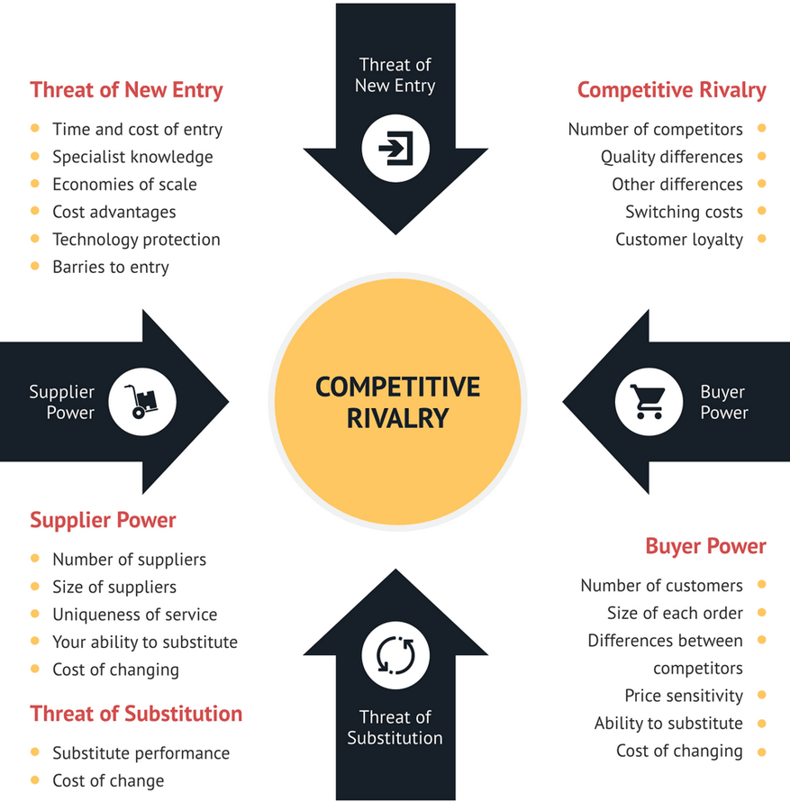
Source: https://consulterce.com/five-forces-analysis/

Let us see how Porter's five factors can be applied to Rolls-Royce, the British luxury car manufacturer.
- The Threat of New Entrants: Because of the high barriers to entry in the luxury automotive industry, including high capital investment, strong brand recognition (which can be only developed over time and cannot be established for one day) and significant investment in skilled and knowledgeable human resources the threat of new entrants is low.
- Bargaining power of suppliers: Rolls-Royce has a high volume of orders and strong bargaining power over suppliers that supply the company with raw materials and goods used to manufacture the cars. There are many suppliers on the market, for example, companies that supply high-quality tyres such as Michelin, Goodyear and Pirelli or trusted leather suppliers that have the power to influence the production, but Rolls-Royce is not stuck to a single supplier for that supply chain intact even in case of adversity. Overall, the bargaining power of the suppliers is low.
- Bargaining power of customers: On the market are not many luxury car manufacturers, and superrich people do not have too many choices when buying luxury cars, which means they cannot demand a lower price. As the end customers of Rolls-Royce products are individual, the customers do not have cohesive bargaining power and cohesive behaviour. Also, Rolls-Royce brand equity and high switching cost are other factors that take away the bargaining power of customers. Following those factors, the bargaining power of customers can be considered moderate.
- The threat of substitutes: Some vehicle manufacturers can be considered substitutes to Rolls-Royce, like- various premium electric cars (Ford and Tesla) available in the market. Rolls-Royce is focused on quality and exclusivity that set it apart from other luxury brands. Other forms of transport would be a substitute for Rolls-Royce, including Mass market cars like Honda, Volkswagen or Toyota for customers who do not require luxury. Public transport that offers conventions and cost-effective transport, and walking for a short distance is an accessible way to get around. After considering those factors, the threats of substitutes can be considered moderate.
- Competitive rivalry: Bentley, Porsche, Audi, and Maybach (Mercedes-Benz) are some of the big players in the industry and have the potential and power to change industry trends and the landscape. Those brands try to innovate and differentiate themselves, investing in safety, customer experience and promotions to win market shares. According to CNBC, Rolls-Royce is the USA's leading market share leader, with nearly 35% of its global sales (FRANK, 2023). Also, to better serve their Middle East customer need, Rolls-Royce opened an invitation-Private office in Dubai.
Rolls-Royce hardens its reputation for exceptional quality and helps to maintain its leading position as a world premium brand in the market. It must be considered that no other brand can give the experience and self-recognition that Rolls-Royce offers -prestige, high class, and excellence. Everything that royalty and superrich people adore, and that is very hard to switch and break customer loyalty.
After all those factors, competitive rivalry can be considered moderate.

Rolls-Royce SWOT Analysis
SWOT Analysis evaluates the brand's strengths, weaknesses, opportunities, and threats and helps Rolls-Royce make strategic improvements to benchmark its business and performance. In any SWOT analysis, strengths and weaknesses are internal factors while opportunities and threats are external factors, and to be successful and competitive company must transform its strengths as opportunities and weaknesses as a treat.

Rolls-Royce Strengths
The strengths of Rolls-Royce's business benefit with a competitive advantage in the market such as high-quality experience workforce, financial power, brand value and product uniqueness. Here are some of Rolls-Royce's strengths:
- Brand reputation: Rolls-Royce has a strong global brand image with solid value in people's minds.
- Product quality: What differentiates Rolls-Royce from other brands is exceptional quality and attention to detail.
- Diversified portfolio: Rolls-Royce is famous for its luxury and outstanding cars and for producing engines for aircraft and ships.
- Rolls-Royce is one of the few significant status brands in the world of the superrich and royal people.
- Strongly supportive from parent Rolls-Royce company.
- Rolls-Royce is the leading luxury car in the world.

Rolls-Royce Weaknesses

Weaknesses are the central aspect of Rolls-Royce's business and must be improved to increase business opportunities and future success. Because of the weaknesses, some competitors perform better than Rolls-Royce. Those are some of the weaknesses of Rolls-Royce:
- High price: Rolls-Royce's car price is significantly higher than other luxury brands, so the customer is limited.
- Customer profiling requirements push more clients to switch to other brands.
- Dependence of external factors: Economic conditions are essential in car demand and affect Rolls-Royce sales.
- Limited market share: Rolls-Royce is a niche luxury automobile brand with a small market share; it can be vulnerable if the market shrinks.

Rolls-Royce opportunities

To increase market share and business growth, companies see the opportunities as areas of improvement. Those are some opportunities for Rolls-Royce SWOT Analysis:
- Expand in a new market: Rolls-Royce can expand in emerging markets like India, Africa, and China, which have an appetite for luxury cars.
- Diversification of the product portfolio: Rolls-Royce should continue diversifying its portfolio by exploring and adopting new technologies and partnerships.
- Growing demand for luxury cars: With the expansion of wealthy people worldwide, Rolls-Royce can increase sales among the elite and business revenue.

11.4. Treats in Rolls-Royce SWOT Analysis

Threats in SWOT analysis factors badly affect business performance, like government policies and procedures, competitors increasing activities, etc. Here are some of Rolls-Royce treats:
- Changes in regulations: Rolls-Royce can lose its market shares and reduce productivity if the government continues changing climate and carbon emission regulations.
- Unwillingness for customers to spend a tremendous amount of money to buy a car.
- Economic recession can impact the luxury car demand and affect Rolls-Royce.

Rolls-Royce Competitors

Here are some of Rolls-Royce's competitors:
- Mercedes -Maybach 650
- Bentley Flying Spur
- Aston Martin
- Maserati
- McLaren Automotive Ltd
- Starstone Ltd (www.zoominfo.com, 2023).

Segmentation, Targeting, and Positioning in Rolls Royce

Market segmentation is a dividing process where buyers are separated depending on their features, needs or behaviour, as a single product cannot serve all market needs. Marketing segmentation is critical for modern marketing and is one of the most applied marketing models. Rolls-Royce must optimise marketing activities, set clear objectives, and define the target audience that will benefit from efficient growth in customer base and revenue to achieve its goals.

Segmentation

- Demographics: For example, Rolls-Royce target super wealthy people regardless of their age, gender, tape, or residence but with high net income that can afford to buy Rolls-Royce automobiles, and the target audience are people with specific lifestyles focusing on glamorous lifestyle. Those people have the power to decide; they want to be recognised and stay away from the mass. Consequently, they need a car like them- unique and distinctive.
- Psychographic segmentation: Rolls-Royce uses photographic segmentation to divide their customers based on -buying patterns, hobbies, leisure activities, etc., everything that refers to personality and emotions based on customer behaviour. Psychographics segmentation helped Rolls-Royce understand that people from the same demography or geographic area have different characteristics based on individual life experience and environment.
- Geographic segmentation: Rolls-Royce is focused on regions with a high concentration of high-net-worth customers who enjoy sophistication and exclusivity. For example, North America-Canada and the USA are significant markets for Rolls-Royce. The Middle East is the critical geographical target segmentation region in countries such as OAE, Saudi Arabia and Qatar because of their strong culture of opulence and luxury lifestyle. Asia-Pacific countries like China, South Korea, and Japan are emerging markets for Rolls-Royce as the number of superrich individuals in those countries continues to grow. European countries like the UK, Germany, France, and Monaco are other important Rolls-Royce markets.
Many customers have similar want and need even though they are in different countries, political systems or cultures, and Rolls-Royce can use cross-marketing segmentation to target customers in different marketplaces.

Targeting

Only one automotive brand globally has the power to symbolise status and aristocracy -Rolls-Royce and the brand is regarded as a luxurious and prestigious status symbol worldwide. Rolls-Royce market targeting refers to various consumer segments such as benefits, financial resources to target specific segments, competition in the target segment, organisational, technical capabilities, and regulatory and other entry barriers. Rolls-Royce must evaluate each marketing segment's attractiveness and select at least two to serve.
Rolls-Royce is a luxury car brand focusing on differentiated targeting by targeting a specific group of customers with high net worth, people who like sophistication, exclusivity, and craftsmanship. Rolls-Royce product appeal to this specific target market. Rolls-Royce can differentiate itself from other luxury brands and command premium prices by tailoring any specific product to individual customer preferences and tastes. Differentiate targeting strategy also allowed Rolls-Royce to focus and allocate resources to serve the wants and needs of core customers while maintaining a solid reputation and brand equity within the automotive industry.

Positioning

Positioning is the last element of the STP process, and a position map helps Rolls-Royce to analyse the current position in the company's market and identify possible opportunities if any gap in the market exists. Position the product in a distinctive place in the mind of target customers.
For example, the customer ecosystem is a factor that Rolls-Royce needs to consider when positioning its product to be consistent with the consumer ecosystem. Is another example of competitors can replace or imitate Roll-Royce products?

Rolls-Royce Marketing Mix (4Ps)

Marketing is a combination of product strategy, price strategy, place strategy and promotion strategy helping companies to identify marketing options in terms of product, price, place and promotion.
According to Philip Kotler, an American marketing author, consultant, and professor, "The marketing mix is the set of marketing tools the firm uses to pursue its marketing objectives in the target market."

Figure 3. Marketing Mix 4Ps
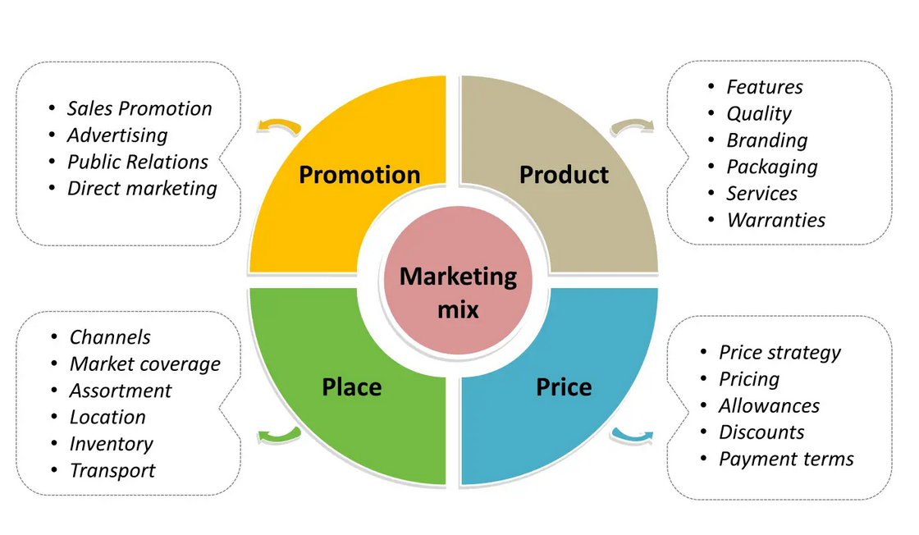
Source: www.yourfreetemplates.com

Product Strategy

According to Kotler and Armstrong, "Anything offered to a market for retention, acquisition, use or consumption that might satisfy a need or want" are product and is different from a service.
Rolls-Royce is a world luxury recognised car brand supplying elite clients. Rolls-Royce's production portfolio has several prominent brands, like Ghost, Wraith, Dawn, and Phantom, offering customers customised cars. Rolls-Royce car has unique product design, reputation, and ultimate criteria for luxury to stand out in the competitive market. Packaging, quality, and augmented service are part of the factors Rolls-Royce focused on in a niche premium segment, creating a car concept keeping the future in mind.

Figure 4. Product Variety of Rolls-Royce
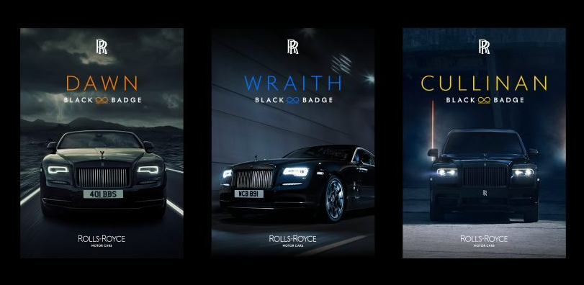
Source: https://sonnydickson.com/2020/08/27/rolls-royce-the-most-famous-brand-receives-an-update-for-2020/
Rolls-Royce's current branding strategy focuses on exclusivity, luxury, and craftsmanship, which are core values as Rolls-Royce focuses on maintaining its position as a leading luxury car brand and serving the individual needs and preferences of its worldwide wealthy customers.
Rolls-Royce also uses partnerships and marketing campaigns to reach a new audience and enhance its brand image. For example, Rolls-Royce collaborates with high-end fashioned brands and hosts events like the Goodwood Festival of Speed and Pebble Beach Concours elegance to expand and reinforce its brand image.

Price strategy

Rolls-Royce's price strategy is high because the product's value for target customers is outstanding. Rolls-Royce Ghost, for example, offers the car to start from £ £280,420 - £325,420, according to https://www.parkers.co.uk/rolls-royce/. That is an entry-level price, and all customisation, additional add, and interiors can increase the car's price as everything depends on customer needs and wants. No Rolls-Royce product will ever be offered below the current market price range.
That shows Rolls-Royce differentiated its price strategy focused on offering high quality and a premium price. The brand's revenues are estimated to reach $ 1.08 Bn in 2023 (Statista, 2023).

Place strategy
Rolls-Royce has a vast global presence, and the brand offices are situated in more than 50 countries around the globe. Customers from over 150 countries like China, the Middle East, the USA, the U.K. and Russia use Rolls-Royce cars. The Headquarters of Rolls-Royce is in the U.K., where administrative and production facilities for customers are situated with a global distribution network.
Rolls-Royce positioned its dealer showrooms strategically in a very strategically placed in areas with a high volume of wealthy and famous rich people and areas full of other luxury automotive dealers.
Rolls-Royce also provides customers with doorstep service for customised spare parts and servicing.
Rolls-Royce is focused and follows a niche market mix strategy for the place and distribution of cars and spare parts, which is part of its uniqueness.

Promotion and advertising strategy

The following are some of Rolls-Royce's marketing promotional and advertising strategies.
Rolls-Royce is an inspirational brand offering a product that the masses will not buy, so Rolls-Royce does not follow the common advertising strategies in the marketing mix. Using all mass advertising channels like T.V., radio, and social media does not make sense for the luxury brand. Rolls-Royce is a social status and glamour lifestyle symbol, attracting the global elite. There are few but solid advertisements Rolls-Royce use- word of mouth, usage of successful businessmen, celebrities, athletes or movie stars and usage of wealthy and royal people, that makes Rolls-Royce the world's number one powerful brand.
Rolls-Royce's brand awareness includes expensive gifts, exclusive events and exclusive merchandise when engaging with its customers. That is done to spoil the solid bond with clients, enrich the brand value and increase loyalty. Customers feel part of the Rolls-Royce brand family—regular P.R. coverage, news prominence, and reiterating Rolls-Royce’s dominant luxury car market position.
Art is another vital part of Rolls-Royce's strategy, for example, the project between Rolls-Royce and artist Marc Quinn supporting medical research.

Conclusions

The current report evaluated the importance of PESTLE analysis, the Macro environment, SWOT analysis, Porter's five factors, STP and Marketing mix strategies in the Rolls-Royce Motor Cars brand case. The manager's main job is to design strategies to benefit the whole organisation and create innovative products that satisfy customer desires.
Due to increasing competition and demanding clientele, Rolls-Royce needs to take good care of its strengths and to know the threats it faces inside and outside the company.

Question B

Rolls-Royce Recommendation of Future Marketing Strategies
The Ansoff Matrix is a strategic tool created to guide and facilitate companies in decisions applied to business growth. There are four strategic choices for businesses -market penetration, market development, product development and diversification, as companies can choose one of four or a combination -everything depends on external and internal factors. For example, external factors can be the region's economy or political stabilities, and internal; factors, including resource capabilities, financial or human, and talent management.
All various strategies for growth that businesses will decide to use broadly can be explained under the ANSOF matrix.
The following graft shows four stages in the Ansoff matrix with included risk for businesses.

Figure 4. ANSOF Matrix of Rolls-Royce Motor Cars
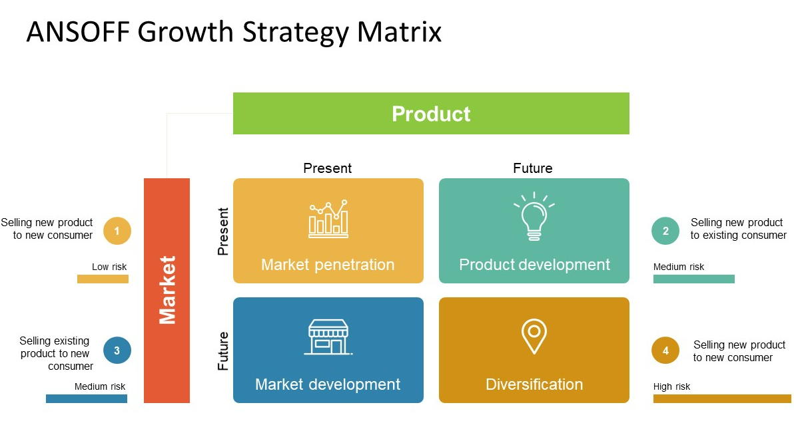
Source: https://powerslides.com/powerpoint-business/

Rolls-Royce's use of the Ansoff matrix for successful business growth

Rolls-Royce has succeeded in its worldwide performance and strategic business choices and decisions based on various internal and external factors, proving that the ANSOF matrix is well established in Rolls-Royce's decision-making process, benefiting Rolls-Royce with the leading automotive giant globally.
Some strategies and recommendations for business growth under the Ansoff matrix are detailed below.

Market Development

Rolls-Royce can use this strategy to enter a new market with existing Rolls-Royce products. For example, the company can use the 2022 Rolls-Royce Ghost to expand into new geographical markets such as Africa, China or India or target new customer segmentation because of the characteristics and specifications of the model. The model is full of modern technology, a potent engine, and enough space for the passengers, and until now has not been equal to other luxury brands.

Diversification

Another strategy under the Ansoff matrix that Rolls-Royce can use for successful company growth is diversification, which means entering a new market with a new product. For example, with an excellent reputation and brand recognition, Rolls-Royce can use this strategy to start creating luxury jets or yachts again, targeting wealthy and superrich people worldwide to expand its product line.
Because of its substantial brand equity, Rolls-Royce can focus on sustainability by developing an environment-friendly product using sustainable energy solutions.
By analysing and evaluating each of Ansoff's matrix models, Rolls-Royce can determine which strategy is good depending on company goals and resources. Ansoff matrix can help Rolls-Royce to identify and predict any challenges and potential risks associated with the chosen strategy and develop and adopt a plan to avoid and minimise those risks, expand the market and product portfolio and increase company revenue streams.

References
MBA Skool Team, 2022. Rolls Royce Porter Five Forces Analysis. [Online]
Available at: https://www.mbaskool.com/five-forces-analysis/companies/18319-rolls-royce.html
[Accessed 31 March 2023].
Carlier, M., 2023. Global luxury car market size from 2010 to 2022. [Online]
Available at: https://www.statista.com/statistics/281574/size-of-the-luxury-car-market/
[Accessed 30 March 2023].
Eckl-Dorna, W., 2023. Rolls-Royce Says Super Rich Keep on Buying Luxury Cars. [Online]
Available at: https://www.bloomberg.com/news/articles/2023-01-09/rolls-royce-says-super-rich-keep-on-buying-luxury-cars
[Accessed 30 March 2023].
FRANK, R., 2023. Rolls-Royce sees record sales in 2022, no slowdown in spending by the wealthy. [Online]
Available at: https://www.cnbc.com/2023/01/09/rolls-royce-2022-sales-soar-ceo-says-no-slowdown-in-spending-by-the-rich.html
[Accessed 1 April 2023].
Goi, C. L., 2009. A review of marketing mix: 4Ps or more?. International Journal of Marketing Studies, 1(1), pp. 1-4.
Heubel, M., 2023. Porter's Five Forces Analysis: Definition, Model & Examples Explained. [Online]
Available at: https://consulterce.com/five-forces-analysis/#5-forces-definition
[Accessed 30 March 2023].
Hunt, N., 2021. Here's How The Rolls-Royce Ghost Compares With The Competition. [Online]
Available at: https://www.hotcars.com/rolls-royce-ghost-compares-competition/
[Accessed 1 April 2023].
IntelliNews, b., 2021. Rolls-Royce set new Russian sales record in 2020. [Online]
Available at: https://www.intellinews.com/rolls-royce-set-new-russian-sales-record-in-2020-203557/
[Accessed 30 March 2023].
Jain, K., 2014. The Rolls Royce Saga. Scribt, pp. 1-5.
Lawbite, 2022. Understanding consumer rights in the U.K. [Online]
Available at: https://www.lawbite.co.uk/resources/blog/consumer-rights-uk
[Accessed 06 April 2023].
Londhe, D. B. R., 2014. Marketing mix for next generation marketing. ScienceDirect, 11(9), pp. 335-340.
Mir, P., 2022. The ultimate theory of the marketing mix:A proposal for marketers and managers. International journal of entrepreneurship, March, 26(4), pp. 1-20.
Monash University, 2023. Macro-Environment. [Online]
Available at: https://www.monash.edu/business/marketing/marketing-dictionary/m/macro-environment
[Accessed 02 April 2023].
N ramya, D. S. M. A., 2016. Factors Affecting Consumer Buying Behaviour. International Journal of Applied Research, 2(0), pp. 76-80.
Silverstein, K., 2022. Rolls-Royce Says Carbon-Reduction Programs Are Costly But Create Business Opportunities. Environmen+Energy Leader, 24 May.
Statista, 2023. Rolls-Royce (Passenger Cars) - Worldwide. [Online]
Available at: https://www.statista.com/outlook/mmo/passenger-cars/rolls-royce/worldwide
[Accessed 19 March 2023].
www.zoominfo.com, 2023. Top Competitors of Rolls-Royce Motor Cars. [Online]
Available at: https://www.zoominfo.com/c/rolls--royce-motor-cars-ltd/370554187
[Accessed 28 March 2023].

