
‘Support Vector Machine and Decision Tree Models’
Artificial Intelligence and Machine Learning (ACCA6011)

Jonathan Lesmond (2300728)
BSc Applied Computing

Abstract
This report explores data on online gaming behaviour by providing some visualisations that also include the use of the K-Means and Mini Batch K-Means clustering algorithms to identify trends and patterns in the data. The support vector machine and decision tree machine learning algorithms are also used in this report to determine which is the best predictive model for predicting player’s level of engagement in a variety of games. From the predictive model training, the support vector machine using the radial basis function kernel was the best performing kernel in comparison to other kernels available to the algorithm and the decision tree using the log loss criterion was the best performing criterion compared to the others available. In the final comparison between the support vector machine with the radial basis function kernel and the decision tree with the logistic loss criterion, the support vector machine performed the best.
Table of Contents
1. Introduction 4
2. Literature Support 5
3. Methodology 7
4. Conclusion 12

Table of Figures
Figure 1 - Bar Charts Showing Age and Gender Distribution in the Dataset. 7
Figure 2 - Bar Charts to Show Player Locations to show and Game Genres. 8
Figure 3 - Bar Charts to Showing Play Time in Hours in Different Ranges and Distribution of Engagement Levels. 8
Figure 4 - Scatter Graph Showing Playtime in Hours and Average Session Duration (Left) and Age and Playtime in Hours (Right). 9
Figure 5 - Mini Batch K-Means Clustering (Left) and K-Means Clustering (Right) Performed on Ages and Play Time in Hours. 9
Figure 6 - Confusion Matrix of SVC with RBF Kernel (Left) and Decision Tree Classifier with Entropy Criterion. 11

1. Introduction
Machine learning models are a set of mathematical functions that are used to make predictions based on historical data, the methods that are used to train machine learning models come under supervised or unsupervised learning categories. In particular, the objectives of training machine learning models through supervised learning can be placed into two categories which are classification and regression, classification models are trained to predict discrete or categorical values on a given input, while regression models are used to predict continuous values that are usually numerical on a given input.[1]
Machine learning models have applications spanning a very broad range of industries such as finance, healthcare, crime, gaming etc. and as such have variety different algorithms under the regression and classification models category.[1]
This report gives an overview of support vector machines and decision trees, the report will also document the implementation and comparison of a specific support vector machine and a decision tree model to predict player engagement based on a large dataset relating to player engagement in online gaming.

2. Literature Support
Support Vector Machines
Support Vector Machines (SVMs) are a highly reputed group of machine learning models that have applications in classification and regression through Support Vector Classifier and Support Vector Regressor. [2] [3] Studies say the SVMs are popular due to its ability to make predictions of higher accuracy than other models on smaller and non-linear training datasets, they also mention its efficiency on computing hardware.[2][3]
In a dataset where the target value consists of two or more classes SVMs operate by using the most extreme values in each class or the value from each class that is closest to the opposing classes which are called the support vectors and act as the boundaries that establish the hyperplane which splits the features within the training dataset into separate classes while maximising the distance between the closest points in both groups to the hyperplane.[2][3][4][5] the way in which the SVM calculates the hyperplane is determined by a feature known as the kernel function, kernel functions are a set of mathematical functions that convert the features in a dataset to more compatible format to fit the SVM, usually by changing the dimensional space of the training dataset (usually 2D) into a higher dimensional space (usually 3D).[6] There are four popular types of kernel functions which are Linear, Polynomial, Radial Basis Function (RBF) and Sigmoid.
SVMs have applications within healthcare and have developed a good reputation. For example, In a study that compared multiple machine learning algorithms on the detection of Parkinson’s disease using a dataset of 195 voice recordings, the SVM had the highest accuracy (96.61%), the second highest F1 score (96%), the highest precision (100%) and the third highest recall which demonstrates its superiority with smaller datasets.[3]
Another study on the progress of Electroencephalogram (EEG) show that SVMs that have been incorporated with EEGs have been highly successful at detecting epilepsy in adults and children for nearly a decade, the same study also mentions that the preprocessing of EEG signals and fitting it into a combination of machine learning algorithms that include the SVM can achieve an accuracy of up to 99.83%.[7]
The main disadvantage of using support vector machine is that it is possible to use the wrong kernel function when training the model which can result in lower accuracy metrics, for example, using the linear kernel function to train a model using a dataset that is not linearly separable which will lead to a worse performance. However, this problem can be countered by testing other kernels which are tailored more towards non-linearly separable data.[8]
Decision Trees
Decision trees are another type of machine learning algorithm used for classification and regression, decision trees operate by dividing the main objective into smaller objectives and determining the rules or choices in the features that lead achieving the main objective, this is usually presented as a tree diagram where the root node represents that best feature in the dataset which can describe the entire dataset and the decision nodes are the other features in the dataset which are used to determine the outcome which are known as leaf nodes.[9][10][11]
The metrics used to evaluate the accuracy of a decision tree differ compared to the support vector machine, in addition to popularly used evaluation metrics in machine learning such as precision, recall, f1-score etc. decision trees use Gini index and information gain, the Gini index is used to measure the prevalence of specific classes after reaching a decision node. Information gain is used to measure the relationship of a particular feature with a particular outcome.[12][13]
The decision tree has been credited for its high interpretability, the algorithm presenting it learning process as a tree diagram closely resembles the thinking patterns of humans which could therefore be interpreted more easily by groups or individuals with lower technical proficiency such as stakeholders and medical staff.[13]
Decision trees have proven to be useful when applied to medical scenarios, for example, a study that compared a normal decision tree model with an optimised version to classify various type of arrhythmia resulted in the normal decision tree model achieving an accuracy of 94.5% while the optimised version achieved an accuracy of 98.77%, although the normal decision tree model achieved a high accuracy, in a medical context a minor classification error could lead to more major problems in the future.[11]
Decision trees are also sensitive to overfitting complexity, decision tree models that are trained on highly complex data will result in a highly complex tree making it less accurate and less interpretable.[14] However, these problems can be resolved through pruning, which is a technique to reduce tree complexity by removing nodes that are not considered important to the target variable.[15]

3. Methodology
Dataset and Data Exploration
Link to Video: https://youtu.be/GbRycI_3V_4
Column Name | Description
Player ID | Identifier for each player
Age | Age of the Player
Gender | Gender of the Player
Location | Location of the Player
Game Genre | Genre of the game that the Player is playing
Playtime in Hours | Average Session Duration in Hours
In Game Purchases | Signals whether the player has made an in-game purchase. Represented as a Boolean where 0 = No and 1 = Yes
Game Difficulty | Difficulty of the game. Represented as either Easy, Medium or Hard
Sessons Per Week | Number of sessions per week
Average Session Duration in Minutes | Average duration of each session in minutes
Player Level | Player’s level within the game
Achievements Unlocked | Number of achievements that the player has unlocked
Engagement Level | Level of player engagement. Represented as Low, Medium and High
Table 1 - Description of Columns in Kaggle Dataset.
The dataset used in this report was taken from Kaggle in CSV format. The dataset has 40034 rows of data and 13 columns in which table 1 provides the description for each column, the target variable in the dataset is engagement level.[16]
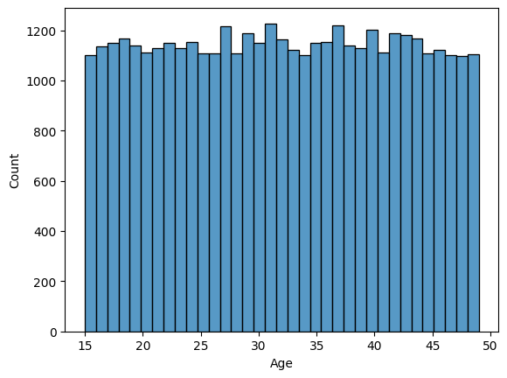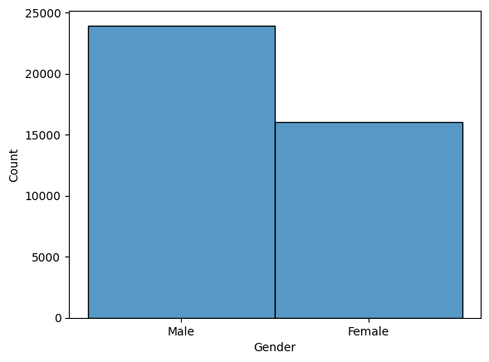
Figure 1 - Bar Charts Showing Age and Gender Distribution in the Dataset.
Figure 1 is a histogram of the number of players at certain ages, all players in the dataset range between 15 and 49 with most players being 31 years old (1228), the majority of players are aged between 25 and 45 years old. The gender of players in the dataset is more biased towards males, as there are 23959 males and 16075 females
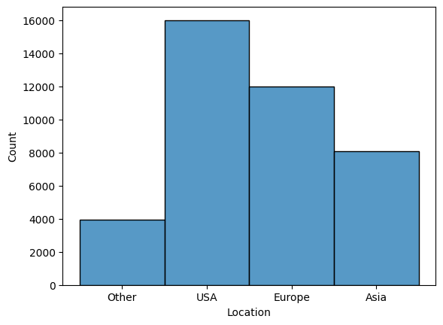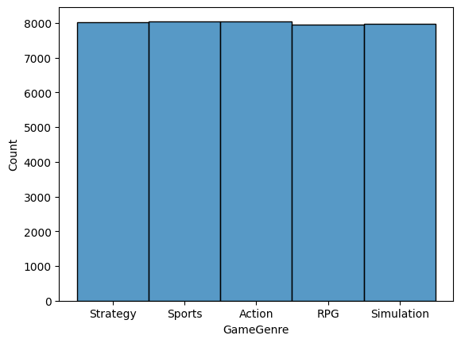
Figure 2 - Bar Charts to Show Player Locations to show and Game Genres.
In figure 2 it shows that most players in the dataset are located in the USA. The game genres played are spread evenly with the sports genre narrowly being the most commonly played genre at 8048 players while the action genre is played by 8039 players
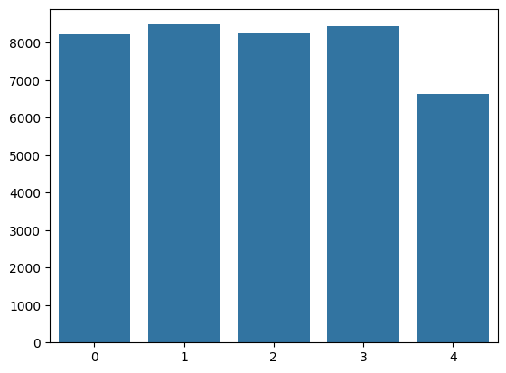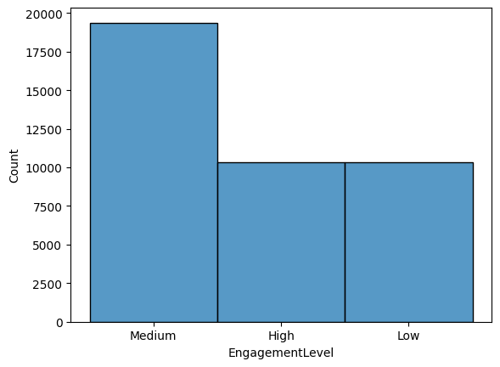
Figure 3 - Bar Charts to Showing Play Time in Hours in Different Ranges and Distribution of Engagement Levels.
Figure 3 showing play time through numeric groups. Group 0 represents a play time of 0-5 hours, group 1 represents 5-10 hours, group 2 represents 10-15 hours, group 3 represents 15-20 hours and group 4 represents 20-24 hours. Figure 3 show that most players in the dataset have a play time between 5-20 hours, with the largest group being group 1 with 8481 players and group 3 closely behind with 8438 players. Also within figure 3 there are equal amounts of players that are considered to have high or low engagement levels while there are significantly more players who are considered to have a medium engagement level.
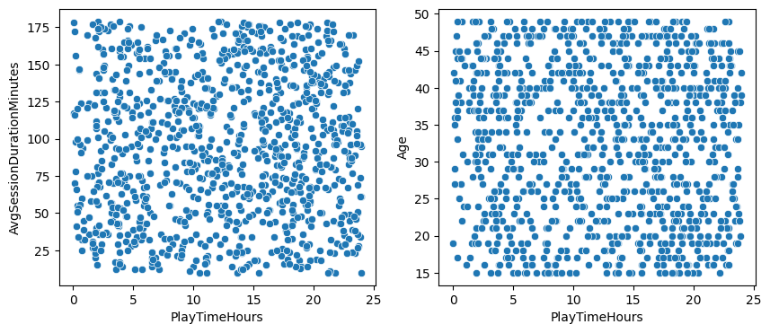
Figure 4 - Scatter Graph Showing Playtime in Hours and Average Session Duration (Left) and Age and Playtime in Hours (Right).
The scatter graphs in figure 4 were made to see if the was a relationship between age, average session duration and playtime, since there are around 40000 total datapoints in the dataset the graphs in figure 4 only show the first 1000 datapoints. Although both graphs in figure 4 do not imply a relationship between average session duration, age and play time, Some observations were made in the right graph in figure 4, one of them being that less people aged between 25-40 had a playtime between 10-15 hours, another observation is that a lot less people aged between 30-35 had a play time of between 5-10 hours.
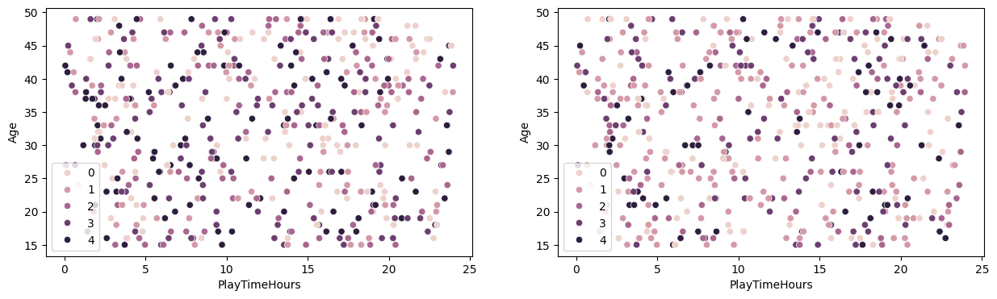
Figure 5 - Mini Batch K-Means Clustering (Left) and K-Means Clustering (Right) Performed on Ages and Play Time in Hours.
Clustering algorithms were performed on 500 datapoints in both graphs within figure 5, both clustering algorithms failed to form any clusters, this is due to the previously mentioned observation that there was no relationship between the factors. Another observation that can be made in figure 5 is that the Mini Batch K-Means algorithm included more values into cluster 4 than in the normal K-Means algorithm.
Dataset Preprocessing and Feature Selection
To preprocess the data, visual studio code was used as the integrated development environment, the Jupyter extension was installed into visual studio code to provide a notebook environment, additionally, scikit-learn was imported to utilise its support vector classifier and decision tree classifier algorithms, the different kernel functions available in the support vector machine will be compared with each other. pandas and NumPy was also imported to load and reshape the data into a format usable for the scikit-learn algorithms.
The features selected for the implementation consisted of all columns with the exception of PlayerID and Engagement Level, a pandas function was used to check the dataset for null values, however, there were no null values in the dataset, then a scikit-learn function was used to split the dataset into a train-test split with 30% of the dataset used for testing.
Model Selection and Training
A comparison of kernel functions within the Support Vector Machine Classifier (SVC) to find out the best kernel for the dataset, the best performing kernel from the chosen set will be used to compare with the decision tree classifier. The metrics used to compare each model will include Accuracy, Precision, Recall, F1-Score and AUR-ROC
Kernel Function | Accuracy | Average Precision | Average Recall | Average F1-Score | AUR-ROC Score
Linear | 83% | 83% | 81% | 82% | 0.92
RBF | 88% | 89% | 87% | 88% | 0.94
Polynomial | 85% | 86% | 84% | 85% | 0.93
Sigmoid | 69% | 68% | 68% | 68% | 0.85
Table 2 - Classification Report of Each Kernel Function in the SVM.
The results in table 2 show that the SVC with the Radial Basis Function kernel performed the best overall with an accuracy of 88% while the sigmoid kernel performed the worst overall with an accuracy of 69%.
Criterion Type | Accuracy | Average Precision | Average Recall | Average F1-Score
Gini | 83% | 82% | 83% | 83%
Entropy | 84% | 83% | 84% | 83%
Logistic loss | 84% | 84% | 84% | 84%
Table 3 - Classification Report of Each Criterion Type in the Decision Tree.
The results in table 3 have showed that the decision tree using the logistic loss criterion performs the best in comparison to the other criterion types, although, the entropy criterion narrowly performed worse on precision.
Final Results
Model | Accuracy | Precision | Recall | F1-Score
SVC with RBF Kernel | 88% | 89% | 87% | 87%
Decision Tree Classifier with log loss Criterion | 84% | 84% | 84% | 84%
Table 4 - Evaluation Metrics of the Decision Tree Classifier and SVC with the RBF Kernel.
Between the decision tree classifier and the SVC with the RBF kernel, the SVC performed better, with an accuracy of 88%, while the decision tree got an accuracy of 84%.

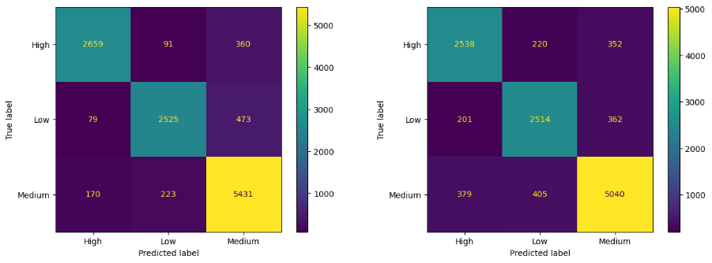
Figure 6 - Confusion Matrix of SVC with RBF Kernel (Left) and Decision Tree Classifier with Logistic Loss Criterion.
Figure 6 shows the confusion matrices for the decision tree and SVC. One observation that was made that the SVC struggled the most predicting medium engagement levels with 13.2% of occurrences being misclassified, the decision tree struggled the most predicting low engagements levels with 19.9% of occurrences being misclassified.

4. Conclusion
This report investigated engagement levels in players of different game genres, age groups and locations using the support vector machine classifier, decision tree classifier, clustering algorithms were also used to identify any trends which were unsuccessful. Before doing the final comparison between the support vector machine and decision tree, a comparison between the kernel functions was conducted and resulted in the RBF kernel being the most successful scoring an accuracy of 88% and so the SVC with the RBF kernel was deemed the most suitable for comparison with the decision tree. A comparison between the three criterions of the decision tree was also conducted which resulted in the logistic loss being the best performing criterion for the dataset with an accuracy of 84%. Finally, the comparison between the SVC with the RBF kernel and the decision tree using the logistic loss criterion resulted in the SVC performing the best in terms of accuracy.

References
[1] A. Géron. A. Géron. Hands-on Machine Learning with Scikit-Learn, Keras, and TensorFlow Hands-on Machine Learning with Scikit-Learn, Keras, and TensorFlow 2022Available: http://ebookcentral.proquest.com/lib/trinity/detail.action?docID=30168989.
[2] H. Li. H. Li. An overview on remote sensing image classification methods with a focus on support vector machine. An overview on remote sensing image classification methods with a focus on support vector machine. 2021 International Conference on Signal Processing and Machine Learning (CONF-SPML) 2021 International Conference on Signal Processing and Machine Learning (CONF-SPML) pp. 50. pp. 50. 2021. . DOI: 10.1109/conf-spml54095.2021.00019.
[3] I. Gupta, D. Vashisth and R. Garg. I. Gupta, D. Vashisth and R. Garg. Performance comparison of machine learning algorithms for parkinson's disease detection. Performance comparison of machine learning algorithms for parkinson's disease detection. Presented at 2024 14th International Conference on Cloud Computing, Data Science & Engineering (Confluence). Presented at 2024 14th International Conference on Cloud Computing, Data Science & Engineering (Confluence). 2024, . DOI: 10.1109/Confluence60223.2024.10463297.
[4] P. Chhajer, M. Shah and A. Kshirsagar. P. Chhajer, M. Shah and A. Kshirsagar. The applications of artificial neural networks, support vector machines, and long–short term memory for stock market prediction. The applications of artificial neural networks, support vector machines, and long–short term memory for stock market prediction. Decision Analytics Journal Decision Analytics Journal 22pp. 100015. pp. 100015. 2022. Available: https://www-sciencedirect-com.ezproxy.uwtsd.ac.uk/science/article/pii/S2772662221000102. DOI: 10.1016/j.dajour.2021.100015.
[5] A. Kurani, P. Doshi, A. Vakharia and M. Shah. A. Kurani, P. Doshi, A. Vakharia and M. Shah. A comprehensive comparative study of artificial neural network (ANN) and support vector machines (SVM) on stock forecasting. A comprehensive comparative study of artificial neural network (ANN) and support vector machines (SVM) on stock forecasting. Ann. Data. Sci. Ann. Data. Sci. 1010(1), pp. 183. pp. 183. 2021. . DOI: 10.1007/s40745-021-00344-x.
[6] Mohammed Amin Almaiah, O. Almomani, A. Alsaaidah, S. Al-Otaibi, N. Bani-Hani, A. K. Al Hwaitat, A. Al-Zahrani, Abdalwali Lutfi, Ali Bani Awad and Theyazn H H Aldhyani. Mohammed Amin Almaiah, O. Almomani, A. Alsaaidah, S. Al-Otaibi, N. Bani-Hani, A. K. Al Hwaitat, A. Al-Zahrani, Abdalwali Lutfi, Ali Bani Awad and Theyazn H H Aldhyani. Performance investigation of principal component analysis for intrusion detection system using different support vector machine kernels. Performance investigation of principal component analysis for intrusion detection system using different support vector machine kernels. Electronics Electronics 1111(21), 2022. Available: https://www.proquest.com/scholarly-journals/performance-investigation-principal-component/docview/2734621542/se-2?accountid=130472 https://libkey.io/libraries/1422/openurl?ctx_ver=Z39.88-2004&ctx_enc=info:ofi/enc:UTF-8&rfr_id=info:sid/ProQuest&rft_val_fmt=journal&rft.genre=article&rft.jtitle=Electronics&rft.atitle=Performance+Investigation+of+Principal+Component+Analysis+for+Intrusion+Detection+System+Using+Different+Support+Vector+Machine+Kernels&rft.au=Mohammed+Amin+Almaiah%253BAlmomani%252C+Omar%253BAlsaaidah%252C+Adeeb%253BAl-Otaibi%252C+Shaha%253BBani-Hani%252C+Nabeel%253BAl+Hwaitat%252C+Ahmad+K%253BAl-Zahrani%252C+Ali%253BAbdalwali+Lutfi%253BAli+Bani+Awad%253BTheyazn+H+H+Aldhyani.&rft.aulast=Mohammed+Amin+Almaiah&rft.aufirst=&rft.date=2022-01-01&rft.volume=11&rft.issue=21&rft.spage=3571&rft.isbn=&rft.btitle=&rft.title=Electronics&rft.issn=&rft_id=info:doi/10.3390%252Felectronics11213571 https://doi.org/10.3390/electronics11213571. DOI: 10.3390/electronics11213571.
[7] C. Hao, C. Chen, Y. Wen, F. Meng, Z. Chi, R. Zhao, Y. Wu, Q. Lian, L. Wang, P. Li and L. Cheng. C. Hao, C. Chen, Y. Wen, F. Meng, Z. Chi, R. Zhao, Y. Wu, Q. Lian, L. Wang, P. Li and L. Cheng. Research progress of electroencephalogram (EEG) classification method and its application based on support vector machine (SVM). Research progress of electroencephalogram (EEG) classification method and its application based on support vector machine (SVM). Presented at 2023 16th International Congress on Image and Signal Processing, BioMedical Engineering and Informatics (CISP-BMEI). Presented at 2023 16th International Congress on Image and Signal Processing, BioMedical Engineering and Informatics (CISP-BMEI). 2023, . DOI: 10.1109/CISP-BMEI60920.2023.10373233.
[8] R. Guido, S. Ferrisi, D. Lofaro and D. Conforti. R. Guido, S. Ferrisi, D. Lofaro and D. Conforti. An overview on the advancements of support vector machine models in healthcare applications: A review. An overview on the advancements of support vector machine models in healthcare applications: A review. Information Information 1515(4), 2024. . DOI: 10.3390/info15040235.
[9] Scikit-learn. Scikit-learn. 1.10. decision trees. 1.10. decision trees. Available: https://scikit-learn.org/stable/modules/tree.html.
[10] E. Kavlakoglu. E. Kavlakoglu. What is a decision tree? What is a decision tree? Available: https://www.ibm.com/think/topics/decision-trees#684929710.
[11] Mohebbanaaz, L. V. R. Kumari and Y. P. Sai. Mohebbanaaz, L. V. R. Kumari and Y. P. Sai. Classification of ECG beats using optimized decision tree and adaptive boosted optimized decision tree. Classification of ECG beats using optimized decision tree and adaptive boosted optimized decision tree. SIViP SIViP 1616(3), pp. 695. pp. 695. 2021. . DOI: 10.1007/s11760-021-02009-x.
[12] S. Tangirala. S. Tangirala. Evaluating the impact of GINI index and information gain on classification using decision tree classifier algorithm*. Evaluating the impact of GINI index and information gain on classification using decision tree classifier algorithm*. .
[13] I. D. Mienye and N. Jere. I. D. Mienye and N. Jere. A survey of decision trees: Concepts, algorithms, and applications. A survey of decision trees: Concepts, algorithms, and applications. IEEE Access IEEE Access 1212pp. 86716. pp. 86716. 2024. . DOI: 10.1109/access.2024.3416838.
[14] G. Nanfack, P. Temple and B. Frénay. G. Nanfack, P. Temple and B. Frénay. Constraint enforcement on decision trees: A survey. Constraint enforcement on decision trees: A survey. ACM Comput. Surv. ACM Comput. Surv. 5454(10s), pp. 1. pp. 1. 2022. . DOI: 10.1145/3506734.
[15] A. M. Hassan, A. H. Amee, M. I. Hossain, S. F. Khan and D. M. Farid. A. M. Hassan, A. H. Amee, M. I. Hossain, S. F. Khan and D. M. Farid. A novel pessimistic decision tree pruning approach for classification. A novel pessimistic decision tree pruning approach for classification. 2023 6th International Conference on Electrical Information and Communication Technology (EICT) 2023 6th International Conference on Electrical Information and Communication Technology (EICT) pp. 1. pp. 1. 2023. . DOI: 10.1109/eict61409.2023.10427593.
[16] R. El Kharoua. Predict Online Gaming Behavior Dataset. Available: https://www.kaggle.com/datasets/rabieelkharoua/predict-online-gaming-behavior-dataset/data.

