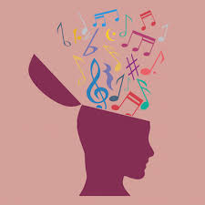
MUSIC THERAPY
Music therapy is an established psychological clinical intervention to help people whose lives have been affected by injury, illness or disability through supporting their psychological, emotional, cognitive, physical, communicative and social needs (BAMT.2024)

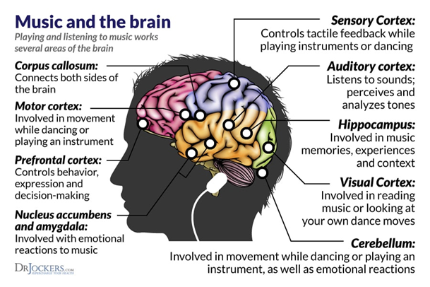

The Science that underpins Music Therapy
- Neuroscience
- Cognitive neuroscience
- Psychology
(NHS Lothian. 2024)

Listening to music has an impact on the human stress response, particularly on the hypothalamic pituitary adrenal (HPA)axis and the autonomic nervous system. Evidence shows that high frequency music leads to the greatest stress relief, lowering cortisol and increasing oxytocin levels. (Cherry, K. 2024)
According to researchers, music and rhythmic vibrations trigger chemical releases within the brain, altering a patients state physically and mentally. These chemicals are – Endorphins, Cortisol, Dopamine and Immunoglobin. (Jernigon, C. 2021)

Six health benefits of music therapy!
- Reduces anxiety and physical effects of stress
- Improves healing, physically and mentally
- It can help manage neurological conditions such as Parkinsons’ and Alzheimer’s
- Helps to reduce depression in people of all ages
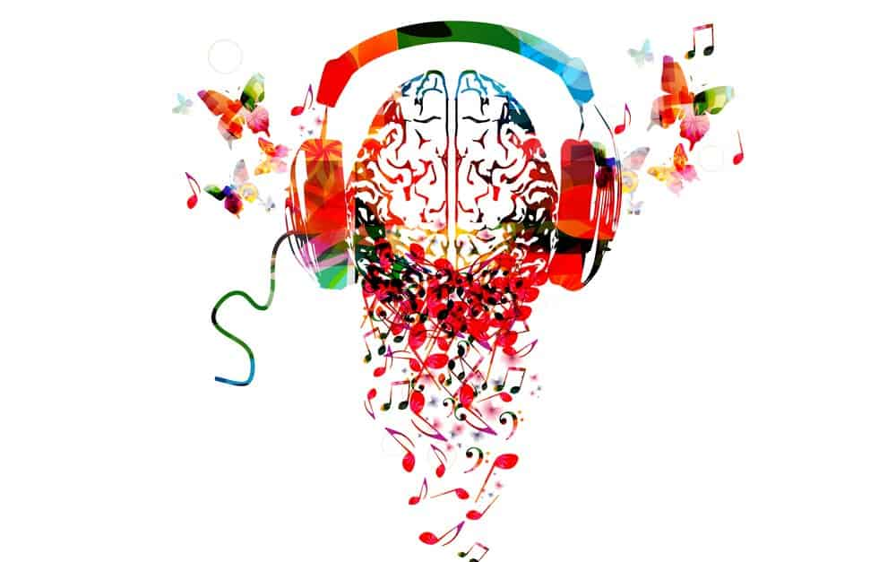
- Helps to reduce symptoms of psychological disorders including schizophrenia
- Improves self-expression and communication
(Craig, H, BPsySc. 2024)

References

BAMT. British Association for music therapy (2024). What is music therapy? Available at: https://www.bamt.org/music-therapy/what-is-music-therapy (Accessed October 2024)
Cherry, K. (2024) Very Well Mind. How listening to music can have psychological benefits. Available at: https://verywellmind.com/suprising-psychological-benefits-of-music-4126866#:~:text=Fotunately%2C%20this%20is%20one%20trend,and%20the%20autonomic%20nervous%20system (Accessed October 2024)
Craig, H, BPsySc. (2024) Positive Psychology.com. What are the benefits of Music Therapy? Available at: https://www.positivepsychology.com/music-therapy-benefits/ (Accessed October 2024)
Jernigon, C. (2021) Incadence. The science behind the sound (Music therapy and our brains) Available at: https://www.incadence.org/post/the-science-behind-the-sound-music-therapy-and-our-brains#:~:text=According%20to%20researchers%2C%20music%20and,Endorphins (Accessed October 2024
NHS Lothian (2024) Arts Psychotherapies. Why Music? (IMAGE) Available at: https://services.nhslothian.scot/artspsychotherapies/connecting-with-music/why-music/ (Accessed October 2024)

