Setting up a Python project in PyCharm

1. Start PyCharm by finding it in your programs menu (if you can't find it – search for "PyCharm" on your computer)

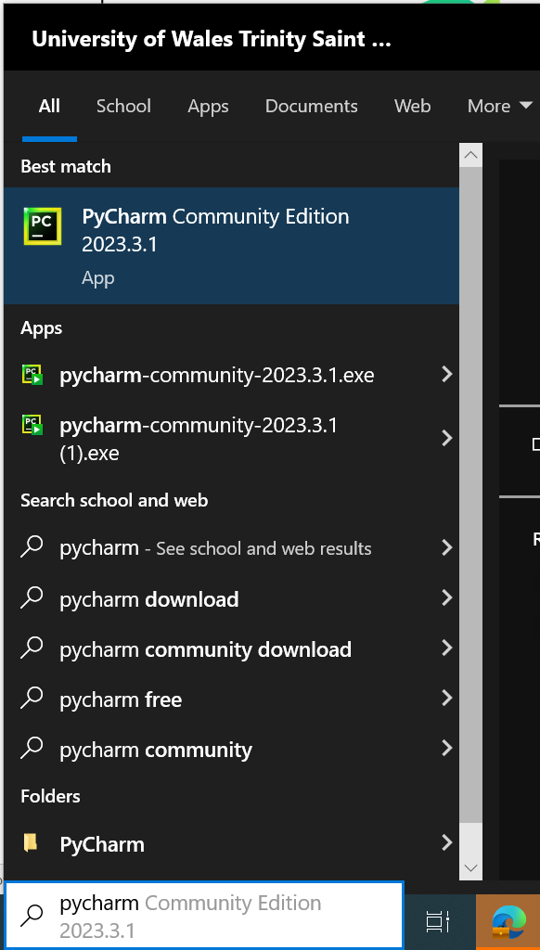

You may see a configuration screen – you can configure this how you like, but it is probably a good idea to tick the .py association at least. (Don’t worry if this screen doesn’t appear, it won’t be a problem to the installation.)

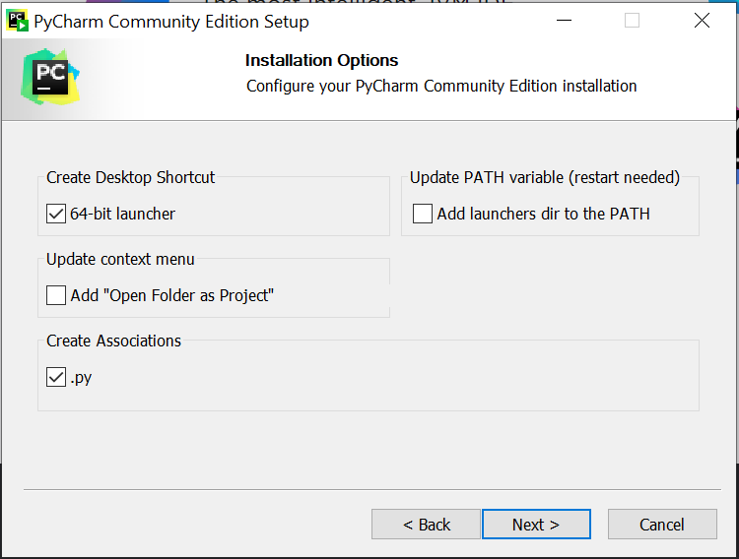

2. On first run, you should see something like this. Click on "New Project"

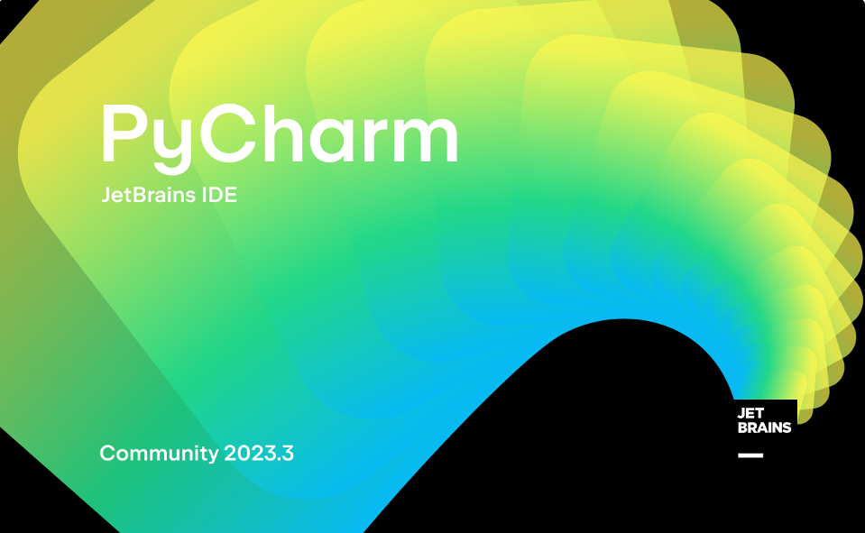

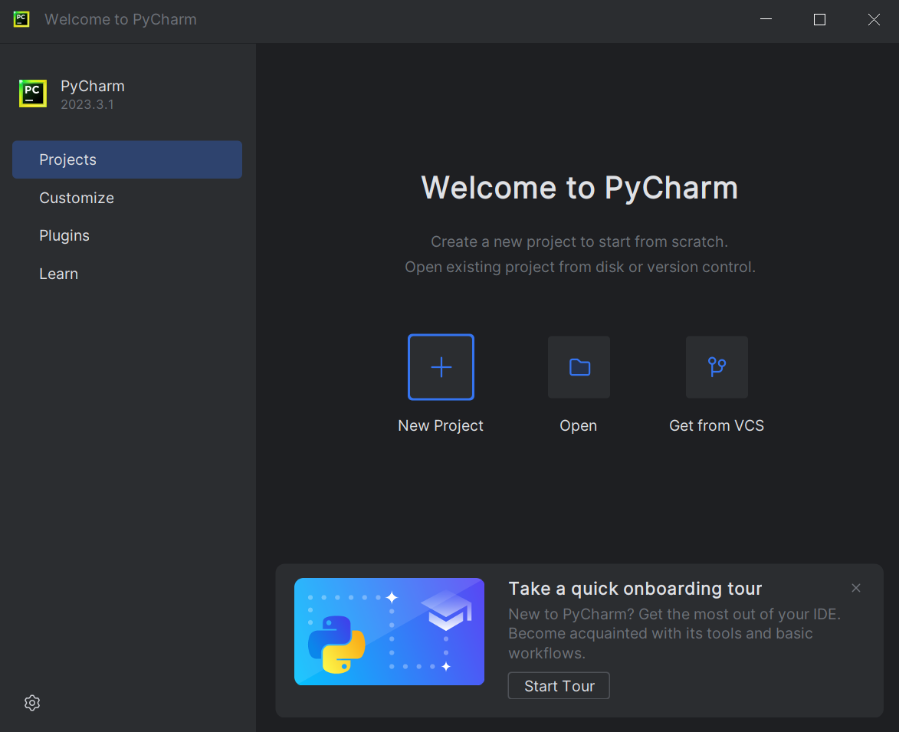

3. You should see something like the screenshot below.

Change the location to somewhere that you will be easily able to find your project later, for example Desktop. I’ve pre-created myself a folder called PyCharmStuff.

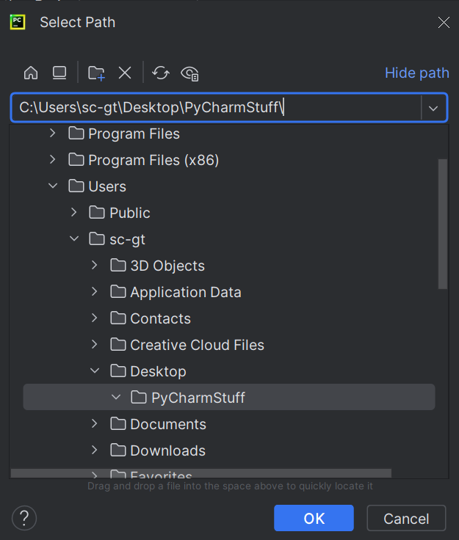

4. The following screen will appear:

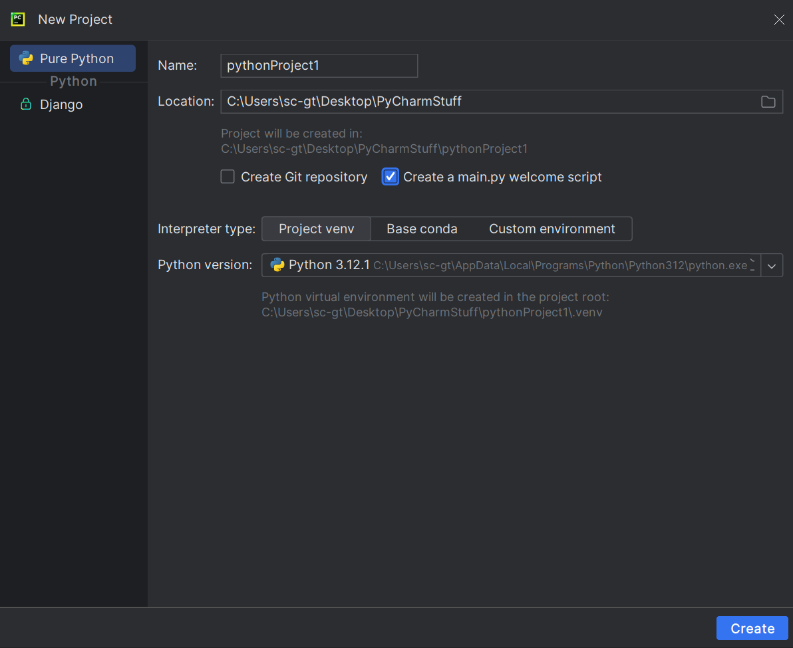

You can change the project name if you like, and also make sure you tick “Create a main.py welcome script”

The Interpreter type and Python version is usually automatically pre-selected, but if it isn't, you may have to navigate to where the Python language is installed on your computer.

5. When the project has been created, you should see something like this. Note that a sample main.py file has been created.

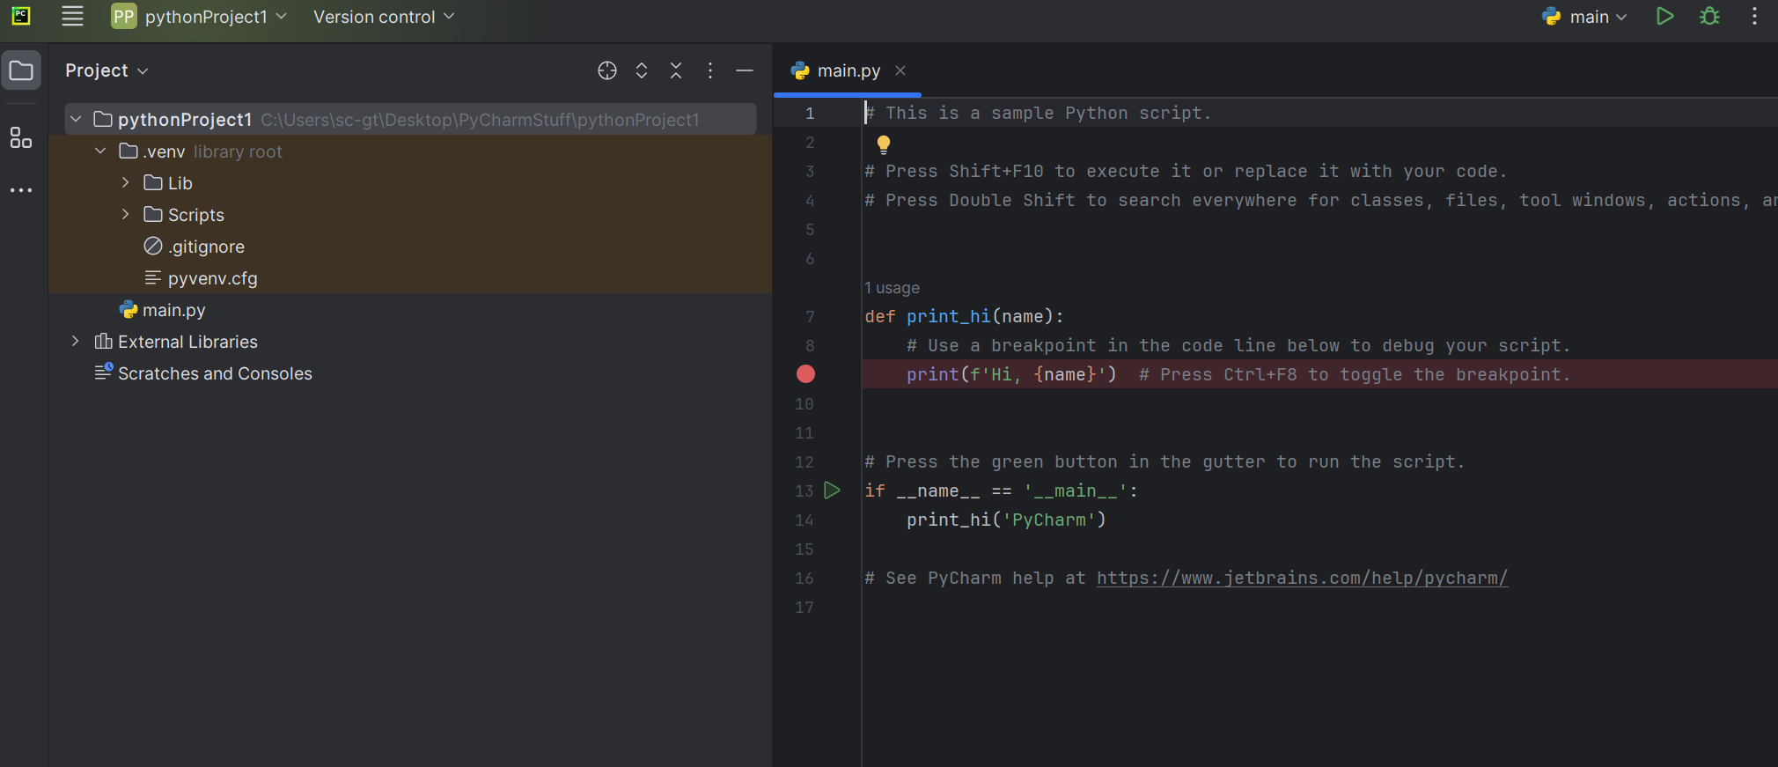

Delete everything from the right hand side window.

We are now ready to write some Python programmes. Here is a simple one:
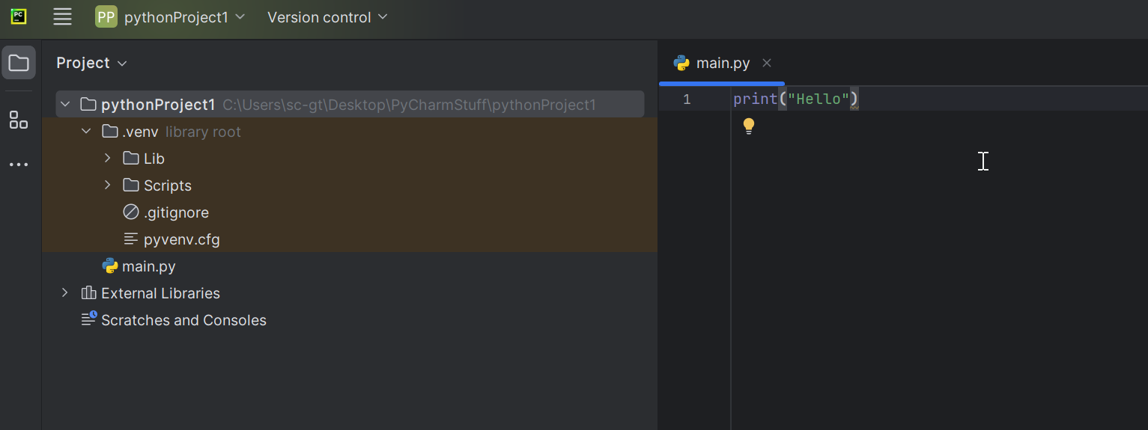
6. NOTE: The default skin for PyCharm currently seems to be the “Dark” settings (black background). If you prefer a Light background, you can change it as follows

Go to File – Settings

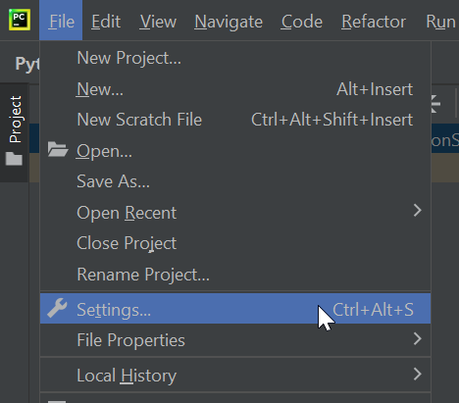

Under “Appearance”, change the Theme

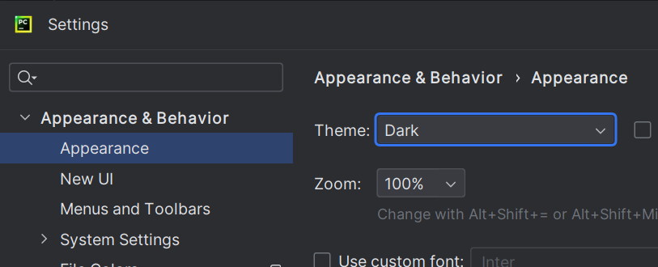

7. When you are happy with the background colour, test out the IDE.

Delete the sample code in the right hand section of the screen (if you haven’t already) and put in a simple print("Hello") instead:

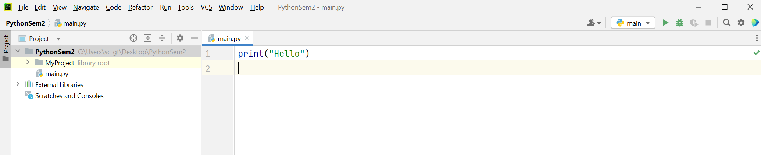

8. Run the program by right-clicking on the background and selecting "Run main"

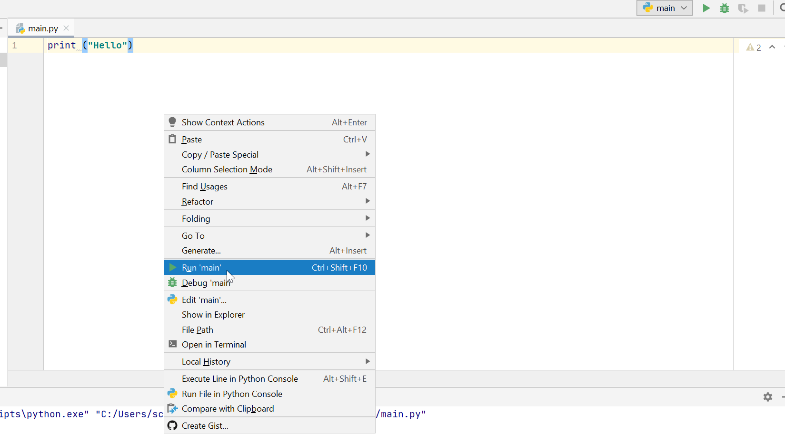

9. After running the program, you will see the result of the program in the window at the bottom of the screen:

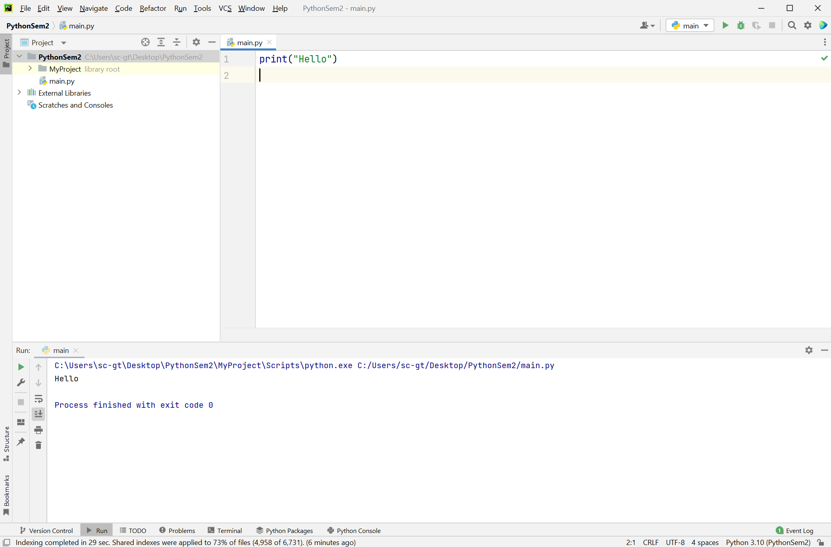

You can detach the window if you want using the 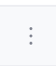 symbol at the right of each section of the screen – whatever you prefer.

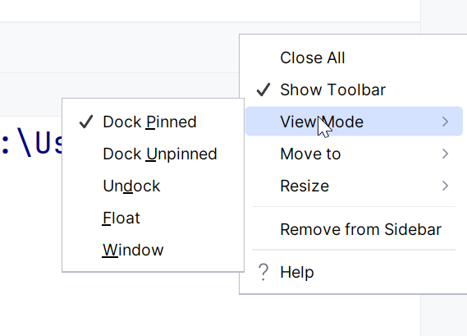

The editor can be customised to your preferred layout.



