University Of Wales Trinity Saint David

Digital Skills and Research Methods
Assessment
Shenses Maksud (1605761)

Executive summary
Digital technology has changed the entire landscape of the business environment. From the time of introduction of digital technologies in businesses, organizations have been able to expand their businesses activities into new regions and countries and enhance their earnings and revenue. In future, digital technologies promise to bring more new changes in the way business is carried out with more development and advancement. This assignment includes brief discussion on cloud storage and web conferencing. Both the technologies have exceptional features and characteristics that make them highly useful and attractive for organizations.

Table of Contents
Introduction 4
1. Usefulness of the technology in the workplace 5
2. Ways through which both the Technology can improve Efficiency at Workplace 6
3. Ways through which both the Technology can help to increase Employability at Workplace 7
Social media marketing………………………………………………………………………..1
Conclusion 9
Reference list………………………………………………………………………………....12

Introduction
Digital technologies are seen as an essential tool for enhancing the work culture, boosting productivity and performance of employees as well as revenue and earnings of an organization. This is the reason these technologies are widely being incorporated in businesses in 21st century, with growing competition, digital technologies are being considered as a tool to gain competitive edge in the market. Two important digital technologies selected in this assignment are web conferencing and cloud file storage. Usefulness of these two technologies in the business environment have been explained and the ways through which these two technologies enable the organization to enhance their efficiency and employability is briefly outlined.

1. Usefulness of the technology in the workplace
Web Conferencing
Web conferencing technology is a wider system that includes different types of services such as web seminars, peer level web meetings and webcasts. As more number of employees work from different locations, it becomes difficult for them to attend office meetings and participate in essential board meetings involving major decision making process (Wessling, 2014). Therefore, web conferencing helps an organization to create a virtual workspace and that integrates all employees, executives and managers to combine together and participate in important meetings and decision making process. This technology enables its participants to share documents, presentations, ask questions and deliver their own opinions and views on the matter instantly even being miles away from the office. This technology enables managers and executives to communicate with each other and collaborate on projects across geographic and cultural boundaries. However, with new advancement in the technology, web conferencing is also being used for providing training and development both internally and externally, boosting sales activities, and marketing strategies. All these advantages are having a combined positive impact on the revenue generation capacity of the organization. The major reason behind aggressive use of this technology in the business environment is that it enables high level of collaboration and productivity among geographically dispersed teams (Gusev and Burke,, 2015).

2. Ways through which both the Technology can improve Efficiency at Workplace
Web Conferencing
Web conferencing can immensely improve the way business activities are conducted due its large number of benefits. Web conferencing enables employees and co-workers to be a part of the meeting from their own home, thereby allowing employees to interact with important clients without having to travel to far distances. Therefore, this decreases the loss of time that is usually lost in travelling from one place to another (Bolton et al., 2017). Employees will have more time to focus on different tasks and activities, thus in a way increasing efficiency of the organization. Many employees do not appreciate travelling to different places, as they have to leave their families. Thus, web conferencing has removed the need of such activity and simplified the process for both the organization and employees (McCoy, 2016). Earlier, employees had to travel to different countries fro meeting new clients and establishing the relationships with the, that required high expenditure on air fares, but with the introduction of web based conferencing the cost of travel and hotel expenses has been removed. Therefore, in many ways web conferencing has enabled organizations to achieve more with less expenditure of vital resources. Managers and employees can use web conferencing to keep in touch with significant clients as well as potential clients. Web conferencing enables employees to construct strong relationships without the need to physically meet or occupy too much time of the client’s. The major advantage of web conferencing is that it allows effective meetings to happen just like face-to-face meetings, however, without incurring travel costs (Okike, and Mbero, 2015).

3. Ways through which both the Technology can help to increase Employability at Workplace
Web Conferencing
Web conferencing enables an organization to develop a virtual work environment within an organization. Thus, enabling employees to work flexibly and enjoy maximum benefits of working from home. This allows organization to meet their goals and objectives, keep their bond with the clients strong and friendly and in addition boost job satisfaction of its employees. This is a major feature that attracts organizations to invest in digital technologies. This has a multi-fold advantage for the organization as it is able to meet its goals with reduced expenditure as well as ensuring higher efficiency of employees at workplace (O'sullivan et al., 2017). Organizations can also use this technology to provide training and development to their employees improving their skill and talent. High focus on improvement of employees enables organization to increase employability at workplace. Embracing new technologies and incorporating futuristic collaboration tools like web conferencing has immense measurable benefits for the organization. HR managers are at much better position to boost employability at workplace by using these technologies. Next generation employees are bringing more new ideas and creativity at workplace thereby increasing the expertise in the workplace. Web conferencing has huge potential in future to enhance the capabilities of the organization to boost employability.

4. Social media marketing:

Social media marketing consists of the attempt to use social media to persuade consumers that one’s company, products and/or services are worthwhile. Social media marketing is marketing using online communities, social networks, blog marketing and more.
Lazer and Kelly’s (1973) define social marketing as "concerned with the application of marketing knowledge, concepts, and techniques to enhance social as well as economic ends. It is also concerned with the analysis of the social consequences of marketing policies, decisions and activities." Social media marketing is not merely about hitting the front page of Digg or any other social news website. It is a strategic and methodical process to establish the company’s influence, reputation and brand within communities of potential customers, readers or supporters.

4.1 Benefits of social media marketing:

Significantly different from conventional marketing strategies, Social Media Marketing (SMM) offers three distinct advantages. One, it provides a window to marketers to not only present products / services to customers but also to listen to customers’ grievances and suggestions. Two, it makes it easy for marketers to identify various peer groups or influencers among various groups, who in turn can become brand evangelist and help in organic growth of a brand. And, three, all this is done at nearly zero cost (as compared to conventional customer outreach programmes) as most of the social networking sites are free.
Social media marketing helps in:

_ Generating exposure to businesses.
_ Increasing traffic/subscribers.
_ Building new business partnerships.
_ Rise in search engine rankings.
_ Generating qualified leads due to better lead generation efforts.
_ Selling more products and services.
_ Reduction in overall marketing expenses.

4.3 List of 3 social media accounts:
- LinkedIn
- Facebook
- Twitter

https://www.linkedin.com/in/shenses-maksud-4b861a16a/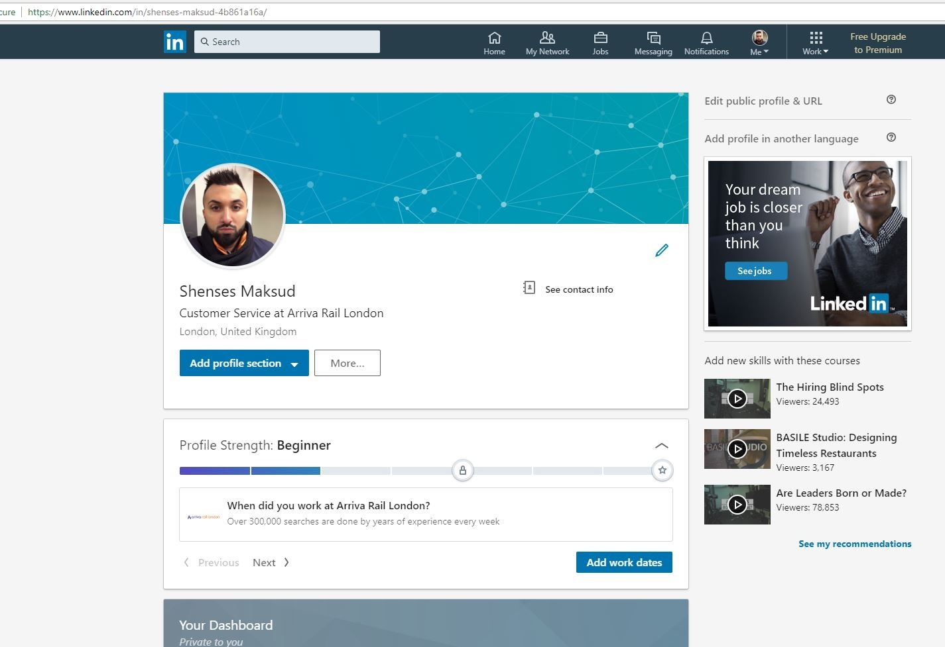https://www.facebook.com/shenses.maksud
https://twitter.com/
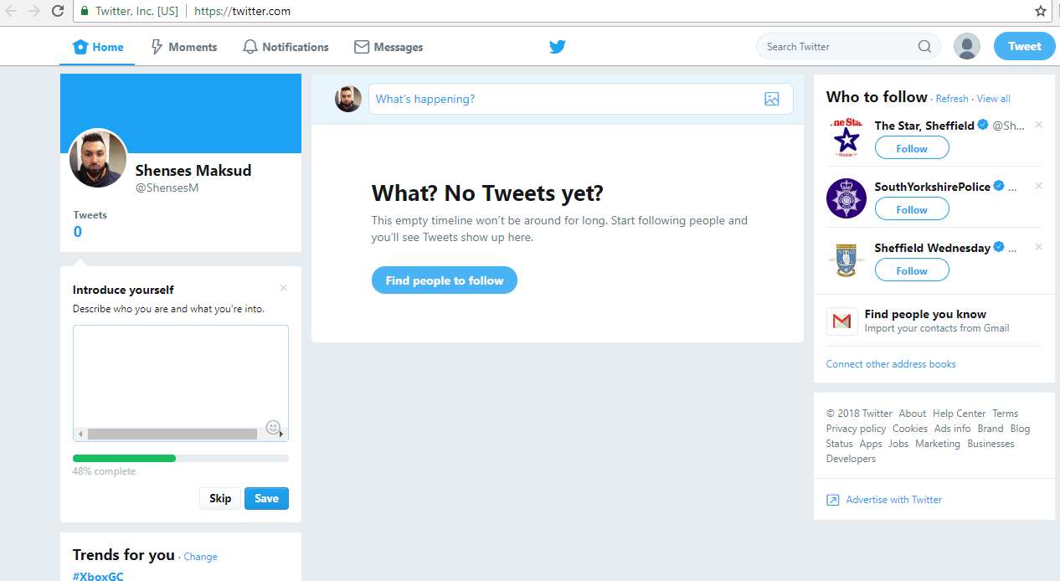

5. Cloud file storage
Digital technology can support employees to be more productive and smart in their approach to solve problems and issues at workplace (Ratten, 2016). This technology can boost individuals to stay connected at office and outside. Cloud file storage can help the organization to boost employability by enhancing the organization culture at workplace. This can have huge impact on the way employees address the goals and priorities of the organization. Organizations that invest highly on enhancing the work culture in its office environment are seen to be viewed highly by employees, boosting their morale and professionalism among employees. One of the main reasons that lead to improved job satisfaction at workplace. These employees can help the organization to build a better image of the organization in the industry. Therefore, enable the organization to attract skilled and experienced employees towards the organization. Organizations that have a superior perception are always more adapt in pulling talented staff workers towards itself. Cloud file storage can offer organizations an opportunity to align their employees with organizational goals and objectives, thus benefiting both of them. Employees that are more skilled in suing these technology will have higher scope getting selected in a job interview.

Conclusion
The above discussion on digital technologies and social media has provided an in-depth knowledge about the usefulness of these technologies at workplace. Cloud storage technology is one of its kind that assists employees to store data at a single storage and access it using internet from anywhere, thus keeping the information safe and organised along with that ensuring that it is easily accessible. Web conferencing is also an internet based digital technology that supports organizations to conduct meetings and conferences with individuals that may be at far distances from the actual location of the organization. Therefore, ensures high connectedness with customers, clients and employees. This technology is very useful in case an organization plans to held a conference or meeting with clients that stay at different counties. This technology has reduced the costs of travel by removing the need to be physically present at an organization meeting or conference.

Reference list
Aljabre, A., 2012. Cloud computing for increased business value. International Journal of Business and social science, 3(1).
Bolton, A., Murray, M. and Fluker, J., 2017, January. Transforming the workplace: Unified communications & collaboration usage patterns in a large automotive manufacturer. In Proceedings of the 50th Hawaii International Conference on System Sciences.
Chou, D.C., 2015. Cloud computing: A value creation model. Computer Standards & Interfaces, 38, pp.72-77.
Dinh, H.T., Lee, C., Niyato, D. and Wang, P., 2013. A survey of mobile cloud computing: architecture, applications, and approaches. Wireless communications and mobile computing, 13(18), pp.1587-1611.
Gupta, P., Seetharaman, A. and Raj, J.R., 2013. The usage and adoption of cloud computing by small and medium businesses. International Journal of Information Management, 33(5), pp.861-874.
Gusev, P. and Burke, J., 2015, September. Ndn-rtc: Real-time videoconferencing over named data networking. In Proceedings of the 2nd ACM Conference on Information-Centric Networking (pp. 117-126). ACM.
McCoy, K., 2016, March. When Distance is the Issue: Using Zoom, Cloud Based Video Web Conferencing System: Perspectives, Possibilities & Potential in Higher Education. In Society for Information Technology & Teacher Education International Conference (pp. 301-304). Association for the Advancement of Computing in Education (AACE).
Lazer, W., Kelley, E.J. (1973). Social Marketing: Perspectives and Viewpoints.
Homewood: Richard D. Irwin

Okike, E.U. and Mbero, Z.A., 2015. Information Technology (IT) Knowledge Management system stage model: A proposal for today's workplace. International Journal of Computer Science Issues (IJCSI), 12(5), p.193.
O'sullivan, P.J., Raguillat, F., Stern, E.H. and Willner, B.E., International Business Machines Corp, 2017. Enhanced management of a web conferencing server. U.S. Patent 9,721,215.
Ratten, V., 2016. Continuance use intention of cloud computing: Innovativeness and creativity perspectives. Journal of Business Research, 69(5), pp.1737-1740.
Wessling, C., Microsoft Corp, 2014. Two-way video conferencing system. U.S. Patent 8,675,038.

