Hand rendered draft - 9 x spot block repeat tile. This is a useful way to layout/ compose a tile (technically repeating as a block, but could be worked as a drop, brick or other repeat system). This example has been worked as a block repeat, repeating out side by side.
Draft: the first version of a design (not finished, but has the bones to become a finished outcome)

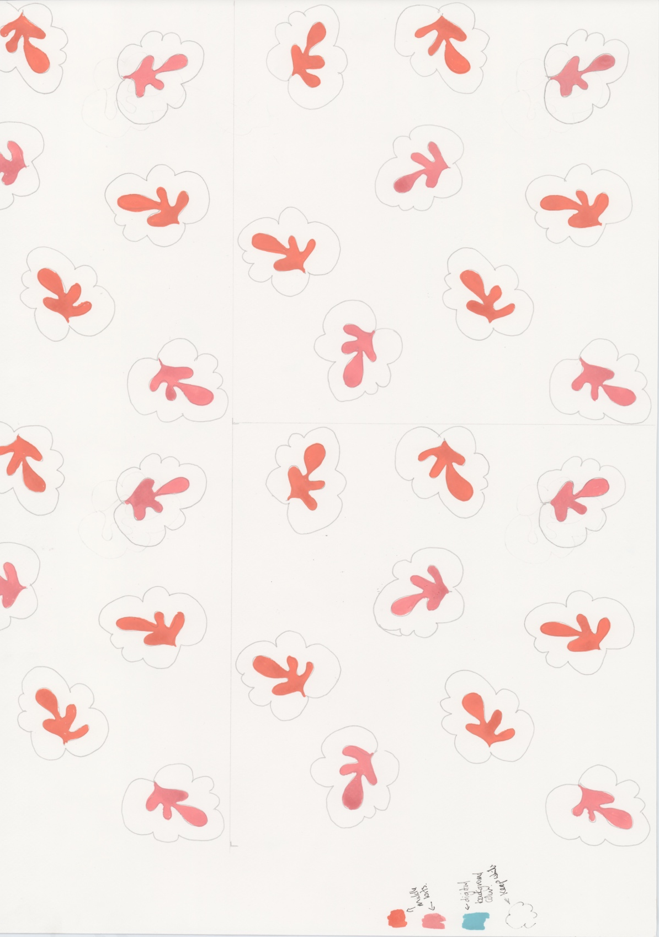
Original artwork gouache

These pattern types can work well in a spot repeat layout, but are not limited to this method of repeat. Abstract, Fauna, Floral, Foliage, Geometric, Paisley, Scattered, Spot, Stripe, Toile de Jouy.

You can draft out a 9 spot repeat within the framework of a square or rectangle, something like this…

9 x spot tile layout (arrows indicate direction/ rotation of motif but can be used without)

9 x spot tile layout

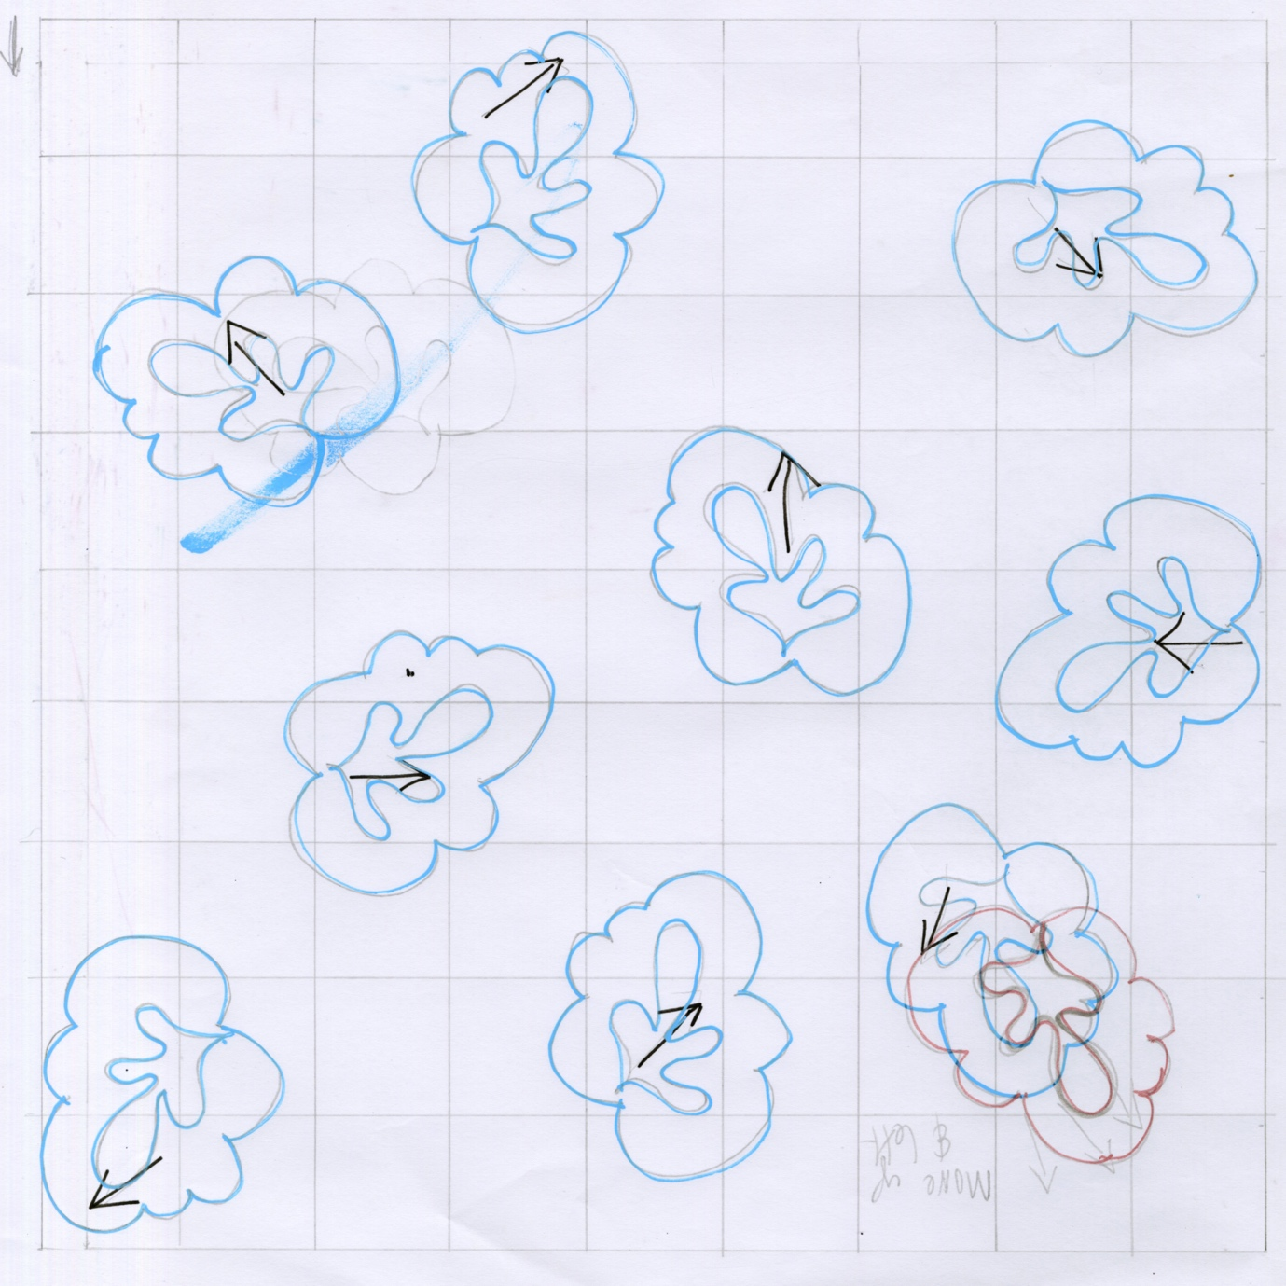

Hand rendered 9 x spot tile (draft) using the arrows to force the direction of the motifs
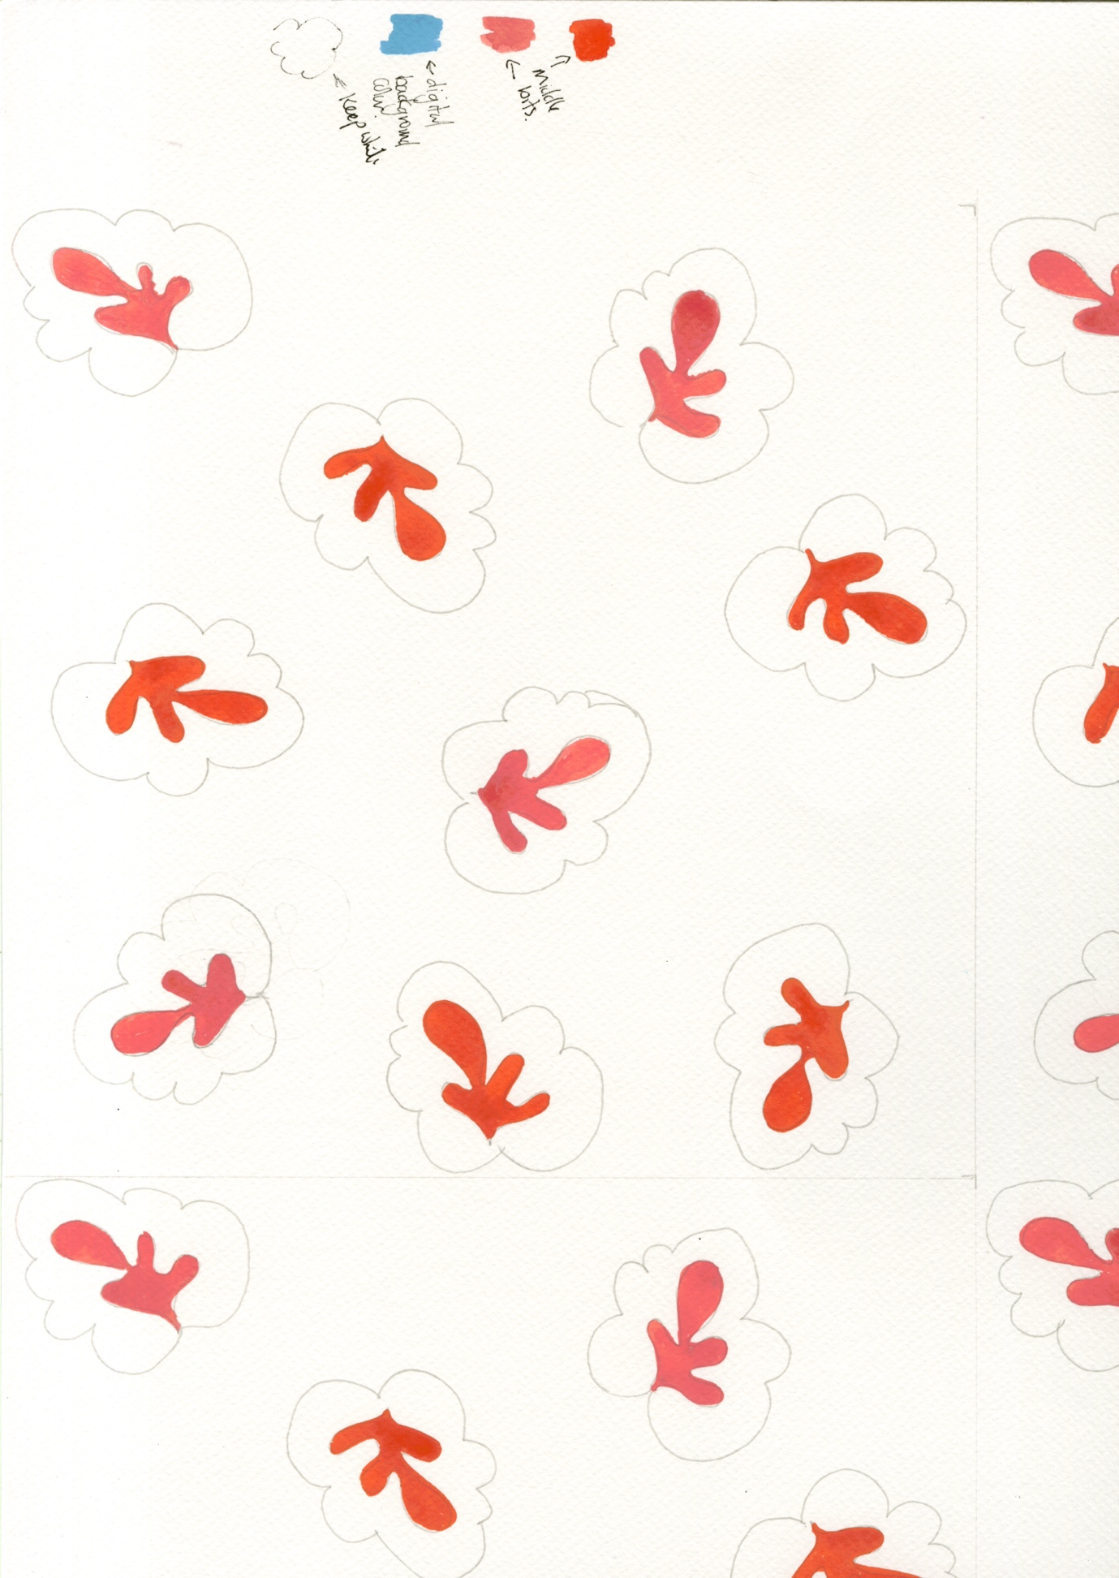
Hand rendered 9 x spot…drawn out and painted with gouache.

