Contemporary Software Applications for Enhancing Technology-Based Business Solutions
An Exploration and Practical Evaluation of e-Commerce, Office, Communication and Collaboration Applications
Full Name: SYED ANJUM ABBAS
Student ID: 2544806
Module Name: Software Solutions for Business
Module Code: ACCA 4026
Group: 1
Lecturer’s Name: Rajeev Nath

Contents
Introduction 3
Task 1. e-Commerce Website builders/software solutions 3
1.1 Wix 3
1.2 Shopify 4
Task 2. Mind-map of contemporary software applications 4
2.1 Describe mind mapping and explain the benefits of using mind mapping 4
2.2 Create a mind map of contemporary software applications 5
Task 3. Office Applications 6
3.1 Four office software solutions for business operations 7
Ms Word 7
Ms Excel 7
Ms PowerPoint 8
Ms Access 8
3.2 Test any two features 9
Mail Merge 9
IF Statement 12
Task 4. Communication and Collaboration applications 13
4.1 One contemporary Communication and one Online Collaboration 14
Gmail 14
Google Meet 14
4.2 Test one feature of a freely available Communication (1) and one feature of a Collaboration (1) application 15
Gmail 15
Google Meet 16
Conclusion 17
References 19

Introduction
In today's organizations, software is used for nearly all routine tasks, whether it's creating a letter to a customer or analyzing performance ratings or having a meeting across the country. It is not the individual features of these tools that make them commercially valuable, rather, how they eradicate repetitive manual work, minimize error and give access to information to those who need it. This report assumes an approach that takes the position that information systems are not valuable in and of themselves, but when they are applied to the operation of the firm [1].
Task 1 gives a description of two current e-Commerce website builders, Wix and Shopify. Task 2 introduces the concept of mind mapping, reviews the evidence behind using mind mapping and creates a mind map of the software applications used in the day-to-day running of the business. Task 3 explores the use of Microsoft Word, Excel, PowerPoint and Access and records the actual testing of Mail Merge and the IF function. Task 4 involves analyzing Gmail as a communication application, and Google Meet as a collaboration application, and describing the test of one feature of each.
Practical work was performed by the author, as a simulation. No real, private or commercial information has been used and the names, marks and content of the messages displayed on the screenshots are fictional and have been made up in order to illustrate the features being tested. The discussion will be evaluative and not descriptive; it will highlight the advantages and disadvantages of each of the tools.

Task 1. e-Commerce Website builders/software solutions
An online e-Commerce website builder is a hosted service that enables an organisation to build and run an online store without having to learn to code or run servers, and includes a site editor, product catalogue, add to cart and checkout features, payment integration and marketing capabilities all within a single subscription. Some of the most popular include Wix and Shopify, and while they have similar features, they were built to serve different purposes.

1.1 Wix


Wix started out as a web page builder and then expanded to include e-Commerce, with its Wix Stores offering. The most notable feature is the "drag and drop editor" which allows for the placement of each element at will. According to Wix, their e-Commerce plans provide free hosting, free domain name for one year, editor, inbuilt marketing tools, as well as ongoing customer service [2]. Wix Stores offers customizable shop pages, a currency converter, mobile optimization, the ability to display in more than three and a half dozen languages, analytics and an app market [3].
Its main advantage for small business is that it's breadth with a low technical barrier: one subscription includes a marketing website, a blog, a booking system and a shop, which would be ideal for an organization that has a significant content presence as well as online sales.
It has also got one of its greatest drawbacks – design freedom. Elements are not mobile responsive, so if they are not carefully edited, they may be fine on a desktop but look bad on a mobile device - which will need to be tested separately. Wix is also not as strong when it comes to high-volume retail: inventory and fulfilment are less mature, and if a retailer outgrows it, they're met with a migration, not an upgrade.

1.2 Shopify


Shopify is created particularly for sale. It claims to be a full commerce platform for online or offline selling, with over two hundred pre-built themes, drop shipping and print on demand options [4]. Shopify claims it's an all-in-one system, meaning that it includes storefront design, inventory management, order and shipping processing, marketing, search engine optimization and sales analysis in one dashboard [5].
It offers a more sophisticated checkout, inventory management, multi-channel selling and reporting as compared to a general website builder and has a large app ecosystem which enables specialized requirements to be met without bespoke development. It's a hosted service as well, which eliminates the need for security patching and payment card compliance at the infrastructure level, and thus, the operational risk for a small team.
It's also obvious what it can't do. TCO can be greater than the subscription, as some transaction fees pick up where Shopify's gateway isn't used and a lot of the flexibility is provided by paid third-party apps. The Liquid templating language is required for deep customization, and the content management tools are relatively simple.
It is thus a question of what the business center of gravity is. Wix is a better deal if the Web site itself is the main brand and the product catalogue is relatively limited; Shopify's dedicated infrastructure is worth the extra expense if selling and fulfilment are the driving activities of the company [1].

Task 2. Mind-map of contemporary software applications

2.1 Describe mind mapping and explain the benefits of using mind mapping
Mind mapping is a visual note taking and thinking style that arranges an idea at the center of a page and then extends branches of ideas outwards, including a key word or image, which then further branches off into more detailed ideas. The method was popularized by Tony Buzan, who claimed that it is easier to create and remember the map than a linear list, and that the use of color, imagery and spatial hierarchy represent a form of ‘radiant thinking’ that can be externalized in a map [6].
The purported advantages can be divided into three categories. The first is related to comprehension and recall; since a map shows the relations between the items, the structure of the map is easily seen briefly. Farrand, Hussain and Hennessy reported a significant difference in factual recall of medical students who used mind maps but also noted lower levels of motivation to employ mind maps, which resulted in a limited practical benefit [7]. Evidence is thus supporting with qualification.
The second type is related to business communication: a map can take a complex domain and distill it into one page—the ideal briefing tool when you need to convey some technical information to a manager, or a new hire. The third has to do with planning, as mind mapping works well for the divergent part of the task, for example, when scoping a project or auditing which software a department is depending on, gaps and duplications are exposed whilst building the mind map.
There are real-world constraints. Mind maps can't be too dense – with too many branches, they become illegible. This technique is inherently hierarchical and therefore is not suitable for networked relationships or for domains where sequence and/or quantity is important, which a flowchart or a Gantt chart would be more appropriate. Maps are also individualistic and are influenced by the associations of the person that created them and a map created by a colleague may not be understood as the author intended unless explained.

2.2 Create a mind map of contemporary software applications
The mind map in Figure 1 shows a summary of the types of modern software that are used to manage everyday businesses. The central node represents the subject; eight branches are radiating from the central node, each naming one of the functional categories, its purpose and representative applications.
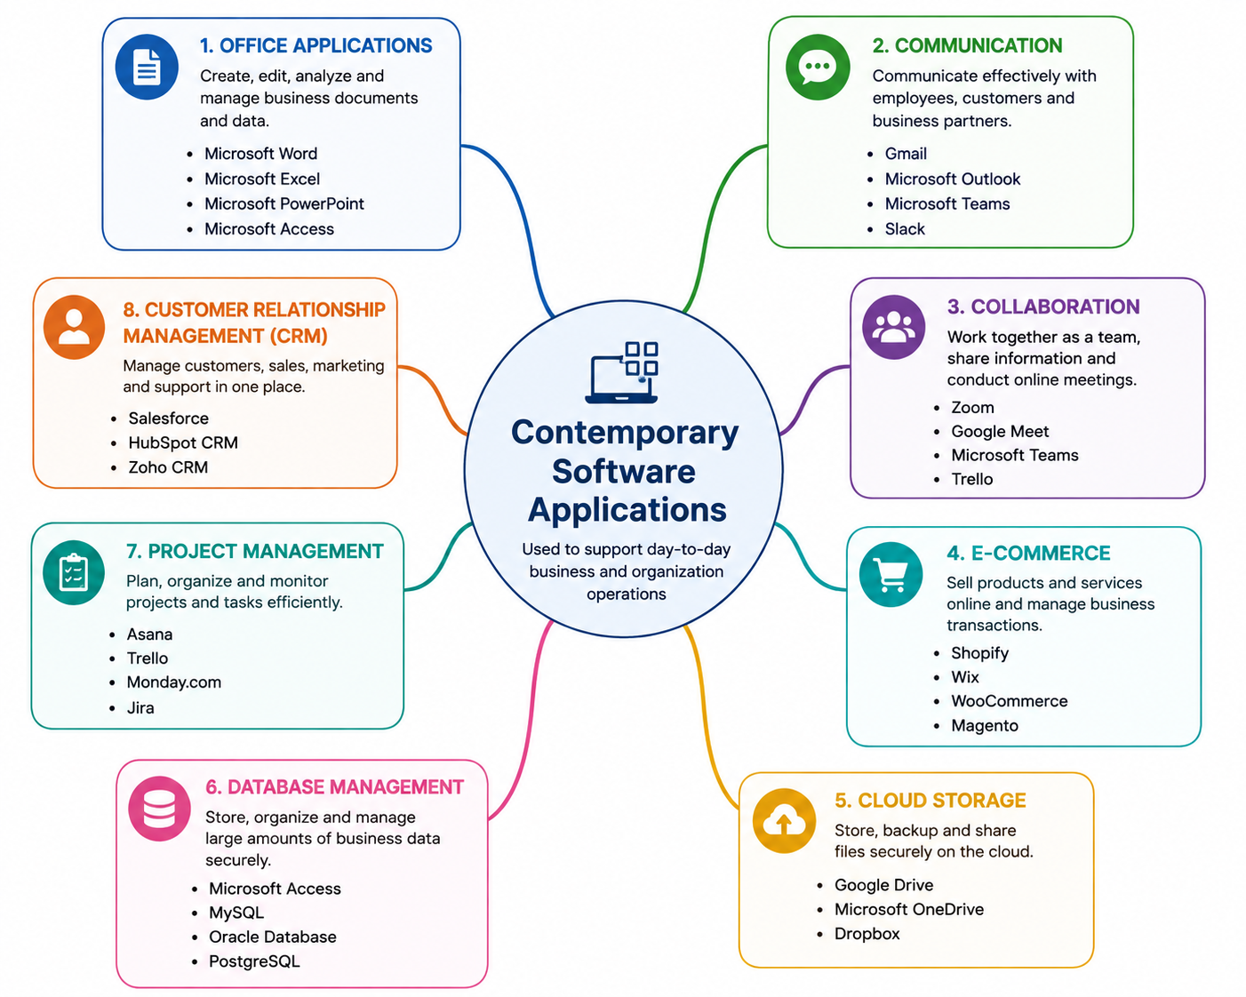
Figure 1: Mind Map of Contemporary Software Applications
The intent of the map is to present the software by business function instead of vendor, as organizations tend to choose software to address an operational issue, not to complete a product family. From office applications and communication to collaboration, e-Commerce, cloud storage, database management and project management to customer relationship management.
There are two observations that are not easily seen in a list. First, there are several applications that fall under multiple categories (Microsoft Teams are listed in both communication and collaboration), indicating that the lines are not hard and fast, and that a single application can meet multiple needs. Secondly, they are interdependent, such as an e-Commerce site, which produces data that is analyzed in a spreadsheet, stored in a database and then acted upon via a CRM system.

Task 3. Office Applications
Office applications are general purpose applications that are used to create, store, present and analyze information. The four that we’ll look at here are part of the Microsoft Office suite. Part of the importance of them is for their individual abilities and part of the importance is for their ability to interoperate, i.e., data generated in one can be re-used in the other without being re-entered.

3.1 Four office software solutions for business operations

MS Word 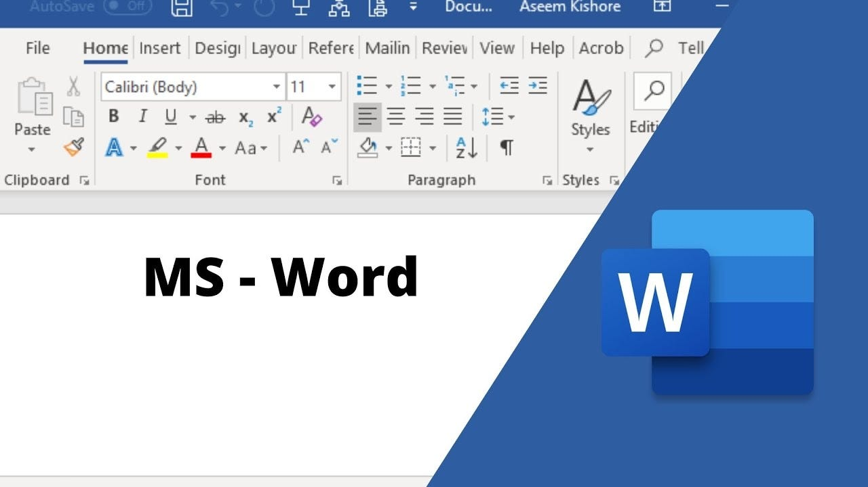

Microsoft Word is a word processing software that is used for creating, editing, formatting and sharing text-based documents. It is the tool used in business to create most of a company's formal written communication, such as contracts, reports, policies, proposals and correspondence.
It can include full paragraph and text formatting, styles (sets of formatting for consistency and the ability to create a table of contents), templates (standard documents for recurring document types), tools for reviewing documents (e.g., tracked changes and comments) and Mail Merge (standard document + data source = personalized document per record) [8].
Styles and templates make documents look the same, no matter who does them, and document review tools document change made by whom, which is crucial if a document has contractual weight.
Word is still document oriented. It is good with unstructured text but doesn't work as a good repository for structured data because information within a Word table cannot be easily sorted and aggregated. Many pictures and cross references in complex documents can make them slow, and formatting is often lost when moving files to and from other word processors.

MS Excel

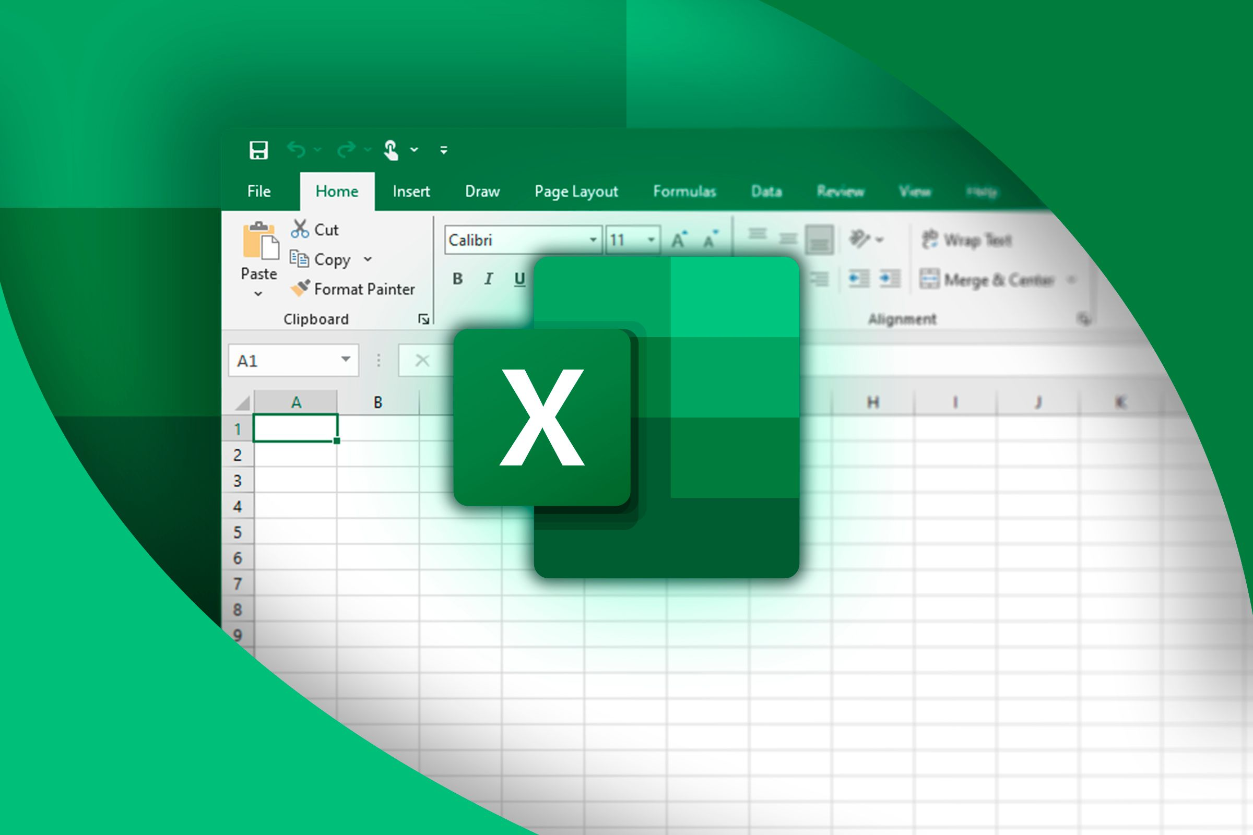
Microsoft Excel is a spreadsheet application which is used for storing and calculating numerical and tabular data, analysis and visualization. It is the analytical workhorse of most organizations and is used for budgeting, forecasting, stock control, payroll, performance reporting etc.
It offers a formula engine that contains over 500 built-in functions in logical, statistical, financial and lookup categories [9]; charting capabilities; PivotTables to summarize large amounts of data; conditional formatting; data validation; and the IF function which allows to return a value when a condition is true and a different value when the condition is false [10].
The advantage is that it is fast and readily available. A member of staff without programming skills can create a working model in an afternoon and as formulas are automatically recalculated, it is easy to change an assumption and see what happens, which is good for scenario analysis.
There are some restrictions that are significant. Spreadsheets are prone to mistakes: a formula copied in the wrong cell range may yield a seemingly correct answer which no one can catch, and you can't get a database's referential integrity. Weakness in version control. Microsoft even warns against the use of many nested IFs as the logic could be very hard to get right and upkeep [11].

MS PowerPoint

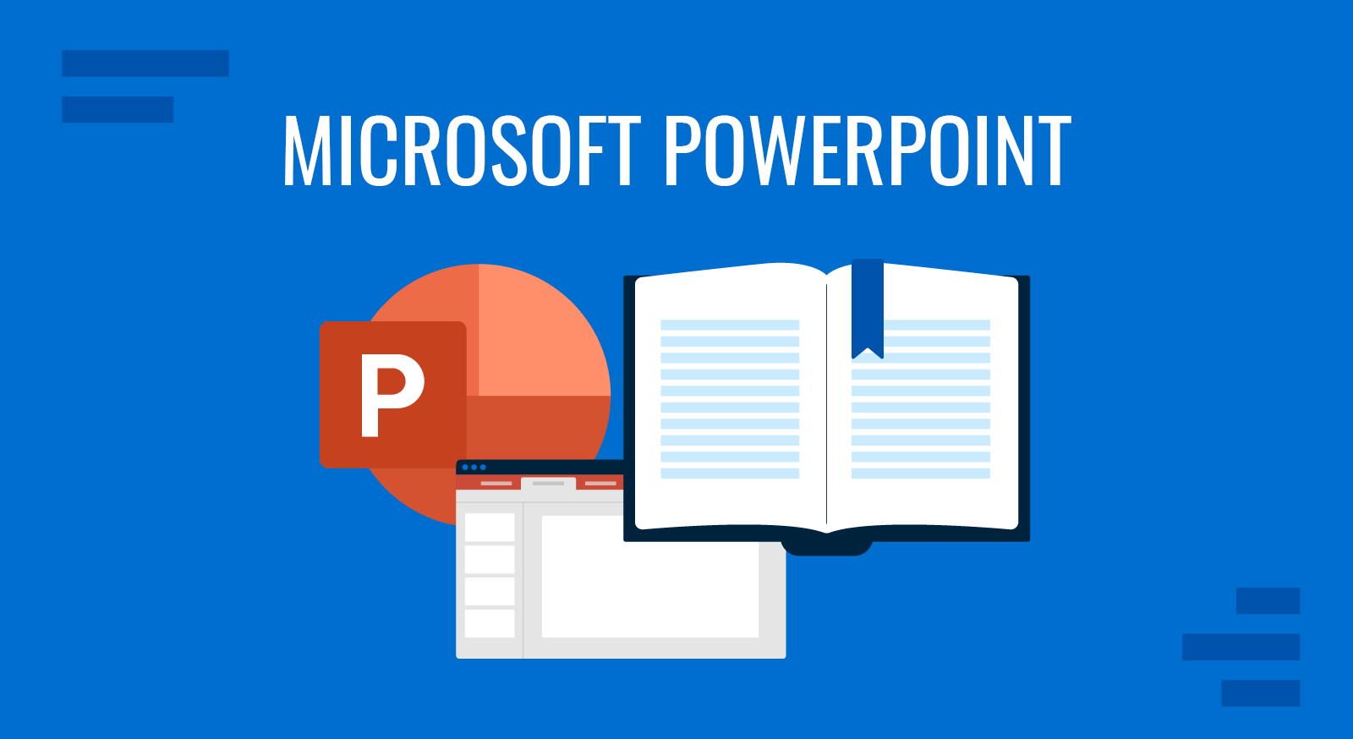
Microsoft PowerPoint is a software program for creating presentations that consists of a series of screens or pages of text and graphics, charts and animation. It is utilized by businesses for internal briefings, sales pitch, training delivery and induction material.
The biggest features include slide layouts and master slides, providing a consistent slide design throughout the deck; SmartArt and charting tools, allowing for the pacing of information revealed; presenter view and presenter notes; and Speaker Coach, which provides feedback on the presentation during rehearsal [12]. Decks may also be shared for co-authorship, and comments may be used to call out a colleague to a particular slide [13].
The advantages are clarity and reusability: if quantitative relationships are at hand, visual material can help you to understand; a deck can be circulated afterwards and used again for the next round.
The restrictions are mainly ones of misuse. The use of dense slides to read makes for less—not more—comprehension, and the fact that animation is so easy, invites decoration that detracts from the argument. Another problem with PowerPoint is that it's not a great medium for documentation; a PowerPoint presentation without its presenter is often confusing.

MS Access 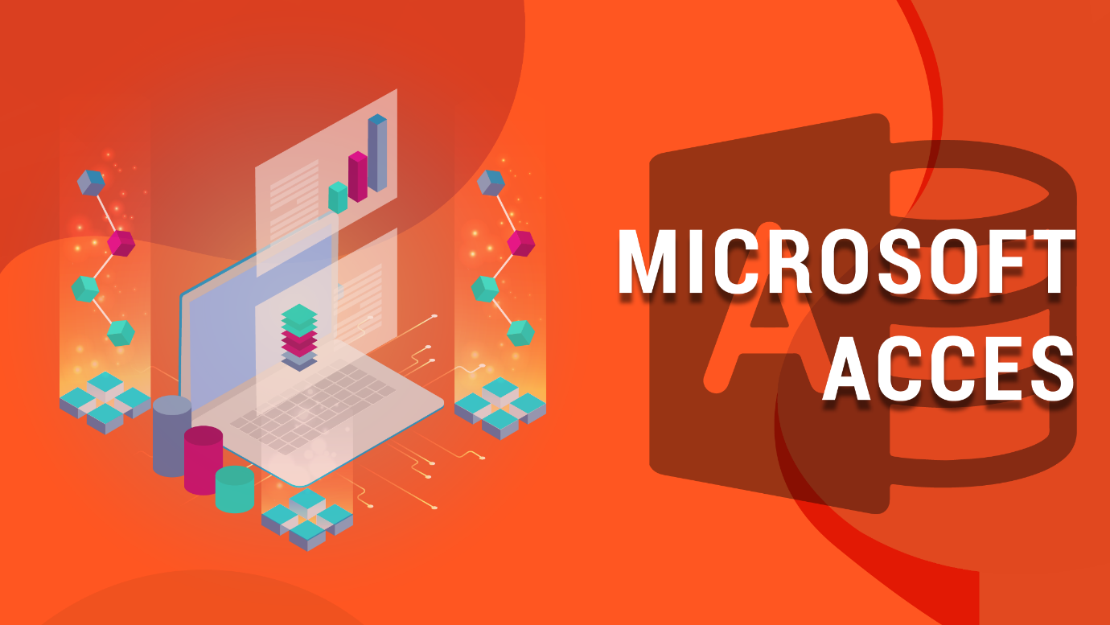

Microsoft Access is a relational database management system that includes a database engine and a graphical user interface to design tables, queries, forms and reports. It lies somewhere between a spreadsheet and an enterprise database server, and is appropriate for departmental applications like membership registers, asset inventories and booking systems.
Microsoft defines the primary objects as: tables contain the data itself and in records and fields; queries are used to select specific data and to filter data based on specific criteria; forms are used to enter and edit data; reports format and display data; and macros and modules add functionality, the latter in a Visual Basic for Applications (VBA) language [14] [15].
Where the data is relational, the advantages over a spreadsheet are very significant. By using separate related tables for customers and orders, there is no duplication of customer information on orders as would be found in a flat sheet, and by using validation rules, data integrity is maintained right at the source of the data entry.
The limitations are in terms of scale and concurrency. There is a limit on the size of the database, and it is not optimized for large numbers of users; reliability decreases when many users access the same database concurrently via a network. It requires a level of design that spreadsheets don't, as well. So, it's suitable for a departmental problem and not suitable for an organization-wide system.
Application | Primary purpose | Key business benefit | Principal limitation
MS Word | Creating and formatting text documents | Consistent, professional documents; Mail Merge removes repetitive personalization | Poor container for structured data; formatting degrades across versions
MS Excel | Storing, calculating and analyzing numerical data | Rapid modelling and automatic recalculation support scenario analysis | Error-prone; weak version control; unsuited to very large datasets
MS PowerPoint | Designing and delivering slide presentations | Visual clarity and reusable, brand-consistent decks | Weak as standalone documentation; encourages text-heavy slides
MS Access | Storing structured relational data in a desktop database | Enforces data integrity; queries, forms and reports for departmental systems | File size limits; unreliable with many concurrent users; Windows only
Table 1: Comparison of the four Microsoft Office applications examined

3.2 Test any two features
The practical testing of two features from the brief (Mail Merge in Word, and IF in Excel) is documented in this section. They were both tested with the help of simulated data. The scenario involves an imaginary organization, ABC Training Institute, which has to inform learners that they have completed courses and decide on the assessments.

Mail Merge
Mail Merge is the process of taking a main document and a data source and creating a personalized document for each data record. Microsoft says it is "generating a collection of documents customized for each recipient, where the placeholders are filled in with data from an associated list, spreadsheet or database" [8]. It automates the process of sending a message out to each recipient that normally would have to be done individually – such as certificates, invoices, appointment letters.
The scenario tested was the problem of creating a letter to inform a learner about the completion of a course – and to create a letter for every learner from one template and in a personalized way.
Step 1 — Writing the main text. The letter was created initially in Word, and then the Mailings tab was opened and the merge started. All text which appears in all copies (organization’s name, congratulatory message and sign-off) is contained in the main document. It is important to do this prior to connecting a data source as the merge fields should be placed in the finished text, not the other way round. The final letter with the Mailings tab turned on and the merge fields placed in the salutation is seen in Figure 2.
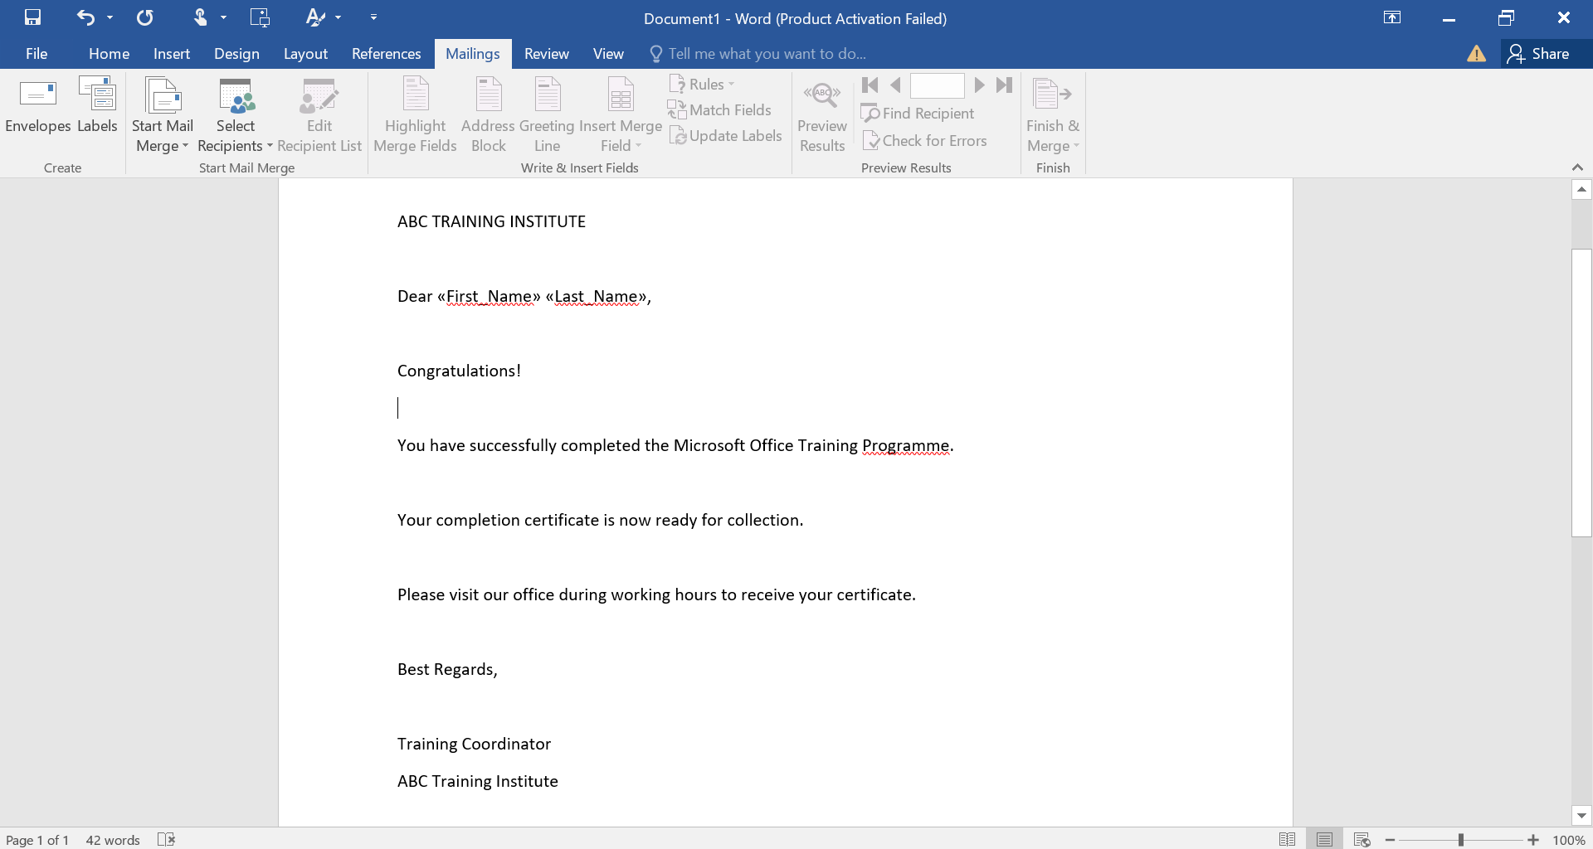
Figure 2: Starting the Mail Merge Process in Microsoft Word
Step 2 — Building up the list of recipients. The data source was created by selecting Select Recipients and Type a New List. Word displays the New Address List dialogue, which is a tabular editor that contains a variety of predefined columns, such as Title, First Name and Last Name. Four false records were made. The creation of the list in Word would usually be used for a small, one-off mailing, while with a recurring mailing an existing Excel worksheet would typically be connected, as Microsoft documents [16]. The recipient list is displayed on entry, as indicated in figure 3.
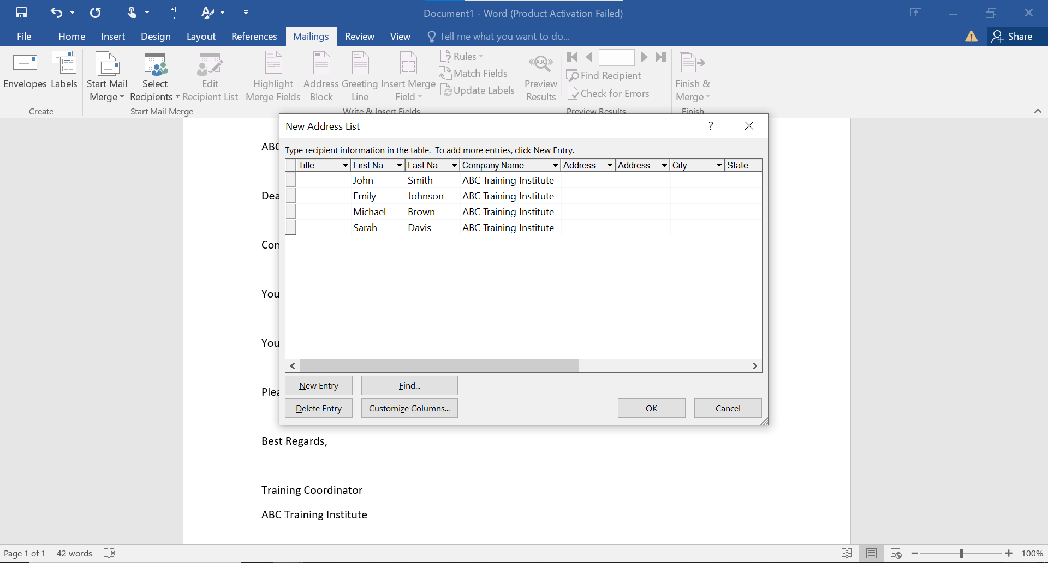
Figure 3: Creating the Mail Merge Recipient List
Step 3 — Adding the merge fields. The placeholders were placed in the salutation with Insert Merge Field, which resulted in a salutation of: First_Name» «Last_Name». The Merge Fields was then highlighted to show them from regular text, which helps verify that they have been properly typed into a merge field, since a field typed as regular text will not be highlighted and won't merge. As can be seen in figure 4, the merge fields are in place and highlighted.
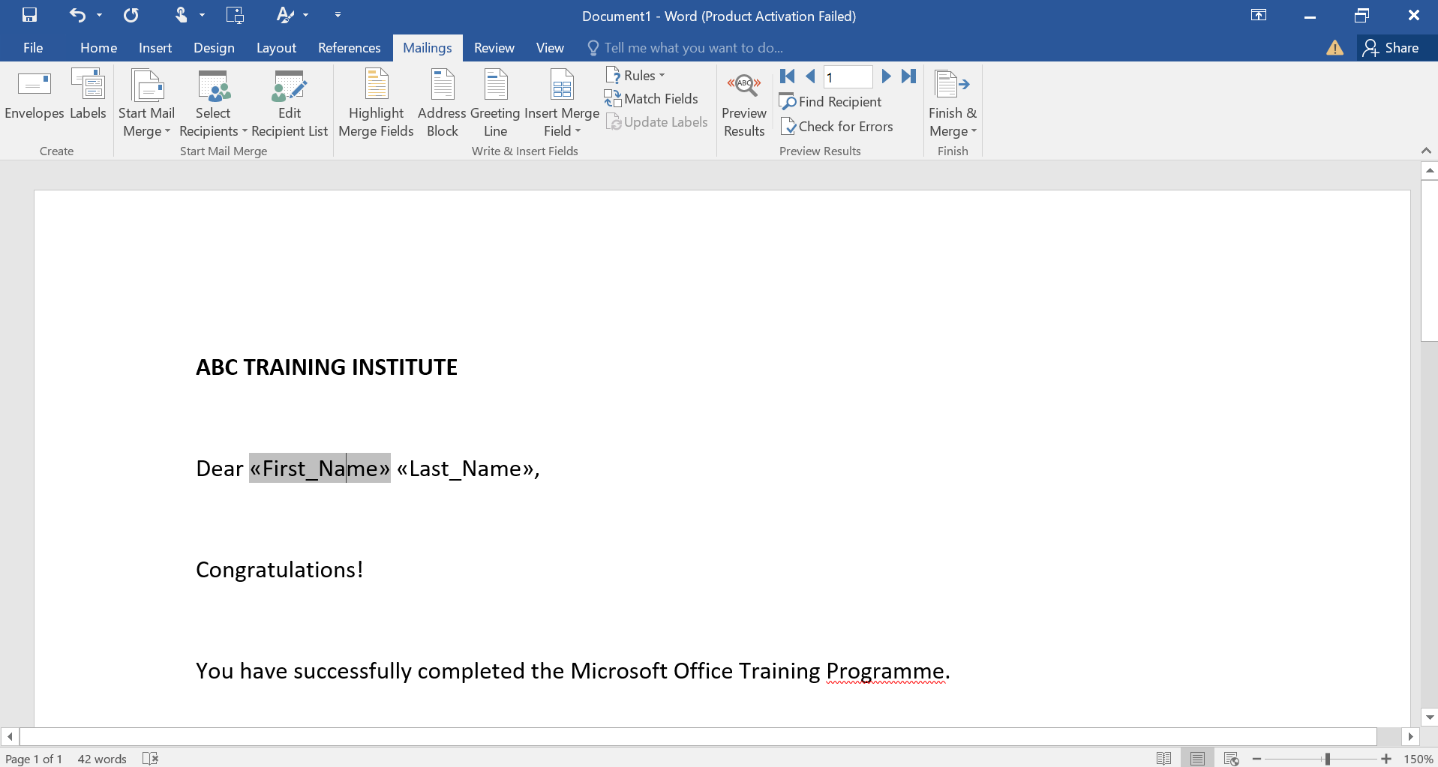
Figure 4: Inserting Merge Fields into the Letter
Step 4 — Previewing the output of the merge. Preview Results were chosen to act as a preview to check the field codes with real data before finalizing the merge. The salutation was correct (Dear John Smith), and the 'Next' and 'Previous' arrows were used to view each record in turn. This is the key quality control in the process, and it will show you which fields are turned around, or which ones have been spaced out or incorrectly spaced, before it becomes too costly to fix them. The first letter recipient's preview is shown in figure 5.
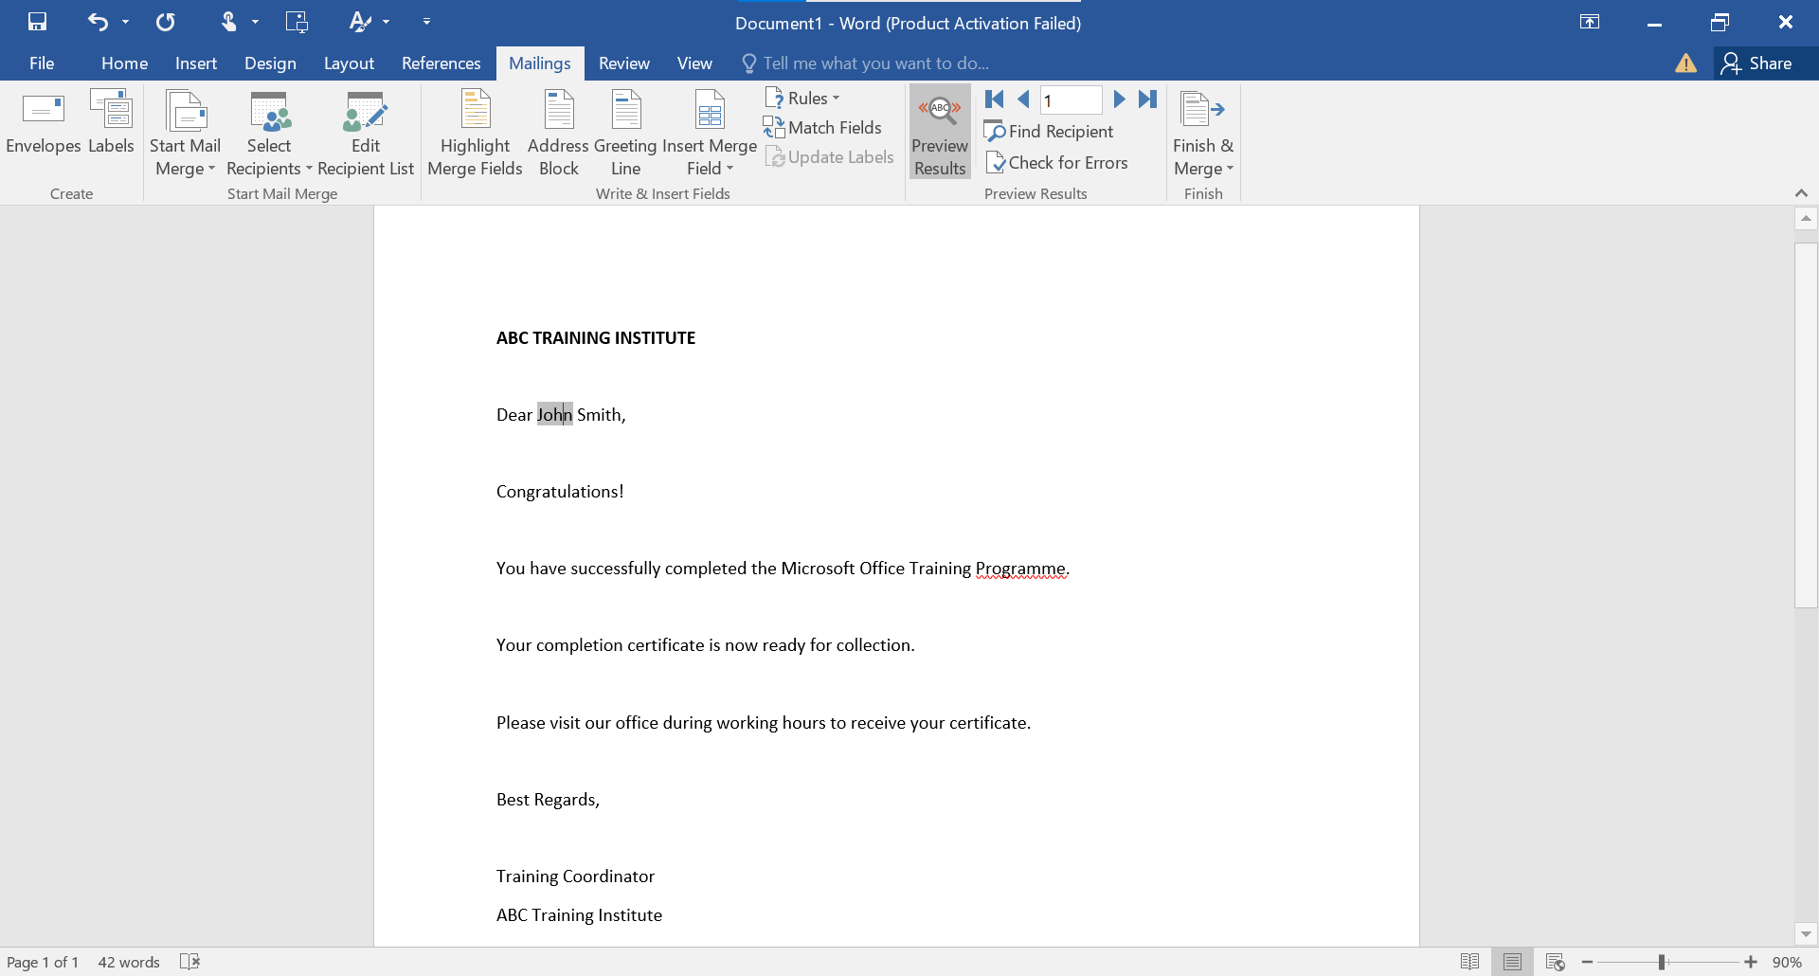
Figure 5: Previewing the Personalised Mail Merge Letter
Evaluation. The test was a success, demonstrating that Mail Merge can create personalised documents without any problems and the time to create the document was effectively independent of the number of learners: it took the same time to prepare the document for 4 learners as for four hundred. There were two drawbacks evident. There's no way to prevent misspelling since the output is just as accurate as the data source; and the feature personalizes fields but not structure, so there is a need for merge rules when adding conditional content.

IF Statement
The IF function is one of the logical functions of Excel. Microsoft states that it makes logical comparisons and gives out one result when it's true and another when it's false [10]. The business relevance is that it applies to a decision rule automatically, written correctly, it is applied to each row, no labor and no inconsistencies in manually classifying a record.
A scenario tested was deciding pass/fail results based on a pass mark of fifty per cent.
Step 1 — Preparing the dataset. A worksheet was prepared, with column A for the name of the student, column B for the mark he received and column C for the result. Five fake records were made; marks were purposefully placed on either side of the mark, because a formula that is only tested with values that have the same result isn't really tested. The data in the figure below is the original data set without any formula applied.
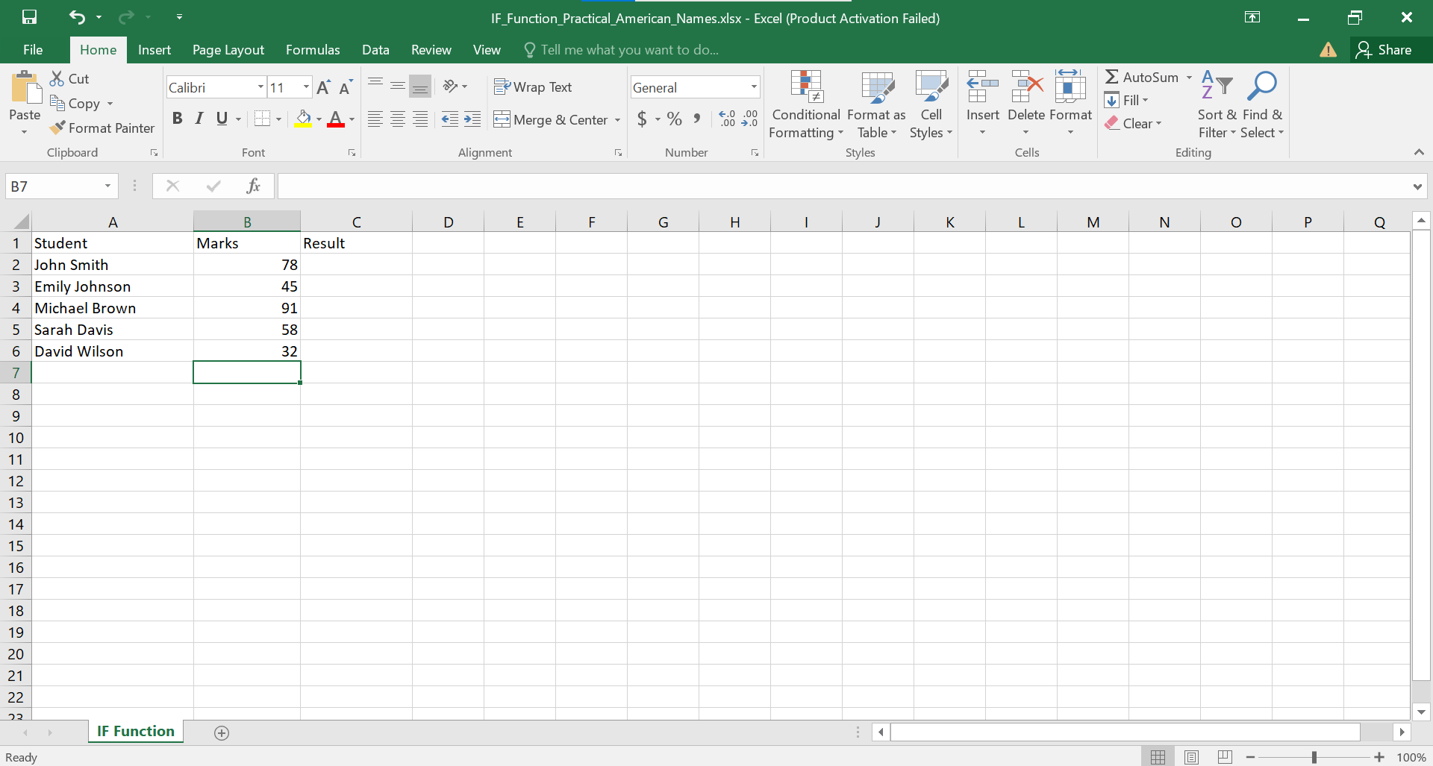
Figure 6: Student Marks Dataset in Microsoft Excel
Step 2 — Using the IF Function. Cell C2 was given the formula =IF(B2>=50,"Pass","Fail") and the formula was pasted down to row 6. It has three arguments: a logical test, a value to be returned if the logical test is true and a value to be returned if the logical test is false; text is enclosed in quotation marks as required by Excel. This is because B2 is a relative reference, so when it is filled downwards it becomes B3, B4 etc. and each row is judged according to its own mark. The formula in the cell is shown in the formula bar of Figure 7.
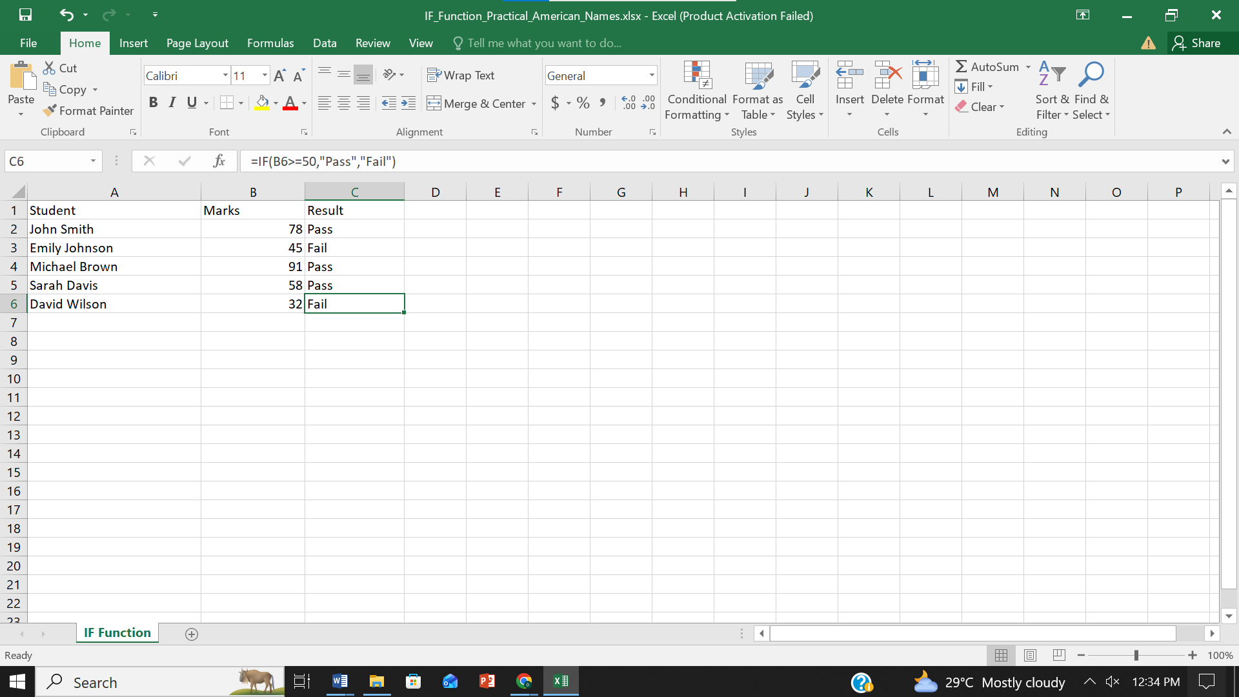
Figure 7: Applying the IF Function to Determine Pass and Fail Results
Evaluation. The results were accurate in all cases, and the effect of the boundary condition was correct. What matters is the greater than or equal to operator, not just the greater than because it is important to know that if a learner got 50 of the 100 marks, they would also fail the test - which is not what we would want. The broad advantage is that all the records are consistent.
There are two restrictions that should be commented on. This is not good practice in a larger model as the pass mark is built into the formula and should be set in a separate cell and referenced so that the rule can be altered in one place. This two-outcome structure can also be used for a binary decision but is not easily extensible to graded classifications – in this case, it is easier to use an IFS or a look-up table than to nest IF functions [11].

Task 4. Communication and Collaboration applications
Communication and collaboration applications are used for information sharing and collaboration. The difference is one of emphasis: a communication tool is a vehicle that is used to send a message to one or more recipients while a collaboration tool is a tool used for several to collaborate, often in real time. Gmail is used here as a communication app, and Google Meet as a collaboration app.
Note that the practical evidence in Section 4.2 was created using Google Meet and not Zoom and the analysis in Section 4.1 has been aligned accordingly to ensure the tool discussed and tool tested are the same.

4.1 One contemporary Communication and one Online Collaboration

Gmail


Gmail is a Web-based e-mail service offered by Google that is free and part of Google Workspace. Email is the most prevalent method of formal business communication because it is not synchronous, can be used by anyone regardless of email provider, and is self-documenting since the message and the thread document what's been said and when.
Some of its most important functions consist of conversation threading, search operators, labels and filters (which will be activated on the arrival of messages), spam protection and confidential mode. Google documents the latter as protecting sensitive information, letting the sender set an expiration date or revoke access, with forwarding, copying and downloading disabled [17]. But it's clear that this doesn't prevent the recipient from taking a photo of the message [17] another thing for a recipient to watch out for, as end-to-end protection is often confused with this feature.
Cloud access means you can access your mail from any device, and search and effectively unlimited retention means that email isn't a queue but a searchable organisational archive.
E-mail is still an inadequate tool for quickly discussing a topic, and excessive use results in full inboxes where e-mail messages get lost. There are also data protection concerns when storing correspondence on a third-party service and the free version won't provide quite as much administrative control as Workspace.

Google Meet


Google Meet is Google's video conferencing service, available in browser and mobile apps, for video conferencing with dispersed participants, team meetings, client video calls and remote training.
Its main features are no installation required, joining via browser, on-demand and scheduled links (via Google Calendar), screen sharing, chat, live captioning, and recording (for the paid versions). According to Google, one can start a meeting for free and up to 100 people can join, and the time can last up to an hour any Google user with an account can create a meeting. Host controls include asking for permission before a participant can join [19].
The advantages include immediate and easy accessibility. No client software is needed – anyone can join through a link in seconds; screen sharing can be used so that a document can be read together instead of having to read out. Not to mention, meeting without travel is also cost-effective and time efficient.
The sixty-minute limit for meetings, however, still hinders longer meetings as a free group, while the more advanced governance tools require a subscription. Quality is also affected by the links of participants, which the organizer has no control over.

4.2 Test one feature of a freely available Communication (1) and one feature of a Collaboration (1) application

Gmail
The feature tested was the composition and sending of an email message.
Step 1 — Composing the message. Compose was selected and the window that appears in figure 8 is opened. A fake address was given and the subject line 'Assignment Practice' was provided and typed content was provided in the body. The window also displays the formatting toolbar (as well as the Attachments and Confidential Mode controls). The subject line is a serious business as it is the key to the recipients' inbox and the key to his or her later retrieval of the message.
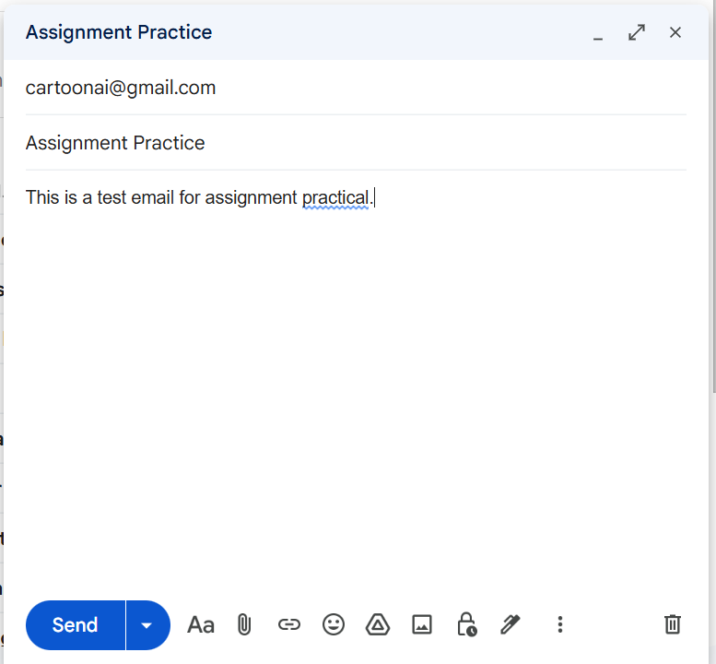
Figure 8: Composing an Email in Gmail
Step 2 — Confirming delivery. The message was sent and confirmed as follows: Open message in recipient inbox (Figure 9) to check that subject, sender, recipient and message text have not been altered from that composed in the original message, and to see the Reply and Forward controls. It's worth confirming that it was received as a message sent isn't guaranteed to be delivered.

Figure 9: Successfully Sending an Email
Evaluation. The basic send/receive loop was solid, and the Reply and Forward buttons provide an example of the threading model used in email to make it self-documenting. Only very basic sending was made use of, the features that distinguish Gmail are organizationally would require a Workspace account.

Google Meet
The feature tested was the creation of a new meeting and generation of a shareable link.
Step 1 — Initiating a new meeting. Google Meet home page opened when signed in to a Google account. The user interface is displayed in Figure 10: a field for an existing code and a New button, and a calendar strip with the day's meeting, which in this case were none. The New button provides a meeting to be used later, instant meeting or meeting in Calendar; the instant was picked [19].
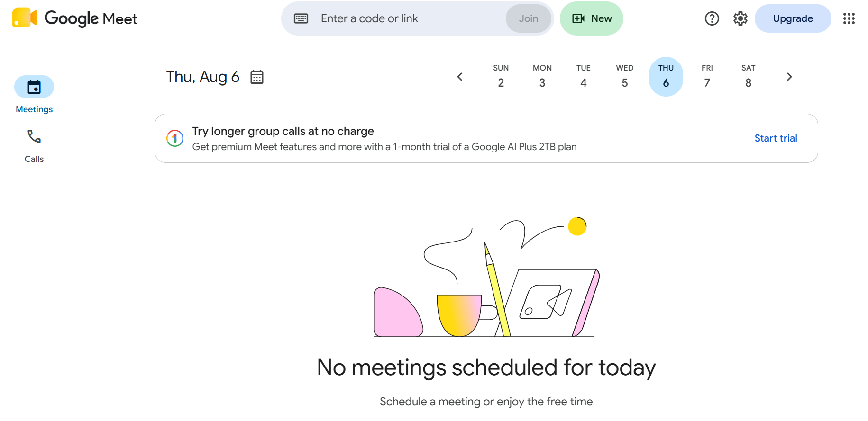
Figure 10: Creating a New Meeting in Google Meet
Step 2 — Obtaining the meeting link. The meeting started instantly and Meet showed a 'Your meeting's ready' panel with the created link as displayed in the Fig. 11. The panel offers the Add others button and a copy control, and says that people using the link have to be given permission from the host to join.
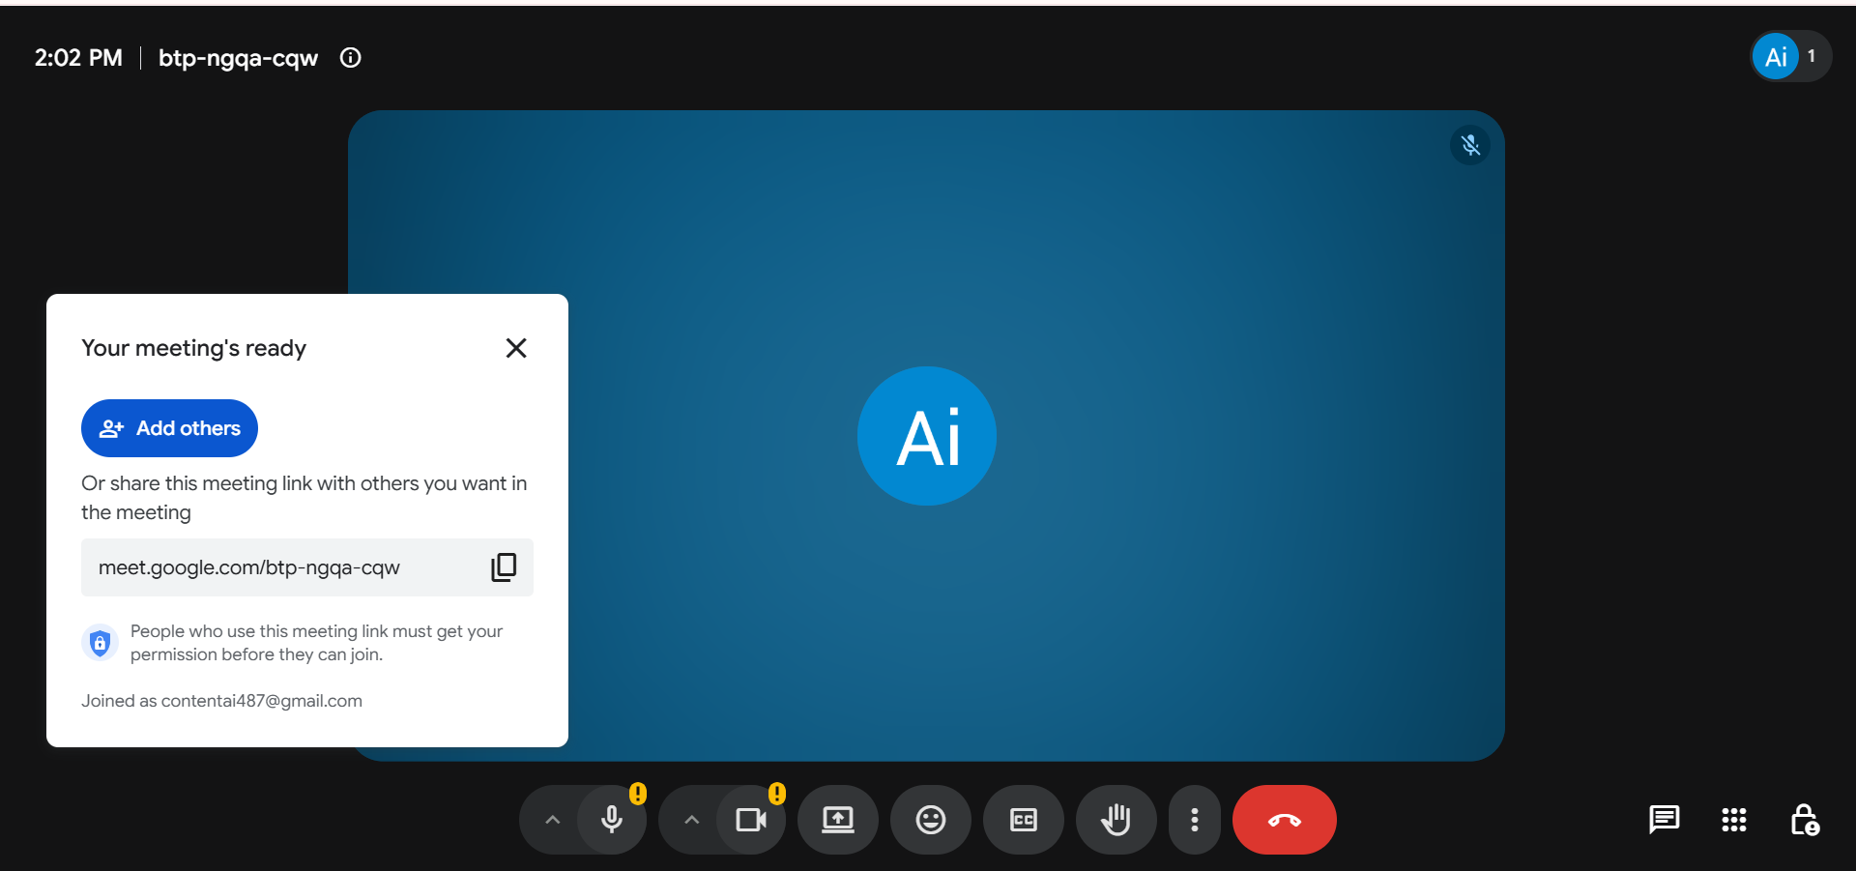
Figure 11: Google Meet Meeting Link Generated Successfully
Evaluation. The usable meeting was created, and a link was obtained in seconds, without installing and without a scheduling step, so there is no need to create a separate meeting for an ad hoc discussion. Admission control is a proper security feature since it will not allow an uninvited person with the link to join unannounced, but it requires the host to check for joining requests.

Conclusion
This report covers four areas of the current business software and tests some of the features of each. Task 1 concluded that Wix serves more as a business model that is designed to be more about brand and less about online sales, while Shopify is more about commerce and sales as the main process. Task 2 introduced mind mapping, indicated that evidence of its usefulness is supporting but qualified [7] and created a mind map to illustrate the interdependence of the categories of software.
Task 3 explored Word, Excel, PowerPoint and Access and testing created a Mail Merge and using the IF function. The same concept was proved in both tests: the value is to substitute a manual judgement repeated many times with a rule that is once-and-finished. Both also revealed the same weakness: Automation disseminates the quality of its inputs. Task 4 examined Gmail and Google Meet, which turn out to be frictionless, with features that are important for governance behind the paywall.
Three conclusions follow. Firstly, software selection should be based on the operation process to be supported, and not on a comparison of features in an abstract way [1]. Second, the value of automation can only be seen in the areas where data is well maintained; otherwise, data quality is a prerequisite, and not an add-on or an optional feature. Third, all the applications analyzed have limitations that are often not apparent when purchasing -- Access cannot be used concurrently by multiple enterprises, spreadsheets are inherently susceptible to error, and confidential mode is not truly confidential, and free-tier conferencing is time-limited. It is essential to understand these limitations as well as the features themselves.

References
[1] K. C. Laudon and J. P. Laudon, Management Information Systems: Managing the Digital Firm, 17th ed., Global Edition. Harlow, U.K.: Pearson Education, 2021.
[2] Wix.com Ltd., "eCommerce website builder: Build an eCommerce site." [Online]. Available: https://www.wix.com/ecommerce/website. [Accessed: 03-Aug-2026].
[3] Wix.com Ltd., "Wix Stores: An overview of store features," Wix Help Center. [Online].Available: https://support.wix.com/en/article/wix-stores-an-overview-of-store-features. [Accessed: 04-Aug-2026].
[4] Shopify Inc., "What is Shopify?" [Online]. Available: https://www.shopify.com/what-is-shopify. [Accessed: 03-Aug-2026].
[5] Shopify Inc., "Shopify pricing: Find the right plan for your business." [Online]. Available: https://www.shopify.com/pricing. [Accessed: 03-Aug-2026].
[6] T. Buzan and B. Buzan, The Mind Map Book: Unlock Your Creativity, Boost Your Memory, Change Your Life. Harlow, U.K.: BBC Active / Pearson Education, 2010.
[7] P. Farrand, F. Hussain, and E. Hennessy, "The efficacy of the 'mind map' study technique," Medical Education, vol. 36, no. 5, pp. 426-431, May 2002. doi: 10.1046/j.1365-2923.2002.01205.x.
[8] Microsoft Corporation, "Use mail merge for bulk email, letters, labels, and envelopes," Microsoft Support. [Online]. Available: https://support.microsoft.com/en-us/office/use-mail-merge-for-bulk-email-letters-labels-and-envelopes-f488ed5b-b849-4c11-9cff-932c49474705. [Accessed: 06-Aug-2026].
[9] Microsoft Corporation, "Excel functions (by category)," Microsoft Support. [Online]. Available: https://support.microsoft.com/en-us/excel/excel-functions-by-category. [Accessed: 04-Aug-2026].
[10] Microsoft Corporation, "IF function," Microsoft Support. [Online]. Available: https://support.microsoft.com/en-us/excel/functions/if-function. [Accessed: 05-Aug-2026].
[11] Microsoft Corporation, "IF function - nested formulas and avoiding pitfalls," Microsoft Support. [Online]. Available: https://support.microsoft.com/en-us/excel/if-function-nested-formulas-and-avoiding-pitfalls. [Accessed: 07-Aug-2026].
[12] Microsoft Corporation, "PowerPoint help & learning," Microsoft Support. [Online]. Available: https://support.microsoft.com/en-us/powerpoint. [Accessed: 05-Aug-2026].
[13] Microsoft Corporation, "Quick tips: Share and collaborate with PowerPoint," Microsoft Support. [Online]. Available: https://support.microsoft.com/en-us/office/quick-tips-share-and-collaborate-with-powerpoint-1b9a8796-173d-4aff-84f6-e71b49fcfc9d. [Accessed: 06-Aug-2026].
[14] Microsoft Corporation, "Database basics," Microsoft Support. [Online]. Available: https://support.microsoft.com/en-us/office/database-basics-a849ac16-07c7-4a31-9948-3c8c94a7c204. [Accessed: 03-Aug-2026].
[15] Microsoft Corporation, "Introduction to Access programming," Microsoft Support. [Online]. Available: https://support.microsoft.com/en-us/office/introduction-to-access-programming-92eb616b-3204-4121-9277-70649e33be4f. [Accessed: 04-Aug-2026].
[16] Microsoft Corporation, "Mail merge using an Excel spreadsheet," Microsoft Support. [Online]. Available: https://support.microsoft.com/en-us/office/mail-merge-using-an-excel-spreadsheet-858c7d7f-5cc0-4ba1-9a7b-0a948fa3d7d3. [Accessed: 05-Aug-2026].
[17] Google LLC, "Send & open confidential emails," Gmail Help. [Online]. Available: https://support.google.com/mail/answer/7674059. [Accessed: 06-Aug-2026].
[18] Google LLC, "Google Meet: Online web and video conferencing calls," Google Workspace. [Online]. Available: https://meet.google.com/. [Accessed: 03-Aug-2026].
[19] Google LLC, "Start or schedule a Google Meet video meeting," Google Meet Help. [Online]. Available: https://support.google.com/meet/answer/9302870. [Accessed: 04-Aug-2026].

