Understanding Type 2 Diabetes: Blood Glucose Regulation, Cellular Metabolism, Monitoring and Lifestyle Management

Student Name: Anila Mansoor
Stuent id: 2433628
Module Name: introduction physiology
Module code: bnhp5023
Lecturer name: Gillian Waver
Assignment Title: Component 1
Written assignment case study report

Table of Contents
Introduction 1
Blood Glucose Regulation 2
Cellular Metabolism and Energy Production 3
Importance of Monitoring Blood Glucose 4
Evidence-Based Lifestyle Recommendations 5
Conclusion 6
Reference list 8

Table of Figures
Figure 1 Blood Glucose Trends Over Four Weeks in Well-Controlled and Poorly Controlled Diabetes 6

Introduction
Diabetes mellitus is a chronic metabolic condition in which the blood glucose level is higher than it should be, either because there is a problem with insulin production or it has an effect that is weaker than it should be, or there is a combination of both (Nadhiya J, Vijayalakshmi M.K and Showbharnikhaa S, 2024). Among the different forms of diabetes, Type 2 diabetes mellitus (T2DM) is the most common, accounting for the majority of diabetes cases worldwide (Nanda et al., 2022). In Type 2 diabetes, the insulin-producing cells remain intact, and insulin resistance is a key factor, unlike Type 1 diabetes where the insulin-producing cells are destroyed by an autoimmune process (Accili, Deng and Liu, 2025).
Diabetes mellitus type 2 is an emerging public health problem with implications for long-term complications. Complications of these include heart disease, kidney disease, neuropathy, vision problems and health problems (Fragoso, Borges and Ramos, 2024). The increasing obesity and sedentary lifestyles around the world have played a significant role in the burden of disease.
There are several risk factors for Type 2 diabetes. These include obesity, genetic risk, age, lack of exercise and smoking (Kim et al., 2024). Other risk factors may include poor nutrition and overuse of alcohol.
A knowledge of how blood glucose is regulated and physiological processes related to energy metabolism is essential for the management of Type 2 diabetes. Blood sugar monitoring and lifestyle changes are important components in managing the disease and preventing complications (Osunde et al., 2025) People with Type 2 diabetes can better manage their blood sugar levels and achieve good health and wellbeing by using the right self-management and evidence-based interventions.

Blood Glucose Regulation
Glucose is the major source of energy for the body and it is necessary for the proper functioning of cells, tissues and organs (Hantzidiamantis, Lappin and Awosika, 2024). It comes from food carbohydrates and is carried in the blood to the cells where it is used to generate energy. The body regulates the blood glucose level within a fairly narrow range, which is a process called homeostasis.
A major function of the pancreas is to help maintain blood glucose levels (Karpińska and Czauderna, 2022). It is located behind the stomach and has special groups of cells, called the islets of Langerhans. Beta cells produce insulin and alpha cells produce glucagon in these islets. These hormones combine to keep blood glucose at an appropriate level (Nicolai et al., 2023).
When the blood glucose level rises, as after meals, the beta cells secrete insulin. It mainly helps to move glucose from the blood into body cells, particularly muscle and fat cells. Insulin also helps to store extra glucose in liver and muscle as glycogen. Insulin increases the uptake and storage of glucose and decreases blood glucose levels, which helps maintain the balance of the body (Bhavya and Sanjay, 2022).
Food Intake
↓
Blood Glucose Increases
↓
Pancreas Releases Insulin
↓
Glucose Enters Cells
↓
Blood Glucose Returns to Normal
Glucagon has an opposite effect. If blood glucose becomes low, alpha cells secrete glucagon into the blood. Glucagon causes liver glycogen to be converted to glucose and released into the blood (Hædersdal et al., 2023). It too encourages the formation of glucose by gluconeogenesis. These activities raise blood glucose and maintain a steady flow of energy during fasting or when there is a high need for energy.
Blood Glucose Falls
↓
Pancreas Releases Glucagon
↓
Liver Releases Stored Glucose
↓
Blood Glucose Returns to Normal
Insulin and glucagon act antagonistically in regulating blood glucose levels in healthy people. Insulin is released more and glucagon less after a meal. Glucagon increases and insulin decreases during fasting. This organized response helps to maintain normal blood glucose levels.
This regulatory system is however impaired in type 2 diabetes as a result of insulin resistance. Insulin resistance happens when body cells aren't able to respond as well to insulin. Therefore, the rate of glucose uptake by cells slows down and glucose levels rise in the blood. In the initial period, the pancreas makes more insulin in an attempt to make up for the loss. However, as time goes on, the pancreatic beta cells can no longer keep up with the demand and are unable to produce enough insulin.
Insulin resistance leads to chronic hyperglycaemia, reduced glucose utilization and the risk of diabetes-related complications (Arvind Singh Jadon et al., 2024). Chronic high blood glucose levels can damage blood vessels, nerves and organs throughout the body. Hence, knowledge of blood glucose regulation is vital to understanding the pathophysiology and management of Type 2 diabetes.

Cellular Metabolism and Energy Production
Cellular metabolism is the sum of biochemical pathways involved in the uptake and use of energy by cells. Cellular respiration is one of the most critical metabolic pathways that breaks down glucose to release energy as adenosine triphosphate (ATP) (Biro, 2022).
Glucose enters cells via specialised transport proteins in the cell membrane. Insulin promotes the movement of glucose transporters to the cell surface in many tissues, which leads to efficient uptake of glucose. Glucose enters the cell and enters into a series of metabolic reactions starting with glycolysis in the cytoplasm.
During aerobic respiration, glucose is broken down in the presence of oxygen. After glycolysis, metabolic intermediates go into the mitochondria where the Krebs cycle and electron transport chain take place. The end electron acceptor in the electron transport chain is oxygen which allows for the production of ATP efficiently. If oxygen is not present, cells need to use the less efficient anaerobic pathway that produces much less ATP (Glass, Elbon and Williams, 2022).
ATP can be called the energy currency of the cell as it is involved in many physiological processes. These involve muscular contraction, nerve impulse transmission, protein synthesis, active transport and cell repair. This is why sufficient ATP generation is crucial for proper body function and health.
In Type 2 diabetes, the impaired glucose control may cause cells to be unable to use glucose for energy. Glucose can be present in the blood but is not taken up properly by cells. As a result, the cells can have high blood sugar and low energy level. Chronic hyperglycaemia can also cause damage to mitochondria, which decreases the efficiency of metabolism even more (González et al., 2023).
Disruption of normal glucose metabolism leads to fatigue, decreased physical performance and eventual tissue damage. Good glycaemic control restores normal cellular metabolism, enhances energy production and optimal physiological function.

Importance of Monitoring Blood Glucose
One of the key elements of Type 2 diabetes is blood sugar monitoring (Pleus et al., 2022). It offers useful information about the body's ability to control blood sugar levels, and can help people make decisions about diet, exercise, and medications.
Most blood glucose testing involves obtaining a reading from a hand-held blood glucose monitoring device. A blood sample is drawn from a finger and tested for immediate feedback of the current level of glucose. Frequent testing allows people to detect changes and see the effect of lifestyle on glycaemic control.
One of the other key monitoring tools is a glycated haemoglobin (HbA1c) test (Gomez‐Peralta et al., 2022). HbA1c is a measure of the percentage of haemoglobin molecules that contain glucose, giving an idea of average blood sugar over the past 2-3 months. The HbA1c test is used to assess glucose control over time and is helpful to determine how effective treatment is, as opposed to single blood glucose measurements.
Time-series analysis is a specialised method that may be especially useful in diabetes management. Multiple measurements enable healthcare providers and patients to detect trends, track improvements, and adjust treatment if needed. For instance, readings that stay high may suggest dietary changes, higher exercise or adjustments in medications.
Regular monitoring also prevents complications of diabetes. Early recognition of poor glycaemic control helps to be able to intervene before significant damage is done. Stabilizing glucose levels can lower the risk of cardiovascular disease, kidney dysfunction, neuropathy and vision impairment.
Moreover, monitoring helps patients to take an active role in their care. People become more informed about themselves and can assess how well lifestyle changes and drugs are working. Therefore, blood glucose testing is still an essential tool to enhance health outcomes and aid in long-term diabetes management.
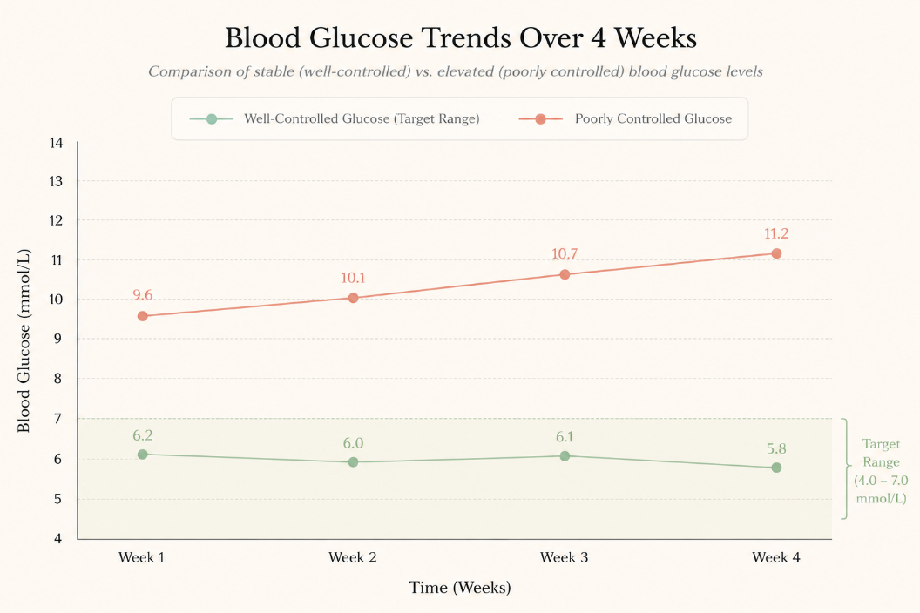
Figure 1 Blood Glucose Trends Over Four Weeks in Well-Controlled and Poorly Controlled Diabetes

Evidence-Based Lifestyle Recommendations
Lifestyle changes are a key component of Type 2 diabetes prevention and management. The consistent evidence of the health benefits of healthy lifestyle behaviours is that it significantly improves glycaemic control, decreases complications and improves health (Osunde et al., 2025b).
It's important to have a balanced diet to keep blood glucose levels stable. People should eat a diverse diet rich in whole grain foods, fruits and vegetables, lean protein and good fats. These foods are high in nutrients and help to slow glucose release and prevent blood sugar spikes.
The consumption of refined sugars and excess saturated fats have to be reduced especially. Glycemic foods can lead to a quick rise in blood sugar, and a high intake of saturated fats can increase the risk of cardiovascular diseases and obesity. This switch helps maintain a healthy metabolism and reduces the risk of developing diabetes.
Weight management plays a crucial role in diabetes management (Kurtzhals, Flindt Kreiner and Singh Bindra, 2023). Too much body fat, especially around the abdomen, greatly adds to insulin resistance. Any amount of weight loss can help to improve insulin sensitivity, lower blood glucose and decrease the need for medications. So it's crucial to keep the body weight at a healthy level.
Exercise promotes glucose uptake by cells in the skeletal muscle, and increases the insulin sensitivity (Richter, Bilan and Klip, 2025). Walking, cycling, swimming and resistance training can help to enhance cardiovascular fitness and aid weight management. Regular exercise has been linked to improved glycaemic control and decreased diabetes-related complications.
Smoking cessation is strongly recommended as smoking raises insulin resistance and is a risk factor for cardiovascular disease (Rouland et al., 2024). People who quit smoking may find that their health improves overall and that they have a lower risk of diabetes complications.
Alcohol restriction also is good. Too much alcohol can disrupt your blood sugar levels, lead to weight gain and raise your risk for other health issues. If appropriate, moderate use helps maintain healthy metabolisms.
Stress management is also a crucial part of diabetes management. Hormones like cortisol are released during chronic stress, increasing blood sugar (Sharma et al., 2022). Mindfulness and relaxation strategies and social support are helpful diabetes management techniques for reducing stress.
Good sleep is also important. Less than optimal sleep and inadequate sleep are linked to higher insulin resistance and glucose intolerance. Maintain regular sleeping patterns and sleep hygiene may help to achieve better glycaemic control.
These are all evidence-based recommendations for lifestyle changes that will help to maintain good blood sugar control, improve insulin sensitivity and decrease the complications by Type 2 diabetes.

Conclusion
Type 2 diabetes is a multi-factorial metabolic disease that involves a decreased ability to regulate blood glucose levels due to insulin resistance and decreased insulin sensory activity. The maintenance of glucose homeostasis is vital for ensuring normal physiological function and adequate energy production by cells. Changes in these processes lead to long-term hyperglycemia and an elevated risk of potential health problems.
The mechanisms governing the regulation of glucose and cellular metabolism, as understood in physiology, offers important clues to disease pathogenesis and treatment. Monitoring via blood glucose testing and hemoglobin A1c (HbA1C) enables the patient and the healthcare provider to evaluate the effectiveness of treatment and make informed decisions about management.
Good nutrition, healthy eating, regular exercise, weight control, quitting smoking, reducing alcohol use, avoiding or minimizing stress, and getting adequate rest continue to be key elements of good diabetes management. With knowledge of self and continued self monitoring, people with Type 2 diabetes can have better glycaemic control, lower level of complications and a higher quality of life.

Reference list
Accili, D., Deng, Z. and Liu, Q. (2025). Insulin resistance in type 2 diabetes mellitus. Nature reviews. Endocrinology, [online] pp.10.1038/s41574-02501114-y. doi:https://doi.org/10.1038/s41574-025-01114-y.
Arvind Singh Jadon, Mahabir Parshad Kaushik, Kuttiappan Anitha, Bhatt, S., Poonam Bhadauriya and Sharma, M. (2024). Types of diabetes mellitus, mechanism of insulin resistance and associated complications. Elsevier eBooks, pp.1–18. doi:https://doi.org/10.1016/b978-0-443-13195-0.00001-6.
Bhavya, E. and Sanjay, G. (2022). Diabetes and the importance of insulin. International journal of health sciences, pp.8479–8487. doi:https://doi.org/10.53730/ijhs.v6ns1.6844.
Biro, G.P. (2022). Oxygen and ATP: the Energy Economy of the Cell. Blood Substitutes and Oxygen Biotherapeutics, pp.21–32. doi:https://doi.org/10.1007/978-3-030-95975-3_2.
Fragoso, V., Borges, W.R. and Ramos, P. (2024). The Main Diseases Related to Type 2 Diabetes Mellitus: A Scoping Review. Scientia. Technology, science and society., [online] 1(2), pp.17–27. doi:https://doi.org/10.59324/stss.2024.1(2).02.
Glass, J.B., Elbon, C.E. and Williams, L.D. (2022). Something old, something new, something borrowed, something blue: the anaerobic microbial ancestry of aerobic respiration. Trends in Microbiology. doi:https://doi.org/10.1016/j.tim.2022.08.006.
Gomez‐Peralta, F., Choudhary, P., Cosson, E., Irace, C., Rami‐Merhar, B. and Seibold, A. (2022). Understanding the clinical implications of differences between GMI and HbA1c. Diabetes, Obesity and Metabolism, 24(4). doi:https://doi.org/10.1111/dom.14638.
González, P., Lozano, P., Ros, G. and Solano, F. (2023). Hyperglycemia and Oxidative Stress: An Integral, Updated and Critical Overview of Their Metabolic Interconnections. Hyperglycemia and Oxidative Stress: An Integral, Updated and Critical Overview of Their Metabolic Interconnections, [online] 24(11), pp.9352–9352. doi:https://doi.org/10.3390/ijms24119352.
Hædersdal, S., Andersen, A., Knop, F.K. and Vilsbøll, T. (2023). Revisiting the role of glucagon in health, diabetes mellitus and other metabolic diseases. Nature Reviews Endocrinology, [online] 19(6), pp.321–335. doi:https://doi.org/10.1038/s41574-023-00817-4.
Hantzidiamantis, P.J., Lappin, S.L. and Awosika, A.O. (2024). Physiology, glucose. [online] PubMed. Available at: https://www.ncbi.nlm.nih.gov/books/NBK545201/.
Karpińska, M. and Czauderna, M. (2022). Pancreas—Its Functions, Disorders, and Physiological Impact on the Mammals’ Organism. Frontiers in Physiology, [online] 13(807632). doi:https://doi.org/10.3389/fphys.2022.807632.
Kim, M.S., Shim, I., Fahed, A.C., Do, R., Park, W.-Y., Natarajan, P., Khera, A.V. and Won, H.-H. (2024). Association of genetic risk, lifestyle, and their interaction with obesity and obesity-related morbidities. Cell Metabolism, [online] 36(7), pp.1494-1503.e3. doi:https://doi.org/10.1016/j.cmet.2024.06.004.
Kurtzhals, P., Flindt Kreiner, F. and Singh Bindra, R. (2023). The role of weight control in the management of type 2 diabetes mellitus: Perspectives on semaglutide. Diabetes Research and Clinical Practice, [online] 203, p.110881. doi:https://doi.org/10.1016/j.diabres.2023.110881.
Nadhiya J, Vijayalakshmi M.K and Showbharnikhaa S (2024). A Brief Review on Diabetes Mellitus: Short Communication. Journal of Pharma Insights and Research, [online] 2(1), pp.117–121. Available at: http://jopir.in/index.php/journals/article/view/89.
Nanda, M., Sharma, R., Mubarik, S., Aashima, A. and Zhang, K. (2022). Type-2 Diabetes Mellitus (T2DM): Spatial-temporal Patterns of Incidence, Mortality and Attributable Risk Factors from 1990 to 2019 among 21 World Regions. Endocrine, 77(3), pp.444–454. doi:https://doi.org/10.1007/s12020-022-03125-5.
Nicolai, Holst, J.J., Cherrington, A.D., Finan, B., Lise Lotte Gluud, E. Danielle Dean, Campbell, J.E., Bloom, S.R., Tan, T., Knop, F.K. and Timo Müller (2023). 100 years of glucagon and 100 more. Diabetologia, 66(8), pp.1378–1394. doi:https://doi.org/10.1007/s00125-023-05947-y.
Osunde, R.N., Olaolorunpo Olorunfemi, Edwards, O.S., Oduyemi, R.O. and Jaminat Omotade Sodimu (2025a). Transforming Diabetes Management: Optimizing Blood Glucose Control through Lifestyle Strategies for Better Health Outcomes – Scoping Review. Bangladesh Journal of Endocrinology and Metabolism, [online] 4(1), pp.18–25. doi:https://doi.org/10.4103/bjem.bjem_19_24.
Osunde, R.N., Olaolorunpo Olorunfemi, Edwards, O.S., Oduyemi, R.O. and Jaminat Omotade Sodimu (2025b). Transforming Diabetes Management: Optimizing Blood Glucose Control through Lifestyle Strategies for Better Health Outcomes – Scoping Review. Bangladesh Journal of Endocrinology and Metabolism, [online] 4(1), pp.18–25. doi:https://doi.org/10.4103/bjem.bjem_19_24.
Pleus, S., Freckmann, G., Schauer, S., Heinemann, L., Ziegler, R., Ji, L., Mohan, V., Calliari, L.E. and Hinzmann, R. (2022). Self-Monitoring of Blood Glucose as an Integral Part in the Management of People with Type 2 Diabetes Mellitus. Diabetes Therapy, 13(5), pp.829–846. doi:https://doi.org/10.1007/s13300-022-01254-8.
Richter, E.A., Bilan, P.J. and Klip, A. (2025). A Comprehensive View of Muscle Glucose Uptake: Regulation by Insulin, Contractile Activity and Exercise. Physiological reviews, [online] p.10.1152/physrev.00033.2024. doi:https://doi.org/10.1152/physrev.00033.2024.
Rouland, A., Philippe Thuillier, Abdallah Al-Salameh, Farid Benzerouk, Thibault Bahougne, Blandine Tramunt, Berlin, I., Clair, C., Thomas, D., Anne-Laurence Le Faou, Vergès, B. and Durlach, V. (2024). Smoking and diabetes. Annales d Endocrinologie, [online] 85(6). doi:https://doi.org/10.1016/j.ando.2024.08.001.
Sharma, K., Akre, S., Chakole, S. and Wanjari, M.B. (2022). Stress-Induced diabetes: A review. Cureus, [online] 14(9), p.e29142. doi:https://doi.org/10.7759/cureus.29142.

