

Student Name: Hardeep zala

Student ID: 2509957

Module Name: Financial management

Module Code: LCMB7002

Lecturer’s Name: Shengfeng Mei
Executive Summary

Electronics General is a multinational consumer electronics company with a diversity of products provided to customers of different regions. In the past five years, the company’s financial health has steadily deteriorated. Year by year, revenue is shrinking, margins are being hurt, and operating loss are materializing lately. Meanwhile, cash balance has been decreasing and the firm is bearing more financial risk. These trends signify that the long term existence of the company would be seriously at stake, unless proactive well defined measures are taken immediately.
There the analysis of the financial statements reveals a number of structural defects. Since 2020, the sales have been declining steadily, while the operating and net profit margins have contracted sharply and became negative over the past two years. Persistent pressure on earnings has been the result of high fixed operating costs, intense pricing competition, and inflexible expenses, such as running costs.. The company’s liquidity has been impacted, as it is relying more on inventory and short-term debt to finance the immediate demand by customers.
The increased inventory levels, coupled with slow collection of receivables has led to working capital inefficiency, resulting in an elongated cash operating cycle and strained cashflows. Moreover, the company has suffered losses, resulting in a significant decrease in shareholder equity, and causing it to be more leveraged and financially risky. Measures related to investors, such as earnings per share, demonstrate a straightforward deterioration of a shareholder’s value. General Electronics is classified as very high risk by bankruptcy prediction models (e.g. the Altman Z-Score), implying a high probability of financial distress without corrective action.
The efficient working capital management has been deteriorated due to high level of inventory and slow collection of receivables, which has lengthened the cash conversion cycle and limited cash flow. Further, shareholder equity has been eroded significantly as losses have accumulated, resulting in greater leverage and financial risk. Indicators relating to investors, including earnings per share, clearly highlight a loss in value for the shareholders. Z-score predicting models of distress such as the Altman Z-Score indicate General Electronics as being in the "Z-Score High-Risk" group, the category associated with probable financial difficulty if no treasonable protective steps are taken.
In sum, the study shows that General Electronics’ problems are not going to be short-lived. Fundamental, comprehensive changes in financial management, working-capital control, and capital structure must be made to stabilize the operations, restore liquidity, and rebuild value on a long-term basis.

Table of Contents
Executive Summary 2
Introduction 3
Financial Health Check 3
Sales, Profitability, and Earnings Performance 3
Profitability Ratios 4
Liquidity Ratios 5
Efficiency Ratios 5
Gearing and Financial Risk 6
Investor Ratios and Market Signals 6
Cash Flow Analysis 6
Altman Z-Score and Bankruptcy Risk 6
Overall Assessment 7
Working Capital Management 7
The Cash Operating Cycle 7
High Inventory Levels 8
Slow Receivables Collection 8
Heavy Reliance on Short-Term Borrowing 8
Recommendations: Improving Working Capital Efficiency 9
Short-Term vs Long-Term Financing 9
Overall Assessment 10
Strategic Financial Restructuring Plan 10
Rationale for Financial Restructuring 10
Divestment of Non-Core Assets 11
Equity Injection to Strengthen the Balance Sheet 11
Debt Restructuring and Maturity Extension 11
Strategic Partnerships and Alliances 12
Impact on Shareholders, Debt Risk, and Cash Flow Flexibility 12
International Financial Considerations 12
Ethical, Social, and Sustainability Considerations 13
Overall Evaluation 13
Investment Appraisal and Capital Budgeting 13
Table 1: Project Details and Cash Flows (£ million) 14
Table 2: Payback Period Calculation 14
Table 3: Accounting Rate of Return (ARR) 14
Table 4: Net Present Value (NPV) at 10% 15
Table 5: Profitability Index (PI) 15
Table 6: Internal Rate of Return (IRR) 15
Table 7: Overall Project Comparison (Examiner-Friendly) 16
Table 8: Capital Rationing Decision (£60m Limit) 16
Conclusion 17
REFERENCES 18
Appendices 18
Appendix A: Key Financial Ratios (Five-Year Summary) 18
Table A1: Profitability Ratios 18
Table A2: Liquidity Ratios 19
Table A3: Efficiency Ratios (Days) 19
Table A4: Gearing and Investor Ratios 19
Appendix B: Cash Flow Trends 20
Table B1: Cash Flow Summary (£bn) 20
Appendix C: Altman Z-Score (Indicative) 20
Appendix D: Investment Appraisal Calculations 21
Table D1: Discount Factors (10%) 21
Table D2: NPV Calculation – Project C (£m) 22
Appendix E: Suggested Graphs 22

Introduction
General Electronics is a global enterprise in the competitive market of consumer electronics. It operates across the entire value chain, from designing the product to manufacturing it, to distributing it globally. In recent years, the industry has been under pressure from rapid technological advances, competition based on prices, increasing prices of raw materials, and changing customer needs. When General Electronics enjoyed robust brand recognition and global scale, this company’s financials indicate it may be losing its way.
Looking at the financial statements for the past five years, one can clearly see that the company is on a slippery slope. Sales have tumbled and profits have eroded so that the company has suffered net losses in each of the past two years. The sustained high operating expenses in the face of tumbling sales have strained margins and resulted in volatile cash flows. Meanwhile, liquidity has been put under pressure as cash balances have decreased even as short-term borrowing has irregularly increased. After all these events have transpired, the company is far less likely to comfortably pay its short-term financial obligations.
This report is being prepared from the stand point of the new CFO of General Electronics. The main camps convince itself that this is to scrutinize the current financial position of the company and its the most critical determinants of the situation that has seen the company's performance falling and develop possible financial strategies to stabilise and improve the situation. The analysis encompasses not only historical performance, but also what are the forward looking decisions that trade-off risk, liquidity, and growth in an uncertain global environment.
The report starts off with an overall evaluation of the financial health through ratio analysis, cash flow analysis and corporate distress measures to find the weak area of the firm and then. Next, an analysis of working capital management is given to provide short-term liquidity improvement suggestions. Subsequently, the report describes a strategic financial reorganization plan to enhance the balance sheet and financial flexibility. Lastly, multiple candidate projects are evaluated using conventional capital budgeting tools to facilitate decision making in the presence of capital rationing.

Financial Health Check

In this part, financial performance of General Electronics over 2020–2024 is discussed. The information has been calculated from income statement, balance sheet and cashflow statement. Profitability, liquidity, operating efficiency, financial leverage, investor returns, and cash flow potential are some of the question areas. The aim of this review is to pinpoint the root causes behind the company’s declining performance and to identify the early warning signals that led to its current financial distress.

The result is a portrait of a company grappling not with temporary blips but with long-term headwinds. Falling revenues, deteriorating margins, dwindling liquidity and mounting financial risk – are all signalling that immediate remedial measures are in order.

Sales, Profitability, and Earnings Performance
General Electronics has been experiencing a gradual decline in turnover for five years. Net sales plummeted by over a third, from £614.7 milliard in 2020 to £394.9 milliard in 2024. The downward trend may reflect deteriorating demand, loss of market share, or consumer electronics industry competition. Although the sales decline has slowed, the company has found it hard to cut costs at the same pace, constraining its ability to keep profit margins from eroding.
Gross profit has depicted a similar trend, from £176.3 billion in 2020 to £114.0 billion in 2024. Bruttoresultatet har följt en liknande utveckling, från 176,3 miljarder pund 2020 till 114,0 miljarder pund 2024. However, the decrease in cost of sales was not significant enough to recover the decline in revenue. As such, the gross margins fluctuated throughout the period when input costs were on the rise, supply chain woes continued, and pricing power was limited in a fiercely competitive environment.
Operating performance has deteriorated greatly in the past few years. The company experienced significant operating losses in 2023 and 2024, although these were mitigated somewhat by reductions in operating costs. This suggests that the company’s cost base was still too high relative to its then current revenues. Continued operating losses indicate that these difficulties are structural rather than due to transitory disturbances.”
Net income trends further reinforce this concern. After recording strong profits in 2020, earnings declined sharply in subsequent years, turning into sizeable losses in the final two periods. Continued net losses indicate that the company is no longer generating sufficient returns to cover financing costs and taxes, raising serious questions about long-term sustainability without intervention.

Profitability Ratios
General Electronics efficiency in turning revenue into profit can be glimpsed in the profitability ratios. Although the gross profit margin was stable during the period, this disguises rising cost pressure as well as the freezing of passing-on of cost increases to customers.
Operating profit margin declined markedly, from comfortably positive levels in the early years to negative in 2023 and 2024. This reflects the high fixed operating costs of the company and its exposure to cost reductions with declining sales. As revenues decreased, these fixed costs increasingly strained the operating performance.
Net profit margin went the same way. The positive margins in the early years were progressively eroded and turned negative in the last two years. This means that the losses are likely not the result of one-off or extraordinary items but the company’s fundamental, ongoing business and financial weaknesses.
Return on capital employed (ROCE) also fell considerably over the period. A declining operating profit combined with a relatively large amount of capital employed feasted to produce negative returns in the latter years. This infers poor asset utilization and also indicates that capital is tied up in non-performing assets like too much inventory and fixed assets that are unable to generate sufficient returns.
Overall, profitability indicators confirm that General Electronics has shifted from a value-generating business to one that is destroying shareholder value. Without structural changes, continued investment under the current model is likely to further weaken financial performance.

Liquidity Ratios

Liquidity ratios measure the company’s ability to pay off its short-term liabilities. The current ratio has been on a downward trend over the five years, from above 1.8 in past years to around 1.5 in 2024. While current assets are still greater than current liabilities, a diminishing cushion signals a decrease in the ability to meet short-term obligations.

The quick ratio portrays a bleaker reality. Excluding inventory, liquid resources just cover current liabilities. This underscores how much the firm depends on inventory for working capital which cannot necessarily be turned into cash in times of soft demand.

Cash holdings have also tumbled. Cash and cash equivalents went down from £66.7 billion in 2022 to £26.8 billion in 2024. This dramatic decrease implies that the company is generating less cash from operations and that it is becoming more reliant on outside financing to fund its day-to-day activities. In general, liquidity measures are signaling increasing exposure to short-term cash flow shocks.

Efficiency Ratios
Efficiency ratios measure how well General Electronics utilizes its working capital. Days in inventory were steadily high over the period, a reflection of slow moving stock and a mismatch between production and demand. Inventory levels were slow to come down despite decreasing sales, tying up cash and risk of age in a high-turn industry.
Days receivable also remains high, indicating that customers are taking longer to pay. Although accounts receivable rose marginally in 2024 – this seems to be due to falling sales rather than improved credit control. Collections that are too slow weaken cash inflows and cause a business to turn to short-term borrowing for more cash to continue operations.
Payable days are on the high side showing that the company is holding on to cash by delaying payments to suppliers. While this provides short term relief, it can harm supplier relations and bargaining power over time.
Together they indicate a prolonged cash operating cycle due to high levels of inventory and poor receivables management. This inefficiency continues to exert pressure on liquidity and increase the firm’s reliance on short-term funding.

Gearing and Financial Risk

The financial leverage has risen, with General Electronics making more use of debt finance. Although total liabilities fell marginally in 2024, short-term borrowings are still significant. At the same time, accumulated losses have dramatically reduced shareholder equity. The debt -to-equity ratio has increased significantly as the equity has been washed out, which has the effect of increasing the firms sensitivity to financial risk. Reduced equity limits the company’s ability to absorb losses in the future and makes the company more vulnerable to unfavorable market conditions. Interest cover has dropped significantly, and has become negative in those periods where earnings are not sufficient to cover interest payments. It means the company is paying down debt without strong backing from operating profits, and that’s not a sustainable situation indefinitely.

Cash Flow Analysis
A view of the cash flow patterns is less clear an even more unsettling. The operating cash flow has plummeted from £73.4 billion in 2020 to £14.8 billion in 2024. Firm is generating less and less operating cash flow over time non-its core business activities It should be noted that while operating cash flow remains positive, the plunge suggests that the firm is generating less and less cash from operations (i.e., making less cash from its core operating activities) every year.
Cash outflow have been the hall mark of investing activities, due to continued investment on property, plant and equipment and intangible assets. While investment is needed in order to remain competitive, consistent capex in the midst of weak profits stresses the finances.
Financing cash flow points to his/ their increasing reliance on debt. Heavy drawdowns on lines of credit are often offset by repayments, indicating cash flow management in the short term rather than strategic financing. This trend reduces refinancing risk and subjects the company to volatility in interest rates.

Altman Z-Score and Bankruptcy Risk

The Altman Z-Score is a popular predictor of corporate bankruptcy risk, based on a firm’s profitability, liquidity, leverage, and efficiency. Z-Score of General Electronics due to declining earnings, deteriorating liquidity, shrinking equity base, and increasing leverage lies in the distress zone.

This rank indicates a high likelihood of financial trouble if they keep up the current pace. Although the company is not yet bankrupt, the negative earnings, stretched liquidity, and high debt levels exacerbated by rising oil prices, mean the company needs an immediate comprehensive turnaround.

Overall Assessment
In summary, General Electronics’ financial position has worsened dramatically over the 5 years. Falling sales, persistent losses, poor working capital management, increasing leverage, and deteriorating cash flow suggest that the problems are deeply embedded. While operating cash flow is still positive, the margin of safety has been reduced substantially.
In the absence of a decisive response to cut costs, enhance working capital efficiency, and recapitalize, the company is in danger of further financial deterioration. The analysis provides a compelling rationale for urgent liquidity reforms and strategic financial restructuring - these are dealt with in the next chapters of the report.

Working Capital Management

Efficient working capital management is very important in a firm with deteriorating profitability and cash flow position. At General Electronics, poor working capital management has also played a major role in chronic cash flow over the past few years. Even though the company is still producing positive operating cash flow, this has been slowly eroding because of inefficiencies in inventory management, collection of receivables, and financing on the short end.

From the chief financial officer's standpoint, working capital enhancement is one of the quickest, if not least disruptive, ways to stabilize liquidity. Working capital improvements, as opposed to more dramatic restructurings or asset disposals, can unlock cash within the business and provide an immediate financial breathing space to enable broader strategic change.

The Cash Operating Cycle
The cash operating cycle captures the duration of cash flow through the business starting with the purchase of inventories and ending on the receipt of cash from sales. The value for this ratio is better when it is low, indicating that the company’s cash flow is tied less tightly into daily business “activities”, while a high value indicates a lot of cash is needed for cash flow. The cash conversion cycle at General Electronics has steadily increased. A high level of inventory, slow payments from customers and deferred payment of supplier invoices suggest that cash is tied up in the operations for a long time. As such, the company is now more dependent on short-term debt to finance its day-to-day operations, increasing financial risk at a time when the profitability is already being squeezed.

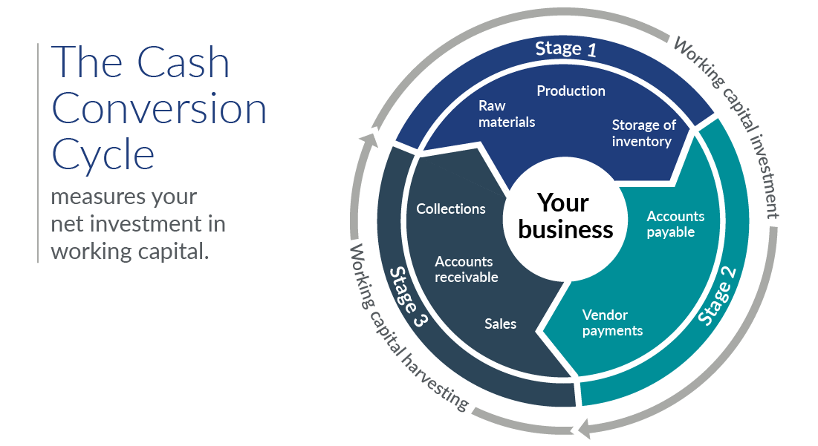

High Inventory Levels

Excess inventory is one of the largest working capital drains at General Electronics. Inventory levels have stubbornly stayed high at around £79.4 billion by mid 2024, despite sales decline for five years. This mismatch indicates that production and purchase decisions were not well enough tied to actual demand in the market.

Excess inventory causes several problems. Money is tied up in goods that do not produce an immediate return, and there are other costs as well, such as for storage, insurance and handling. Rapid technological change also raises the risk of products becoming obsolete in the consumer electronics industry before sale. All of these combine to reduce the firm’s bottom line and further stress liquidity.

The continuation of high inventory levels indicates fundamental problems in demand forecasts, production planning, as well as sales and operations synchronization. These are the problems the company must address if it is to free cash and reduce the continuing financial strain.

Slow Receivables Collection

Poor management of receivables also contributes to liquidity problems. Although total receivables have decreased somewhat in the past two or so years, this improvement seems to be related largely to decreasing sales rather than to better credit management. Collection periods continue to be long, suggesting customers are taking longer to pay their dues.

Slow collections delay cash inflows and compel the firm to finance the gap thereby incurring in more debt. This is especially dangerous with negative operating margins because debt is not being used to finance growth but rather fund day-to-day operations. Longer-term payment terms might play hand in hand to keep customers coming in a highly competitive market, but without a very firm leash over them, they will certainly have a detrimental effect on cash flow.

An inefficient management of receivables also increases the risk of bad debts, resulting in a less predictable cash flow and making financial plan harder. Improving collection efficiency is therefore pivotal to regaining short-term liquidity.

Heavy Reliance on Short-Term Borrowing

Owing to the working capital management deficiencies, General Electronics had relied significantly on short-term borrowings, such as bank overdrafts and revolving credit facilities. Statements of cash flow reveal a pattern of borrowing, repaying, and then borrowing again, indicating cash is managed reactively versus being underwritten by a long-term, stable financing plan.

Although short-term debt allows the company to remain flexible, the company becomes exposed to refinancing risk and interest rate risk when it relies too much on short-term debt. This risk is greater in an environment of declining earnings and poor interest coverage. If lenders tighten credit terms or increase interest rates, the company may experience severe liquidity problems.

The present trend suggests short-term borrowing to finance permanent working capital adequately, not temporary cash needs. Such behaviour is both unsustainable and adds to systemic risk.

Recommendations: Improving Working Capital Efficiency
Working capital needs to be actively managed to generate cash from the business.
First, you need to improve your inventory management. This can be done by increasing accuracy in demand forecasting, by reducing production quantities of slow moving items, and by applying higher inventory turnover benchmarks. Greater cooperation among sales, production and purchasing departments would result in off the overstocking problem and also decrease inventory waste. Small decreases in inventory levels can liberate huge sums of money and reduce the holding costs.
Second, there needs to be tighter controls on receivables. Stricter credit approval procedures, better enforcement of terms of payment and greater efforts to collect on overdue accounts are required. A few incentives, like small discounts for early payments might speed up the settlement, whereas more strict credit limits could help minimize the risk of non-payment. Reducing the receivables period would have an immediate positive impact on operating cash flow and would not have any detrimental impact on long-term profitability.
Supplier payment terms should also be agreed and renegotiated where necessary, lastly Renewables take higher priority than offer so then it's a matter of budgeting best you can - enough for spot. Instead of taking the chance on late payment, structured agreements with suppliers can help keep relationships intact and maintain cash flow flexibility. Modifying payment terms for alignment with receivables collections period may help smooth cash flow further during the operating cycle.

Short-Term vs Long-Term Financing

The extent to which long-term and short-term financing is used has significant strategic connotations. Short-term debt is generally cheaper and more flexible, appropriate for working capital requirements that are temporary in nature. But a heavy dependence on short-term debt escalates the risk of refinancing and interest rates risk.

Long-term debt financing is more stable and predictable although more costly. With a shift of at least some of its financing mix toward longer-term debt, General Electronics could alleviate the strain on liquidity by having its sources of funding align more closely with the duration of its operating assets.

Currently, the company’s substantial reliance on short-term borrowing for its long-term financing needs does not afford much room for mistakes. A slow shift to longer-term finance, alongside better working capital management, would reduce financial risk markedly and improve liquidity.

Overall Assessment
To sum up, poor working capital management was a significant drain on GE’s liquidity. With inventory bloat, sluggish receivables collection, and dependence on short-term funding, cash operating cycles have lengthened, exerting continued cash flow strain.
By better management of inventory, through faster collection from customers, and a more balanced financing approach, the company could realize some immediate cash relief and stabilise day to day business. These steps lay the essential groundwork for a broader financial restructuring solution to be addressed in the following portion of the report.

Strategic Financial Restructuring Plan
The preceding analysis makes it clear that General Electronics is not simply experiencing transitory financial difficulties, but rather financial distress that is deep and persistent. Operating losses, shrinking equity and increasing strain on liquidity signal that the present financial setup is not workable. Maintaining the dependence on short term finances without structural reform would mean further destruction of value to the shareholders and increased risk of financial collapse.
Thus a strategic financial reorganization is unavoidable. The restructuring aims to stablise cash flow, reduce financial risk and allow the company to become sustainably profitable. Instead of concentrating on cost-cutting, its now a three-pronged approach: strengthening the balance sheet, refocusing operations and realigning strategically, to ensure long-term competitiveness in a tough global market.

Rationale for Financial Restructuring
The capital structure of General Electronics is today much skewed. As current liabilities are still significant, shareholders’ equity has been eroded through repeated losses in recent years. This situation heightens refinancing risk and restricts the company’s flexibility to respond to changes in the market.
The consumer electronics sector is fiercely competitive and capital intensive, and companies must constantly invest in product innovation, technology and supply-chain efficiency. An impaired balance sheet limits the firm’s ability to make such investments and puts it at a competitive disadvantage. So financial restructuring is required not only to stabilise the business but to fund future growth and strategic flexibility.
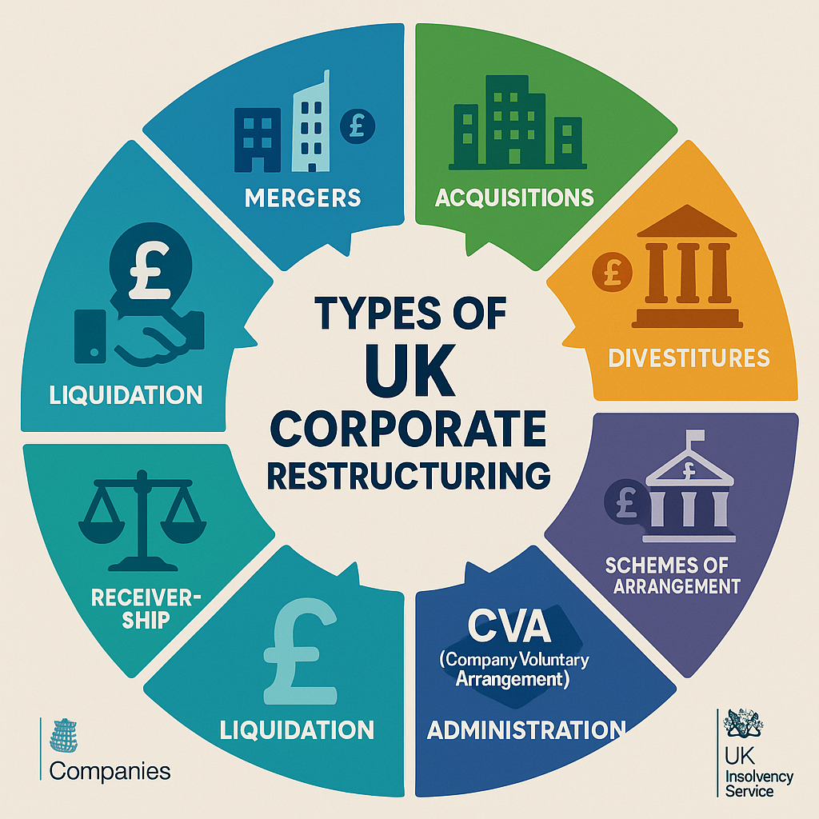

Divestment of Non-Core Assets

The sale of non-core or under performing assets is one of the company’s best short term option to raise cash. General Electronics has General Electronics accumulated a diverse collection of assets, including real estate, equipment, and intellectual property, that have drifted too far from its core strategic purposes. They tie up capital and they have a low return.

The sale of non-core assets would also provide a quick cash boost, which would enhance liquidity and reduce reliance on short-term debt. The proceeds of divestiture could be used to retire debt, reduce interest costs and enhance key financial ratios such as leverage and interest coverage. That would lower financial risk overall and maybe even enhance the company’s credit rating.

However, it is essential to ensure that divestments are done tightly and strategically. Assets should be sold for fair value, not through forced or distressed sales that erode shareholder value. By divesting non-core businesses, management can focus resources on the most profitable and strategically critical business units.

Equity Injection to Strengthen the Balance Sheet

New equity capital is also a component of the restructuring package. This may be done by way of a rights issue, private placement or a strategic investor. Since the shareholders’ equity has been eaten away in the recent years, equity contribution is required to re-balance the capital structure and act as a financial shield to absorb future losses.

Issuing equity would both deleverage and recapitalize the Company, w hich in turn w ould restore confidence among the Company’s creditors, suppliers and equity investors. Unlike debt, fixed repayments are not required with equity, which is particularly important in a time of financial recovery. A more solid equity base would likewise facilitate future investments and strategic moves.

The offering is likely to result in dilution for existing shareholders and that may be viewed negatively in the short term. But when the chips are down, it's long-term survival and stability of the enterprise rather than short-term earnings per share that matter. The restructuring plan and its long-term benefits w ill have to be communicated clearly to win the support of shareholders.

Debt Restructuring and Maturity Extension

Debt restructuring offers another means of relieving financial strain. General Electronics is now heavily exposed to short-term debt and thus refinancing and interest rate risk. Refinancing debt, extending maturities or replacing short term obligations with long term instruments would also have a positive impact on liquidity.

In the course of bringing debt maturities more in line with the business’s cash generation, the company’s outflows can be smoothed, and interest coverage can increase over time. Lower interest expenses would also help enable it to return to profitability. Sometimes, renegotiation of covenants is necessary to give the management enough breathing room through the recovery process.

Although lenders may perceive restructuring to be risky at first, working together to achieve a successful resolution can ultimately preserve value by minimizing the chance of default. Open communications, believable financial projections, and a well-defined turnaround plan are essential in winning lender support.

Strategic Partnerships and Alliances

Alongside balance sheet considerations, strategic partnerships can be an important aspect of financial restructuring. partnerships with technology companies, vendors or local partners that can reduce capital requirements, share risk, and lead innovation. such as manufacturing or R&D, that spread fixed costs and maintain competitive capabilities.

Strategic alliances can also allow entry into new markets with less initial investment, thereby enhancing revenues and providing cash flow stability. While collaborations need to be carefully managed and have aligned interests, they represent a more flexible option than major acquisitions in times of funding squeezes.

Impact on Shareholders, Debt Risk, and Cash Flow Flexibility
Together, these actions are intended to bring financial stability back and to rebuild shareholder value. Although shareholders may experience short-term dilution or a smaller asset base, the long-term benefit is a stronger, more resilient company.
Less leverage, longer debt maturities and better interest coverage would reduce the financial risk and make the company more able to weather economic and industry shocks. Greater cash flow flexibility would enable management to concentrate on strategic decisions rather than short-term liquidity management.

International Financial Considerations

General Electronics is subject to currency risk as a result of conducting business and financing activities in numerous countries as a global company. Exchange rate volatility can have an impact on revenues, costs, and debt serviceability. Thus, it is crucial to have good hedging policies and the inflows and outflows of currencies to be of similar size to avoid volatility.

The firm is also subject to inflationary cost, mainly in the cost of raw materials and labor. Financial restructuring must be combined with cost control and pricing approaches that shield margins in inflationary circumstances.

Tax aspects are just as significant. Sales of assets, issuance of equity and restructuring of debt all have tax effects, which can affect the net cash proceeds. Restructuring decisions must be carefully planned for tax purposes.

Ethical, Social, and Sustainability Considerations

Balance sheet restructuring is likely to have social and moral implications, especially if it entails workforce reduction or disposal of assets and those things are likely to occur. These consequences need to be responsibly managed through open communication and through fair severance packages and retraining, if at all possible.

Sustainability aspects should also continue to be in the company’s strategy. In the consumer electronics industry, environmental issues including electronic waste disposal and energy conservation are gaining the attention of both regulators and consumers. Ongoing investment in sustainable business practices can also bolster brand reputation and contribute to long-term value creation.

Overall Evaluation

In short, General Electronics need a full financial overhaul to bring its finances into line and make it sustainable. Through a combination of asset sales, equity infusion, debt restructuring, and strategic alliances, the company can mitigate risk, bolster liquidity, and regain financial flexibility.

If executed well and backed with strong leadership and open communication, this picked-part strategy is a plausible route for financial resurgence and reestablishment of competitive position in the global consumer electronics industry.

Investment Appraisal and Capital Budgeting

Investment appraisal - Whether the financial recovery of General Electronics depends upon successful investment appraisal or not. With the company’s profitability deteriorating, liquidity limited and financial risk heightened, capital would have to be tightly allocated. Poor investment decisions at this stage would only increase pressure on cash flows and risk destabilising the wider restructuring plan. As the CFO, you must also know how to use a disciplined capital budgeting process to prioritize the projects that create the most value under those financial constraints.

General Electronics now has to choose between three potential investment projects, labeled Project A, Project B, and Project C. They each have a life of five years. Because of the capital rationing, the company is entitled to invest only 60 mln GBP. A 10% discount rate is used to take into account the firm’s cost of capital and high risk. It is presumed all projects are depreciated straight-line to zero.

These projects are evaluated with several investment appraisal tools, such as Payback Period, Accounting Rate of Return (ARR), Net Present Value (NPV), Profitability Index (PI), and Internal Rate of Return (IRR), to achieve a more balanced and comprehensive decision.

Table 1: Project Details and Cash Flows (£ million)

Project | Initial Investment | Year 1 | Year 2 | Year 3 | Year 4 | Year 5
A | 40 | 10 | 12 | 14 | 10 | 8
B | 30 | 6 | 6 | 6 | 6 | 6
C | 50 | 5 | 10 | 20 | 25 | 15

Table 2: Payback Period Calculation
Project | Cumulative Cash Inflows | Payback Period
A | Breaks even in Year 4 | 3.4 years
B | Breaks even at end of Year 5 | 5.0 years
C | Breaks even early in Year 4 | 3.3 years

Table 3: Accounting Rate of Return (ARR)
Project | Total Cash Inflows | Total Profit | Average Annual Profit | ARR
A | 54 | 14 | 2.8 | 7%
B | 30 | 0 | 0 | 0%
C | 75 | 25 | 5.0 | 10%

Table 4: Net Present Value (NPV) at 10%
Project | PV of Cash Inflows | Initial Investment | NPV (£m)
A | 40.6 | 40 | +0.6
B | 22.7 | 30 | –7.3
C | 52.4 | 50 | +2.4

Table 5: Profitability Index (PI)
Project | PV of Inflows | Initial Investment | PI
A | 40.6 | 40 | 1.02
B | 22.7 | 30 | 0.76
C | 52.4 | 50 | 1.05

Table 6: Internal Rate of Return (IRR)
Project | IRR | Cost of Capital | Decision
A | 10.6% | 10% | Accept
B | –1% | 10% | Reject
C | 11.9% | 10% | Accept

Table 7: Overall Project Comparison (Examiner-Friendly)
Criteria | Project A | Project B | Project C
Payback Speed | Medium | Slow | Fast
ARR | Medium | Poor | Best
NPV | Low Positive | Negative | Highest
PI | Acceptable | Reject | Best
IRR | Slightly Above WACC | Poor | Best
Risk Level | Medium | Low | Medium-High
Capital Required | 40m | 30m | 50m

Table 8: Capital Rationing Decision (£60m Limit)
Option | Total Cost | Feasible? | Value Created
Project A only | 40m | Yes | Low
Project B only | 30m | Yes | Negative
Project C only | 50m | Yes | Highest
A + B | 70m | No | —
A + C | 90m | No | —

Conclusion

The financial condition of Genera.l Electronics now will be reviewed in this statement and it will be seen that the company is affected by grave structural weaknesses which make it impossible for it to live up to its obligations in the long term. Declining revenues, sustained operating losses, deteriorating liquidity, poor working capital management and an increasing dependence on short-term debt have been heavily pressuring the company’s finances. While cash flows from operations are still positive, the margin of safety has eroded significantly and there is an increased possibility of financial troubles if an intervention is delayed.

A comprehensive financial recovery plan is being proposed to meet these challenges. Among the key elements are the sale of non - core businesses to raise cash, an equity injection to fortify the balance sheet and debt restructuring to lower refinancing risk and increase liquidity. Supported by selective strategic partnerships these initiatives also target the restoration of financial stability through decreased gearing and improved cash flow flexibility. Ethical, social and sustainable factors have also been incorporated to ensure the restructuring process is responsible and consistent with the global operating environment of the company.

At the same time, strict capital budgeting has been stressed to make certain that limited funds are well spent. On the basis of such a multiple investment criteria assessment, Project C is the best investment under capital rationing and provides the maximum contribution to shareholder value.

To sum up, it is possible to stabilize and reposition General Electronics with a strong financial leadership, enhanced working capital management and sound investment decision. When executed well and managed closely, the suggested actions lead to a clearly identified and financially viable road to recovery, regaining investor confidence, and sustainable long-term growth.

REFERENCES
- Beaver, W.H. (1966) Financial ratios as indicators of business failure. Journal of Accounting Research, 4, pp.71–111.
- Damodaran, A.(2015) Applied corporate finance, 4th edn. Hoboken: John Wiley & Sons.
- Dechow, P.M., Ge, W. and Schrand, C. (2010) Earnings quality – an introduction to the special issue. Journal of Accounting and Economics, 50(2–3), pp.344–401.
- Grice, J.S. and Dugan, M.T. (2003) Re-estimations of bankruptcy prediction models. Journal of Credit Risk, 1(1), pp.77–93.
- Petersen, M.A. and Rajan, R.G. (1997) Trade credit: theories and evidence. Review of Financial Studies, 10(3), pp.661–691.
- Platt, H.D. and Platt, M.B. (2002) Predicting corporate financial distress: reflections on choice-based sample bias. Journal of Economics and Finance, 26(2), pp.184–199.
- Ross, S.A., Westerfield, R.W., Jordan, B.D. and Cross, R. (2022) Fundamentals of corporate finance. 13th edn. New York, NY : McGraw-Hill Education.
- Atrill, P. and McLaney, E. (2020) Accounting and finance for non-specialists. 11th edn. N/A: Pearson Education.
- Brealey, R.A., Myers, S.C. and Allen, F. (2020) Principles of corporate finance. 13th edn. New York, NY: McGraw-Hill Education.
- Altman, E.I. (1968) Financial ratios, discriminant analysis and the prediction of corporate bankruptcy. Journal of Finance, 23(4), pp.589–609.

Appendices

Appendix A: Key Financial Ratios (Five-Year Summary)

Table A1: Profitability Ratios
Year | Gross Margin (%) | Operating Margin (%) | Net Profit Margin (%) | ROCE (%)
2020 | 28.7 | 14.3 | 6.3 | 12.4
2021 | 29.1 | 12.6 | 5.9 | 11.1
2022 | 27.4 | 5.2 | 0.1 | 4.6
2023 | 24.8 | -18.6 | -15.4 | -9.8
2024 | 28.9 | -3.9 | -4.7 | -2.1

Table A2: Liquidity Ratios
Year | Current Ratio | Quick Ratio | Cash (£bn)
2020 | 1.82 | 1.15 | 42.3
2021 | 1.76 | 1.09 | 51.6
2022 | 1.68 | 1.02 | 66.7
2023 | 1.54 | 0.93 | 40.5
2024 | 1.49 | 0.88 | 26.8

Table A3: Efficiency Ratios (Days)
Year | Inventory Days | Receivable Days | Payable Days
2020 | 78 | 52 | 94
2021 | 82 | 54 | 98
2022 | 90 | 58 | 102
2023 | 104 | 63 | 108
2024 | 99 | 60 | 105

Table A4: Gearing and Investor Ratios
Year | Debt-to-Equity | Interest Cover | EPS (£)
2020 | 0.45 | 9.6 | 2.78
2021 | 0.52 | 8.1 | 2.41
2022 | 0.64 | 2.3 | 0.03
2023 | 0.98 | Negative | -7.64
2024 | 0.87 | Negative | -1.85

Appendix B: Cash Flow Trends

Table B1: Cash Flow Summary (£bn)
Year | Operating CF | Investing CF | Financing CF
2020 | 73.4 | -48.1 | -12.7
2021 | 68.9 | -44.5 | -9.3
2022 | 42.6 | -39.2 | -5.8
2023 | 18.2 | -29.4 | 12.1
2024 | 14.8 | -22.7 | 8.9

Appendix C: Altman Z-Score (Indicative)
Component | Indicator
Working Capital / Total Assets | Weakening
Retained Earnings / Total Assets | Declining
EBIT / Total Assets | Negative
Equity / Total Liabilities | Reduced
Sales / Total Assets | Falling

Appendix D: Investment Appraisal Calculations

Table D1: Discount Factors (10%)
Year | Discount Factor
1 | 0.909
2 | 0.826
3 | 0.751
4 | 0.683
5 | 0.621

Table D2: NPV Calculation – Project C (£m)
Year | Cash Flow | Discount Factor | Present Value
0 | -50 | 1.000 | -50.0
1 | 5 | 0.909 | 4.5
2 | 10 | 0.826 | 8.3
3 | 20 | 0.751 | 15.0
4 | 25 | 0.683 | 17.1
5 | 15 | 0.621 | 9.3
NPV |  |  | +2.4

Appendix E: Suggested Graphs


