
Skills for the Workplace
Module Assignment Submission
Student Name: | Neil Jagger
Student Number: | 1910924
Module No: | BMSK4001
Module Title: | Academic and Employability Skills

Statement of Confirmation of Authenticity
By the act of making this submission, the student declares that this is the work of the student named above. The work has not, in whole or in part, been knowingly presented elsewhere for assessment, or where assessment has been built on a previous assessment, this has been identified. Where materials have been used from other sources it has been properly acknowledged. If this statement is untrue, the student acknowledges that an assessment offence has been committed.
Attention is drawn to the plagiarism and unfair practice policies of both the University and of ILM.

Table of Contents
Introduction 3
Part 1 Employability 3
1.0 Explore ‘Leadership Employability Skills’ in general 3
1.2 Evaluate own Leadership Employability skills 4
1.2.1 Current Employability skills 4
Gap Analysis to identify ‘gaps’ in knowledge/skills 4
1.2.2 Action Plan for Improvement 5
Part 2: Academic Skills 6
2.0 Reflection on Academic Skills required for University Level Study 6
2.1 Evaluate own Academic Skills 6
2.1.1 Current Academic Skills 6
Gap Analysis to identify ‘gaps’ in knowledge/skills 6
2.1.2 Action Plan for Improvement 7
Conclusion 7
References 8
Appendix 9

Introduction
In this module I will be looking at academic and leadership skills in the workplace, including what are academic and leadership skills, how to identify different skills that are needed to make a successful manager and leader. After exploring academic and leadership skills in the workplace in general I will then look and critique my own leadership skills, identifying my strengths and weaknesses and where I can improve to make a better leader and manager within the workplace.

Part 1 Employability skills

Employability skills go beyond what qualification and experience you may have. They are a set of skills that you have gained that are transferable from situation to situation. These skills can include communication skills, responsibility, Motivational qualities, Time keeping, delegation, flexibility, being able to give and receive feedback.
These are skills that you gain through life experiences and how you handle them, they are something that are learned both in the work place and outside. In a way they are a set of disciplines.

Explore ‘Leadership Employability Skills’ in general

Having a competent Leader in the workplace is crucial to the success of the business regarless of how big the company is, whether if it has 5 employees or 5 thousand employees and having a manager with good leadership skills are key for success within the team, organisation and company.
The importance of leadership skills are shared by Kumar (2019) who states;
“Did you know that even footballers have to possess leadership skills in order to be successful in their game? Whether it is Messi or Ronaldo or Neymar, communication, team building, time management and the ability to make quick decisions are helping them stay ahead in their game and be effective leaders. Irrespective of which field you choose to work in, certain leadership skills are essential for success. Also, the use of leadership skills is not only for coaches or managers or team leads or senior employees. Every job role or title demands dealing with various situations and different types of people at the workplace and developing leadership skills will help you do it. Remember, no one is born a leader. Everyone, including you, can develop leadership skills. (Kumar, 2019)

There are several key parts that a good manager and leader needs to be successful in leading a team. All of these feed into one another and having a manager who possesses these skills set will allow for good leadership and employee engagement.

Important Leadership Skills for Workplace Success

Communication.

Being able to talk to staff in a polite manner is probably one of the most important leadership skills off all. When speaking to your team it is important to be polite yet authoritative while keeping in mind that you should speak to your team how you would expect your manager to speak to you. Being able to do this will a long way with earning respect from employees while maintaining your leadership position.
There are a wide range of communication skills needed as a leader and manager and these skills can differed whether talking to a group of people, individual person on a one to one basis, or on the telephone. Learning how to talk to people properly in groups and individually is very important and a manager must be able to adapt to the person or target audience they are speaking to, this is also vital as not all people can be spoken to and receive feedback in the same way as there peers. Meaning that some people require the use of simpler more descriptive words, or the tone in which they receive instruction or feedback needs to be adjusted.

Anthony (2019) states that effective leadership in a small business requires knowing how to communicate with all elements of the organization, including employees, managers, customers and investors. Each group may require a different communication style and leadership style. Leaders must be able to adapt based on the group they are communicating with at the time. Effective communication skills are an important aspect of any leader’s portfolio of skills and experience.

The blow out of the BP Oil rig ‘Deep water horizon’ is a good example of poor communication within leadership and the catastrophic consequence of poor communication within an organisation. Groysberb and Slind, (2012) described the key factors effecting the disaster as “poor communications” and a failure “to share important information.
Although the above is a drastic example of the result poor communication can cause, it is important that we learn and understand that communication within every organisation is key, it allows everyone to work in unison to a collective goal.

Motivation.

Maintaining personal motivation as a leader and manager can be difficult; it is often hard to maintain motivation when you are receiving conflicting pressure from both ends including your line managers and the team you are managing.
Then there is the expectation as a leader and manager to promote and motivate your team. It is not enough to have monetary motivation in place as staff moral needs to be maintained and each person’s motivation goals can be different from the next. These could include the need for flexible working hours to meet home commitments, Receiving praise and constructive feedback, and team building days.

Communication and motivation feed into each other and both need to be effective, for the team to be successful and keeping things upbeat, happy and motivated.

External factors could pose a barrier to maintaining staff motivation and moral such as personal and family complications due to illness or bereavement. These are harder for a leader/manager to deal with and this is wear communication skills, and good working relationships are needed and effective company policies that show commitment to individual staffs personal needs such as bereavement time off, flexible working hours and whistle blowing policies.

Craig (2017) states that motivating employees should be one of a managers Top Priorities, It demonstrates a commitment to employee happiness and happy employees are productive employees. A controlled experiments where employees work in a physically welcoming atmosphere with a flexible scheduling and opportunities to unwind with reasonable employee benefit packages that meet their daily needs such as generous sick leave policies, retirement account contributions and paid parental leave have revealed that these motivated employees productivity levels are up to 20% higher that unmotivated employees (Craig, 2017).

Delegating

Giving and shearing jobs and tasks within the workforce is not as easy as it sounds, to be successful at job delegation you must know and understand each of your employee’s strengths and weaknesses to efficiently utilise your team and allow them to work to the best of their ability. As a leader I would never expect someone to do a job or task that I am not prepared to do yourself, to me this shows you are willing to help with jobs and tasks and will get your hands dirty, and I find this helps with the motivation and moral off the staff and in return employees with gain respect for you as a leader/manager.

Lloyd (2020) states that there are many reasons why managers do not delegate as much as they could which include:
- The belief that employees cannot do the job as well as the manager can.
- The belief that it takes less time to do the work than it takes to delegate the responsibility.
- Lack of trust in employees’ motivation and commitment to quality.
- The need to make one’s self indispensable.
- The enjoyment of doing the work one’s self.
- Guilt associated with giving more work to an overworked staff.

Again, delegating and communication come hand in hand. It is important to overcome the above barriers when delegating jobs that the manager follows a series of steps consistently so employees get acquainted with the process, these should include verbally meeting face to face with team members to communicate over email and digital communication as this is likely to convey the message that this discussion is important, give clear timings and expectations and allow for employees to ask questions when needed. It also allows the manager to explain why specific people or teams wore chosen for the task which eliminates the risk of other staff member or team members feeling rejected or that fravroutism is at play.

Feedback
The giving and receiving of feedback whether positive or negative is important to help with the smooth running of a company or department within the company. Positive feedback is important even if it is just to say thank you and what a good job an individual has done or team helps with morale and motivation. Negative feedback is just as important as positive feedback but has its problems that can affect the running and motivation of the company of group, giving an individual or group negative feedback could diminish their motivation and morale so been able to give negative feedback in a way not to upset individuals and team members is no easy task.

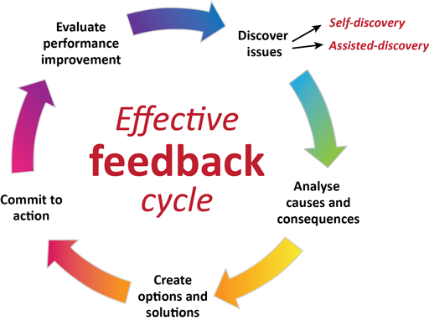

Using an effective feedback cycle such as the one in the above picture will allow employees to evaluate their own performance, adjust their behaviour accordingly to lead to self-discovery. It is important that feedback is not criticism, condemnation or judgmental as this will have a negative effect on employee morale. Feedback is critical for positive workplace engagement and moves the employees to the best version of themselves.
According to Jeffrey (2020) there are seven Characteristics of Effective Feedback which include that feedback should be continuous and received in the moment or as close to the moment as possible, the feedback given should be honest and allow for conversation it should not contain backhanded comments that undermine the employee or the feedback itself. The feedback should be inquisitive instead of forceful which would empower the employee, guide them with questions, and allow them take ownership for their work. The feedback should also be based on the companies larger vision and not driven on personal gain or power over others. The feedback should be specific to the task with clear action steps directed toward the task with the aim of increasing performance on that task and the employees professional growth.
The communication used for feedback should also be descriptive and not critical as judgmental feedback can lower the moral of the employees and reduce motivation. The feedback should be focused on building the strengths of the employees and teams over highlighting their weaknesses.
As a manager is it vital to be prepared and have strategies in place to overcome people’s Resistance to Feedback and again communication and staff moral feed into feedback as communication is vital to giving good constructive feedback that maintain or even boosts staff morale.
Responsibility

As a leader you are responsible for both the successes and failures of the team, meaning you must accept responsibility when things go wrong and not according to plan but on the other hand willing to share the glory of success with the team and not keeping it for yourself.
Employees can and will loose respect for their leader or manager if they start pointing fingers and blaming individual members of the team, making the team less efficient and a drop in moral which in turn lead to making more mistakes and failures putting more pressure on the team leader and could lead to loss of employment.

ConantLeadership (2017) states that even though there is usually a lot of blame to go around it is important that a manager takes responsibility as the quickest and surest way to lose trust is failing to take responsibility, or worse blaming others entirely for the situation. This does not mean that people responsible should not be identifies but that the manager is capable of accepting responsibility and make adjustments, and make sure the same mistakes are not repeated twice. This type of analysis and corrective action is an essential part of effective management and showing as a manager that you are able to own and address the problem.

Again ‘Responsibility’ has elements of morale, communication and feedback that all play an integral role.

Time keeping
Setting examples to your team member that you are able to adhere to good time keeping is vital it sets and example and expectations. It also maintains staff moral as it shows that you as a manager are committed to the goal.
On a larger scale, time keeping is not just turning up to work on time, there are hidden agendas to consider also. Bad time keeping can have repercussions not only for individuals but as a company as whole and can affect other departments and/or companies along the industry line. An example of this would be if you are set a task to wright a report to produce something to order or to deliver an object on a set deadline, if the deadline is not met and is delivered later then the chain of production has been held meaning that there is a chain reaction and other department cannot do their jobs and so on down the line. This could result in penalisations, restrictions and even loss of contracts and employment.
Time management feeds into accountability and time management skills, like other soft skills, such as organizational skills, are in high demand. Employees who manage their time well are more productive, more efficient, and more likely to meet deadlines, be committed to both the organisation and their team. (Doyale, 2019)
Flexibility

Flexible leaders change plans as situations change. This results in an ability to remain productive during times of upheaval or transition. (McDaid, 2018)
A flexible leader has to adapt to the abilities of each individual team member and not expect them to work and learn at the same level and speed as theire peers. Being flexible within a team meaning you can cover another team member roll if needed or assist when help is needed is a good asset for the team .

1.2 Evaluate own Leadership Employability skills
Current Employability skills
My journey into leadership skills started in my early teens when I joined the army cadet force and in my six years I was involved with the cadets reaching the rank of cadet Sargent I learnt a wide range of leadership skills that can be implemented into everyday working life , these skills include been able to speak to individuals and large groups, been able to give and receive orders and instructions, time keeping, teaching of various subjects, been able to work on my own and as a small and large teams, been able to think and work under stress. Been a cadet also taught me confidence, discipline and respect.
As I moved into adulthood, I gained leadership skills within my chosen career. Being given the opportunity to lead problem solving sessions when team members have problems with their communications. This helped with my confidence with speaking and dealing with problems.
When I sat the leadership quiz on Mindtools.com (APX 1.) my overall score was 25 which identified that my leadership style has a tendency to lean toward a democratic or participative style of leadership. Which means i tend to set the parameters for the work and have the final say on decisions, but actively involve my team members in the process. Mindtools.com (2020) states that this style can build trust between leaders and their teams, as employees are likely to feel more engaged and valued. However, there are drawbacks of this style as it is not great in a high-pressure situation that requires a fast turnaround, as it has the potential to slow you down. In addition, if you dislike disagreement or conflict, you might struggle with how people respond to consultation (Mindtool.com, 2020).
I feel that this is a true representation of my leadership style and shares many of the same values that I share in what makes a good manager/leader. I share the belief that a good leader should trust everyone within their team, and that team members should be given the opportunity to take the lead on a project while receiving guidance and supervision. And there should be continuous engagement with the team and mangers. Within my industry in road haulage and construction, this level of leadership is vital. The team members appreciate a manager who does not feel superior to them and is happy to do the same jobs that is expected of them but like knowing that they have someone that they can trust to approach if there is a problem both with work and personal problems.
When I took the USCPrice leadership quiz (APX 2.) My results identified that my leadership style is Postmodern I feel that the description of postmodern leadership also reflects how I feel about leadership. It shares the quality that i believe that individuals in a team all have their unique abilities and each individual brings with them a unique characteristic that makes a team extremely valuable when working collectively.

Gap Analysis to identify ‘gaps’ in knowledge/skills

Objective | Current Position | Deficiency | Action
What do I want to do? | What can I already do? | What am I lacking? | How do I fix this?
Better digital skills | Basic computer and digital skills | Knowledge of office, excel, | Videos and research and general use of programs
Video team meetings | Basic use of Microsoft teams | Knowledge of video calling | Learn to use programs
Learn power point presentation | Basic knowledge | Power point knowhow | Read and research how to use power point

1.2.2 Action Plan for Improvement

Objectives | Tasks | Success Criteria | Time Frame | Resources
List your Goals | What do you need to do to achieve these goals? | How will you identify your success? | When do they need to be done by? | Who or what do you need to help you?
Finish university  Level 4 | Attend classes,  Complete assignments. | Passing assignments | 6 months | Lecturers  Class colleagues  Support from home
University levels 5 and 6 | Finish and pass level 4 | Completing assignments | 3 years | Lecturers  Support from home
Move abroad | Complete university levels 5 and 6 | moving | 5 years | Family
New job abroad | Move abroad  Find job | Getting a job | 5 years | family

Part 2: Academic Skills
Skills learned through academia are the foundation and building blocks for the identified leadership skills above. The skills that students learn through education are vital for success through to later life. They are skills that can be built upon through both work and life experiences.
Bronson (2018) states that one aspect of university that is sometimes overlooked is the fact that you can actually develop your leadership skills and universities offer the perfect activities and processes to develop these leadership skills including; Lead a Group Project’s, Become President or spokesperson of a Club, minority or Organization, Get a Part-time or On-campus Job such as restaurants/café’s and bar work, volunteering opportunities which can help you to learn about humility and compassion or join a Sports Team and that university really is a great place to establish important life skills and to prepare yourself for the working world (Bronson, 2018).

Reflection on Academic Skills required for University Level Study

Similar to employability and leadership skills, academic skills require a student to be able to communicate clearly whether if this is if they don’t understand a topic that they are able to communicate this to their tutor to gain an understanding or if they are presenting assignment in front of a class or on a video conference like Microsoft teams communication skills are vital.
Student need to be motivated especially how universities are now utilising distance learning tools such as google documents, hang out meetings, zoom and self-lead learning. It’s very hard for a student to maintain motivation when they are not attending classes regularly or being guided by their tutor, they need to be self-motivated to set themselves deadlines to complete course work and meet deadlines. This leads to students needing to take responsibility for their own learning they cannot put fifty percent in to their course work and expect to have a two or a two one grade they need to be responsible and realise that what they put into their work is what they will get out from it.
When working in a team on course work students also need poses the quality to delegate tasks and be able to work collaboratively on a task and delegating rolls and responsibilities between each other, so that they come together with one collective peace of work.
Feedback just like in leadership skills plays a big roll the academic journey and feedback received from tutors on course work should go through the effective feedback cycle which leads to the student learning and self-reflecting on what they have done well and what they need to feed forward to improve and gain better marks as they progress through their educational journey.
Time keeping is important where learners are set clear deadlines where assignments need to be submitted they need to be able to manage their time wisely set themselves deadlines and work to a schedule and a goal, then there are the soft skills included in learning such as research skills, research sills are something you need through out your life but are vitally important during academia students need to know how to research how to critic and evaluate what they have read and then be able to put this down on paper other soft skills such as digital literacy all feed in to this.

2.1 Evaluate own Academic Skills
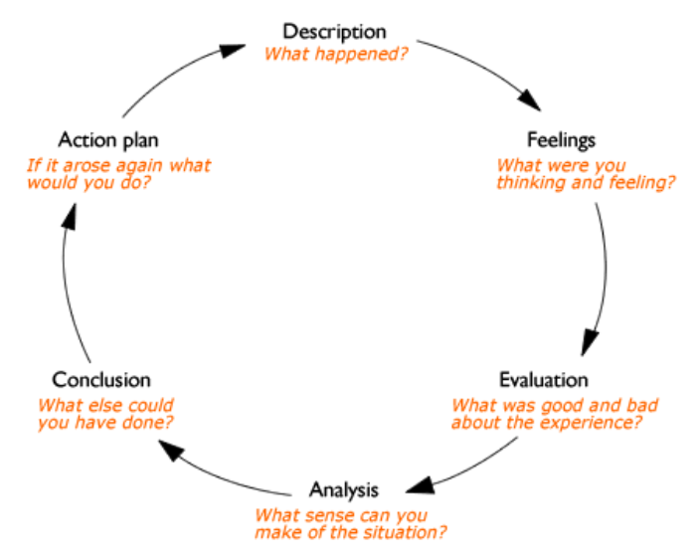

Feelings
At first I thought this assignment was going to be like the other assignments we have done in the past but it turned out to be much more than that, I learnt so much more about myself and what qualities I have as a leader and what I am lacking and where I can improve myself to become the better leader I want and can be.
Evaluation
With the research, it was relevantly easy to find once I got to the right websites but some of the information given was not worded the way I found easy to understand and I had to look up the meanings of words. Google was a great help for this.
The use of the gap analysis and the action was great to understand my leadership abilities and what is needed of me and what I need to look into more to learn and progress the skills I have and the skills I need.
Analysis
After completing the cap analysis and action plan It became clearer to myself where I thought I had skills I was actually missing key factors and realised where I must improve to better these skills .
Conclusion
By doing the assignment, I have a better knowledge of leadership and academic skills and where I can improve these skills and learn more skills to progress through my university courses and through my employment and where to look for these skills in other people to become the leader I want to be.
Action Plan
To progress on the skills, I already have and to learn new skills by doing more research more into employability and academic skills and watch other leaders and take notes on this I can and shouldn’t be using.

2.1.1 Current Academic Skills

I have completed NVQ’s and training courses in the past however I feel the demands and expectations of university are greater. My academic skills are progressing as I progress through the qualification I am learning new skills and tools each week. When I reflect on my first paper to this one I feel, I am more able to structure a piece of work and use words and grammar to my advantage. I have learned about referencing and referencing tools. I have also learned the importance of research; now my research is limited to computer based research.
As I progress through academia, I would like to get to grips with referencing until it becomes second nature and something that I do not have to think about when doing it. I would also like to learn how to utilise the library and its resources and learn how to access online journals that can help both my academic journey and my professional growth. I am hoping when I enter my undergraduate course that we will have sessions in the library to learn these vital skills.
A barrier to my academic progression is my work commitments at times I can be working up to 70 hours a week. Time management and motivation is something that I know I need to prioritise.

I also want to discuss emotional intelligence in relation to academia, does this differ from employability.
Gap Analysis to identify ‘gaps’ in knowledge/skills
Objective | Current Position | Deficiency | Action
What do I want to do? | What can I already do? | What am I lacking? | How do I fix this?
Better research skills | Basic research | Investigative research. And research techniques | Videos. And reading more web sites
referencing | Basic skills | Referencing techniques | Practice more

2.1.2 Action Plan for Improvement

Objectives | Tasks | Success Criteria | Time Frame | Resources
List your Goals | What do you need to do to achieve these goals? | How will you identify your success? | When do they need to be done by? | Who or what do you need to help you?
Learn power point | Learn how to make a power point presentation | When successfully make and presented a power point presentation | Before end of next assignment | Tutor. Research power point use
Video conferencing / meeting. Contents sharing | Learn how to hold a successful video conference and share files | how to hold a successful video conference and share files | Before end of next assignment | Research . tutor

Conclusion

To conclude this Paper, we have identified that there are a number of similarities between academic and leadership skills, they are skills that are built on from academia to leadership positions and beyond and are gained through a number of experiences not limited to work and academia. These include communication, motivation, the skill of delegating work and tasks to team members and been able to give and receive constructive feedback is important in academia, a team leader and manager
Having the ability to communicate with the team in a respectful and authoritative way will allow the team to respect the leader and want to work within the team to achieve the teams goal similarly to academia having the skills to communicate in team work or to lecturers allows personal growth. Effective communication would then feed into motivation because of the team leader of manager can effectively communicate and portray the companies mission to the team members it will share the companies motivation with the team and hopefully motivate the team and want to work towards a collective goal of achieving the companies mission. Having the ability to identify team members strengths and weaknesses will feed in to delegating work to the correct team member and utilising that specific persons skills, strengths and abilities hopefully will result in the best utilisation of the team resulting in higher productivity, communication also feed in to being able to give constructive feedback, feedback should be given to team members as clearly and as soon as possible and as close to the activity requires feedback for it to be relevant if you give feedback to someone a week afterwards then this feedback is no longer relevant at that time to that person so feedback should be delivered as close to the activity as possible, all these things we have identified in the paper communication, motivation, delegating work and been able to give constructive feedback all feed in to each other to promote a good leader manager and to promote a good team that can work together as one unit.
I have identified the areas I need to improve on include digital skills like video conferencing and power point presentations, and the way I am going to overcome and improve my skills to be the best leader and manager I am capable of being is by learning and perfecting the skills I need and putting them in to practice to get the confidence I need to lead a team and not only to manage a team to manage myself to the best of my ability.

References
Anthony, L., 2019. Effective Communication & Leadership. [Online]
Available at: https://smallbusiness.chron.com/effective-communication-leadership-5090.html
[Accessed march 2020].
Bronson, R., 2018. 5 Ways to Develop Leadership Skills at University. [Online]
Available at: https://aboutleaders.com/leadership-skills-university/#gs.2whuqk
[Accessed 09 04 2020].
Connant Leadership, 2017. Why Taking Responsibility Is Always the Best Leadership Choice. [Online]
Available at: https://conantleadership.com/why-taking-responsibility-best-leadership-choice/
[Accessed 03 04 2020].
Craig, W., 2017. Motivating Employees Should Be One of a Leader's Top Priorities. [Online]
Available at: https://www.forbes.com/sites/williamcraig/2017/06/20/motivating-employees-should-be-one-of-a-leaders-top-priorities/#ddc852e1d7d6
[Accessed 07 04 2020].
Doyle, A., 2019. the balance careers. [Online]
Available at: https://www.thebalancecareers.com
[Accessed march 2020].
Groysberg, B. & Slind, M., 2012. The silent killer of big companies. [Online]
Available at: https://hbr.org/2012/10/the-silent-killer-of-big-companies
[Accessed 01 04 2020].
Jeffrey, S., 2020. How to Give Effective Feedback That Leads to Positive Change. [Online]
Available at: https://scottjeffrey.com/effective-feedback/
[Accessed 02 04 2020].
Kumar, B. R., 2019. national skills network. [Online]
Available at: https://www.nationalskillsnetwork.in/employability-skills-leadership/
[Accessed april 2020].
Lloyd, S., 2020. Managers Must Delegate Effectively to Develop Employees. [Online]
Available at: https://www.shrm.org/resourcesandtools/hr-topics/organizational-and-employee-development/pages/delegateeffectively.aspx
[Accessed 03 04 2020].
mcdaid, e., 2018. the leader edge. [Online]
Available at: https://www.leadersedge.com/brokerage-ops/flexible-leadership
[Accessed march 2020].
Mindtool.com, 2020. What's Your Leadership Style? Learn About the Strengths and Weaknesses of the Way You Like to Lead. [Online]
Available at: https://www.mindtools.com/pages/article/leadership-style-quiz.htm
[Accessed 10 04 2020].

Appendix

APX 1.
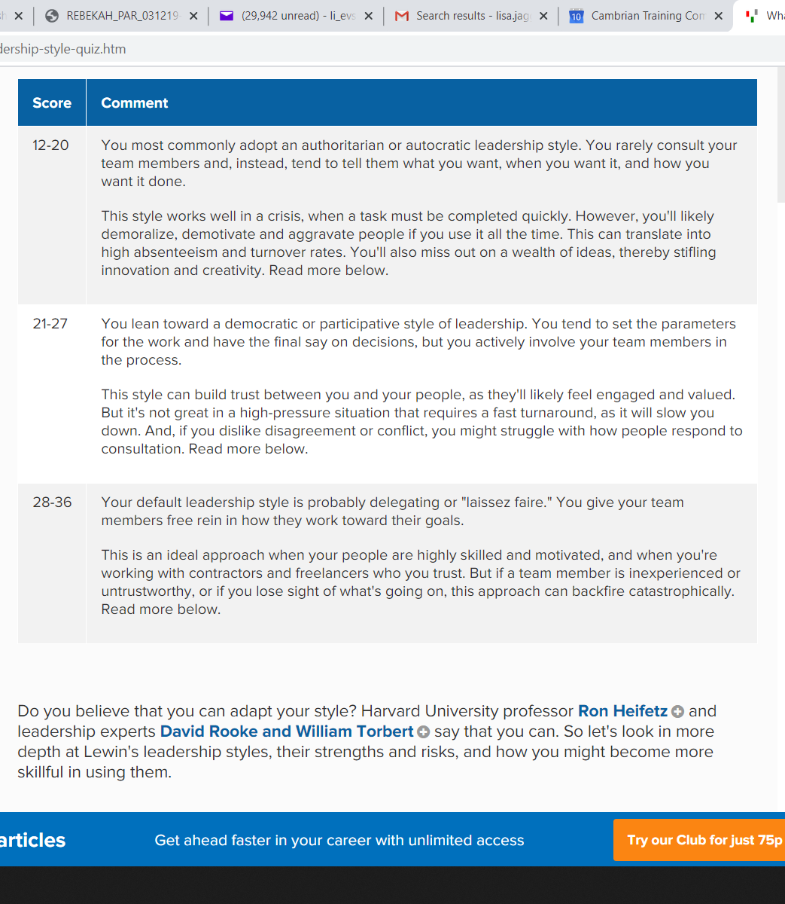
APX 2


