
STUDENT NAME: EMMA RYDER
STUDENT ID:2221740
MODULE CODE: LCBB5013
LECTURE NAME: VASILIOS TAVLARIDIS
RESUBMISON
REFLECTION (500 WORDS)

Personal Reflection

Definitions

Entrepreneurship is the activity of searching for opportunities and resources to create new approaches that offer value though innovation and taking on risk (Burns, 2016). Entrepreneurs are such people who exercise this practice and contribute towards economic and social change by translating ideas into feasible business ventures (Bridge et al., 2019). Franchise has been characterised as a business in which the franchisor grants to a franchisee the use of his/her trade name, mark or commercial symbol (i.e. brand), along with systems that enable the operation of its business (Stanworth & Kaufmann, 2015). Online business are organisations that are mainly based on digital environments rather than brick and mortar or into the internet, therefore adding to less costing and more spreading globally (Chaffey, 2019).

Critical Reflection on the Role of Entrepreneurs and SMEs in the UK Economy
Entrepreneurs and small- and medium-sized enterprises (SMEs) are crucial to the UK’s economy, driving innovation, employment and regional economic growth. At the beginning of 2024 there were an estimated 5.5 million private sector businesses in the UK (Department for Business and Trade [DBT], 2024). There were 5.15 million private businesses, of which 99.2 per cent were SMEs: they employed an estimated 16.6 million people and represented over 60% of all private sector employment. This shows that SMEs are the engine room of the British economy, numerically and functionally speaking.
Entrepreneurial activity is not just about economic output, but also about resilience and adaptability in the face of change. The growth of web-based businesses and Internet start-ups, for example, is indicative of a knowledge economy (Mason & Brown, 2014).
But on closer examination, small businesses are the numerical leaders, but large enterprises continue to hold a lopsided share of economic power. Businesses with more than 250 employees Only 0.2% of businesses in the UK employ over 250 people, but these firms generate around 46% of turnover (DBT, 2024). This structural asymmetry implies that entrepreneurship fosters dynamism and diversity while economic power is still concentrated in the hands of large corporations (Storey, 2016). Therefore, policies for the development of SMEs should not only design on creation of start-ups but also aim to facilitate scale ups and sustainability.

Entrepreneurs remain confronted with long-standing issues such as limited credit, skills gaps, and policy complexity (Fraser et al., 2023). The problems have been exacerbated post-pandemic with inflation, higher interest and supply chain dislocations. Reflecting on the first point, it's encouraging to see that UK business owners – microbusinesses in particular – are adaptable and manoeuvrable, but I'm also reminded of their fragility. As Audretsch and Thurk (2021) indicate, entrepreneurship flourishes in ecosystems where institutions, education and resources are supportive he growth of social enterprises in the UK, estimated at over 100,000 organisations, indicates a broader shift in entrepreneurial motivation toward addressing societal issues such as inequality, sustainability, and community well-being (Social Enterprise UK, 2023). This aligns with the government’s emphasis on “inclusive growth” and demonstrates that entrepreneurship’s value extends beyond economic measures to encompass social impact.

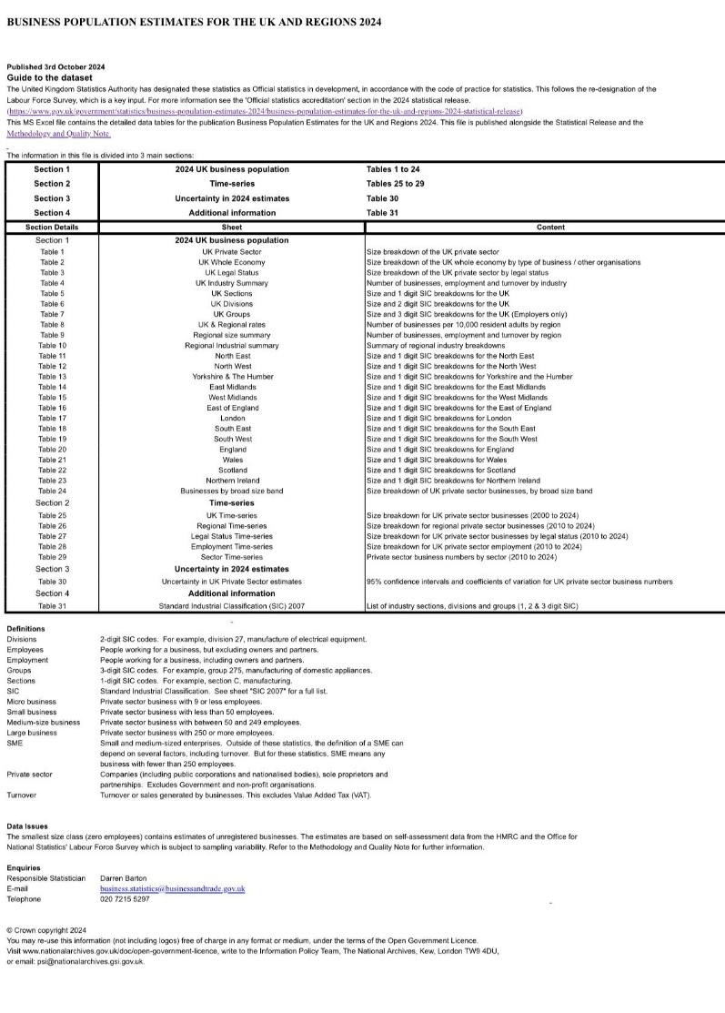

Conclusion

In Conclusion, entrepreneurs and their SMEs are integral to the UK economy; in terms of employment, innovation and regional development. The 2024 numbers reflect their quantitative dominance, but the qualitative picture emerges of system-bound challenges limiting their impact. It is sound policy to enhance access to finance, support digital transformation and promote social entrepreneurship in a well-balanced way. Contextually, on the one hand entrepreneurship represents an opportunity for and a risk to society at large: as an engine of economic rejuvenation, it steers the destiny of economies, but it also needs a supportive institutional architecture to channel individual enterprise into enduring national wealth.

References

- Audretsch, D. B., & Thurk, A. R. (2021). Entrepreneurship and innovation in the knowledge-based economy. Springer.
- Bridge, S., O’Neill, K., & Cromie, S. (2019). Understanding enterprise, entrepreneurship and small business (4th ed.). Palgrave Macmillan.
- Burns, P. (2016). Entrepreneurship and small business: Start-up, growth and maturity (4th ed.). Palgrave.
- Chaffey, D. (2019). Digital business and e-commerce management (7th ed.). Pearson Education.
- Department for Business and Trade (DBT). (2024). Business population estimates for the UK and regions 2024. UK Government.
- Doherty, B., Haugh, H., & Lyon, F. (2014). Social enterprises as hybrid organizations: A review and research agenda. International Journal of Management Reviews, 16(4), 417–436.
- Fraser, S., Bhaumik, S. K., & Wright, M. (2023).
- Mason, C., & Brown, R. (2014). Entrepreneurial ecosystems and growth-oriented entrepreneurship. OECD LEED Programme Papers, 1–38.
- Social Enterprise UK. (2023). State of Social Enterprise Report 2023. Social Enterprise UK.
- Stanworth, J., & Kaufmann, P. J. (2015). Franchising as a hybrid organizational form. Small Business Economics, 45(1), 1–16.
- Storey, D. J. (2016). Understanding the small business sector. Routledge.

