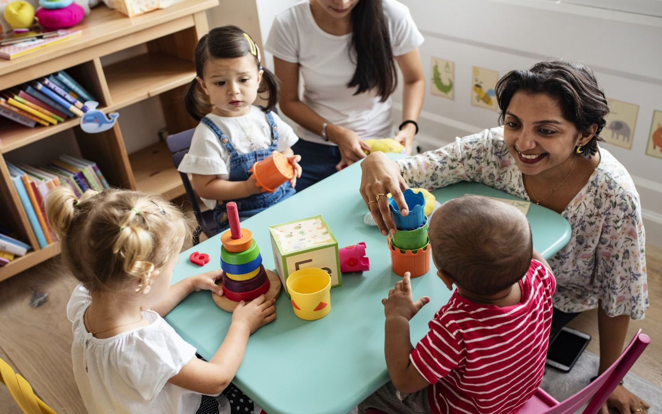
(Source: TTS, no date)
KEY WORKERS HANDBOOK

A GUIDE ON THE IMPORTANCE OF COMMUNICATION DRUING TRANSITION IN THE EARLY YEARS

Contents Page

Purpose 3
What is transition, why is it important and how is it linked with child development? 4
What can key workers do to ensure successful transitions for children? 11
How do we know when child has successfully navigated transition? 16
Summary 17
Reference List 18

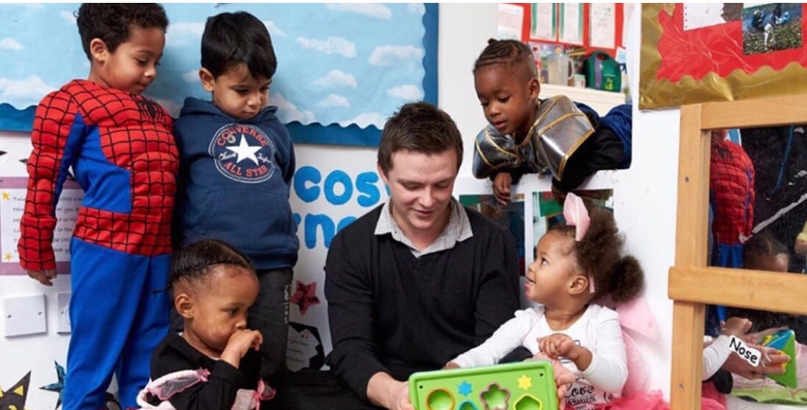
(Source: Medium, 2019)

Purpose

This handbook sets out to promote understanding of effective communication for children’s learning and development during transitions. It is aimed at key workers to assist with improved outcomes for children, ensuring their individual needs are fulfilled to allow smooth transitions from the home to nursery settings.
This handbook supports practice by providing guidance, reinforcing the reasoning behind policy and enhancing the reader’s knowledge of relevant frameworks to assist during transition. It will improve quality by providing clarity to the support required of key workers, and ensuring a consistent approach is adopted by all agencies involved, whilst focusing on National Occupational Standards (NOS).


(Source: Early Years Scotland, 2021)
The NOS aims to assist employers and families within a range of childcare settings, and contributes to the provision of high-quality services, enabling individuals and organisations to effectively provide support to assist during the transition process (Care Council for Wales, 2013). It outlines the requisite skills that an individual must possess to demonstrate competence in a role and forms basis of continuous professional development (Government, 2014).

What is transition, why is it important and how is it linked with child development?


(Source: Tops Days Nurseries, 2019)
Education Scotland (2023) describes transition as the process of moving from one setting to another, such as from the home environment to nursery. Crafter, Maunder and Soulsby (2019) state that they are viewed as stages associated with age-related norms. However, they can also occur when an individual faces change and challenges in different situations (Crafter, Maunder and Soulsby, 2019).
Similarly, according to Queensland Government (2023), transition is a process that unfolds gradually until children establish connections, acquire unfamiliar routines, and experience a profound sense of attachment and inclusion within the unfamiliar environment. These periods can be difficult for children, but with the assistance of parents and key workers, they can be made smoother (Education Scotland, 2023). It is the role of the key worker to work with the child, parents, staff, and other multiagency workers to ensure child-centred approaches that take into consideration the needs of the child whilst working to NOS (HM Government, 2018).
Queensland Government (2023) and Adeona (2021) both claim that smooth transitions are important as early childhood experiences that lead to positive transitions can have life-long advantages, allowing children to establish a strong basis for academic success and improving their development and well-being.
This is supported by Warren and Harden-Threw (2019), who propose that smooth transitions in the early years are vital personally and academically. Birthto5Matters (no date) holds a similar opinion and suggests that managing transitions with sensitivity during the early years allows children to develop positive attitudes towards the various transitions they will encounter throughout their lives.
According to Nursery Story (2021), communication is a vital aspect. Engagement with parents must be prioritised by key workers to ensure partnerships are developed and maintained, and information is shared to enhance the development of the child (Nursery Story, 2021). Oxfordshire County Council (2017) also argue that the success of smooth transitions relies on the dedication of all professionals to establish effective communication channels and adopt a collaborative approach (Oxfordshire County Council, 2017). Dockett (2018) also claims that experts working cooperatively ensures the right decisions are made and creates adequate environments (Dockett, 2018).
Adeona (2021) claims that smooth transitions, based on communication and strong relationships, allow children to thrive and make optimal progress in their growth, development, and learning when they experience a sense of safety, security, and belonging. This builds on Bowbly’s (1969) attachment theory. According to this theory, individuals have an urge to form connections with their caretakers during childhood, which impacts future attachment patterns and chances of survival (Bowbly, 1969). Bowbly (1969) referred to attachment as a long-lasting bond between individuals and claimed that individuals who are able to form this bond, transition more smoothly to adulthood as they receive greater support and comfort from their caregivers, developing a greater sense of security to explore.
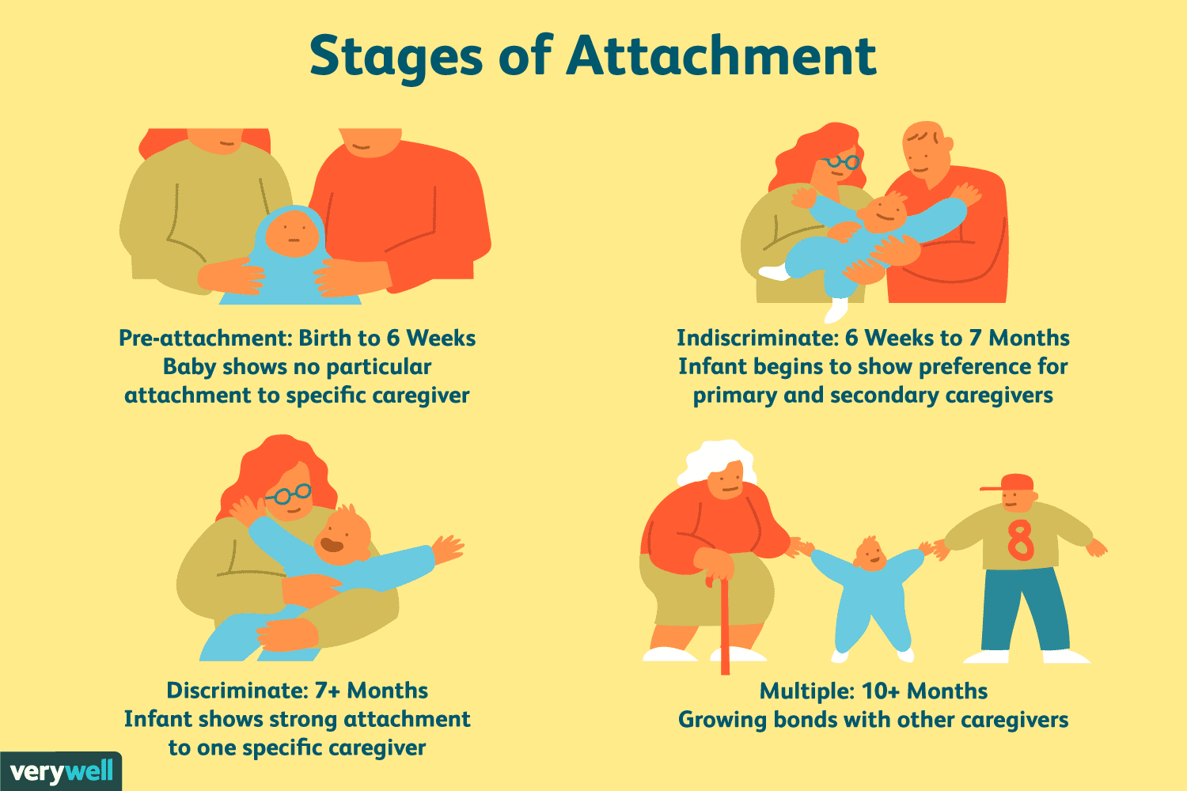
Bowbly (1969) argued that nurturance and responsiveness was responsible for attachment, and highlighted the importance of comprehending the emotional unease encountered by children when they are separated from their primary caretakers. Unlike Freud (1905) who proposed that infants develop a bond with the source of pleasure, Bowbly’s (1969) theory suggests that attachment is made up of distinct behavioural and motivational patterns. When feelings of anxiousness are experienced, they seek support from caregivers to receive comfort, and this builds the basis for attachment (Bowbly, 1969).

(Source: Cherry, 2023)
Building an attachment between the key worker and child is therefore crucial for a smooth transition (PACEY, 2014). Bowlby (1969) emphasised that children with a secure attachment are confident and effectively handle alarming situations or seek assistance when needed. Additionally, children with secure attachments are more likely to exhibit sensitivity, awareness and helpfulness (PACEY, 2014). The attachment figure serves as a secure foundation for the child, enabling them to explore their surroundings and providing support when they experience discomfort, distress, fatigue, or hunger (PACEY, 2014).
The Early Years Foundation Stage (EYFS) 2023 holds a similar view and states that it is imperative for children to form secure relationships, which can be achieved by assigning a key person to each child (Department for Education (DoE), 2023).


(Source: Rainbow Early Years, 2014).
The key person can customise the child's learning and care to meet their specific requirements and assist parents in guiding their child's development at home (DoE, 2023). In case of any specialised support required, the key person can help families access it through the relevant communication channels (PACEY, 2014). Developing a strong bond with the key person is crucial for young children to feel emotionally secure and settle in the absence of their parents and enhances the chances of children enjoying their time in settings and participating in the activities provided (PACEY, 2014).
According to Bowlby (1969), the quality of early interactions with caregivers has a significant impact on the development of a child and can have lasting effects on social relationships in adulthood. Children who are consistently provided with support have a higher probability of developing secure attachments (Bowbly, 1969). Furthermore, children who are exposed to secure attachments have clear expectations of protection and safety, which leads to increased confidence when developing and exploring (National Institute for Health and Care Excellence, 2015).
Freud (1905) also claims that smooth transitions are important to fulfil children’s potentials. However, unlike Bowlby (1969) who argues that children have an urge to form connections with caregivers in order to develop and transition smoothly, Freud’s (1905) psychosexual theory claims that each stage of child development is linked to a child’s needs, and these are based on a specific body part with sexual roots. For example, he claimed that newborn children gain pleasure when receiving milk from their mother (Freud, 1905). His theory suggested that those who can transition smoothly through each of these stages, mature to be successful and calm, and those unable to transition in the same way become fixed on a specific phase (Freud, 1905). For example, if a child’s needs are not met at a particular stage, this leads to frustration (Freud, 1905). Alternatively, when a child’s needs are met, this can cause reluctance to leave the stage (Freud, 1905). His theory therefore reinforces the importance of the support provided to children during each of the phases, allowing them to experience positive feelings without becoming fixated or impacting their development (Freud, 1905).
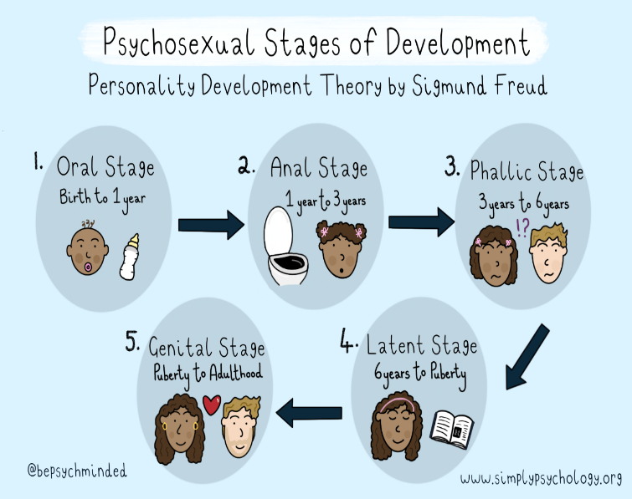
Freud (1905) proposed that behaviour is affected and shaped by early life encounters, and that conflicts arising throughout these stages can exert a lasting impact on an individual's personality and behaviour, allowing them to develop a sense of competence (Freud, 1905). Contrary to other child development theories that propose ongoing changes in personality throughout life, Freud's (1905) perspective emphasised the significance of early experiences in moulding development.
(Source: Mcleod, 2023).
These theories link with the NOS of developing relationships that promote safeguarding, rights and inclusion, and wellbeing. If key workers can promote these efficiently by adopting child-centred approaches based on strong relationships and clear communication, children are more likely to feel a sense of security, which has a positive effect on their development and learning, leading to smooth transitions (Government, 2014).
By building strong relationships through continuous communication with children, they are able to develop a foundation for personality development and shape relationships, social expectations as well as attitudes to rejection (Fonagy et al., 2002). Children learn about their role in the relationship through interactions with the key worker, and as time goes on, they begin to sense both their own and others’ feelings and differences (Fonagy et al., 2002).
Parent et al. (2018) argue that practitioners should be aware of the stresses associated with transition and implement the necessary approaches to reduce these. Not having this knowledge is likely to increase if it is not dealt with in the correct manner (Parent et al., 2018).
According to Love et al. (1992), smooth transitions are based on activities that positively impact children’s development. Patel (no date) highlights the importance of play, stating that it broadens thinking and allows children to acquire creativeness to develop ideas, leading to more successful learning. Key workers should provide the opportunity and support to allow children to commence their own learning (Patel, no date). Similarly, UNICEF (2018) states that play allows children to flourish, build confidence and make associations.
Despite Whitebread et al.’s (2012) view that play is viewed as an unimportant activity with few learning opportunities, Fisher (2020) argues that learning takes place during play, and that children develop transferrable skills required for the wider world, and therefore transition should advocate play. Fisher (2020) focuses on the importance of child-centred approaches in play and recognises that all children may be at different stages of development. Key workers should therefore ensure individual needs are met to promote wellbeing (Fisher, 2020).
The EYFS Framework also encourages learning through play, highlighting its need to build confidence, relationships, goal setting and problem solving (DfE, 2023). Key workers have the responsibility to promote the learning of children, ensuring they are ready for the next phase by carefully planning and communicating with all individuals involved in the process (DfE, 2023). This is based on Vygotsky’s (1978) ideas who suggests that children’s development is linked with play and that it provides children with the skills to develop and stimulate curiosity. They are inspired by this curiosity to engage in critical thinking, problem solving and gaining knowledge (Vygotsky,1978). Key workers have an integral part to play in this process and have a responsibility to guide children and manage the experiences that encourage and support development (Vygotsky, 1978). Play also gives children choice and freedom, encouraging thought and decisions, allowing children to gain emotional skills and learn how to process different environments (Vygotsky, 1978). It is vital that key workers promote participation in activities that encourage exploration, communication, creative and physical play, meeting NOS requirements (NOS, no date).

What can key workers do to ensure successful transitions for children?
Patel (no date) states that key workers should encourage and assist with developing behaviour that children can relate to throughout their lives and argues that smooth transitions lead to easier adjustments for both children and parents.
Moir and Johnson’s (2021) study to understand what is required to promote smooth transitions, highlights the importance of inaugural activities to assist with smooth transitions, and how such planning can reduce anxiety in children and their parents.

According to the Child Welfare Information Gateway (no date) key workers have an integral part to play in smooth transitions, and must work collaboratively with children, parents and other staff to ensure clear communication and strong relationships which lead to effective nurturing environments.
(Source: Early Years careers, 2016)
These are environments that promote listening, love, safety and protection, using discipline to set limits and help children feel a sense of safety (Child Welfare Information Gateway, no date). This can be achieved by encouraging children to express their feelings and ensuring appropriate environments to assist with levels of anxiety (Hunter, no date).
Children face transitions in different learning environments, social group and roles (Vogler, Crivello and Woodhead, 2008). Their ability to adapt to these environments affects their sense of identity and is based on the help and support provided by key workers in the nursery setting (Vogler, Crivello and Woodhead, 2008). Vogler, Crivello and Woodhead (2008) argue that multiagency working and cultural interventions lead to improved participation from both parents and children.
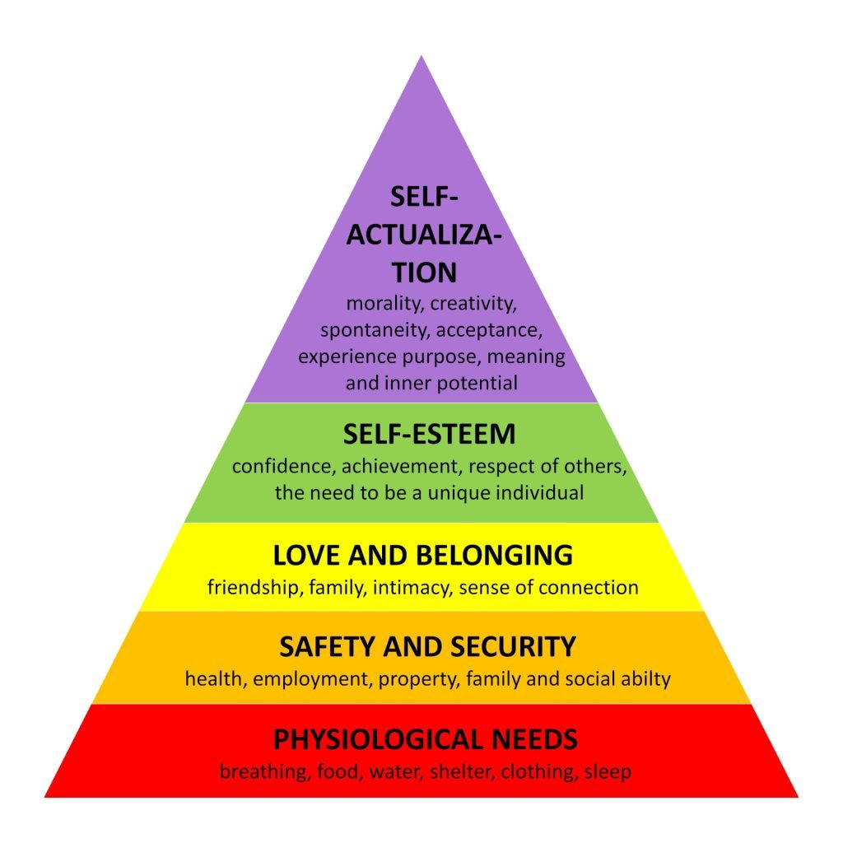
This helps build relationships and allows the child to develop attachments (Vogler, Crivello and Woodhead, 2008). This builds on Maslow’s (1954) theory which suggests that children need to be fed, have safety, sleep and confidence in order to transition. He claims that physiological, safety, love, esteem and self-actualisation are all needs of human beings (Maslow, 1954). These are organised in a pyramid and is based on the idea that these need to be met before progress can be made up the hierarchy to the more complex needs (Maslow, 1954). This theory suggests that all individuals are more likely to be successful if basic needs are met and allows key workers to identify any gaps in children’s development (University of Reading, no date). Therefore, children who have their basic needs can transition smoothly (University of Reading, no date).

(Source: Simply Psychology, 2023)
Strategies have been implemented to facilitate such environments for children. According to the DfE (2017), the child should be gradually introduced into the setting over time and flexibility should be given to the key worker assigned to the child. If there is a greater bond with a particular key worker, then this person should be allocated the role for the child (DfE, 2017). Children should also be given the opportunity to visit the new setting, prior to starting (DfE, 2017). Similarly, Birthto5Matters (no date) highlights the importance of children making frequent visits to the setting, stating that they benefit from informal sessions that allow them an insight into the setting at different times.
Transition should be based on the child’s specific pace and key workers should remain flexible to ensure that the individual needs of the child are met (Birthto5Matters, no date). Similarly, Devon County Council (DCC) (2022) state that activities undertaken by the key worker must be universal, targeted, and specialist to ensure smooth transition. Some children may not experience a smooth transition and experience feelings of stress and confusion, who will need additional support to gain comfort and ease (Birthto5Matters, no date). Key workers need to be attentive to ensure they can easily identify what the child needs to cope with the new setting (Birthto5Matters, no date). Routines should be adapted to meet the needs of the child, remembering that a one size fits all approach is ineffective practice (Birthto5Matters, no date). However, research undertaken by Seiberlich (2016) shows that consistent routines lead to improved behaviour and transition within the early years. Birthto5Matters (no date) explains that having a knowledge of the child’s background, nationality and language also allows the key worker to offer familiar settings and experiences to help with transitions.
It is also a requirement for key workers to consult parents to keep them updated of processes and share information with relevant agencies effectively during meetings (DfE, 2017). According to Nursery Story (2021), this leads to successful transitions, with strong relationships being formed and inputs from all involved individuals enhancing the support provided.
Effective transition is based on efficient communication, through the use of reports, visits, and consultation with parents (DfE, 2017). Wiltshire Local Officer (no date) also claims that effective communication can contribute to creating a shared understanding of children's strengths, needs or interests and that key workers should be involved in all decision making (Birthto5Matters, no date).
DCC (2022) highlights the importance of key workers taking time to get to know the child, discuss the child’s needs with parents and practitioners to share ideas and offer solutions to ensure familiar routines and environments. Moir and Johnson’s (2021) study concluded that multiagency working optimises positive transitions.


(Source: WJEC, no date)
Settings should use a transition document to record the child’s levels of learning and development and to note information about the child’s strengths, difficulties and support needs (DCC, 2022). Similarly, Birthto5Matters (no date) states that records should be made of observations, such as enjoyable moments, distressed moments, strategies implemented and the impact of these, and should be shared with parents and external agencies to inform decision making.
Work carried out by Whalley (2007) highlights the achievements gained by involving parents in their child’s care and development. Research also shows the importance of continuous and joint training between external agencies, and the continuous communication and sharing of knowledge between these individuals (Karila et al., 2022).
Key workers should liaise with other nurseries and early years settings to share knowledge and experience on what makes effective transitions (DfE, 2017). The DfE (2017) also claims that activities should be put in place to prepare children for the transition, such as those that promote increased independence such as play.
Finally, continuity of care is another key factor to consider (Wiltshire Local Offer, no date). During the transition process, children who benefit from continuity of care will experience a feeling of safety and confidence, meeting Maslow’s (1954) hierarchy of needs and experiencing a smooth transition (Wiltshire Local Offer, no date).
It is important that key workers remember to take a holistic approach in the early years setting, addressing children’s individual needs and understanding the complexities that can be involved with transition (Parenta, 2021). Furthermore, Scottish Social Services Council (no date) claim that not only should key workers take into consideration intellectual aspects, but they should also consider children’s wellbeing when adopting a holistic approach. Key workers should use this information to plan appropriate activities to promote smooth transitions (Leicestershire County Council, no date). This type of approach provides children with curiosity and enables them to become creative and independent, resulting in greater confidence and improved communication skills (Twinkl, no date).

How do we know when child has successfully navigated transition?

When a child has successfully transitioned, they will develop friendships, maintain self-esteem and confidence, show an increased interest in the environment, make a smooth transition into their new routine and experience continuity with learning (Anna Freud, 2021). Key workers should look out for signs that the child is uncomfortable, such as screaming, withdrawal or an inability to eat and revise their plan or try other approaches if the child does not show signs of settling (First Discoveries, no date). When a child has settled, they will accept being left at the setting by their parents, develop friendships with children, engage in the activities provided by the key worker and develop a bond and strong relationship with this person (First Discoveries, no date).
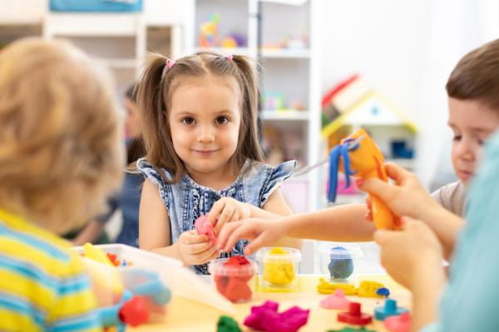
(Source: HFL Education, 2023)

Summary

- Smooth transitions are important as they impact the development and learning of children witch ultimately shapes their behaviours and attitudes for the rest of their lives (Queensland Government, 2023).
- Key workers should encourage communication between children, parents and multi-agency workers to form opinions, and use this to inform decisions (DfE, 2017). Key workers should also remain flexible, observant and open to ensure child centred approaches (DfE, 2017).
- By implementing effective strategies, children are more likely to have smooth transitions, meet Maslow’s hierarchy of needs and successfully complete the stages of Freud (1905) and Bowbly’s (1969) attachment and psychosexual stages.

Reference List

Adeona (2021) The Importance of Transitions in Early Childhood. Available at: https://adeona.com.au/the-importance-of-transitions-in-early-childhood/ (Accessed: 23 November 2023).
Anna Freud (2021) Supporting children's transition to secondary school. Available at: https://www.startnowcornwall.org.uk/documents/supporting-children-through-secondary-transition-final.pdf (Accessed: 26 November 2023).
Birthto5Matters (no date) All About…transitions. Available at: https://birthto5matters.org.uk/wp-content/uploads/2021/03/All-about...-transitions.pdf (Accessed: 26 November 2023).
Birthto5Matters (no date) Transitions. Available at: https://birthto5matters.org.uk/transitions/#:~:text=EYFS%20to%20KS1.-,High%20quality%20transitions%20recognise%20the%20importance%20of%20feeling%20%E2%80%9Cknown%E2%80%9D.,up%20children's%20individual%20learning%20journeys. (Accessed: 22 November 2023).
Bowlby, J. (1969). Attachment. New York: Basic Books.
Care Council for Wales (2013) National Occupational Standards. Available at: https://socialcare.wales/cms-assets/documents/NOS-Guide-for-social-care-early-years-and-childcare.pdf (Accessed: 22 November 2023).
Cherry, K. (2023) What Is Attachment Theory? The Importance of Early Emotional Bonds. Available at: https://www.verywellmind.com/thmb/oUNEbs0cvMEXWHcBjCaF408b2Kg=/1500x0/filters:no_upscale():max_bytes(150000):strip_icc()/what-is-attachment-theory-2795337-5c521affc9e77c0001859c1d.png (Accessed:25 November 2023).
Child Welfare Information Gateway (no date) Nurturing Environments. Available at: https://www.childwelfare.gov/pubPDFs/SilentRealities_21.pdf (Accessed: 26 November 2023).
Crafter, S., Maunder, R. and Soulsby, L. (2019) Developmental transitions: Exploring stability and change through the lifespan. Available at: https://www.routledge.com/Developmental-Transitions-Understanding-changes-and-adaptations-through/Crafter-Maunder-Soulsby/p/book/9781138650534 (Accessed: 23 November 2023).
Department for Education (2017) Study of Early Education and Development: Good practice in Early Education. Available at: https://assets.publishing.service.gov.uk/media/5a8061f4ed915d74e622e223/SEED__Good_Practice_in_Early_Education_-_RR553.pdf (Accessed 29 November 2023).
Department for Education (2023) Statutory framework for the early years foundation stage. Available at: https://assets.publishing.service.gov.uk/government/uploads/system/uploads/attachment_data/file/1170108/EYFS_framework_from_September_2023.pdf (Accessed: 25 November 2023).
Devon County Council (2022) Transition in the early years: Guidance for schools and settings. Available at: https://www.devon.gov.uk/support-schools-settings/inclusion/transition/transition-in-the-early-years/ (Accessed: 26 November 2023).
Dockett, S. (2018). ‘Transition to school: Professional collaborations’, Australian Educational Leader, 40(2). Available at: Transition to school: Professional collaborations | Australian Educational Leader (informit.org) (Accessed: 25 November 2023).
Early Years Careers (2016) Is passion enough to work childcare? Available at: https://www.earlyyearscareers.com/eyc/latest-news/is-passion-enough-to-work-childcare/ (Accessed: 26 November 2023).
Early Years Scotland (2021) Supporting and Understanding Transitions in Early Years. Available at: https://i.ytimg.com/vi/dH-WbTGMJaY/maxresdefault.jpg (Accessed: 23 November 2023).
Education Scotland (2023) What are transitions? Available at: https://education.gov.scot/parentzone/my-child/transitions/what-are-transitions/#:~:text=%E2%80%8BTransitions%20are%20the%20moves,to%20further%20education%20and%20beyond. (Accessed: 22 November 2023).
First Discoveries (no date) How to Help Young Children Settle Into a New Nursery. Available at: https://www.firstdiscoverers.co.uk/new-nursery-settle/ (Accessed 26 November 2023).
Fonagy, P., Gergely, G., Jurist, E., and Target, M. (2002) Affect Regulation, Mentalization, and the Development of the Self. New York: Other Press.
Freud, S. (1905) On Sexuality: Three Essays on the Theory of Sexuality. Penguin.
Government (2014) National Occupational Standards (NOS). Available at: https://www.gov.uk/government/publications/national-occupational-standards (Accessed: 22 November 2023).
HFL Education (2023) 5 Top tips for supporting smooth transitions in the Early Years. Available at: https://www.hfleducation.org/blog/5-top-tips-supporting-smooth-transitions-early-years (Accessed: 28 November 2023).
HM Government (2018) Working Together to Safeguard Children. Available at: https://assets.publishing.service.gov.uk/media/5fd0a8e78fa8f54d5d6555f9/Working_together_to_safeguard_children_inter_agency_guidance.pdf (Accessed: 29 November 2023).
Hunter, C. (no date) Examples of nurturing – How to create a supportive environment in Early Years. Available at: https://www.teachearlyyears.com/learning-and-development/view/nurturing-environments#:~:text=Using%20the%20environment,is%20looked%20after%20and%20valued. (Accessed: 26 November 2023).
Karila, K., Sharmahd, N., Balduzzi, L. and Mlinar, M. (2022) Initial training as a significant forum to build professional competences for smooth and inclusive early years’ transitions. Available at: https://www.issa.nl/sites/default/files/u794/Cross-country-report.pdf (Accessed: 29 November 2023).
Leicestershire County Council (no date) Children’s Starting Points – a holistic approach. Available at: https://resources.leicestershire.gov.uk/sites/resource/files/field/pdf/2022/3/11/children-starting-points-a-holistic-approach.pdf (Accessed: 26 November 2023).
Love, J. M., Logue, M. E., Trudeau, J. V., and Thayer, K. (1992) Transitions to Kindergarten in American Schools. Portsmouth: US Department of Education.
Maslow, A. (1954) Motivation and personality. New York: Harper and Row.
Mcleod, S. (2023) Freud’s Psychosexual Theory And 5 Stages Of Human Development. Available at: https://www.simplypsychology.org/wp-content/uploads/freud-psychosexual-stages.png (Accessed: 26 November 2023).
Medium (2019) Intersectionality In The Early Years Setting. Available at: https://medium.com/@theblacknurserymanager/in-any-early-years-setting-the-richness-of-the-experiences-that-the-children-have-with-regards-to-f3b029d7eae7 (Accessed: 23 November 2023).
Moir, T. and Johnson, J. (2021) ‘Ensuring Quality Transitions From Early Years' Establishments Into Primary Schools: Putting Research Into Practice’, Front Psychol, 23. Available at: https://www.ncbi.nlm.nih.gov/pmc/articles/PMC8490665/ (Accessed: 26 November 2023).
National Instture for Health and Care Excellence (NICE) (2015) Children's Attachment: Attachment in Children and Young People Who Are Adopted from Care, in Care or at High Risk of Going into Care. London: NICE. Available at: https://www.ncbi.nlm.nih.gov/books/NBK356196/ (Accessed: 25 November 2023).
NOS (no date) Support children’s play and learning. Available at: https://www.ukstandards.org.uk/PublishedNos-old/TDASTL10.pdf (Accessed: 26 November 2023).
Nursery Story (2021) Supporting Children and Parents with Transitions. Available at: https://nurserystory.co.uk/resource-centre/supporting-children-and-parents-with-transitions/ (Accessed: 22 November 2023).
Oxfordshire County Council (2017) Smooth Transitions in the Early Years: A Good Practice Guide. Available at: https://www2.oxfordshire.gov.uk/cms/sites/default/files/folders/documents/childreneducationandfamilies/informationforchildcareproviders/Toolkit/goodpractice/EYTransitionPack.pdf (Accessed: 22 November 2023).
PACEY (2014) A guide to help you think about how you can support the transitions and settling in processes that the children in your care experience. Available at: https://www.pacey.org.uk/Pacey/media/Website-files/school%20ready/PG10-transitions-and-settling-in.pdf (Accessed: 22 November 2023).
Parent, S., Lupien, S., Herba, C. M., Dupéré, V., Gunnar, M. R., and Séguin, J. R. (2018) ‘Children’s cortisol response to the transition from preschool to formal schooling: a review’, Psych neuroendocrinology, 99, 196–205. Available at: DOI: 10.1016/j.psyneuen.2018.09.013 (Accessed: 25 November 2023).
Parenta (2021) Embracing a holistic approach to SEND. Available at: https://www.parenta.com/2021/08/01/a-holistic-approach-to-send/ (Accessed: 28 November 2023).
Patel (no date) Transitions in early years – Ideas for supporting children and families. Available at: https://www.teachearlyyears.com/a-unique-child/view/supporting-transitions-in-the-early-years (Accessed: 22 November 2023).
Queensland Government (2023) Transitions in the early years. Available at: https://earlychildhood.qld.gov.au/early-years/transitions (Accessed: 22 November 2023).
Rainbow Early Years (2014) EYFS.... Available at: https://www.google.co.uk/url?sa=i&url=http%3A%2F%2Frainbowearlyyears.co.uk%2Feyfs.htm&psig=AOvVaw04c7yEKuqKbDYUaTvl-UKc&ust=1700591203950000&source=images&cd=vfe&opi=89978449&ved=0CBAQjRxqFwoTCMDu84Ga04IDFQAAAAAdAAAAABAD (Accessed: 25 November 2023).
Scottish Social Services Council (no date) Holistic view of child development and learning. Available at: https://learn.sssc.uk.com/apps/development/chapter-3/#:~:text=Holistic%20approaches%20to%20child%20development,as%20cognitive%20aspects%20of%20learning. (Accessed: 26 November 2023).
Seiberlich, L. (2016) ‘The Effects that Consistent Routines have on Transitions’, Masters of Arts in Education Action Research Papers. Available at: https://sophia.stkate.edu/maed/142/ (Accessed: 29 November 2023).
Simply Psychology (2023) Maslow’s Hierarchy Of Needs. Available at: https://www.simplypsychology.org/maslow.html (Accessed: 28 November 2023).
Tops Days Nurseries (2019) Parent Guide to the Early Years Foundation Stage. Available at: https://www.topsdaynurseries.co.uk/parent-guide-early-years-foundation-stage/ (Accessed: 26 November 2023).
TTS (no date) Early Years Funding: What support is available for Nursery Settings?. Available at: https://worldofeducation.tts-group.co.uk/early-years-funding-what-support-is-available-for-nursery-settings/ (Accessed: 22 November 2023).
Twinkl (no date) Holistic Development (EYFS). Available at: https://www.twinkl.co.uk/teaching-wiki/holistic-development-eyfs#:~:text=A%20Holistic%20Development%20approach%20in%20EYFS%20motivates%20children%20to%20learn,social%20skills%2C%20and%20greater%20confidence. (Accessed: 26 November 2023).
UNICEF (2018) Learning Through Play. Available at: https://www.unicef.org/sites/default/files/2018-12/UNICEF-Lego-Foundation-Learning-through-Play.pdf (Accessed: 25 November 2023).
University of Reading (no date) Maslow’s hierarchy of needs. Available at: https://www.futurelearn.com/info/courses/supporting-learning-primary/0/steps/58666#:~:text=Abraham%20Maslow%20was%20an%20American,the%20shape%20of%20a%20pyramid. (Accessed: 26 November 2023).
Vogler, P., Crivello, G. and Woodhead, M. (2008) Early childhood transitions research: A review of concepts, theory, and practice. The Netherlands: Bernard van Leer Foundation.
Vygotsky, L. (1978) Mind in society: The development of higher psychological processes. Cambridge: Harvard University Press.
Warren, J., and Harden-Thew, K. (2019) ‘Transitions outside the mainstream: Stories of children and their families’, Australasian Journal of Early Childhood, 44(1). Available at: https://journals.sagepub.com/doi/10.1177/1836939119841458#:~:text=Transition%20has%20become%20focal%20point,et%20al.%2C%202008 (Accessed: 23 November 2023).
Whalley, M. (2007) Involving Parents in their Children’s Learning. Great Britain: SAGE.
Wiltshire Local Offer (no date) Smooth Early Years Transitions: Tips for Parents and Educators. Available at: https://wiltshirelocaloffer.org.uk/early-years-transitions/ (Accessed: 26 November 2023).
WJEC (no date) Working in Partnership with others. Available at: http://resource.download.wjec.co.uk.s3-eu-west-1.amazonaws.com/vtc/2018-19/hsc18-19_3-3/_multi-lang/unit02/01-principles-of-partnership-importance-of-multi-agency-working.html (Accessed: 26 November 2023).

