Module: Population Health and Digital Health Promotion
Module code: LCHS7009
Lecturer: Dr. Raheela Shaikh

Assignment Title: Blog 1 & 2.
Agoraphobia and Digital Health Promotion.

Student name: Abeer Ishal
Student number: 2128229


(ExeoFortis Self-generated picture by using Gemini Ai, 2026).

Agoraphobia: a public health concern

The Adult Psychiatric Morbidity Survey in England revealed that agoraphobia exhibits significant comorbidity with other mental health disorders, impacting 17.9% of individuals with post-traumatic stress disorder (PTSD), in contrast to a general comorbidity rate of 14.5% among those without PTSD (Qassem et al., 2021). Furthermore, agoraphobic avoidance is associated with depression and social anxiety, with the latter acting as a common underlying mechanism driven by fears of judgement from others, self-criticism, panic attacks, and feeling external threats (Lambe et al., 2023).

Individuals with a panic disorder lasting over 12 months are at the greatest risk of developing agoraphobia (Schultz et al., 2023). Women show twofold susceptibility to agoraphobia in comparison to men (Preti et al., 2021), and following the publication of the Diagnostic and Statistical Manual of Mental Disorders, Fifth Edition (DSM-5) in 2013, agoraphobia was recognised as a unique diagnostic classification, independent from panic disorder (Fernández-Martínez and Muris, 2026).

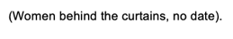

Agoraphobia is marked by avoiding normal public settings where egress may be challenging (Lambe et al., 2023). Agoraphobia is a serious public health issue as it decreases individuals’ quality of life, increases risks of mental comorbidities, limits mobility, limits one from work, education, social engagement, restricts patients' access to therapy and often worsens co-existing medical conditions (Preti et al., 2021; Liu et al., 2024).

An App that helps people with Agoraphobia by giving them therapy.

According to Pauley et al. (2023) digital Cognitive Behavioural Therapy (CBT) for agoraphobia had an 86% improvement rate relative to no intervention and was equivalent to traditional in-person therapy, with no statistically significant difference between the treatment approaches.

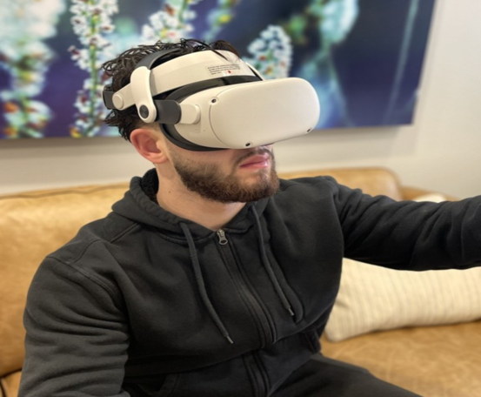
The National Institute for Health and Care Excellence (NICE) presently advocates for the use of Virtual Reality Technologies (VRT) for agoraphobia in research contexts, with some trials being executed in specific NHS trusts, including Greater Manchester, Oxford Health, and South-West London and more (Nice, 2023).



One available digital option is app-based exposure therapy, which is provided via a smartphone programme which includes sensory exposure, psychoeducation, symptom tracking, and real-world exposure tasks (Schultz et al., 2023; Guth et al., 2025). Furthermore, the same study argues some apps also include virtual reality exposure for situations that people are afraid of, like lifts, trains, or crowded public areas.

The holistic approach: Helping people within their homes.

Helping people practise skills in real-life situations rather than only recalling them for clinic sessions is a significant advance for health promotion, as digital intervention delivers support directly in the environments where avoidance behaviour typically occurs (Jung et al., 2025; Guth et al., 2025).

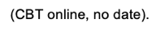
Three key theories are incorporated into the most effective CBT treatment for agoraphobia: Inhibitory Learning Theory, which teaches users to sit with anxiety rather than run away from it, teaching them that feared outcomes are unlikely; Interoceptive Exposure Theory, which helps users confront and tolerate the physical sensations that trigger panic; and Personalisation Theory, which customises treatment content to each individual's unique needs and fears based on prior assessment (Jung et al., 2025).

Reference

CBT online (no date) available at: https://www.pac.bluecross.ca/media/1522/0711_icbt720x720aug2020.jpg?format=webp&v=1d6707ed182aa80 (Accessed: 10 June 2026).

Fernández-Martínez, I. and Muris, P. (2026) “The Youth Anxiety Measure for DSM-5 (YAM-5): An Updated Systematic Review of its Psychometric Properties,” Child psychiatry and human development, 57(2), pp. 593–611. Available at: https://doi.org/10.1007/s10578-024-01712-3.

Guth, M., Wiebe, A., Ekhlas-Schumann, M., Rodenjohann, A., Rohlfsen, F., Buchholz, J., Selaskowski, B., Philipsen, A., and Braun, N. (2025). “Mobile App–Guided Exposure Therapy for Panic Disorder With and Without Agoraphobia: Randomized Controlled Trial,” Journal of medical Internet research, 27(12), pp. e76389–e76389. Available at: https://doi.org/10.2196/76389.

Jung, H. W., Jang, K. W., Nam, S., Kim, A., Lee, J., Ahn, M. E., Lee, S.-K., Kim, Y. J., Shin, J.-K., and Roh, D. (2025). “Digital Cognitive Behavioral Therapy for Panic Disorder and Agoraphobia: A Meta-Analytic Review of Clinical Components to Maximize Efficacy,” Journal of clinical medicine, 14(5), p. 1771. Available at: https://doi.org/10.3390/jcm14051771.

Lambe, S., Bird, J. C., Loe, B. S., Rosebrock, L., Kabir, T., Petit, A., Mulhall, S., Jenner, L., Aynsworth, C., Murphy, E., Jones, J., Powling, R., Chapman, K., Dudley, R., Morrison, A., Regan, E. O., Yu, L.-M., Clark, D., Waite, F., and Freeman, D. (2023). “The Oxford Agoraphobic Avoidance Scale,” Psychological medicine, 53(4), pp. 1233–1243. Available at: https://doi.org/10.1017/S0033291721002713.

Liu, D., Luo, M., Huang, Y., Tan, Y., Cheng, F. and Wu, Y., (2024). “Time trends in anxiety disorders incidence across the BRICS: an age-period-cohort analysis for the GBD 2021,” Frontiers in public health, 12:1467385 Available at: https://doi.org/10.3389/fpubh.2024.1467385.

Panic attack (no date) available at: https://bhbhospital.com/wp-content/uploads/2025/02/managing-panic-attacks.jpg. (Accessed: 20 May 2026)

Pauley, D., Cuijpers, P., Papola, D., Miguel, C., and Karyotaki, E. (2023). “Two decades of digital interventions for anxiety disorders: a systematic review and meta-analysis of treatment effectiveness,” Psychological medicine, 53(2), pp. 567–579. Available at: https://doi.org/10.1017/S0033291721001999.

Preti, A., Piras, M., Cossu, G., Pintus, E., Pintus, M., Kalcev, G., Cabras, F., Moro, M.F., Romano, F., Balestrieri, M. and Caraci, F. (2021). “The Burden of Agoraphobia in Worsening Quality of Life in a Community Survey in Italy,” Psychiatry investigation, 18(4), pp. 277–283. Available at: https://doi.org/10.30773/pi.2020.0342.

Qassem, T., Aly-ElGabry, D., Alzarouni, A., Abdel-Aziz, K., and Arnone, D. (2021). “Psychiatric Co-Morbidities in Post-Traumatic Stress Disorder: Detailed Findings from the Adult Psychiatric Morbidity Survey in the English Population,” Psychiatric quarterly, 92(1), pp. 321–330. Available at: https://doi.org/10.1007/s11126-020-09797-4.

Schultz, J., Baumeister, A., Schmotz, S., Moritz, S., and Jelinek, L. (2023) “Efficacy of an Internet-based intervention with self-applied exposure therapy in virtual reality for people with panic disorder: study protocol for a randomized controlled trial,” Current controlled trials in cardiovascular medicine, 24(1). Available at: https://doi.org/10.1186/s13063-023-07536-1.

The National Institute for Health and Care Excellence (2023). Virtual reality technologies for treating agoraphobia or agoraphobic avoidance: early value assessment. [online] Nice.org.uk. Available at: https://www.nice.org.uk/guidance/htg701/chapter/2-The-technologies. (Accessed: 1 June 2026).

Virtual Reality Exposure Therapy (no date) available at: https://media.licdn.com/dms/image/v2/D5612AQGMthUukeWGZg/article-cover_image-shrink_720_1280/article-cover_image-shrink_720_1280/0/1710957207127?e=2147483647&v=beta&t=uWLfsM10croRZH7fFmN4LFMpbAJGt3pM9KJelaPmCrY(Accessed: 10 June 2026).
Women behind the curtains (no date) available at: https://external-content.duckduckgo.com/iu/?u=https%3A%2F%2Ftse3.mm.bing.net%2Fth%2Fid%2FOIP.481T8bvX_BOxJbyGMehSRQHaEK%3Fr%3D0%26pid%3DApi&f=1&ipt=bb1e6e3cfb77009ba87d2b0c9a47d68e33000db9bf3fa5ead5c705f00db2d506&ipo=images (Accessed: 11 June 2026).

Can digital technology help people with agoraphobia get back into the society?

Agoraphobia is an acute public health concern as it diminishes people's autonomy, mobility, and quality of life (Preti et al., 2021). This condition is not only debilitating but is also linked to other serious medical conditions, such as social phobia, panic disorder and major depressive disorder (Preti et al., 2021). The next generation of digital agoraphobia interventions needs to be effective in therapy and easier to use, given that current digital tools have mixed effects on well-being, lack participation, and has high dropout rates (Lalk et al., 2025; Smith et al., 2025; Guth et al., 2025).

An app that helps people with agoraphobia, to confront their fears.

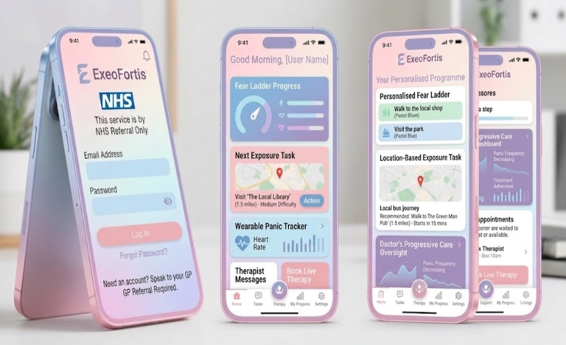
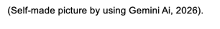
ExeoFortis, meaning "to go out - bravely" in Latin, is a proposed NHS app offering fear ladders, location-based tasks, wearable tracking, and therapist dashboards. However, too many features may overwhelm users (Smith et al., 2025), tracking could intensify bodily anxiety (Jung et al., 2024), and digital exclusion remains likely (Robinson et al., 2024). Without rigorous testing, this promising tool risks failing those it aims to support.

A good public health app would allow users to pick a single valued goal, like going to work alone, or entering a shop, then divide that goal into graded activities completed in real-world settings instead of just on-screen (Jung et al., 2025; Lalk et al., 2025).

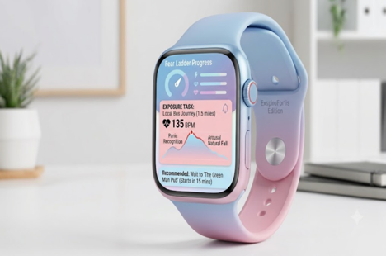
The app, linked to a smartwatch, would track heart rate during exposure tasks. This mirrors the principles of exposure-based learning in anxiety and agoraphobia treatment, to help individuals recognise that their body's anxiety naturally rises and falls without causing any actual harm (Jung et al., 2024; Schultz et al., 2023).

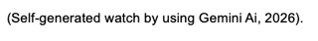
How would this App help your health?

Recent research shows that digital treatments work better when they include sensory based exposure, personalised task design, and counsellor support rather than just general self-help (Jung et al., 2025), this is what would be used to change behaviour.

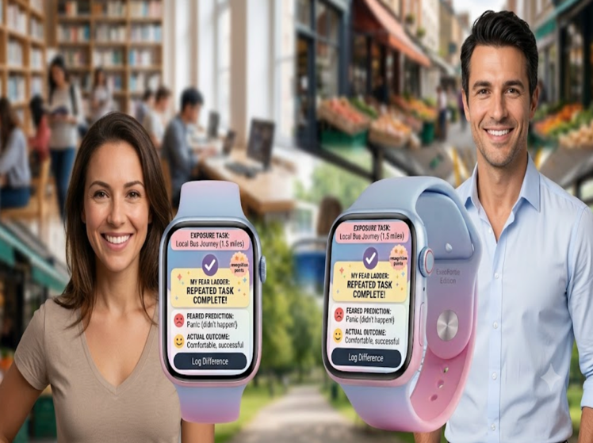
ExeoFortis, the app, will purposely encourage clients to try out their feared predictions in different settings, to repeat the task until they stop avoiding it, and then to write down the difference between what they thought would happen and what actually did. Through this therapy, clients will improve their ability to realise that these scenarios pose no physical harm (Jung et al., 2024; Jung et al., 2025).

When travel expenses, fear, or stigma restrict people from getting care, digital therapy can increase help access (Karyotaki, 2023; Zandieh et al., 2024). Although benefits like location flexibility and real-life therapy practice depend on user engagement and app quality, the data remain limited and more research is needed, even though app-based therapy has helped people to ease agoraphobic symptoms (Schultz et al., 2023; Guth et al., 2025; Lalk et al., 2025). Despite this, challenges remain as users may disengage, feel unsafe, be excluded by low income, or low digital literacy, all recognised equity risks in mental health digital realm (Robinson et al., 2024; Löchner et al., 2025).


Reference

Guth, M., Wiebe, A., Ekhlas-Schumann, M., Rodenjohann, A., Rohlfsen, F., Buchholz, J., Selaskowski, B., Philipsen, A., and Braun, N. (2025). “Mobile App–Guided Exposure Therapy for Panic Disorder With and Without Agoraphobia: Randomized Controlled Trial,” Journal of medical Internet research, 27(12), pp. e76389–e76389. Available at: https://doi.org/10.2196/76389.

Jung, H. W., Jang, K. W., Nam, S., Ahn, M. E., Lee, S.-K., Kim, Y. J., Shin, J.-K., Park, J. H., and Roh, D. (2024). “Personalized virtual reality exposure for panic disorder and agoraphobia: A preliminary neurophysiological study,” Comprehensive psychiatry, 129. Available at: https://doi.org/10.1016/j.comppsych.2023.152447.

Jung, H. W., Jang, K. W., Nam, S., Kim, A., Lee, J., Ahn, M. E., Lee, S.-K., Kim, Y. J., Shin, J.-K., and Roh, D. (2025). “Digital Cognitive Behavioral Therapy for Panic Disorder and Agoraphobia: A Meta-Analytic Review of Clinical Components to Maximize Efficacy,” Journal of clinical medicine, 14(5), p. 1771. Available at: https://doi.org/10.3390/jcm14051771.

Karyotaki, E., Miguel, C., Panagiotopoulou, O. M., Harrer, M., Seward, N., Sijbrandij, M., Araya, R., Patel, V., and Cuijpers, P. (2023). “Digital interventions for common mental disorders in low- and middle-income countries: A systematic review and meta-analysis,” Global mental health, 10. Available at: https://doi.org/10.1017/gmh.2023.50.

Lack of quality of life (no date) Available at: https://livhospital.b-cdn.net/wp-content/uploads/2025/12/29102945/image-3787.webp (Accessed: 29 June 2026)

Lalk, C., Väth, T., Hanraths, S., Pruessner, L., Timm, C., Hartmann, S., Barnow, S., and Rubel, J. (2025). “Evaluation of an Online-Based Self-Help Program for Patients With Panic Disorder: Randomized Controlled Trial,” Journal of medical Internet research, 27(6), p. e54062. Available at: https://doi.org/10.2196/54062.

Löchner, J., Carlbring, P., Schuller, B., Torous, J., and Sander, L. B. (2025). “Digital interventions in mental health: An overview and future perspectives,” Internet interventions : the application of information technology in mental and behavioural health, 40. Available at: https://doi.org/10.1016/j.invent.2025.100824.

Preti, A., Piras, M., Cossu, G., Pintus, E., Pintus, M., Kalcev, G., Cabras, F., Moro, M.F., Romano, F., Balestrieri, M., Caraci, F., Dell’Osso, L., Sciascio, G. Di, Drago, F., Hardoy, M.C., Roncone, R., Faravelli, C., Musu, M., Finco, G., Nardi, A.E. and Carta, M.G. (2021) “The Burden of Agoraphobia in Worsening Quality of Life in a Community Survey in Italy,” Psychiatry investigation, 18(4), pp. 277–283. Available at: https://doi.org/10.30773/pi.2020.0342.

Robinson, A., Flom, M., Forman-Hoffman, V. L., Histon, T., Levy, M., Darcy, A., Ajayi, T., Mohr, D. C., Wicks, P., Greene, C., and Montgomery, R. M. (2024). “Equity in Digital Mental Health Interventions in the United States: Where to Next?,” Journal of medical Internet research, 26(2), p. e59939. Available at: https://doi.org/10.2196/59939.

Schultz, J., Baumeister, A., Schmotz, S., Moritz, S., and Jelinek, L. (2023) “Efficacy of an Internet-based intervention with self-applied exposure therapy in virtual reality for people with panic disorder: study protocol for a randomized controlled trial,” Current controlled trials in cardiovascular medicine, 24(1). Available at: https://doi.org/10.1186/s13063-023-07536-1.

Smith, K. A., Ward, T., Lambe, S., Ostinelli, E. G., Blease, C., Gant, T., Gold, S. M., Holmes, E. A., Paccoud, I., Vinnikova, A., Klucken, J., Uhlhaas, P. J., Sanchez, C. G., Haining, K., Böge, K., Lahutina, S., Tomelleri, L., Ryan, S., Torous, J., and Cipriani, A. (2025) “Engagement and attrition in digital mental health: current challenges and potential solutions,” NPJ digital medicine, 8(1). Available at: https://doi.org/10.1038/s41746-025-01778-w.

Zandieh, S., Abdollahzadeh, S. M., Sadeghirad, B., Wang, L., McCabe, R. E., Yao, L., Inness, B. E., Pathak, A., Couban, R. J., Crandon, H., Torabiardakani, K., Bieling, P., and Busse, J. W. (2024). Therapist-guided remote versus in-person cognitive behavioural therapy: a systematic review and meta-analysis of randomized controlled trials,” Canadian Medical Association journal (CMAJ), 196(10), pp. E327–E340. Available at: https://doi.org/10.1503/cmaj.230274

