Rhiannon Thomas
Advanced AI and Machine Learning
Influence Maps
Lecturer: Gordon Dickers

Table of Contents
Introduction 3
Convolution Filters 3
Example of Convolution Filter 3
Calculation 4
Calculating distance of each cell 4
Example of using distance checking for influence maps 5
Equation 5
Calculation 5
Algorithm Chosen 6
Testing 6
Test 1 6
Test 2 6
Test 3 6
Test 4 6
Test 5 6
Test 6 7
How can the AI bot find the highest influence? 7
Evaluation 7
References 8
Bibliography 8
Appendix 9

Table of Contents
Figure 1 6

Introduction
In this assignment a theory will be investigated of using influence maps and then analyse and established approaches to be implemented. A suitable influence map method will then be selected and use the method to implement an influence map using C++ and then test the effectiveness of the code by evaluating its performance when guiding an AI bot through a dynamically changing environment.

Convolution Filters
A convolution is an operation which changes a function into something else. Convolutions are used so that the original function can be transformed into a form to get more information [1]. Image blur algorithms are ways to update analyses that involves spreading values out from their source [2].
The starting process of creating a convolution filter is to create an influence map where only the values marked are those where the units are actually located [2]. Then the algorithm will work through each individual cell and changes its value so it absorbs not only its own value but also the values of its neighbours [2]. This approach uses a filter called the Gaussian Kernel filter. To perform this filter, each cell in the influence map needs to be updated using this filter, to ensure that influence has spread to its maximum limits of the influence map, then repeat the entire update several times [2].

Example of Convolution Filters
Here is an example of using Convolution Filters using an influence map and Gaussian kernel filter.

Gaussian Kernel Filter
1/16 | 2/16 | 1/16
2/16 | 4/16 | 2/16
1/16 | 2/16 | 1/16

Influence map
 | Col 1 | Col 2 | Col 3 | Col 4 | Col 5 | Col 6
Row 1 | 32 | 32 | 32 | 34 | 34 | 36
Row 2 | 26 | 26 | 26 | 26 | 30 | 36
Row 3 | 18 | 18 | 18 | 24 | 24 | 24
Row 4 | 14 | 16 | 16 | 22 | 22 | 24
Row 5 | 14 | 14 | 14 | 20 | 20 | 18
Row 6 | 16 | 20 | 20 | 22 | 24 | 26
Row 7 | 16 | 22 | 22 | 24 | 26 | 30
Row 8 | 18 | 24 | 24 | 26 | 28 | 32

Calculation:

$$\left(\frac{1}{16}*14\right)+\left(\frac{2}{16}*14\right)+\left(\frac{1}{16}*20\right)+$$
$$\left(\frac{2}{16}*20\right)+\left(\frac{4}{16}*20\right)+\left(\frac{2}{16}*22\right)+$$
$$\left(\frac{1}{16}*22\right)+\left(\frac{2}{16}*22\right)+\left(\frac{1}{16}*24\right)=$$

$\frac{79}{4}$= (19.5)

To present an analysis of this methods’ space and time complexity the big O notation can be used. The big O notation is the language used to describe the complexity of the algorithm, such as how long it takes for the algorithm to run [2].
Key structures used:
- Arrays
- Graphs

This algorithm is suitable when using influence maps because when using an influence, coordinates are applied to it and the coordinates around the influence are also applied. By using convolution filters it will average out the coordinates of where the influence is positioned and the surrounding squares so when an AI bot comes into the zone the AI bot would automatically move the away or move towards the highest calculated influence in that zone.

The limitations of using this algorithm would be this specific algorithm takes time to implement onto the screen and when using the AI bot it can be slow and reactions to collisions with other bots [3].

The reason why this technique will not be sufficient to implement for this assignment is due to expenses, it will be expensive to implement this algorithm including graphically showing how the algorithm works on the screen. However, the only way which this algorithm will work without expenses would be to implement it using object oriented programming approach, which will show the numbers of the calculation on the screen rather than graphically showing how the influence map works.

Calculating distance of each cell
Another method which is used to update influence maps involves calculating the influence at each cell using a formula, an example could be calculating influence based upon distance. Distance-based equations can be used for AI decision making to reason about the world [5]. The AI will be able to move towards or away from influence by checking the distance between x and y positions of the AI and the influence source.

Example of using distance checking for influence maps
Below is an example of calculating the distance between two points.

$$I01=\left(1,1\right)=3.5$$
$$I01=\left(1,6\right)=3.5$$
$$r=8$$

Equation:
$$id=\frac{I01}{(e^{\left(d-r\right)}+1)}$$
Calculation:
$$x∆=1-6= -5$$
$$y∆=3-1= 2$$
$$d=\sqrt{{\left(-5\right)}^{2}+2^{2}}$$
$$d=\sqrt{29}=5.38$$
$$id=\frac{3.5}{(e^{\left(5.38-8\right)}+1)}$$
$$id=\frac{3.5}{(e^{\left(-2.62\right)}+1)}$$
$$id=3.26$$

Equation:
$$id=\frac{I02}{(e^{\left(d-r\right)}+1)}$$
Calculation:
$$x∆=1-6= -5$$
$$y∆=6-3= 3$$
$$d=\sqrt{{\left(-5\right)}^{2}+3^{2}}$$
$$d=\sqrt{34}=5.83$$
$$id=\frac{4.3}{(e^{\left(5.83-8\right)}+1)}$$
$$id=\frac{4.3}{(e^{\left(-2.17\right)}+1)}$$
$$id=3.85$$

To present an analysis of this methods’ space and time complexity is working out N. Usually the problems that need solving have a natural size which is referred to as N. Normally users refer to the resources used in solving problem sixe N and the most common resource which users are interested in is time (t). Users are interested in the average time taken to solve the problem when data is inputted, and the minimum and maximum times for the worst possible input configuration [4]. N is used when the running time is linear, like this calculation, the time increases in direct proportion with the size of N, when a small amount of processing is done on each step. When N doubles the time doubles [4].

Algorithm chosen
The algorithm which will be created in Visual Studio is the distance check method. This method has been chosen because it is effective. The source of influence will be calculated using distance checks between x and y values in the grid (influence map) and the x and y values of the influence source. The influence will then be calculated using the equation above setting Io as the position of the influence divided by e (distance – radius position) +1. The AI bot will be able to move using simple Up, Down, Left and Right functions. The AI bot will move to the direction of the highest influence source by checking Up, Down, Left and Right where the highest influence is and then move towards the source. The code is shown in the appendix.

Testing

Test No. | Test Name | Expectation | Actual | Did it work?  (Yes/No) | Screenshot
1 | Red Distance Calculation | $$\sqrt{9*9+9*9}$$  $$= 12.727922$$ | $$\sqrt{9*9+9*9}$$  $$= 12.727922$$ | Yes | 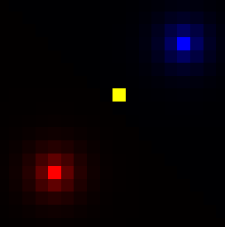
2 | Blue Distance Calculation | $$\sqrt{19*19+19*19}$$  $$= 26.87005$$ | $$\sqrt{19*19+19*19}$$  $$= 26.87005$$ | Yes
3 | Red Influence Calculation | $$id1=\frac{2.0}{\left(e^{\left(14.14-4\right)}+1\right)}$$  = 1.000079 | $$d1=\frac{2.0}{\left(e^{\left(14.14-4\right)}+1\right)}$$  = 1.000079 | Yes | 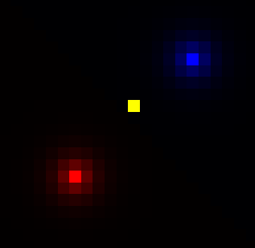
4 | Blue Influence Calculation | $$id1=\frac{2.0}{\left(e^{\left(28,28-4\right)}+1\right)}$$  = 1.000157 | $$id1=\frac{2.0}{\left(e^{\left(28,28-4\right)}+1\right)}$$  = 1.000157 | Yes
5 | AI bot movement | Moves left, right, up and down | Moves left, right, up and down | Yes | 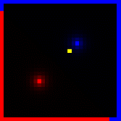  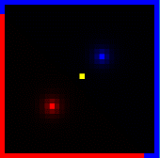  Before After
6 | AI move to highest influence | Move to blue influence | Move to blue influence | Yes | 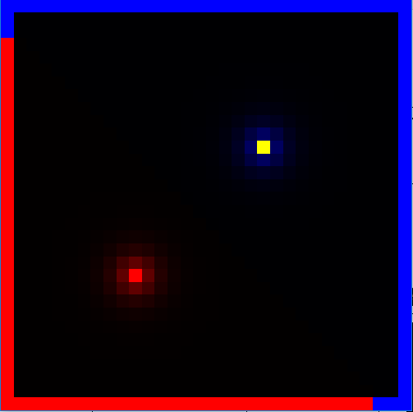

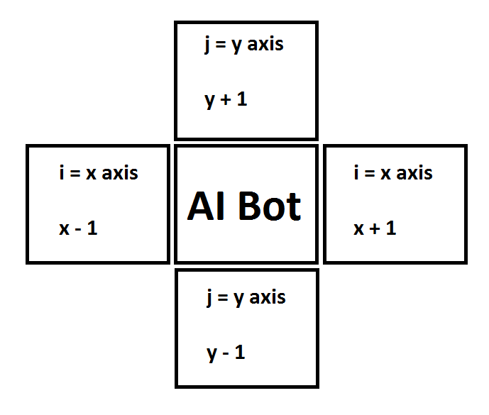
How can the AI bot find the highest influence?
In the algorithm which has been written, a function has been made for the AI bot to move. What has been done here is a simple technique which allows the AI to look Up, Down, Left and Right in the grid where the R,G,B colour values can be found. The AI is able to move due to the x and y coordinates, in Figure 1 there is an example of how the AI is able to move around the grid using the $\left[i\right][j]$ values of the two dimensional array which has been created at the top of the program. Also, for the AI bot to move to the highest influence, the influence variable must be set to a low number to start with so the influence can be updated correctly. Temporary variables must be used so when the AI bot moves, the location will be stored in a temporary variable. Lastly, below are screenshots which shows what happens when the algorithm has been implemented.
Figure 1: Example of AI bot looking Up, Down, Left Right
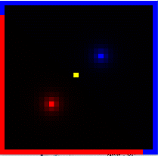
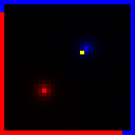
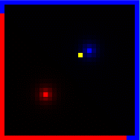
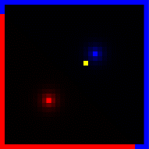
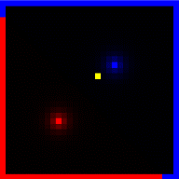
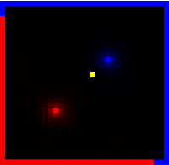
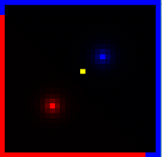
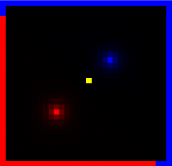

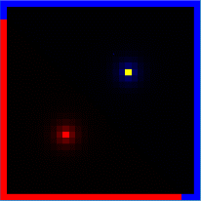
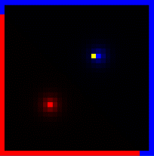

This is a timeline of screenshots where the AI starts at its start point and then moves towards the influence with the highest source.

Evaluation
In this assignment the two following influence mapping techniques have been discussed which are convolution filters using the Gaussian filter and distance checking. The technique that has been implemented was the distance check algorithm which works correctly, the AI bot successfully moves its way to the highest influence which has been calculated by the distance check. For future improvements, boundary algorithms can be implemented so the AI will be able to move away from the red influence and towards the blue influence when the red influence is in the way of the blue influence. Also, boundary algorithms can be used to ensure that the AI does not move off the grid (screen).

References

[1] | S. Chatterjee, “Different Kinds of Convolutional Filters,” 20 December 2017. [Online]. Available: https://www.saama.com/blog/different-kinds-convolutional-filters/.
[2] | J. F. Ian Millington, Arficial Intellegence for Games Second Edition, Morgan Kaufmann Publishers.
[3] | K. Sehgal, “A Simplified Explanation of the Big O Notation,” Medium, 26 November 2017. [Online]. Available: https://medium.com/karuna-sehgal/a-simplified-explanation-of-the-big-o-notation-82523585e835.
[4] | “Advantages/Disadvantages of using and not using a gaussian filter,” MathWorks, [Online]. Available: https://www.mathworks.com/matlabcentral/answers/64683-advantages-disadvantages-of-using-and-not-using-a-gaussian-filter.
[5] | A. J. Champandard, “The Mechanics of Influence Mapping: Representation, Algorithm & Parameters,” AiGameDev.com, 19 May 2011. [Online]. Available: http://aigamedev.com/open/tutorial/influence-map-mechanics/.
[6] | G. Dickers, “Moodle,” [Online]. Available: https://moodle.uwtsd.ac.uk/mod/resource/view.php?id=158111.

Bibliography

[1] | S. Chatterjee, “Different Kinds of Convolutional Filters,” 20 December 2017. [Online]. Available: https://www.saama.com/blog/different-kinds-convolutional-filters/.
[2] | J. F. Ian Millington, Arficial Intellegence for Games Second Edition, Morgan Kaufmann Publishers.
[3] | K. Sehgal, “A Simplified Explanation of the Big O Notation,” Medium, 26 November 2017. [Online]. Available: https://medium.com/karuna-sehgal/a-simplified-explanation-of-the-big-o-notation-82523585e835.
[4] | “Advantages/Disadvantages of using and not using a gaussian filter,” MathWorks, [Online]. Available: https://www.mathworks.com/matlabcentral/answers/64683-advantages-disadvantages-of-using-and-not-using-a-gaussian-filter.
[5] | A. J. Champandard, “The Mechanics of Influence Mapping: Representation, Algorithm & Parameters,” AiGameDev.com, 19 May 2011. [Online]. Available: http://aigamedev.com/open/tutorial/influence-map-mechanics/.
[6] | G. Dickers, “Moodle,” [Online]. Available: https://moodle.uwtsd.ac.uk/mod/resource/view.php?id=158111.

Appendix

////// Includes
#include <stdio.h>
#include <stdlib.h>
#include "glut.h"
#include <math.h>
#include <cmath>
#include <iostream>
using namespace std;
#define GRIDSIZE 32

////// Global Variables
typedef struct rgbtag {
float r;
float g;
float b;
}rgb;

typedef struct vector {
float x; // position of grid x
float y; // position of grid y

float redinfluencex; // position of red influence x axis
float redinfluencey; // position of red influence y axis
float blueinfluencex; // position of blue influence x axis
float blueinfluencey; // position of blue influence y axis

float radius;
float influence;
}vec;

typedef struct AIbot {
int x; // position of AI bot x axis
int y; // position of AI bot y axis
}ai;

ai aibot;
vec pos;

float id1 = 1.0f; // Influence calculation
float id2 = 1.0f;
float r = 2.0; // Radius
float d1; // Distance calculation
float d2;
float maxinfluence = 0.0;
float redinf = 0.0; // red influence
float blueinf = 0.0; // blue influence

rgb grid[GRIDSIZE][GRIDSIZE];
rgb gridtemp[GRIDSIZE*GRIDSIZE];
//function prototypes
void init(void);
void display(void);
void drawBox(float w, float h, float l);
void reshape(int w, int h);
void aibotmove();

void init()
// Initialize
//************************************************************************
// desc: initializes OpenGL
{
glClearColor(0.0f, 0.0f, 0.0f, 0.0f); // clears colour buffer
glEnable(GL_DEPTH_TEST); // hidden surface removal
glEnable(GL_CULL_FACE); // do not calculate inside of poly's
glFrontFace(GL_CCW); // counter clock-wise polygons are out

for (int i = 0; i<GRIDSIZE; i++) {
for (int j = 0; j<GRIDSIZE; j++) {

grid[i][j].r = 0;
grid[i][j].g = 0;
grid[i][j].b = 0;
}
}

// Positions for grid
pos.x = 0.0;
pos.y = 0.0;

// positions for red influence
pos.redinfluencex = 10.0;
pos.redinfluencey = 10.0;

// positions for blue influence
pos.blueinfluencex = 20.0;
pos.blueinfluencey = 20.0;

pos.radius = 4.0;
pos.influence = 2.0;

// Ai bot positions
aibot.x = 15.0;
aibot.y = 15.0;
}

void drawBox(float w, float h, float l)
//drawBox
//***************************************************************************
//This function first translates a further x,y,z units then draws a box of
//width w, height h, length l
{
glPushMatrix(); //save modelview
w = w / 2.0; h = h / 2.0; l = l / 2.0; //adjust values so centre is in middle of box
//draw faces of box
glBegin(GL_POLYGON);
glVertex3f(w, l, h);
glVertex3f(w, l, -h);
glVertex3f(-w, l, -h);
glVertex3f(-w, l, h);
glEnd();
glBegin(GL_POLYGON);
glVertex3f(w, l, h);
glVertex3f(-w, l, h);
glVertex3f(-w, -l, h);
glVertex3f(w, -l, h);
glEnd();
glBegin(GL_POLYGON);
glVertex3f(w, l, h);
glVertex3f(w, -l, h);
glVertex3f(w, -l, -h);
glVertex3f(w, l, -h);
glEnd();
glBegin(GL_POLYGON);
glVertex3f(-w, l, h);
glVertex3f(-w, l, -h);
glVertex3f(-w, -l, -h);
glVertex3f(-w, -l, h);
glEnd();
glBegin(GL_POLYGON);
glVertex3f(-w, -l, h);
glVertex3f(-w, -l, -h);
glVertex3f(w, -l, -h);
glVertex3f(w, -l, h);
glEnd();
glBegin(GL_POLYGON);
glVertex3f(w, -l, -h);
glVertex3f(-w, -l, -h);
glVertex3f(-w, l, -h);
glVertex3f(w, l, -h);
glEnd();
glPopMatrix(); //restore previous modelview matrix so leaving things as you found them
}

// display
//************************************************************************
// desc: handles drawing of scene
void display()
{
glClear(GL_COLOR_BUFFER_BIT | GL_DEPTH_BUFFER_BIT); // clear screen and depth buffer
glLoadIdentity(); // reset modelview matrix

gluLookAt(0.0, 0.0, 1.0, 0.0, 0.0, 0.0, 0.0, 1.0, 0.0); //reset camera position
glColor3f(0, 0, 0); //set colour
glTranslatef(0.5, 0.5, 0.5); //move by x,y and z units
//tests grid by applying greyscale values to each position
//
for (int i = 0; i<GRIDSIZE; i++) {
for (int j = 0; j<GRIDSIZE; j++) {
if (grid[i][j].r>grid[i][j].b)
{
glColor3f(grid[i][j].r, 0, 0);
}
else
{
glColor3f(0, 0, grid[i][j].b); //set colour }
}

// create ai bot on screen
if (aibot.x == i && aibot.y == j)
{
glColor3f(1, 1, 0);
}

glPushMatrix(); //save current position/orientation, etc.
glTranslatef(i, j, 0);
drawBox(1, 1, 1); //draw
glPopMatrix(); //restore previous "current" position/orientation etc.
}
}

glFlush(); //force drawing

glutSwapBuffers(); // bring backbuffer to foreground
//any errors then display error codes
GLenum errCode;
const GLubyte *errString;
if ((errCode = glGetError()) != GL_NO_ERROR)
{
errString = gluErrorString(errCode);
fprintf(stderr, "OpenGL error : %s\n", errString);
}

}

// Distance Checks with Red influence and Blue influence
void keyboardread(unsigned char key, int x, int y)
{

switch (key) {
case 'u':

break;
case ' ':

maxinfluence = 0.0;

for (int i = 0; i < GRIDSIZE; i++) {
for (int j = 0; j < GRIDSIZE; j++)
{
pos.x = i;
pos.y = j;
d1 = 0.0;
d2 = 0.0;
id1 = 0.0;
id2 = 0.0;

d1 = sqrt(((pos.redinfluencex - pos.x)*(pos.redinfluencex - pos.x)) + ((pos.redinfluencey - pos.y)*(pos.redinfluencey - pos.y)));

id1 = (pos.influence / exp(d1 - pos.radius) + 1.0);

// Setting the red colour of the grid
grid[i][j].r = id1;

// Normalize influence
if (maxinfluence < id1)
{
maxinfluence = id1;
}

redinf = id1;

d2 = sqrt(((pos.blueinfluencex - pos.x)*(pos.blueinfluencex - pos.x)) + ((pos.blueinfluencey - pos.y)*(pos.blueinfluencey - pos.y)));

id2 = (pos.influence / exp(d2 - pos.radius) + 1.0);

printf("blue influence: %f \n", id2);

// Setting the blue colour of the grid
grid[i][j].b = id2;

// Normalize influence
if (maxinfluence < id2)
{
maxinfluence = id2;
}

blueinf = id2;

}
}

// Normalizing max influence by colour
for (int i = 1; i < GRIDSIZE - 1; i++)
{
for (int j = 1; j < GRIDSIZE - 1; j++)
{
grid[i][j].r /= maxinfluence;
}

for (int j = 1; j < GRIDSIZE - 1; j++)
{
grid[i][j].b /= maxinfluence;
}
}

aibotmove();

glutPostRedisplay();
break;
}

}

// Make the ai move to max influence
void aibotmove()
{
float influence = -999;
ai temp;
float tempUp = 0.0, tempDown = 0.0, tempLeft = 0.0, tempRight = 0.0;

rgb lookUp, lookDown, lookLeft, lookRight; // Make ai bot look up, down, left and right
lookUp = grid[aibot.x][aibot.y + 1];
lookDown = grid[aibot.x][aibot.y - 1];
lookLeft = grid[aibot.x - 1][aibot.y];
lookRight = grid[aibot.x + 1][aibot.y];

// Move AI bot to highest influence
tempUp = lookUp.b - lookUp.r;
tempDown = lookDown.b - lookDown.r;
tempLeft = lookLeft.b - lookLeft.r;
tempRight = lookRight.b - lookRight.r;

if (tempUp > influence )
{
influence = tempUp;
temp.x = aibot.x;
temp.y = aibot.y + 1;
}
if (tempDown > influence)
{
influence = tempDown;
temp.x = aibot.x;
temp.y = aibot.y - 1;
}
if (tempLeft > influence)
{
influence = tempLeft;
temp.x = aibot.x - 1;
temp.y = aibot.y;
}
if (tempRight > influence)
{
influence = tempRight;
temp.x = aibot.x + 1;
temp.y = aibot.y;
}

aibot = temp;
}

void reshape(int w, int h)
//reshape
//************************************************************************
//OpenGL reshape callback is called when the window is resized
{
glViewport(0, 0, (GLsizei)w, (GLsizei)h); //respecify size of view port to match new w and h
glMatrixMode(GL_PROJECTION); //go into projection mode
glLoadIdentity(); //reset projection matrix
glOrtho(0.0, GRIDSIZE, 0.0, GRIDSIZE, 0.0, 100.0); //defines orthoganal projection (parrallel
// viewing volume
// window limits of display
// left =0.0, right =2.0,
// bottom = 0.0, top = 2.0
// near =0.0, far = 100.0
//gluPerspective(60.0,(GLfloat)w/(GLfloat)h,1.0,200.0); //redefine projection matrix to match changes in w and h
glMatrixMode(GL_MODELVIEW); //switch back to modelview mode
glLoadIdentity(); //reset modelview matrix
gluLookAt(0.0, 0.0, 1.0, 0.0, 0.0, 0.0, 0.0, 1.0, 0.0); //reset camera position
}

int main(int argc, char** argv)
{
glutInit(&argc, argv);
glutInitDisplayMode(GLUT_DOUBLE | GLUT_RGB | GLUT_DEPTH);
glutInitWindowSize(500, 500);
glutInitWindowPosition(100, 100);
glutCreateWindow(argv[0]);
init();
glutDisplayFunc(display);
glutReshapeFunc(reshape);
glutKeyboardFunc(keyboardread);
glutMainLoop();
return 0;
}

