Strategic Management: Tesla's Entry into the US Auto Industry
Monica Maria Panetta

Gladius Kulothungan
University Wales Trinity Saint David
HRM Strategic Management
Date

Contents
STRATEGIC MANAGEMENT: TESLA'S ENTRY INTO THE US AUTO INDUSTRY 3
Abstract 3
Introduction 4
Company background 4
MISSION AND STRATEGIC OBJECTIVES 5
CHANGING FACE OF MOBILITY 6
TESLA ENTRY STRATEGY 6
STRATEGIC CONCEPTS EMPLOYED BY TESLA 7
Business strategy 7
Human Resource in Tesla Company 9
Quality administration 11
STRATEGIC MANAGEMENT PROCESS 12
Strategy position 12
Macro-Environment Analysis 12
Pestle Analysis 13
MICRO-ENVIRONMENT ANALYSIS 17
The Five Forces Analysis 18
Threat from new entrants 18
The Bargaining Power of Buyers 18
Threat of Substitution 19
The Bargaining power of Supplier 20
Rivalry in the Industry 21
SWOT Analysis 21
Strengths 22
Weaknesses 24
Opportunities 25
Threats 26
INTENSIVE GROWTH STRATEGIES AT TESLA 27
Market Penetration 28
Product Development 28
Market Development 28
Diversification 28
Conclusion 29
Recommendations 29
Bibliography 30

STRATEGIC MANAGEMENT: TESLA'S ENTRY INTO THE US AUTO INDUSTRY

Abstract
The development and success of Tesla Motors has brought more prominent change in the vehicle business. What models can elective energy new organizations acknowledge while thinking about market into a set up industry? Keeping an eye on the progression the board composing, we review the ascent of Tesla Motors and explore its commercialization of electric vehicles through a logical examination. We tap in numerous exclusive data and promote a show that portrays Tesla's entry into the auto-industry market close by fighting electric vehicles, to show that Tesla Motors has not followed a risky advancement strategy. Tesla's commercialization method is explained according to the viewpoint of Architectural Innovation and the upper hand. Ideas are obliged in the new market entry and achievement. This report will focus on the macro and micro analysis of the business environment that has led to the success of the company.

Introduction
One growing challenge for the planet is climatic change; automotive vehicle emission plays a large part in causing climate change. In any company, strategic management plays an essential role in ensuring that the activities and leadership process turns for its success among its competitors. Strategic management in any company involves setting objectives, instructions, and goals to make the organization or the company more competitive (Lynch, 2018, p. 5). Exploring strategies plays an essential role in ensuring that the company investigates insights from a different perspective, including the people managing the organization and the economics (Whittington, et al., 2020, p. 4).
Over the years, there have been numerous changes in the business environment requiring the business to constantly assess its strategies towards success. The primary purpose of this report is to provide a strategic analysis for Tesla's entry into the US auto industry. The information will focus on the company's issues when using theories and models for emergent strategies. Using appropriate theoretical frameworks, techniques, and appropriate concepts explored in the module. The report will give the findings and necessary recommendations with a summary at the end of the report.

Company background
Tesla Motors, Inc. is an American automaker company with Elon Musk as the CEO. The company made a significant move by participating in the market entry through Roadster sportscar, a battery-powered vehicle. In 2018, the United States auto industry had marked new stages that were believed to bring essential evolution in how individuals used and bought cars. Elon Musk had ensured that his company would get electric vehicles in the maximum evolution period. In 2015, the company sold over 90 000 electric vehicles. Tesla embraces unique corporate culture executed and cultivated by the charismatic leader and product architect. By 2016, the company had assumed an increased revenue of $ 4 billion (Sull & Reavis, 2019, p. 3).
To increase the entry of electric mobility into the US market, the CEO of Tesla summarized a few strategies like building a sports car, manufacturing affordable vehicles, and ensuring that they manufacture zero-emission electric power cars (Elon Musk, 2013). The process of Tesla company was to enter the high-end market where most consumers were to pay a premium while they drive down the call to the higher volumes at a lower price with successive models. The advanced technology realized that it was harmful to the environment; therefore, resorting to electric vehicles would ensure an eco-friendly product that the American market would be willing to explore.

MISSION AND STRATEGIC OBJECTIVES
The case study states that the new passenger car market is worth close to 300 billion at the retail level as of 2016. The United States has a large market with new millenniums. In 2016, most Americans were willing to buy big cars; Tesla company saw the opportunity to bring in small vehicles that would be new for the market and the new population. The main objective of Tesla was to create a unique strategy that would help the company establish its market. The company took an approach that would make a compelling vehicle for demand for electric cars.
The company's mission, according to Elon Musk states, "If we could have (mass-marketed) our first product, we would have, but that was simply impossible to achieve for a startup company that had never built a car and that had one technology iteration and no economies of scale. Our first product was going to be expensive no matter what it looked like, so we decided to build a sports car, as that seemed like it had the best chance of being competitive with its gasoline alternatives" (Elon Musk, 2013). The statement showed that the company was working to ensure that they brought unique products that are important for the economy.

CHANGING FACE OF MOBILITY
Several changes have helped reshape the automobile industry. Climatic concerns have played a part in the changing automobile industry's environment; climatic changes have forced electronic vehicles. In the United States, over 200000 Electric cars were sold in 2017, which indicated an increase of 25% over the previous year, 2016 (Sull & Reavis, 2019, p. 6). Electric vehicles were economically viable for the manufactures and the consumers. The expensive EV is the lithium-ion battery, which costs close to $12000, 33% of the car's final price. Autonomous driving is also a significant part that has played a role in the changing automobile industry. There have been numerous researches based on having fully automated self-driving vehicles on the road safely; most researchers believe that by the year 2020, autonomous cars will have taken over the entire automobile industry, there are measures of safety that are still under progress to fully accept independent enterprises (Sull & Reavis, 2019, p. 9).

TESLA ENTRY STRATEGY
At the hour of building up Tesla Motors, big enterprises, such as Toyota and General Motors, ruled the American vehicle market. This snag did not upset Tesla from working together in a similar market. All in all, the organization fostered a very determined passage system that started with a plausible base development, in particular, the creation of the top-quality grand electric vehicle that would be sold distinctly to the modest number of customers who could pay for it. Authors argue that the requirement for a business procedure is essential as it assists an organization with evaluating its strategy before embracing it (Lynch, 2018, p. 26). It empowers a business to know about the usual dangers and openings on the lookout.

On a similar issue, the organization was torn as far as the choices or reach for electric vehicles, including the obscure time it could take to completely charge a car and the set number of areas where such charging should be possible. The issue of capital was one more boundary that Tesla needed to survive. The first idea was to start by delivering a tasteful yet low-volume vehicle that could make it ready for the organization to join the market utilizing the then restricted monetary assets.
In its underlying stages, the organization battled with raising money to work with its business, a circumstance that constrained Elon Musk to discard a portion of his resources, for example, to control the postponements seen in the enterprise's creation lines (Elon Musk, 2013). Henceforth, concerning its entrance methodology and comparative with different organizations like Toyota, BMW, and Mercedes-Benz, it is evident that Tesla's methodology was not average of a new market member (Hanley, 2015). Indeed, as per the case study, the organization sold under 2600 Roadster vehicles, although the number fulfilled the market section objective that Elon Musk had imagined.
Consequently, from the above approach by Tesla, different organizations, for example, Nissan, ought to acquire excellent illustrations. In addition, Nissan ought to get familiar with the quintessence of presenting negligible units of any first vehicle, rather than being over-goal-oriented to the degree of creating mass vehicles that bear another innovation. Clients are consistently reluctant to embrace cars that are outfitted with innovations, for example, electric-fueled vehicles, since they are uncertain of their presentation adequacy.

STRATEGIC CONCEPTS EMPLOYED BY TESLA

Business strategy
As shown by the About Tesla page, Tesla's focal objective is to accelerate the world's advancement to usable energy. In 2008, Tesla introduced its outright first front line and tip top execution electric games vehicle — Tesla Roadster. Elon Musk, the CEO of Tesla Motors and Co-Founder, communicated that "Tesla Motors is to help with working with the move from a mine-and-devour hydrocarbon economy towards a daylight based electric economy, which I acknowledge to be the fundamental, but not particular, efficient arrangement" (Elon Musk, 2013; Tesla, n.d.). It can go more than 200 miles on a singular blame for its lithium-molecule battery pack, assessed at $110,000. Tesla was first brought into the vehicle market by factoring in on inventive vehicle segments as a specialty differentiator. Its acceptable high ground isolates itself from the customary vehicle makers with pragmatic, eco-obliging electric vehicles.
Musk moreover pointed out that "Tesla is to enter at the high completion of the market, where customers are prepared to pay a premium, and subsequently, drive down market as fast as possible to high unit volume and lower costs with every ever-evolving model" (Elon Musk, 2013). Tesla's significant strategy is a wide partition to focus on the two pieces by zeroing in on premium buyers and low-esteem buyers in the auto business. Considering that nonexclusive technique, Tesla isolates itself from the contenders by extending its assessment and making theory reliably to encourage an extraordinarily creative novel climate for creating returns to a monetary issues scale.
Tesla gives a grouping of things and organizations from one side of the planet to the next, including premium electric vehicles, a SUV variation of Model Y (Sull & Reavis, 2019). They have an extent of 200 miles to 300 miles and go with assorted battery execution flexible seats and limit. They similarly sell sunlight based situated housetop plans, sun oriented based chargers powerpack, megapack batteries, and other related things. Agreed with the far-reaching partition strategy, SolarCity combined with Tesla, Inc. to all the almost certain foster an ideal energy climate. Musk said, "we acknowledge exceptionally that Solar city's development added to Panasonic's cell advancement will make it the best and in the long run the most economical sun based put together cell with respect to the planet" (Elon Musk, 2013). Tesla has employed research and development in automation process to help develop cost-effective materials at a lower price and a high advantage ground.

Human Resource in Tesla Company
HR assume a fundamental part in guaranteeing the satisfaction of the creation viability and effectiveness by recruiting the best abilities who share a similar objective for the organization and permit development worldwide to meet their business objective. As indicated by Tesla, their main role of recruiting is to expand the world progress into economical energy (Tesla, n.d.). This is accomplished by recruiting the world's most splendid and best individuals who have similar interests to change the world and embrace the imaginative culture.
As shown by Tesla's site page, its key mission is "to accelerate the world's advancement to conservative energy" by selecting the world's great and most amazing people who share comparable interests in changing the world and will work in their speedy moving imaginative culture (Elon Musk, 2013). Tesla's system is to keep propelling constant courses of action and upholding predictable upgrades by keeping with human resource capacities to foster the overall electric vehicles market (Tesla, n.d.). By achieving these destinations, Tesla instills a various leveled culture that encourages its laborers to keep on being imaginative and inventive to chip away at their mechanical capacities, wherein delegates are redressed and changed (Sull & Reavis, 2019).
The company demands stretched out periods to achieve creation capability. Elon Musk yields, "the Model 3 creation slant was just made possible due to "strange effort" and "hundred-hour work filled a long time by everyone." they significant work culture attracts energetic applicants since it gives a level progressive development that grants anyone paying little regard to any establishment the opportunity to be heard and offer their imaginative viewpoints, which very few huge associations work out. Through their growing longing headway centers, the association desires to continue mentioning expanded periods for the accompanying quite a while ahead.
Tesla brand goes through an outrageous recruitment process. Ex-Tesla enlisting workers demonstrates that the enrolling framework starts with screening each contender's experience, accomplishments, and specific limits. Furthermore, getting some information about the association's social requests; the resulting stage is close by with interviews with Tesla's laborers and going through mechanical and planning tests ultimately is to get the support of the CEO. In like manner, Tesla's HR leaders set up a program that helps organize workers about their progressive culture and how it is a critical variable in their business procedures (Tesla, n.d.). By doing this, they exploit the individuals’ capacities and capacities to ensure thing ampleness.
Tesla company hopes to develop its market worldwide by setting up new work environments and workplaces, which is an element of its strategy of being an overall harbinger in the vehicle business. On their c page, they express that they hope to deal with the world's interests by enlisting talented employees worldwide and building a complete environment (Elon Musk, 2013). This is their framework for creation capability to drive their association into the

overall market by opening working environments and selecting their employees from different
ethnic background and rely on their close base to ensure that their employees serve their consumers without any difficulties.
Lately, Tesla is experiencing a high turnover rate among its chiefs. Tesla has a yearly turnover speed of 45% past nine months which is fundamentally higher than various associations. They are similarly experiencing a lessening in external volunteers. As demonstrated, Tesla has lost different volunteers and pioneers in particularly critical positions, like head bookkeeping official, general knowledge, and head of overall security, at unusually high rates. The high turnover rate is possible through the effects of the mentioning work culture and the strain to keep on creating.
According to the data collected, Tesla's work diminishes paying little heed to turnovers and reductions, and limited open positions are not being filled. They are similarly focusing on enrolling in their Fremont headquarters and the head brand. Tesla state on their page, that its essential mission is "to accelerate the world's advancement to legitimate energy" by utilizing the world's great and most magnificent people that share comparable interests in changing the world and will work in their fast moving and imaginative culture (Elon Musk, 2013; Tesla, n.d.). Specialists argue that Tesla's approach is to keep improving their different plans and upholding ceaseless updates by keeping with human resource capacities to extend advancement in the overall electric vehicles market. By achieving these milestones, Tesla give a progressive culture that asks its workers to keep on being innovative and creative to chip away at their mechanical capacities where delegates are redressed and changed.

Quality administration
Tesla's things are known for their outstanding presentation, financial energy, and novel arrangement. Nevertheless, changing and further creating proficiency without relinquishing quality has been hard for Tesla previously. Overpromising and under-passing on issues happened constantly initially stages. Quality is one important factor that will help outline how much the brand will stay in the US market. Ceaseless generally speaking audits furthermore attested the inferior quality control. Tesla set aside an immense measure of money on creation lines and robotization to additionally foster helpfulness and quality (Sull & Reavis, 2019). Rather than re-appropriating from parts suppliers, Tesla directly ensured that they participate in the auto-industry growth. Tesla asserts different groups of Giga fabricating plants around the world, Shanghai Giga handling plant has more than 200 at this point, and Tesla will pass on north of 600000 vehicles in 2020. Rather than using different batteries, Tesla officially dressed batteries size in the Model 3 and enhanced cycles (Sull & Reavis, 2019). This shift grows the administrative cost anyway deals with quality and helpfulness.

STRATEGIC MANAGEMENT PROCESS
Strategic management is how an organization defines its activities to ensure that they remain relevant in the market. Strategic processes are the ways managers can make choices in a set of strategies that will ensure that the organization achieves a better performance. Strategic management is a process that will enable the business and other companies involved to be better than the competitors and ensure that all the goals are met within the company. Strategic management processes employed in Tesla company include Environmental scanning, strategy formulation. Strategy implementation and strategy evaluation.

Strategy position
Scanning refers to the process that involves the collection, provision, and scrutinization for strategic purposes. The main purpose of environmental scanning is to ensure that it helps to analyze the internal and external factors that affect Tesla's entry into the international market. Strategic management processes follow some trajectory and direction. According to Whittington and co-authors, Tesla motors have moved from their original electric cars into making diversified solar power vehicles that are eco-friendly to the environment (Whittington, et al., 2020, p. 8).

Macro-Environment Analysis
According to Whittington, most organizations depend upon their environment or success (Whittington, et al., 2020, p. 35). the macro-environment analysis involves a broad environmental factor that impacts many sectors, industries, and organizations to a lesser and greater extent. Some of the factors that are known to affect the business include internet, climate change, the market, and economic growth rates. PESTLE analysis defines and explains the macro-environment analysis explains the company's success in the new market (Whittington, et al., 2020, p. 36). Pestle analysis plays an important role in ensuring that the company remains competitive in the competitive market in the USA.

Pestle Analysis

- Political Factors
Tesla has expanded and spread to various countries and businesses, and it continues to develop and work on its retail, organization, and Supercharger capacities across the globe. Along these lines, they rely upon a combination of legal, political, and authoritative requirements, similarly as various social and money related conditions over which they have little control (Whittington, et al., 2020, p. 37). The Tesla association may be impacted by various trade techniques that are neighborhood to a particular region. These political viewpoints may in like manner be impacted by the populace that spins around the USA, similarly as the public authority's drive around the new market. Political weakness and changing monetary cycles influence their errands.
A couple of risks identified with worldwide business practices brief a development in costs, which ultimately impacts its capacity to sell its things. These issues require consistent thought from the organization. There are certain necessities that Tesla association needs to agree to, including explicit worldwide rules and security requirements for all of its vehicles, similarly as charging stations and other electric establishments (Whittington, et al., 2020, p. 39). Various components that impact the association's proposition are changes in the new government obligations, rules, and permit necessities for import similarly as a product, trade restrictions, customs rules, collects and cost, and tendencies of outside nations for privately made things.
b) Economic Factors
Vehicles are viewed as lavishness items in huge agrarian countries and should be assessed fittingly to get significant business areas. By and by, Tesla vehicles in these making regions are considered to be expensive, and anyway one wishes to buy a Tesla, the prerequisite for charging stations that are satisfied. With the public authority propelling the proposal of the vehicle by giving inspirations, it is at least a point for the Tesla business (Whittington, et al., 2020, p. 40). It can design and modify vehicles according to the necessities of the customers in different regions, with keeping moderateness in the image close by government forces.
the United States growth rate is close to 3% which is an economic crisis that affects a business set-up in the country. an increase in the number of consumers show that the country has a bigger market for their products in their new generation. Electric car market has increased over the years in United States; despite the new rates, the use of electric vehicles is still on the low. when people buy an EVs, they get a federal tax credit worth $7000 which do cover the EVs sold in US (Sull & Reavis, 2019). in Addition, the US economy keeps growing which encourages the consumers to receive more incentives from the state and the government when they buy electric vehicles. This is great indication that Tesla has a huge potential in their road to success and growth.
The organization's critical movement right presently is to convince its buyers that it will be all set for the since quite some time in the past run. At the point when that is cultivated, Tesla will need to satisfy the necessities of the overall population by and large (Sull & Reavis, 2019). Inside accessible monetary activity extended after the slump time span, and extended arrangements of SUV, Tesla has a nice shot at expanding its year-on-year esteems are the expenses paid are following the brand regard.
c) Social Factors
With the world moving towards a more 'Reasonable social request,' individuals wish to make their responsibilities towards diminishing the carbon impression. Social elements in the business will impact the idea of market interest and monetary development (Whittington, et al., 2020, p. 41). Thusly, the chance of an electric vehicle sound more uplifting as time goes on. These vehicles are more reasonable to the extent fuel consumed and support when stood out from conventional vehicles. Social factors moreover think about the prerequisite for staying aware of individual status (Gerry, 2016). By improving vehicles looking and favored performing over ordinary vehicles, Tesla draws in a more noteworthy part of customers, who will pay extraordinary proportions of money for status as company and brand respect. By changing continually with the models and adapting to the necessities of individuals, Tesla has left a positive etching in the fields of electric vehicles. With an overall settled picture in the characters of individuals, Tesla has the edge over different arguments (Valentin, 2015). With additional discoveries by the UN to solidify proportion of electric vehicle maritime power into emerging nations, Tesla has a pleasant chance to serve the market and appropriately increment its effectiveness.
d) Technological variables
There is steady improvement in development, and Tesla has been leading diverse tech degrees of progress watching out. Another model is the 'splendid call' programming that the association has followed through on an underlying reason. The new Tesla’s product can be used in all vehicles that have full self-driving capacity or further developed autopilot. This advancement goes past, pushing the vehicle ahead and in turn around (Sull & Reavis, 2019). It truly can be set to reach you from the stopping region, yet given that it is inside sight. Moreover, technological innovation gives off an impression of being top tier and entrancing; the business can make improvements to diminish the vehicle's restriction. Dissecting the innovative elements in an organization assists with distinguishing the potential exercises that are utilized in the association (Whittington, et al., 2020, p. 43). Another essential component that Tesla has brought out is their social factors like Carole and Netflix. The Carole is a device that will bring a heap of tunes and stanzas in various tongues to the vehicle's central control place. Technology and innovation is one important factors that are employed by the company to ensure that they remain successful in the competitive environment.
e) Legal Factors
The company turned to seek basic market space, given the short period of time. With the possibility of offering better help to customers around the world, Tesla wishes to fill in various countries. Tesla should stay revived with all of the overall copyrights, legal papers, and licenses existing business sector it will enter. There are countries that do not think about direct selling (Valentin, 2015, p. 20), in which case Tesla should accept a task outlining a chain of suppliers, which consolidates various sellers. Tesla needs to notice the other work laws and guarantee that their exercises run by its guidelines and guidelines. Tesla has effectively guaranteed that they have set more than 70 assistance habitats across US where they concede and help their shoppers (Sull & Reavis, 2019, p. 11). US has outlined laws related to collecting that the new company needs to follow. If any of the laws are mishandled, the costs identified with consistency will be tremendous. The legal process should be figured out to allow the company to determine the best system and they should ensure that they gain interest and understand any new laws that are articulated in the market.
f) Environmental factors
The remote or macro-scale factor of the international enterprise entirely depends on the regular condition that is factored in the PESTLE analysis. environmental factors describe how the business will survive in the new environment that they operate in. For example, regular examples choose the openness of materials used in the association's inventive approaches (Whittington, et al., 2020, p. 35). Tesla’s entrance to the new market describes its performance and how they embraced the different factors in US auto-industry. For the present circumstance, the going with natural external factors impact Tesla's market:

• Environmental change (opportunity)

• Growing regular ventures (opportunity)

• Rising standards on garbage evacuation (opportunity)
This PESTEL/PESTLE examination thinks about natural components as basic powers on Tesla, Inc's. industry environment. For instance, the business has the chance to drive its electric vehicles subject to weights on normal change, expanding ecological endeavors, and rising guidelines on junk removal. The affiliation's electric batteries, cars and solar-based filled chargers are considered reasonable in tending to these outside factors related with business worthiness and harmless environmental factors (Gerry, 2016, p. 200; Gerry, et al., 2012, p. 137). This piece of the PESTEL assessment shows that Tesla has essential progression openings dependent upon the chance of their products.

MICRO-ENVIRONMENT ANALYSIS
The Electric car market keeps increasing and changing over time which calls for motor companies to change their management and activities to fit the needs of the consumers. Some of the factors that promote the growth of the innovative industry include technological advancements, changing consumer expectations, regulations on safety vehicle emissions. Tesla Motors Inc. has an important company to discuss the advances and changes in the motor industry. Tesla has a unique business model that ensures that the company focuses on new entry markets to expand its activities (Gerry, 2016). In this analysis, we will use the five forces analysis to describe the internal environment that affects the strategic planning in Tesla Company.

The Five Forces Analysis

Threat from new entrants
There is a high cost of development where the Tesla industry resides, which is an essential factor that controls how the brand reacts and relates with other consumers in the market. There is a high expenditure cost required to set up the business in America and other countries. It is essential to understand that most big manufacturing car companies have the resource necessary to open up their shops in different markets and other nations. The extensive help available can be used to set up the needs and the requirements of the new market they are entering (Valentin, 2015). Tesla is one of the largest car manufacturing companies, which benefits from the existing resource they tend to put in their market and the new entrants. Tesla benefits from other increasing economies that surround the production sector, which is a strong force in the new entrant market.

The Bargaining Power of Buyers
In the automotive industry, consumer impact plays an essential role in detecting how much the company will benefit from the sales. The effect of consumers on firms and the car, battery, and sun-powered charger industry environment is represented in this part of the Five Forces Analysis (Dubey & Gunasekaran, 2016). Tesla's customers are a primary variable that decides the organization's business income (Tesla, n.d.). The accompanying outside factors and their powers keep up with the moderate intensity of the bartering force of clients on the organization:
- Low exchanging costs (solid power)
- Moderate substitute accessibility (moderate power)
- Low volume of buys (poor management)
Low changing expenses decrease obstructions for Tesla clients to buy vehicles from different suppliers. With regards to this current Porter's Five Forces examination, this outside factor forces a solid power against the organization and foreign players in the car business climate. Despite this, the accessibility of substitutes is just moderate by and large, in this manner restricting clients' bartering power against Tesla Inc. For instance, numerous clients in rural regions have limited admittance to public transportation, making it more pragmatic to drive their vehicles (Tesla, n.d.). Moreover, the low volume of buys (every client purchases and keeps just one or a couple of cars) diminishes the impact of clients on Tesla. Hence, the powers of the outside factors in this part of the Five Forces investigation prioritize the dealing force of clients as a moderate power and an auxiliary administration need. This prioritization is reflected in Tesla Inc's. Nonexclusive procedure and concentrated techniques.

Threat of Substitution

Tesla, Inc. encounters the effect of substitutes on the auto and energy arrangements industry climate. In this part of the Five Forces Analysis, the powers of the external variables that lead to the moderate strength of the danger of replacement against the organization are thought of as follows:
- Low exchanging costs (solid power)
- Average substitute accessibility (intermediate ability)
- Moderate execution of substitutes (moderate intensity)
As called attention to in different parts of this current Porter's Five Forces examination of Tesla Inc., low exchanging costs empower rivalry. In this outer investigation case, low exchange rates empower substitutes, like public transportation, to effectively draw in clients. This external variable forces a solid power against Tesla's industry climate. In any case, the moderate accessibility of substitutes cutoff points to such impact of providers; for instance, clients have just a reasonable and set number of substitute choices on the lookout. In connection, many substitutes have just a moderate degree of execution in fulfilling clients' viable necessities. For example, public transportation isn't so flexible as a private vehicle. This condition further restricts substitutes' power against Tesla. In this part of the Five Forces investigation of Tesla, Inc., the outer elements highlight the danger of replacement as an optional administration thought in the organization's methodologies.

The Bargaining power of Supplier

Tesla Inc.'s business relies upon the strong quality of providers. This part of the Five Forces Analysis shows what providers shape the business climate by meaning the accessibility of materials that organizations need. The powers of the outside factors that make the moderate power of the haggling force of Tesla's providers are as per the following:
- Moderate forward joining (moderate intensity)
- The medium size of providers (medium strength)
- Intermediate stockpile level (middle power)
Tesla Inc. providers have a low degree of forwarding joining. This outer variable alludes to providers' restricted control in conveying and offering their items. For instance, a few providers utilize outsiders to provide their materials to Tesla, while others straightforwardly execute with the organization. In Porter's Five Forces examination structure, this outer variable forces a moderate power on the company (Elon Musk, 2013). Also, the more significant part of these providers is tolerably estimated, having a restricted effect on the auto business climate. Another outside factor is the moderate degree of supply, which engages providers to influence Tesla, however just somewhat. This part of this current Porter's Five Forces examination of Tesla Inc. demonstrates the dealing force of providers as an optional fundamental administration need.

Rivalry in the Industry

Tesla, Inc. works in an exceptionally competitive market. This part of the Five Forces Analysis traces the contest's impact on the auto and energy arrangements industry climate. For this situation of Tesla, the outer elements and their powers liable for the reliable strength of serious competition are as per the following:
- A modest number of firms (powerless power)
- The high forcefulness of firms (solid management)
- Low exchanging costs (stable power)
There are just a few firms working in the auto market. In Porter's Five Forces investigation system, this outer component restricts the impact of rivalry on organizations like Tesla, Inc. Nonetheless, these organizations are by and large forceful in advancing and advancing their items. For instance, enormous auto organizations have violent showcasing efforts. Tesla's marketing blend meets such forcefulness, which reinforces the impacts of contenders against the business. Likewise, the common obstacles for clients to purchase vehicles from different producers (low exchanging costs) further fortify the power of substitutes. This part of the Five Forces examination of Tesla Inc. focuses on serious competition as a high-need acute administration thought in the car and energy arrangements industry climate.

SWOT Analysis
The SWOT analysis is used to examine an insight about the business model in Tesla company. The strengths, weaknesses, opportunities, and Threats are some of the significant factors that define the entrants of Tesla into the market. SWOT analysis is used to analyze the strategic position of Tesla in the U.S. market in the future.

Strengths
The strength of Tesla Inc plays an important role that includes the company's positive aspects that reinforced the company's position in the automobile industry. Some of the factors prove more essential points that ensure that the company remains relevant. A good organization is as good as its people to work within different departments (Modern, 2016). Tesla is a top employer company which is one of the best that outlines its survival in the U.S. market. Reports from the Tesla page states that Tesla is an ideal place for the employees due to its innovative culture and diversity (Sull & Reavis, 2019). Recently, Tesla has been listed as one of the ideal places to work, attracting talents and innovating young minds.
According to numbers from the website, Tesla has increased the number of sales close to 100000 higher delivered cars to the consumers (Tesla, n.d.). The increased number of sales has ensured that the company has expanded its market capitalization, making Tesla the most valuable automobile company globally. Therefore, from the increased number of sales, Tesla will penetrate the U.S. market.
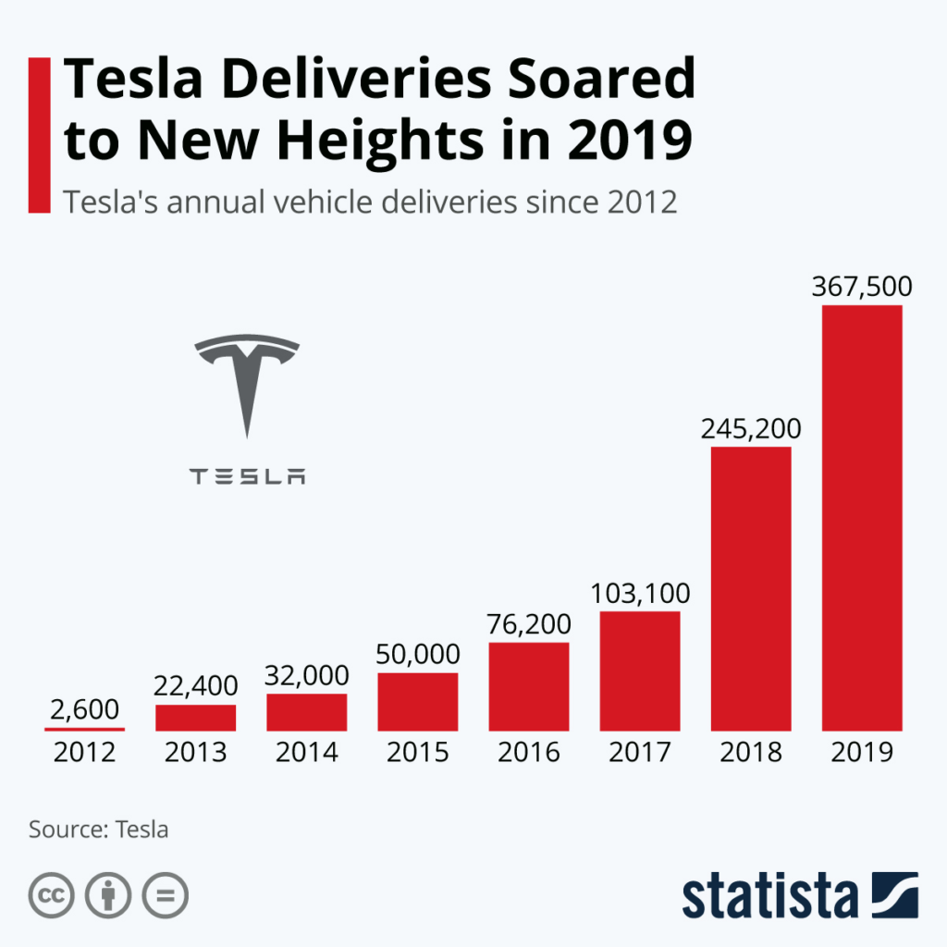
In Addition, Tesla is one of the best companies concerned with delivering in-class electric cars in the automobile market. Tesla has been an influential company that is a step ahead in manufacturing the finest electric vehicles from the other brands. Tesla's electric cars have proved to cover maximum distances, which is the best brand to penetrate the U.S. market.
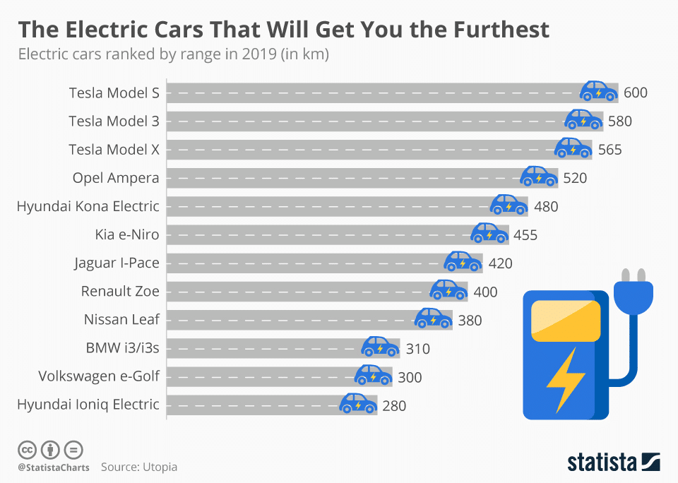

Weaknesses
The internal factors in the company can also cause problems in their market. The elements might result in weaknesses in the performance evaluation—some of the reasons why Tesla faces issues that will reduce the company's competitiveness and growth. Higher innovation factors result in manufacturing problems and increase the risk of production. Tesla is affected by numerous manufacturing and continuous launch of their new products. For example, when Tesla were launching their Model X, there were delays in distribution processes due to manufacturing challenges. Also, when the company does not meet the demands of its consumers, it may result in inland value problems (Gerry, 2016; Stacey, 2011). In addition, the lack of high volume production in Tesla will affect the company's brand name. in one of the shareholder meetings, Elon Musk explained that there was a reduced production rate because of the limited batteries supply to the company (Elon Musk, 2013). the shortage of batteries affects production, which in turn affects the production rate in the market.

Opportunities
Opportunities in the SWOT analysis emphasize the emerging chances of growth for the business (Whittington, et al., 2020). Sales expansion is an important aspect determining how much the company will expand its market in the new territory, particularly when Tesla needs to grow its worldwide market to develop its economic strength and more grounded market existence.
Tesla is costly because of its offbeat dependence on development, which needs the most

significant monetary help to engage innovation.

Tesla, recently, has dispatched the Model 3, which is a more appropriate adaptation of Model S with less reach, power, and fewer highlights. In any case, it is a brilliant chance for Tesla to grow the size of their crowd market. Tesla plans to make its battery cells. The move can be the main event transformer as it will assist the organization with expanding its assembling rate while lessening its creation cost. Right now, Panasonic is their essential provider of batteries. As indicated by the National Automobile Dealer Association portion of the comprehensive industry information, pick-up trucks represent 18 percent of the U.S. auto market (Sull & Reavis, 2019), which has an immense chance of development in Electric vehicles.
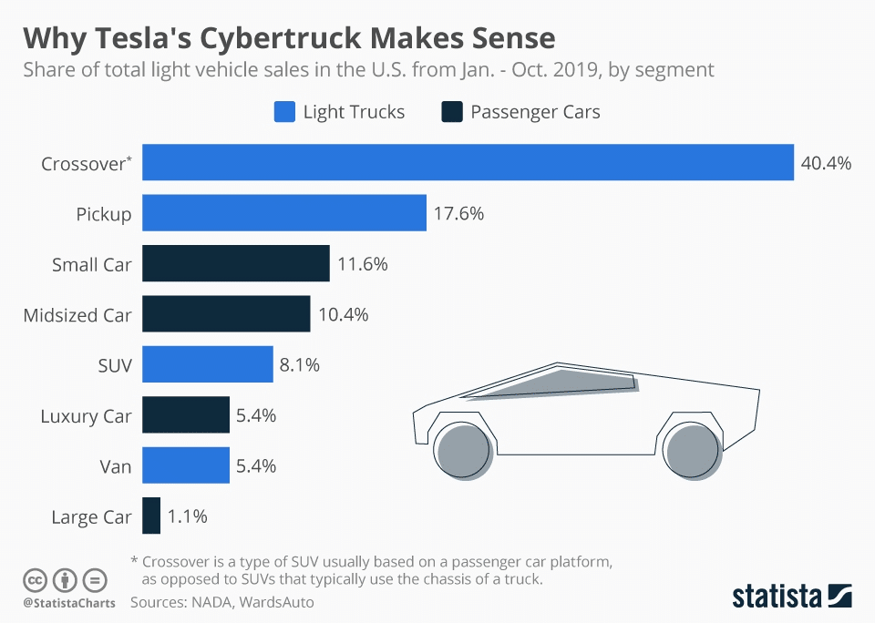

Threats
The threat factor in the analysis represents the factors that affect the company's growth from taking full benefits and advantages in the existing market. Tesla is facing a few threats due to the unpredictable conditions in the market. Regardless of Tesla's exceptional quality affirmation and only expectations of assembling, the auto business is acclimated with confronting critical item responsibility claims that the organization's concerns are one of the most significant financial business.
Tesla has dispatched numerous autopilot vehicles, and not every one of them has been effective if there should arise an occurrence of a mishap. The organization has confronted claims identified with the disappointment of innovation in their items. Assuming that these risk claims proceeded, then, Tesla might be exposed to more major monetary mishaps.
Many brands do not wanting to send their current circumstance well-disposed/self-driving innovation, yet additionally, they are offering them at an equivalently lower cost. It is a particular danger for an organization like Tesla, which blossoms with its special incentive for imaginative vehicles, which are very costly and unreasonable for some.
Because of the profound, complex design for imaginative vehicles, Tesla's cars and other energy items have displayed significant defects as a rule. The bad things frequently have shortcomings in the plan, fabricating, and different elements, hurting the organization's brand forever (Hanley, 2015). For any organization, the confirmation of long-haul supportability is fundamental to keep the brand’s image and the organization's confidence (Lynch, 2018). Because of its unsound assembling conditions, Tesla experiences mistrust among general society about its drawn-out presence, bringing about an insufficiency in additional business improvement. Any business is run according to customer acknowledgment (Valentin, 2015). If people, in general, are prepared to adjust to change, organizations benefit from the inventive scope of items. In any case, it very well may be a passive, unforgiving cycle, delivering new difficulties for organizations like Tesla. The company profoundly relies on clients' ability to take on electric vehicles.

INTENSIVE GROWTH STRATEGIES AT TESLA
Growth strategy a Tesla requires objectives that will ensure competitive advantage. the main strategic goal is to satisfy market demand for renewable energy solutions like batteries for various uses. The best competitive strategy is to help create competitiveness by increasing the market reach and support brand popularity by generating more sales (Gerry, 2012).

Market Penetration
Tesla uses market penetration to the current growth strategy. an example is the aggressive way that the company uses to market their products and resell more electric cars in the United States (Tesla, n.d.). This helps the company to maximize their revenues in the market they are operating. Market penetration is a strategy that help to increase the sales within the company.

Product Development
Another secondary intensive growth strategy is product development at Tesla company. in this strategy, the company increases by developing their best products to the market which helps to improve their new sales. using advanced technology, the company applies this method by developing products that have minimal effect to the environment (Ordone De Pablos & Patricia, 2014).

Market Development
Market development at Tesla company is an intensive growth strategy in the industry. The main objective of the strategy when entering a new market is to help grow the business and generate more sales. The company is placing new offices around the world that helps articulate their strength and their new market sales. The strategy supports the company’s vision and mission statement which states that, “global leadership in the automotive industry, with energy solutions for the transportation and other sectors “ (Tesla, n.d.).

Diversification
Tesla is one of the global companies that applies diversification in their operations. the intensive growth strategy is an important way to help in the growth of the company by creating new opportunities. The main purpose is to develop a new product rivalry for different products applications. This strategy has a great impact to the financial -performance of the company. Tesla uses their strategy and method for market penetration and product development that is essential to help in the growth of energy solutions and automotive businesses.

Conclusion
Tesla is one company that has great impact to the society. the strategies that the company has employed has ensured that they have greater financial impacts. Developmental strategies in the company involves analyzing the external and internal environmental analysis of the business. Therefore, understanding the new environment is one way that the company will ensure that they focus in the new market to improve its service sand financial growths by increasing sales.

Recommendations
From analysis the Five Forces of the company, the greater factor impact of the business competition, therefore the company should employ innovation by prioritizing this force in a strategic formulation. the first recommendation is for Tesla to strengthen their competitiveness in the business industry. In addition, I recommend that Tesla should pursue stronger ties with the market in the global and international expansion of the business. Tesla should seek to increase their brand approach and visibility in countries that have adopted electric vehicles. Using differentiation strategy, the company should widen the range of products for their market. availability and affordability are important factors that the company should consider to ensure that they increase their growth measures and their analysis to cover full market.

Bibliography
Dubey, R. & Gunasekaran, A., 2016. Strategic Management of Sustainable Manufacturing Operations. s.l.:s.n.
Elon Musk, 2013. Tesla.. [Online]
Available at: https://www.tesla.com/blog/mission-tesla
[Accessed 20 11 2021].
Gerry, J., 2012. Fundamentals of strategy.. s.l.:Financial Times/Prenctic Hall.
Gerry, J., 2016. Exploring Strategy: Text and Cases. 11th ed. s.l.:Pearson Education.
Gerry, J., Whittington, R. & Scholes, K., 2012. Fundamentals of strategy. s.l.:Pearson Prentice hall.
Hanley, S., 2015. Tesla pop-up stores skirt dealer regulations. [Online]
Available at: https://gas2.org/2015/05/27/tesla-pop-stores-coming/.
[Accessed 20 11 2021].
Lynch, R., 2018. Strategic Management. Eighth edition ed. Harlow: Pearson.
Modern, T., 2016. Principles of strategic management. 3rd ed. New York: Routledge.
Ordone De Pablos & Patricia, 2014. International business strategy and entrepreneurship : an information technology perspective. Hershey: Business Science Reference.
Stacey, R., 2011. Strategic management and organisational dynamics : the challenge of complexity to ways of thinking about organisations. s.l.:Financial Times Pretice Hall.
Sull, D. & Reavis, C., 2019. Tesla’s Entry into the U.S. Auto Industry, s.l.: MIT.
Tesla, n.d. About Us: Tesla’s mission is to accelerate the world’s transition to sustainable energy.. [Online]
Available at: https://www.tesla.com/about
[Accessed 27 11 2021].
Valentin, E. K., 2015. Business Planning and Market Strategy. Los Angeles: SAGE Publications, Inc..
Whittington, R. et al., 2020. Exploring strategy : text and cases. 12th Edition ed. Harlow: Pearson.

s

