Ryan Hopkins (2221956)
2221956@student.uwtsd.ac.uk
Abstract
A discussion into networking concepts with a technical demonstration in task 2
Network operating system and services
ACCA5023

Contents
Hypervisors 2
Advantages of type 1 and type 2 hypervisors 2
IP Addresses 2
Routing 3
Network services 4
Task 2: Technical Documentation 5
Network Topology 5
Cisco packet tracer 6
Hypervisor 7
Virtual machine setup 8
Static IP addressing 9
Firewalls 10
Linux Static IP setup 11
Linux testing 11
IP Check on Linux server 12
Linux server pinging the windows server 13
Windows 11 Client pinging windows server 14
Windows server pinging linux and client 15
Bibliography 16

Hypervisors
A hypervisor is a piece of firmware or software that allows emulation of an operating system to run, there are two different types of hypervisors, type 1 also known as a bare metal hypervisor, these run without a host operating system. Examples of type 1 hypervisor firm ware is VMware ESXI and Microsoft Hyper-V, both allow the client to modify the hardware used by each virtual machine, if a network administrator wanted to setup a network and shared dedicated resources, such as VRAM (provided from a graphics card) typically a type 1 hypervisor would be used on high maintenance servers, where they need the most out of the resources, a simply FTP server could be hosted on a type 2 hypervisor as it only requires a high storage amount. For a visual demonstration see figure 1
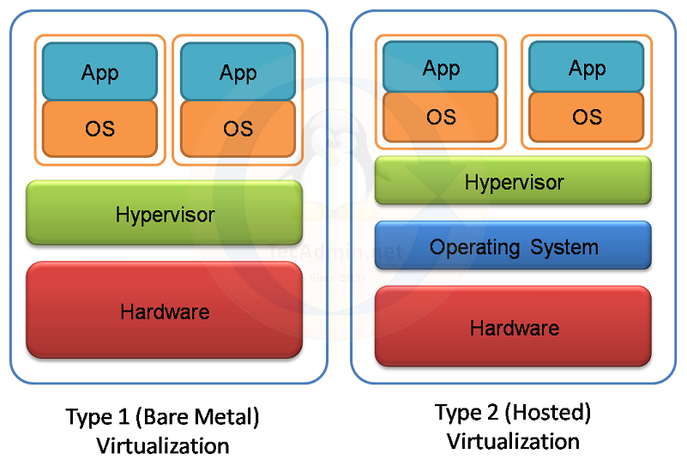
Figure 1 hypervisor demonstration from medium [1]

Advantages of type 1 and type 2 hypervisors
See the figure 1.2:
Type 1 hypervisor | Type 2 hypervisor
Better performance | Easy to install
Reliable (due to not requiring a host OS) | Cost to run (Most Type 2 hypervisors are completely free to run)
Better optimised for larger environments (used in loads of servers such as amazon) | Better for smaller environments (such as a small ftp server for a local business)
Figure 2 table comparing the hypervisors advantages created by Ryan Hopkins (2221956)

IP Addresses
IP addresses is critical in networking, enabling a network to send and receive packets, in networks its important to ensure the ip addresses used are correct, for example if a computer only accesses internal networks, it does not require a public IP so it could be assigned a class b address which would reduce the strain on public IP addresses as there is a limit on them. When designing a network an experienced technician might use static ipv6 addresses as they are Unique Local Addresses, on an internal network these are very specific addresses which they could give directly to an end item for example a printer, these ULAs are only routable on internal networks, which make using them perfect for network specific hardware such as a printer, where it only needs to be accessed from the internal network, as Alex Scroxton [2] said “printer with a malicious Internet Printing Protocol (IPP) URL to a vulnerable machine and start a print job on it.” It is not necessary to have a printer on a public network, doing this will cause a big cybersecurity problem.
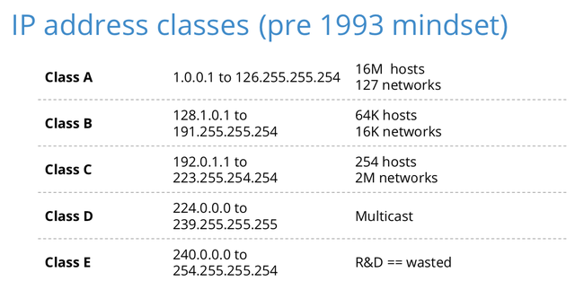
Figure 3 a table showing the different classes for IP addresses [3]

subnetting
A subnet is a smaller network inside a network, they are more efficient than a singular large network, as it conserves IP addresses as it prevents a large network from taking too many public IP addresses by dividing them into smaller and smaller networks, if a large corporation has a large unsubnetted network the likelihood of the corporation having a large scale issue is huge, for example if a network had a lot of broadcast traffic it would slow down the network and harm productivity throughout the company. The solution to these issues would be implementing subnetting and VLANs. As this increases the amount of security between a computer and a File transfer server.

Routing
Routing is a concept which determines the best path for packet traffic to reach a specific destination in the network, there is two different types of routing protocols static or dynamic routing, static routing is used on small offices whereas dynamic routing is used on larger networks, a routing protocol makes decisions to update the network topology to optimise traffic flow.

Static routing
Static routing is having a predetermined path throughout the network for packet routing, this often causes more bandwidth issues on larger networks, essentially enough traffic on this network will inevitably reduce the operational capacity of the business.

Dynamic routing
In networking dynamic routing is the most optimal way of data routing in a network, as the route that is taken by the network is determined by the path of least resistance or the fastest route, this will allow for higher tolerance to high traffic times, what does this mean? Take for example cloudflare, when a client is having a high amount of traffic to their website cloudflare will handle the traffic by announcing the same IP address as their client and reroute the traffic to their own servers often in the closest country to the end user, they modify their own IP address through using bgp anycast. BGP anycast will change the IP address of the server to help alleviate the pressure of the clients server.

Network services

VPNs
A VPN is a virtual private network, this is a secure service which provides another level of encryption when using the internet, there are many different VPN providers, however the most important and best practice when searching for a VPN host is the encryption used on the system, typically the best is AES256. When searching for VPNs its always best to avoid using free services as these typically have worse security, often stealing cookies which could be used to access online banking or secure systems, while the google article doesn’t expressly say VPNs it gives an indepth look into cookie theft [5].

DHCP (Dynamic Host Configuration Protocol)
DHCP automatically assigns an IP to devices connecting to the network. When enabling DHCP on the network it offers a way of logging traffic from specific users, traffic logging helps detect issues throughout the network, ensuring that no two devices have the same IP address. The best practice is to ensure that mission critical hardware has a static IP which the DHCP will not try to remove off the network. For a visual representation on the process of DHCP see figure 4
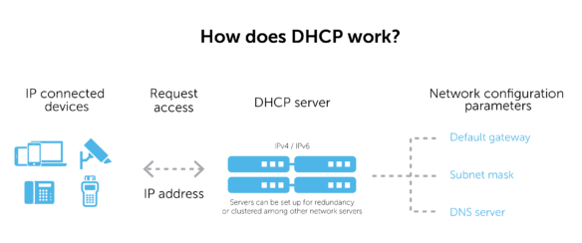
Figure 4, the process of DHCP From bluecat network [6]

Active directory domain services
Active directory domain services is a Microsoft application on windows, which allows the administrator to limit read write access to certain members, the benefits of using ADDS is the SSO (single sign on) when discussing the security vs usability tradeoff a number of companies will use a SSO policy so the staff can be more efficient when doing their work, however a single sign on policy is very weak in cyber security as a number of employees can/will fall for phishing attacks, the use of fake emails to act like a credible company and/or person, to counter this type of attack typically ADDS will be used on critical operating systems only on an internal network.

Certificate authorities
Certificate authorities are trusted companies/ persons who issues/ validates certificates for software, in networking CAs typically refer to Public key infrastructure which ensures encrypted data is only received by those with the correct keys, for example if I sent a file over a public network, anyone can intercept the file however they will not have the correct set of keys to decrypt the file and read it. To request authentication from the server typically they request a TLS handshake, which requests the client to see if it has the necessary certificate to view the material.

Task 2: Technical Documentation

Network Topology
The disclosed topology shown in the brief uses 4 nodes, 2 of which are regular end user computers and the other 2 are servers, with one being a windows server, and the other a Linux server seen in figure 7, to reflect the Ip addresses used I’ve created and provided a new network topology using cisco packet tracer see the heading (cisco packet tracer) for an indepth dive into the topology I used.
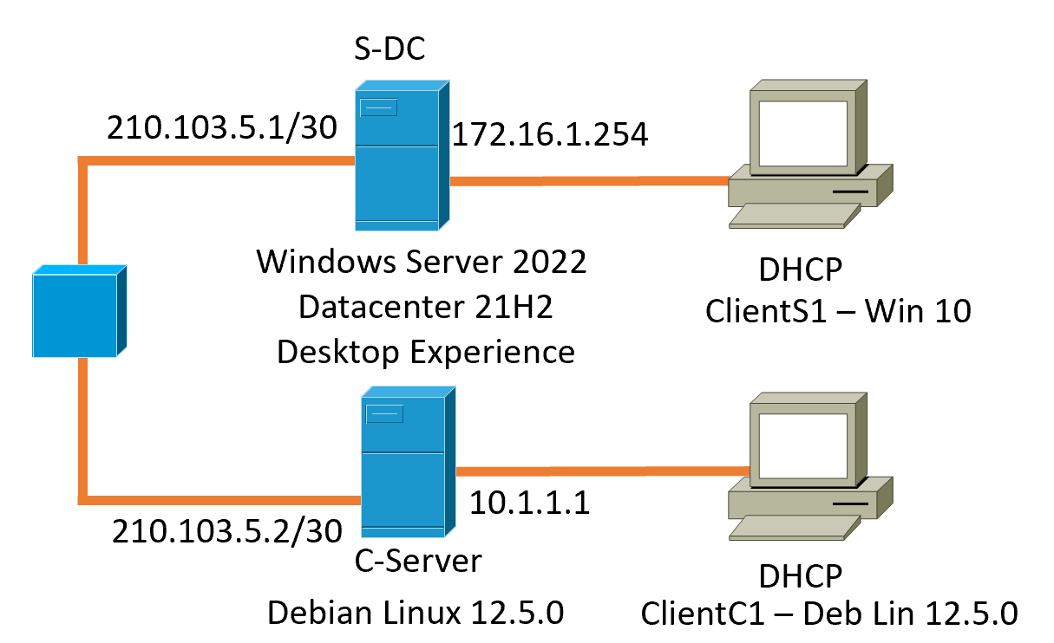
Figure 5 shows the network topology provided in the brief
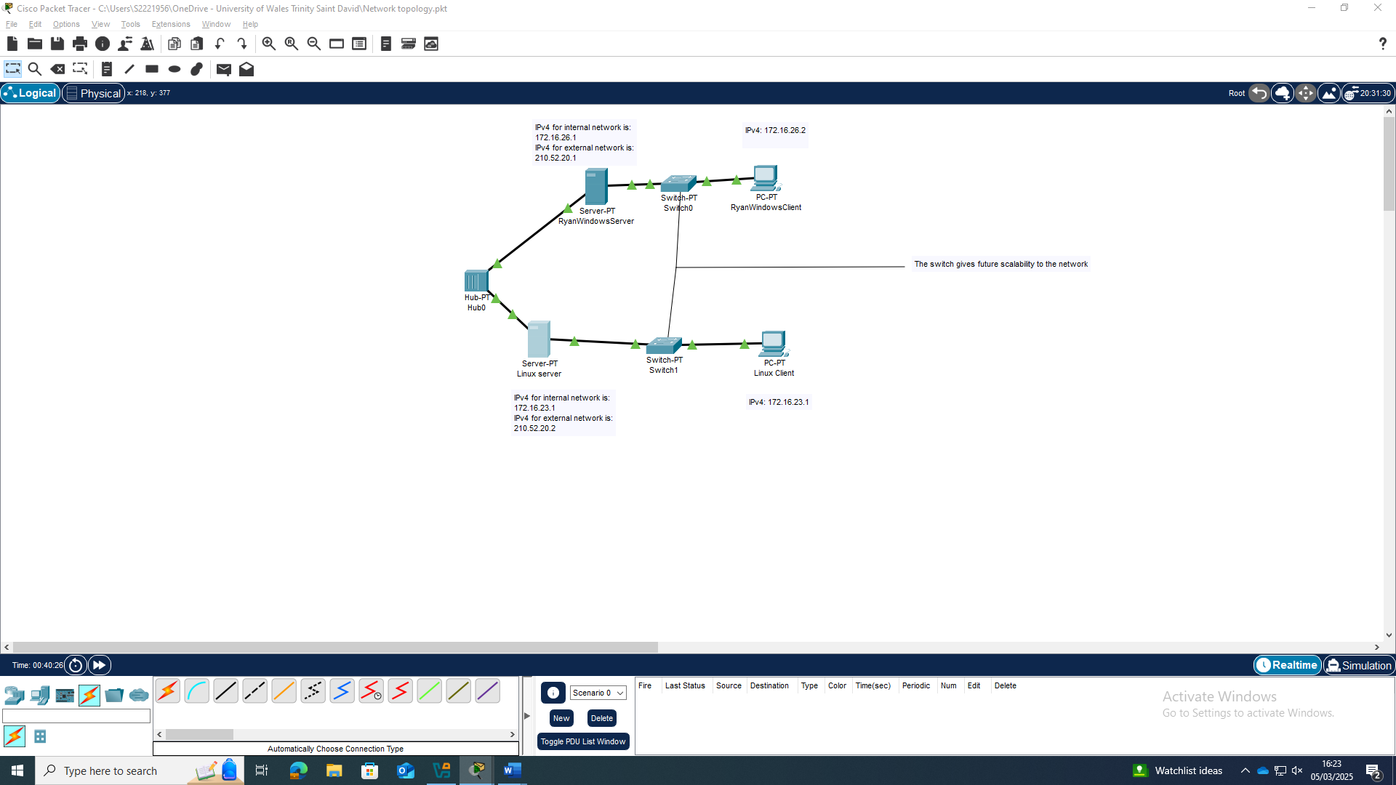
Figure 6 cisco packet tracer of the new network topology created by Ryan Hopkins (2221956) created on the 5/03/2025

Cisco packet tracer
When developing a network its important to keep the static IP addresses logged, as reusing important IP addresses can cause a massive issue with routing the correct packets to the location, when debugging the network later on, the network technician can look at the topology and understand where the problem is in the network, when setting up this topology its important to know that these IP addresses work, so cisco offers a command prompt on their systems such as a server and computer, which simulate the situation, figure 7 shows the working environment between all 4 connections. When creating the topology I had future scalability in mind, so I decided to add a switch between the end user and the server, which offers an additional 10 ports for future use, the limitation then being the network bandwidth which will suffer with more active ports being used, in the meantime the network technician can disable any unused ports to ensure system security, although this may not be used as it effects the security vs usability tradeoff negatively, as the end user is more likely to use the wrong port if they tamper with the ethernet cable.
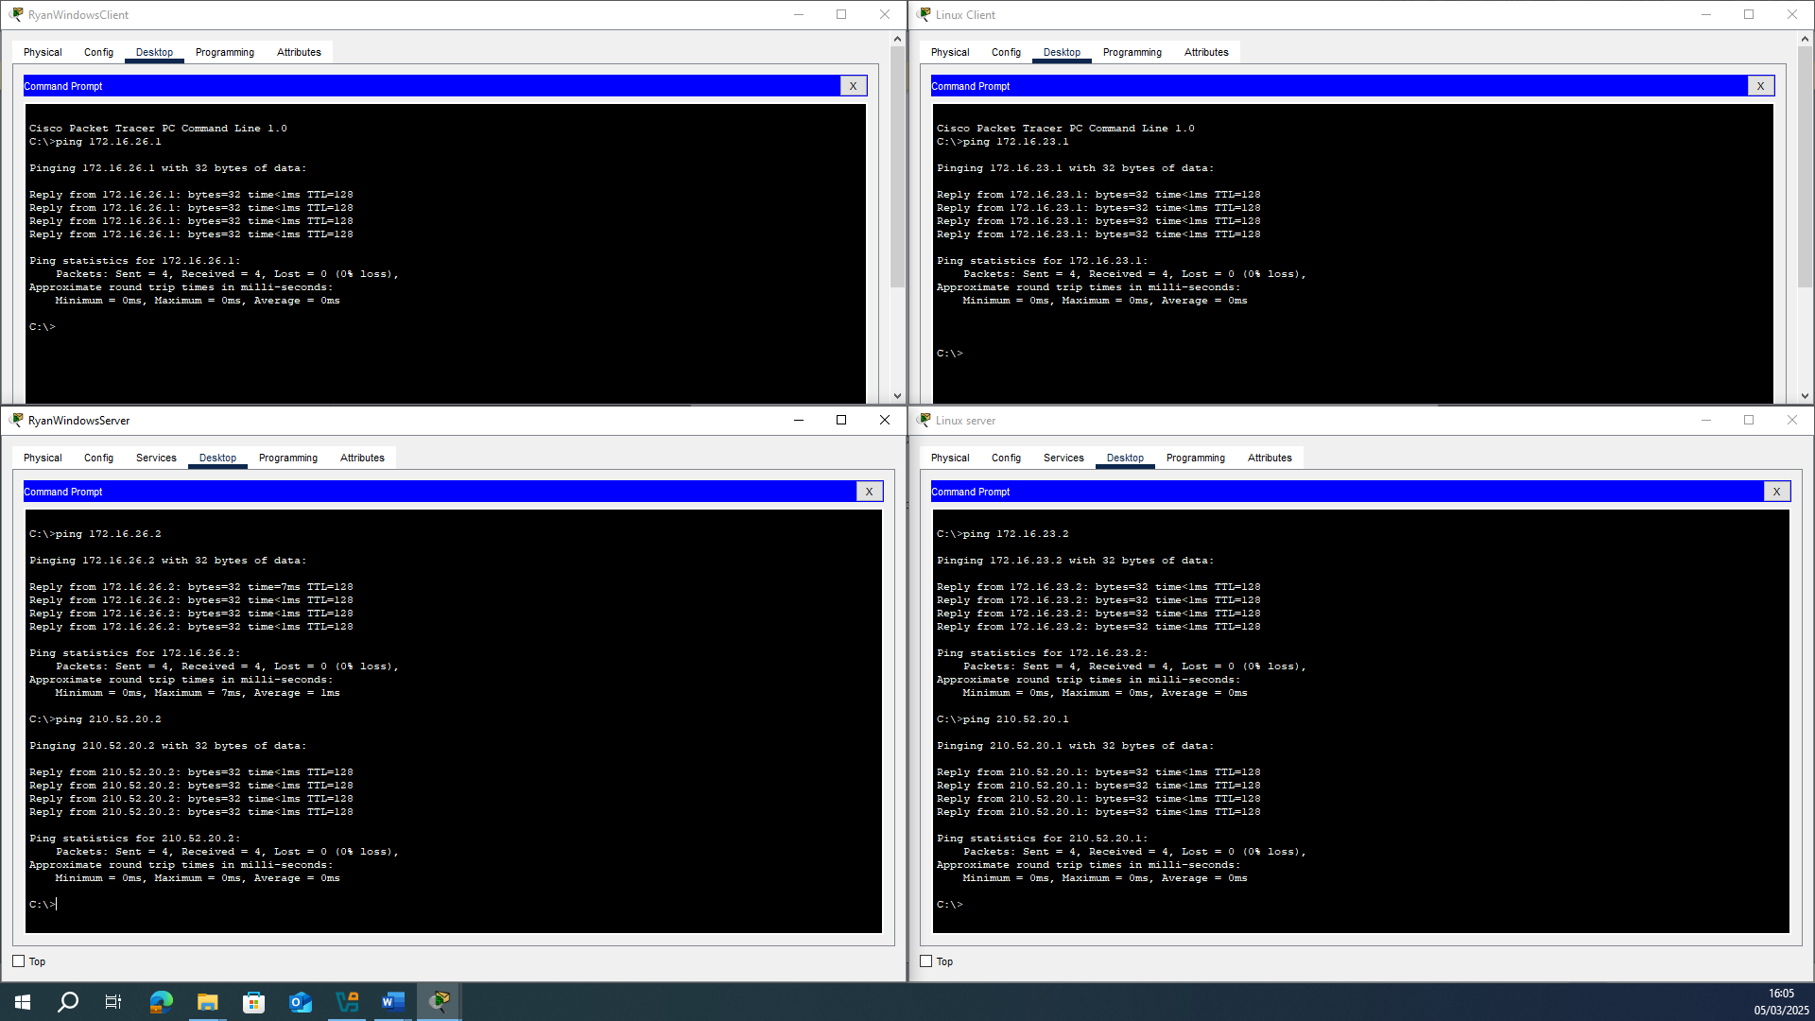
Figure 7 displaying the pings throughout the cisco packet tracer topology

Hypervisor
For this I have chosen to do a type 2 hypervisor, as I do not need to control every piece of hardware in the system I could use just type 2 hypervisor, as its more user friendly I could trust that even if I made a mistake in the setup, it would still boot and run. The chosen virtual machine software is Oracle virtual box, as they have features such as snapshots which help when recovering lost data, this would be important when modifying the firewall rules. As I have previous experience with type 1 virtualisation, I almost chose to do this, however I decided against it as I’ve previously had other virtual machines corrupt due to insufficient resources, and I couldn’t guarantee the resources I could use.

Virtual machine setup
All 4 systems are using the same “intnet” adapter, this will act as if they’re all connected through ethernets, the setup for the VMs are as goes:
windows server as seen in figure 8 is: Windows server 2022: 12GB RAM, 4 Processors and 50 GB, the windows server vm has the highest requirements out of all 4, as the requirements and demand the server will be operating at requires a lot of processing power.
Windows Client: Windows 11 OS: 8GB RAM, 2 processor cores, 12 GB storage. As this client does not need to store a high amount of files I’ve given the base requirements for windows 11
Linux server: Debian Command line: 2GB RAM, 2 processor cores, 20GB storage. As the server has the capability to host a FTP server, I’ve decided to give it a little more storage than base specification
Linux Client: Debian GUI: 4GB, 2 processor cores, 10 GB storage. The Debian client has a lot less background tasks when compared to windows 11, so the 4GB of ram is more than necessary.
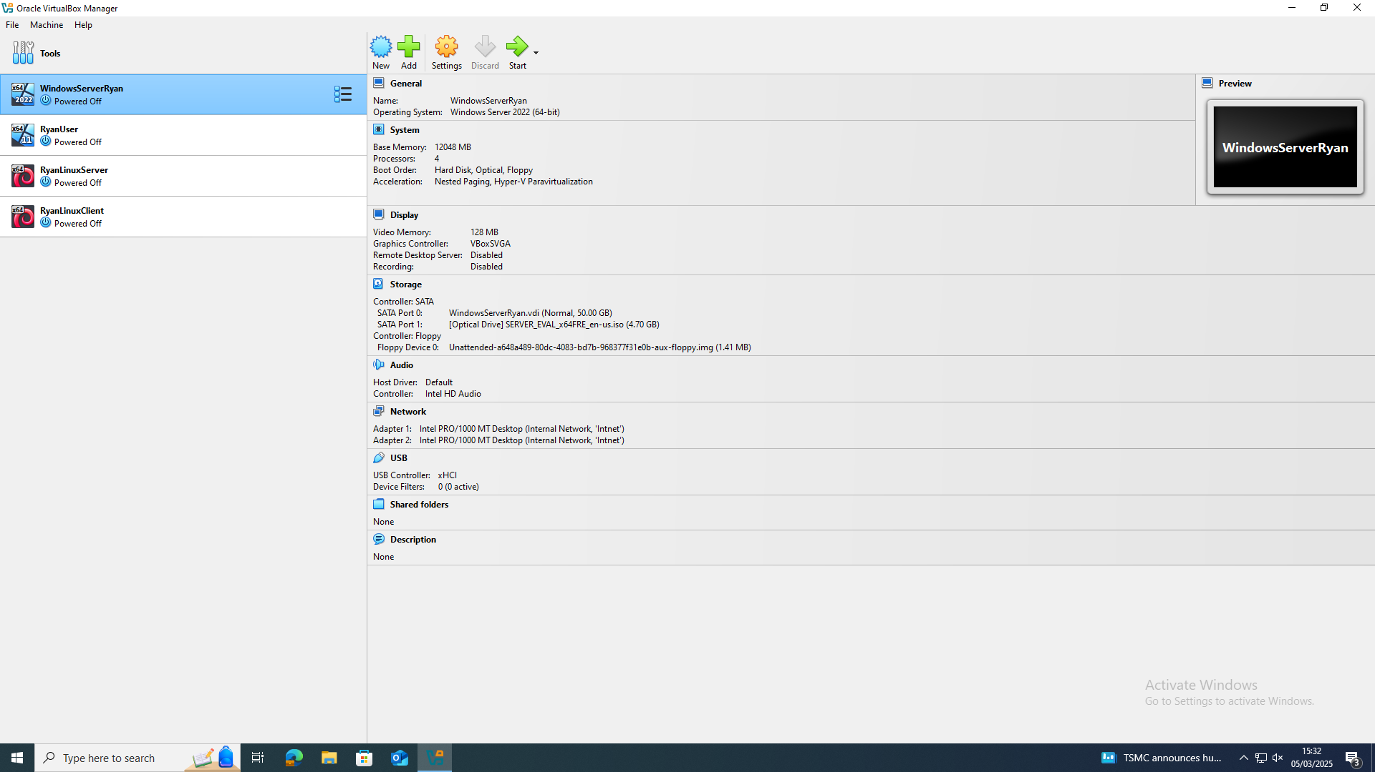
Figure 8 Oracle box hovering over windows server.

Static IP addressing
The setting the IP addresses on both windows 11 and windows server 2022 both operate in the same capacity, where the administrator has to go into TCP/IPv4 properties in order to set a static IP, figure 9 shows this, and figure 10 shows the overall view from the server, where you can see the IP’s set for each adapter.

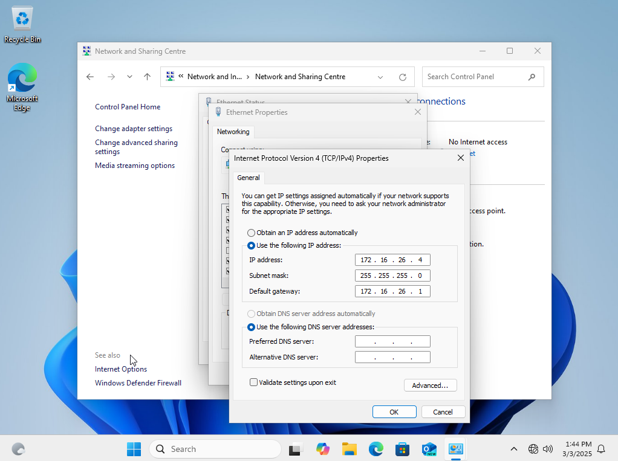
Figure 9 TCP/IPv4 setup on windows 11
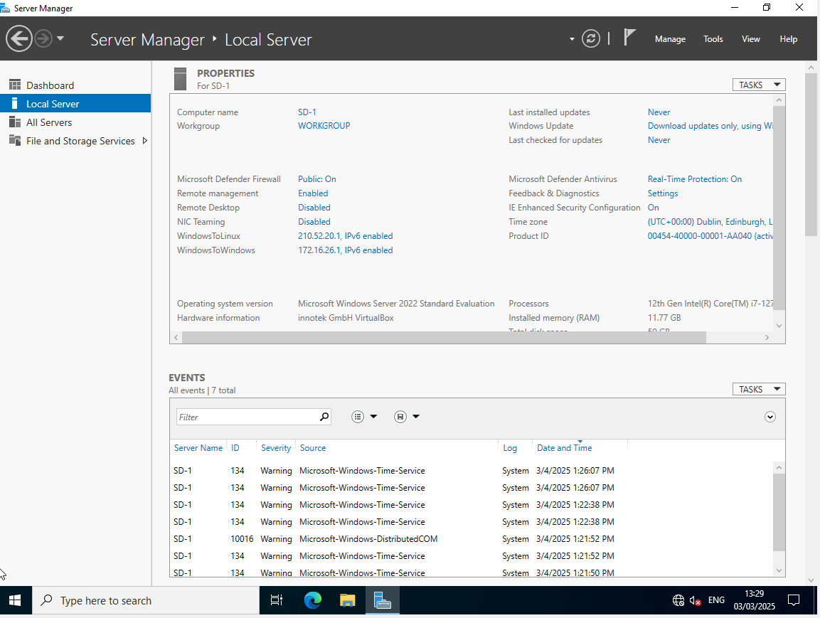
Figure 10 windows server, on local server to see the Static IPs setup

Firewalls
The screenshot below shows the firewall rules being updated to allow ICMPv4 traffic in and out this stops the firewall from blocking legitimate pings. This was done on both the server and the windows 11 client, however the photo below is just the client. The firewall rules were only modified on the windows server and windows 11. See figure 11 for the Command line firewall.
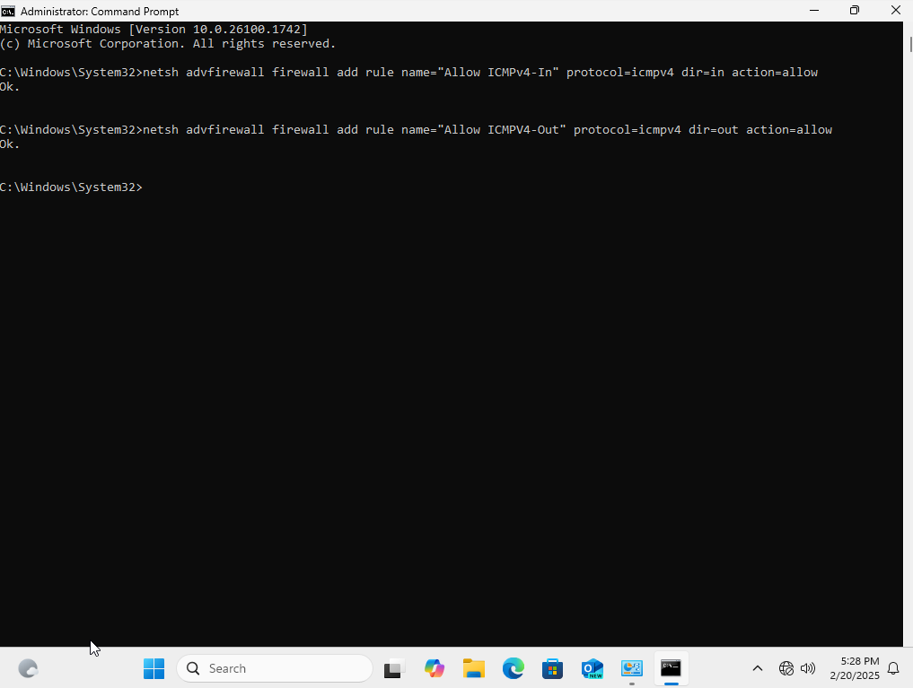
Figure 11 Command prompt running in administrator mode to edit firewall rules to allow the client and server to communicate

Linux Static IP setup
The linux setup is quite different to the windows setup, instead of modifying the TCP/IPv4 adapter, you need to write a script which specifies which network adapter by using the name enp0s3 or enp0s8 see figure 12.
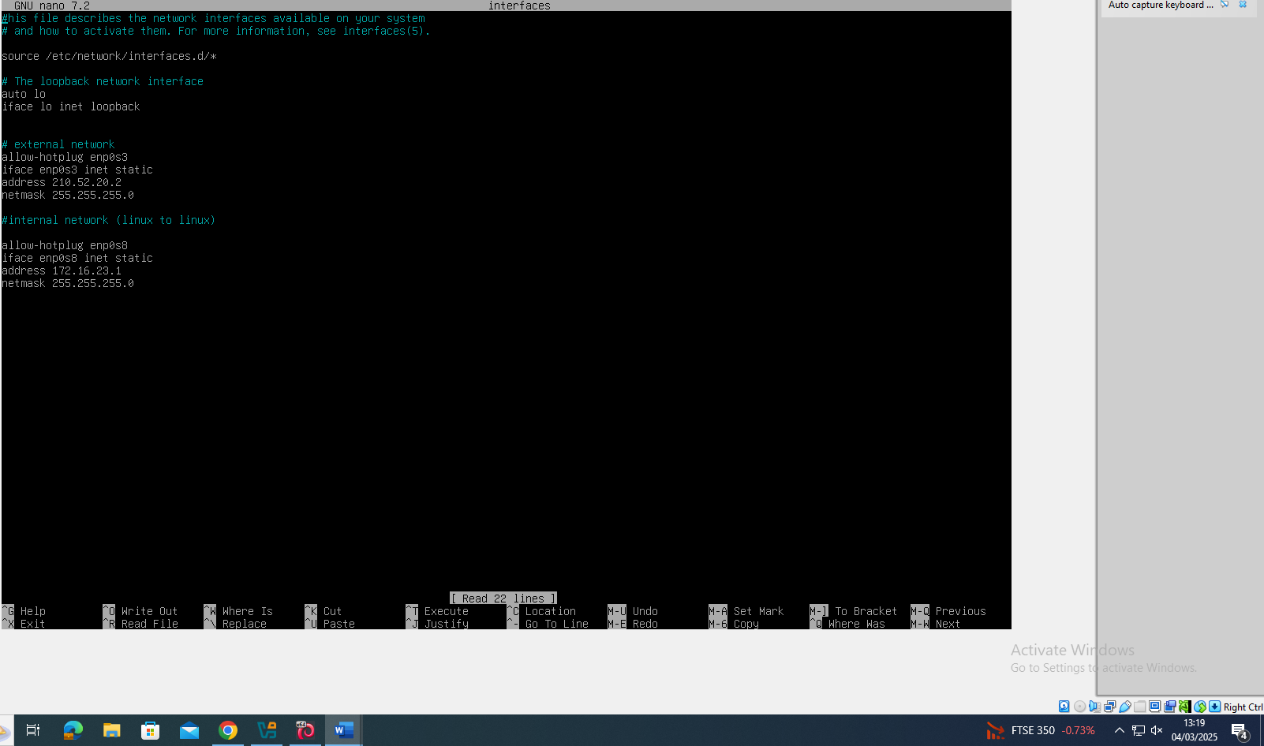
Figure 12 using the network interfaces file to modify the ip for adapters enp0s3 and enp0s8 to 210.52.20.2 and 172.16.23.1, the screenshot was taken on the 4th of march 2025 at 1:19pm

Linux testing
The testing involves checking the IP of the host and sending a ping to the respective party such as 172.16.23.1 for figure 13, 14 and 15.
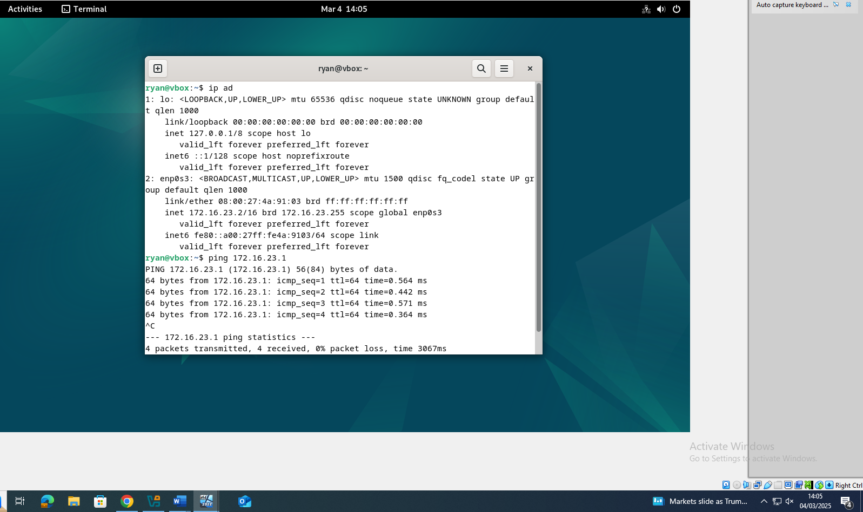
Figure 13 terminal script to show the network adapters IP address and pinging the linux server to ensure that it connects (the linux server having the IP address 172.16.23.1) the screenshot was taken on the 4th of march 2025.

IP Check on Linux server
This is important to ensure that the IP address was saved and is correct, if something was incorrect the IP address would be auto set to 127.0.0.1
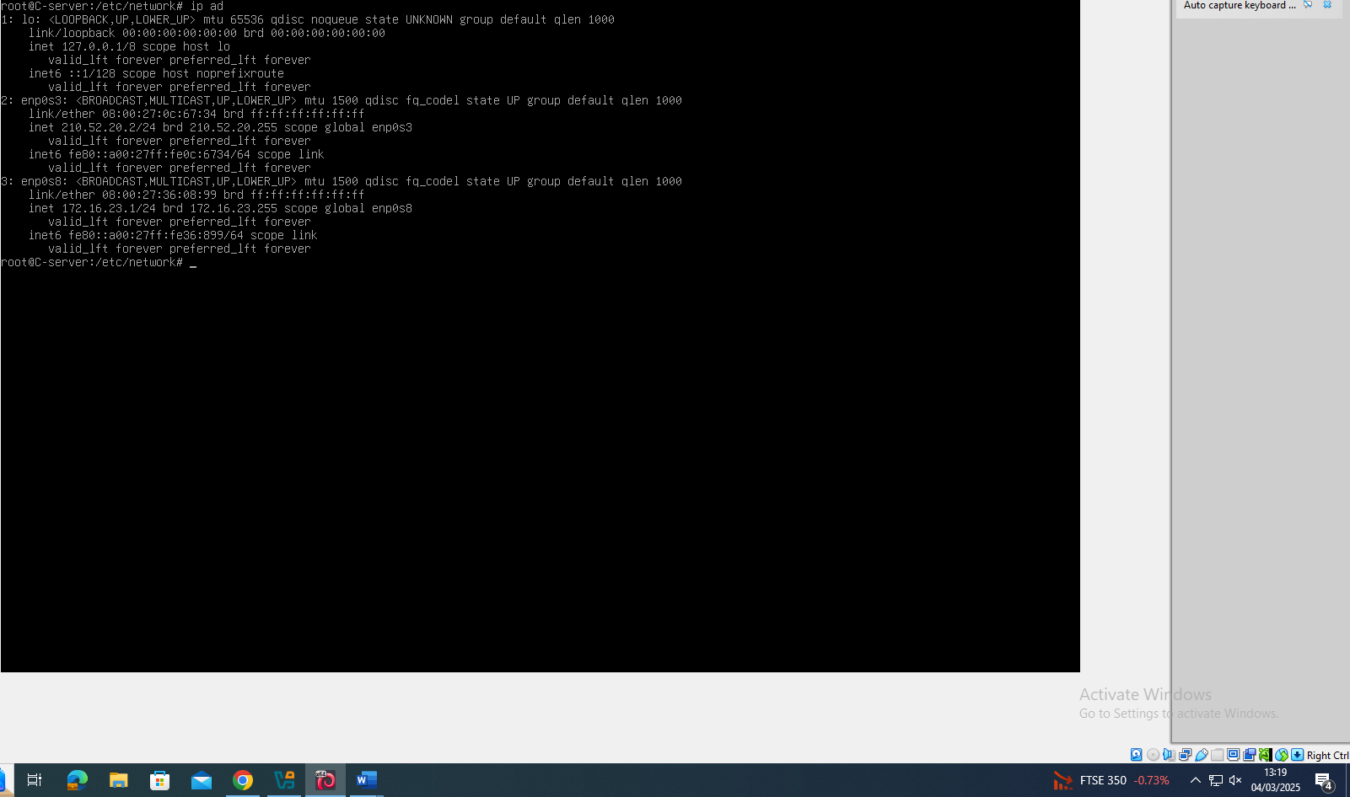
Figure 14 the linux server IP ad command, displaying the static IP set in the interfaces file. The screenshot was taken on the 4th of march 2025 at 1:19pm.

Linux server pinging the windows server
After setting up the IP addresses on both the windows server and linux server its important to ensure that the data can be sent from one server to the other without having issues like Destination host unavailable.
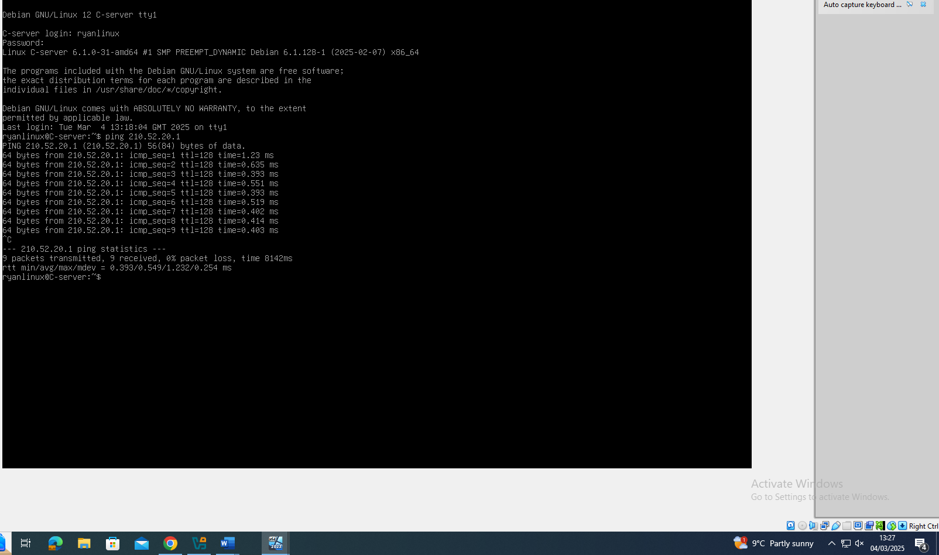
Figure 15 the linux server pinging the window server on 210.52.20.1

Windows 11 Client pinging windows server
This test shows the firewall rules we added previously worked, and we can ping the windows server
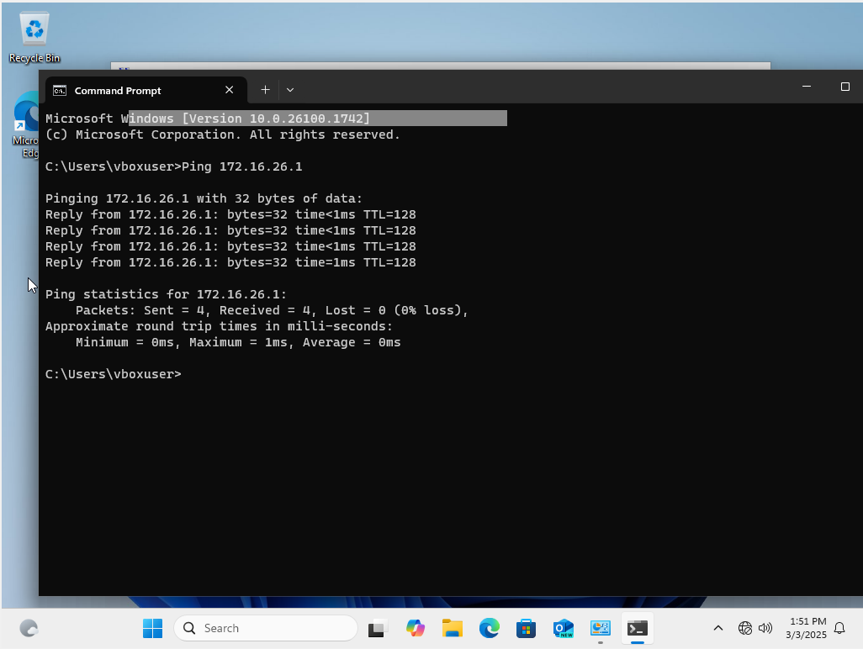
Figure 16 successful pinging between windows 11 client and windows server on the 3rd of March 2025 at 1:51pm.

Windows server pinging linux and client
The windows server needed to show that it pinged the server and client, both show that 4 receieved and none lost. See figure 17
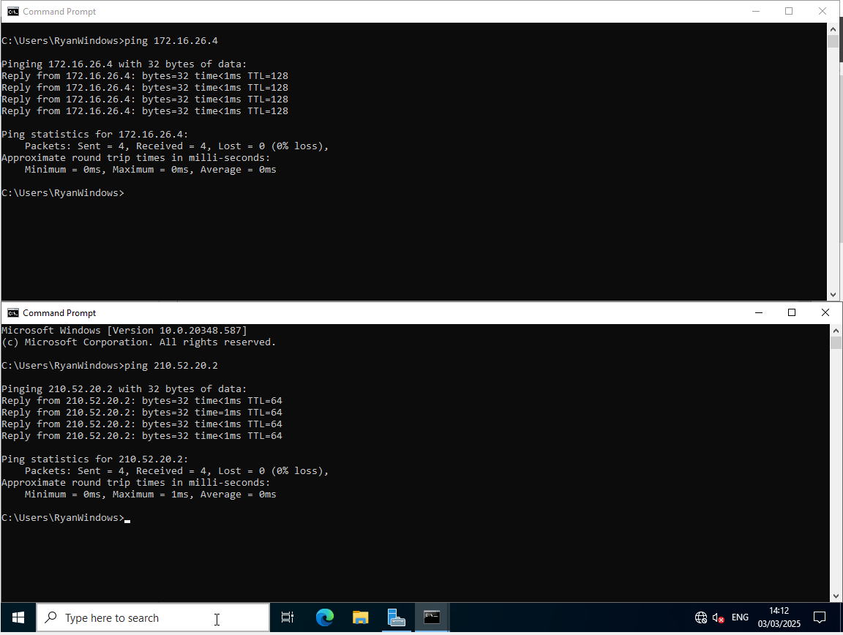
Figure 17 the windows server pinging the windows client on 172.16.26.4 and the Linux server on 210.52.20.2

Bibliography

[1] | R. Patel, “Understanding Hypervisors: Exploring Type-1 vs Type-2 and Full vs Para Virtualization,” Medium, 20 Fev 2024. [Online]. Available: https://medium.com/@ravipatel.it/understanding-hypervisors-exploring-type-1-vs-type-2-and-full-vs-para-virtualization-71b4dad9abd9. [Accessed 06 Mar 2025].
[2] | A. Scroxton, “Cups Linux printing bugs open door to DDoS attacks, says Akamai,” ComputerWeekly, 04 Oct 2024. [Online]. Available: https://www.computerweekly.com/news/366612800/Cups-Linux-printing-bugs-open-door-to-DDoS-attacks-says-Akamai. [Accessed 06 Mar 2025].
[3] | Ó. Guðmundsson, “What do we know about an IP Address?,” Ripe labs, 4 Jul 2019. [Online]. Available: https://labs.ripe.net/author/olafur_gudmundsson/what-do-we-know-about-an-ip-address/. [Accessed 07 Mar 2025].
[4] | P. S. V. K. Shailesh N.Sisat, “IP Subnetting,” international journal of electrionics, communication & soft computing science and engineering, vol. 2, no. 5, pp. 1-5, 2012.
[5] | A. Shen, “Phishing campaign targets YouTube creators with cookie theft malware,” Google, 20 Oct 2021. [Online]. Available: https://blog.google/threat-analysis-group/phishing-campaign-targets-youtube-creators-cookie-theft-malware/. [Accessed 07 Mar 2025].
[6] | Bluecat networks, “What is DHCP (Dynamic Host Configuration Protocol)?,” 4 March 2025. [Online]. Available: https://bluecatnetworks.com/glossary/what-is-dhcp/. [Accessed 7 March 2025].

