Climate change
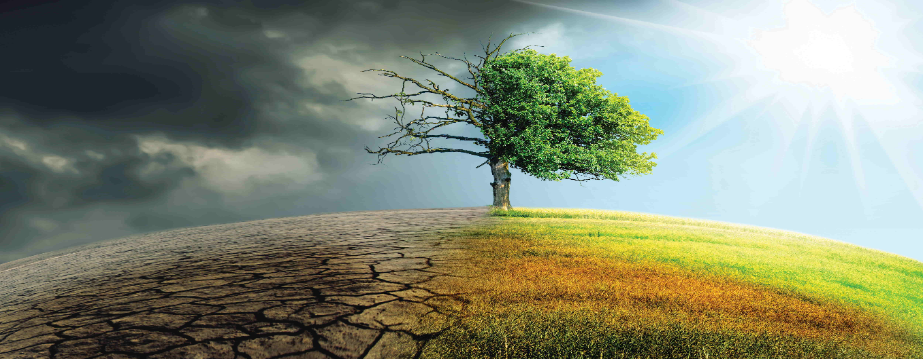
What is climate change.? Climate change refers to the change in weather and temperature. These shifts of course could be natural, or they could also be something that humanity has contributed by our own means and from the time of the 1800’s this certainly has been the case. – United nations. The harm of humanity doing such things like burning coal, oil and gas are what contributes to these factors, in doing this generates greenhouse gases that sort of like a quilt that covers the earth trapping the suns powerful heat rays and raising the temperature. During this report on climate change we will go over a lot of things, this will vary from the benefits of what's come from climate Oppurtunites and what negative impact can also be a result of climate. At the end of these factors, you can make up your own minds.

1) Let us take some time now to delve into the good that comes from climate change. Some of the biggest changes in our tech has come from trying to reduce or limit and to come up with better alternatives to human C02 dependency – WWF. So, let's have a look at the renewable energy sector and see the current and future benefits that we will all see. We see that see that these renewable energy projects are popping up everywhere and there's exceptionally good reason for this, most clean energy now is producing truly little to no global warming harmful emissions. But what is renewable energy? It is using earth natural elements to produce electricity I.e the sun that blares in the sky, the winds that flow through the terrain, heat from the planet, our beautiful flowing waters all of these go through paticular processes to create a never-ending natural flow of energy. Solar energy harnesses the energy of the sun while the light shines all day on the solar panels to create energy. We also have hydro ways of creating electricity. This method works from producing fast flowing water to turn kinetic energy to turn turbines and therefore producing clean electricity. Infact study's have shown by NREL found that renewable energy means could quite comfortably produce up to 80% of all the United States power – UCSUSA.

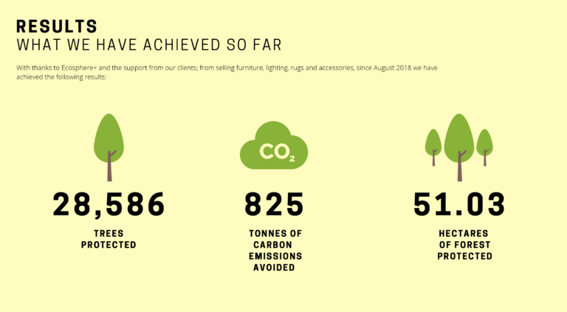
2) Now while all the clean energy sector is a major player in climate change, let's take another angle when looking at this, and that is the amount of jobs that this will create, for example the solar sector is producing an extraordinary number of jobs. In 2021 it provided “4.3 million jobs” - United Nations. This statistic is major as it is only from the solar section alone. This number is significant because of the pandemic that we have all seen in the past 2 years and the clean energy jobs are still booming. But while this a plus we also have to look at the other end of the spectrum. While we are producing more jobs we are also decreasing the amount of people that will eventually be unemployed because of the fossil fuel sector being slowed down because of the current rate of people turning to be more productive in the way we produce energy from the greener side of production. A study from the university of Manchester has come up with a goal that we are to achieve if we are the meet the requirements of the paris agreement, its shown that the output of oil and gas from more developed countries need to be sliced by as much as 74% by 2030, then to be completely phased out by 2034.
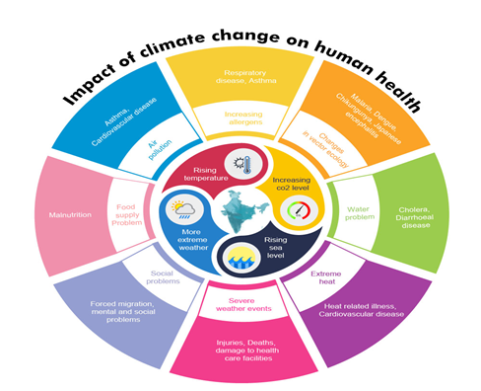
3) Let's get down to some health problems, as we know the obvious burning off these fossil fuels are outputting are problematic to health, these have been linked to breathing problems, cancer links, heart attacks, and premature death. There has been a study by Harvard university that estimate that the public health effect of coal is around the $74.6 billion dollars every year. As you can imagine health would obviously become a concern for newer methods when it comes to producing energy, such as the methods previously stated like solar, wind and hydroelectric no such things get produced as a deadly by-product. As the solar farms only require light to produce and the wind farms only require wind, so therefore creating a everlasting energy supply through natural accruing elements of the earth.
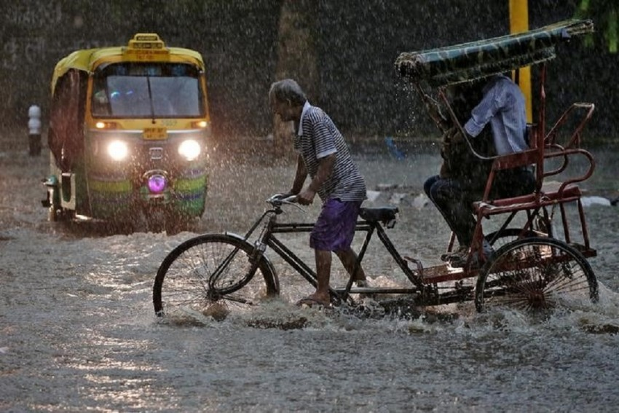
4) Now we can go over the effects of global warming as a whole. There is cause for concern when we categorise and have a closer look into what is happening when we think global warming, we think so little of it. If it was the case that it was not a big deal, we would not be looking into better methods of creating a greener planet. So, let’s have a few points about what we are doing to our planet. As we know global warming is not a problem of the future, changes to the climate of the earth is driven by the accelerated pace at which we are producing harmful emissions and causing heat-trapping, greenhouse gases are already having a very widespread effect on our environment. Some one these changes are things such as wildfires, droughts and extreme rainfall and these are actually happening quicker than scientists predicted previously. They actually have a high confidence that the temperature will continue to rise for many decades more and this is predominately by what humans produce.
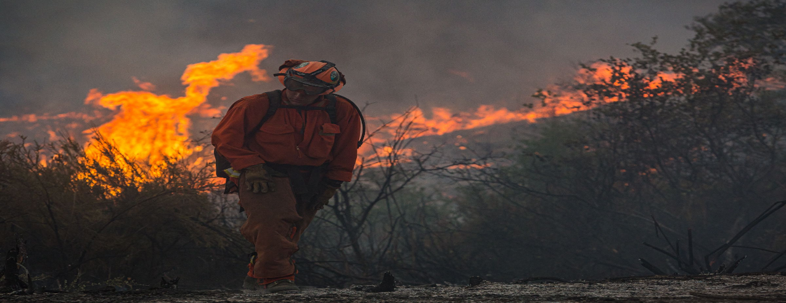
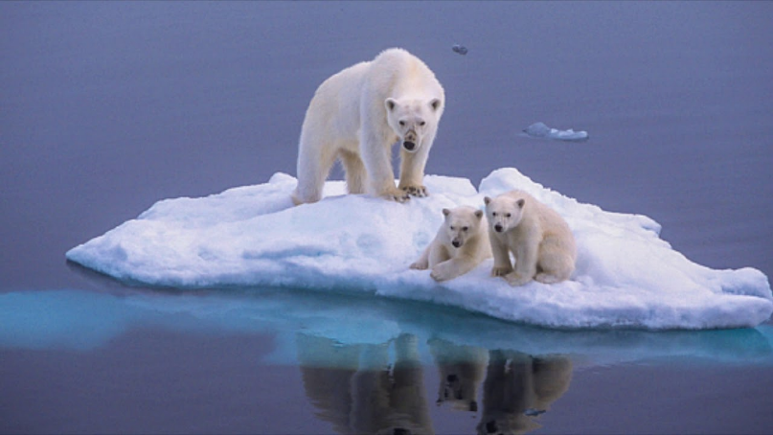
5) Ice caps are making there way into the news also, this is most definitely because of the global warming that everyone is talking about. Now if this was to happen we would be in quite some trouble. The polar ice caps is starting to melt. We are starting to lose artic ice at a rate of 13% per decade – WWF. The oldest of the original artic ice of the past 30 years, the oldest and the most thickest of the ice in the artic has been declined by a massive 95%. If we do not check our emissions and start to make a difference then scientists predict that we could have no artic ice by the summer of the year 2040. But here is the kicker, the artic ice being melted Is not just going to affect our everyday lives. It is going to affect the habitats and the lives of the animals that are living on our planet, think of the polar bears, the melting of the artic sea in the spring and the later time to freeze later on leaves many parts of the sea unfrozen a long time. Polar bears which need the sea ice to hunt – Greenpeace - 27 August 2012. It is not just the artic species that face problems also. The increase of temperature would cause the collapse of fragile ecosystems and a potential huge wave of extinction. The rising temperature affect things such as vegetation, access to food and water and much more. Ecosystems may become uninhabitable for certain species. This would force certain animals to shift outside of there natural patterns in search for food and a nice cosy place to live. This would cause huge stress to animals that are being forced to either adapt or die. -IFAW.
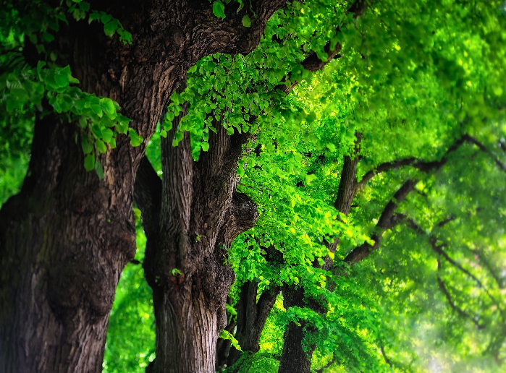
6) We do have a great eco-systems and animals that do help us in our battle to combat this for example our trees on the planet and the animals we have that help us combat this, the united nations predict that the ecosystems could account for 37% of the amount of carbon reductions needed to limit global temperature rises. Healthy ecosystems and natural systems are doing an amazing job in absorbing carbon from the planet and storing it. So to preserve and to protect the natural things on the planet is a really good place to start, for and example of this whale poop provides good nutrients to phytoplankton which in turn capture large amounts of C02 and convert it into energy, thus removing carbon from the atmosphere, and when they are eaten by other animals this keeps the carbon out of the atmosphere and this is then not contributing to the global warming crises. The trees are another good tool at our disposal, planting more trees would greatly reduce this as well as when trees absorb C02 and gives us clean oxygen in return, making better quality of air and better quality of life.
7) Sea levels rising is a direct result of the ice caps melting as we previously discussed. Sea levels are predicted to rise by a foot by the time we reach the year 2050. - National geographic – February 15th 2022. Thermal explanation is something to talk about, when water starts to heat up, about half of the sea level rise over the past 25 years is due simply to the water getting warmer. When sea level rises it causes much more catastrophic effects than what we would generally expect, think if the sea continues to rise think of all of the coastland areas in the world, there is no more space for the water to go in the ocean, therefore it rises and that will in time go over coastal areas and cause severe flooding and disruption of farms nearby and cause potential food disruptions for that area, a loss of life is another thing to look at. Ports would also be disrupted, forcing us to try to stabilise and get things back on track for quick movement of our everyday needs such as foods, products anything that can be moved by water or on freights would suffer as there would be nowhere to port. Higher sea levels are also linked to typhoons and hurricanes that move more slowly and drop more rain, contributing to more powerful storms and cause devastation in their paths. This rise of water would cause loads of people forced out of there coastline homes and seeing many people in seeking shelter and aid from people as they would be left defenceless and without a home.
8) There are obviously benefits that will be a result of global warming, and this can be short term and long term benefits. For example, there will be a decrease in mortality rate from the colder periods being shorter and on the flip slide there will be more mortality rates from the heat waves and hotter periods. Lets talk about some short term benefits as in farmers would benefit from global warming as the earlier onset of spring and from a longer duration of warm seasons that is better for growing crops. Studies also show that an increase in carbon monoxide levels actually seem to make plants more tolerant to drought, but as we speak about things thriving in this environment other plants and weeds benefit from this also, -David Herring, October 29th 2020.
And although global warming could increase the shipping lane productivity, it could also create problems as its solving some for example the icebergs would become less compacted and would create icebergs that could potentially float into shipping lanes being very problematic, with the ice melting in the Antarctic this would release methane also which contributes the global warming problem.
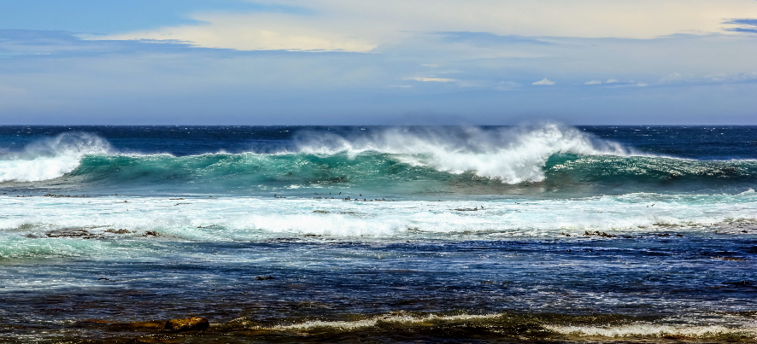
9) Shipping routes would be more accessible by boats and ships crossing the seas. This would provide easier access to go from Atlantic sea to pacific seas without the use of the Panama canal, this would be beneficial for faster products to reach the destination faster. Potentially giving the consumer a wider variety of good that they may of previously not been able to acquire.
10) Global warming would create a breeding ground for infection diseases to be able to manifest at a quicker rate, it would encourage a higher rate of mosquito production. This deadly creature would be able to stay in larger proportions and for longer periods of time as well.
Things are not all doom and gloom there are certain steps that we can all take to insure we all do our best to help prevention of the current way things are going. A lot of our electricity is and heat which we in our houses are produced from methods such as coal, gas and oil. We can use less energy by lowering the number of things we use in our households such as lowering the heating and cooling. Using methods such as using power saving LED bulbs and energy saving appliances in the household, using cold water to wash your clothing and hanging them on a line to dry with wind rather than putting them in the dryer – United Nations act now. Another measure that can be taken is to walk to meet your friends if its close by, use a pushbike to cut down on using a car. The less we use as individuals the better the outcome will be. We can decide to use a bus. If a lot of people who had cars used buses instead imagine how many cars could be potentially taken of the road, or for that matter not used anymore, the results would be noticeable. If that’s not quite you forte you could also carpool and hop in with friends. This is still better than using 2 or 3 cars rather than using just the 1 full with people. We could hop into the three r’s reduce, reuse and recycle. When the consumer buys a product things in the process are having effects from extracting the raw materials then through the manufacturing process and then to transport and delivery. If we can reuse what we purchased it can make all the difference, if we recycle the already existing product so that no more raw minerals are needed to recreate the product then we are all helping the cause.
In the conclussion of this I believe there are a lot more disadvantages to global warming and climate change than there is for the benefits of it. There would be a lot more loss of life, floodings, natural occurring events that would not bode well for a lot of coastline places. Some smaller islands would be completely forced to migrate. And all the while thinking about this. It might not even effect our generation but if we all do our bit to help keep the planets health at tip top shape then we can keep this beautiful place we call home for more generations to come and everyone can enjoy a happier cleaner way of living on the planet.

https://seec-tonko.house.gov/sites/sustainableenergyandenvironmentcoalitioncaucus.house.gov/files/featured_image/issues/climate-change-tree.jpg
https://doddsandshute.com/wp-content/uploads/2020/06/Screenshot-2020-06-16-at-17.21.30-768x423.png
https://bn.nhp.gov.in/NHPimages/climate%20change.png
https://www.the-sun.com/wp-content/uploads/sites/6/2020/08/NINTCHDBPICT000603763431.jpg
https://images.outlookindia.com/public/uploads/articles/2017/10/4/rain_570_850.jpg
https://i.ytimg.com/vi/Th9rseF3CMQ/maxresdefault.jpg
https://cff2.earth.com/uploads/2021/06/01164233/shutterstock_5009500962-scaled.jpg
https://wallpapercave.com/wp/wp6671792.jpg
United Nations - https://www.un.org/en/climatechange/what-is-climate-change
WWF - https://www.wwf.org.uk/updates/10-reasons-why-climate-change-important
UCSUSA - https://www.ucsusa.org/resources/benefits-renewable-energy-use
United Nations - https://news.un.org/en/story/2022/09/1127351
WWF - https://www.worldwildlife.org/pages/six-ways-loss-of-arctic-ice-impacts-everyone
IFAW- https://www.ifaw.org/journal/impact-climate-change-animals
Greenpeace - https://secure.gravatar.com/avatar/70448ecfeae7f5ab10a6376a20584914?s=96&d=blank&r=g
Greenpeace International
27 August 2012
National Geographic - https://www.nationalgeographic.com/environment/article/sea-level-rise-1
climate.gov - https://www.climate.gov/news-features/climate-qa/are-there-positive-benefits-global-warming
United Nations https://www.un.org/actno

