Programme: MBA- Masters of Business Administration
Module: Entrepreneurship
Module code: LCMB7004

Assessment – 1: Critically evaluation of concepts and knowledge about enterprise and entrepreneurship

Student ID:2128679
Student Name:Shabaaz Ali Syed
Lecturer Name: Jayalakshmi Gapalkrishna
Submission Date:-03/05/2023

Table of Contents
1. Introduction 3
2. Conceptual foundation for enterprise and entrepreneurship with examples 3
3. Evaluation of concepts of enterprise and entrepreneurship from the perspective of an entrepreneur 4
4. Conceptual foundation of personality traits theories with examples 5
5. Evaluation of traits, characteristics, attributes and motivations of entrepreneurs 5
7. Analysis of “for-profit” and “not-for-profit” small organisations with relevant examples 7
8. Entrepreneurs' values and beliefs in “for-profit” and “non-profit” small organisations with applications 9
9. Conclusion 10
10. Reference List 12

1. Introduction
Entrepreneurship is defined as the ability and readiness to develop and organise a business enterprise while dealing with different types of challenges in the market to make a profit. In the field of economics, entrepreneurship is related to land, labour and the resources that are available to generate an adequate amount of profit. The assignment will analyse the organisations and entrepreneurship required to run any organisation. Entrepreneurship is seen as the desire to establish a ministerial organisational venture along with the risks involved in it to generate profit. Entrepreneurs often have the knowledge of different innovative ideas to enter the market and make a presence in the market.

2. Conceptual foundation for enterprise and entrepreneurship with examples
In the conceptual foundation for an enterprise, there can be several types of challenges or opportunities in the market. In recent times the business leader has to consider different factors like capital labour and market trends so they understand how they can use them to develop their organisation. Conceptual foundations for a certain field are defined as the set of propositions and concepts that explain why the structures are designed in the way they have been designed (Keating and Katina, 2019, p 687).
The conceptual foundations also look at how the tasks are arranged and accomplished in a systematic way. There are three approaches to a conceptual foundation like the intersection approach which is open to accepting any concept from any subject and can add inside to the information practice and research (Negri et al. 2021, p 2856). A core approach can be defined as the way to explain those ideas that characterised the discipline and make it unique. On the other hand, an evolutionary approach is defined as a cohesive group of concepts that combine concepts from the core approach with the concepts of other fields over time and can be useful information. The concept of an enterprise is explained as a legal entity that has the right to conduct business on its own by entering into contracts with other businesses (Buckley, 2020, p 1585). The enterprise also has the ability to incur liabilities and create bank accounts for transactions. The enterprise can be classified into various categories according to this site or for its purpose. The concept of entrepreneurship depends on the individual who has the idea of creating a new business by bearing the risks and enjoying the rewards (Catherine, 2022, p 15). The process of establishing a business is known as entrepreneurship. Entrepreneurs are known to play a major role in any economy by using their skills to bring new ideas and income to the market. into the market.

3. Evaluation of concepts of enterprise and entrepreneurship from the perspective of an entrepreneur
The skills of an entrepreneur can create new ideas about a certain idea. Bill Gates is one of the most famous entrepreneurs in the world who was able to start a revolution in the field of technology by creating a software company like Microsoft. The CEO of Microsoft is known to have dropped out of Harvard in 1974. Bill Gates has become a philanthropist investor in the current market. Microsoft had a very humble beginning and has gone on to become a tech giant in the global industry. Microsoft has managed to constantly innovate their strategies to keep up with the market trends (Gawer, 2022, p 115). Bill Gates has explained that the most important issue is cultural and not technical. Microsoft has been able to expand into the international market and establish itself in different countries. The concept of an entrepreneur transforming their idea into a reality can be seen in an effective manner in the formation of Microsoft by Bill Gates. Additionally, Microsoft has been able to predict future needs in advance and design the software in that manner. In this manner, the company has managed to stay ahead of its competitors due to its long-term vision.
Bill Gates has highlighted the importance of wasting time and has created the Microsoft features and such a way customer that it is able to save time and avoid destruction. In today's world, almost every user in the world uses Microsoft for the process of work and other things. An entrepreneur learns from their mistakes and is not afraid to take risks (Nicolás Martínez, Rubio Bañón and Fernández Laviada, 2019, p 445). This quality can be seen reflected in Bill Gates who describes that accepting failure is important and he learnt from his mistakes to understand how success can be cooperated. Moreover, Bill Gates made sure to be persistent with the business of Microsoft and focus on Innovation and efficiency.

4. Conceptual foundation of personality traits theories with examples
Personality traits are known to reflect the person's characteristic factors of thoughts, behaviours and feelings. The trait theory in psychology explains that every individual differs from another based on the strength of their major trait dimensions (Schimmelpfennig and Hunt, 2020, p 490). There are three major personality traits that can characterise individuals like consistency, stability and individual differences. Individuals need to be consistent in different situations and behave related to their traits. The individual's personality trait should also stay stable over time and can be a demonstrator in the behaviour. Moreover, an individual can be different from another depending on their behaviour.

Jack Ma, the founder of the e-commerce platform Alibaba has displayed consistency in a magnificent way by making sure to learn the English language which would enable him to communicate with Western business leaders. Alibaba went on to become a global company that specialised in retail and the Internet. Jack Ma also understood the importance of the Internet and provided training to his employees (Koohang et al. 2023, p 15). Amazon was created by Jeff Bezos as a book-selling website. The company diversified its strategies and entered the e-commerce market as well as the cloud services market. During the COVID-19 pandemic, when most of the companies across the world were suffering from financial loss, Amazon was able to stay stable in their income. The stable revenue for Amazon was due to the diversification strategies that ensured the flow of revenue from different directions. Individual differences can exist in the field of entrepreneurship when two entrepreneurs do not look eye to eye regarding a certain idea. Moreover, an entrepreneur that preferred to take risks might be considered more courageous than the other entrepreneur (Salmony and Kanbach, 2022, p 715). Moreover, entrepreneur innovativeness is also considered a psychological trade that needs to be given attention. Some entrepreneurs have an inclination towards innovation. Entrepreneurs can change the market with their innovative ideas and distinguish themselves from the other traditional businesses in the industry.

5. Evaluation of traits, characteristics, attributes and motivations of entrepreneurs
The characteristics of an entrepreneur are creativity, professionalism, risk-taking, passion, knowledge, social skills, empathy and customer importance. The entrepreneur needs to be creative when it comes to transforming an idea into a reality in the market. The entrepreneur should be able to look for a gap in the business to understand the requirements of the customers and the opportunities present in the market (Morrish and Jones, 2020, p 85). The entrepreneur needs to use his creativity in coming up with new solutions for problems and design new products to engage the interest of the customers. Moreover, professionalism is an important quality in entrepreneurs which is related to their manners with the client. The professionalism culture of the organisation encourages discipline and productivity. Additionally, entrepreneurs should be able to take risks in the business and apply unconventional methods to generate revenue.
The entrepreneur needs to be passionate towards work and understand that motivation can be a driving factor in productivity. Entrepreneurs should also be able to motivate their employees in order to make sure that they work towards the company's objectives. The entrepreneur should also have expert knowledge regarding market trends and the industry. The knowledge of the entrepreneur can help them stay ahead in the market and predict the future of the sector. the market and trends and industry (Milana and Ashta, 2021, p 200). Moreover, the knowledge of the entrepreneur can help them in staying ahead in the market and predict future outcomes.
The social skills of an entrepreneur are critical in business since they are required to meet several people for the sake of their business. The field of social skills includes relationship building with business partners and recruitment strategies to hire talented employees. Entrepreneurs also have to formulate unique strategies for their teams to make sure that they are able to work towards the company objectives in an effective manner. Additionally, the social skills of an entrepreneur can also impact the interpersonal relationship they have with their employees (Kenayathulla, Ahmad and Idris, 2019, p 100). Moreover, with social skills, the entrepreneur is also able to convince customers to buy their product or services. The customers are the most important factor for an entrepreneur to become successful in the market. The business leader has to remember that the product and services should be designed in a way that is meeting the expectations of the customers. Customers are the most important person to a business since they purchase services and products from the company. Moreover, if the company is not meeting their needs the customer might stop using the products of the company.

6. Conceptual foundation of for-profit and non-profit small organisations with examples
Any organisation that establishes itself in the market to generate profit from daily operations and selling their products to their customers can be seen as a profit organisation full stop the profit that is earned by such organisations is used to build financial capital for future ventures or kept as a reserve. The financial capital of these organisations can also be distributed among the owners as a dividend. The business structure can be based on a partnership or proprietorship or joint venture. Profit organisations' primary motive is to attract more and more customers for their company and expand the business in different markets (Kusa, Duda and Suder, 2021, p 236). The profit organisations do not have any responsibility towards the community and are only focused on generating revenues from the sale of the products and services. On the other hand and non-profit organisation is established to promote the public good rather than make a profit.
Non-profit organisations are usually founded by a group of individuals who collaborate for a particular common purpose to provide a certain type of service to the community. The managing committee for non-profit organisations looks after the people who consist of the management and have been chosen by the owners themselves. The non-profit organisation is focused on endorsing a social cause by helping the community in an effective manner (Sepulcri, Mainardes and Pascuci, 2022, p 575). Non-profit organisations can exist in the form of public hospitals, sports club cooperative societies and religious institutions. Non-profit organisations fund or take donations to solve the community through their projects. The key differences between a non-profit organisation and a profitable organisation are noticed in the financial power of both organisations. A profit company is focused on generating revenue through its products and becoming a prominent company in the market. On the other hand, a non-profit organisation is focused on doing good for the people and does not care about prominence in the market. Additionally, a profit organisation would do anything to maximise the profits if that harms the community. On the other hand, non-profit companies are dedicated to working for the community and do not aim to maximise profit.

7. Analysis of “for-profit” and “not-for-profit” small organisations with relevant examples
In January 2021 it was found that almost 5.6 million businesses existed in the private industry of the UK. The private sector is largely created by self-employed owners, traders and small business employers. In the UK, almost 7,700 businesses are considered large businesses with more than 250 employees (Lozano, 2020, p 985). Small business organisations make up almost 99% of the business world of the UK. There has been an increase in the businesses of the UK from 2020 to 2021. The increase in businesses in the UK in 2021 was up by 8.4%. England and Wales have the highest quantity of registered companies.

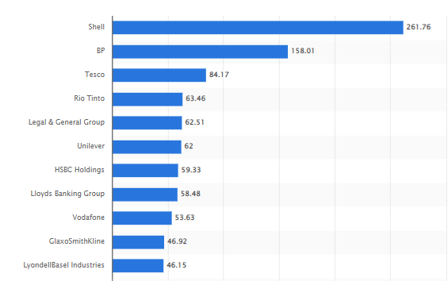
Figure 1: Biggest companies in the UK based on Revenue 2022
(Source: Statista.com, 2023)
The above chart shows that Shell Plc is one of the largest companies in the UK with 261.76 billion dollars. Legal and General Group is 5th from the top with 62.51 billion dollars.
The number of non-profit organisations in the UK is also high and works for the community in a significant manner. Cancer Research UK is a non-profit organisation that is very popular in the country and is liked by most of the population in the UK. The company provides information regarding cancer and helps patients to deal with the symptoms and cope after the treatment. The company also provides funding for researchers and medical professionals in the field of clinical medicine.
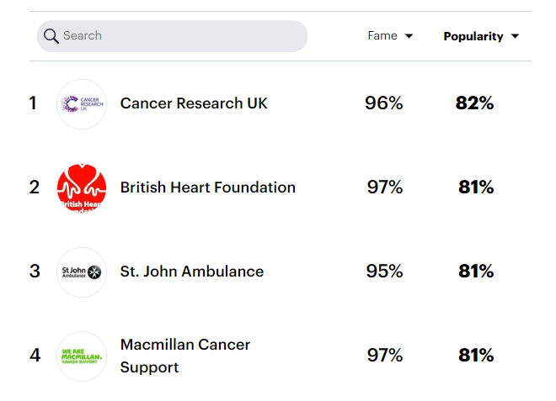
Figure 2: Popular charity organisations in the UK 2023
(Source: Yougov.co.uk 2023)
The above chart shows that Cancer Research UK is the most popular Charity in the UK followed by British Heart Foundation. The next two organisations are Saint John Ambulance and Macmillan Cancer Support. The British Heart Foundation is a charity-based organisation that encourages citizens to donate their items. The charity also provides tutorials for CPR and a free Health magazine regarding the problems of the heart. The company also provide information on how to eat healthy on a budget.

8. Entrepreneurs' values and beliefs in “for-profit” and “non-profit” small organisations with applications
Entrepreneurs who are associated with profit and non-profit organisations have different types of values they apply in their companies. Moreover, the entrepreneur of the profit companies is more focused stone generating profits rather than focusing on the people. The entrepreneur of a profitable organisation is brief and creative in their mission to achieve the company objectives. The business leaders of profit companies respect their employees and motivate them to work in a productive manner. The managers of a profit company should also be honest in their behaviour and give proper information to the employees regarding the strategies of the company.
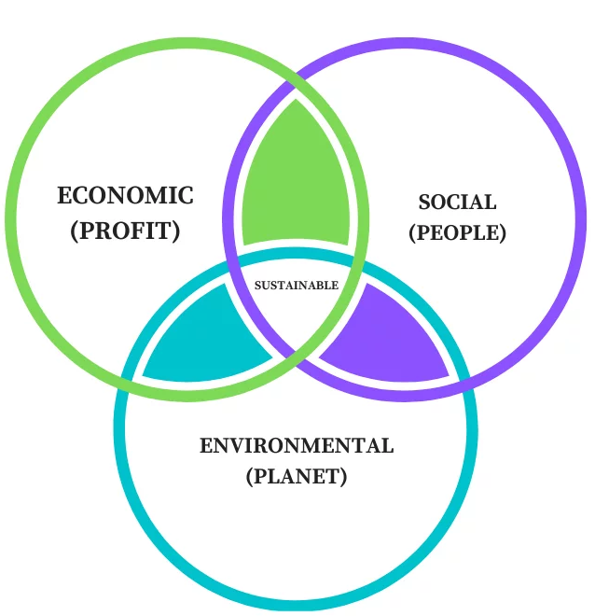
Figure 3: Triple Bottom Line Approach
(Source: Safdar et al. 2020, p 122662)
The above model illustrates the Triple Bottom Line theory which is a significant approach in the CSR field. The triple bottom line model focuses on three aspects of the business- Profit, People and Planet. The Entrepreneurs who are keen to make a profit will not focus on people and the planet and would choose to highlight profit. The non-profit organisations will choose to select people and the planet as their most important highlights.
On the other hand, the entrepreneur of a non-profit organisation is selfless and creates a project to improve the life of the people. Social entrepreneurs are passionate about creating something valuable for the community in the long-term process. The owner of a non-profit organisation focuses on the people and makes sure that they are happy and that their needs have been solved before the revenue. In contrast, the owner of a profit organisation can choose to point out the flaws of the employees if they do not perform in a productive manner.

9. Conclusion
Entrepreneurs are defined as individuals who have the ability to create an organisation based on their idea and creativity. Entrepreneurs can establish enterprises of different types like for-profit and non-profit organisations. The conceptual foundations for enterprises and entrepreneurship are important to understand the fields in detail. The personality traits of the individuals can decide what type of entrepreneur they will become in the future. The entrepreneurs of profit and non-profit organisations hold different values and visions for their companies. The profit organisations are dominant in the private sector of the UK. The number of the non-profit organisation is growing in the UK but not like the growth of commercial companies.

10. Reference List
Buckley, P.J., 2020. The theory and empirics of the structural reshaping of globalization. Journal of International Business Studies, 51, pp.1580-1592. [DOI: https://doi.org/10.1057/s41267-020-00355-5 ]
Catherine, S., 2022. Keeping options open: What motivates entrepreneurs?. Journal of Financial Economics, 144(1), pp.1-21. [DOI: https://doi.org/10.1016/j.jfineco.2022.01.001 ]
Gawer, A., 2022. Digital platforms and ecosystems: remarks on the dominant organizational forms of the digital age. Innovation, 24(1), pp.110-124. [DOI: https://doi.org/10.1080/14479338.2021.1965888 ]
Keating, C.B. and Katina, P.F., 2019. Complex system governance: Concept, utility, and challenges. Systems Research and Behavioral Science, 36(5), pp.687-705. [DOI: https://doi.org/10.1002/sres.2621 ]
Kenayathulla, H.B., Ahmad, N.A. and Idris, A.R., 2019. Gaps between competence and importance of employability skills: evidence from Malaysia. Higher Education Evaluation and Development, 13(2), pp.97-112. [DOI: https://doi.org/10.1108/HEED-08-2019-0039 ]
Koohang, A., Nord, J.H., Ooi, K.B., Tan, G.W.H., Al-Emran, M., Aw, E.C.X., Baabdullah, A.M., Buhalis, D., Cham, T.H., Dennis, C. and Dutot, V., 2023. Shaping the metaverse into reality: a holistic multidisciplinary understanding of opportunities, challenges, and avenues for future investigation. Journal of Computer Information Systems, pp.1-31. [DOI: https://doi.org/10.1080/08874417.2023.2165197 ]
Kusa, R., Duda, J. and Suder, M., 2021. Explaining SME performance with fsQCA: The role of entrepreneurial orientation, entrepreneur motivation, and opportunity perception. Journal of Innovation & Knowledge, 6(4), pp.234-245. [DOI: https://doi.org/10.1016/j.jik.2021.06.001 ]
Lozano, R., 2020. Analysing the use of tools, initiatives, and approaches to promote sustainability in corporations. Corporate Social Responsibility and Environmental Management, 27(2), pp.982-998. [DOI: https://doi.org/10.1002/csr.1860 ]
Milana, C. and Ashta, A., 2021. Artificial intelligence techniques in finance and financial markets: a survey of the literature. Strategic Change, 30(3), pp.189-209. [DOI: https://doi.org/10.1002/jsc.2403 ]
Morrish, S.C. and Jones, R., 2020. Post-disaster business recovery: An entrepreneurial marketing perspective. Journal of Business Research, 113, pp.83-92. [DOI: https://doi.org/10.1016/j.jbusres.2019.03.041 ]
Negri, M., Cagno, E., Colicchia, C. and Sarkis, J., 2021. Integrating sustainability and resilience in the supply chain: A systematic literature review and a research agenda. Business Strategy and the environment, 30(7), pp.2858-2886. [DOI: https://doi.org/10.1002/bse.2776 ]
Nicolás Martínez, C., Rubio Bañón, A. and Fernández Laviada, A., 2019. Social Entrepreneur: Same or Different from the rest?. VOLUNTAS: International Journal of Voluntary and Nonprofit Organizations, 30, pp.443-459. [DOI: https://doi.org/10.1007/s11266-018-00053-9 ]
Safdar, N., Khalid, R., Ahmed, W. and Imran, M., 2020. Reverse logistics network design of e-waste management under the triple bottom line approach. Journal of Cleaner Production, 272, p.122662. [DOI: https://doi.org/10.1016/j.jclepro.2020.122662 ]
Salmony, F.U. and Kanbach, D.K., (2022). Personality trait differences across types of entrepreneurs: a systematic literature review. Review of managerial science, 16(3), pp.713-749. [DOI: https://doi.org/10.1007/s11846-021-00466-9]
Schimmelpfennig, C. and Hunt, J.B., 2020. Fifty years of celebrity endorser research: Support for a comprehensive celebrity endorsement strategy framework. Psychology & Marketing, 37(3), pp.488-505. [DOI: https://doi.org/10.1002/mar.21315 ]
Sepulcri, L.M.C.B., Mainardes, E.W. and Pascuci, L., 2022. Non-profit Brand Orientation as a Strategic Communication Approach. International Journal of Strategic Communication, 16(4), pp.572-598. [DOI: https://doi.org/10.1080/1553118X.2022.2058948 ]
Statista.com (2023). Largest UK companies based on revenue 2019. [online] Statista. Available at: https://www.statista.com/statistics/1111246/largest-uk-based-companies-revenue/ [Accessed 1 May 2023].
YouGov (2023). The most popular charities & organisations in the UK | Politics | YouGov Ratings. [online] Yougov.co.uk. Available at: https://yougov.co.uk/ratings/politics/popularity/charities-organisations/all [Accessed 1 May 2023].

