Workplace Relationship in Unilever
Name of the Student: Grigor Zdravkov
Name of the subject: BMSK5002 - Developing Relationships and Workplace Achievement
Name of the University: University of Wales Trinity Saint David

Executive Summary:
Workplace relationship between the employees and management play important role in the performance of the organisations. This relationship is even more complex ion multinational companies like Unilever. The apex management of these companies stress on development of upper level staff but the lower level employees do not receive these benefits. The paper points out the importance of uniformity in employee development across hierarchies and its benefits.
Table of Contents
Introduction: 4
About Unilever: 4
Financial performance of Unilever: 4
HR metrics of Unilever: 5
Section 1: Potential benefits to Unilever and individual of personally developing individuals: 9
Alignment to macroeconomic changes in the market: 9
Political factors: 9
Economic factors: 12
Social: 14
Technology: 16
Role of employees in the macroeconomic factors in Unilever: 16
Retaining competitive position in the global market: 17
Investment and marketing decision making: 17
Section 3: Management of individual expectations in respect of personal development: 18
Training: 18
Diversity management and promotion: 19
Section 2: Evaluation of development vehicles in Unilever and appropriateness to development needs of employees: 19
Section 3: Development of plan to meet identified developmental needs and individual expectations: 20
Recommendations: 21
Training of lower level employees: 21
Empowering of weak subsidiaries: 21
Conclusion: 22
References: 23

Introduction:
Development of strategies to manage performances as well as personal and career development of employees have proved to be important standing pillars of multinational corporate organisations. The employees of multinational business corporations are no more mere workers executing orders. They have emerged into drivers of the business generation in the organisations employing them and consequently have emerged to be recognised as significant internal stakeholder. Albrecht et al. (2015) in their work link two important variables namely, human resource management and competitive advantage of companies. They clearly mention that human resources in business organisations are the very crux of their business decisions, execution and consequently their business performances. It is this business performance of business organisations which forms the basis of the competitive advantage which organisations boast and thrive on in the global market. Brewster, Chung and Sparrow (2016) mention a term ‘Globalizing Human Resource Management’ which means that global organisations empower and train the employees to operate in ways so as to bring about career as well as personal development of the employees. Hollenbeck and Jamieson (2015) point out the very basis of competitive advantage and human resource management of companies rests of their capability to retain talents and manage their performance. Considering the stiff competition which commences between multinational companies to acquire and retain talents, the multinational employers make strategies to bring about professional as well as personal development of employees to boost job satisfaction among the latter, thus ensuring prolonged retention. The paper would revolve around development of strategies for performance management and employee development in workplaces. The paper would open against the employee development project which Unilever has undertaken to promote professional skill and personal skill development among employees called ‘Developing & engaging our people’ (Unilever.com. 2018). This publication by Unilever would be the case study on which the entire study would be based.

About Unilever:
Unilever is a multinational company based in London and Rotterdam under the names of Unilever Plc and Unilever NV respectively. Unilever PLC is primarily listed on the London Stock Exchange while its Dutch counterpart is listed on the Euronext Amsterdam. The product umbrella of Unilever consists of beauty and personal care, food and refreshments, home care and water purifier. The company owns brands like Lux, Axe, Dove and Surf giving it leading positions in the global consumer goods market.

Financial performance of Unilever:
Unilever Group earned a net profit of EU 6486 million in 2017 compared to EU 5547 million which means actually shows the revenue generation power of the company.
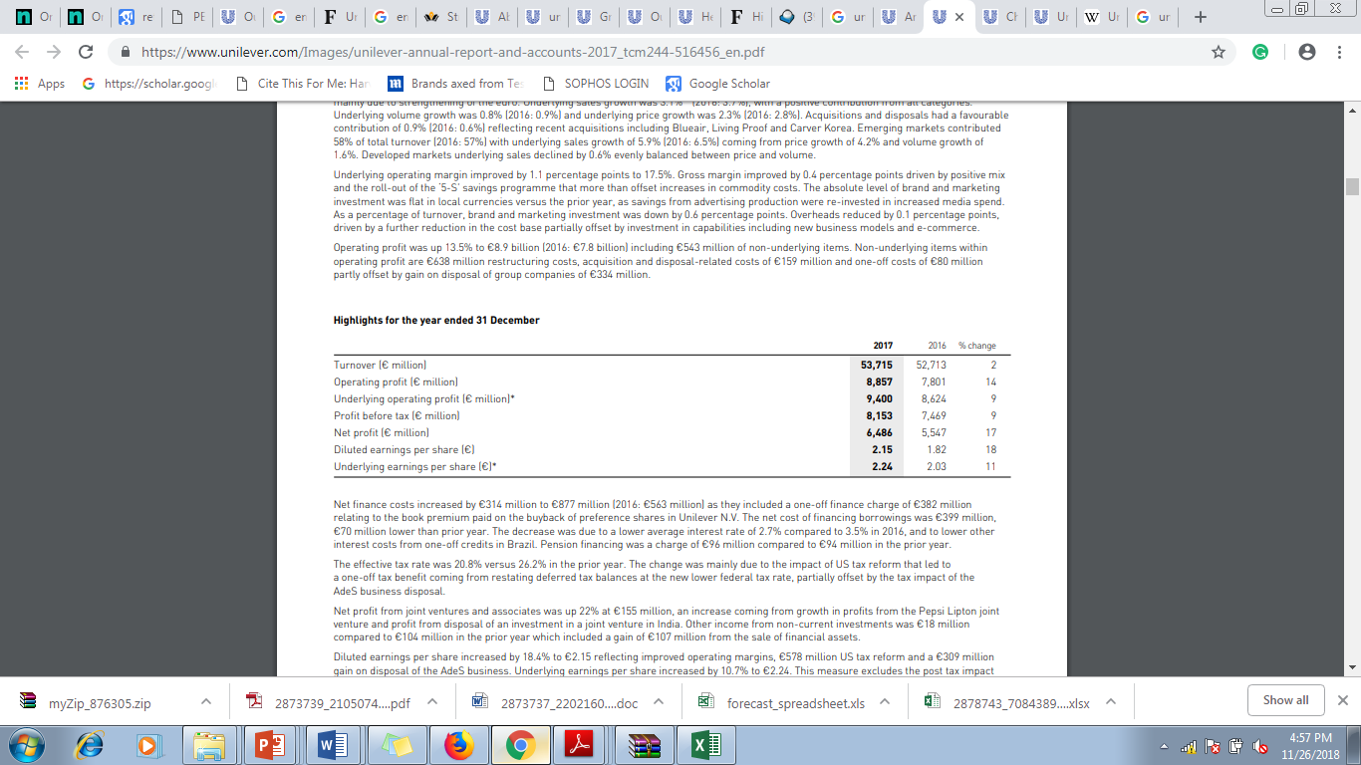
Figure 1. Excerpt from the financial statements of Unilever showing financial performance
(Source: Unilever.com. 2018)

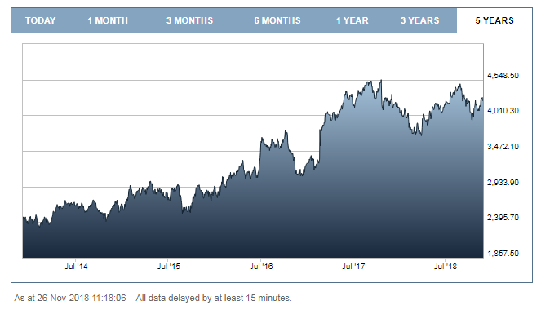
Figure 2. 5 years share price graph of Unilever on LSE
(Source: Londonstockexchange.com. 2018)
The trend of high profit generation of Unilever in the global market continues into its share market trend as well. It can be pointed out from the graph that the company enjoys a high position in the stock market. These two findings namely, revenue generation and capital generation show that Unilever enjoys a high competitive advantage in the global market. However, it can be pointed out that two facts pointed out above namely, capital generation and revenue directly point out to performance management of Unilever expect the fact that the financial statements mention the expenditure spent on employee salaries. This makes it pertinent to delve into HR metrics of 2017 Unilever Group released on the official website.

HR metrics of Unilever:
The HR metrics reveals a very poor performance of Unilever in performance management and employee development areas. The two main branches of Unilever along with the subsidiaries companies, some of which are also public limited companies and function as the Unilever Group are among the largest employers in the industry. Unilever is a global employer employing a total 149666 permanent employees and 10900 temporary employees. The metrics further shows that on average employees of Unilever have received 14 hours of training towards which the company has incurred an expenditure of EU 519 per employee on average. The metrics below shows that number of employees of both categories have fallen in 2017 compared to 2016 and 2015. The rate of employee satisfaction in the 2017 was 74 percent compared to 76 percent and 77 percent in 2016 and 2015. This waning employee satisfaction clearly points out to the degrading employee developmental strategies of Unilever to ensure professional and personal development of employees. The number of employees resigning voluntarily has increased to 7.4 percent compared to 7.6 percent and 5.9 percent respectively. The only positive aspect of HR management of Unilever as per the HR metrics is the increased amount of training hours to 14 form 8 in the previous two years. These figures of the GR metrics of Unilever shows that the company has not performed well as a global employer.
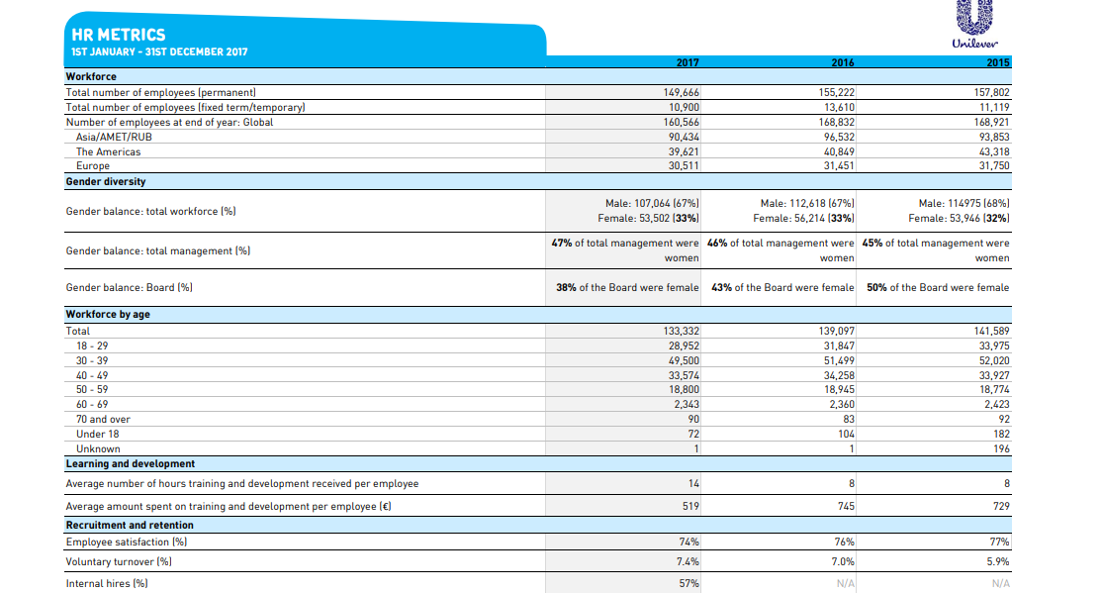
Figure 3. HR metrices of Unilever for 2017
(Source: Unilever.com. 2018)

Figure 4. Net profit per employee in Unilever
(Source: Author)
The above graph shows that the net profit of Unilever has increased but the number of employees both permanent as well as temporary has decreased. Thus, it can be inferred taking the business expansion of Unilever, that the company puts pressure on its existing employees. The outcome of this stress can be pointed out in the falling rate of employee satisfaction rate. The same can be also be inferred from the number of voluntarily retiring employees which rose to 7.4 percent in 2017 from 7 percent in 2016. The HR metrics further shows that the British-Dutch company has increased the number of training hours but decreased the amount it spent in 2017 compared to 2016. Thus, it can be inferred that Unilever’s employees benefit standards are not up to its global employer status and need further development. This makes Unilever an appropriate organisation to study the topic mentioned above.

Section 1: Potential benefits to Unilever and individual of personally developing individuals:
Unilever reaps several potential benefits by development of individual employees in the workplaces:

Alignment to macroeconomic changes in the market:
The development and retention of employees enable the Unilever to align as well as adapt its business operations to macroeconomic changes in the global market. The eighth page of the Annual Reports of Unilever for the period ended 2017 provides strong evidence that the company comes the influence of macroeconomic influences (Unilever.com. 2018). Grant (2016) mentions that multinational companies need to form to adapt to the external environmental factors. This would make it pertinent to delve into the macroeconomic influences under whose Unilever comes and the way the company uses its human resources to adapt these influences.

Political factors:
The political factors are one of the most important influencing factors acting on Unilever and necessitate it to develop its individual employees to decisions regarding different political changes in its global market. The political factors plays a very important role because the policy of the home country government of multinational have significant on impacts on all aspects of their businesses including their international expansion (Jabbour and de Sousa Jabbour 2016). The first political factor influence as far as Unilever is concerned is foreign expansion. Unilever is has headquarters in both the United Kingdom as well as Netherlands. This location is of tremendous importance to the business operations of the multinational company. It can be pointed out that Netherlands has foreign numbers of countries which concludes most of European and North American countries but few countries from South America and Asia. Further it can be pointed out that Netherlands does not share relationships with countries like India and Myanmar (Government.nl. 2018). Thus, in other words, the foreign relationship of Government of Netherlands would prevent Unilever from exploiting the emerging giants like India which is one of its biggest markets. This is where the foreign relationships of the United Kingdom, the headquarters of Unilever Plc comes into play. London has strong bilateral relationships with as many as 225 countries which includes both developed and emerging markets (Gov.uk. 2018). Thus, it is evident that foreign relationship of domicile countries of Unilever allows it to enter several countries and acquire talents from them besides marketing its products in these host countries.
The second importance of political factors as far as business of Unilever is concerned is formation of laws. Huq, Chowdhury and Klassen (2016) mentions that government bodies forms laws which the multinational companies have to comply with in order to operate. The laws cover several areas include taxation and human resource exploitation. The Government of the United Kingdom and Netherlands form laws which Unilever has to comply with. For example, the company while employing employees in the United Kingdom has to comply with the National Minimum Wage rates which is decided by the government (Gov.uk. 2018). Similarly, while operating in countries members to the European Union, the company has to comply with the minimum wage rates prevailing in the respective countries (Eurofound.europa.eu. 2018). It can be pointed out that China, one of the fastest growing economic giants has strict wage regime for exploitation its human resources. The Labour Law Article 50 mandates the commercial organisations to pay wages to employees on monthly while Article 44 of law mentions that the overtime wages should be minimum 150 times the normal wages of employees (Clb.org.hk. 2018). Similarly, the taxation laws which multinational corporations like Unilever pay varies from country to the next. For example, in the United Kingdom, the limited companies of both UK origin as well of foreign origin having an office in the UK have to pay corporation tax (Gov.uk. 2018). As far as Australia is concerned, it can be pointed out that Australian Taxation Office, Government of Australia imposes 30 percent tax in large limited companies which also includes Unilever functioning in its economy (Ato.gov.au. 2018).
The third important influence which political factors have on multinational companies including Unilever is changing relationship between their home country government(s) and international organisations. Holmes, McGrattan and Prescott (2015) point out that multinational companies are able to exploit the human resources in different countries. Employees from different countries enable the companies to bring about innovation in their operations. This need to exploit talents from different countries to bring about innovation in operations and ensure continuous supply of talents from all over the world make companies subject to changing political equations in the global market. It can be pointed out one of the most significant political events which has affected multinational companies like Unilever significantly is Brexit, the exit of the United Kingdom from the European Union. Unilever decided to leave the United Kingdom and move its headquarters to Netherlands to take advantage of the European Union. This would mean that the company has to cede its listing on London Stock Exchange and lose majority of its shareholders (Fortune.com. 2018). This would impact the capital generation and the entire operations of the multinational company. Thus, it is clear political decisions between countries and international organisations have significant impacts on the decisions of multinational companies like Unilever.

Economic factors:
Multinational companies like Unilever operate in more than a hundred countries and come under the influences of several macroeconomic factors. The first economic factor which impact crucial areas of business of these multinational companies is changing exchange rates of international currencies (Hair et al. 2015).
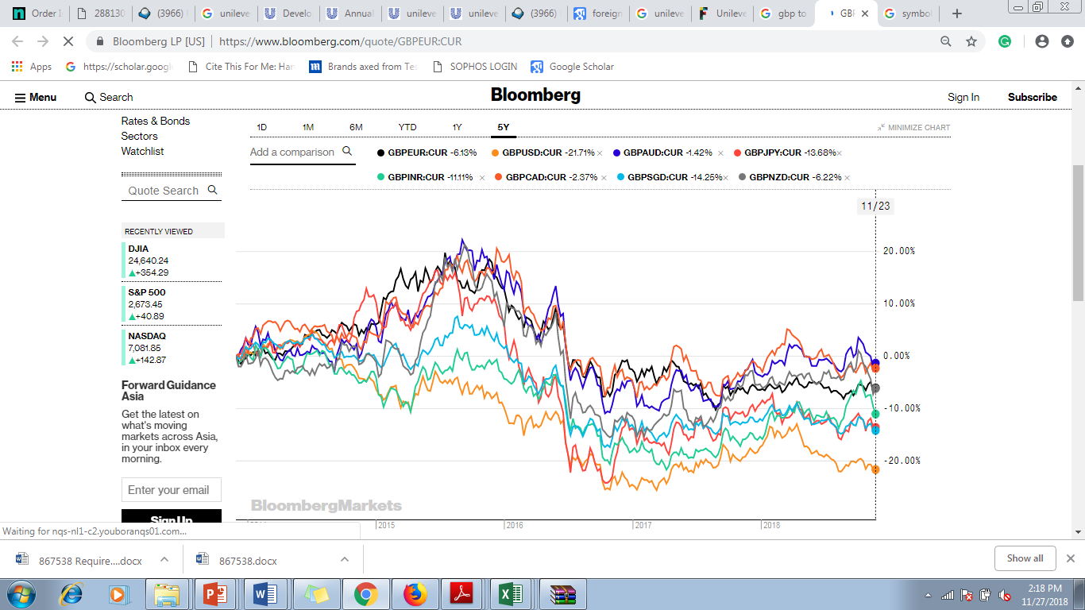
Figure 5. GBP exchange rates to USD, JPY, INR, CAD, AUD, SGD, NZD and EUR
(Source: Bloomberg.com. 2018)
The above graph shows that changing exchange rates of GBP with respect to five important currencies. The North American market is presented by the United States of America and Canada represented by their currencies USD and CAD respectively. The Asian market is represented by Japan, India and Singapore by their respective currencies JPY, INR and SGD. The Australian and New Zealand markets are represented by AUD and NZD respectively while the European Union is represented by EUR. The graph above shows that GBP is weakening comparison to all the chosen currencies which means that Unilever would have to spend immense amount of expenditure to import raw materials in these countries. Further it can also be pointed out that GBP is showing signs of resurgence in case of CAD, EUR NZD and AUD. As far as INR is concerned, GBP is predicted to fall further. In case of the other currencies, GBP also shows signs of weakening. It can be pointed out as far as Unilever is concerned, it can use its Dutch operations to source raw materials from Europe which to some extent would nullify the GBP and EUR exchange rate difference. Karolyi and Liao (2017) mention that fluctuating currency rates have strong influences on companies right from their acquisition of financial resources, material resources, human resources, knowledge capital and sale of goods. Considering the above graph it can be inferred that the exchange rates of the currencies in the international currency markets would have strong impact on the operations of Unilever.
The second economic factor which comes into play is supply chain management. Heckmann, Comes and Nickel (2015) mention that multinational companies require to source raw materials from all around the globe to fuel their immense manufacturing processes which in turn form the base of their product umbrellas. This means that multinational companies are dependent to a great extent on the supply chains available in their host countries. For example, while operating in markets rich in resources like India, the USA and China, the multinational companies can depend on the supply chains available within these markets. Contrarily while operating in countries with poor resident supply chains, the multinational corporations have to depend on foreign supply chains to a greater extent. While the first set of countries companies like Unilever can achieve higher degree of economies of scale, the second types of host markets the companies have to incur immense expenses to source raw materials in these markets. The same is applicable for sourcing financial resources which would be discussed latter.

Social:
The social factors come to play at all stages of operations of multinational companies like Unilever. The first social factor which influences the multinational companies is resident population of their host markets.
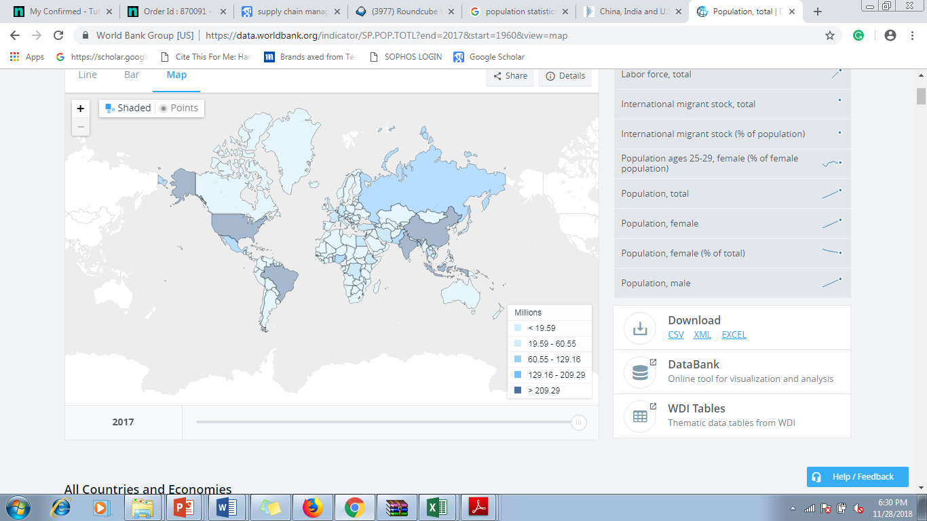
Figure 6. World map showing population density
(Source: Data.worldbank.org. 2018)
The above world map published by the World Bank shows that global world population. The map shows that countries like the US and China are highly populated. This is an important factor because population available in a country provides companies with their customer bases which forms the base of their revenue generation. As far as Unilever is concerned, it can be pointed out that most of the market of the company is present in these countries compared to the less populated countries.
The second factor which influences the multinational companies is cultural differences between countries. De Mooij (2018) points out that cultures have great influences on consumption habits of consumers and consequently on the revenue generation of multinational companies like Unilever. The figure below shows four important markets of the company namely the UK, the US, China and India. It can be pointed China and India, being eastern markets exhibit great cultural differences from their western counterparts namely, the US and the UK. Thus it can be pointed out that Unilever has to adapt to the social conditions of all its host markets in order to function profitably in the global market.
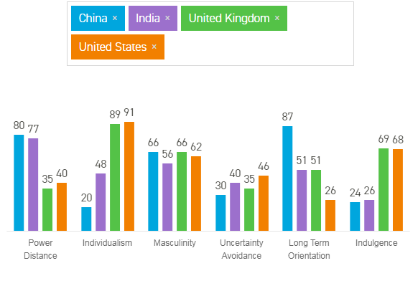

Technology:
Technology is one of the most significant factor affecting the operations of multinational companies like Unilever. Görg and Strobl (2016) point out that technology plays a very significant role towards driving their mass production of goods and services to cater to the needs of the consumers. Kolk (2015) supports this argument by mentioning that business organisations like technology to bring about innovation in their products. Andersson et al. (2016) contradict these opinions and point out that the application of technology is not linked to manufacturing alone and in fact pervades all aspects of businesses of MNCs like Unilever. For example, advanced technology like cloud enable the managers of located in one market hold meetings with managers located in other markets to take important business decisions. Thus, it can be pointed out that technology has emerged as one of important macroeconomic factors.

Role of employees in the macroeconomic factors in Unilever:
It can be pointed out from the above analysis of the external business environment of Unilever that it requires to ensure development of the individual employees in order to retain them and adapt to the market changes. Włodarkiewicz-Klimek (2015) in this respect points out that adapting to macroeconomic changes require business organisations to form strategies to adapt to the changes. The strategies aim to maximise the driving forces in the market like increase and remove or at least minimise the negative impacts like economic downturns. Thus, the business organisations require to retain their employees to form strategies to capitalise on the market opportunities and manage the risks. As far as Unilever is concerned, it can be pointed out that the multinational company functions in more than a hundred countries each with a diverse external market environments. Eriksson et al. (2015) point out in this respect the multinational companies require to make appropriate decisions to adapt to the market. Faulty market decisions can lead to losses worth billions to the company, thus impairing its global position. This means that the Unilever has to ensure development of employees, especially the experienced employees in order to take appropriate decisions to adapt to the macroeconomic changes discussed above.

Retaining competitive position in the global market:
Unilever requires to ensure development of its human resources in order to maintain its competitive advantage and global position. Deresky (2017) points out that competitive advantage of multinational companies depends to a large extent on the decision making power of companies. This statement is extremely applicable to Unilever because it can pointed out that the company shares its international market with competitors like P&G. This means retention of competitive position against P&G would depend largely on the decision making power of the senior management. De Mooij (2018) strengthens this view by mentioning that the retention of market position of companies are not only dependent on the decision making of their senior managers but also in the execution power of the lower level employees. Thus, in this light it can be pointed out that Unilever in order to sustain in stiff competition is dependent on both senior managers as well lower level executives to ensure effective decision making and execution respectively. This means that the company needs to ensure development of both its senior level employees as well as junior level employees in order to retain its global position.

Investment and marketing decision making:
Unilever requires to promote development of its employees to ensure appropriate decision making in investment and marketing. Lehmann (2015) points out in this respect that business organisation require to invest their acquired capital from the market to generate higher returns. Erel, Jang and Weisbach (2015) point out in this respect that asset positions of the multinational organisation as well as revenue generation depends a great on their abilities to make appropriate decisions on acquisitions and mergers. This is evident from the product portfolio of Unilever which consists of brands acquired by the company. It can also be pointed out that some of these brands like Brut and Axe are some of the biggest brands generating a high revenue for the company in the global market. Giuliani et al.(2014) contradicts this statement and points out that acquisition of subsidiaries alone cannot ensure profit. The companies have to form strategies so as to market the acquired brands and generate immense profits. This is again very true for Unilever considering its immense marketing power. It can pointed out that making marketing and investments decisions require the company to retain employees with tremendous decision making power. Thus, it can be concluded that making investment and marketing decisions requires Unilever to develop its employees to retain them (Deresky 2017).

Section 3: Management of individual expectations in respect of personal development:
Unilever being a global employer manages the expectations of the individual employees in several ways to ensure their personal development. The following are the ways in which Unilever manages the expectations of the employees:

Training:
Unilever offers training to its employees to improve their skills and develop their decision making power. Hanaysha (2016) point that training enhances the efficiency of the employees. Considering the macroeconomic environment of Unilever, it can be pointed out that the business environment of the multinational undergoes drastic changes ranging from political, economic, social, technological or an combination of these factors. Gutierrez-Gutierrez et al.(2018) strengthens the discussion by adding the extreme competition in the market requires business companies to develop new products in order to leave its competitors behind. As far as Unilever is concerned, the company faces competition from both international and local firms. The firm trains its employees to embrace the newly evolving market trends. This enables the employees of Unilever operate in several hundred economies and cater to market needs. This employment development of Unilever can be proved by the performances of its subsidiaries. Hindustan Unilever, the Indian subsidiary of Unilever featured in the 8th position for its innovativeness (Forbes.com. 2018). This article proves that Unilever does not only train the employees deployed in the headquarters but also the employees of its subsidiaries. Thus, it can be proven that Unilever develops its global human resources by empowering them with training.

Diversity management and promotion:
Unilever brings about development of employees by awarding them promotion and ensuring diversity management. Fernandez et al.(2015) point out that promotion and diversity management motivates employees and bring about their development. Companies which empower and promote employees are able to retain the employees for longer tenure. Unilever can be described as global trend setter as far as diversity management and promotion are concerned. The apex management promoted Leena Nair, an Asian as its chief HR officer (Thestraitstimes.com 2018). This promotion and diversity management in Unilever can again be observed from the apex managers. The apex management is led by people across Europe, Asia, North America and Africa, thus upholding diversity in action (Unilever .com 2018).

Section 2: Evaluation of development vehicles in Unilever and appropriateness to development needs of employees:
An analysis of the human resources metrics of Unilever shows that in spite of being a multinational company, the company fails to manage individual expectations of employees. The official website of the Unilever claims that it maintains high level of fairness while employing human resources. The company on its official website claims that it ensures promotion of human rights and provides its employees self-development opportunities. The official website on Unilever in its case study tirtled ‘Developing & Engaging our people’ further claims that company provides training to its employees to empower them to take more appropriate decisions. The company further claims that it ensures employee development using robotics and artificial intelligence (unilever.com 2018). This claim of Unilever is rendered effortless by a report published by the Resource Centre Human, Human Rights Organisation. The report mentions employees in Kenya serving Unilever face sexual harassments. The report points out that supervisors of tea plantations under Unilever’s possession harass female by paying them low wages and allocating them difficult tasks (Business-humanrights.org. 2018). The Guardian reports that Unilever sources palm oil grown in plantations employing child labour (Davies 2018). Thus, it can be evaluated that far from ensuring development of its employees, the company resorts to exploitation to get more productivity at lower wages. It can also be evaluated that the current development vehicle of Unilever is appropriate to ensure development of its employees.

Section 3: Development of plan to meet identified developmental needs and individual expectations:
The development plan to develop employees at Unilever would follow the global employer status of the company The development session would be started by the departmental managers measuring the performances of the employees and recognising the shortcomings. The departmental should submit a report regarding the development needs with the apex management of the respective subsidiary. The national heads should submit a report with the apex management. The apex management would form a development plan. The employee development plan would be broken down according to the markets starting with Asia. Asia would be followed by Europe, North America, South America, Africa and Australia. The starting date of the plan would be December 3, 2018. The activity series is as follows:

Recommendations:
The following are the recommendations which can be made to Unilever in terms of employee development:

Training of lower level employees:
Unilever should train its lower level and outsourced employees. The above discussion emphasises on employee development and diversity management up the organisational pyramid which is undoubtedly worth praising. However, the exploitation of the plantation workers show the employee development initiatives do not travel downward the pyramid. The company should apply employee development initiatives at the lower level as well.

Empowering of weak subsidiaries:
The apex management should empower and develop the employees posted in the weak subsidiaries as well. The leadership of the company is dominated by employees from mianly Europe, North America, Australia and Asia, all; of which are important markets and homes to strong subsidiaries. However, it can be pointed that the apex management should also train the employees of the weaker subsidiaries like Africa.

Conclusion:
It can finally be concluded that Unilever has come a strong employee development infrastructure. However, the employee development methods applied in different markets and at different organisational levels lack uniformity. While the employees holding high positions in the important subsidiaries enjoy development and promotions, the employees posted in poor markets and at lower levels hardly receive any benefit. The apex management should introduce the training and employee development initiatives at the lower levels as well. It must also be noted that the scope of the task does not cover aspects like marketing and innovative. Incorporating these two concepts would have rendered the task a greater depth.

References:

Albrecht, S.L., Bakker, A.B., Gruman, J.A., Macey, W.H. and Saks, A.M., 2015. Employee engagement, human resource management practices and competitive advantage: An integrated approach. Journal of Organizational Effectiveness: People and Performance, 2(1), pp.7-35.
Andersson, U., Dasí, À., Mudambi, R. and Pedersen, T., 2016. Technology, innovation and knowledge: The importance of ideas and international connectivity. Journal of World Business, 51(1), pp.153-162.
Ato.gov.au. 2018. Ato.gov.au. [online] Available at: https://www.ato.gov.au/Rates/Changes-to-company-tax-rates/?page=1#Base_rate_entity_company_tax_rate [Accessed 27 Nov. 2018].
Bloomberg.com. 2018. Bloomberg.com. [online] Available at: https://www.bloomberg.com/quote/GBPEUR:CUR [Accessed 27 Nov. 2018].
Brewster, C., Chung, C. and Sparrow, P., 2016. Globalizing human resource management. Routledge.
Business-humanrights.org. 2018. Retrieved from https://www.business-humanrights.org/en/kenya-paper-examines-unilevers-response-to-allegations-of-sexual-harrassment-at-kericho-tea-plantations-using-un-guiding-principles-finds-firm-falls-short-of-own-commitments
Clb.org.hk. 2018. Clb.org.hk. [online] Available at: https://clb.org.hk/content/employment-and-wages [Accessed 27 Nov. 2018].
Data.worldbank.org. 2018. Data.worldbank.org. [online] Available at: https://data.worldbank.org/indicator/SP.POP.TOTL?end=2017&start=1960&view=map [Accessed 28 Nov. 2018].
Davies, R. 2018. The Guardian.com. Retrieved from https://www.theguardian.com/law/2016/nov/30/kelloggs-unilever-nestle-child-labour-palm-oil-wilmar-amnesty
De Mooij, M., 2018. Global marketing and advertising: Understanding cultural paradoxes. SAGE Publications Limited.
De Mooij, M., 2018. Global marketing and advertising: Understanding cultural paradoxes. SAGE Publications Limited.
Deresky, H., 2017. International management: Managing across borders and cultures. Pearson Education India.
Erel, I., Jang, Y. and Weisbach, M.S., 2015. Do acquisitions relieve target firms’ financial constraints?. The Journal of Finance, 70(1), pp.289-328.
Eriksson, K., Johanson, J., Majkgård, A. and Sharma, D.D., 2015. Experiential knowledge and cost in the internationalization process. In Knowledge, Networks and Power (pp. 41-63). Palgrave Macmillan, London.
Eurofound.europa.eu. 2018. Eurofound.europa.eu. [online] Available at: https://www.eurofound.europa.eu/publications/report/2017/eu-member-states/statutory-minimum-wages-in-the-eu-2017 [Accessed 27 Nov. 2018].
Fernandez, S., Resh, W.G., Moldogaziev, T. and Oberfield, Z.W., 2015. Assessing the past and promise of the Federal Employee Viewpoint Survey for public management research: A research synthesis. Public Administration Review, 75(3), pp.382-394.
Forbes.com. 2018. Retrieved from https://www.forbes.com/companies/hindustan-unilever/#73ec1aeb3ecd
Fortune.com. 2018. Fortune.com. [online] Available at: http://fortune.com/2018/10/05/unilever-london-netherlands-move/ [Accessed 27 Nov. 2018].
Giuliani, E., Gorgoni, S., Günther, C. and Rabellotti, R., 2014. Emerging versus advanced country MNEs investing in Europe: A typology of subsidiary global–local connections. International Business Review, 23(4), pp.680-691.
Görg, H. and Strobl, E., 2016. Multinational Companies, Technology Spillovers and Plant Survival. In Multinational Enterprises and Host Country Development (pp. 289-303).
Gov.uk. 2018. Gov.uk. [online] Available at: https://www.gov.uk/foreign-travel-advice [Accessed 27 Nov. 2018].
Government.nl. 2018. Government.nl. [online] Available at: https://www.government.nl/latest/news/2012/09/18/foreign-policy-in-the-interests-of-dutch-citizens-and-businesses [Accessed 27 Nov. 2018].
Grant, R.M., 2016. Contemporary strategy analysis: Text and cases edition. John Wiley & Sons.
Gutierrez-Gutierrez, L.J., Barrales-Molina, V. and Kaynak, H., 2018. The role of human resource-related quality management practices in new product development: A dynamic capability perspective. International Journal of Operations & Production Management, 38(1), pp.43-66.
Hair Jr, J.F., Wolfinbarger, M., Money, A.H., Samouel, P. and Page, M.J., 2015. Essentials of business research methods. Routledge.
Hanaysha, J., 2016. Examining the effects of employee empowerment, teamwork, and employee training on organizational commitment. Procedia-Social and Behavioral Sciences, 229, pp.298-306.
Heckmann, I., Comes, T. and Nickel, S., 2015. A critical review on supply chain risk–Definition, measure and modeling. Omega, 52, pp.119-132.
Hollenbeck, J.R. and Jamieson, B.B., 2015. Human capital, social capital, and social network analysis: Implications for strategic human resource management. Academy of management perspectives, 29(3), pp.370-385.
Holmes, T.J., McGrattan, E.R. and Prescott, E.C., 2015. Quid pro quo: technology capital transfers for market access in China. The Review of Economic Studies, 82(3), pp.1154-1193.
Huq, F.A., Chowdhury, I.N. and Klassen, R.D., 2016. Social management capabilities of multinational buying firms and their emerging market suppliers: An exploratory study of the clothing industry. Journal of Operations Management, 46, pp.19-37.
Jabbour, C.J.C. and de Sousa Jabbour, A.B.L., 2016. Green human resource management and green supply chain management: Linking two emerging agendas. Journal of Cleaner Production, 112, pp.1824-1833.
Karolyi, G.A. and Liao, R.C., 2017. State capitalism's global reach: Evidence from foreign acquisitions by state-owned companies. Journal of Corporate Finance, 42, pp.367-391.
Kolk, A., 2015. The role of international business in clean technology transfer and development. Climate Policy, 15(1), pp.170-176.
Lehmann, D.R., 2015. Marketing and organic revenue growth. GfK Marketing Intelligence Review, 7(1), pp.16-21.
Londonstockexchange.com. 2018. Londonstockexchange.com. [online] Available at: https://www.londonstockexchange.com/exchange/prices-and-markets/stocks/summary/company-summary/GB00B10RZP78GBGBXSET1.html [Accessed 26 Nov. 2018].
Unilever.com. 2018. Unilever.com. [online] Available at: https://www.unilever.com/sustainable-living/our-strategy/embedding-sustainability/developing-and-engaging-our-people/ [Accessed 26 Nov. 2018].
VELLOOR, R. 2018. Thestraitstimes.com. Retrieved from https://www.straitstimes.com/singapore/in-good-company-unilevers-leena-nair-cracks-glass-ceilings-again-and-again
Włodarkiewicz-Klimek, H., 2015. The analysis and assessment of the degree adaptation of human capital in polish enterprises’ to the knowledge-based economy requirements. In Int Forum Knowl Asset Dyn, IFKAD, Bari.

