BEng Electrical and Electronic Engineering
Design of an Unsigned two Number uneven Parallel Multiplier and the design of a FSM in hardware and VHDL
ElectronicsII
Joshua Hunt
5/4/2021

Contents
Introduction 2
TASK 1 2
Binary multipliers 2
Braun Multiplier 3
Wallace tree 3
Baugh-Wooley Multiplier 4
Booth multiplier 4
Array Multiplier 5
Comparison of Multipliers 5
Development of a 12x4 Multiplier 6
Half Adder 7
Full Adder 8
Line 0 11
Line X 15
THE FULL 12X4 MULTIPLIER 20
TASK 2 24
VHDL 25
Discrete gate solution 28
Conclusion 31
Bibliography 31

Introduction
This report investigates the different binary multipliers to determine the best one based on their pros and cons. The development of a 12x4 binary multiplier using Xilinx design software is explained. Also a FSM state diagram is designed, simulated and synthesised as both a VHDL and discrete gate solution.

TASK 1

Binary multipliers
A binary multiplier is a process used in digital electronics to multiply two binary numbers, built using binary adders. There are many different techniques used to implement a digital multiplier which are as follows;

Braun Multiplier
Braun multiplier is a type of parallel array multiplier. The standard architecture of Braun multiplier mainly consists of some Carry Save Adders, array of AND gates and one Ripple Carry Adder. See figure 1 which shows a 3 x 3 bit multiplier as an example. (Ms. Madhu Thakur, 2012) (Bagyaveereswaran, 2011)
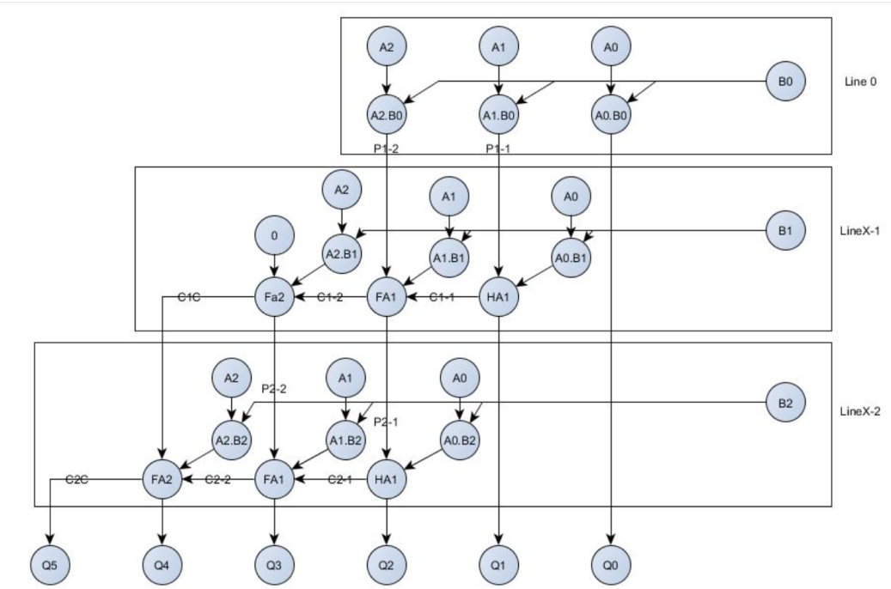
Figure 1

Wallace tree
This method is an efficient hardware implementation that uses two integers, devised by an Australian computer scientist by the name of Chris Wallace. It reduces the number of partial products and use carry select adder for the addition of partial products. The Wallace tree has three steps (Soniya, 2013); (Asif, 2014)
1. Multiply each bit of multiplier with same bit position of multiplicand. Depending on the position of the multiplier bits generated partial products have different weights.
2. Reduce the number of partial products to two by using layers of full and half adders.
3. After second step we get two rows of sum and carry, add these rows with conventional adders.
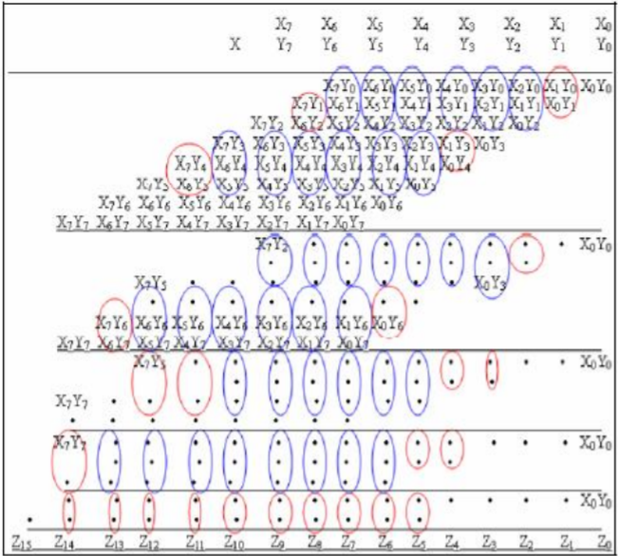
Figure 2 (Example of 8 bit×8 bit Wallace tree multiplier)

Baugh-Wooley Multiplier
The Baugh-Wooley technique is suited for 2’s compliment numbers as it was created to design regular multipliers. It uses parallel products to complement multiplication and adjusts the partial products to maximize the regularity of multiplication array. (Prasada, 2020)
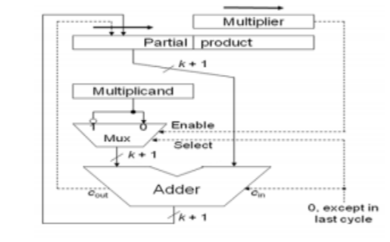
Figure 3 (Hardware of Baugh-Wooley Multiplier)

Booth multiplier
Booth multiplication algorithm gives a procedure for multiplying binary integers in signed -2’s complement representation. The implementation of Booth’s consists of making a booth table, examination of the multiplier bits, and shifting of the partial product. See Figure 4 which shows an example of how it works. (Studytonight, 2021)
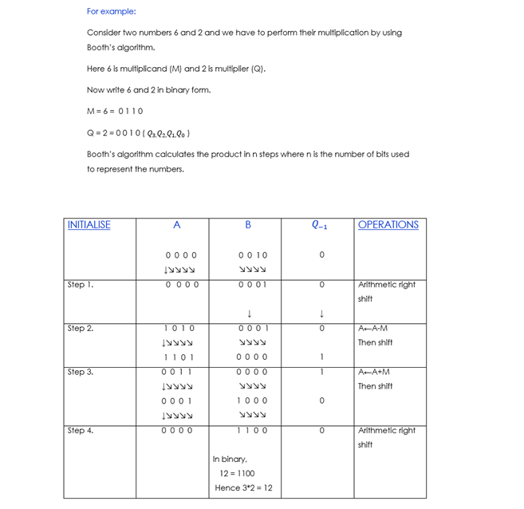
Figure 4

Array Multiplier
This multiplier uses an array of half and full adders for multiplying two binary numbers. To form the various product terms, an array of AND gates is used before the Adder array. This multiplier is circuit is based on the add shift algorithm. (skylags, 2019)
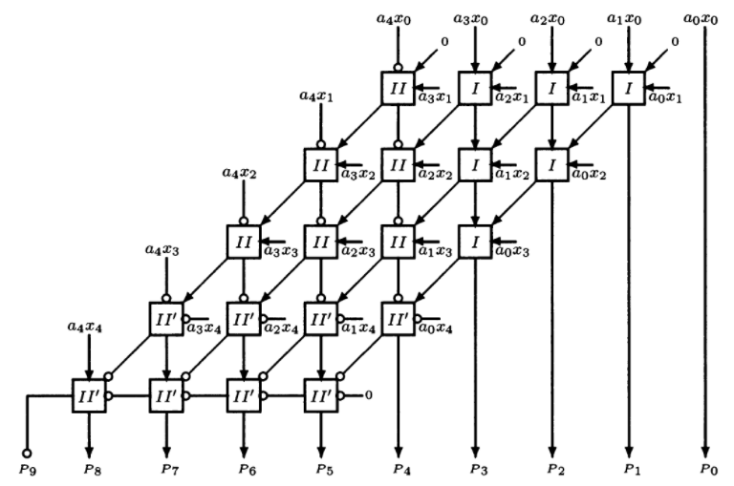
Figure 5
Figure 6

Comparison of Multipliers
TYPE OF MULTIPLIER | BRAUN | WALLACE TREE | BAUGH-WOOLEY | BOOTH | ARRAY
IMAGE | 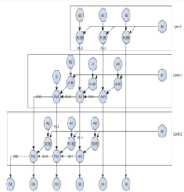 | 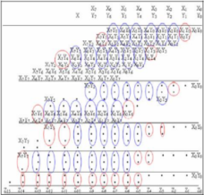 | 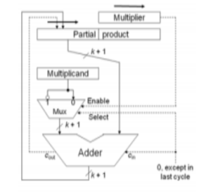 | 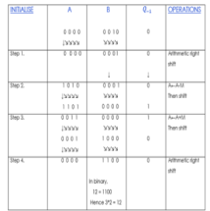 | 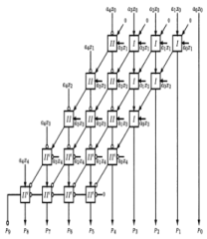
PROS | * Regular structure *easy to layout *small area *design time a lot less | * High speed  * Small delay * Power consumption is low | * High Speed *Sign of the partial bits are always kept positive so array addition techniques can be directly applied * Less delay * Low power *Small area occupied | * Reduced partial product, great for >16 bits * Deals with both positive and negative multiplier | * Simple to design * Regular in shape * Small area
CONS | * Only suitable for less than 16-bit, more bits will increase area occupied and power consumption * Restricted to performing multiplication of two unsigned numbers | * Complex to layout * Has irregular wires | * Consumes more power than wallace tree | * Complex circuit *inefficiency of the circuit when isolated 1’s are encountered | * High Power consumption * High Delay

The main purpose of comparing the above multipliers is to determine the best and fastest method. The main factors that contribute to the overall speed are the delay, power and area of the multiplier. There are pros and cons to every single one which can be seen in the table above, so what the multiplier is used for will need to be considered before choosing one. However the Fastest multiplier is the Wallace tree as it has lower power consumption and smaller delay, having said that it does have a more complex layout.

Development of a 12x4 Multiplier
Based upon a simple parallel Braun multiplier, a 12x4 multiplier was designed, simulated and synthesised. This was done using Xilinx design software. The Multiplier consists of a line X, line 0 and a series of half and full adders that all work simultaneously to ultimately achieve a working multiplier. Below is a more in depth look at each characteristic.
Before delving into the main characteristics of a binary multiplier, it’s worth noting that the working principle is very similar to how most would multiply decimal numbers by hand. By keeping this in mind it becomes easier to understand the operation of the characteristics in a binary multiplier.
Figure 7
Take the above calculation of 111x19 for example. Once B1 has been multiplied with A1, A2 & A3 to produce Line 0 the same is done with B2 to produce Line X. From right to left, line 0 is then added with line X to produce an answer. So, looking at the column circled red, this is where a half adder would come into play. A half adder can add two bits of data, in this case the 9 and the 1 to produce two outputs which would be the 0 (SUM) and the CARRY of 1. The blue circle is where a Full adder would work. A full adder is capable of adding three inputs, which are in this case the 9+1 but also the 1 that was carried over (Carry-IN), it then operates the same as a half adder in the fact that it has two outputs, the sum and the carry.

Half Adder
A half adder is capable of adding two bits of data (A+B) to produce two outputs which are the SUM and CARRY. The truth table, schematic representation and XOR//AND realization of a half adder are shown in the figure below. (Admin, 2018)
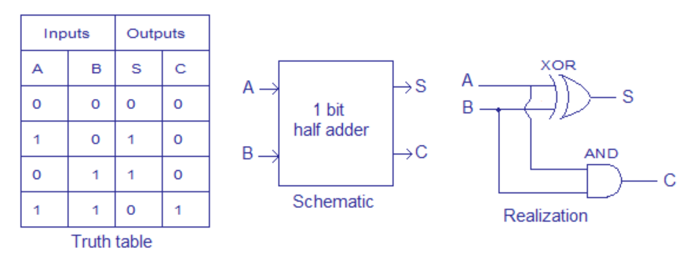
Figure 8
This was then written in ISE ready to be called in with the full multiplier. As you can see it only has two inputs and two outputs.
entity halfadder is
Port ( A : in STD_LOGIC;
B : in STD_LOGIC;
Sum : out STD_LOGIC;
Carry : out STD_LOGIC);
end halfadder;

architecture Behavioral of halfadder is

begin

Sum <= A xor B;
Carry <= A and B;

end Behavioral;

A Test bench is then created which allows the behavioural to be simulated to produce a graph and identify if it is working correctly. In the figure below, it’s clear that when A is 1 and B is 0 then the sum is 1 and carry is 0. On the right it shows that when A is 1 and B is 1 then the sum remains 0 while a 1 is carried over. This is exactly how a half adder should work.

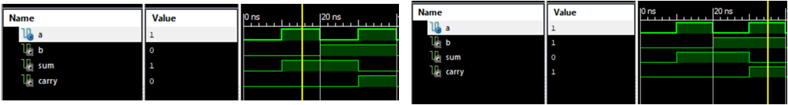
Figure 9

Full Adder
A full adder is capable of adding three bits of data which are (A+B+ Carry IN) to produce two outputs which are the SUM and CARRY. The truth table and schematic diagram for a full adder can be seen in Figure 8. (Lala, 2006) (Crowe, 2004)
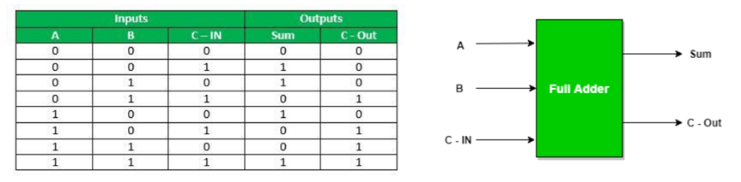
Figure 10 (geeksforgeeks, 2019)
Again, this logic is written out in a new project on Xilinx software as follows;-
entity fulladder is
Port ( A : in STD_LOGIC;
B : in STD_LOGIC;
C : in STD_LOGIC;
Sum : out STD_LOGIC;
Carry : out STD_LOGIC);
end fulladder;

architecture Behavioral of fulladder is

signal AxB : STD_LOGIC;
signal AxBnC: STD_LOGIC;
signal AnB : STD_LOGIC;

begin
AxB <= A xor B;
AxBnC <= AxB and C;
AnB <= A and B;

Sum <= AxB xor C;
Carry <= AxBnC or AnB;

end Behavioral;

A test bench is then created to synthesise and produce a graph in order to view if it is working correctly ;-

ARCHITECTURE behavior OF fulladder_TB IS

-- Component Declaration for the Unit Under Test (UUT)

COMPONENT fulladder
PORT(
A : IN std_logic;
B : IN std_logic;
C : IN std_logic;
Sum : OUT std_logic;
Carry : OUT std_logic
);
END COMPONENT;

--Inputs
signal A : std_logic := '0';
signal B : std_logic := '0';
signal C : std_logic := '0';

--Outputs
signal Sum : std_logic;
signal Carry : std_logic;
-- No clocks detected in port list. Replace <clock> below with
-- appropriate port name

BEGIN

-- Instantiate the Unit Under Test (UUT)
uut: fulladder PORT MAP (
A => A,
B => B,
C => C,
Sum => Sum,
Carry => Carry
);

-- Stimulus process
stim_proc: process
begin
-- hold reset state for 10 ns.
wait for 10 ns;
A <= not A;

end process;

stim_proc1: process
begin
-- hold reset state for 20 ns.
wait for 20 ns;
B <= not B;

end process;

stim_proc2: process
begin
-- hold reset state for 40 ns.
wait for 40 ns;
C <= not C;

end process;

END;

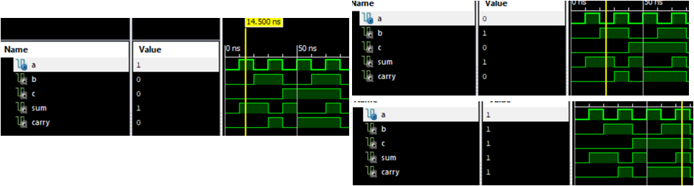
Figure 11
In the figure above, it’s clear that the full adder is working, as the data in the inputs (a, b and c) are having the exact results you’d expect on the outputs (sum and carry) based on the information on how adders work previously in the report.

Line 0
As previously discussed, the workings of a binary multiplier are similar to that of how most would work out a decimal multiplication by hand. Therefore similar to figure 7, a random 12x4 binary multiplication was written out in order to reference key aspects to replicate in the coding.
LINE0
Figure 12
Line 0, is the result of multiplying B0 with every (A) which is seen above in figure 12.
This is then written out using Xilinx design software, just like figure 12 which can be seen above, there are 13 inputs (A0 – A11 & B) and 12 outputs (Q0-Q11).
entity line0 is
Port ( A0 : in STD_LOGIC;
A1 : in STD_LOGIC;
A2 : in STD_LOGIC;
A3 : in STD_LOGIC;
A4 : in STD_LOGIC;
A5 : in STD_LOGIC;
A6 : in STD_LOGIC;
A7 : in STD_LOGIC;
A8 : in STD_LOGIC;
A9 : in STD_LOGIC;
A10 : in STD_LOGIC;
A11 : in STD_LOGIC;
B : in STD_LOGIC;
Q0 : out STD_LOGIC;
Q1 : out STD_LOGIC;
Q2 : out STD_LOGIC;
Q3 : out STD_LOGIC;
Q4 : out STD_LOGIC;
Q5 : out STD_LOGIC;
Q6 : out STD_LOGIC;
Q7 : out STD_LOGIC;
Q8 : out STD_LOGIC;
Q9 : out STD_LOGIC;
Q10 : out STD_LOGIC;
Q11 : out STD_LOGIC);
end line0;

architecture Behavioral of line0 is

begin
Q0 <= A0 and B;
Q1 <= A1 and B;
Q2 <= A2 and B;
Q3 <= A3 and B;
Q4 <= A4 and B;
Q5 <= A5 and B;
Q6 <= A6 and B;
Q7 <= A7 and B;
Q8 <= A8 and B;
Q9 <= A9 and B;
Q10 <= A10 and B;
Q11 <= A11 and B;
end Behavioral;

Once that has been written, it needs to be checked to see if it works. This is done by creating a test bench which can be seen below. Every single one must go through the stimulation process to make sure there isn’t a pattern error. All the input signals are set to 0. So, every 10 ns A0 will flip and become a 1, 10ns later it will go back to 0. Every 20ns A1 will become a 1 then go back to 0 after 20ns, this process continues as you can see below. This is to exercise all of the inputs in order to look at all of the outputs from them.
--Inputs
signal A0 : std_logic := '0';
signal A1 : std_logic := '0';
signal A2 : std_logic := '0';
signal A3 : std_logic := '0';
signal A4 : std_logic := '0';
signal A5 : std_logic := '0';
signal A6 : std_logic := '0';
signal A7 : std_logic := '0';
signal A8 : std_logic := '0';
signal A9 : std_logic := '0';
signal A10 : std_logic := '0';
signal A11 : std_logic := '0';
signal B : std_logic := '0';
-- Stimulus process
stim_proc: process
begin
-- hold reset state for 10 ns.
wait for 10 ns;
A0 <= not A0;

end process;

stim_proc2: process
begin
-- hold reset state for 20 ns.
wait for 20 ns;
A1 <= not A1;

end process;

stim_proc3: process
begin
-- hold reset state for 40 ns.
wait for 40 ns;
A2 <= not A2;

end process;

stim_proc4: process
begin
-- hold reset state for 80 ns.
wait for 80 ns;
A3 <= not A3;

end process;

stim_proc5: process
begin
-- hold reset state for 160 ns.
wait for 160 ns;
A4 <= not A4;

end process;

stim_proc6: process
begin
-- hold reset state for 320 ns.
wait for 320 ns;
A5 <= not A5;

end process;

stim_proc7: process
begin
-- hold reset state for 640 ns.
wait for 640 ns;
A6 <= not A6;

end process;

stim_proc8: process
begin
-- hold reset state for 1280 ns.
wait for 1280 ns;
A7 <= not A7;

end process;

stim_proc9: process
begin
-- hold reset state for 2560 ns.
wait for 2560 ns;
A8 <= not A8;

end process;

stim_proc10: process
begin
-- hold reset state for 5120 ns.
wait for 5120 ns;
A9 <= not A9;

end process;

stim_proc11: process
begin
-- hold reset state for 10240 ns.
wait for 10240 ns;
A10 <= not A10;

end process;

stim_proc12: process
begin
-- hold reset state for 20480 ns.
wait for 20480 ns;
A11 <= not A11;

end process;

stim_proc13: process
begin
-- hold reset state for 40960 ns.
wait for 40960 ns;
B <= not B;

end process;
END;

Once the Test bench is simulated a graph is produced which can be seen below, this is further evidence that line 0 works as it shows consistency throughout its calculations are correct. The top line multiply the middle gives the answer on the bottom line.
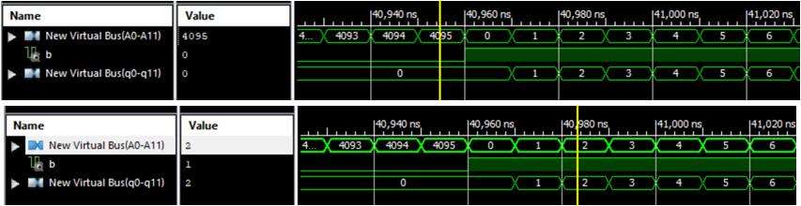
Figure 13

Line X
By using the same example from line 0 it’s easier to understand the commands used in the coding of line X. As line 0 has already been taken care of, it’s now time to develop line X; this is the result of multiplying B1 with each of A0-A11. The difference this time is that the results from the previous line must be added to achieve the correct final result. For example, B1 x A0 = 0(s0) the result above is then added (P1) to calculate Q1.
Figure 14
By using this knowledge it is then written in Xilinx as follows;-
entity multi12x4_line_x is
Port ( A0 : in STD_LOGIC;
A1 : in STD_LOGIC;
A2 : in STD_LOGIC;
A3 : in STD_LOGIC;
A4 : in STD_LOGIC;
A5 : in STD_LOGIC;
A6 : in STD_LOGIC;
A7 : in STD_LOGIC;
A8 : in STD_LOGIC;
A9 : in STD_LOGIC;
A10 : in STD_LOGIC;
A11 : in STD_LOGIC;
B2 : in STD_LOGIC;
P1 : in STD_LOGIC;
P2 : in STD_LOGIC;
P3 : in STD_LOGIC;
P4 : in STD_LOGIC;
P5 : in STD_LOGIC;
P6 : in STD_LOGIC;
P7 : in STD_LOGIC;
P8 : in STD_LOGIC;
P9 : in STD_LOGIC;
P10 : in STD_LOGIC;
P11 : in STD_LOGIC;
P12 : in STD_LOGIC;
Q1 : out STD_LOGIC;
Q2 : out STD_LOGIC;
Q3 : out STD_LOGIC;
Q4 : out STD_LOGIC;
Q5 : out STD_LOGIC;
Q6 : out STD_LOGIC;
Q7 : out STD_LOGIC;
Q8 : out STD_LOGIC;
Q9 : out STD_LOGIC;
Q10 : out STD_LOGIC;
Q11 : out STD_LOGIC;
Q12 : out STD_LOGIC;
Q13 : out STD_LOGIC);
end multi12x4_line_x;
architecture Behavioral of multi12x4_line_x is

COMPONENT halfadder
PORT(
A : IN std_logic;
B : IN std_logic;
Sum : OUT std_logic;
Carry : OUT std_logic
);
END COMPONENT;

COMPONENT fulladder
PORT(
A : IN std_logic;
B : IN std_logic;
C : IN std_logic;
Sum : OUT std_logic;
Carry : OUT std_logic
);
END COMPONENT;
signal s0 : STD_LOGIC;
signal s1 : STD_LOGIC;
signal s2 : STD_LOGIC;
signal s3 : STD_LOGIC;
signal s4 : STD_LOGIC;
signal s5 : STD_LOGIC;
signal s6 : STD_LOGIC;
signal s7 : STD_LOGIC;
signal s8 : STD_LOGIC;
signal s9 : STD_LOGIC;
signal s10 : STD_LOGIC;
signal s11 : STD_LOGIC;

signal c0 : STD_LOGIC;
signal c1 : STD_LOGIC;
signal c2 : STD_LOGIC;
signal c3 : STD_LOGIC;
signal c4 : STD_LOGIC;
signal c5 : STD_LOGIC;
signal c6 : STD_LOGIC;
signal c7 : STD_LOGIC;
signal c8 : STD_LOGIC;
signal c9 : STD_LOGIC;
signal c10 : STD_LOGIC;

begin
-- and gate sequence.
s0 <= A0 and B2;
s1 <= A1 and B2;
s2 <= A2 and B2;
s3 <= A3 and B2;
s4 <= A4 and B2;
s5 <= A5 and B2;
s6 <= A6 and B2;
s7 <= A7 and B2;
s8 <= A8 and B2;
s9 <= A9 and B2;
s10 <= A10 and B2;
s11 <= A11 and B2;

HA1: halfadder
Port Map
( s0, P1, Q1, c0);

FA1: fulladder
Port Map
( s1, P2, c0, Q2, c1);

FA2: fulladder
Port Map
( s2, P3, c1, Q3, c2);

FA3: fulladder
Port Map
( s3, P4, c2, Q4, c3);

FA4: fulladder
Port Map
( s4, P5, c3, Q5, c4);

FA5: fulladder
Port Map
( s5, P6, c4, Q6, c5);

FA6: fulladder
Port Map
( s6, P7, c5, Q7, c6);

FA7: fulladder
Port Map
( s7, P8, c6, Q8, c7);

FA8: fulladder
Port Map
( s8, P9, c7, Q9, c8);

FA9: fulladder
Port Map
( s9, P10, c8, Q10, c9);

FA10: fulladder
Port Map
( s10, P11, c9, Q11, c10);

FA11: fulladder
Port Map
( s11, P12, c10, Q12, Q13);
end Behavioral;

The coding of line X consists of 25 inputs (A0-A11, B2, P1-P12) and 13 outputs (Q1-Q13), however there are also 23 internal signals (S0-S11) and the carry signals (c0-c10) which was discussed in Development of a 12x4 Multiplier.

Of course with the added factor of carrying numbers over, it is essential to call in the previously made half and full adders to act as a tool. So, with the first half adder it is add the two bits s0 + P1 to produce the outputs Q1 and c0 (carry0). Followed by the first full adder which is capable of adding 3 bits (s1 +P2) but also taking into consideration the carry from before (c0) to produce the outputs of Q2 and also the carry for the next stage C1.

Exactly the same as the others, a test bench is generated to make sure it is working correctly. Again, all the inputs are set to 0, which are then flipped in the Stimulus process section to exercise all the inputs and to get an output.
--Inputs
signal A0 : std_logic := '0';
signal A1 : std_logic := '0';
signal A2 : std_logic := '0';
signal A3 : std_logic := '0';
signal A4 : std_logic := '0';
signal A5 : std_logic := '0';
signal A6 : std_logic := '0';
signal A7 : std_logic := '0';
signal A8 : std_logic := '0';
signal A9 : std_logic := '0';
signal A10 : std_logic := '0';
signal A11 : std_logic := '0';
signal B2 : std_logic := '0';
signal P1 : std_logic := '0';
signal P2 : std_logic := '0';
signal P3 : std_logic := '0';
signal P4 : std_logic := '0';
signal P5 : std_logic := '0';
signal P6 : std_logic := '0';
signal P7 : std_logic := '0';
signal P8 : std_logic := '0';
signal P9 : std_logic := '0';
signal P10 : std_logic := '0';
signal P11 : std_logic := '0';
signal P12 : std_logic := '0';
-- Stimulus process
stim_proc: process
begin
-- hold reset state for 100 ns.
wait for 10 ns;
A0 <= not A0;
end process;

stim_proc2: process
begin
-- hold reset state for 100 ns.
wait for 20 ns;
A1 <= not A1;
end process;
THIS CONTINUES TILL ALL THE INPUTS ARE EXERCISED.

Once the Test bench is simulated a graph is produced which can be seen below, this is further evidence that line X works. Figure 15, shows three separate examples that it works. (The first line x the second) + line 3 = line 4.
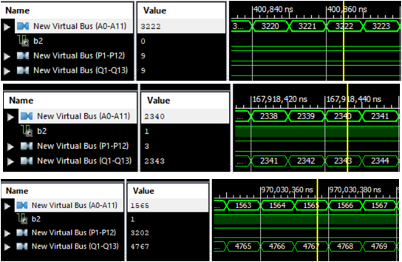
Figure 15

THE FULL 12X4 MULTIPLIER
By using everything that has been discussed, the full multiplier was created. Below is a flowchart that was put together to help understand what is going on and to help in the development of the coding for the full multi.
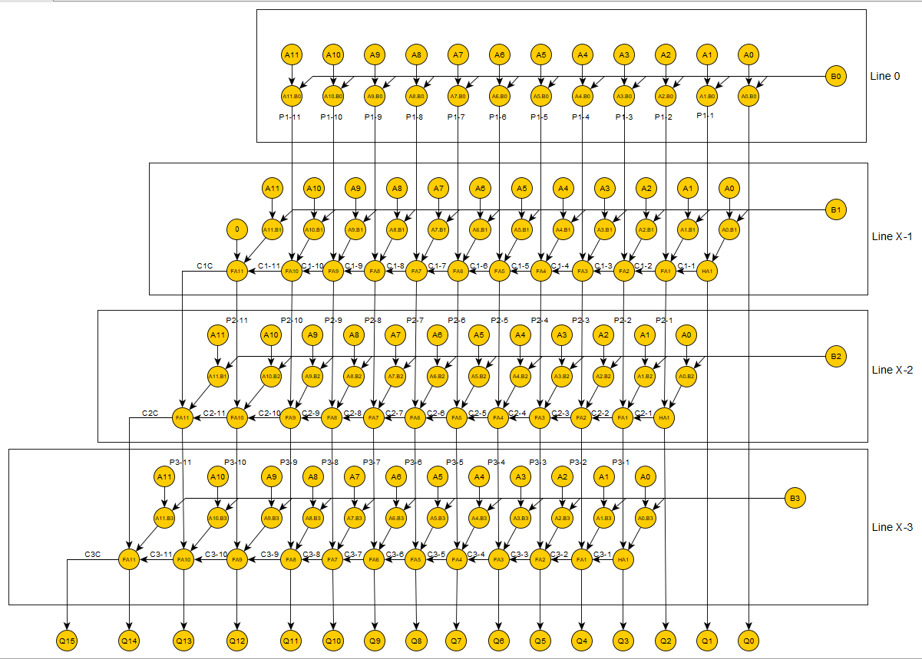
Figure 16
The above flowchart is a 12x4 full multiplier. It is evident that for this, it needs a line 0 and the Line X needs to be called in 3 times. Below is a list of the inputs and outputs of the full multi which has been taken directly from Xilinx.
entity multi12x4_full is
Port ( A0 : in STD_LOGIC;
A1 : in STD_LOGIC;
A2 : in STD_LOGIC;
A3 : in STD_LOGIC;
A4 : in STD_LOGIC;
A5 : in STD_LOGIC;
A6 : in STD_LOGIC;
A7 : in STD_LOGIC;
A8 : in STD_LOGIC;
A9 : in STD_LOGIC;
A10 : in STD_LOGIC;
A11 : in STD_LOGIC;
B0 : in STD_LOGIC;
B1 : in STD_LOGIC;
B2 : in STD_LOGIC;
B3 : in STD_LOGIC;
Q0 : out STD_LOGIC;
Q1 : out STD_LOGIC;
Q2 : out STD_LOGIC;
Q3 : out STD_LOGIC;
Q4 : out STD_LOGIC;
Q5 : out STD_LOGIC;
Q6 : out STD_LOGIC;
Q7 : out STD_LOGIC;
Q8 : out STD_LOGIC;
Q9 : out STD_LOGIC;
Q10 : out STD_LOGIC;
Q11 : out STD_LOGIC;
Q12 : out STD_LOGIC;
Q13 : out STD_LOGIC;
Q14 : out STD_LOGIC;
Q15 : out STD_LOGIC);
end multi12x4_full;

Line 0 and Line X are then called in from the previous projects, followed by the signals that are declared to go between the lines;-
signal p1_1 :STD_LOGIC;
signal p1_2 :STD_LOGIC;
signal p1_3 :STD_LOGIC;
signal p1_4 :STD_LOGIC;
signal p1_5 :STD_LOGIC;
signal p1_6 :STD_LOGIC;
signal p1_7 :STD_LOGIC;
signal p1_8 :STD_LOGIC;
signal p1_9 :STD_LOGIC;
signal p1_10 :STD_LOGIC;
signal p1_11 :STD_LOGIC;

signal p2_1 :STD_LOGIC;
signal p2_2 :STD_LOGIC;
signal p2_3 :STD_LOGIC;
signal p2_4 :STD_LOGIC;
signal p2_5 :STD_LOGIC;
signal p2_6 :STD_LOGIC;
signal p2_7 :STD_LOGIC;
signal p2_8 :STD_LOGIC;
signal p2_9 :STD_LOGIC;
signal p2_10 :STD_LOGIC;
signal p2_11 :STD_LOGIC;
signal p2_12 :STD_LOGIC;

signal p3_1 :STD_LOGIC;
signal p3_2 :STD_LOGIC;
signal p3_3 :STD_LOGIC;
signal p3_4 :STD_LOGIC;
signal p3_5 :STD_LOGIC;
signal p3_6 :STD_LOGIC;
signal p3_7 :STD_LOGIC;
signal p3_8 :STD_LOGIC;
signal p3_9 :STD_LOGIC;
signal p3_10 :STD_LOGIC;
signal p3_11 :STD_LOGIC;
signal p3_12 :STD_LOGIC;

The rest of the code is below which it is clear that is in sync with the flow chart with its one line 0 and three line x. Using line 1 as an example, it’s basically saying (A0-A11 x B0) which drops out Q0 and also produces (p1_1 – p1_11) which is accounted in the next line as the previous one to be added. As you can see they are carried over to the next line to give out Q1 and the same process ripples throughout.

begin

line1 : line0
Port Map
(A0, A1, A2, A3, A4, A5, A6, A7, A8, A9, A10, A11, B0, Q0, p1_1, p1_2, p1_3, p1_4, p1_5, p1_6, p1_7, p1_8, p1_9, p1_10, p1_11) ;

line2 : multi12x4_line_x
Port Map
(A0, A1, A2, A3, A4, A5, A6, A7, A8, A9, A10, A11, B1, P1_1, P1_2, p1_3, p1_4, p1_5, p1_6, p1_7, p1_8, p1_9, p1_10, p1_11,'0', Q1, p2_1, p2_2, p2_3, p2_4, p2_5, p2_6, p2_7, p2_8, p2_9, p2_10, p2_11, p2_12);

line3 : multi12x4_line_x
Port Map
(A0, A1, A2, A3, A4, A5, A6, A7, A8, A9, A10, A11, B2, P2_1, P2_2, p2_3, p2_4, p2_5, p2_6, p2_7, p2_8, p2_9, p2_10, p2_11, p2_12, Q2, p3_1, p3_2, p3_3, p3_4, p3_5, p3_6, p3_7, p3_8, p3_9, p3_10, p3_11, p3_12);

line4 : multi12x4_line_x
Port Map
(A0, A1, A2, A3, A4, A5, A6, A7, A8, A9, A10, A11, B3, P3_1, P3_2, p3_3, p3_4, p3_5, p3_6, p3_7, p3_8, p3_9, p3_10, p3_11, p3_12, Q3, Q4, Q5, Q6, Q7, Q8, Q9, Q10, Q11, Q12, Q13, Q14, Q15);

end Behavioral;

As always, the next stage is to create a test bench to make sure it is working. The inputs are all set to 0 and then flipped in the stimulus process to exercise all the inputs.
--Inputs
signal A0 : std_logic := '0';
signal A1 : std_logic := '0';
signal A2 : std_logic := '0';
signal A3 : std_logic := '0';
signal A4 : std_logic := '0';
signal A5 : std_logic := '0';
signal A6 : std_logic := '0';
signal A7 : std_logic := '0';
signal A8 : std_logic := '0';
signal A9 : std_logic := '0';
signal A10 : std_logic := '0';
signal A11 : std_logic := '0';
signal B0 : std_logic := '0';
signal B1 : std_logic := '0';
signal B2 : std_logic := '0';
signal B3 : std_logic := '0';

-- Stimulus process
stim_proc: process
begin
-- hold reset state for 100 ns.
wait for 10 ns;
A0 <= not A0;
end process;

stim_proc1: process
begin
-- hold reset state for 100 ns.
wait for 20 ns;
A1 <= not A1;
end process;

stim_proc2: process
begin
-- hold reset state for 100 ns.
wait for 40 ns;
A2 <= not A2;
end process;

stim_proc3: process
begin
-- hold reset state for 100 ns.
wait for 80 ns;
A3 <= not A3;
end process;

stim_proc4: process
begin
-- hold reset state for 100 ns.
wait for 160 ns;
A4 <= not A4;
end process;
THIS CONTINUES UP TO B3.

Once synthesised, a graph is produced to look further into the multiplier. Below are three separate screen outputs of these graphs to the multiplier is working correctly. The first line (A) X the second line (B) = line three (Q). The second line goes up to 15 then resets due to the fact this is a 12x4 multiplier so 4 bits 1111 max out at 15.
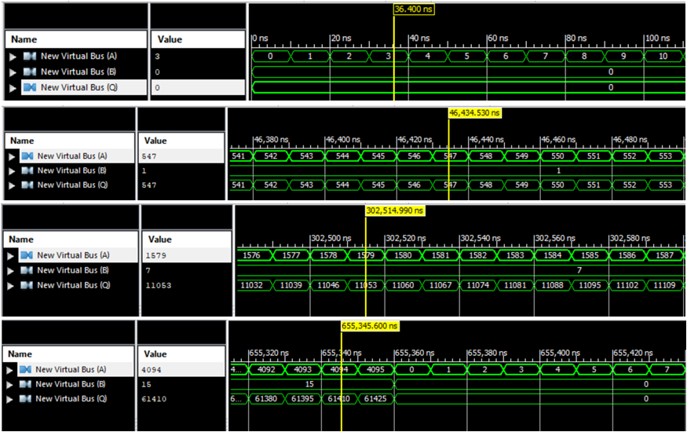
Figure 17

TASK 2
The next part of this report is to design, simulate and synthesise the FSM described by the state diagram below as both a VHDL and discrete gate solution.
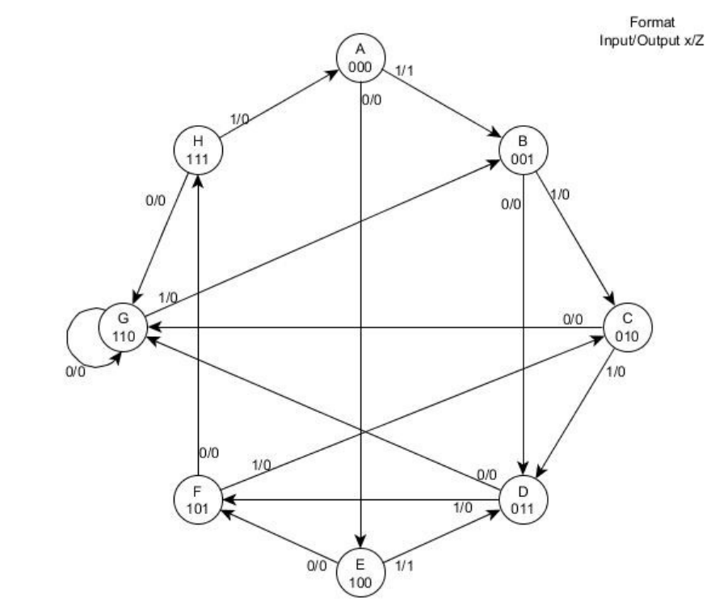
Figure 18

VHDL
The above state diagram shows the operation of an FSM. It has 8 states so the design will require 3 flip flops (memory locations). Below is a copy of the design in a VHDL format.
entity fm2 is
Port ( X : in STD_LOGIC;
Clk : in STD_LOGIC;
Z : out STD_LOGIC;
Y : out STD_LOGIC_VECTOR (2 downto 0));
end fm2;

As specified, the FSM has an X as an input and a Z as an output. It also has a CLK input and Y has been set as a 3 bit output in order to see which state is in use.

architecture Behavioral of fm2 is

type state_type is (state_A, state_B, state_C, state_D, state_E, state_F, state_G, state_H);
signal present_state : state_type := state_A;
signal next_state : state_type := state_A;

These are the state types that are being used; it is clear there are 8 possible positions.

begin
State: process (present_state,X)
begin
if x='0' Then
case present_state is
When state_A => next_state <= state_E;Y <="000"; Z <='0';
When state_B => next_state <= state_D;Y <="001"; Z <='0';
When state_C => next_state <= state_G;Y <="010"; Z <='0';
When state_D => next_state <= state_G;Y <="011"; Z <='0';
When state_E => next_state <= state_F;Y <="100"; Z <='0';
When state_F => next_state <= state_H;Y <="101"; Z <='0';
When state_G => next_state <= state_G;Y <="110"; Z <='0';
When state_H => next_state <= state_G;Y <="111"; Z <='0';
When OTHERS => NULL;
end case;
else if x='1' Then
case present_state is
When state_A => next_state <= state_B;Y <="000"; Z <='1';
When state_B => next_state <= state_C;Y <="001"; Z <='0';
When state_C => next_state <= state_D;Y <="010"; Z <='0';
When state_D => next_state <= state_F;Y <="011"; Z <='0';
When state_E => next_state <= state_D;Y <="100"; Z <='1';
When state_F => next_state <= state_C;Y <="101"; Z <='0';
When state_G => next_state <= state_B;Y <="110"; Z <='0';
When state_H => next_state <= state_A;Y <="111"; Z <='0';
When OTHERS => NULL;
end case;
end if;
end if;
end Process State;

The above piece of programming is written to match the state diagram. The next state will depend on the input, for example when X=1 state A will go to state E, however if the input was 0 then it would go to B. As previously explained the Y output is there to identify each state with the 3 bit binary code relating to the state number. The Z output also mirrors the information found on the state diagram.
clocked: Process (Clk)
begin
if((Clk='1') and (Clk'last_value='0')) Then
present_state <= next_state;
end if;
end Process clocked;

end Behavioral;

Finally, the clocked statement is saying that the process is dependent on the clk. If the clk is at 1 but the last time it was looked at it was at 0 then it will do this as it is looking for the leading edge.

A test bench is then run in order to test the FSM.

--Inputs
signal X : std_logic := '1';
signal Clk : std_logic := '0';

--Outputs
signal Z : std_logic;
signal Y : std_logic_vector(2 downto 0);

This shows that when it is initiated it will start off at X=1.

-- Stimulus process
stim_proc: process
begin
-- hold reset state for 100 ns.
wait for 10 ns;
Clk <= not Clk;
end process;

The clk is 10ns so 10ns up and 10ns down equating to 20ns. This is important to remember for the next lines of the programming as the length of time it takes to move from one state to another is exactly 20ns.

stim_proc2: process
begin
-- hold reset state for 100 ns.
wait for 100 ns; -- Step through 0,1,2,3,5,2
X <= '0';
wait for 40 ns; -- Step through 2,6 then 6 again due to loop
X <= '1'; -- goto 1
wait for 20 ns;
X <= '0'; -- goto 3
wait for 20 ns;
X <= '1'; -- goto 5
wait for 20 ns;
X <= '0'; -- goto 7
wait for 20 ns;
X <= '1'; -- goto 0
wait for 20 ns;
X <= '0'; -- goto 4,5
wait for 40 ns;
X <= '1'; -- goto 2,3,5
wait for 60 ns;
X <= '0'; -- goto 7
wait for 20 ns;
X <= '1'; -- goto 0
wait for 20 ns;
X <= '0'; -- goto 4
wait for 20 ns;
X <= '1'; -- goto 3
wait for 20 ns;
X <= '0'; -- goto 6
wait for 20 ns;
X <= '1'; -- goto 1
wait for 20 ns;
X <= '0'; -- goto 3
wait for 20 ns;
X <= '1'; -- goto 5
wait for 20 ns;
X <= '0'; -- goto 7,6
wait for 40 ns;
X <= '1'; -- goto 1
wait for 20 ns;
X <= '0'; -- goto 3
wait for 20 ns;
X <= '1'; -- goto 5
wait for 20 ns;
X <= '0'; -- goto 7
wait for 20 ns;
X <= '1'; -- goto 0
wait for 20 ns;
end process;

END;

This fully tests the FSM as it goes through every state following every single path possible. Due to the fact it has been written to start off at X=1 the first ‘wait for 100ns’ will push it from 0 (state A) through 1 (state B) ,2 (state C) ,3 (state D) ,5 (state F) and back to 2 (state C) as 100ns/20ns = 5 movements. The inputs will then change to 0 and wait for 40ns which will allow 2 movements. This can then be simulated and views using the graph.

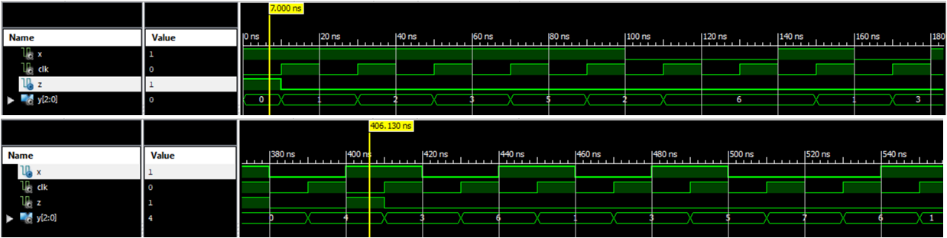
Figure 19

This graph is further proof that it is working correctly as you can see, in the first screen output it starts and follows the same state sequence that was described, every time there is a new clk pulse. It’s also clear that the output Z=1 appears as described in the FSM that was given, which is from 0 (state A) to 1 (state B) and from 4 (state E) to 3 (state D).

Discrete gate solution
The FSM is then designed in hardware using discrete gate solution.
To begin with, a state table is generated based on the state diagram (Figure 18) in TASK 2, to define the sequence behaviour of the circuit. This is then checked for possible state redundancies and to make sure all state are necessary, which they are by looking at the below figure.
Figure 20
Next, a truth table is designed. This shows exactly what is happening with the FSM state diagram. Each state is represented by its binary numerical value, showing exactly where the present state is going depending on the input. The output is also shown on this truth table.
Figure 21

Assuming 3 D type flip flops are used, Karnaugh type maps are then created directly from the truth table to group the bits and convert back to its sum of products for DA,DB,DC and the output Z. This can be seen below.

Finally, the synchronous sequential circuit is drawn. This is drawn based on the sum of products that were worked out form the K-maps. For example DA=/C./X + /A.B.C + A.C so this is represented on the schematic diagram with 3 AND gates which go to a OR gate then goes into the DA flip flop. This is done for DB, DC and also the output DZ.
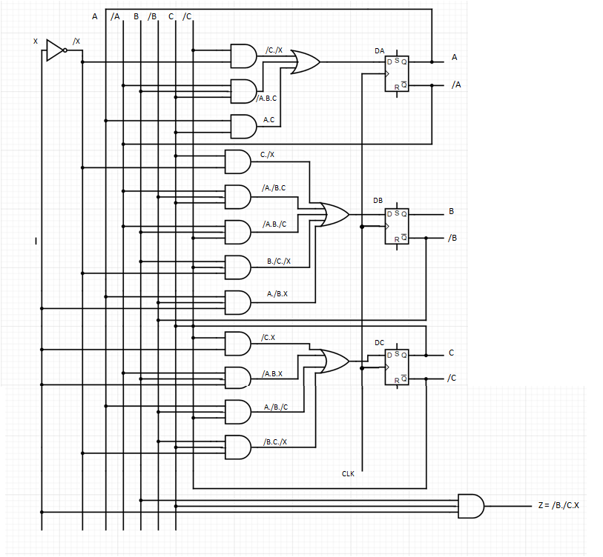
Figure 22 (Schematic Diagram of the FSM)

Conclusion
To conclude, this report has identified that the fastest multiplier is the Wallace tree as it has lower power consumption and smaller delay, by researching and comparing the other multipliers that are used. A 12 X 4 multiplier was constructed using Xilinx design software and looking into the key elements that make up a binary multiplier. There design of a FSM in hardware, however the same process can be done in a quarter of the time in VHDL which is also detailed in this report.

Bibliography
Admin. (2018, August 11). circuits today . Retrieved from Circuits Today: https://www.circuitstoday.com/half-adder#:~:text=Half%20adder%20is%20a%20combinational,AND%20of%20A%20and%20B.
Asif, S. (2014, 05 12). Hindawi. Retrieved 03 29, 2021, from Hindawi: https://www.hindawi.com/journals/vlsi/2014/343960/
Bagyaveereswaran, R. A. (2011). FPGA Implementation of Braun’s Multiplier. Retrieved 04 17, 2021, from link.springer: https://link.springer.com/chapter/10.1007%2F978-3-642-22543-7_49
Crowe, J. (2004). sciencedirect. Retrieved 05 02, 2021, from sciencedirect: https://www.sciencedirect.com/topics/computer-science/full-adder
geeksforgeeks. (2019, 11 25). geeksforgeeks. Retrieved from geeksforgeeks: https://www.geeksforgeeks.org/full-adder-in-digital-logic/
Lala, P. K. (2006). Principles of Modern Digital Design. In P. K. Lala, Principles of Modern Digital Design. John Wiley & Sons, Inc.
Ms. Madhu Thakur, P. J. (2012). Design of Braun Multiplier. Retrieved 05 12, 2021, from ijser: https://www.ijser.org/paper/Design-of-Braun-Multiplier-with-Kogge-Stone-Adder-Its-Implementation-on-FPGA.html#:~:text=Braun%20multiplier%20is%20a%20type,and%20one%20Ripple%20Carry%20Adder.
Prasada, S. V. (2020). Performance Analysis of Various Multipliers Using 8T-full Adder with 180nm Technology. Retrieved from eurekaselect: https://www.eurekaselect.com/178128/article
skylags. (2019, December 30). geeksforgeeks. Retrieved from geeksforgeeks: https://www.geeksforgeeks.org/array-multiplier-in-digital-logic/
Soniya, S. K. (2013). A Review of Different Type of Multipliers and. U.I.E.T: ijettcs.org.
Studytonight. (2021). Booth's Multiplication Algorithm. Retrieved from Study Tonight: https://www.studytonight.com/computer-architecture/booth-multiplication-algorithm

