Understanding and Solving the Complex Problem of Staff Absenteeism in Mid-Cheshire Hospital Trust


Student Name: Samuel Filipe Torres da Silva
Student ID: 2107485
Module Code: BMSW4004
Course Title: Problem Solving and Decision Making
Lecturer`s Name: Chijioke Uba

Content
1. Introduction: 3
2. Staff absenteeism, the nature, and impact at (MCHT) 4
3. Understanding the reasons for the problem through the use of the Pestle model and Fishbone diagram 4
4. The PESTLE analysis will be used to discover external variables for staff absenteeism in the (MCHT). 5
5. A Fishbone diagram will be used to discover internal variables for staff absenteeism in the (MCHT). 6
6. Alternative solutions to the staff absenteeism in MCHT 7
7. Evaluation of the most appropriate solutions 8
I. PMI Solution (staff transport system) 8
II. PMI Solution (Health and Safety Department implementation) 9
8. Plan for implementing a solution, monitoring and review process/system: 9
I. Action plan 10
II. Monitoring Plan 11
III. Evaluation Plan 11
9. Conclusion: 12
10. References: 13

Introduction

In this report, we will discuss and elaborate on the impact of staff absenteeism in the Mid Cheshire Hospital Trust (MCHT) through the use of reliable models and diagrams to understand the causes of the problem.
Also, present a plan of action to solve the problem found at (MCHT) with the high rise in the numbers of staff absenteeism to tackle the complex situation and a description of the success indicators that will be used to evaluate the effectiveness of our solution.
As a result, this research provides vital practical lessons for the entire NHS in general and not only the (MCHT).

Staff absenteeism, the nature, and impact at (MCHT)

Staff absenteeism is defined as an employee's regular absence from work. Habitual non-presence expands further than the permitted range of days absent from the workplace for perfectly valid reasons like scheduled vacations, training and family emergencies.
Staff absenteeism is a complex and organisational problem found on (MCHT) which rapidly and steadily increased from 2007 to 2012 that derives from internal and external causes.
This is a situation that impacts a wide range of communities adjacent to the supported areas around the (MCHT) and the employees affecting both sides negatively socially and financially.
It is a long-standing issue that has been significantly rising and that urgently needs to be addressed before catastrophic results occur.

Understanding the reasons for the problem through the use of the Pestle model and Fishbone diagram

To understand the reasons for the complex problem in the (MCHT), these tools will be employed.
The PESTLE model as per Rastogi, and Trivedi, (2016) allows us to find external elements that are connected to the complex problem and with the use of the Fishbone diagram in accordance with Ishikawa, (1968) we can look at the complex problem past external causes and be able to address the main causes of the critical situation on the (MCHT).

The PESTLE analysis will be used to discover external variables for staff absenteeism in the (MCHT).

The table below is the PESTLE analysis tool used to discover the contributor external factors causing the complex problem at (MCHT).

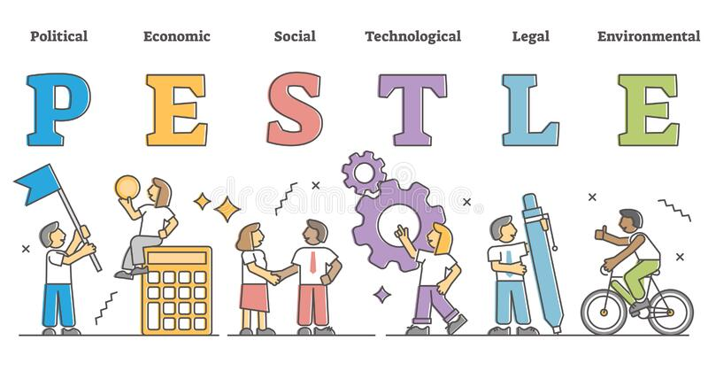

The PESTEL analysis takes into account external elements that go beyond our control and have far impacts on our organisation. Of the six PESTLE analysis factors discussed in this table, Environmental was the factor that stands out as the external major cause for staff absenteeism at (MCHT) on which we will be focusing.

A Fishbone diagram will be used to discover internal variables for staff absenteeism in the (MCHT).

The below Fishbone diagram is the tool used to discover the contributor internal factors causing the complex problem at (MCHT).

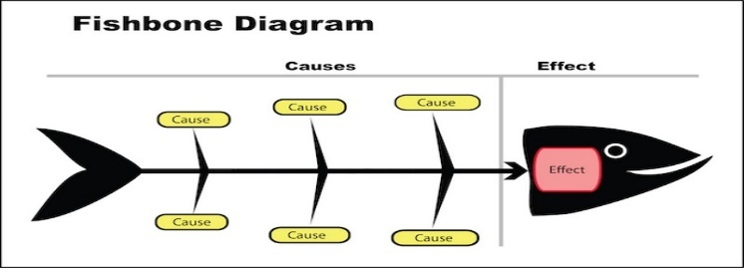
Of the three main Fishbone Diagram factors, health issues were the major factor that stands out as the internal cause of staff absenteeism at (MCHT). When we examine the other two factors, we can see that the health issues data collection is easier to gather than if we compare it to ‘ineffective supervision’ or ‘staff demotivation’ which are more abstract areas to get straight black and white results.
So, for that reason from the Fishbone diagram, we will focus on the ‘health issues’ factor.

Alternative solutions to the staff absenteeism in MCHT

From the external and internal causes found on the PESTLE and Fishbone, we need to address the possible solutions to the main complex problems found at (MCHT).
To address PESTLE analysis of the Environmental problem caused by the freezing weather conditions and air quality the (MCHT) management team could organise a staff transport system with the use of several coaches with air conditioning so staff can safely commute to work.
To address the health and safety issues raised in the Fishbone diagram, the (MCHT) management team could implement a Health and safety department to address the reasons why the staff members are getting more and more health-related absenteeism while regulating and creating awareness of safety work ethic in order to avoid injuries to the staff body at (MCHT).
With the use of these two solutions, the levels of staff absenteeism could finally start to lower and eventually increase the level of patient care quality reducing the expenses caused by patient injuries due to lack of staff and reduce as well the use of external agencies' services.

Evaluation of the most appropriate solutions

A PMI decision-making tool was utilized to calculate the best of the solution options found.
The PMI decision-making tool according to De Bono, (2018) stands for (Plus, Minus, and Interesting).
PMI is beneficial for brainstorming ideas and making critical decisions by examining and weighing the pros and cons of various possibilities. Lester, (2006)
Each of the main possible solutions has gone through the PMI decision-making tool.

PMI Solution (staff transport system)
Plus | Minus | Interesting
Help with staff journey safety. (+5) | Time-consuming for the department to organize routes. (-1) | Less staff absenteeism. (+4)
Socially valued infrastructure. (+3) | Time-consuming on infrastructure built. (-2) | Infrastructure facilities must be established. (-5)
Dedicated infrastructure. (+2) | Extra costs to the Trust. (-5) | Increment in staff work attendance. (+5)
Total = 10 | Total = -8 | Total = 4

For the first PMI solution, if we combine the three total scores from the Plus + Minus + Interesting, a total combined score of 6 come out of this resolution.

PMI Solution (Health and Safety Department implementation)

Plus | Minus | Interesting
Help with staff injury prevention. (+5) | Time-consuming for the department to do aware material. (-2) | Less staff absenteeism. (+5)
Dedicated trained staff for injury prevention. (+3) | Time-consuming on training the staff department. (-1) | Physiotherapy or recuperation facilities must be established. (-2)
Staff injury recovery times are faster. (+4) | Extra costs to the Trust. (-3) | Increment in the confidence of staff in the Trust. (+4)
Total = 12 | Total = -6 | Total = 7

For the second PMI solution, if we combine the three total scores from the Plus + Minus + Interesting, a total combined score of 13 come out of this resolution.

Furthermore, looking at the PMI chart tool for the environmental area solution a total score of four was reached for the implementation of a staff transport system and by using a PMI chart for the Health and Safety Issues area solution a total score of thirteen was reached for the implementation of the Health and Safety department.

Plan for implementing a solution, monitoring and review process/system:

In this section, the plan for implementation, monitoring and evaluation are discussed according to Damschroder, et. al, (2009) it is very important to have a clear plan that clarifies what needs to be done before the solution is implemented. Also, a plan that outlines how the solution will be monitored during implementation, and how it will be evaluated post-implementation. In addition, Lowe, (2002) visibly identifies the four key components of any good action plan to include action, timeline and staff responsible for completing the action. According to Powell, B. J., et al, (2012) about the implementation of compilation strategies, this approach was applied in developing the action plan for the chosen implementation solution of a Health and Safety Department in the (MCHT).

The table below is the action plan before the solution is implemented.

Action plan

Action | Description | Timeline | Staff Responsible
Health and Safety Department implementation. | Introduce and establish a Health and Safety department in the (MCHT). | Starting immediately within a week space. | (MCHT) Management team.
Recipients of the department implementation program. | Use of attendances and area development. | Starting immediately within a week space. | (MCHT) Management team and managers.
Instructors’ identification. | Determination of the best instructors. | Starting in a week to two weeks. | (MCHT) Management team.
Create a program schedule. | Schedule to include time venue and communicate to relative managers and staff. | Starting in a month to two months. | Instructors and managers.

The next step in planning is to detail how the solution will be monitored when it is ongoing. Monitoring is the measure of the quality of the action plan and if it is effective according to Schneider, et. al, (2001) in this case, this is what we have done.

The table below shows the monitoring plan.

Monitoring Plan
Action | Description | Timeline | Staff Responsible
Level of engagement feedback. | Response from managers. | To be monitored on a weekly basis. | (MCHT) Management team and instructors.
Level of understanding feedback. | Use quizzes or direct questions to test the levels of understanding. | To be monitored on a weekly basis. | Instructors.
Level of attendance. | Percentage of managers and staff in situ. | To be monitored on a weekly basis. | Instructors.

Coming next is the evaluation plan. Evaluation is the process of monitoring a program implementation according to Saunders, et al, (2005) it tells you how successful the implementation plan has been in terms of how is the outcome we want and, in this case, you need a key performance indicator, because this is the solution when it is implemented this is what we expect so the key performance indicator will be feedback. The feedback will come from two sources.

First, will be gathered from staff attendance data and this way compares if the levels of staff attendance are increasing.

Secondly, it will be gathered by patient survey data and this way compares if the positive satisfaction levels are increasing.

The table below shows the evaluation plan.

Evaluation Plan
Performance Indicator | Description | Timeline | Staff Responsible
Check staff attendance levels | Speak with managers. | To be monitored on a monthly basis. | HR
Patient surveys feedback | Check the level of patient care satisfaction. | To be monitored on a monthly basis. | Managers

With the help of an action plan implementation in place, a well-elaborated plan with appropriate timelines, and a defined implementation team in charge it is safe to say that this way the results improve staff absenteeism in the (MCHT) which looks very promising with the expectation of the levels of staff absenteeism to lower and consequently the patient care service levels to grow in the next several months to come.

Conclusion:

A conclusion can be approached, with the PMI charts of possible solutions that target the main causes.
With this conclusion, it is possible to see that the two areas of most importance that stand out in reducing long-term absenteeism in the (MCHT), but for now, taking special priority through the results gathered from the PMI chart of the area of Health and Safety and leaving, at present, the finance implementation for the staff transport system behind.
To make sure that the targets of the implementation plan for the Health and Safety are to be achieved, we will focus on the results of the monitoring plan to keep the levels of staff absenteeism on the right path by contrasting the outcomes of the monitoring plan with the results of the evaluation plan, so we can get independent results and get the most accurate indication that the complex problem at (MCHT) is being tackled to reverse the high levels of staff absenteeism that suddenly increase in the last years.

References:
- Bush, T., 2019. PESTLE Analysis of the NHS. [Online] Available at: https://pestleanalysis.com/nhs-pestle-analysis/ [Accessed 05 March 2022].
- Damschroder, L. J., Aron, D. C., Keith, R. E., Kirsh, S. R., Alexander, J. A., & Lowery, J. C. (2009). Fostering implementation of health services research findings into practice: a consolidated framework for advancing implementation science. Implementation science, 4(1), 1-15. [Accessed 29 March 2022].
- De Bono, E. (2018). Conflicts: A better way to resolve them. Random House. [Accessed 29 March 2022].
- Ishikawa, K (1968) Guide to Quality Control, JUSE, Tokyo [Accessed 29 March 2022].
- Lester, A., 2006. Project management, planning, and control: managing engineering, construction, and manufacturing projects to PMI, APM, and BSI standards. Elsevier. [Accessed 04 March 2022].
- Lowe, G. S. (2002). High-quality healthcare workplaces: A vision and action plan. Hospital Quarterly, 5(4), 49-56. [Accessed 30 March 2022].
- Powell, B. J., McMillen, J. C., Proctor, E. K., Carpenter, C. R., Griffey, R. T., Bunger, A. C., ... & York, J. L. (2012). A compilation of strategies for implementing clinical innovations in health and mental health. Medical care research and review, 69(2), 123-157. [Accessed 02 April 2022].
- Rastogi, N.I.T.A.N.K. and Trivedi, M.K., 2016. PESTLE technique–a tool to identify external risks in construction projects. International Research Journal of Engineering and Technology (IRJET), 3(1), pp.384-388. [Accessed 06 March 2022].
- Saunders, R. P., Evans, M. H., & Joshi, P. (2005). Developing a process-evaluation plan for assessing health promotion program implementation: a how-to guide. Health promotion practice, 6(2), 134-147. [Accessed 01 April 2022].
- Schneider, E. C., Zaslavsky, A. M., Landon, B. E., Lied, T. R., Sheingold, S., & Cleary, P. D. (2001). National quality monitoring of Medicare health plans: the relationship between enrollees' reports and the quality of clinical care. Medical care, 1313-1325. [Accessed 31 March 2022].
- Wong K.C., Woo K.Z., Woo K.H. (2016) Ishikawa Diagram. Quality Improvement in Behavioral Health, Switzerland: Springer International Publishing Forbes, D., Smith, S., & Horner. [Accessed 06 March 2022].
- Yüksel, I., 2012. Developing a multi-criteria decision-making model for PESTEL analysis. International Journal of Business and Management, 7(24), p.52. [Accessed 07 March 2022].

