
2025
2D Diffusion Equation Model using Explicit Finite Difference Method (Report)

HARLEY OULTON

Abstract

This report explores the application of the heat equation to model thermal diffusion and temperature distribution within a 2D material. The heat equation, a key concept in mathematical physics, is solved numerically using the explicit finite difference method (FDM) using Matlab coding and analytically. A detailed discussion of the governing equation, numerical approximations, and implementation is provided, alongside an analysis of FDM’s accuracy and limitations. The study highlights stability conditions, error sources, and parameter sensitivity, focusing on grid spacing, time step, and convergence tolerance. Analytical and computational results are compared, demonstrating close agreement within a margin of error, validating the model. Finally, the report evaluates the FDM's limitations and proposes potential improvements for modelling complex geometries and enhancing computational efficiency, such as the use of FEM and adaptive timestep.

Contents
Abstract 1
Contents 2
List of Figures 3
Introduction 4
Governing Equation 4
Numerical Method 5
First Derivative Approximations 5
Forward Difference 5
Backwards Difference 5
Central Difference 6
Second Derivative Approximations 7
Central Difference 7
Explicit Finite Difference Scheme for the Heat Equation 7
Boundary Conditions and Analytical Solution 8
Code Description 9
1. Clear All 9
2. Material Properties 10
3. Geometric Parameters 10
4. Grid Spacing (h) Compatibility 10
5. Matrix Dimensions 11
6. Boundary and Initial Conditions 11
7. Input Timestep 11
8. Computation 12
9. Analytical Solution 13
10. Graph Plotting 14
Code Validation 14
Sensitivity Analysis 15
Grid Spacing 15
Time Step Analysis 16
Tolerance Changes 17
Discussion 18
Improvements 18
Conclusion 19
References 19
Appendix 20

List of Figures
Figure 1: Initial Boundary Conditions 9
Figure 2: Clear all section 9
Figure 3: Material Properties Section 10
Figure 4: Geometric Parameters Section 10
Figure 5: Grid Spacing Compatibility Section 10
Figure 6: Matrix Dimension Section 11
Figure 7: Boundary and Initial Conditions 11
Figure 8: Input Timestep section 11
Figure 9: Lines 94-102 12
Figure 10: Lines 104-121 12
Figure 11: Computation Loop 13
Figure 12: Lines 146-151 13
Figure 13: Analytical Solution Section 13
Figure 14: Graph Plotting Section 14
Figure 15: Comparison of two Results 14
Figure 16: Colour Map of two results 15
Figure 17: Graph of Influence of Grid Spacing on Thermal Equilibrium Time 16
Figure 18: Influence of Time Step on Thermal Equilibrium Time 17
Figure 19: Influence of Tolerance Change on Thermal Equilibrium Time 17

Equation 1: Heat Equation for 2D region 4
Equation 2: Taylor Series Expansion (compact form) 5
Equation 3: Taylor Series Expansion 5
Equation 4: Rearranged to solve for f'(x) 5
Equation 5: Forward Difference Approximation 5
Equation 6:Taylor Series Expansion 6
Equation 7: Rearranged to solve for f'(x) 6
Equation 8: Backwards Difference Approximation 6
Equation 9: Taylor Series Expansions 6
Equation 10: Second Expansion subtracted from the first 6
Equation 11: Central Difference Approximation 6
Equation 12: Taylor Series Approximations 7
Equation 13: Two above Equations added together 7
Equation 14: Central Difference Approximation to the 2nd Derivative 7
Equation 15: Time- Dependant Heat Equation 7
Equation 16: Temporal first derivative 7
Equation 17: Spatial Second Derivatives 8
Equation 18: Fourier Number 8
Equation 19: Explicit Finite Difference in terms of Fo 8
Equation 20: Analytical Solution 9

Introduction

This report aims to investigates the application of the heat equation to model the thermal diffusion process and temperature distribution within a material.
The heat equation, a key concept in mathematical physics, describes the flow of heat over time and has wide-ranging applications across various fields. In particular, the explicit finite difference method (FDM) will be employed to numerically solve the equation. The report will cover the code written to solve the problem, and description of each section covered.
Later in the report, the strengths and weaknesses of the FDM in solving heat conduction problems will be discussed and potential improvements to address its limitations covered.

Governing Equation

The governing equation for this problem is the Heat Equation. This equation is fundamental to mathematical physics and originated from the study of heat conduction. Joseph Fourier first derived and outlined this equation in “The Analytical Theory of Heat” (Fourier, 1822). The equation describes the time-dependant distribuation of temperature within a medium. While the equation is mainly used to model heat transfer in solids, it’s principles can extend to other sectors, such as financial mathematics (Kreyszig, 2011).
The heat equation is defined as a parabolic partial differential equation or partial PDE and is a second order PDE that is used to model time-dependant phenomena such as diffusion (Incropera et al., 2013). It is known for its smoothing effect on temperature distributions (Hunter, 2013). The equation can model the flow of heat from hotter to colder areas, allowing it to be used in the study of systems involving diffusion, both in theory and real-life applications (Carslaw and Jeagar, 1959)
For a 2D region with no internal heat source, like the one discussed in this report, the heat equation is expressed as follows:
$$\frac{d^{2}T}{dx^{2}}+\frac{d^{2}T}{dy^{2}}= \frac{1}{α}*\frac{dT}{dt}$$
Equation 1: Heat Equation for 2D region
T is the temperature, t is time, x and y are positions. α is thermal diffusivity of the material, defined as the below equation:
$$α= \frac{k}{ρc_{p}}$$
Equation 2: Thermal Diffusivity
Where k is the thermal conductivity (W/m·K). of the material, ρ is the material density (kg/m³) and finally, $c_{p}$ is the specific heat capacity at constant pressure (J/kg·K). Thermal diffusivity is the material ability to conduct heat relative to its ability to store heat. This property is a what determines how quickly heat diffuses through a material (Carslaw and Jeagar, 1959).
Three assumptions are made for the above formulation:
- No internal heat source (Q = 0)
- Homogenous and isotropic material properties, meaning α is constant throughout the region
- Heat transfer is primarily due to conduction (Widder, 1976)

Numerical Method

The numerical discretisation of the heat equation is most commonly performed using the Explicit finite difference method (FDM) (Incropera et al., 2013). Derivatives are replaced by finite difference approximations, that are derived from the Taylor series expansions, in which both the spatial and temporal domains are discretised into grids (Incropera et al., 2013).
The starting point for deriving the finite difference approximations is the Taylor series expansion (LeVeque, 2007).
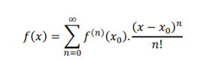
Equation 2: Taylor Series Expansion (compact form)

First Derivative Approximations

Forward Difference
For Forward Difference, the approximation of the first derivative of function f at a point x using the value of the function at x and x+h:
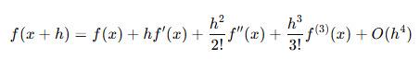
Equation 3: Taylor Series Expansion

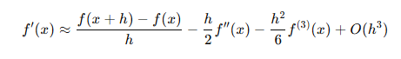
Equation 4: Rearranged to solve for f'(x)
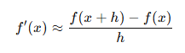
Equation 5: Forward Difference Approximation
The error term O(h) indicates that the forward difference is a first order approximation (Burden and Faires, 2015). The error term is not present in the final approximation by still applies to the equation.

Backwards Difference
For Backwards Difference, the approximation of the first derivative of function f at a point x using the value of the function at x and x-h:
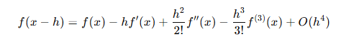
Equation 6:Taylor Series Expansion
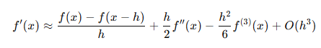
Equation 7: Rearranged to solve for f'(x)
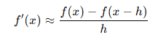
Equation 8: Backwards Difference Approximation
As with Equation 4: Forward Difference Approximation error term O(h) indicates that the forward difference is a first order approximation (Burden and Faires, 2015). The error term is not present in the final approximation by still applies to the equation.

Central Difference
For Central Difference, the approximation of the first derivative of function f at a point x using the value of the function at x+h and x-h:
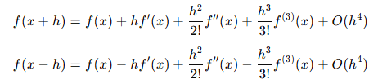
Equation 9: Taylor Series Expansions
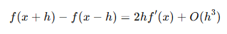
Equation 10: Second Expansion subtracted from the first
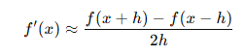
Equation 11: Central Difference Approximation
Equation 10 is resolved for f(x) and then integrated, leaving equation 11, which has the error term removed. The error term is not present in the final approximation by still applies to the equation. The error term is O(h²) indicating that the central difference is a second-order approximation and thus more accurate than Forward or Backwards as the value of h is smaller (Chapra, 2018).

Second Derivative Approximations

Central Difference
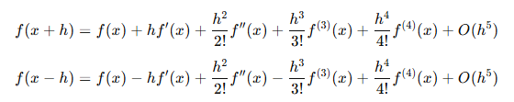
Equation 12: Taylor Series Approximations
Equation 13: Two above Equations added together
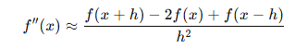
Equation 14: Central Difference Approximation to the 2nd Derivative
Equation 13 is resolved for f(x) and then double integrated, leaving equation 14, which has the error term removed. The error term is not present in the final approximation by still applies to the equation. the error term is O(h²) indicating that the central difference is a second-order approximation and thus more accurate than Forward or Backwards as the value of h is smaller (Chapra, 2018). The error term is not present in the final approximation by still applies to the equation.

Explicit Finite Difference Scheme for the Heat Equation

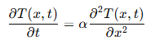
Equation 15: Time- Dependant Heat Equation
Above is the heat equation, where T(x,t) is the temperature at position x and time t. α is the thermal diffusivity.
The derivatives are replaced by the finite difference approximations. Firstly, using the forward difference approximation. This approximation is first-order accurate in time, as discussed in Burden and Faires (2015).
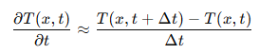
Equation 16: Temporal first derivative
Secondly, using the central difference method to approximate the second spatial derivative. This method provides a second-order accurate approximation in space (Chapra and Canale, 2015).
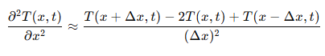
Equation 17: Spatial Second Derivatives
To form a grid of discrete points indexed by i, the spatial domain is divided.
$$x_{i}=iδx for i=0, 1, 2……., N$$
This grid spacing $δx$ must be a chosen value which is small enough to capture the solution accurately. Spacing is uniform and typically used for consistency and simplicity (LeVeque, 2007).
Like the grid spacing, the timestep is divided into discrete step, noted by n.
$$t_{n}=nδt for n=0, 1, 2……$$
To ensure numerical stability of the solution, a small timestep must be selected (Smith, 1985).
By substituting the forward difference approximation for the temporal derivative and the central difference approximation for the spatial second derivative into the heat equation, the below equation is derived.
$$\frac{T_{i}^{n+1}-T_{i}^{n}}{δt}= α\frac{T_{i+1}^{n}-2T_{i}^{n}+T_{i-1}^{n}}{(δx^{2})}$$
This is then rearranged to solve for T_{i} .
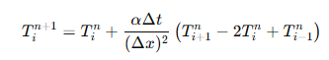
This equation calculates the temperature T_{i} at the next timestep n+1 based on the values at the current timestep.
Fourier number Fo is a dimensionless parameter used in heat conduction problems. It is defined as:
$$Fo= \frac{αδt}{{(δx)}^{2}}$$
Equation 18: Fourier Number
In terms of Fo the explicit finite difference equation is written as:
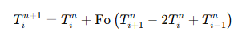
Equation 19: Explicit Finite Difference in terms of Fo
The stability of the explicit solution is analysed using the von Neuman Stability analysis (Incropera et al., 2013). The stability criterion requires the Fourier number to satisfy Fo ≤ ½. This ensures that the numerical solution remains stable over time. If it exceeds the criteria the solution will become unstable and diverge (LeVeque, 2007; Chapra and Canale, 2015).

Boundary Conditions and Analytical Solution

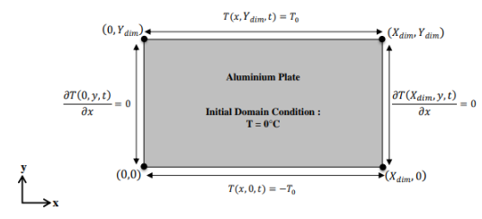
Figure 1: Initial Boundary Conditions
The initial temperature in the plate will be 0⁰C and the East/West boundary walls will be insulated, so not to allow any heat transfer in or out. These are the Neumann Boundaries. The user will input a value for the North Boundary, which is then applied negatively to the South Boundary. Solution assumes the heat source is constant and uniform at both boundaries.
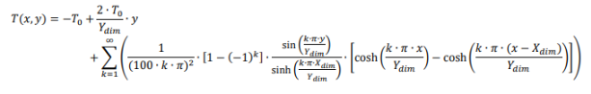
Equation 20: Analytical Solution
Above is the analytical solution which be converted to code for use to compare the computational results.

Code Description

The following section of the report will cover the code written to solve the problem. Snapshots of each section will be provided and discussed.

Clear All
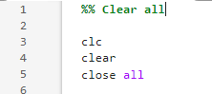
Figure 2: Clear all section
This initial section clears all the saved data from the Matlab workspace and command window and closes and pop-ups that may be loaded from a previous code.

Material Properties
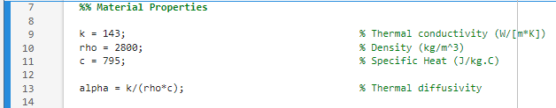
Figure 3: Material Properties Section
The second section provides the material properties to the workspace for later use and calculates the thermal diffusivity of the material.

Geometric Parameters
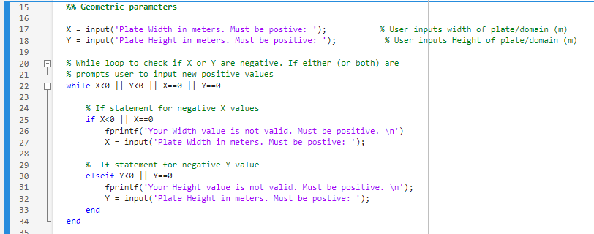
Figure 4: Geometric Parameters Section
In this section the user inputs their desired geometric parameters into the code. The code prompts the user to input a positive value in. After the prompt, a while loop is placed to check the inputted values. The While loop will only engage if the value input matches any of the statements next to it. These statements check if the inputted parameters are suitable for the code to run. The only requirements are that the value is positive and not zero. If any of these are true for X or Y, If statements within the While loop will prompt the user to enter a new value. When both values are suitable, the While loop ends and the code progresses.

Grid Spacing (h) Compatibility
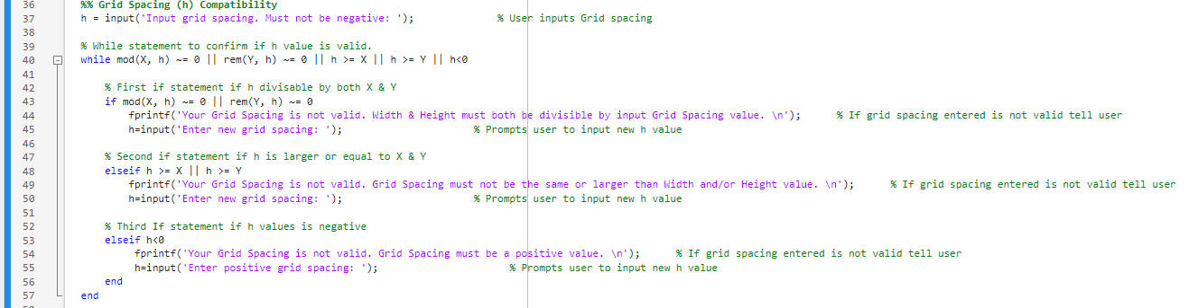
Figure 5: Grid Spacing Compatibility Section
Section 4 is where the grid spacing value is input by the user. After the user has input a value, a While loop will check the inputted value against several OR statements. If any match, they will trigger the respective If statement which will prompt the user to enter a new value which is compatible. These statements are outlined in the green commented text in the code. Again, the while loop ends when all the requirements are satisfied.

Matrix Dimensions
Figure 6: Matrix Dimension Section
When a correct grid spacing, h, has been selected the code moves to the next section where the matrix dimensions are calculated. The dimensions are the X/Y value, divided by the grid spacing and +1. This plus one is due to 0m for both X and Y requiring node points.

Boundary and Initial Conditions
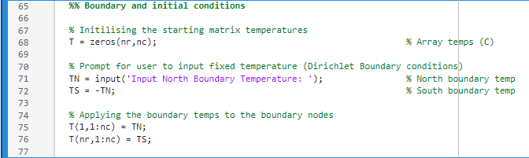
Figure 7: Boundary and Initial Conditions
0 value is assigned to all nodes of the matrix initially. The user is then prompted to provide a North boundary temperature to the matrix. The south boundary temperature is negative of the inputted temperature. The final bit of this section applies the select temperature and negative temperature to the north and south boundary of the matrix.

Input Timestep
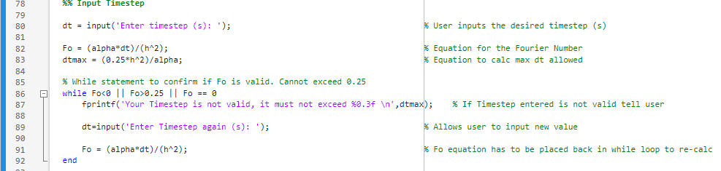
Figure 8: Input Timestep section
User is prompted to input the timestep for the computation. The Fourier number and max possible timestep is calculated before these values are checked with a while loop. The value is checked to be inside a range of 0-0.25, and not 0. If outside this range, user is prompted to choose a new value. The max possible timestep is shown to avoid multiple failures.

Computation
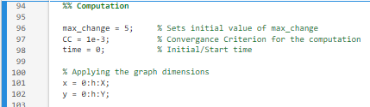
Figure 9: Lines 94-102
At the start of the computation section, an initial error value is provided to begin the while loop that will follow. A convergence criterion is selected for the computation, in future this could be changed to an additional user prompt. Finally, an initial start time for the loop is provided.
Lines 100-102 provide dimensions for the later graphs that will be created.
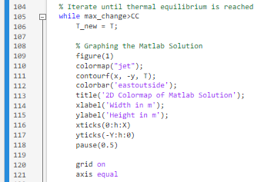
Figure 10: Lines 104-121
Line 105 sets the requirement for the while loop to continue. While max_change (error) is greater than the CC, the while loop will repeat.
The following lines create the graph of the Computational Solution. As this graph is within the while loop, it will update after each iteration. A pause has been added to allow lower powered computers time to calculate the graph for each iteration.
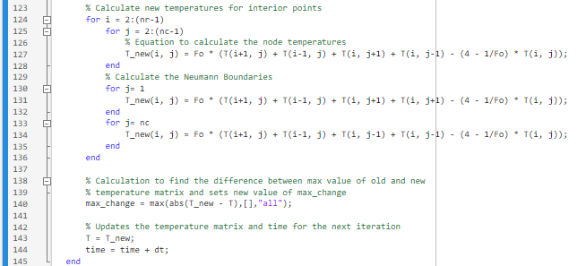
Figure 11: Computation Loop
This section is where the temperature for each node is calculated using FDM and using the derived from the Taylor series equations. Lines 124-127 calculate the internal nodes, while lines 129-134 calculate the Neuman Boundaries at the insulated walls.
After the calculations for the iternation are completed, line 140 finds the max absolute difference in temperature between the previous iteration temperature matrix against the current iteration. If the max_change value found is greater than the CC value, a new iteration begins. The values of the temperature matrix T is outdated, and the time is updated by adding the timestep to the previous time. When the max_change value is lower than the CC, the while loop is satisfied and stops, calculating the final time, which is the time taken to achieve Thermal Equilibrium.
Figure 12: Lines 146-151
Line 147 converts the time into a readable value of hours. The following lines display the results for the final temperature matrix and the time taken to reach Thermal Equilibrium.

Analytical Solution
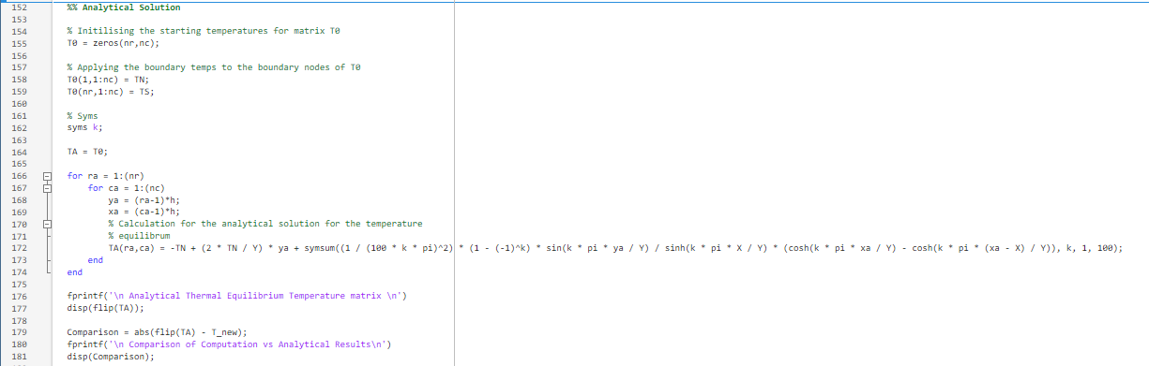
Figure 13: Analytical Solution Section
Here a new matrix is initialised, and the analytical solution is calculated to compare against the computational results. The final analytical solution must be flipped to match the orientation of the computation matrix. It is then displayed, in the command window as well as the comparison results.
This section uses a syms function to provide a value to k, and the range in which it runs.

Graph Plotting
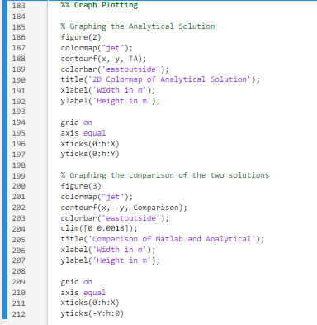
Figure 14: Graph Plotting Section
This section plots and displays the graphs for the analytical solution and the comparison of the two matrices. Both graphs use the same settings/parameters as the graph for the computational results, shown in section 8, except that the Comparison graph has a colour bar range added in (clim).

Code Validation

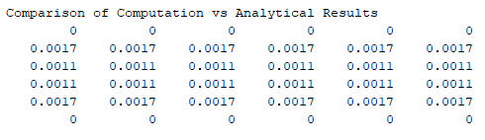
Figure 15: Comparison of two Results

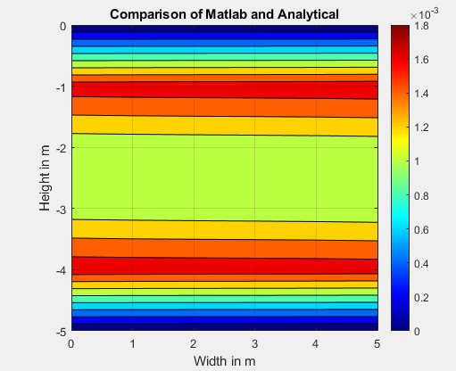
Figure 16: Colour Map of two results
The two methods calculated results to within 0.00175ºC of one another. From this is can be gathered that the computational method is accurate.
The difference between the two results could be explained by a few factors. Numerical solutions are computed using finite precision arithmetic, leading to round-off errors that accumulate over multiple iterations. These errors are absent in analytical solutions (Higham, 2002). Secondly, the analytical solution applies boundary conditions precisely, while numerical methods approximate them over discrete grid points. This can introduce local errors near the boundaries, which propagate into the solution (Morton and Mayers, 2005). Finally, the analytical solution assumes continuity and accounts for all higher-order terms, which the FDM neglects, leading to slight discrepancies (Chapra and Canale, 2015).

Sensitivity Analysis

This section of the report will discuss the results of sensitivity analysis of the code. The change of the Thermal Equilibrium Time when varying one of three selected variables (Grid Spacing, Time Step and Thermal Equilibrium Tolerance), while other two remain fixed. Each of the varying variable’s results are split into subheadings below.
The dimensions of the plate for this test were set at 12m x 12m, using 50°C for the north boundary, -50°C for the south boundary and 0°C for east and west boundaries.

Grid Spacing

Figure 17: Graph of Influence of Grid Spacing on Thermal Equilibrium Time
In this analysis, the Time Step and Tolerance were fixed at 150s and 0.001 respectively. The Grid Spacing was tested through a range of 0.2-4mm. 13 different Grid Spacing values were tested, and the results are shown in the figure above.

Using the results gather from the Grid Spacing sensitivity tests, it can be gathered that as the grid spacing increases, the time required for the simulation to reach Thermal Equilibrium increases.
As the Grid spacing decreases, the mesh becomes finer, increasing the accuracy of the model. The model will detect temperature changes under the Convergence Criteria sooner, thus the decreasing Equilibrium Time. This increased accuracy comes a cost of at the cost of increased computational effort (Burden and Faires, 2015). Becker (2006) outlines that a balance must be struck between accuracy and computational efficiency for finite difference models.

Time Step Analysis

Figure 18: Influence of Time Step on Thermal Equilibrium Time
Changes in the Time Step have an inverse exponential relationship with Thermal Equilibrium time. Initially there is a large increase in the time required to reach thermal equilibrium, the rate of this increase decreases as the Time Step increases. If further tests were performed at higher Time Step values, the results on the graph would begin to plateau.
The Courant-Friedrichs-Lewy (CFL) condition provides a criterion for stability, normally requiring dt be proportional to dx². Higher timesteps also lead to instability, but too small increases computational time. According to LeVeque (2007) selecting the appropriate time step is to satisfy the CFL condition is essential to ensuring stability.

Tolerance Changes

Figure 19: Influence of Tolerance Change on Thermal Equilibrium Time
The thermal equilibrium tolerance defines the convergence criterion for iterative solutions. A tighter tolerance ensures a solution closer to true equilibrium but may require more iterations, increasing computational time. Conversely, a looser tolerance reduces computational effort but may result in a less accurate solution. Selecting an appropriate tolerance is crucial for balancing accuracy and efficiency. As noted by Li et al. (2019), a good practice is to adjust the tolerance based on the required precision for the problem at hand, ensuring that the computational cost does not exceed the necessary level of detail.

Discussion

This section of the report discusses limitations of the model. Some limitations have already been discussed previously, such as round-off errors and discrepancies.
Round-off errors were discussed when comparing the two results, and Higham (2002) was referenced. He adds that round-off errors are particularly significant in problems requiring high precision or long simulation times (Higham, 2002). This limits FDM to modelling simple systems with short simulation times, and low accuracy requirements.

The explicit FDM is best suited for problems with simple, regular geometries such as rectangular domains. Versteeg and Malalasekera (2007) discuss how the simplicity of the FDM's grid structure makes it less suited for modelling complex geometries without additional techniques. For complex geometries, such as irregular shapes or regions with boundaries that require special handling, the method becomes significantly more challenging. Versteeg and Malalasekera (2007) continue to discuss how techniques like domain decomposition or unstructured grids can be used to tackle complex shapes, but these add computational complexity and can still result in less accurate solutions.

Chapra and Canale (2015) highlight that, while convergence criteria such as temperature differences are often used in numerical simulations, they do not always accurately model the underlying physical processes. Material properties are not uniform throughout and boundary conditions may vary along. By simply comparing temperature differences, the code may miss subtleties in the behavior of the thermal system, leading to slight inaccuracies in representing steady-state conditions (Chapra, 2018).

The lack of adaptive tolerance would reduce the computational time needed as suggested by Mauri et al. (2017). They state how a more adaptive tolerance mechanism, which dynamically adjusts based on the changes observed in the solution, could lead to more efficient simulations and better accuracy.

Improvements

FDM is limited in its accuracy stability and the ability to handle complex geometry. Other methods of modeling have been developed that would enhance the current model.
IFDM can handle larger time steps without sacrificing stability, allowing for longer simulation times, but does require increased computation cost. FEM is more suited for complex geometries and unstructured meshes. It provides higher accuracy for the same grid resolution (Zienkiewicz and Taylor, 2005) and can handle irregular boundaries with greater flexibility.
Mesh refinement, adaptive grids or unstructured meshes can handle complex geometries. This approach adapts the grid resolution based on spatial features, ensuring that the solution remains accurate while reducing computational costs (Parks et al., 2006).
For modelling thermal equilibrium, one improvement would be the use of adaptive time stepping. This method is employed to adjust the timestep based on the rate of temperature change. Salem, Errera and Marty (2019) and Baker et al (2015) demonstrated how it can improve both the computational efficiency and the accuracy of modelling, especially in systems with dynamic boundaries.

Conclusion

In conclusion, the heat equation provides a foundational mathematical framework for modelling thermal diffusion and temperature distribution. Using the explicit finite difference method (FDM), the equation is discretised and solved iteratively, providing valuable insights into the time-dependent behaviour of temperature within a material. Although the approach offers reliable results, especially for simple geometries, it is not without its limitations, such as susceptibility to round-off errors and difficulty handling complex geometries. Improvements, such as incorporating adaptive tolerance mechanisms and exploring alternative methods like the finite element method (FEM), could enhance both the accuracy and computational efficiency of the model. Despite these challenges, the approach serves as a practical tool for solving heat transfer problems in a variety of engineering applications.

References
Baker, S.P., Foch, M., and Johnson, M. (2015). "Adaptive Time-Stepping for Heat Transfer Simulations". International Journal of Heat and Mass Transfer, 87(3), pp. 158-170.
Becker, W. (2006). Finite Difference Methods: An Introduction. 2nd ed. New York: Springer.
Burden, R.L. and Faires, J.D., 2015. Numerical Analysis. 10th ed. Boston: Brooks/Cole.
Carnahan, B., Luther, H.A. and Wilkes, J.O., 1969. Applied Numerical Methods. New York: Wiley.
Carslaw, H.S. and Jaeger, J.C., 1959. Conduction of Heat in Solids. 2nd ed. Oxford: Oxford University Press.
Chapra, S.C. and Canale, R.P., 2015. Numerical Methods for Engineers. 7th ed. New York: McGraw-Hill.
Chapra, S.C., 2018. Applied Numerical Methods with MATLAB for Engineers and Scientists. 4th ed. New York: McGraw-Hill.
Fourier, J., 1822. The Analytical Theory of Heat. Cambridge: Cambridge University Press.
Higham, N.J. (2002) Accuracy and Stability of Numerical Algorithms. 2nd ed. Philadelphia: SIAM.
Hunter, J., 2013. Introduction to Partial Differential Equations. [online] University of California, Davis. Available at: https://www.math.ucdavis.edu/~hunter/pdes/ch6.pdf
Incropera, F.P. et al. (eds) (2013) Foundations to heat transfer. 6. ed., internat. student version. Singapore: Wiley.
Kreyszig, E., 2011. Advanced Engineering Mathematics. 10th ed. Hoboken: Wiley.
LeVeque, R.J., 2007. Finite Difference Methods for Ordinary and Partial Differential Equations: Steady-State and Time-Dependent Problems. Philadelphia: Society for Industrial and Applied Mathematics.
Li, M., Zhang, Y., and Liu, S. (2019). "Effect of Tolerance on Convergence in Thermal Simulations". Journal of Computational Physics, 415(1), pp. 220-231.
Mauri, L., Beretta, F., and D’Amico, A. (2017) "Adaptive Tolerance for Finite Difference Simulations". Journal of Computational and Applied Mathematics, 319, pp. 13-25.
Morton, K.W. and Mayers, D.F., 2005. Numerical Solution of Partial Differential Equations: An Introduction. 2nd ed. Cambridge: Cambridge University Press
Oberkampf, W. L. , and Roy, C. J. , 2010, Verification and Validation in Scientific Computing, 1st ed, Cambridge University Press, Cambridge, UK, p. 11.
Parks, M., Williams, K., and Lee, M. (2006). "Mesh Refinement and Adaptive Grids in Heat Conduction Problems". Journal of Computational Physics, 219(1), pp. 295-307.
Salem, R., Errera, M. and Marty, J. (2019) ‘Adaptive diffusive time-step in conjugate heat transfer interface conditions for thermal-barrier-coated applications’, International Journal of Thermal Sciences, 145, p. 106048. Available at: https://doi.org/10.1016/j.ijthermalsci.2019.106048.
Smith, G.D., 1985. Numerical Solution of Partial Differential Equations: Finite Difference Methods. 3rd ed. Oxford: Clarendon Press.
Strikwerda, J.C. (2004) Finite Difference Schemes and Partial Differential Equations. 2nd ed. Philadelphia: SIAM.
Versteeg, H.K. and Malalasekera, W. (2007) An Introduction to Computational Fluid Dynamics: The Finite Volume Method. 2nd ed. Harlow: Pearson Education.
Zienkiewicz, O.C., and Taylor, R.L. (2005). The Finite Element Method. 6th ed. Butterworth-Heinemann

Appendix
%% Clear all

clc
clear
close all

%% Material Properties

k = 143; % Thermal conductivity (W/[m*K])
rho = 2800; % Density (kg/m^3)
c = 795; % Specific Heat (J/kg.C)

alpha = k/(rho*c); % Thermal diffusivity

%% Geometric parameters

X = input('Plate Width in meters. Must be postive: '); % User inputs width of plate/domain (m)
Y = input('Plate Height in meters. Must be positive: '); % User inputs Height of plate/domain (m)

% While loop to check if X or Y are negative. If either (or both) are
% prompts user to input new positive values
while X<0 || Y<0 || X==0 || Y==0

% If statement for negative X values
if X<0 || X==0
fprintf('Your Width value is not valid. Must be positive. \n')
X = input('Plate Width in meters. Must be postive: ');

% If statement for negative Y value
elseif Y<0 || Y==0
fprintf('Your Height value is not valid. Must be positive. \n');
Y = input('Plate Height in meters. Must be postive: ');
end
end

%% Grid Spacing (h) Compatibility
h = input('Input grid spacing. Must not be negative: '); % User inputs Grid spacing

% While statement to confirm if h value is valid.
while mod(X, h) ~= 0 || rem(Y, h) ~= 0 || h >= X || h >= Y || h<0

% First if statement if h divisable by both X & Y
if mod(X, h) ~= 0 || rem(Y, h) ~= 0
fprintf('Your Grid Spacing is not valid. Width & Height must both be divisible by input Grid Spacing value. \n'); % If grid spacing entered is not valid tell user
h=input('Enter new grid spacing: '); % Prompts user to input new h value

% Second if statement if h is larger or equal to X & Y
elseif h >= X || h >= Y
fprintf('Your Grid Spacing is not valid. Grid Spacing must not be the same or larger than Width and/or Height value. \n'); % If grid spacing entered is not valid tell user
h=input('Enter new grid spacing: '); % Prompts user to input new h value

% Third If statement if h values is negative
elseif h<0
fprintf('Your Grid Spacing is not valid. Grid Spacing must be a positive value. \n'); % If grid spacing entered is not valid tell user
h=input('Enter positive grid spacing: '); % Prompts user to input new h value
end
end

%% Matrix Dimensions

% Calculate Matrix dimensions
nr= (Y/h)+1; % Matrix rows is Y (plate height) / user input for h + plus 1 for the additional row
nc= (X/h)+1; % Matrix coloumns is X (plate width) / user input for h + plus 1 for the additional coloum

%% Boundary and initial conditions

% Initilising the starting matrix temperatures
T = zeros(nr,nc); % Array temps (C)

% Prompt for user to input fixed temperature (Dirichlet Boundary conditions)
TN = input('Input North Boundary Temperature: '); % North boundary temp
TS = -TN; % South boundary temp

% Applying the boundary temps to the boundary nodes
T(1,1:nc) = TN;
T(nr,1:nc) = TS;

%% Input Timestep

dt = input('Enter timestep (s): '); % User inputs the desired timestep (s)

Fo = (alpha*dt)/(h^2); % Equation for the Fourier Number
dtmax = (0.25*h^2)/alpha; % Equation to calc max dt allowed

% While statement to confirm if Fo is valid. Cannot exceed 0.25
while Fo<0 || Fo>0.25 || Fo == 0
fprintf('Your Timestep is not valid, it must not exceed %0.3f \n',dtmax); % If Timestep entered is not valid tell user

dt=input('Enter Timestep again (s): '); % Allows user to input new value

Fo = (alpha*dt)/(h^2); % Fo equation has to be placed back in while loop to re-calc
end

%% Computation

max_change = 5; % Sets initial value of max_change
CC = 1e-3; % Convergance Criterion for the computation
time = 0; % Initial/Start time

% Applying the graph dimensions
x = 0:h:X;
y = 0:h:Y;

% Iterate until thermal equilibrium is reached
while max_change>CC
T_new = T;

% Graphing the Computational Solution
figure(1)
colormap("jet");
contourf(x, -y, T);
colorbar('eastoutside');
title('2D Colormap of Matlab Solution');
xlabel('Width in m');
ylabel('Height in m');
xticks(0:h:X)
yticks(-Y:h:0)
pause(0.5)

grid on
axis equal

% Calculate new temperatures for interior points
for i = 2:(nr-1)
for j = 2:(nc-1)
% Equation to calculate the node temperatures
T_new(i, j) = Fo * (T(i+1, j) + T(i-1, j) + T(i, j+1) + T(i, j-1) - (4 - 1/Fo) * T(i, j));
end
% Calculate the Neumann Boundaries
for j= 1
T_new(i, j) = Fo * (T(i+1, j) + T(i-1, j) + T(i, j+1) + T(i, j+1) - (4 - 1/Fo) * T(i, j));
end
for j= nc
T_new(i, j) = Fo * (T(i+1, j) + T(i-1, j) + T(i, j-1) + T(i, j-1) - (4 - 1/Fo) * T(i, j));
end
end

% Calculation to find the difference between max value of old and new
% temperature matrix and sets new value of max_change
max_change = max(abs(T_new - T),[],"all");

% Updates the temperature matrix and time for the next iteration
T = T_new;
time = time + dt;
end

final_time = time/(60*60); % Equation to change time into readable unit
fprintf('\n Computational Thermal Equilibrium Temperature matrix \n')
disp(T); % Displays Temp Equilibrum Matrix
fprintf('Thermal equilibrium reached at time = %0.2f hours\n', final_time); %displays the final time taken to reach equilibrum in hours

%% Analytical Solution

% Initilising the starting temperatures for matrix T0
T0 = zeros(nr,nc);

% Applying the boundary temps to the boundary nodes of T0
T0(1,1:nc) = TN;
T0(nr,1:nc) = TS;

% Syms
syms k;

TA = T0;

for ra = 1:(nr)
for ca = 1:(nc)
ya = (ra-1)*h;
xa = (ca-1)*h;
% Calculation for the analytical solution for the temperature
% equilibrum
TA(ra,ca) = -TN + (2 * TN / Y) * ya + symsum((1 / (100 * k * pi)^2) * (1 - (-1)^k) * sin(k * pi * ya / Y) / sinh(k * pi * X / Y) * (cosh(k * pi * xa / Y) - cosh(k * pi * (xa - X) / Y)), k, 1, 100);
end
end

fprintf('\n Analytical Thermal Equilibrium Temperature matrix \n')
disp(flip(TA));

Comparison = abs(flip(TA) - T_new);
fprintf('\n Comparison of Computation vs Analytical Results\n')
disp(Comparison);

%% Graph Plotting

% Graphing the Analytical Solution
figure(2)
colormap("jet");
contourf(x, y, TA);
colorbar('eastoutside');
title('2D Colormap of Analytical Solution');
xlabel('Width in m');
ylabel('Height in m');

grid on
axis equal
xticks(0:h:X)
yticks(0:h:Y)

% Graphing the comparison of the two solutions
figure(3)
colormap("jet");
contourf(x, -y, Comparison);
colorbar('eastoutside');
clim([0 0.0018]);
title('Comparison of Matlab and Analytical');
xlabel('Width in m');
ylabel('Height in m');

grid on
axis equal
xticks(0:h:X)
yticks(-Y:h:0)

