Impact of current challenges on the human resource department relating to recruitment and retention

Module: Personnel Resourcing and development
Module number: BMIH5005
Lecturer: Deborah Lloyds
Word count: 2135

STUDENT NAME: CECILIA MARIA COJOCARU STUDENT NUMBER: 1816288
1.Executive summary 3
2. Introduction 3
3.Main body 5
3.1Pestel 5
3.2 SWOT 7
3.3 Automated intelligence in Ritz Carlton 8
3.4 Employee retention in Ritz Carlton 8
4 Conclusion 10
5. Recommendations 11
References 13

1.Executive summary

The external factors can shape the internal operations as hotels must survive and compete with competitors and this is not different when it comes to the employee’s recruitment and the employee retention as talented employees can be attracted by competitor companies which in a large scale can affect the hotel services. The report acknowledges that the organisation is vulnerable to external environmental influences that impact recruitment and retention strategies, including political shifts, economic difficulties, and the dynamic social environment. Excluding these obstacles, The Ritz-Carlton has consistently prioritised employee development by implementing comprehensive training programmes and empowerment strategies to guarantee outstanding service quality. The hotel's commitment in the face of political disruptions such as Brexit, its substantial economic contributions, its social dedication to diversity and inclusion, its prudent adoption of technological innovations, its environmental consciousness as evidenced by the "Community Footprints" initiative, and its unwavering adherence to legal regulations are all aspects outlined in the PESTEL analysis. The SWOT analysis identifies the following: The Ritz-Carlton's strengths are employee welfare and brand recognition; its weaknesses are market exclusivity and rigorous recruitment procedures; its opportunities for expansion are diversity and professional development; and its potential employee attrition resulting from high luxury exposure constitutes a threat. The report examines the incorporation of automated intelligence, placing particular emphasis on the brand's commitment to innovation by empowering employees rather than relying too heavily on technology. In contrast to industry norms, it also emphasises the exceptional employee retention strategies implemented by Ritz-Carlton, which are supported by comprehensive training, competitive benefits, and a strong sense of community. Employee retention and ratings at The Ritz-Carlton are superior to those of its rivals, which are critical to the company's competitive advantage in the luxury hotel industry. The conclusion reaffirms that Ritz-Carlton's culture of empowerment, learning, and change adaptation, in addition to its unwavering investment in human resources, contributed to the company's success in managing external pressures. It emphasises the significance of maintaining a commitment to employee satisfaction and growth in order to preserve the brand's standing as an authority on luxury and service. Suggestions for the organisation encompass augmenting its digital footprint concerning diversity and inclusion; organising leadership forums; elucidating employee benefits; advocating for sustainability; providing flexible work arrangements; establishing mentorship initiatives; designing environmentally conscious travel packages; and forging alliances with academic establishments in order to entice millennials and foster workplace inclusiveness and welfare.

2. Introduction
Ritz-Carlton Hotel Company (2023) stands as an emblem of opulence in the hospitality sector. Revered not just for its luxurious ambiance but also for its distinguished service, Ritz-Carlton's success is deeply rooted in its human resource. However, like any global organisation, it is susceptible to the oscillations of the external environment, impacting its recruitment and employee retention strategies. Recognised for its sophistication and excellent service, the company's success depends on its human capital (Ritz Carlton, 2023). The hotel industry is affected by many external factors. Politics, including labour rights and work regulations (Gov 2023), affect Ritz-hiring Carlton's and employment practises. Compliance with these guidelines ensures fair working hours, safe environments, and fair pay, boosting Ritz-Carlton's employee status (Michelli, 2020). Global finance affects the hotel industry especially economically. While economic downturns may require staff adjustments, Ritz Carlton's comitment to employee development remains. New hires undergo over 250 hours of rigorous training in their first year, showing the hotel's commitment to long-term staff investment (Michelli, 2020). However, challenges are numerous. One obstacle is "tides of retirement". As seniors near retirement, younger staff must be integrated to ensure a smooth transition of the hotel's values (Lee, 2023). Increasing hospitality automation exacerbates demographic change. The integration of technology and service requires a well-trained workforce to navigate this dynamic environment. This external change has revealed several urgent issues (CIPD 2020). The retirement wave may cause staff shortages, which could compromise Ritz Carlton high quality service. Lack of training, especially in the age of rapid technological progress, may leave staff unprepared to meet changing customer expectations (Hyder, 2021). Poor management has not been a Ritz-Carlton issue, but it remains a risk for any large company (Holloway, 2019). Due to the above issues, HR is primarily responsible to involves more than just hiring; it promotes development, learning, and longevity (Friedman, 2021). Comprehensive human resources strategies are needed to address organisational issues like staff shortages, outdated training, and management issues. By fostering ongoing education, reinforcing the hotel's core values, and ensuring employees' recognition and inclusion in the Ritz-Carlton storyline, human resources can attract and retain the exceptional staff that make the hotel an icon (Nhat Tan Pham et al., 2023).

3.Main body
The Ritz-Carlton prioritises employee empowerment significantly as a fundamental aspect of its operational strategy. An atmosphere of employee motivation and recognition is created by endowing their "Ladies and Gentlemen" with decision-making authority, resources, and confidence. This empowerment not only serves to augment the job satisfaction of personnel but also guarantees that guests are attended to in a timely and individualised fashion. Through the provision of such care for its staff, The Ritz-Carlton guarantees that they will subsequently deliver exceptional service to guests, thereby bolstering the brand's reputation for unmatched quality (Solomon, 2014).

3.1Pestel
Political | The hospitality industry suffered greatly as a result of Brexit, but Ritz Carlton was able to overcome it due to the stable job opportunities it provides to its employees and because its employee turnover is low, it was not impacted as much as low-cost hotels such as Premier Inn. Political influences such as Ukraine and inflation are putting pressure on the hospitality industry in terms of cost increases (Bartrum 2022).
Economical | The hotel industry contributes directly to the economy through employment, Gross Value Added (GVA), taxes, and investments. Indirectly, it boosts the economy via its supply chain and the multiplier effect, where both guests and the workforce spend in the local community. Luxury brands like The Ritz-Carlton, with their premium services, amplify these contributions significantly. However external factors like inflation can deeply influence the customer expenditure power (Ignite Economics, 2023).
Social | Social influence such as diversity and inclusion, created a The Ritz-Carlton emphasised culture of excellence built on robust systems and processes that empower its employees to provide legendary service. Key components of this culture include The Ritz-Carlton Gold Standards, a rigorous selection and onboarding process, and a commitment to customers and employee engagement. The brand's empowerment model allows employees to make decisions for guest well-being, reducing problem resolution costs and ensuring consistent top-tier service (Michelli, 2008). Luxury hotels must keep in mind the high demand for sustainability requests from customers (Amatulli, De Angelis & Stoppani, 2021)
Technological | While technology is a part of Ritz Carlton daily operation and the outside pressure is big as the word is moving along with the automated intelligence however, Ritz-Carlton Leadership Centre (2018) emphasises the importance of authentic employee engagement in relation to customer retention, as opposed to implementing artificial intelligence and big data, according to a new communication from Ritz Carlton leadership centre (2023) they still opposing.
Environmental | For over 40 years, the Ritz-Carlton Hotels has been committed to environmental sensitivity and community support, actively realising this vision through their Community Footprints programme, which aims to engage, contribute, and inspire positive change in the destinations in which they operate. They emphasise travel as a means to foster cultural and environmental understanding, embracing their responsibility (Ritz Carlton 2023).
Legal | The Ritz-Carlton actively adheres to legal mandates by maintaining stringent health and safety protocols, ensuring data protection and fair employment practises, and collaborating with local authorities to ensure compliance. To further align with evolving regulations and societal expectations, they have also incorporated sustainability and community engagement initiatives, such as their "Community Footprints" programme (Ritz Carlton, 2023).

3.2 SWOT

Strength | The Ritz-Carlton is a Icon in the luxury hospitality industry, owing to its strong brand awareness that evokes luxury, elegance, and impeccable service. The company has an impressive employee retention rate, which is a testament to their robust training programmes and dedication to employee welfare. This commitment to their employees can be seen in the brand's operational philosophies, such as The Ritz-Carlton Gold Standards (2023), which include principles such as The Credo, Motto, and The Employee Promise. These frameworks not only shape the guest experience, but they also foster a nurturing and empowering environment for employees (Zhao, 2023).
Weakness | The Ritz-Carlton, while renowned for its luxury and impeccable service, operates in a specialised market, primarily catering to high-end clients. This exclusivity is reflected in their pricing, which may appear to be expensive to the average traveller. Furthermore, while ensuring a top-notch guest experience, their strong and stringent employee recruitment criteria can limit the pool of potential hires and potentially lengthen the hiring process. While these factors are consistent with the brand's luxury positioning, they may pose challenges in terms of market expansion and staffing in specific regions.
Opportunity | The Ritz-Carlton can improve employee recruitment and retention by emphasising diversity to access a larger talent pool, providing continuous learning for professional growth, and adapting to flexible working arrangements. Employee well-being can be improved by incorporating wellness programmes, and partnerships with educational institutions provide a direct pipeline to potential recruits.
Threat | The Ritz-Carlton, which operates in the luxury hospitality sector, may face significant challenges in terms of employee retention. According to Comparability data, employees would consider leaving for better-paying jobs elsewhere. Being immersed in a luxurious environment on a daily basis may heighten employee aspirations and make them more ambitious. This exposure may raise their expectations for higher pay, posing a challenge for The Ritz-Carlton in retaining top talent.

3.3 Automated intelligence in Ritz Carlton
The Ritz-Carlton (2023) concurs with this viewpoint, placing particular emphasis on their dedication to innovation and delegating the ongoing improvement of guest experiences to each member of their staff. Although they do not have a dedicated innovation team, every employee is motivated to innovate by their culture of empowerment. They maintain the view that innovation extends beyond technology and emphasise the criticality of ensuring that technological advancements it diminish the overall guest experience. The brand places importance on both substantial and minute modifications, realising that even minor adjustments can greatly influence the experiences of guests. This includes both procedural changes and physical space transformations.

3.4 Employee retention in Ritz Carlton
Friedman (2021) outlines the various challenges that human resources (HR) leaders encounter. These challenges include: improving employee experiences, identifying and training for future skills, facilitating remote work, managing organisational changes, addressing skills gaps, equipping future leaders, navigating talent shortages, facilitating remote work, and fostering a psychologically and physically healthy work environment. In order to guarantee the success of a diverse organisation, productive workforce, it is critical to effectively confront these challenges. The current generation has distinct values that distinguish it from previous generations; many of them are willing to accept lower pay and benefits in exchange for a job (Lee, 2022).
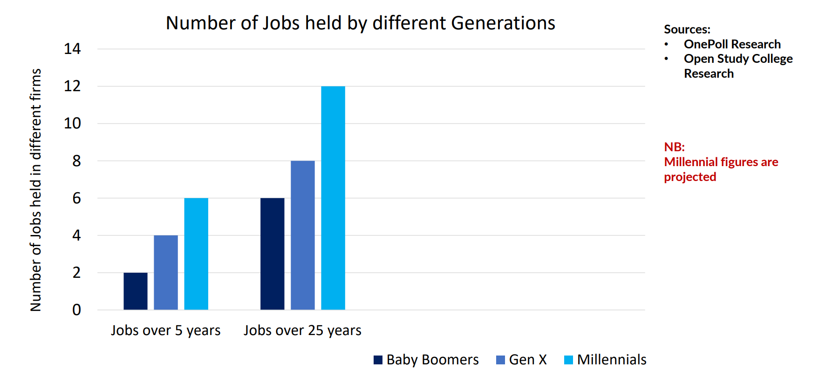

According to Hampson (2023) By prioritising employee development, fostering a positive work environment, and offering competitive compensation, The Ritz Carlton maintains an exceptionally low turnover rate of approximately 20 percent, which is in contrast to the industry average of 30-40 percent. The organisation implements diverse employee retention strategies, such as providing competitive benefits, cultivating a sense of community, investing in employee welfare and job contentment, and conducting comprehensive training programmes (Ritz-Carlton gold 2002)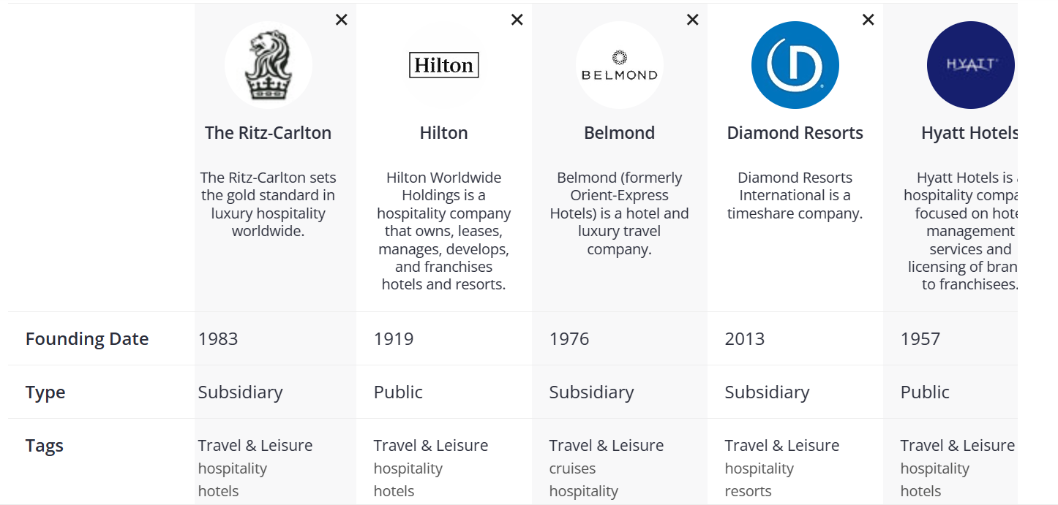
How Ritz Carlton doing in comparison to competitors Craft (2023)

The employee rating of Ritz-Carlton is in competition with other businesses.
According to Skift and Comparably surveys (Sperance 2022; Comparably 2023)
Hotel name | Company culture score | Employee retention score
Ritz Carlton | A- | 81
Diamond | A+ | 83
Hyatt | A | 83
Belmond | C+ | 78
Hilton | C- | 40

The survey indicates Ritz Carlton is competing closely with the industry partners therefore ensuring to prioritises employee is parament.

4 Conclusion
The operations of Ritz-Carlton, an iconic icon in the luxury hospitality industry, demonstrate the intricate balance between the external environment and internal organisational strategies. The Ritz Carlton resilience in the face of external fluctuations is a testament to its commitment to human capital, emphasising the importance of robust human resource strategies in recruitment and retention. Political upheavals like Brexit, economic factors like inflation, and societal shifts toward diversity, inclusivity, and sustainability highlight the numerous external pressures influencing the hotel industry (Bartrum, 2022; Ignite Economics, 2023; Amatulli, De Angelis & Stoppani, 2021). The ability of Ritz-Carlton to navigate these challenges demonstrates its foresight and adaptability. Despite technological advances and the increasing integration of artificial intelligence in hospitality, Ritz-Carlton remains committed to genuine human interactions and authentic service delivery (Ritz Carlton Leadership Centre, 2023). Their insistence on balancing technology with the indispensable human touch demonstrates how much they value their employees' contributions to the guest experience. Furthermore, through initiatives such as the "Ladies and Gentlemen" programme, Ritz Carlton dedicated focus on employee empowerment aligns with Solomon's (2014) assertion that empowering employees leads to superior service delivery. According to the SWOT analysis, Ritz-Carlton's strength are its global brand recognition and employee-centric approach, as reflected in the Ritz-Carlton Gold Standards (Zhao, 2023). While the luxury positioning may limit its market reach, there are numerous opportunities for growth and improvement, particularly in harnessing diversity and promoting continuous professional growth. Increased employee aspirations must be mitigated by reinforcing the company's commitment to competitive pay and a nurturing work environment. Furthermore, benchmarking against industry competitors reveals that Ritz-Carlton is holding they ground in terms of employee ratings and retention, providing a competitive advantage in the highly competitive luxury hotel market (Sperance 2022; Comparably 2023). Such indicators highlight the critical importance of ongoing investments in employee development and satisfaction. Ritz-Carlton's success in the face of external environmental challenges can be attributed to the company's unwavering commitment to its employees, who understand their critical role in maintaining the brand's reputation. Ritz-Carlton emphasises the importance of human resources in the rapidly changing hospitality landscape by fostering a culture of empowerment, continuous learning, and adaptability to external changes. Future strategies should emphasise these values even more, ensuring that the Ritz-Carlton name remains synonymous with luxury and unrivalled service.

5. Recommendations
These suggestions can help Ritz-Carlton attract millennials and promote inclusivity, sustainability, and well-being in the workplace.
- Increasing Ritz Carlton digital presence by adding a diversity and inclusion section to the website and social media.
- Think Leadership: by Hosting webinars, workshops, and conferences on workplace diversity, inclusivity, and employee well-being.
- Clear Benefits Package: Explaining the comprehensive employee benefits package, including health, mental health, and professional development.
- Sustainability: Promoting waste reduction, energy conservation, and sustainable product sourcing across all platforms.
- Flexible Work Options: To meet millennial needs, offers like remote working, flexible hours, and other options.
- Mentorship Programs: Giveing millennials and other employees career advice from experienced professionals.
- Eco-friendly travel packages: Millennials value environmental responsibility, so design packages that emphasise eco-tourism and sustainable practises.
- Partner with Educational Institutions: Offering internships, workshops, and courses at colleges and universities to prepare students for hospitality careers.

References

Amatulli, C., De Angelis, M., & Stoppani, A. (2021). The appeal of sustainability in luxury hospitality: An investigation on the role of perceived integrity. Tourism Management, 83, 104228. Available at: The appeal of sustainability in luxury hospitality: An investigation on the role of perceived integrity - ScienceDirect Accessed on (2nd Nov 2023).
Borzykowski B (2018) Ritz-Carlton Leadership Center BrandVoice: Creating Value Through Meaningful Experiences: How Volkswagen Australia Wins Customers And Earns Their Loyalty, Forbes. Available at: https://www.forbes.com/sites/ritz-carltonleadershipcenter/2018/05/22/creating-value-through-meaningful-experiences-how-volkswagen-australia-wins-customers-and-earns-their-loyalty/? (Accessed: 2 November 2023).
CIPD (2020) CIPD | Workplace technology: the employee experience, CIPD. Available at: https://www.cipd.org/uk/knowledge/reports/workplace-technology-employee/ (Accessed: 2 November 2023).
Comparably (2023) Ritz Carlton Retention score. Analysis date 2nd Nov 2023 available on: Ritz-Carlton Retention Score | Comparably [Accessed on 2nd Nov. 2023].
Hampson, A. (2023) What is the Ritz Carlton employee turnover rate?, Employment Security Commission. Available at: https://www.ncesc.com/what-is-the-ritz-carlton-employee-turnover-rate/#:~:text=Yes%2C%20the%20Ritz%20Carlton%20understands%20the%20importance%20of (Accessed: 2 November 2023).
Henry Rose Lee (2022) Young Talent: How to Attract, Retain & Develop Millennials and Generation Z. [Image] Elevational executive coaching. PowerPoint Presentation (intergenerationalexpert.com) (Accessed on 2nd Nov 2023).
Henry Rose Lee (2023) How to Engage, Motivate, Manage & Retain Millennials & GenZ at Work, Inter-Generational Diversity and Inclusion Expert - Henry Rose Lee. Available at: https://www.intergenerationalexpert.com/ (Accessed: 2 November 2023).
Hyder, S. (2021) How Technology Is Transforming Workplace Training In 2021, Forbes. Available at: https://www.forbes.com/sites/shamahyder/2021/05/18/how-technology-is-transforming-workplace-training-in-2021/ (Accessed: 2 November 2023).
Ignite Economics (2023) THE ECONOMIC CONTRIBUTION OF THE UK HOSPITALITY INDUSTRY. Available at: https://cdn.ymaws.com/www.ukhospitality.org.uk/resource/resmgr/EMBARGOED_00.01_14.06.23_Eco.pdf (Accessed: 2 November 2023).
Michelli, J. (2020) Training the Talented, the Ritz-Carlton Way, Amanet.org. Available at: https://www.amanet.org/articles/training-the-talented-the-ritz-carlton-way/ (Accessed: 2 November 2023).
Michelli, JA 2008 The New Gold Standard: 5 Leadership Principles for Creating a Legendary Customer Experience Courtesy of the Ritz-Carlton Hotel Company : 5 Leadership Principles for Creating a Legendary Customer Experience Courtesy of the Ritz-Carlton Hotel Company, McGraw-Hill Education, New York. Available from: ProQuest Ebook Central. [2 November 2023].
Nhat Tan Pham et al. (2023) Socially responsible human resources management and employee retention: The roles of shared value, relationship satisfaction, and servant leadership, Journal of Cleaner Production, 414, pp. 137704–137704. Available at: https://doi.org/10.1016/j.jclepro.2023.137704. (Accessed: 2nd November 2023)
Pravin, P. (2021) Ritz Carlton Business Strategy - The Strategy Story, The Strategy story. Available at: https://thestrategystory.com/2021/06/09/ritz-carlton-business-strategy/ (Accessed: 2 November 2023).
Ritz-Carlton employees go for gold (2002) Human Resource Management International Digest, 10(7), 23–25. Available at: https://doi.org/10.1108/09670730210792395 (Accessed: 2nd November 2023)
Solomon, M. (2014) Is Self-Leadership the Best Leadership? Ritz-Carlton’s Employee Empowerment, Forbes. Available at: https://www.forbes.com/sites/micahsolomon/2014/05/13/ritz-carltons-corporate-culture/ (Accessed: 2 November 2023).
Sperance, C. (2022b) Hilton’s Latest Employee Benefit Leans into the Labor Shortage Crisis, Skift. Available at: https://skift.com/2022/01/19/hiltons-latest-employee-benefit-leans-into-the-labor-shortage-crisis/#:~:text=Hilton%20touted%20its%20already%20significant%20rate%20of%20retention (Accessed: 2 November 2023).
The Ritz Carlton (2023) Always Moving Forward: Innovation at The Ritz-Carlton, Ritz-Carlton Leadership Centre. Available at: https://ritzcarltonleadershipcenter.com/2023/03/20/always-moving-forward-innovation-at-the-ritz-carlton/ (Accessed: 2 November 2023).
Zhao, Y. (2023) Delivering Service Excellence: 5 Lessons from Ritz-Carlton, hospitalityinsights.ehl.edu. Available at: https://hospitalityinsights.ehl.edu/delivering-service-excellence (Accessed: 2 November 2023).

