

Internet Technology and Security Website creation and evaluation

Callum Sullivan
1903417@student.uwtsd.ac.uk
Contents

Introduction 3
Requirements 3
Implementation 3
Website pages: 3
Validation: 6
Evaluation 7
Web accessibility 8
References 9

Introduction
In this report, you will find the design decisions that have been made in order to produce a website based on a video game bar. Specifics include; who the target audience is, requirements that need to be met to be successful in this design and how well the design was implemented. You will also see the author’s evaluation which will have screenshots of each page and evaluation of the accessibility the website has undertaken.

Requirements
As mentioned in the introduction, the website will be aimed at customers who want to be able to have a drink and play video games in a communal area. For this design, it will be best to look at using a darker theme with neon colours for the images and buttons. A menu will need to be created that has used a grid that changes size depending on how big the screen is on the device you are using for accessibility reasons; this report will talk more about this later in the accessibility section.
There should also be a form in order to “book an event” at this business for the use of the customers to be able to have private sessions with friends etc.

Implementation

Website pages:
Main landing page:
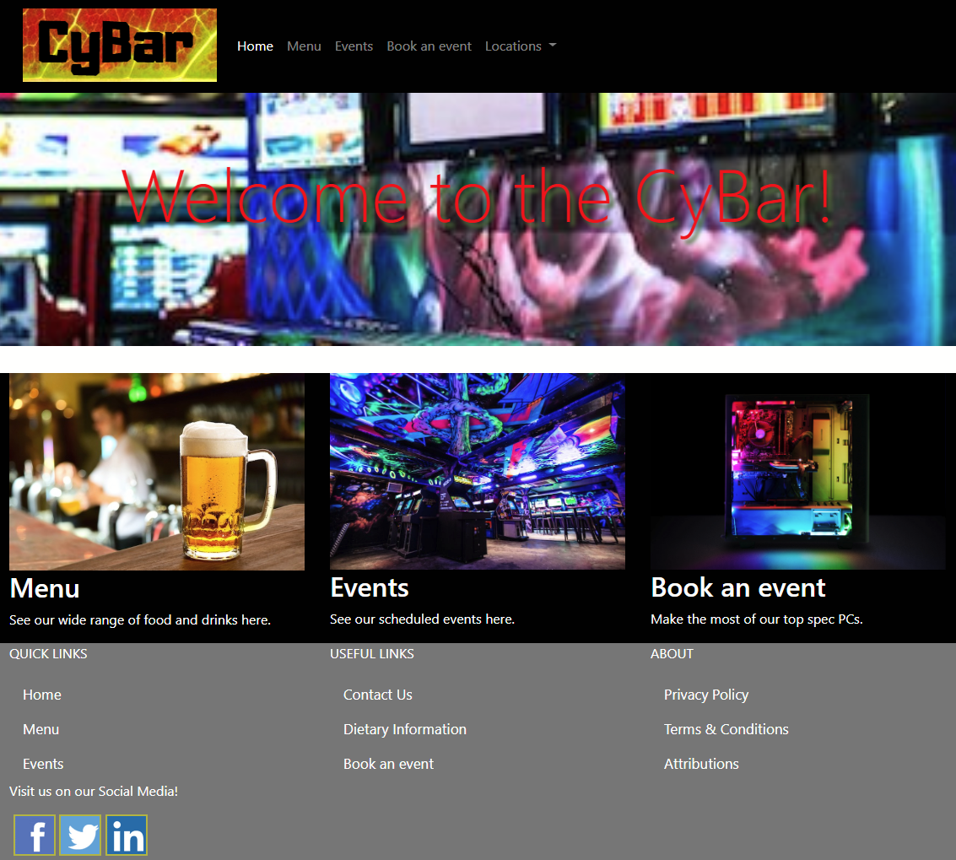
Menu:
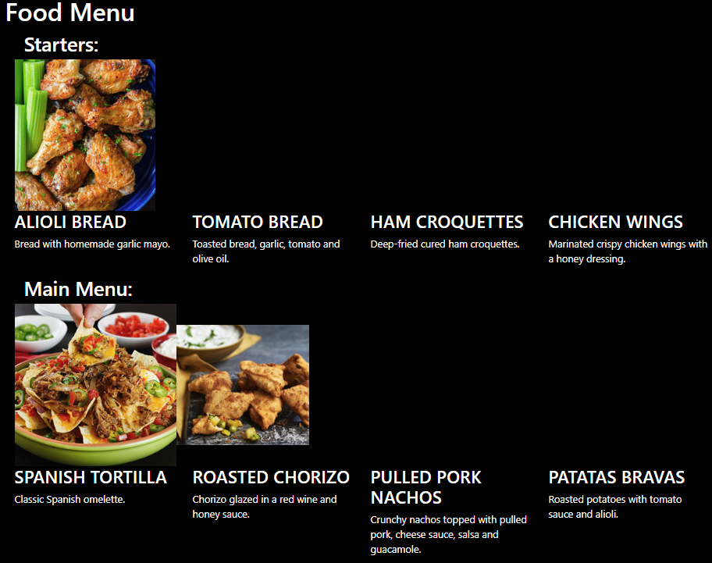
Events page:
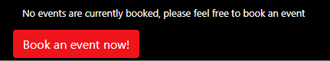

Event booking page:
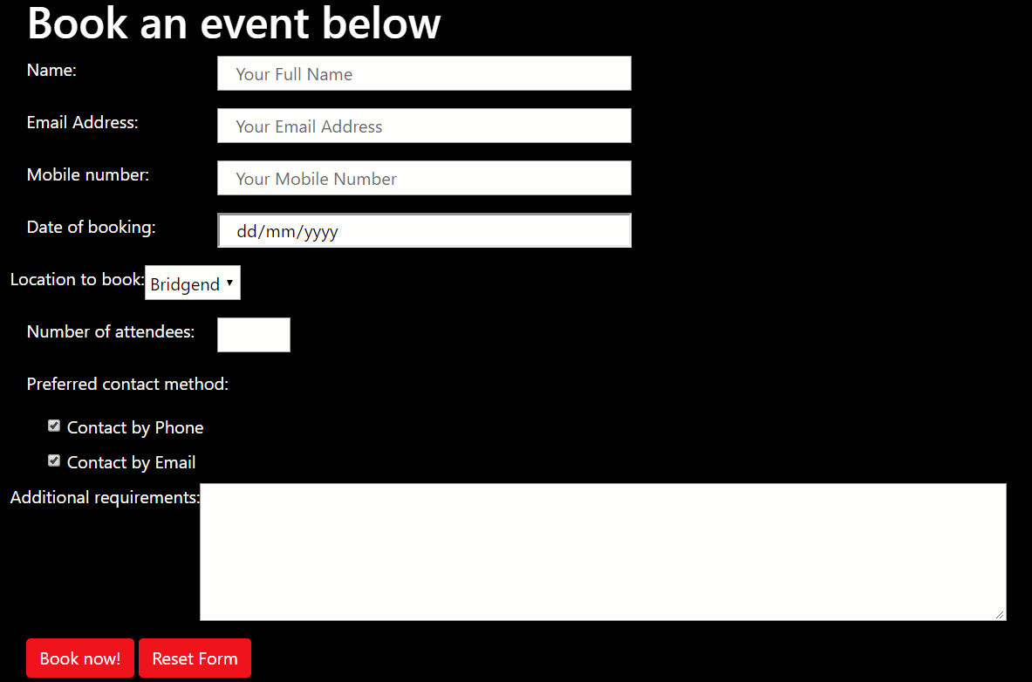
Confirmation page:
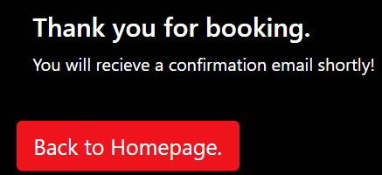

Location page:
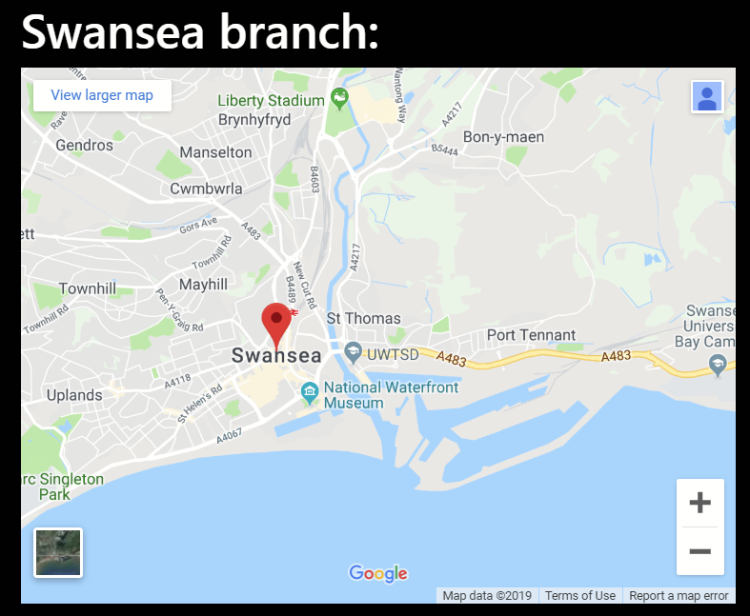

Validation:
After checking all the HTML pages, the only issues found were:
(found on the event booking page)
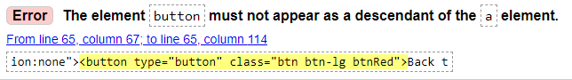
(found on confirmation page and Events page)
This error is down to the use of the <button> tag inside of an <a> tag, this has been done in order to make the button as a link as the author does not know how to make a link otherwise.
After some investigation however, this method of creating a button with a link has been replaced with <input type="button" onclick="window.location.href = 'book-event.html';" value="Book now!" class="btn btn-primary btnRed" />
CSS validation has also been completed:
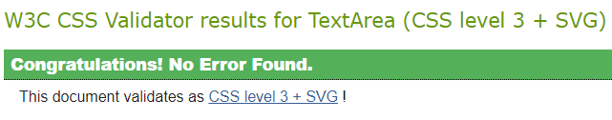

Evaluation
The final website that has been produced uses a dark theme as specified in the requirements; this gives the website a “night” look which reflects the theme of the bar (since it is considered as “nightlife”) The nav bar at the top of the page works fully and the ‘active’ page is highlighted when you are on that page.
Home page;
The jumbotron is relevant to the gaming / pub theme, one improvement that could be made is that the text is slightly difficult to read. Below the jumbotron, there is a white gap, this gap was not intended, the source of the gap is unknown. Below that on the page, the 3 sections are all accessible on different screen sizes, at the smallest sized screen, the sections change from being horizontal across the screen to being vertical down the page. The same goes with the footer on the page. All the relevant links are clickable and link to the correct page.
The Header and the footer of the page has been saved in a Template.html file and was copied to create the other pages, this way the design of the pages is uniform and are the same throughout. Another design that is found on multiple pages are the classes bg-black and whiteText which is (as the names suggest) creates the black background and white text.
Menu page;
This page could be improved greatly since currently, there is only 1 image for each course and the images themselves could be a uniform size, another improvement could be that the images could be in sprite format since there are several images on the same page, this would make page load times faster as there are less images that need to be downloaded. The functionality of the page is clear and is structured, the menu grid is also created with accessibility in mind and when the screen gets smaller, the menu goes towards using the full page per menu entry.
The events page has an active button that links to the book-events page, this page could have a lot more information on it or have other features such as an embedded Youtube video or an animation etc.
The book-event page has a fully functioning form and works as intended; the type of method used in the form is a “get” which is not as secure as using a “post” method as a “get” method posts the form in plain text so if there are any personal information on the form them it can be easily read by anyone who wants to see it. The information requested in the form is suitable in terms of it only asking for what is needed. When the form has been filled in and submitted, the confirmation page appears with a link back to the home page.
The last page is the location page, this page has embedded maps for each location the bar is present in, an improvement that can be made here is making the dropdowns on the nav bar link to the certain areas of the location page that map is on. For example, clicking Cardiff on the drop down opens the location page to the Cardiff map.
In terms of search engine optimisation, the following tag has been entered in the Head section of the HTML doc:
<meta name="keywords" content="bar, pub, beer, games, video games, food, hot food, tapas, TVs, craft beer, wine, shots" />
This tag allows the search engine to find the site using the keywords entered above which makes the site more visible and easier to find by whoever may be looking.

Web accessibility
Mentioned above several times has been the term “Web Accessibility”, this term “means that websites, tools, and technologies are designed and developed so that people with disabilities can use them.” [1], it can also relate to users of other devices such as mobile phones or devices that do not have access to a fast-enough internet connection to download the images on a page.
In terms of the website that has been created, the “ALT” element has been used for most of the images. This element converts an image to text format using the text entered into this element, reasons this is helpful can be for users that use a screen reader on websites, it can also be used for users with low internet speeds and the text shows instead of the image in this situation.
Using the WAVE add-on for chrome, here is the evaluation of each page:
Homepage:
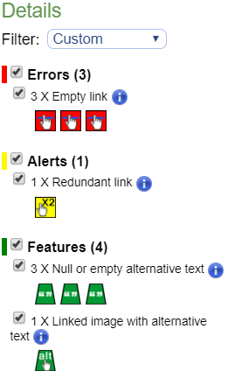
The “Empty link” error found is relating to the Social media buttons, the complaint here is that the images used for social media may not be explanatory to users who cannot see the images or users who may not know what the images used relate to. This does not cause that many issues however since it is not part of the main section of the page.
The redundant link relates to the “home” button and the logo links going to the same page which is not an issue either.
The null/empty text relates to images that do not bring much value to the page and is only there to improve the visuals.
Having looked at the other pages, they are all having the same errors that have been discussed above.

References
[1] https://www.w3.org/WAI/fundamentals/accessibility-intro/ accessed 23/07/19

marking criteria and Student FEEDBACK

This section details the extent to which the assessment criteria are demonstrated by you, which in turn determines your mark. The marks available for each category of skill are shown. Lecturers will use the space provided to comment on the achievement of the task(s), including those areas in which you have performed well and areas that would benefit from development/improvement.

Common Assessment Criteria Applied (Assignment 1) | Marks available | Marks  awarded
1. Engagement with Literature Skills

A generally good definition of web accessibility has been provided. In general, the evidence of engagement with literature skills is weak as demonstrated by the limited list of references. It is expected that you would consult a wider range of reference sources. Expand the scope of references consulted to further improve your work. (Grade mark: 40.00%) | 5 | 2
2. Knowledge and Understanding Skills

Demonstrates a very good understanding of the standards used to design and implement a website as demonstrated by the interpretation of the validation results and overall valid HTML and CSS implemented in the website. For the web accessibility and on-page SEO, some basic evaluation has been provided but this would be further improved by carrying out the necessary research to understand on-page SEO and WCAG 2.1. Some good recommendations for improvements have also been discussed. (Grade mark: 55.00%) | 30 | 16.5
3. Cognitive and Intellectual Skills

NA | NA | NA
4. Practical Application Skills

A very good attempt featuring a well-thought-out website with some good and relevant content, and a very good attempt at making it responsive. There is, however, some room for improvement and I would have liked to see some of your own ideas for the home page beyond basing the structure and design on the class tutorial exercise. Also, be careful with your choice of colours and limit busy images or ensure that you do not have too many of these very close to each other. See your report for detailed, suggested improvements and some corrections. (Grade mark: 75.00%) | 60 | 45
5. Transferable Skills for Life and Professional Practice

The report is generally well-written and presented. (Grade mark: 70.00%) | 5 | 3.5

Assignment Mark (Assessment marks are subject to ratification at the Exam Board. These comments and marks are to give feedback on module work and are for guidance only until they are confirmed. ) | Late Submission Penalties (tick if appropriate) |  | 67%
 | Up to 1 week late (40% Max) |  | 67%
 | Over 1 week late (0%) |  | 67%

